1. Telecom Alert Data Cleaning & Preprocessing
import pandas as pd
import json
import re
print("Task 1 Alert Cleaning Started")
with open("data/network_alerts.json", "r") as file:
data = json.load(file)
print("JSON loaded successfully")
alerts = data["result"]
df = pd.DataFrame(alerts)
print("\nDataFrame Created Successfully\n")
df["clock"] = pd.to_numeric(
df["clock"],
errors="coerce"
)
df["clock"] = pd.to_datetime(
df["clock"],
errors="coerce",
unit="s"
)
print("Timestamp Converted Successfully\n")
def extract_host(message):
match = re.search(r"Host:\s*(.*)", str(message))
return match.group(1) if match else None
def extract_severity(message):
match = re.search(r"Severity:\s*(.*)", str(message))
return match.group(1) if match else None
def extract_problem_name(message):
match = re.search(r"Problem name:\s*(.*)", str(message))
return match.group(1) if match else None
df["host"] = df["message"].apply(extract_host
df["severity"] = df["message"].apply(
extract_severity
)
df["problem_name"] = df["message"].apply(
extract_problem_name
)
df["host"] = df["host"].str.strip()
df["severity"] = df["severity"].str.strip()
df["problem_name"] = df["problem_name"].str.strip()
print("Message Extraction Completed\n")
df["invalid_clock"] = df["clock"].isna()
df["empty_subject"] = (
df["subject"].astype(str).str.strip() == ""
)
df["empty_message"] = (
df["message"].astype(str).str.strip() == ""
)
df["alert_status"] = df["subject"].apply(
lambda x: "Resolved"
if "Resolved" in str(x)
else "Problem"
)
print("Data Quality Checks Completed\n")
print(
df[
[
"alertid",
"clock",
"host",
"severity",
"problem_name",
"invalid_clock",
"empty_subject",
"empty_message",
"alert_status"
]
].head(10)
)
df.to_csv(
"output/cleaned_alerts.csv",
index=False
)
print("\ncleaned_alerts.csv saved successfully”)

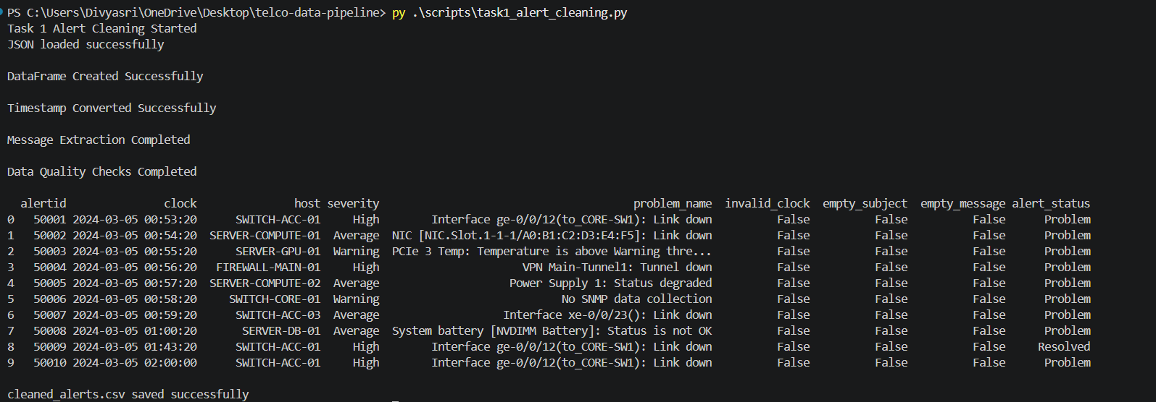
2. KPI Data Cleansing & Standardization Engine
import pandas as pd
print("Task 1 KPI Cleaning Started")
df = pd.read_csv("data/kpi_metrics.csv")
print("KPI dataset loaded successfully\n")
print(df.head())
print("\nMissing Values\n")
print(df.isnull().sum())
df["value"] = pd.to_numeric(
df["value"],
errors="coerce"
)
df = df[df["value"] >= 0]
print("\nNegative values removed\n")
pivot_df = df.pivot_table(
index=["endtime_utc", "object_name"],
columns="kpi_name",
values="value"
).reset_index()
print("Pivot Transformation Completed\n")
print(pivot_df.head())
pivot_df.to_csv(
"output/cleaned_kpi_wide.csv",
index=False
)
print("\ncleaned_kpi_wide.csv saved successfully")
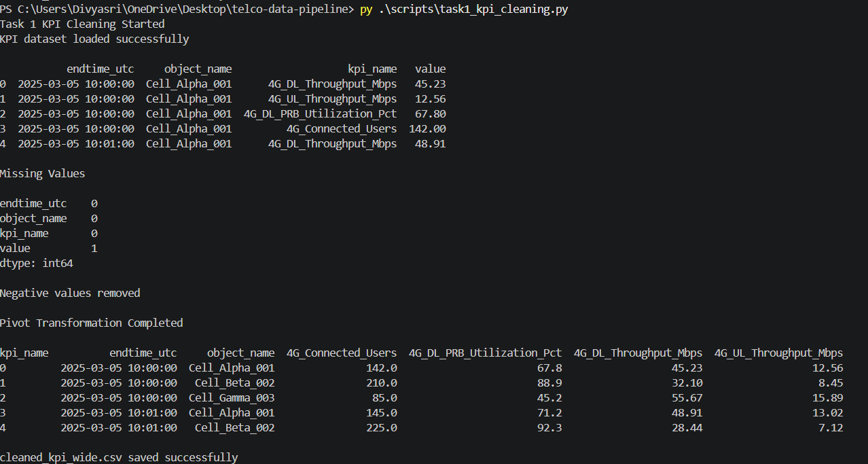

3.Incident Ticket Extraction & Parsing System
import pandas as pd
import re
print("Task 2 Ticket Extraction Started")
df = pd.read_csv("data/trouble_tickets.csv")
print("Trouble tickets dataset loaded successfully\n")
print(df.head())
def extract_cells(text):
cells = re.findall(
r"(Cell_[A-Za-z]+_\d+|BTS-\d+)",
str(text)
)
return ", ".join(cells)
def extract_devices(text):
devices = re.findall(
r"(SWITCH-[A-Z\-0-9]+|SERVER-[A-Z\-0-9]+|FIREWALL-[A-Z\-0-9]+)",
str(text)
)
return ", ".join(devices)
def extract_users(text):
match = re.search(
r"(\d+)\s*(users|subscribers)",
str(text),
re.IGNORECASE
)
if match:
return int(match.group(1))
return 0
def extract_root_cause(text):
patterns = [
r"root cause is (.*?)(\.|,)",
r"suspected cause is (.*?)(\.|,)",
r"caused by (.*?)(\.|,)",
r"due to (.*?)(\.|,)"
]
for pattern in patterns:
match = re.search(
pattern,
str(text),
re.IGNORECASE
)

if match:
return match.group(1)
return None
df["affected_cells"] = df["description"].apply(
extract_cells
)
df["affected_devices"] = df["description"].apply(
extract_devices
)
df["affected_users"] = df["description"].apply(
extract_users
)
df["root_cause"] = df["description"].apply(
extract_root_cause
)
print("\nExtraction Completed\n")
def calculate_impact_score(row):
score = 1
if row["priority"] == "P1":
score += 4

elif row["priority"] == "P2":
score += 3

elif row["priority"] == "P3":
score += 2

if row["status"] == "Open":
score += 2
users = row["affected_users"]

if users >= 1000:
score += 3

elif users >= 100:
score += 2

elif users > 0:
score += 1
return min(score, 10)
df["impact_score"] = df.apply(
calculate_impact_score,
axis=1
)
print("Impact Score Calculation Completed\n")
print(
df[
[
"ticket_id",
"priority",
"status",
"affected_users",
"impact_score",
"root_cause"
]
].head()
)
df.to_csv(
"output/extracted_ticket_data.csv",
index=False
)
print("\nextracted_ticket_data.csv saved successfully")

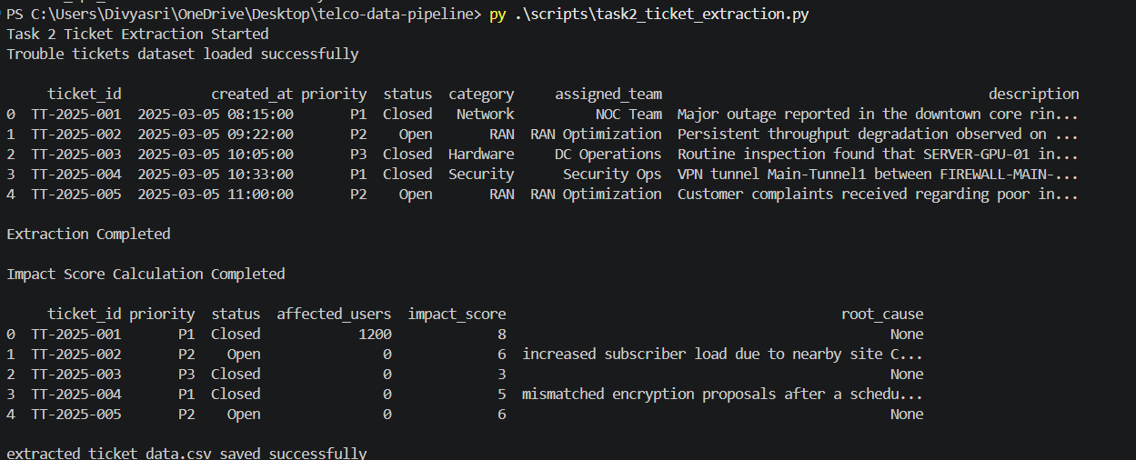
4. Telecom Alert Enrichment & Contextual Intelligence
import pandas as pd
print("Task 3 Alert Enrichment Started")
alerts_df = pd.read_csv(
"output/cleaned_alerts.csv"
)
topology_df = pd.read_csv(
"data/topology.csv"
)
print("Datasets loaded successfully\n")
print(topology_df.head())
topology_grouped = (
topology_df.groupby("hostname")
.agg({
"destination_node": lambda x:
", ".join(x.astype(str)),
"ip_address": "first"
})
.reset_index()
)
print("\nTopology aggregation completed\n")
topology_grouped.rename(
columns={
"destination_node": "connected_to"
},
inplace=True
)

enriched_df = pd.merge(
alerts_df,
topology_grouped,
left_on="host",
right_on="hostname",
how="left"
)
enriched_df["topology_found"] = (
enriched_df["hostname"].notna()
)
print("Alert enrichment completed\n")
print(
enriched_df[
[
"alertid",
"host",
"ip_address",
"connected_to",
"topology_found"
]
].head()
)
enriched_df.to_csv(
"output/enriched_alerts.csv",
index=False
)
print("\nenriched_alerts.csv saved successfully")
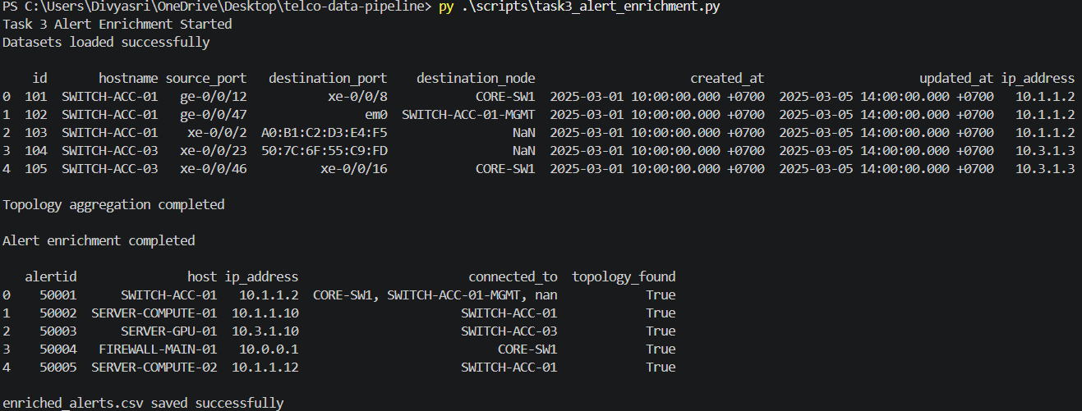
5. KPI Aggregation & Telecom Performance Analytics
import pandas as pd
print("Task 3 KPI Aggregation Started")
df = pd.read_csv(
"output/cleaned_kpi_wide.csv"
)
print("Dataset loaded successfully\n")
df["endtime_utc"] = pd.to_datetime(
df["endtime_utc"]
)
df["time_window"] = df["endtime_utc"].dt.floor("5min")
print("5-minute window created\n")
agg_df = (
df.groupby(
["time_window", "object_name"]
)
.agg({
"4G_DL_Throughput_Mbps": "mean",
"4G_UL_Throughput_Mbps": "mean",
"4G_DL_PRB_Utilization_Pct": "max",
"4G_Connected_Users": "max"
})
.reset_index()
)
agg_df.rename(
columns={
"4G_DL_Throughput_Mbps":
"avg_dl_throughput",

"4G_UL_Throughput_Mbps":
"avg_ul_throughput",

"4G_DL_PRB_Utilization_Pct":
"max_prb_utilization",

"4G_Connected_Users":
"max_connected_users"
},
inplace=True
)
def classify_load(prb):

if prb < 50:
return "Low"

elif prb < 80:
return "Medium"

elif prb < 90:
return "High"

return "Critical"

agg_df["cell_load_category"] = (
agg_df["max_prb_utilization"]
.apply(classify_load)
)
print("KPI aggregation completed\n")
print(agg_df.head())
agg_df.to_csv(
"output/kpi_aggregated_5m.csv",
index=False
)
print("\nkpi_aggregated_5m.csv saved successfully")
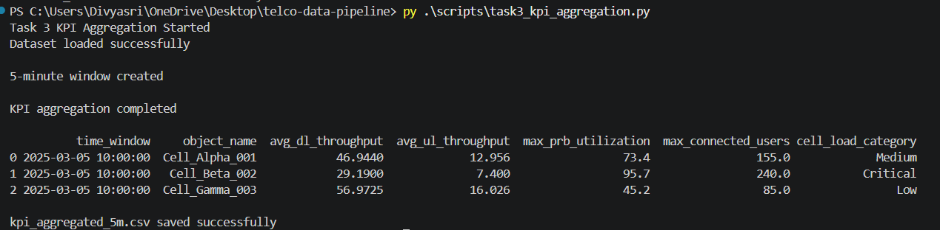
Telecom Predictive AIOps Platform

- AI-Based Alert Correlation & Incident Linking
import pandas as pd
print("Innovation 10 - Self-Healing Automation Started")
df = pd.read_csv(
"output/predictive_forecasting.csv"
)
print("Dataset loaded successfully\n")
def self_healing_action(row):
anomalies = str(
row["detected_anomalies"]
).lower()
forecast = str(
row["predictive_forecast"]
).lower()
if (
"congestion" in anomalies
or
"congestion" in forecast
):
return (
"Recommend automatic traffic redistribution, "
"dynamic load balancing, and subscriber rerouting."
)
elif (
"throughput" in anomalies
):
return (
"Recommend automated QoS optimization "
"and bandwidth reallocation."
)
elif (
"high prb utilization" in anomalies
):

return (
"Recommend automatic spectrum optimization "
"and congestion mitigation policies."
)
return (
"No self-healing action required. "
"Infrastructure operating normally."
)
df["self_healing_recommendation"] = (
df.apply(
self_healing_action,
axis=1
)
)

print("Self-healing recommendation completed\n")
print(
df[
[
"object_name",
"detected_anomalies",
"predictive_forecast",
"self_healing_recommendation"
]
]
)
df.to_csv(
"output/self_healing_recommendations.csv",
index=False
)

print(
"\nself_healing_recommendations.csv saved successfully"
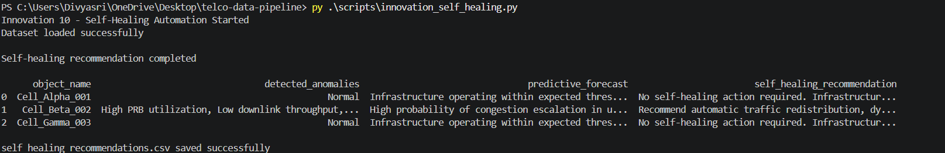
)

2.AI-Based Root Cause Analysis Engine
import pandas as pd
print("Innovation 3 - AI Root Cause Recommendation Started")
df = pd.read_csv(
"output/risk_predicted_alerts.csv"
)
print("Dataset loaded successfully\n")
def recommend_root_cause(row):
severity = str(row["severity"])
problem = str(row["problem_name"]).lower()
host = str(row["host"]).lower()
if (
"temp" in problem
or
"temperature" in problem
):
return (
"Possible overheating detected. "
"Check cooling systems and GPU/server airflow."
)
elif (
"vpn" in problem
or
"tunnel" in problem
):
return (
"Possible VPN negotiation failure or "
"firewall policy mismatch."
)
elif (
"link down" in problem
or
"interface" in problem
):
return (
"Possible fiber disconnect, "
"switch port failure, or network instability."
)
elif (
"power" in problem
):

return (
"Possible hardware degradation "
"or redundant power supply failure."
)
elif (
"snmp" in problem
):
return (
"Monitoring communication failure. "
"Check SNMP agent/network reachability."
)
elif (
"firewall" in host
):
return (
"Possible security policy conflict "
"or HA synchronization issue."
)
elif severity == "Disaster":
return (
"Critical infrastructure instability detected. "
"Immediate investigation required."
)
return (
"Further investigation required."
)
df["ai_root_cause_recommendation"] = (
df.apply(
recommend_root_cause,
axis=1
)
)

print("AI root cause recommendation completed\n")
print(
df[
[
"alertid",
"host",
"problem_name",
"ai_root_cause_recommendation"
]
].head(15)
)
df.to_csv(
"output/ai_root_cause_analysis.csv",
index=False
)

print(
"\ai_root_cause_analysis.csv saved successfully"
)
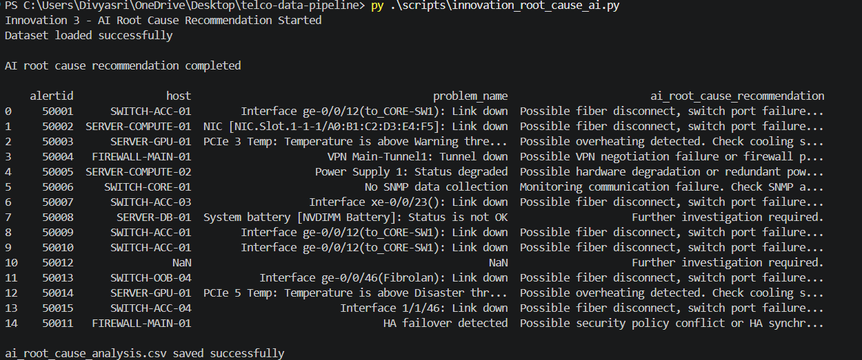

3. Telecom Operational Risk Prediction Model
import pandas as pd
print("Innovation 2 - Risk Prediction Started")
alerts_df = pd.read_csv(
"output/correlated_alerts.csv"
)
tickets_df = pd.read_csv(
"output/extracted_ticket_data.csv"
)
kpi_df = pd.read_csv(
"output/kpi_aggregated_5m.csv"
)
print("Datasets loaded successfully\n")
def calculate_risk(row):
score = 0
severity = str(row["severity"])

if severity == "Disaster":
score += 5

elif severity == "High":
score += 4

elif severity == "Average":
score += 3

elif severity == "Warning":
score += 2
host = str(row["host"])

if (
"CORE" in host
or
"FIREWALL" in host
):
score += 3

elif (
"SERVER" in host
or
"SWITCH" in host
):
score += 2
topology = str(row["connected_to"])

connected_count = len(
topology.split(",")
)

if connected_count >= 3:
score += 3

elif connected_count >= 2:
score += 2

elif connected_count >= 1:
score += 1

return min(score, 10)
alerts_df["risk_score"] = alerts_df.apply(
calculate_risk,
axis=1
)
def classify_risk(score):

if score >= 9:
return "Critical"

elif score >= 7:
return "High"

elif score >= 5:
return "Medium"

return "Low"

alerts_df["risk_category"] = (
alerts_df["risk_score"]
.apply(classify_risk)
)

print("Risk prediction completed\n")
print(
alerts_df[
[
"alertid",
"host",
"severity",
"risk_score",
"risk_category"
]
].head(15)
)
alerts_df.to_csv(
"output/risk_predicted_alerts.csv",
index=False
)

print(
"\nrisk_predicted_alerts.csv saved successfully"
)

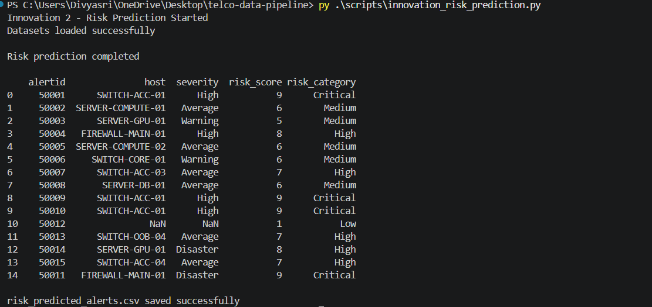

4. AI Incident Priority Recommendation Engine
import pandas as pd
print("Innovation 6 - Incident Priority Recommendation Started")
df = pd.read_csv(
"output/risk_predicted_alerts.csv"
)
print("Dataset loaded successfully\n")
def recommend_priority(row):
risk = row["risk_score"]
severity = str(row["severity"])
if (
risk >= 9
or severity == "Disaster"
):
return "P1"
elif risk >= 7:
return "P2"
elif risk >= 5:
return "P3"
return "P4"
df["recommended_priority"] = (
df.apply(
recommend_priority,
axis=1
)
)

print("Priority recommendation completed\n")
print(
df[
[
"alertid",
"host",
"severity",
"risk_score",
"recommended_priority"
]
].head(15)
)
print("\nPriority Distribution\n")

print(
df["recommended_priority"]
.value_counts()
)
df.to_csv(
"output/priority_recommendation.csv",
index=False
)

print(
"\npriority_recommendation.csv saved successfully"
)

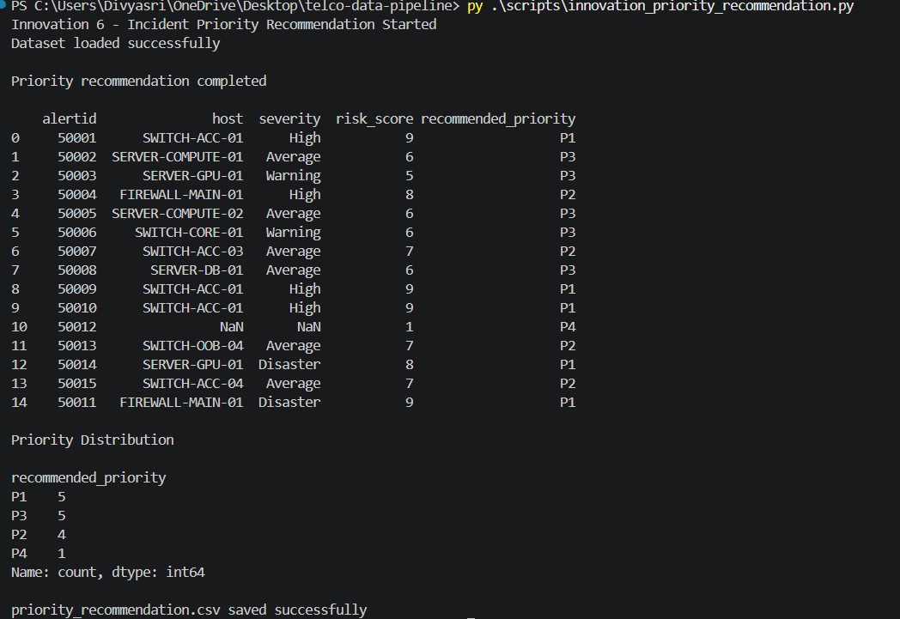

5. Predictive Telecom Incident Forecasting System
import pandas as pd
print("Innovation 9 - Predictive Incident Forecasting Started")
risk_df = pd.read_csv(
"output/risk_predicted_alerts.csv"
)
anomaly_df = pd.read_csv(
"output/kpi_anomaly_detection.csv"
)
print("Datasets loaded successfully\n")
def forecast_incident(row):
anomalies = str(
row["detected_anomalies"]
).lower()
users = row["max_connected_users"]
prb = row["max_prb_utilization"]
if (
"high prb utilization" in anomalies
and users >= 200
):

return (
"High probability of congestion escalation "
"in upcoming monitoring cycles."
)
elif (
"low downlink throughput" in anomalies
):
return (
"Potential service degradation risk "
"for connected subscribers."
)
elif prb >= 95:
return (
"Possible cell instability or overload "
"condition predicted."
)
return (
"Infrastructure operating within "
"expected thresholds."
)
anomaly_df["predictive_forecast"] = (
anomaly_df.apply(
forecast_incident,
axis=1
)
)
print("Predictive forecasting completed\n")
print(
anomaly_df[
[
"object_name",
"detected_anomalies",
"predictive_forecast"
]
]
)
anomaly_df.to_csv(
"output/predictive_forecasting.csv",
index=False
)

print(
"\npredictive_forecasting.csv saved successfully"
)

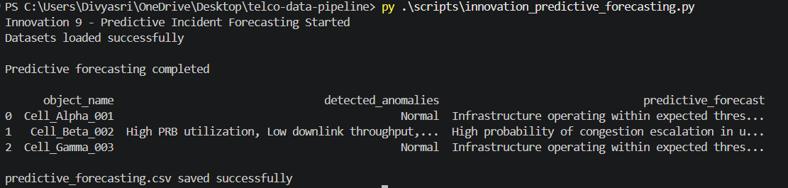

6. AI-Driven KPI Anomaly Detection Framework
import pandas as pd
print("Innovation 7 - KPI Anomaly Detection Started")
df = pd.read_csv(
"output/kpi_aggregated_5m.csv"
)
print("Dataset loaded successfully\n")
def detect_anomaly(row):
prb = row["max_prb_utilization"]
dl = row["avg_dl_throughput"]
users = row["max_connected_users"]
anomalies = []
if prb >= 90:
anomalies.append(
"High PRB utilization"
)
if dl < 30:
anomalies.append(
"Low downlink throughput"
)
if users >= 200:
anomalies.append(
"High user congestion"
)

if len(anomalies) == 0:
return "Normal"
return ", ".join(anomalies)
df["detected_anomalies"] = (
df.apply(
detect_anomaly,
axis=1
)
)

df["anomaly_status"] = (
df["detected_anomalies"]
.apply(
lambda x:
"Anomaly Detected"
if x != "Normal"
else "Normal"
)
)

print("KPI anomaly detection completed\n")
print(
df[
[
"object_name",
"avg_dl_throughput",
"max_prb_utilization",
"max_connected_users",
"detected_anomalies",
"anomaly_status"
]
]
)

df.to_csv(
"output/kpi_anomaly_detection.csv",
index=False
)

print(
"\nkpi_anomaly_detection.csv saved successfully"
)

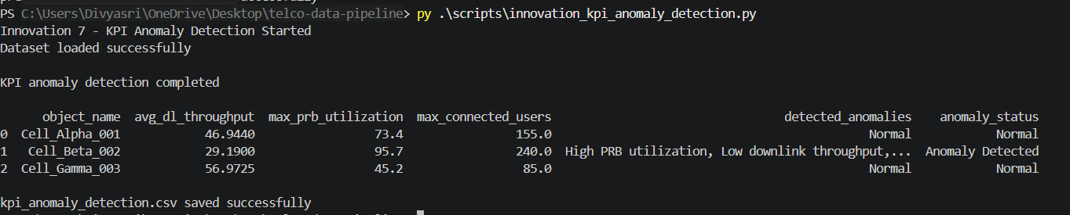

7. AI Executive Incident Summary Generator
import pandas as pd
print("Innovation 5 - Executive Incident Summary Started")
alerts_df = pd.read_csv(
"output/risk_predicted_alerts.csv"
)
kpi_df = pd.read_csv(
"output/kpi_aggregated_5m.csv"
)
print("Datasets loaded successfully\n")
total_alerts = len(alerts_df)
critical_alerts = len(
alerts_df[
alerts_df["risk_category"]
== "Critical"
]
)
high_alerts = len(
alerts_df[
alerts_df["risk_category"]
== "High"
]
)
overloaded_cells = len(
kpi_df[
kpi_df["cell_load_category"]
== "Critical"
]
)
top_risky_hosts = (
alerts_df.groupby("host")["risk_score"]
.max()
.sort_values(ascending=False)
.head(5)
)
top_root_causes = (
alerts_df["problem_name"]
.value_counts()
.head(5)
)

print("")
print(" Telecom Executive Incident Summary ")
print("\n")

print(f"Total Alerts: {total_alerts}")

print(f"Critical Risk Alerts: {critical_alerts}")

print(f"High Risk Alerts: {high_alerts}")

print(f"Overloaded Cells: {overloaded_cells}")

print("\nTop Risky Hosts\n")

print(top_risky_hosts)

print("\nMost Frequent Problems\n")

print(top_root_causes)
summary_data = {

"total_alerts": [total_alerts],

"critical_alerts": [critical_alerts],

"high_risk_alerts": [high_alerts],

"overloaded_cells": [overloaded_cells]
}
summary_df = pd.DataFrame(summary_data)
summary_df.to_csv(
"output/executive_summary.csv",
index=False
)
print(
"\nexecutive_summary.csv saved successfully"
)

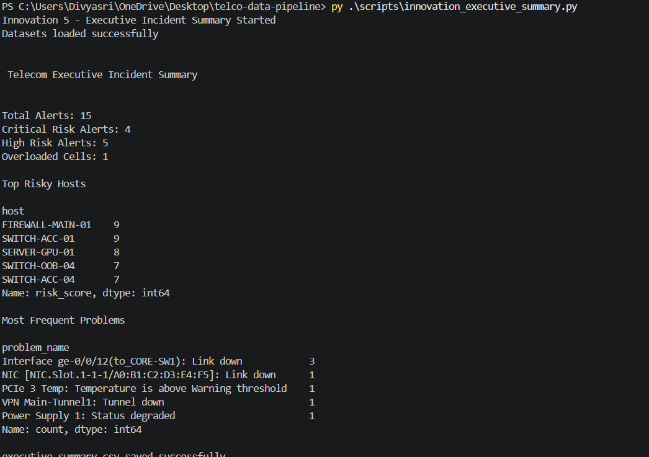
8. Network Blast Radius Impact Analysis System
import pandas as pd
print("Innovation 4 - Blast Radius Visualization Started")
df = pd.read_csv(
"output/enriched_alerts.csv"
)
print("Dataset loaded successfully\n")
def build_blast_radius(row):
host = str(row["host"])
connected = str(row["connected_to"])
if connected == "nan":
return (
host
+
"\n ↓\n No connected devices"
)
connected_devices = connected.split(",")
blast_map = host
for device in connected_devices:
blast_map += (
"\n ↓\n "
+
device.strip()
)
return blast_map
df["blast_radius_map"] = df.apply(
build_blast_radius,
axis=1
)

print("Blast radius mapping completed\n")
for i in range(min(10, len(df))):
print(
"\n"
)

print(
f"Alert ID: {df.loc[i, 'alertid']}"
)

print(
f"Host: {df.loc[i, 'host']}"
)

print("\nBlast Radius Map:\n")

print(
df.loc[i, "blast_radius_map"]
)

print(
"\nBlast radius visualization completed"
)
df.to_csv(
"output/blast_radius_analysis.csv",
index=False
)

print(
"\nblast_radius_analysis.csv saved successfully"
)
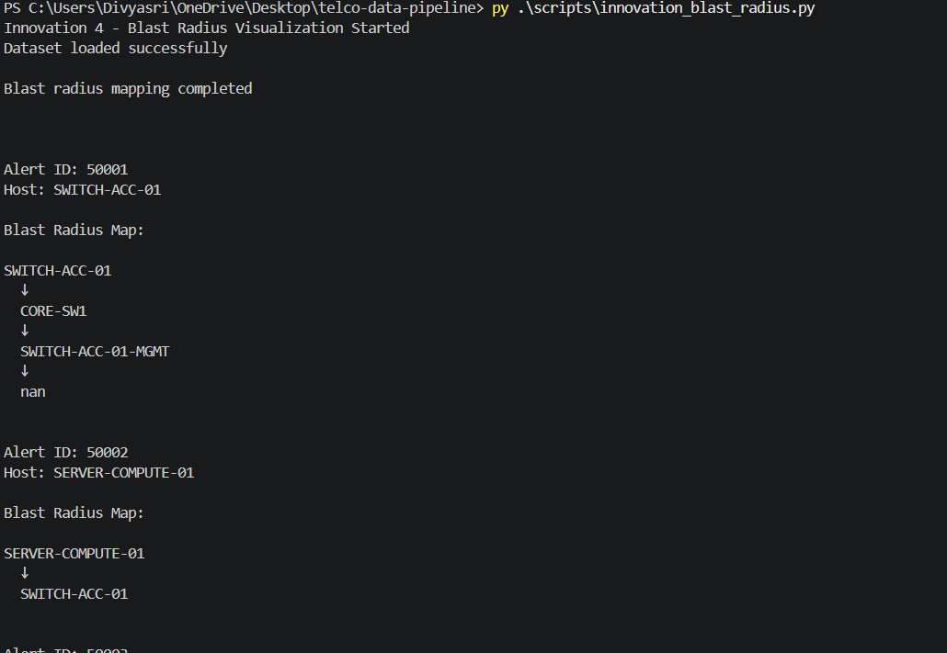

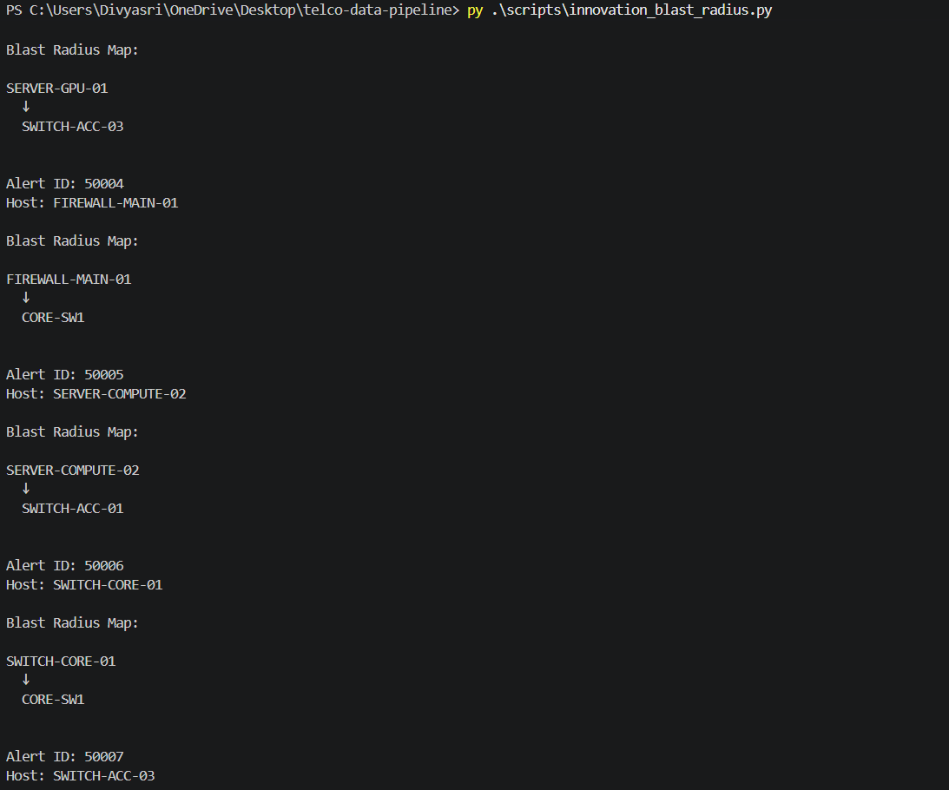
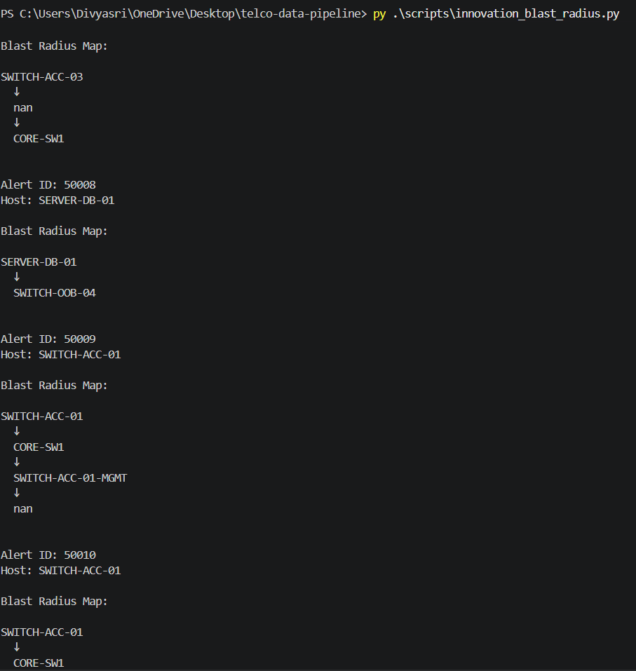

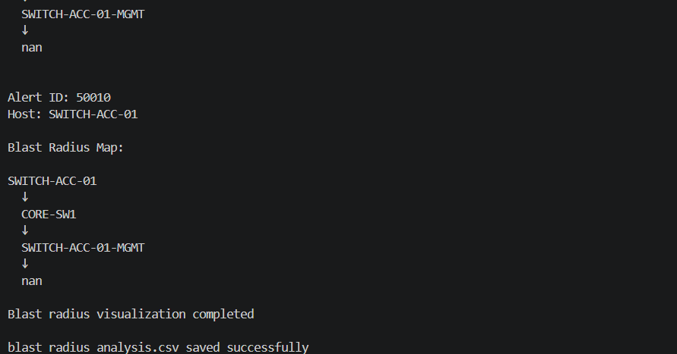

9. Automated Telecom Incident Remediation Engine
import pandas as pd
print("Innovation 8 - Auto Remediation Suggestions Started")
df = pd.read_csv(
"output/ai_root_cause_analysis.csv"
)

print("Dataset loaded successfully\n")
def generate_remediation(row):

problem = str(row["problem_name"]).lower()

recommendation = str(
row["ai_root_cause_recommendation"]
).lower()
if (
"vpn" in problem
or
"tunnel" in problem
):

return (
"Verify VPN tunnel configuration, "
"restart tunnel negotiation, "
"and validate firewall policies."
)

elif (
"temp" in problem
or
"temperature" in problem
):

return (
"Inspect cooling systems, "
"verify airflow, "
"and check server/GPU fan status."
)
elif (
"link down" in problem
or
"interface" in problem
):

return (
"Inspect fiber connectivity, "
"verify switch port health, "
"and check interface stability."
)

elif (
"power" in problem
):

return (
"Check redundant power supplies, "
"inspect hardware components, "
"and validate power redundancy."
)

elif (
"snmp" in problem
):

return (
"Verify SNMP agent availability, "
"check monitoring connectivity, "
"and validate network reachability."
)
return (
"Perform detailed operational "
"investigation and infrastructure validation."
)

df["auto_remediation_action"] = (
df.apply(
generate_remediation,
axis=1
)
)

print("Auto remediation generation completed\n")
print(
df[
[
"alertid",
"host",
"problem_name",
"auto_remediation_action"
]
].head(15)
)
df.to_csv(
"output/auto_remediation_actions.csv",
index=False
)

print(
"\nauto_remediation_actions.csv saved successfully"
)

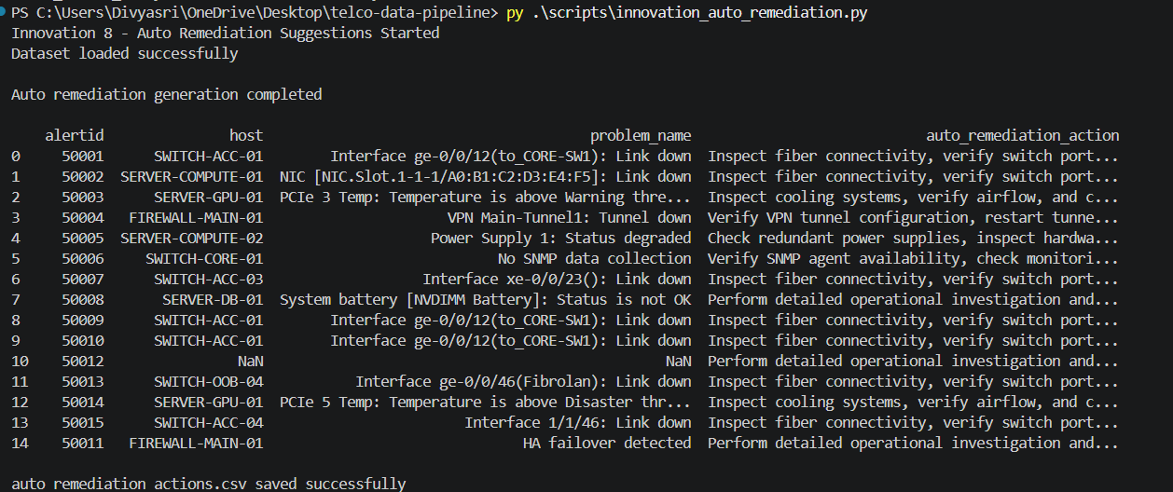

10. AI-Based Alert Correlation & Incident Linking
import pandas as pd
print("Innovation 1 - Alert Correlation Started")
df = pd.read_csv(
"output/enriched_alerts.csv"
)
print("Dataset loaded successfully\n")
df["clock"] = pd.to_datetime(df["clock"])
df = df.sort_values("clock")
df["correlation_id"] = None
correlation_counter = 1
for i in range(len(df)):
if pd.isna(df.loc[i, "correlation_id"]):
current_host = df.loc[i, "host"]
current_time = df.loc[i, "clock"]
correlation_id = (
f"INCIDENT_{correlation_counter}"
)
df.loc[i, "correlation_id"] = (
correlation_id
)
for j in range(i + 1, len(df)):
compare_host = df.loc[j, "host"]
compare_time = df.loc[j, "clock"]
time_diff = abs(
(
compare_time - current_time
).total_seconds()
) / 60
if (
time_diff <= 30
and (
current_host == compare_host
or
df.loc[i, "connected_to"]
==
df.loc[j, "connected_to"]
)
):
df.loc[j, "correlation_id"] = (
correlation_id
)

correlation_counter += 1
print("Alert correlation completed\n")
print(
df[
[
"alertid",
"host",
"problem_name",
"correlation_id"
]
].head(15)
)
df.to_csv(
"output/correlated_alerts.csv",
index=False
)

print(
"\ncorrelated_alerts.csv saved successfully"
)

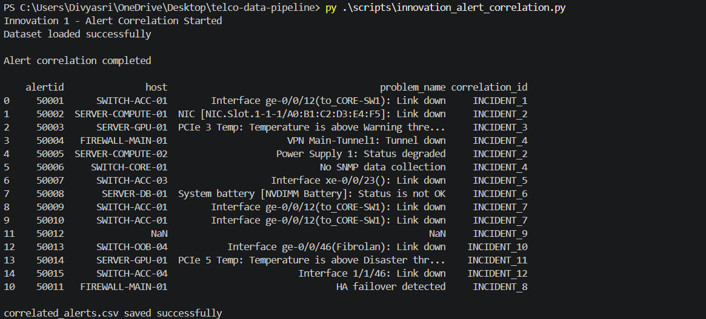

SQL

1.Query1 : Top_Hosts
SELECT
host,
COUNT(*) AS total_problem_alerts,
SUM(
CASE
WHEN severity = 'High'
THEN 1
ELSE 0
END
) AS high_alerts,
SUM(
CASE
WHEN severity = 'Average'
THEN 1
ELSE 0
END
) AS average_alerts,
SUM(
CASE
WHEN severity = 'Warning'
THEN 1
ELSE 0
END
) AS warning_alerts,
SUM(
CASE
WHEN severity = 'Disaster'
THEN 1
ELSE 0
END
) AS disaster_alerts
FROM alerts
WHERE alert_type = 'Problem'
GROUP BY host
ORDER BY total_problem_alerts DESC
LIMIT 5;

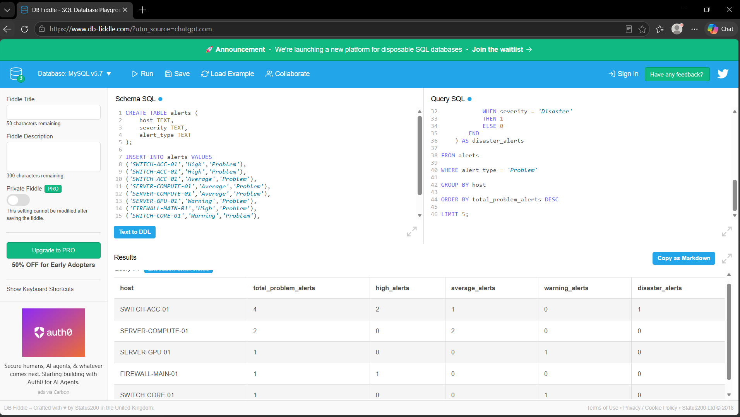

2.Query2 : Cell_Performance
SELECT
object_name,
AVG(dl_throughput_mbps)
AS avg_dl_throughput,
AVG(ul_throughput_mbps)
AS avg_ul_throughput,
MAX(prb_utilization_pct)
AS peak_prb_utilization,
MAX(connected_users)
AS peak_connected_users
FROM kpi_data
GROUP BY object_name
ORDER BY peak_prb_utilization DESC;

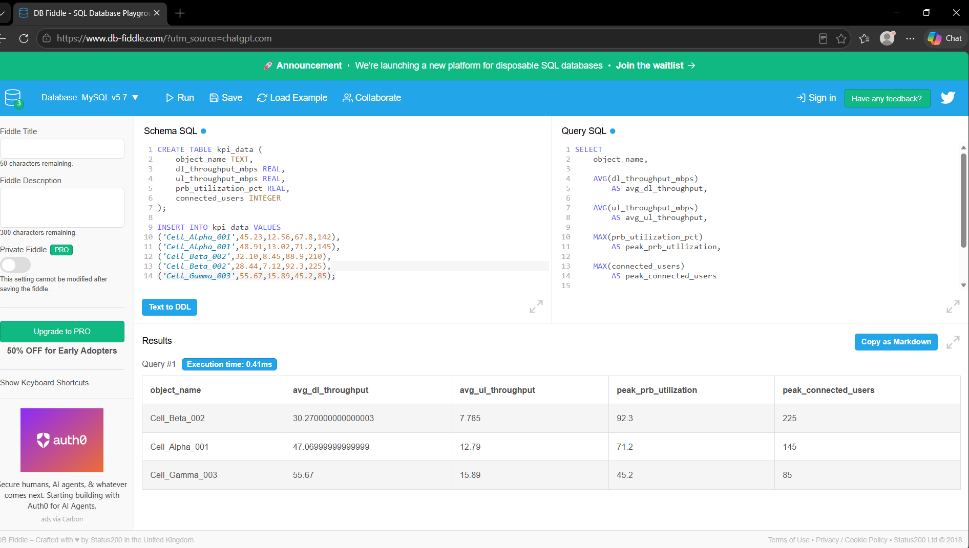
3.Query3 : Alert_Resolution_Time
WITH problem_alerts AS (
SELECT
host,
problem_name,
timestamp AS problem_time
FROM alerts
WHERE alert_type = 'Problem'
),
resolved_alerts AS (
SELECT
host,
problem_name,
timestamp AS resolved_time
FROM alerts
WHERE alert_type = 'Resolved'
)
SELECT
p.host,
AVG(
EXTRACT(
EPOCH FROM (
r.resolved_time - p.problem_time
)
) / 60
) AS avg_resolution_minutes
FROM problem_alerts p
JOIN resolved_alerts r
ON p.host = r.host
AND p.problem_name = r.problem_name
GROUP BY p.host;
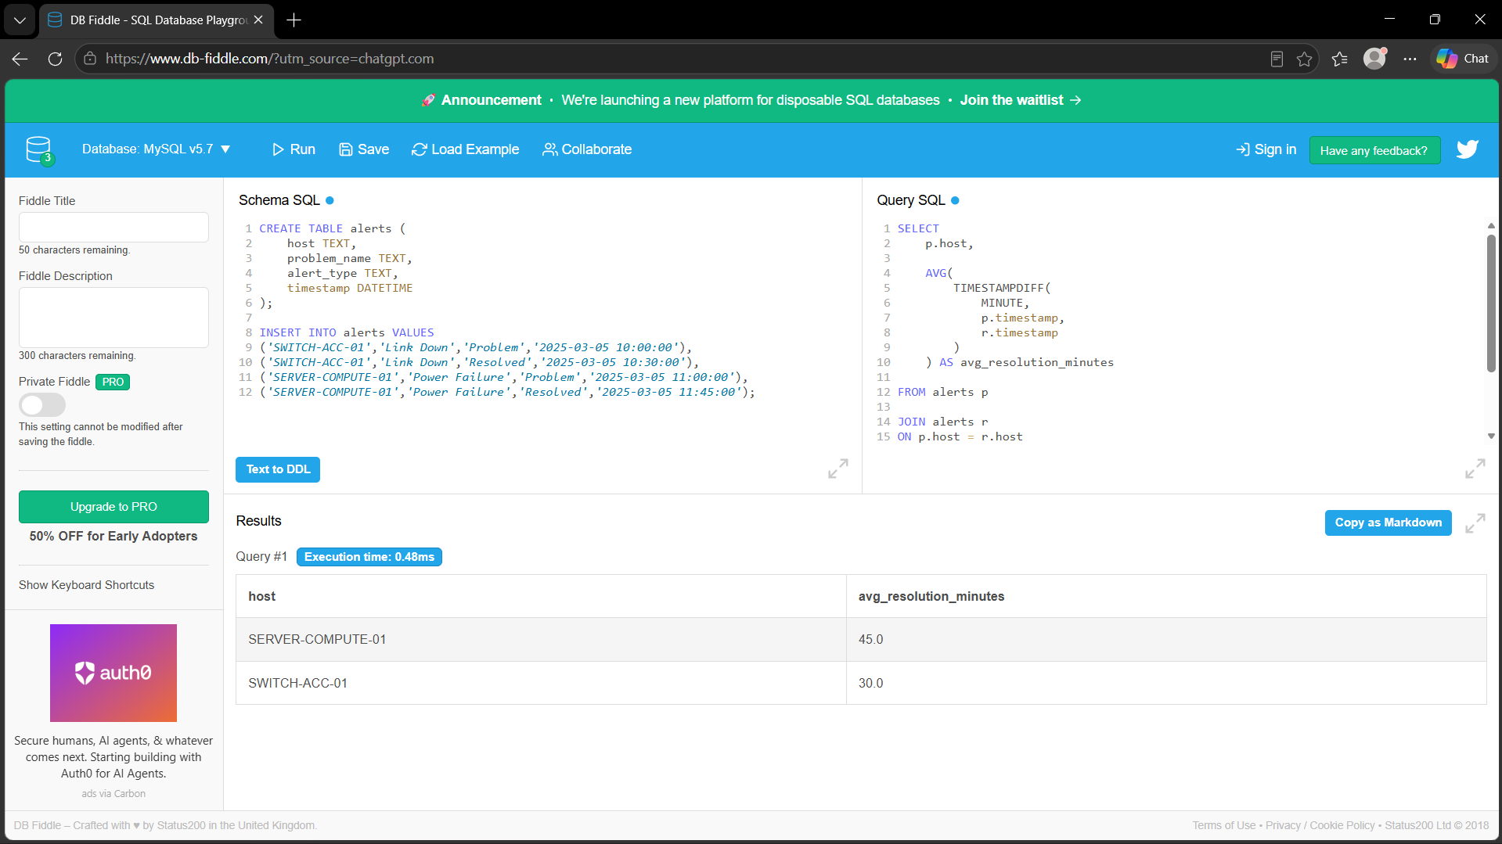

4. Query4 :Network_Blast_Radius
SELECT
a.host,
a.problem_name,
COUNT(t.destination_node)
AS connected_devices_count
FROM alerts a
LEFT JOIN topology t
ON a.host = t.hostname
WHERE a.alert_type = 'Problem'
AND NOT EXISTS (
SELECT 1
FROM alerts r
WHERE r.host = a.host
AND r.problem_name = a.problem_name
AND r.alert_type = 'Resolved'
)
GROUP BY
a.host,
a.problem_name
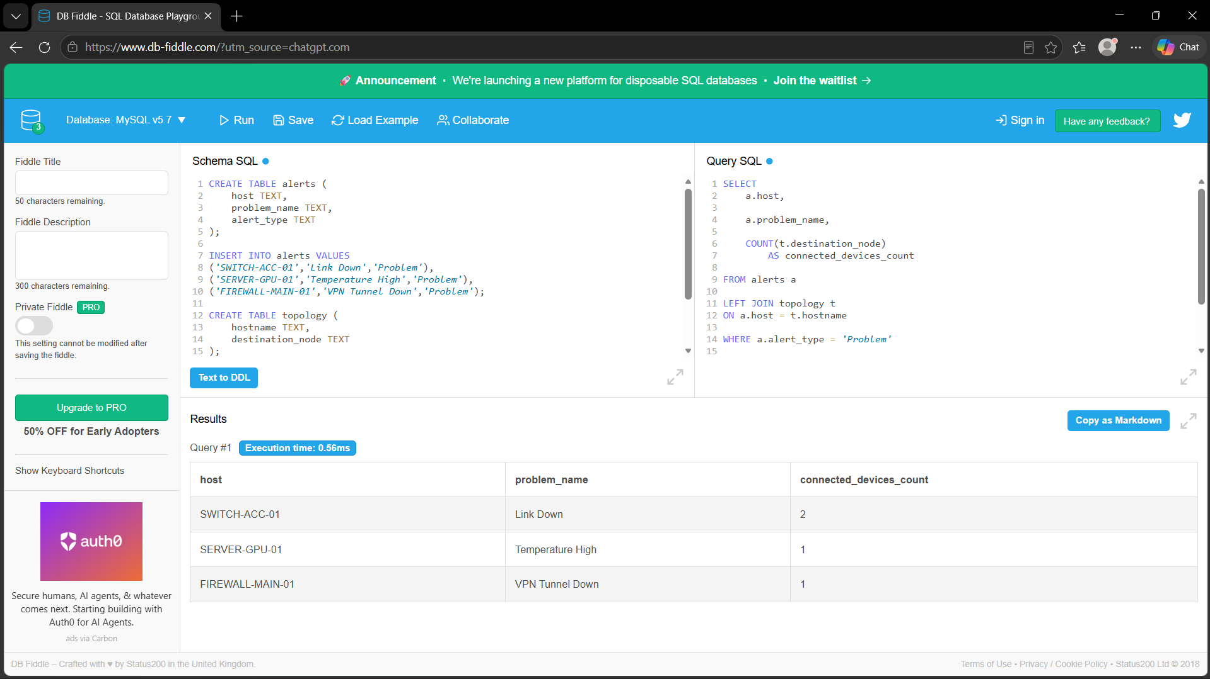
ORDER BY connected_devices_count DESC;
5. Query5 : Overloaded_Cells
WITH overloaded_cells AS (
SELECT
object_name,
endtime_utc,
prb_utilization_pct,
CASE
WHEN prb_utilization_pct > 90
THEN 1
ELSE 0
END AS overloaded
FROM kpi_data
),
grouped_overloads AS (
SELECT
object_name,
endtime_utc,
ROW_NUMBER() OVER (
PARTITION BY object_name
ORDER BY endtime_utc
)
ROW_NUMBER() OVER (
PARTITION BY object_name, overloaded
ORDER BY endtime_utc
) AS grp
FROM overloaded_cells
WHERE overloaded = 1
)
SELECT
object_name,
MIN(endtime_utc)
AS overload_start_time,
COUNT(*) AS duration_minutes
FROM grouped_overloads
GROUP BY
object_name,
grp
HAVING COUNT(*) >= 3
ORDER BY duration_minutes DESC;

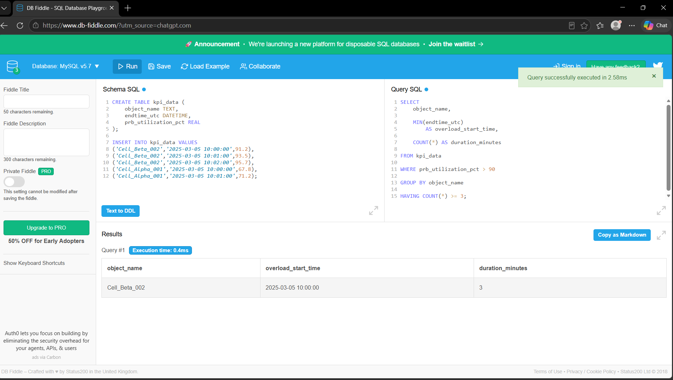

DASHBOARD UI-INTERFACE

