Employee Sentiment Analysis – Final Report

# 1. Introduction

This report presents findings from the Employee Sentiment Analysis project. The objective was to analyze internal communications to determine employee sentiment, evaluate engagement, identify potential flight risks, and apply predictive modeling to uncover trends using NLP and statistical techniques.

# 2. Methodology

## 2.1 Sentiment Labeling

Each message was labeled as Positive, Neutral, or Negative using TextBlob's sentiment polarity scoring.

## 2.2 Exploratory Data Analysis (EDA)

We visualized sentiment distribution and message volume over time.

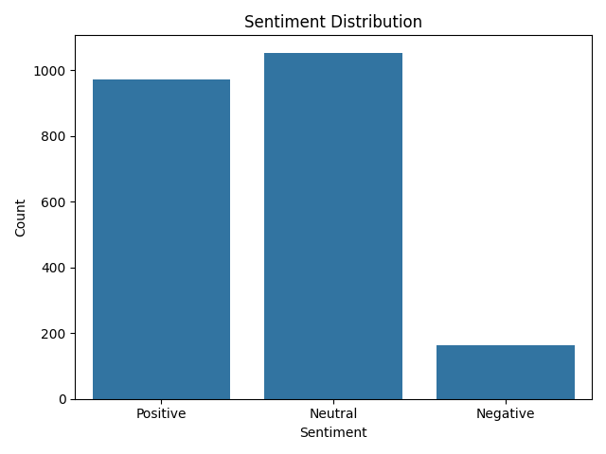

Figure 1: Sentiment Distribution

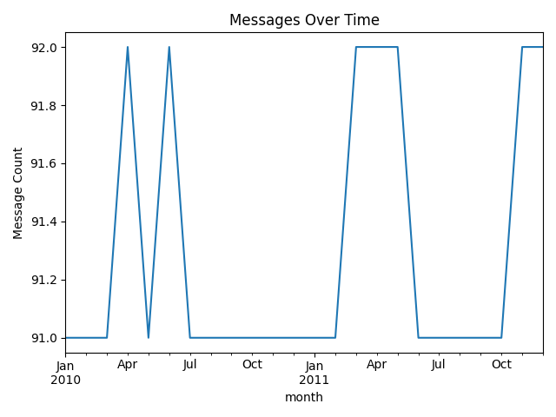

Figure 2: Messages Over Time

## 2.3 Monthly Sentiment Scoring

Each employee's messages were scored monthly (+1 for Positive, -1 for Negative, 0 for Neutral) to derive engagement levels.

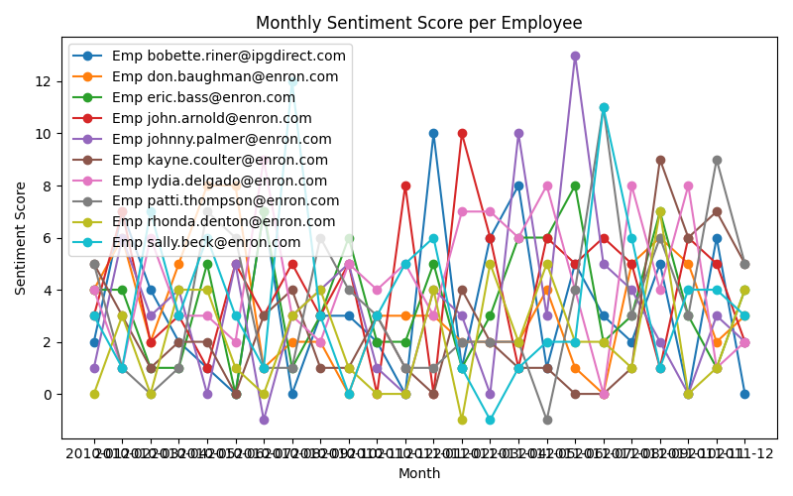

Figure 3: Monthly Sentiment Score per Employee

## 2.4 Employee Ranking

Employees were ranked monthly based on their sentiment scores.

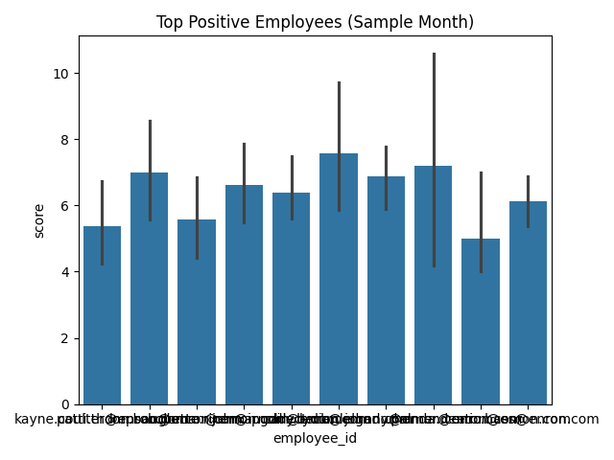

Figure 4: Top Positive Employees

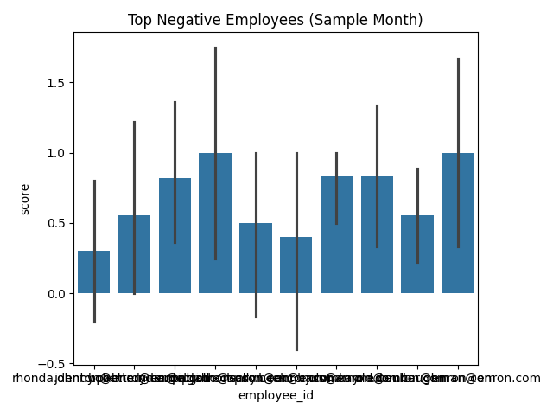

Figure 5: Top Negative Employees

## 2.5 Flight Risk Identification

Employees with four or more negative messages in any rolling 30-day period were flagged as potential flight risks.

## 2.6 Predictive Modeling

We built a linear regression model using features like message count and message length to predict sentiment trends.

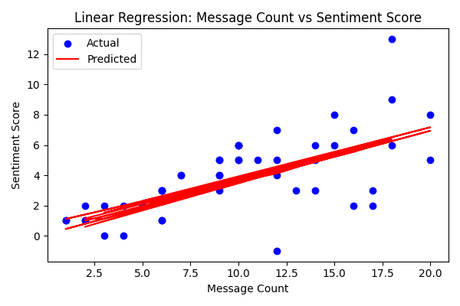

Figure 6: Regression - Message Count vs Sentiment Score

# 3. Key Findings

- Majority of employee messages were positive or neutral.  
- A minority of employees consistently produced negative sentiment, indicating disengagement.  
- Flight risk criteria effectively highlighted employees needing attention.  
- Predictive modeling demonstrated correlation between message patterns and sentiment scores.

# 4. Recommendations

- Follow up with flagged employees to understand issues.  
- Recognize consistently positive contributors.  
- Use monthly sentiment analysis as part of HR's early intervention process.  
- Enhance sentiment prediction using additional NLP features or models.