**Learning Journal**

**Student Name:** DIVYA SRI PASUPULETI (40309907)

**Course:** SOFTWARE PROJECT MANAGEMENT

**Journal URL:** https://github.com/divyasri5i0/SPM-Winter2025

**Dates Rage of activities**: [WEEK-4] 7 MARCH 2025 – 16 MARCH 2025

**Date of the journal:** 12-03-2025

**Key Concepts Learned**:

* Deep dived in to the concepts of project monitoring and control. Project planning sets a baseline for execution, monitoring, and control, covering scheduling, budgeting, manpower, communication, and quality planning. Scheduling follows either a top-down (starting from overall duration) or bottom-up (starting from smaller tasks) approach.
* Project budgets, like schedules, can be tracked against baseline figures as work progresses. Earned Value Management (EVM) is an effective tool for measuring both schedule and budget performance. Accurate baseline and actual data are essential for determining variances.
* Monitoring: Collecting sufficient data to measure progress.
* Control: making sure project delivers the initial objectives, cost and quality by making corrections when necessary.
* Project monitoring and control involve comparing baseline plans with actual events to identify deviations and take corrective actions. Re-planning is applied to manage:
* Cost
* Schedule
* Scope
* quality, and contracts effectively
* **Designing a Project Monitoring and Control System -** involves establishing a structured approach to track project performance, identify deviations, and take corrective actions. Key steps are as follows:
* Establish baselines : Set performance benchmarks and key milestones. Define base plan for
* Cost(budget)
* Time (Schedule)
* Performance (quality, specification)
* Scope (WBS)
* Monitor & Measure performance : tracking project progress using project management tools like EVM (Earned Value Management). Collecting data on :
* Percentage completion
* Cost expended
* Quality tests
* Scope change reports
* Compare performance to base line
* Identify variances between actual progress and planned targets.
* Analyse deviations and assess potential risks.
* Take corrective action
* Implement adjustments to bring the project back on track.
* Update plans, reallocate resources, or revise schedules as needed.
* **Earned Value Analysis (EVA)** evaluates project progress by integrating cost and time constraints. It assigns a dollar value to tasks or work packages and measures progress in monetary terms rather than time. Curves Representing Key EVM Metrics:
* Planned Value (PV)
* Earned Value (EV)
* Actual Cost (AC)

Example: from the figure we can observe that

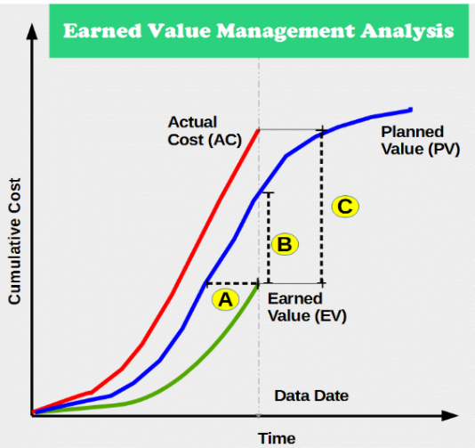**EV < PV** 🡪 project is behind schedule

**EV < AC** 🡪 the project is over budget

**Conclusion:**

project is both **over budget** and **behind schedule**, indicating inefficiencies in execution.

**Application in Real Projects:**

Real-World Applications of Project Planning, Monitoring, and Earned Value Analysis (EVA).

* Manufacturing & Production

Application: EVA helps measure production efficiency and cost-effectiveness.

Ex: Automakers track production line performance by comparing planned production rates to actual output.

* Aerospace & Defence

Application: Strict project monitoring ensures compliance with deadlines and budgets.

Ex: NASA uses EVA to manage spacecraft development projects.

* Event Management

Application: Budget tracking and milestone monitoring for large-scale events.

Ex: The Olympics committee uses project monitoring systems to track stadium construction and event logistics.

**Peer Interactions:**

* peer-to-peer interaction helped in understanding the concept in a better way which is so helpful for overall subject analysis.
* Peer interactions not only brushed up my knowledge but also helped me in improving my communication skills.
* We discussed how Earned Value Analysis (EVA) can be used in our project to actually know and evaluate the expected and obtained results in the project.
* Peer interactions encouraged open discussions and knowledge sharing among us.
* Team members with experience in similar projects are **helping in trouble shooting issues efficiently**.

**Challenges Faced:**

* Coordinating between teams and tasks was initially difficult, impacting workflow and deadlines.
* Understanding EVA calculations and interpreting cost/schedule variances required deep learning and practice.
* **Adapting to Changes:** Unexpected deviations from baseline plans made it challenging to realign project schedules and budgets.
* **Cross-Team Communication Barriers:** Ensuring seamless collaboration across different team members made me understand their approach and verify whether their methodologies suit my project objectives.
* **Tracking Real-Time Progress:** Keeping performance data up to date for effective monitoring required dedicated tools and consistent reporting which I personally felt is so challenging in the beginning but eventually got used to the flow.

**Personal Development Activities:**

* Spending time on reading Lecture notes which is making Lecture Journals easy to finish and also giving me better understanding about Software Project Management, day by day.
* This knowledge and peer interactions helped me to give a good presentation and score well in my recent topic Analysis where I clearly made relevant and valid points for the pitchers presentation.
* Connecting to peers developed my communication skills which helped me personally develop as a good presenter and speaker.
* Started to connect with people which is helping me improve my way of thinking broadly and improve my performance.
* These Lecture journals not only helped me to gain knowledge in SPM but also motivated me to spend at least 2-3 hrs a day journaling on other subjects as well, which made it easy for me to tackle tests and assignments.

**Goals for the Next Week:**

* Next week I want to primarily focus on my deep understanding of project and work towards Project deliverable 2.
* I will start by focusing on the topics that I feel difficult to analyse and go over the other concepts.
* I want to go through the chapters overall to grasp the topics which will help me to tackle the final exam with ease.