**Project – 8**

**TITLE – Smart water fountain**

**-submitted by : Divya Sri D E**

**PHASE 3**:

Deploy IOT sensors (E.g., Temperature sensors, Pressure sensors) in public water fountains to monitor water flow and detect malfunctions. Develop a python script on the IOT sensors to send real-time water fountain status data to the platform.

**SMART WATER FOUNTAIN:**

Fountain wirelessly communicate with base station. Base stations collect and transmit usage, filter, and system information to the cloud via Ethernet. Wireless communications use a low-power unlicenced band for improved security and power savings.

**HARDWARE SETUP OF SMART WATER FOUNTAIN:**

* ESP32 development board
* HC-SR04 ultra sonic distance sensor
* DHT22
* ATmega328p microcontroller IC
* Soil moisture sensor
* Real-time clock (DS3231)
* Relay module
* Arduino mini
* LED

**SIMULATION DIAGRAM**

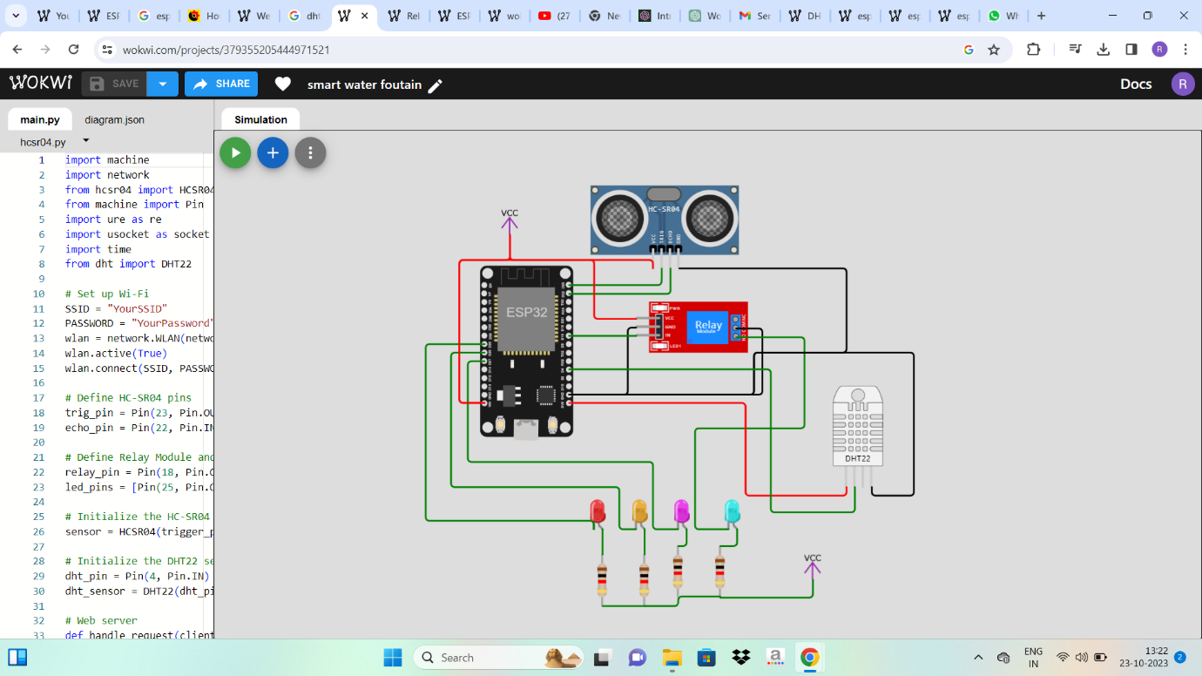

**ABOUT CIRCUIT LAYOUT:**

* The Arduino board connected to the relay through a digital pin, Relay is connected to the pump.

* Relay Module:

- GND to GND

- VCC to VCC

-Vin to D18

* Ultrasonic Sensor (HC-SR04):

- VCC to VCC

- GND to GND

- Trig to Node MCU GPIO (D23)

- Echo to Node MCU GPIO ( D22)

* LED
* Meters and sensors (is used to transmit the output to real-time)

**PYTHON SCRIPT:**

import machine

import network

from hcsr04 import HCSR04

from machine import Pin

import ure as re

import usocket as socket

import time

from dht import DHT22

# Set up Wi-Fi

SSID = "YourSSID"

PASSWORD = "YourPassword"

wlan = network.WLAN(network.STA_IF)

wlan.active(True)

wlan.connect(SSID, PASSWORD)

# Define HC-SR04 pins

trig_pin = Pin(23, Pin.OUT)

echo_pin = Pin(22, Pin.IN)

# Define Relay Module and LED pins

relay_pin = Pin(18, Pin.OUT)

led_pins = [Pin(25, Pin.OUT), Pin(26, Pin.OUT), Pin(27, Pin.OUT)]

# Initialize the HC-SR04 sensor

sensor = HCSR04(trigger_pin=trig_pin, echo_pin=echo_pin)

# Initialize the DHT22 sensor

dht_pin = Pin(4, Pin.IN)

dht_sensor = DHT22(dht_pin)

# Web server

def handle_request(client):

request = client.recv(1024).decode('utf-8')

if 'GET /on' in request:

relay_pin.on()

elif 'GET /off' in request:

relay_pin.off()

distance = sensor.distance_cm()

water_level = "High" if distance < 10 else "Low"

dht_sensor.measure()

temperature = dht_sensor.temperature()

humidity = dht_sensor.humidity()

response="HTTP/1.1200OK\r\nContent-Type: text/html\r\n\r\n"

response+=f"<html><body><h1>Water Level and Temperature/Humidity Monitoring</h1>"

response += f"<p>Distance: {distance} cm</p>"

response += f"<p>Water Level: {water_level}</p>"

response+=f"<p>Temperature:{temperature}°C</p>"

response+=f"<p>Humidity:{humidity}%</p>"

response+="<p><a href='/on'>TurnPumpOn</a></p>"

response+="<p><a href='/off'>TurnPumpOff</a></p>"

response += "</body></html>"

client.send(response)

client.close()

def run_server():

s=socket.socket(socket.AF_INET, socket.SOCK_STREAM)

s.bind(('', 80))

s.listen(5)

while True:

client, addr = s.accept()

handle_request(client)

# Main loop

while True:

distance = sensor.distance_cm()

dht_sensor.measure()

temperature = dht_sensor.temperature()

humidity = dht_sensor.humidity()

print("Distance:", distance, "cm")

print("Temperature:", temperature, "°C")

print("Humidity:", humidity, "%")

# Control the water pump based on distance

if distance < 10:

relay_pin.on()

else:

relay_pin.off()

# Indicate water level using LEDs

if distance < 10:

for i in range(3):

led_pins[i].on()

else:

for i in range(3):

led_pins[i].off()

# Run the web server

run_server()

# Delay for a while to avoid excessive measurements

time.sleep(2)

**OUTPUT OF SIMULATION:**

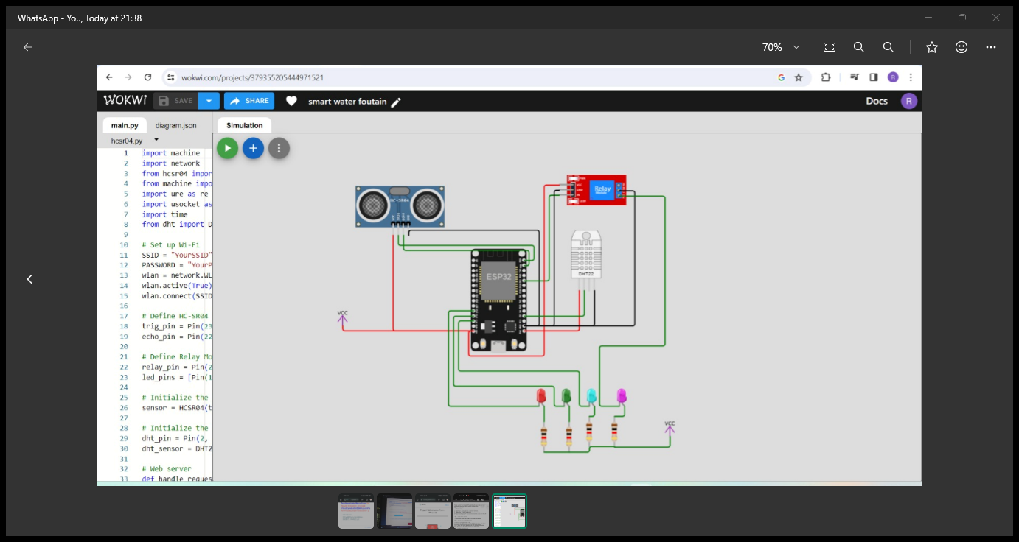

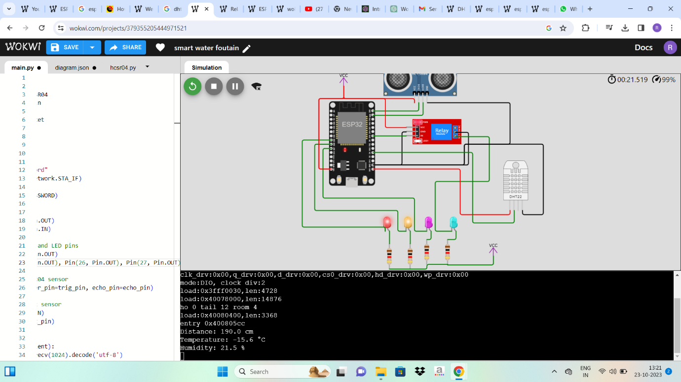

**THANK YOU**