**DESIGN**

**Block Diagram**

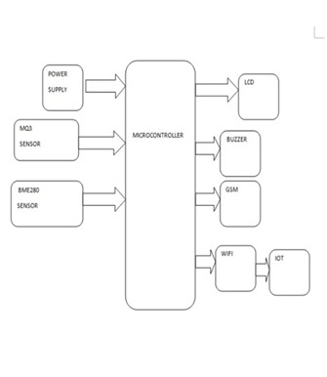

*Figure-2: Block Diagram*

**POWER SUPLY**