**IMPLEMENTATION**

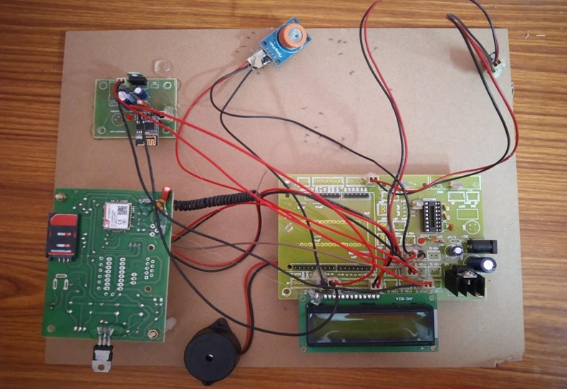

ThingSpeak is a cloud platform used to represent or provide the visuals of the stored data.In this project we used ThingSpeak platform to represent the readings of temperature, humidity, pressure and status of MQ3 readings in graphical form.

The data is stored and can be accessed at any time using cloud web pages.

<https://thingspeak.com/channels/937004/charts/1>

<https://thingspeak.com/channels/937004/charts/2>

<https://thingspeak.com/channels/937004/charts/3>

<https://thingspeak.com/channels/937004/charts/4>