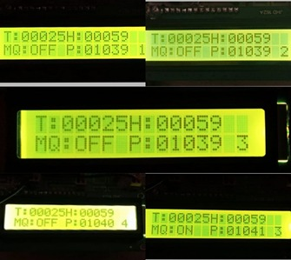**RESULT**

*Figure5: Example Format of readings on LCD screen Figure6: Example format of message to phone*

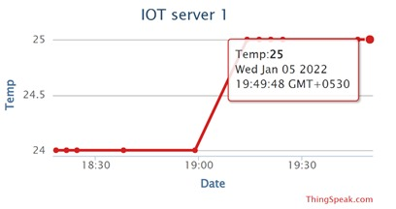 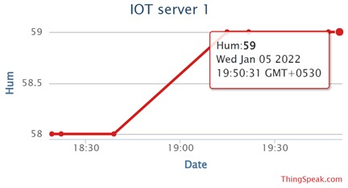

*Figure7: Temperature Readings in Cloud Figure8: Humidity Readings in Cloud*

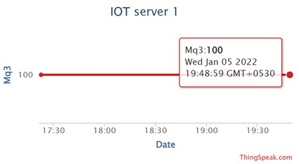 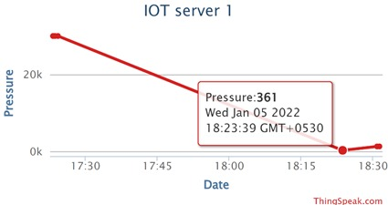

*Figure9: Mq3 Readings in Cloud Figure10: Pressure Readings in Cloud*

**CONCLUSION:**

The proposed IoT based air pollution system is a good device to measure the air quality in outdoors and indoors. This device can be useful to measure the level of gases in a highly dense area like markets hospitals, railway station, bus stand etc from the remote-control room. If data is stored, we can use the data for further experiments which can conclude a significant result. This system is IoT based so it can be used in the smart home for the purpose of cooling, ventilation and other purposes. IoT will enhance the artificial intelligence in the world, so the system can be used in automated systems in factories and industries. For the varied experiments that were meted out on the air sample and also the air sample with completely different gases the subsequent conclusions were arrived. It has been noted that there's associate• improvement within the most pollution density and also the optimum dissolved pollution content for the air sample that is treated with metal chloride answer. In terms of the accrued geographic region the• planting of hairdo and usage of transportation is kind of troublesome