JavaScript

In this module we cover basic concepts of JavaScript .Including functions and its scope, Variables, Datatypes, Operators, Arrays and Objects Control flow and loops . Students can apply these concepts in this workshop.

Workshop1

In this workshop students should create a web based application which is related to jobportal system. You should create a application based on job posting, it includes basics concepts of JavaScript functions and its scope, Variables, Datatypes, Operators, Arrays and Objects Control flow and loops



In this you should create createJob it means jobPosting. After jobposting we can view that posted jobs and can delete and update that job.

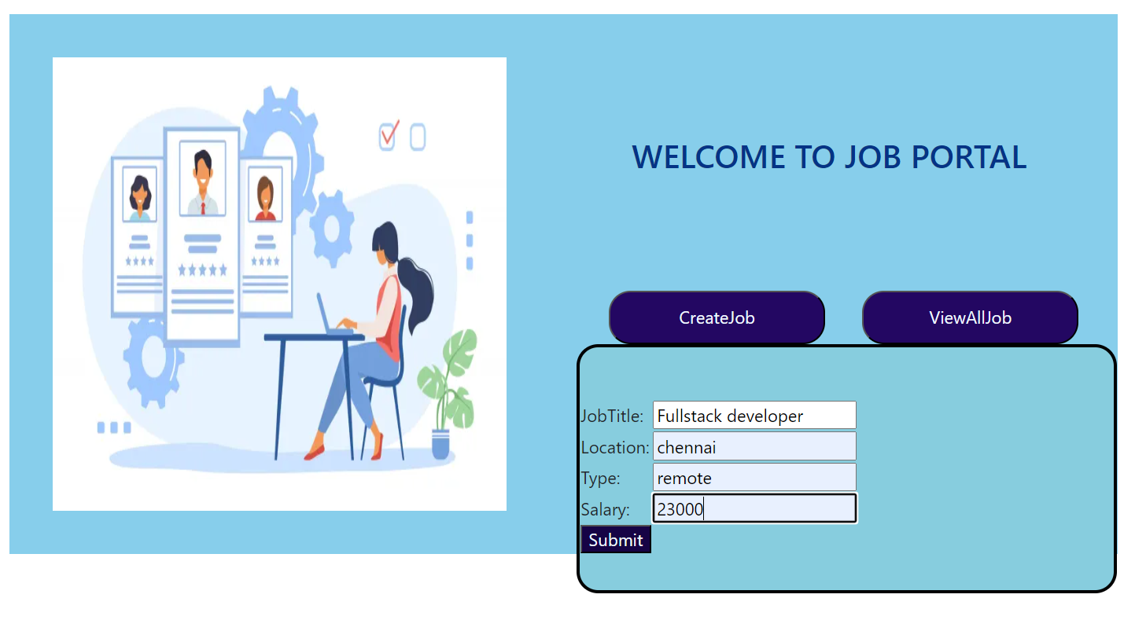

Expected output



In this workshop you should include edit button and edit function, you can add your own logic to complete the workshop.



Workshop2

In this workshop you should create a signup form for Jobseeker account creation. It includes Functions and Scope Arrays and Objects Variables, datatypes, and Operators Control Flows and Loops

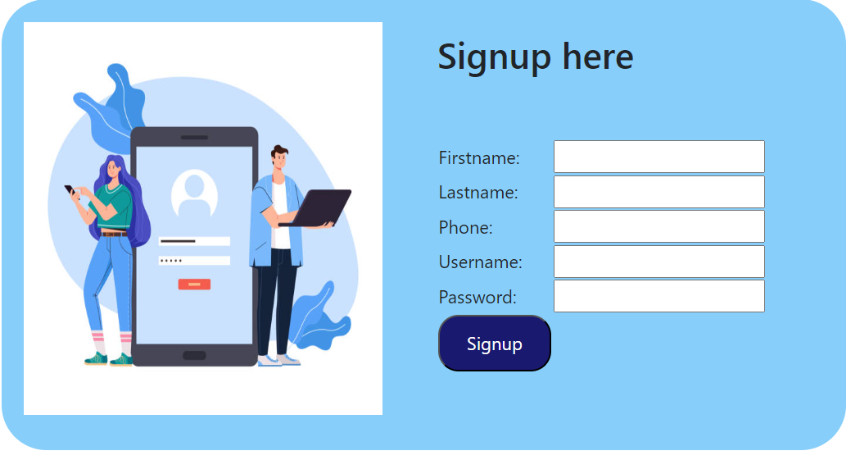

In this you should create a signup form . When clicking signup button the data pushed into an array. After this display a success message.

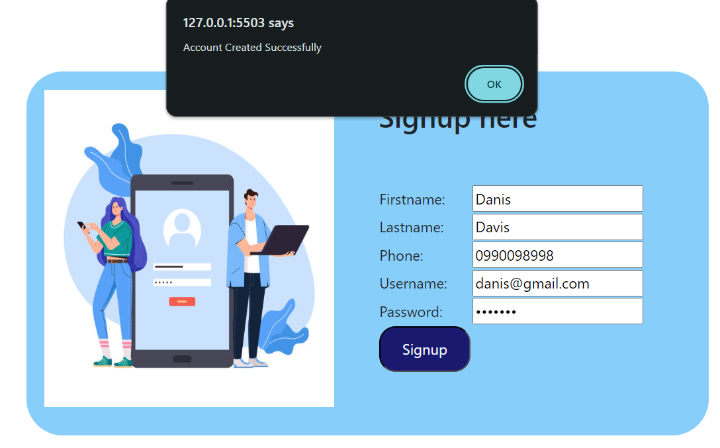

Workshop3

In this workshop you should create Hiring managers.It includes Functions and Scope Variables, datatypes, and Operators Arrays and Objects Control Flows and Loops

In this you should create Hiring manager . And after we can view the all jobs.

We can delete and update each job.

Expected output

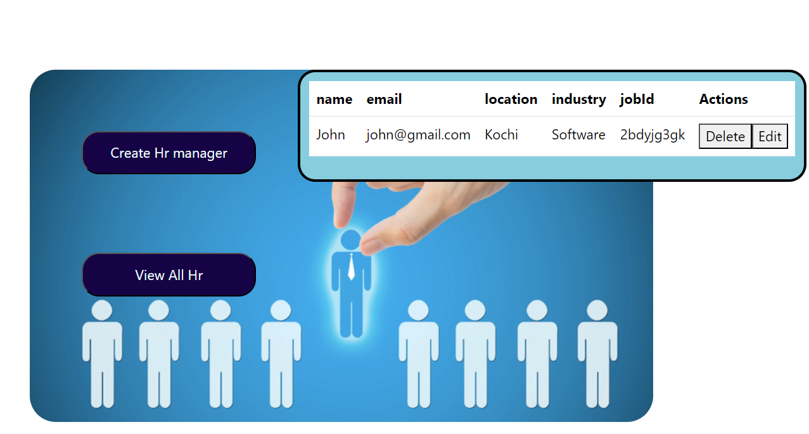

In this workshop you should add delete button and its function. Take your own way and complete the workshop as output expected.

