
A Project Report on,
Chi-Square Test of Independence and Correspondence Analysis in Retail Consumer Choice
By,
Divya Sutar
(SRN: 31241091)
Project No : 1
Guided By
Dr. Anupriya Kamble
Course Name: Research Methodology
For the Programme
B.Sc. - COMPUTER SCIENCE
Third Year
2026-27
Pursued in
Department of Computer Science
Faculty of Science & Technology
Vishwakarma University, Pune
CERTIFICATE
This is to certify that the work incorporated in the project entitled “Chi-Square Test of Independence and Correspondence Analysis in Retail Consumer Choice” submitted to Vishwakarma University, Pune, by Divya Sutar, for the completion of the course Research Methodology, was carried out by her under my supervision in the Department of Computer Science, Faculty of Science and Technology, Vishwakarma University, Pune, Maharashtra, India.
This work has not been previously submitted by her to this or any other university for the award of any degree, diploma, associateship, or any other similar title.

Place: Pune Dr. Anupriya Kamble
Date: Course Coordinator
DECLARATION
I hereby declare that the present research work in the form of a project report entitled “Chi-Square Test of Independence and Correspondence Analysis in Retail Consumer Choice” is an original work carried out by me under the guidance of Dr. Anupriya Kamble, Assistant Professor, Department of Computer Science, Faculty of Science and Technology, Vishwakarma University, Pune, Maharashtra, India, for the completion of the course Research Methodology.
I further declare that, to the best of my knowledge, this project work does not contain any part of any work that has been submitted for the award of any degree, either at this university or at any other university/deemed university, without proper citation.
I further declare that all materials referred to from other sources have been duly acknowledged in this project report.

Place: Pune Divya Sutar
Date: SRN: 31241091
ABSTRACT

Retail businesses record thousands of transactions, but raw records do not make customer patterns easy to see. Categorical statistics help summarize how transactions are distributed across groups such as city, customer type, and product line, and test whether the observed differences are larger than random variation would explain.

This project, “Chi-Square Test of Independence and Correspondence Analysis in Retail Consumer Choice”, analyzes a supermarket sales dataset of 1,000 transactions and 17 columns. It asks two questions: whether customer type (Member or Normal) is associated with city, and whether product-line distribution is associated with city across Mandalay, Naypyitaw, and Yangon.

Pearson’s Chi-Square Test of Independence gave χ² = 0.4188 (df = 2, p = 0.8111) for City × Customer Type and χ² = 11.5594 (df = 10, p = 0.3156) for City × Product Line. Both p-values exceed 0.05, so neither test provides sufficient evidence to reject independence. Correspondence Analysis, run in R, produced a two-dimensional map in which Dimension 1 explains 69.5% of inertia and Dimension 2 explains 30.5%. Because the overall test is not significant, the map is treated as an exploratory visual aid only.

The project demonstrates a reproducible workflow that combines Excel-based tabulation with R-based Correspondence Analysis, and shows why visual patterns must be read alongside inferential results.

Keywords: Chi-Square Test, Test of Independence, Correspondence Analysis, Contingency Table, Retail Analytics, Consumer Choice, Supermarket Sales, R (ca package).
INDEX
Sr. No. | Content | Pg. No.
1. | Introduction | 6
 | 1.1 Objective | 6
 | 1.2 Novel Idea | 6
 | 1.3 Significance | 6
 | 1.4 Specifications | 6
2. | Literature Survey | 8
3. | Methodology | 9
4. | Implementation | 11
5. | Results | 12
6. | Conclusion | 14
7. | Future Scope | 15
8. | References | 16
1. Introduction
Retail businesses collect large amounts of transaction data, but the raw records do not always make customer patterns easy to understand. Statistical methods can summarize categorical variables and test whether observed differences are larger than would reasonably be expected from random variation. This project applies two related techniques to supermarket transaction data: the Chi-Square Test of Independence and Correspondence Analysis.
1.1 Objective: The objective of this project is to examine how supermarket transactions are distributed across city, customer type, and product line, and to decide, using a formal hypothesis test and an exploratory map, whether these categories appear to be associated.
- To organize transactions into contingency tables for City × Customer Type and City × Product Line.
- To test the independence of each pair of variables using the Pearson Chi-Square Test.
- To visualize the City × Product Line table with Correspondence Analysis.
- To separate statistical evidence from exploratory visual impressions when interpreting results.

1.2 Novel Idea: The project combines a formal hypothesis test with a visual multivariate technique in a single retail example. The Chi-Square tests give a clear inferential decision at a stated significance level, while Correspondence Analysis shows how row and column categories sit relative to one another on a two-dimensional map. It is an applied analysis of the supplied dataset, not a claim of a new statistical algorithm.

1.3 Significance: Understanding how transactions are distributed across cities, customer types, and product lines helps retailers describe customer activity and decide where deeper analysis may be worthwhile. In this dataset, neither test is significant at the 5% level, so the results do not show that city affects customer type or product-line choice. Reporting such a null finding honestly is itself useful, as it prevents over-interpreting small differences in counts.

1.4 Specifications:
Software:
- Microsoft Excel (frequency tables, expected counts, Chi-Square calculations)
- R (Correspondence Analysis and map export)
Libraries:
- ca package for R (simple Correspondence Analysis)
Data Sources:
- supermarket_sales.csv, supplied as the Original_data sheet of the Excel workbook
- Project workbook rmproject1.xlsx (frequency tables and calculations)
Hardware:
- Standard desktop or laptop capable of running Excel and R
Output Files:
- Excel workbook and Correspondence_Analysis_Map.png

Dataset:
The dataset contains 1,000 supermarket transaction records and 17 columns. The study uses three categorical variables: City (Mandalay, Naypyitaw, Yangon), Customer type (Member, Normal), and Product line (six categories).
2. Literature Survey
Categorical-data analysis is commonly used when observations are summarized as counts across groups. This section reviews the statistical background that the project follows.
2.1 Chi-Square Test of Independence
Pearson’s Chi-Square Test of Independence compares observed counts with the counts expected if two categorical variables were independent. It is widely used because it yields an interpretable test statistic and p-value, provided the data and expected-frequency assumptions are appropriate. Agresti’s Categorical Data Analysis gives a detailed treatment of contingency tables, tests of independence, and the interpretation of categorical association, which is directly relevant to the two tables analyzed here.
2.2 Correspondence Analysis
Correspondence Analysis is an exploratory technique for studying relationships in a contingency table. It converts row and column profiles into a low-dimensional representation based on chi-square distances. Greenacre’s work explains the geometry of correspondence maps and the meaning of inertia as a measure of the variation represented by each dimension. Friendly’s Visualizing Categorical Data supports the use of graphical displays alongside formal tests. A map can make relative patterns easier to inspect, but apparent closeness should not replace a formal assessment of the table’s overall association.
2.3 Categorical Analysis in Retail Analytics
Retail transaction data often include branch, city, customer type, product line, payment method, and sales amounts. Frequency tables and categorical tests are useful first steps because they reveal the structure of the data before more complex modeling is considered. However, data from a few stores or a single period may not represent all customers or retail settings.
2.4 Research Gap and Project Focus
The focus of this project is practical and educational: to show how one categorical dataset can be examined with both hypothesis testing and exploratory visualization. The literature supports the chosen methods but does not imply that this dataset must show a significant relationship; the findings depend only on the observed counts. The project does not attempt to predict individual purchases, estimate causal effects, or generalize beyond the supplied records.
3. Methodology
The project follows a systematic workflow, from collecting the transaction data to interpreting the Chi-Square results and the Correspondence Analysis map.
Step 1: Data Collection
Load the supermarket sales data (Original_data sheet): 1,000 transactions and 17 columns.
Step 2: Variable Selection
Select City (3 categories), Customer type (2 categories), and Product line (6 categories).
Step 3: Contingency Table Preparation
Build pivot-style frequency tables in Excel by counting invoice records for City × Customer Type and City × Product Line.
Step 4: Expected Frequencies
Calculate expected counts under independence for every cell of each table.
Step 5: Chi-Square Statistic
Compute χ², the degrees of freedom, and the p-value for each table.
Step 6: Decision at α = 0.05
Reject the null hypothesis only when p < 0.05; otherwise report insufficient evidence of association.
Step 7: Correspondence Analysis
Apply the ca package in R to the City × Product Line table and export the map as a PNG image.
Step 8: Map Interpretation
Read the map as an exploratory aid, using the inertia of each dimension and the Chi-Square result together.
Step 9: Reporting
Document the data, methods, numerical results, figure, limitations, and references.

Hypotheses and Formulas
For each contingency table, H₀: the two variables are independent; H₁: they are associated. The expected count for cell (i, j) and the test statistic are:
Expected frequency = (row total × column total) / grand total
χ² = Σ (Observed − Expected)² / Expected
Degrees of freedom = (rows − 1) × (columns − 1), and the significance level is α = 0.05. A non-significant result does not prove that the variables are exactly independent; it means the data do not provide sufficient evidence of association.
Workflow Diagram

Data Collection → Variable Selection → Contingency Tables → Expected Frequencies → Chi-Square Test → Decision at α = 0.05 → Correspondence Analysis (R) → Map Interpretation → Reporting
Tools Used
- Microsoft Excel: organizes observed counts, expected counts, row and column profiles, and the Chi-Square calculations.
- R with the ca package: performs Correspondence Analysis on the City × Product Line table.
- PNG export: saves the map as Correspondence_Analysis_Map.png for the report.
4. Implementation
The project was implemented in two stages: Excel for tabulation and the Chi-Square calculations, and R for Correspondence Analysis. All results come from the supplied dataset.
4.1 Data Preparation
The Original_data worksheet was summarized with pivot-style tables. The City × Customer Type table has row totals of 332, 328, and 340 (grand total 1,000). The City × Product Line table uses the same city totals, with product-line column totals of 170, 178, 174, 152, 160, and 166.
4.2 Chi-Square Calculation in Excel
Separate worksheets hold the observed tables, the expected tables, and the calculations. Expected counts follow the formula in Section 3. For City × Customer Type, the expected counts are:
City | Member | Normal
Mandalay | 166.332 | 165.668
Naypyitaw | 164.328 | 163.672
Yangon | 170.340 | 169.660

All expected counts in both tables are above 5 (smallest: 49.856 for City × Product Line), so the Chi-Square approximation is appropriate for these tables.
4.3 Correspondence Analysis in R
The City × Product Line frequency table was passed to the ca package, which computes the row and column profiles and the principal inertias. The first two dimensions were plotted with cities as blue points and product lines as red triangles, and the figure was saved as a PNG file.
library(ca)
fit <- ca(city_by_product) # 3 x 6 table of counts
summary(fit) # inertia per dimension
plot(fit) # two-dimensional map
4.4 Output and Execution
The Excel workbook (rmproject1.xlsx) is opened in Microsoft Excel to view the frequency tables and calculations. The R commands are then run in R to regenerate the map, which is saved as Correspondence_Analysis_Map.png and inserted in Section 5 of this report.
5. Results
5.1 Analysis 1: City vs Customer Type
City | Member | Normal | Total
Mandalay | 165 | 167 | 332
Naypyitaw | 169 | 159 | 328
Yangon | 167 | 173 | 340
Total | 501 | 499 | 1000

The test gives χ² = 0.4188, df = 2, p = 0.8111. Since p > 0.05, the result is not significant and the null hypothesis is not rejected: there is no sufficient evidence of an association between city and customer type. The observed counts are close to the expected ones, which is consistent with the test but is not proof that the proportions are exactly equal.
5.2 Analysis 2: City vs Product Line
City | Elec. acc. | Fashion acc. | Food & bev. | Health & beauty | Home & lifestyle | Sports & travel | Total
Mandalay | 55 | 62 | 50 | 53 | 50 | 62 | 332
Naypyitaw | 55 | 65 | 66 | 52 | 45 | 45 | 328
Yangon | 60 | 51 | 58 | 47 | 65 | 59 | 340
Total | 170 | 178 | 174 | 152 | 160 | 166 | 1000

The test gives χ² = 11.5594, df = 10, p = 0.3156. Since p > 0.05, the null hypothesis is not rejected: the data do not provide sufficient evidence that product-line distribution is associated with city. Some cells are larger or smaller than others, but the test assesses the overall departure from independence, so single count differences should not be treated as meaningful on their own.
5.3 Correspondence Analysis Map
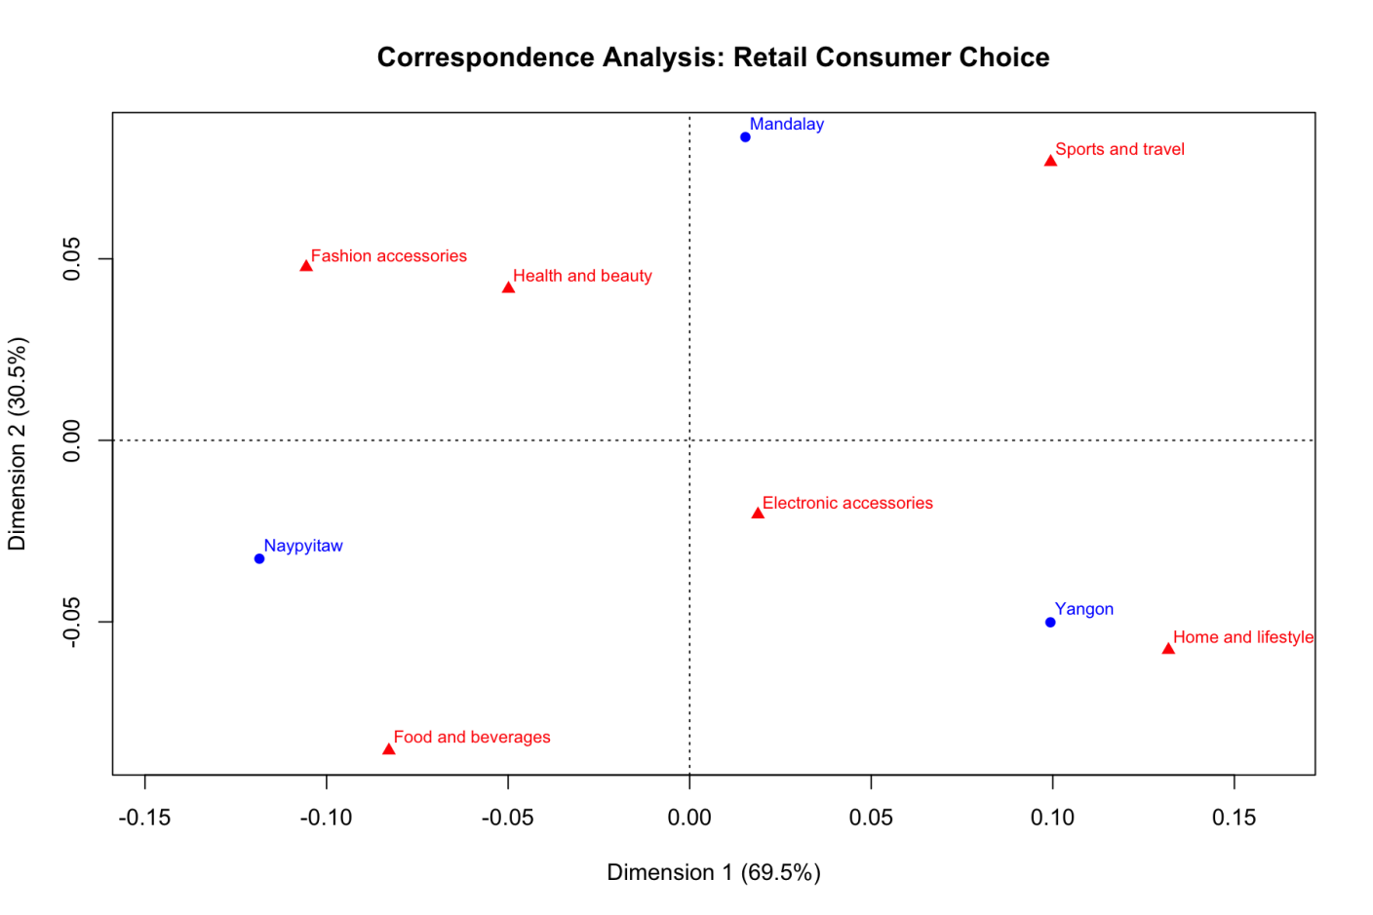
Figure 1. Correspondence Analysis map for City × Product Line.
The map shows the three cities as blue points and the six product lines as red triangles. Dimension 1 explains 69.5% of inertia and Dimension 2 explains 30.5%; the dotted lines mark the origin. Naypyitaw lies on the left near Food and beverages, Yangon on the right near Home and lifestyle, and Mandalay at the top near Sports and travel. Because the global Chi-Square test is not significant (p = 0.3156), these positions are exploratory and are not evidence that a city is significantly tied to a product line.
5.4 Summary of Statistical Results
Analysis | χ² | df | p-value | Decision at α = 0.05
City × Customer Type | 0.4188 | 2 | 0.8111 | Not significant; do not reject H₀
City × Product Line | 11.5594 | 10 | 0.3156 | Not significant; do not reject H₀

6. Conclusion
This project applied the Chi-Square Test of Independence and Correspondence Analysis to 1,000 supermarket transactions. Two relationships were examined: City × Customer Type and City × Product Line. The first test returned χ² = 0.4188 with 2 degrees of freedom and p = 0.8111; the second returned χ² = 11.5594 with 10 degrees of freedom and p = 0.3156.
Both p-values are greater than the chosen significance level of 0.05, so neither analysis provides sufficient evidence to reject the null hypothesis of independence. Within this dataset there is no statistically significant evidence that customer type differs by city or that product-line distribution is associated with city.
Correspondence Analysis complemented the tests by producing a two-dimensional map of the City × Product Line profiles, with 69.5% and 30.5% of inertia on its two dimensions. The visual patterns remain exploratory and must be read together with the non-significant overall test.
The project demonstrates a clear workflow for preparing contingency tables, calculating expected frequencies, testing categorical association, and presenting the results visually. Its conclusions are limited to the variables and transactions in the supplied dataset and do not establish causation.
Limitations
- The analysis uses one dataset of 1,000 transactions and three cities, so it may not represent all retail customers.
- The tests assess association, not causation, and do not explain why a pattern occurs.
- A non-significant result does not prove exact independence.
- Correspondence Analysis is exploratory; visual closeness is not a significance test.
7. Future Scope
The project can be extended in several ways to make the analysis more complete and more useful for retail decision-making.
- Extend to Other Variables: Analyze other categorical variables in the workbook, such as gender, branch, or payment method, where the research question is clearly stated.
- Use More Data: Include additional months, stores, or retail organizations to check whether patterns hold across time and location.
- Check Assumptions Systematically: Verify expected cell counts and data quality before every Chi-Square test, and use suitable alternatives if assumptions are not met.
- Follow-up Analysis: If a future test is significant, use standardized residuals or planned follow-up comparisons to see which cells drive the association, accounting for multiple testing.
- Compare Correspondence Maps: Compare Correspondence Analysis results across datasets and report the scaling and interpretation used for each map.
- Predictive Models: Explore predictive models only when there is a suitable target, a validation strategy, and sufficient data.

With these improvements, the workflow could grow into a more comprehensive categorical-analysis toolkit for retail data.
8. References
- Agresti, A. (2013). Categorical Data Analysis. 3rd ed. Wiley.
- Greenacre, M. (2017). Correspondence Analysis in Practice. 3rd ed. Chapman and Hall/CRC.
- Friendly, M. (2000). Visualizing Categorical Data. SAS Institute.
- R Core Team. R: A Language and Environment for Statistical Computing. R Foundation for Statistical Computing, Vienna, Austria.
https://www.R-project.org/
- Nenadic, O. and Greenacre, M. (2007). Correspondence Analysis in R, with Two- and Three-dimensional Graphics: The ca Package. Journal of Statistical Software, 20(3).
https://doi.org/10.18637/jss.v020.i03
- Project materials supplied by the student: rmproject1.xlsx (frequency tables and calculations) and Correspondence_Analysis_Map.png (Correspondence Analysis visualization).

