Threat Model and Secure Configuration
Fictional Student Academic Portal – Defensive Cybersecurity Lab
Environment: Fictional defensive lab. Any testing described in this report should be performed only on localhost or an isolated VM. Do not scan or test external systems.

1. Introduction
This threat-model exercise analyzes a fictional Student Academic Portal used by students, faculty and administrators. The purpose is to identify important assets, trust boundaries, realistic abuse cases and security controls, then prioritize hardening actions based on likelihood and impact.

2. Application Description
The portal provides authenticated access to student profiles, marks, attendance and assignment files. Faculty can manage academic information, while administrators manage users and privileged functions. The application is assumed to run in a controlled defensive laboratory environment.

3. System Architecture and Trust Boundaries
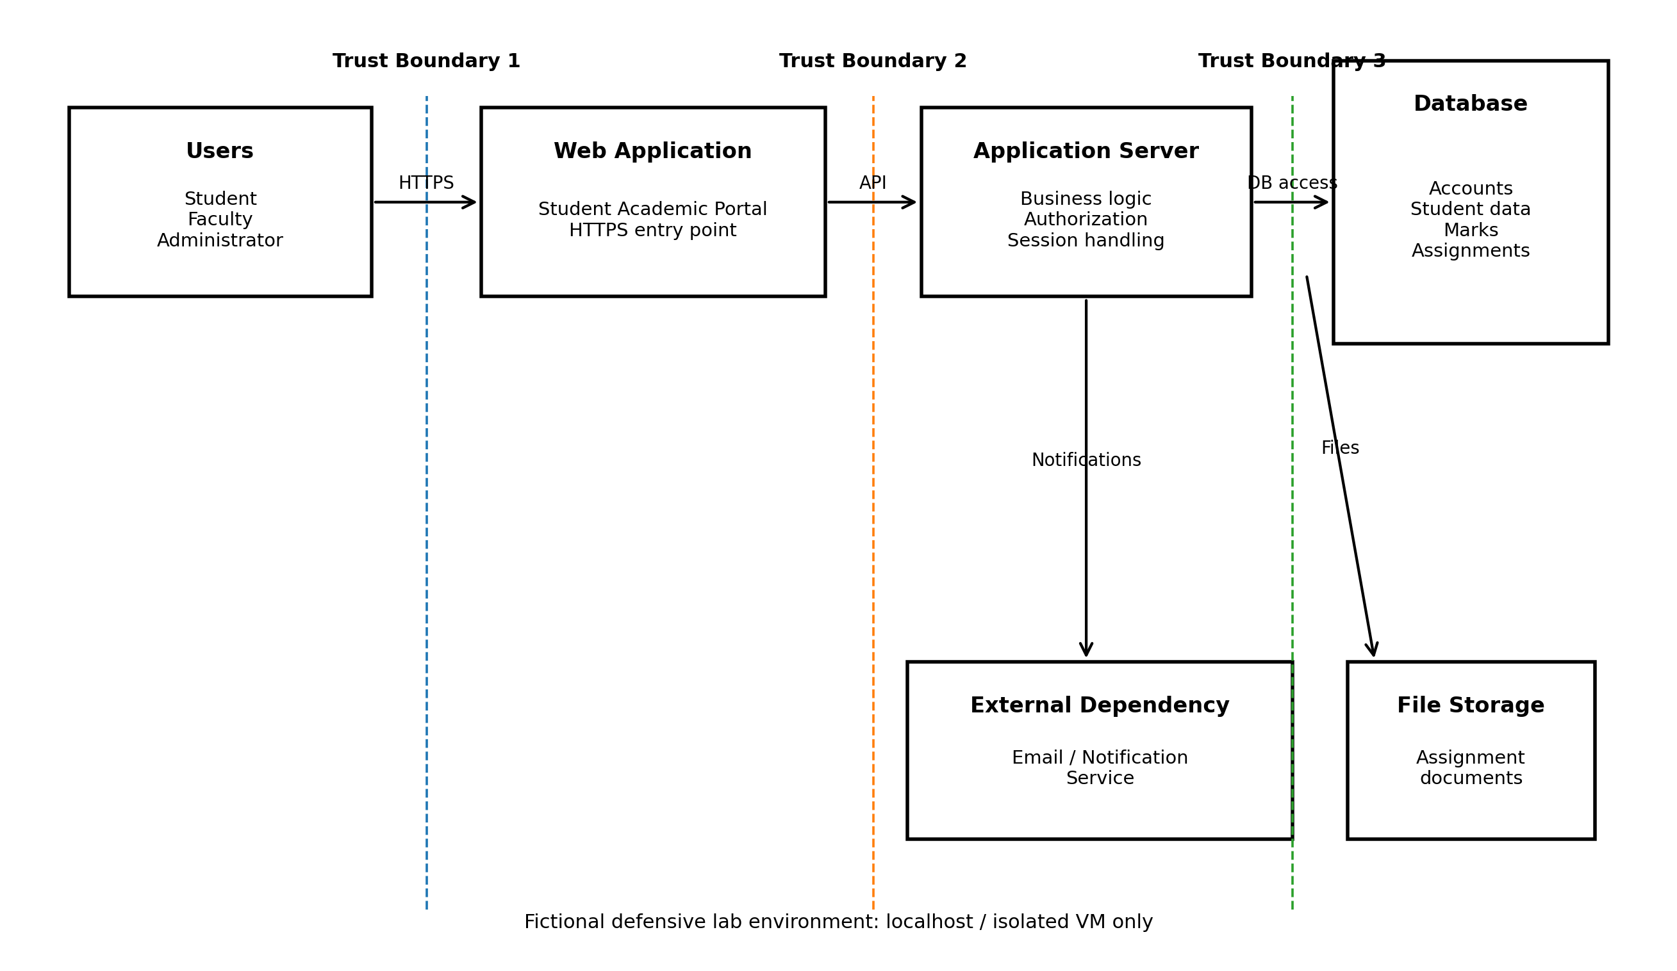
Figure 1. Threat-model architecture for the fictional Student Academic Portal.
Trust Boundary 1 separates untrusted external users from the web application entry point. Trust Boundary 2 separates the web-facing application from backend business logic. Trust Boundary 3 separates application services from the database and protected data stores. External notification and file-storage services are treated as additional dependencies that should be accessed using controlled interfaces and least-privilege credentials.

4. Assets and Owners
Asset | Description | Owner
Student credentials | Usernames, passwords and authentication information | Student / Institution
Student personal data | Name, email, contact and profile information | Student / Institution
Academic records | Marks, grades and attendance information | Institution
Assignment files | Files submitted by students and managed by faculty | Student / Faculty
Session tokens | Information used to maintain authenticated sessions | Application
Faculty/Admin accounts | Privileged accounts with additional functions | Institution
Database | Central storage for portal data | Institution

5. Entry Points and External Dependencies
- Login and authentication endpoint – accepts user credentials.
- Student profile and academic-record pages – provide access to personal and academic information.
- Assignment upload/download functions – handle user-provided files.
- Faculty/admin management functions – provide privileged operations.
- Database connection – stores application and academic information.
- Notification service – may send email or other alerts.
- File storage – may hold assignments and academic documents.

6. STRIDE Threat Analysis
Category | Threat / Abuse Case | Potential Impact
Spoofing | Attacker obtains or guesses a user's password and logs in. | Account takeover and unauthorized access
Tampering | Unauthorized user attempts to modify marks or other records. | Academic record integrity is affected
Repudiation | A user disputes a sensitive action because activity was not logged adequately. | Difficult investigation and accountability
Information Disclosure | Unauthorized user accesses another student's personal or academic information. | Privacy breach and data exposure
Denial of Service | Excessive requests make the portal unavailable to legitimate users. | Service disruption
Elevation of Privilege | A normal student account attempts to access faculty/admin functions. | Unauthorized privileged actions

7. Detailed Abuse Cases
7.1 Account takeover
Scenario: An attacker repeatedly attempts credentials against the login function. If a password is guessed or reused, the attacker may obtain access to the student's account.
Mitigation: Use strong password controls, secure password hashing, rate limiting, temporary delays/lockout, monitoring and MFA where appropriate.
7.2 Unauthorized grade modification
Scenario: A student attempts to invoke a faculty-only function to modify marks.
Mitigation: Enforce server-side role-based authorization and log all sensitive academic-record changes.
7.3 Student information exposure
Scenario: A user attempts to access another student's record by changing an identifier in a request or using an unauthorized endpoint.
Mitigation: Enforce object-level authorization and return only information the authenticated user is permitted to see.
7.4 Session compromise
Scenario: A stolen or improperly protected session token is used to access an active account.
Mitigation: Use secure cookie attributes, session expiration and invalidation after logout.
7.5 Privilege escalation
Scenario: A normal account attempts to access administrator functions.
Mitigation: Apply least privilege and server-side authorization checks for every privileged action.
7.6 Service disruption
Scenario: A source sends excessive requests to consume application resources.
Mitigation: Apply rate limiting, request throttling and resource controls appropriate to the isolated lab application.

8. Risk Assessment
Priority | Threat | Likelihood | Impact | Risk | Reason
1 | Account takeover / credential attack | High | High | Critical | Login endpoints are common targets; compromise exposes account data and functions.
2 | Unauthorized grade modification | Medium | High | High | Academic records require integrity and should be changed only by authorized roles.
3 | Student information exposure | Medium | High | High | Personal and academic data should only be accessible to authorized users.
4 | Session compromise | Medium | High | High | A stolen active session can bypass normal login controls.
5 | Privilege escalation | Medium | High | High | Improper authorization could allow student access to faculty/admin functions.
6 | Service disruption | Medium | Medium | Medium | Excessive requests could reduce availability of the portal.
7 | Insufficient audit logging | Low | Medium | Low | Missing logs can make security investigations difficult.

9. Prioritized Hardening Plan
Priority | Control | Implementation / Recommendation | Verification
1 | Authentication protection | Strong password policy, secure password hashing, login rate limiting, temporary delay/lockout for repeated failures, and MFA where appropriate. | Use the isolated lab to test repeated failed logins and confirm rate limiting and logging.
2 | Role-based access control | Separate Student, Faculty and Administrator permissions. Enforce authorization on the server for every privileged action. | Verify a Student account cannot access Faculty/Admin functions.
3 | Academic-record protection | Allow mark changes only to authorized roles; validate requests server-side; log sensitive changes. | Perform a controlled test change and confirm authorization and audit logging.
4 | Data protection | Use HTTPS; restrict database access; minimize sensitive data exposure; encrypt sensitive data where appropriate. | Inspect traffic/configuration in the isolated environment and verify database permissions.
5 | Session security | Use secure, HttpOnly and appropriate SameSite cookie settings; expire sessions; invalidate sessions on logout. | Inspect session cookie attributes and verify logout invalidates the session.
6 | Input validation | Validate input on the server and safely handle unexpected values and errors. | Submit controlled invalid inputs in the lab and verify safe rejection.
7 | Monitoring and logging | Record authentication failures, privilege changes and academic-record modifications. Protect logs from unauthorized modification. | Perform test actions and confirm expected events appear in logs.
8 | Availability controls | Apply request throttling/rate limits and resource limits appropriate to the application. | Generate controlled test traffic in the lab and verify the service remains usable.

10. Verification Checklist
Control | Verification Step | Expected Result
Authentication | Attempt repeated failed logins in the isolated lab. | Requests are rate-limited/delayed and events are logged.
Authorization | Use a Student test account to request a Faculty/Admin function. | Request is denied by server-side authorization.
Record integrity | Attempt a controlled unauthorized change to a grade. | Change is rejected and the attempt is logged.
Session security | Inspect the session cookie after login. | Appropriate Secure/HttpOnly/SameSite settings are present.
Data protection | Check application responses for unnecessary sensitive information. | Only required data is returned.
Logging | Perform login and privileged test actions. | Relevant security events are recorded.
Availability | Send controlled repeated requests in the lab. | Rate limiting prevents excessive load from overwhelming the service.

11. Recommended Evidence
For the internship submission, retain the following supporting evidence in the same repository/folder:
- Threat-model diagram (PNG).
- This report (PDF/DOCX).
- Hardening checklist.
- Optional screenshots from the isolated lab showing configuration or verification results. Redact passwords, tokens, personal information and other secrets.
- Optional README explaining the scope and how the evidence maps to the passing checklist.

12. Conclusion
The threat model identifies authentication, authorization, academic-record integrity, data confidentiality, session security, availability and monitoring as key security areas for the fictional portal. The prioritized hardening plan focuses first on account and privilege protection, followed by data, session, validation, monitoring and availability controls. Verification should be performed only in the supplied localhost or isolated-VM defensive laboratory.

