# Python API - HOmework

Objective is to show the effects of weather as one goes closer to the equator.My objective is to build a series of scatter plots to showcase the following relationships:

* Temperature (F) vs. Latitude

* Humidity (%) vs. Latitude

* Cloudiness (%) vs. Latitude

* Wind Speed (mph) vs. Latitude

**As final considerations:**

* You must complete your analysis using a Jupyter notebook -- done

* You must use the Matplotlib or Pandas plotting libraries -- done

* You must include a written description of three observable trends based on the data - done- see below.

* You must use proper labeling of your plots, including aspects like: Plot Titles (with date of analysis) and Axes Labels.-- Done

## Conclusion 1

* **Conclusion1:**

The humidity near the equator is always above 60%

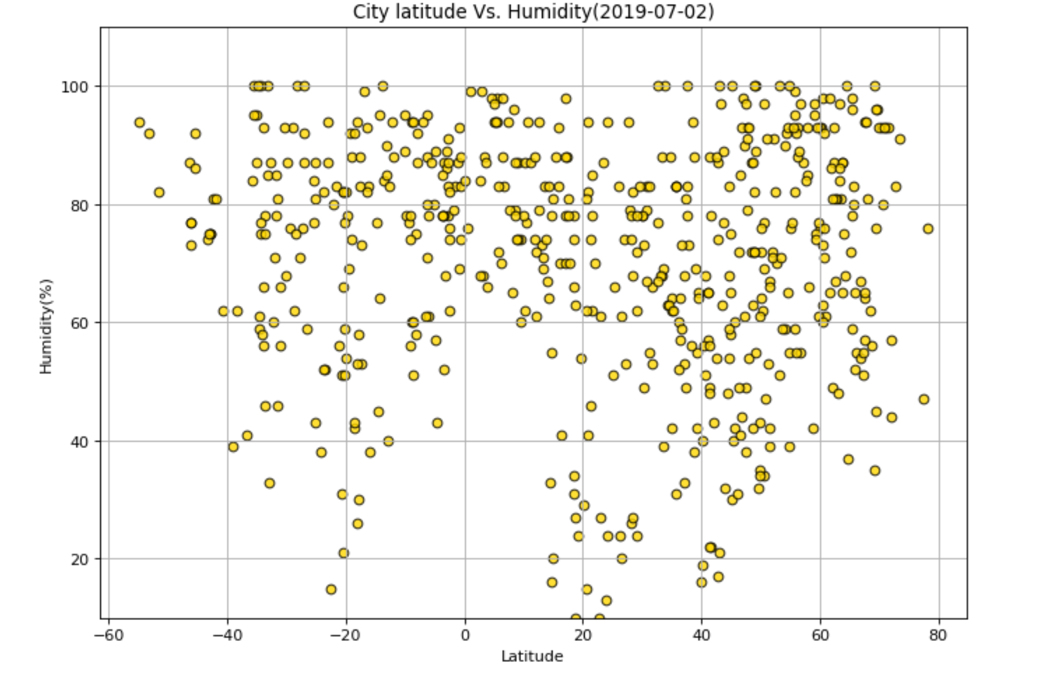

* **Conclusion 2:**

Temperatures are usually higher near the equator. More than 20F on July 2, 2019.

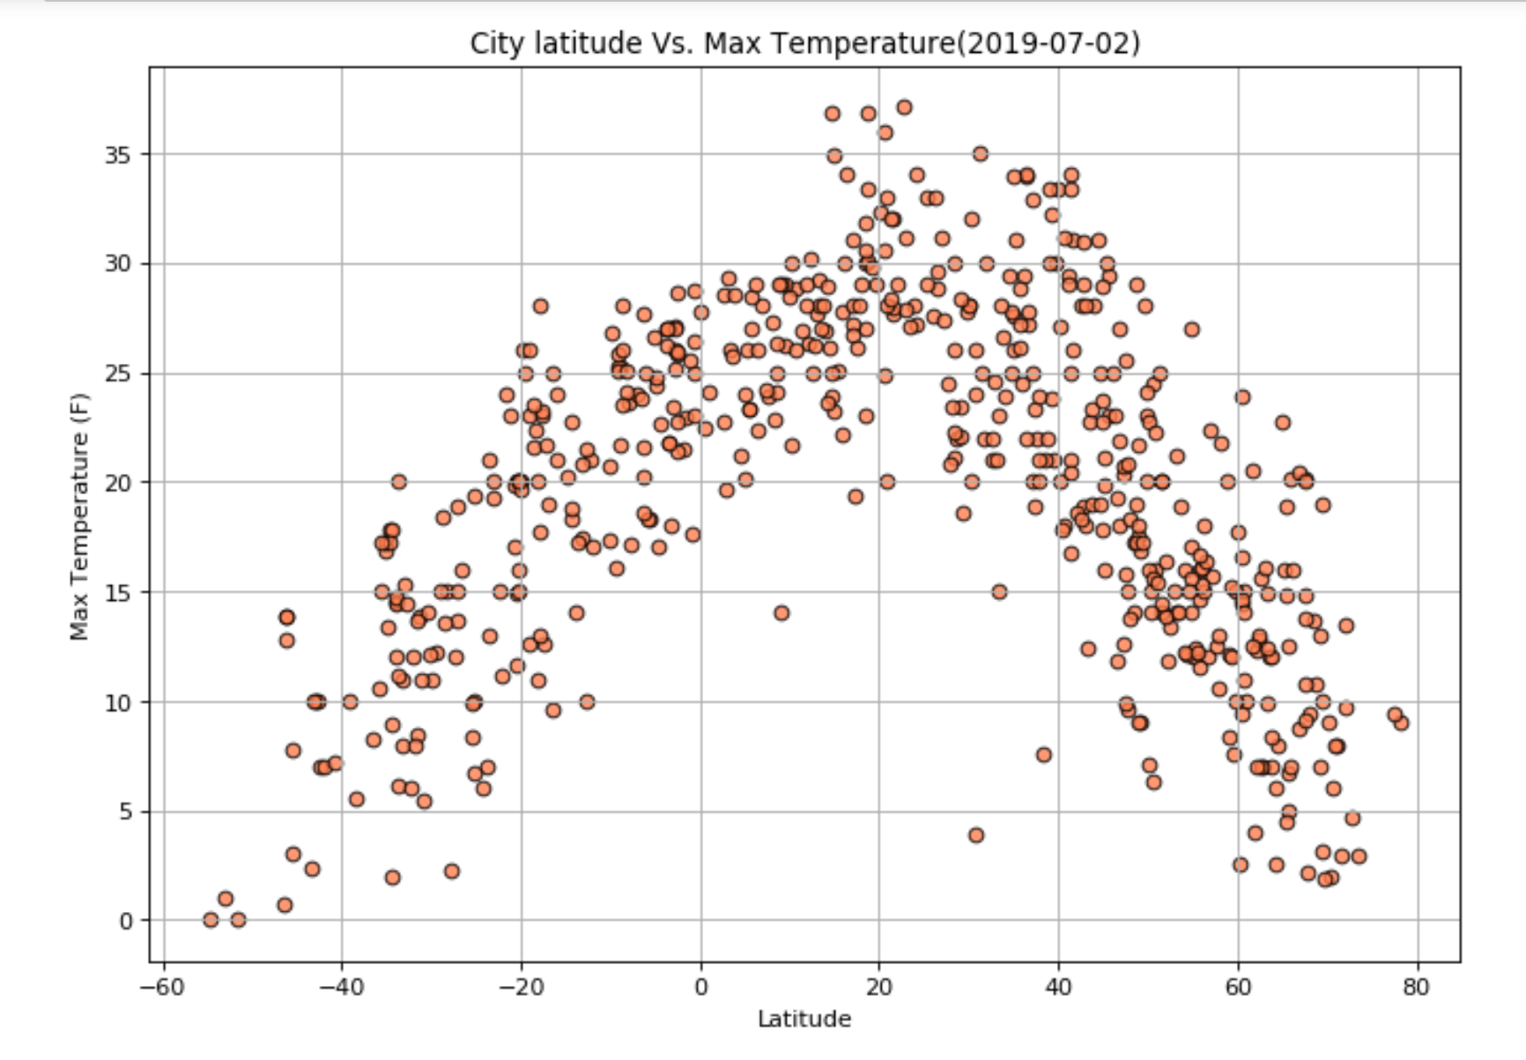

* **Conclusion 3:**

Windspeed doesn’t seem to vary with the city’s distance from the equator.

