Table of Contents

6-Python API- June 22 Summary 2

Exercise 01 - JSON Traversal Review 2

This activity we to practice load and parse JSON in Python. 2

Exercise 02- Requests & Responses 4

Exercise 03- Use API key from a config file and access data 5

Sign up at Open Weather Map and get my API KEY - https://home.openweathermap.org/api_keys 5

Looking at API Documentation - https://openweathermap.org/api 5

Understanding what APIS are available to work on and pick the appropriate one. 5

Exercise 04- Weather in Bujumbura 5

Exercise 05- Ins_OpenWeatherDataFrame 6

Exercise 06- TV Ratings 7

Exercise 07 & 08- Exception handling 8

Exercise 09 – importing API specific modules and using them to build URLs and other things. 9

Exercise 010 – importing API specific modules and using them to build URLs and other things. 9

### 6-Python API- June 22 Summary

**Class objectives:**

* Students will create applications from scratch using nothing but their knowledge of Python and an API documentation
* Students will load JSON from API responses into a Pandas DataFrame
* Students will be able to use try and except blocks to handle errors

### Exercise 01 - JSON Traversal Review

### This activity we to practice load and parse JSON in Python.

**Instructions**

* Load the provided JSON
* Retrieve the video's title
* Retrieve the video's rating
* Retrieve the link to the video's thumbnail
* Retrieve the number of views this video has

##### Divya’s Solution Code:

Load the JSON file and check the data type.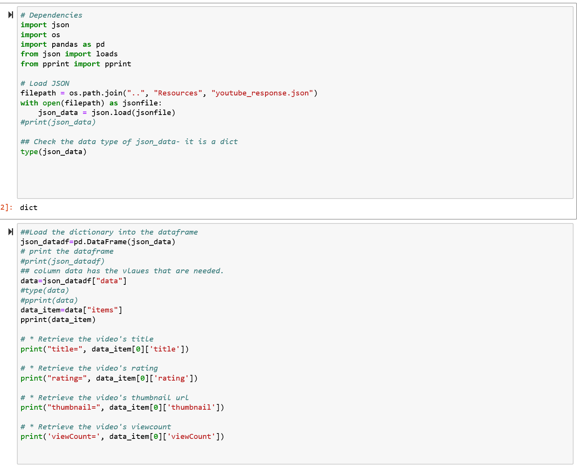

##### Output of the calculations:

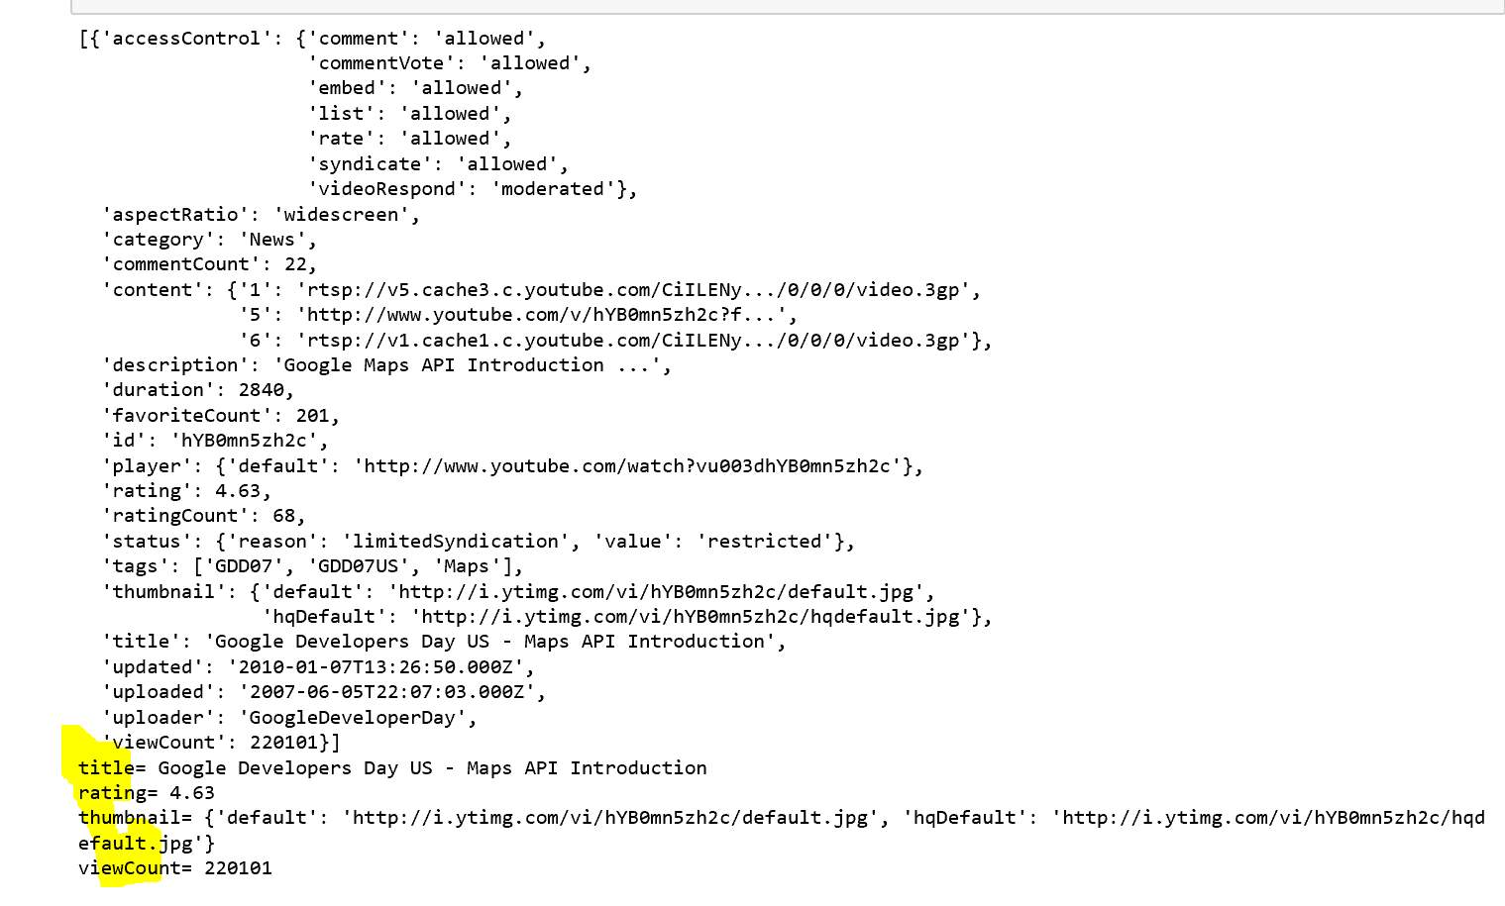

### Exercise 02- Requests & Responses

This activity provides practice making API calls, converting the response to JSON, and then manipulating the result with Python.

**Instructions**

* Make a request to the following endpoint (<http://nyt-mongo-scraper.herokuapp.com/api/headlines>) and store the response.
* JSON-ify the response.
* Print the JSON representations of the first and last posts.
* Print number of posts received.

##### Divya’s Solution Code:

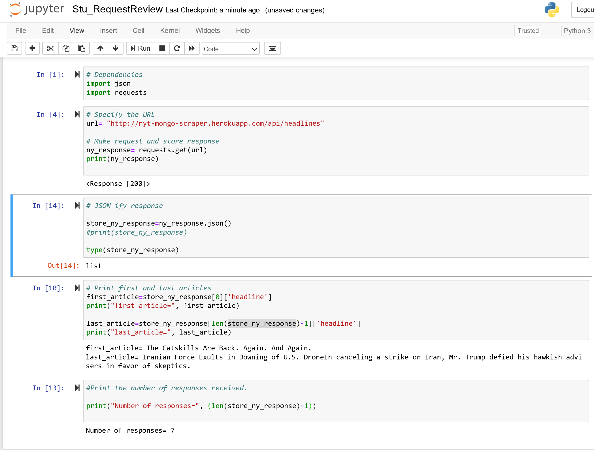

### Exercise 03- Use API key from a config file and access data

Use “from config import api_key” and keep a valid key in the config file. Replace the key if it expires. Used the api key mentioned in the slack channel and it worked!

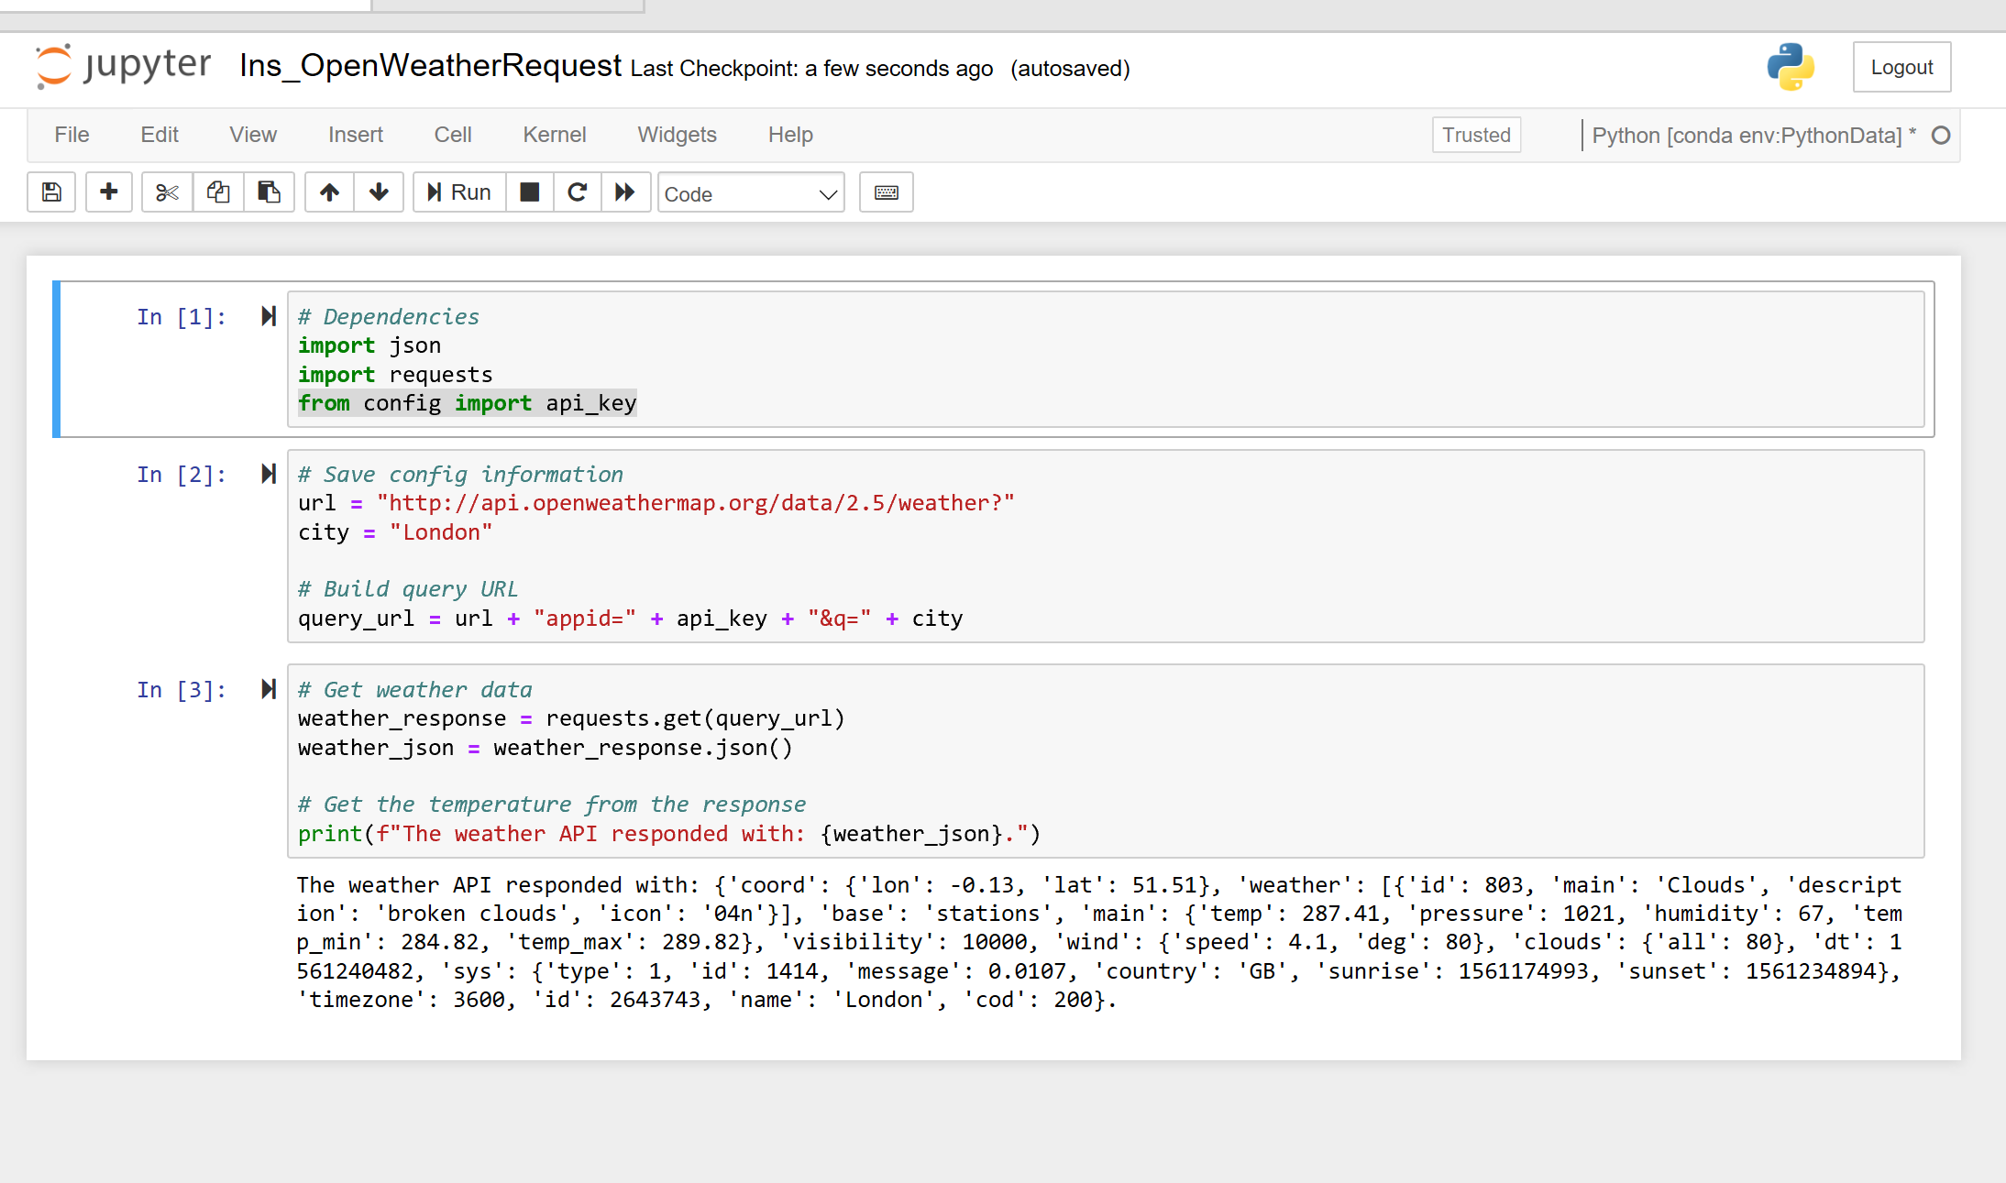

**APIs have different versions.**

Exercise 03 – Set up API keys and look at API documentation

### Sign up at Open Weather Map and get my API KEY - <https://home.openweathermap.org/api_keys>

### Looking at API Documentation - <https://openweathermap.org/api>

### Understanding what APIS are available to work on and pick the appropriate one.

### Exercise 04- Weather in Bujumbura

This activity gives students practice with making API calls and handling responses.

**Instructions**

* Save all of your "config" information—i.e., your API key; the base URL; etc.—before moving on.
* Build your query URL. Check the documentation to figure out how to request temperatures in Celsius.
* Make your request, and save the API response.
* Retrieve the current temperature in Bujumbura from the JSON response.
* Print the temperature to the console.

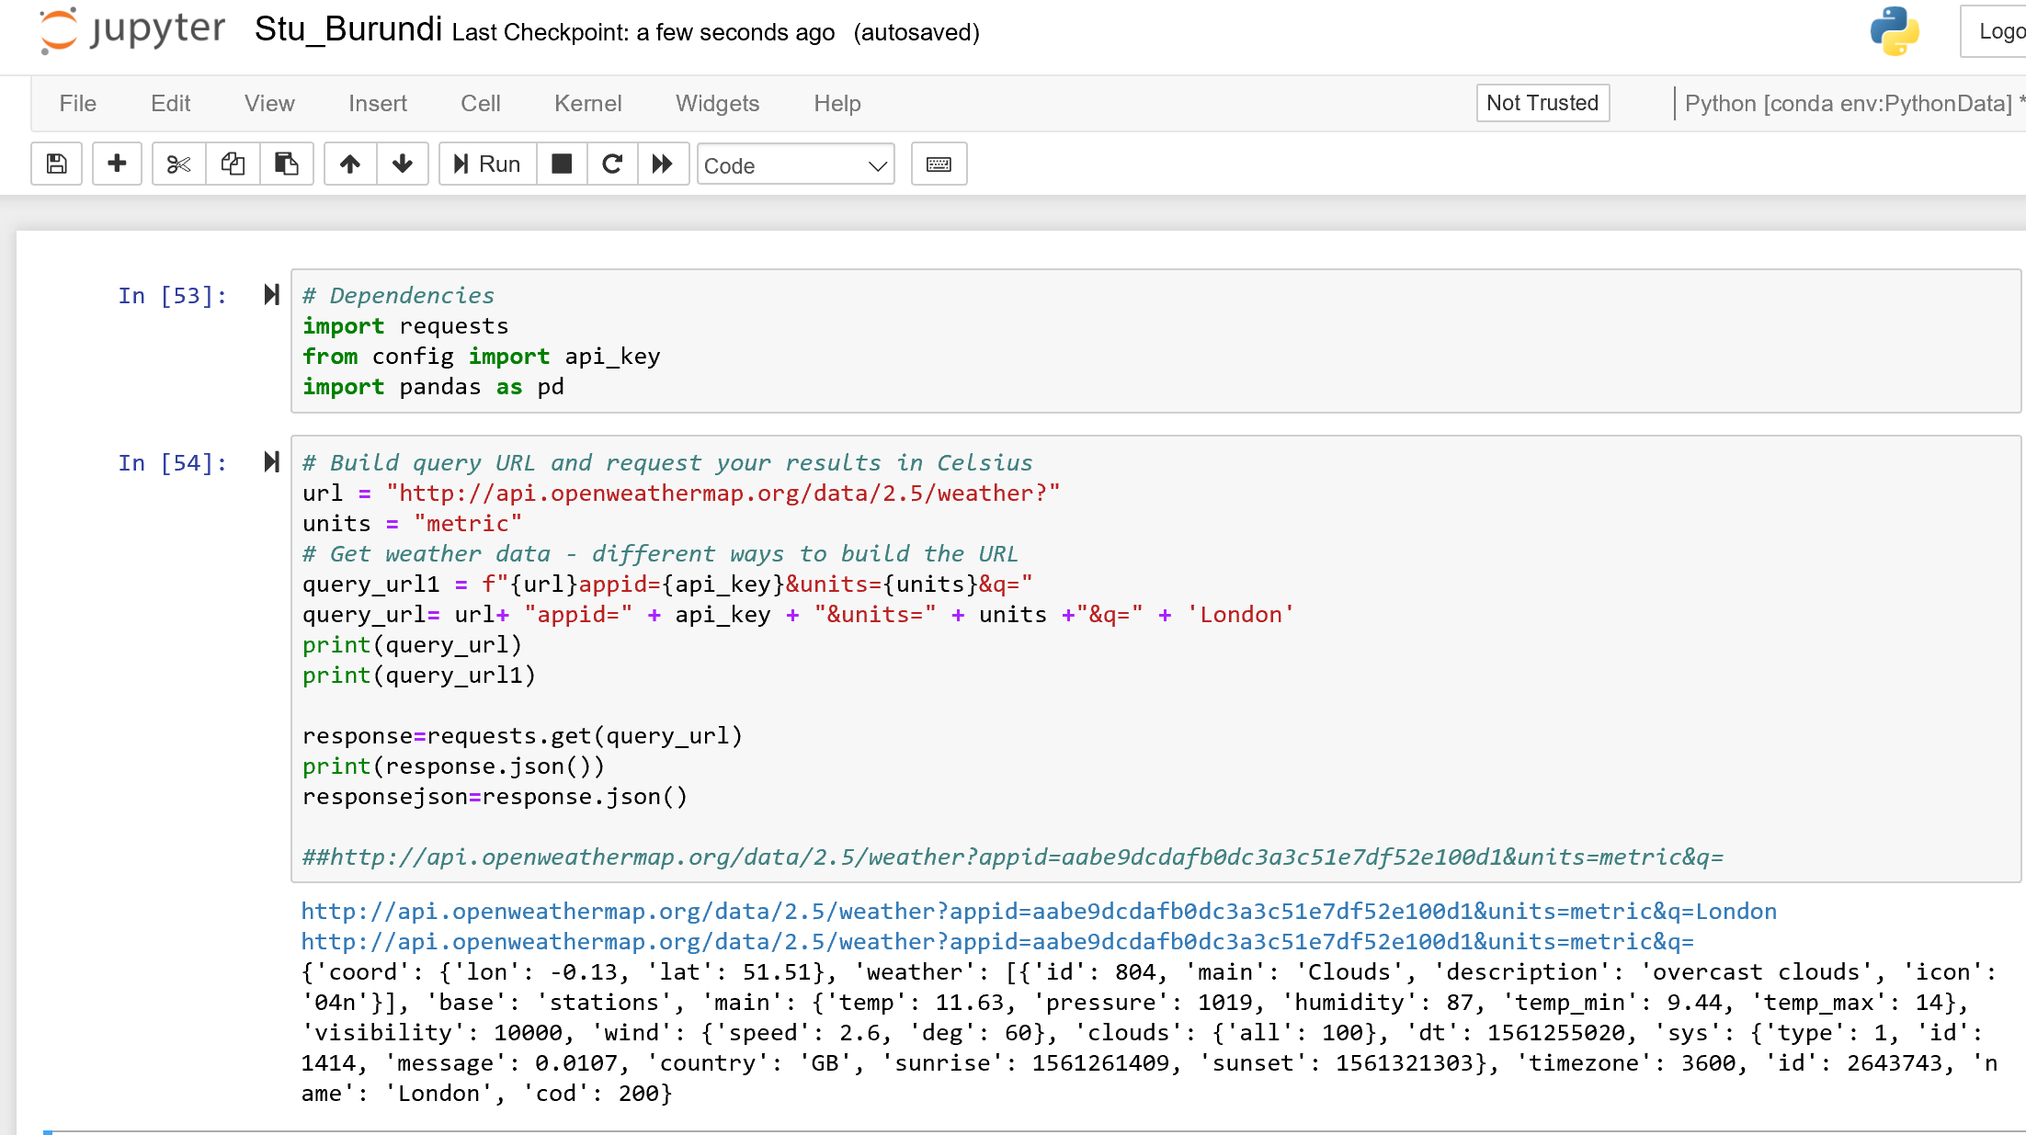

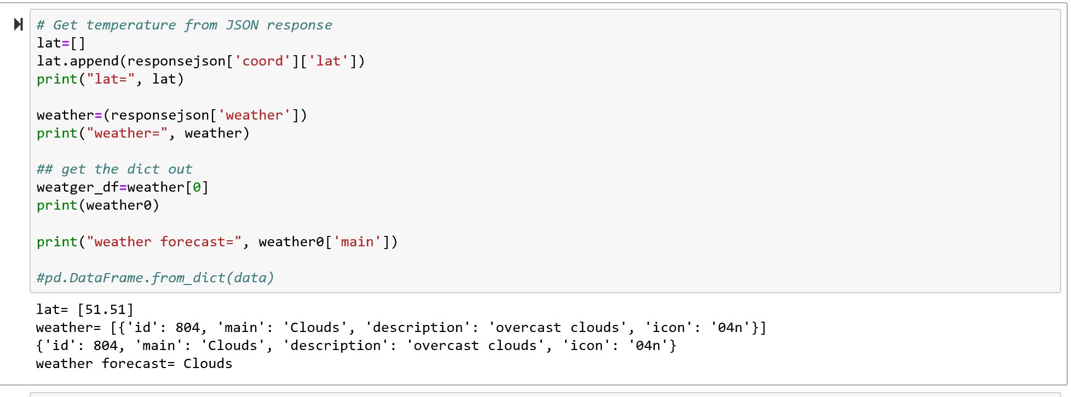

### Exercise 05- Ins_OpenWeatherDataFrame

* Build a query with the API key
* Make a call and get the response and initiate a JSON object.
* Start calculations of the response.
* Plot the data with matplotlib.

#### Test the length of the lists to make sure you don’t exceed the response limit for the day set by the server.

### Exercise 06- TV Ratings

* You may use the list of TV shows provided in the starter file or create your own.
* Request information on each TV show from the [TVmaze API's Show Search endpoint](https://www.tvmaze.com/api#show-search)
* Store the name and rating information into lists.
* Store this data in a dictionary and use it to create a Pandas DataFrame.
* Use matplotlib to create a bar chart comparing the ratings of each show.

###### Divya’s code:

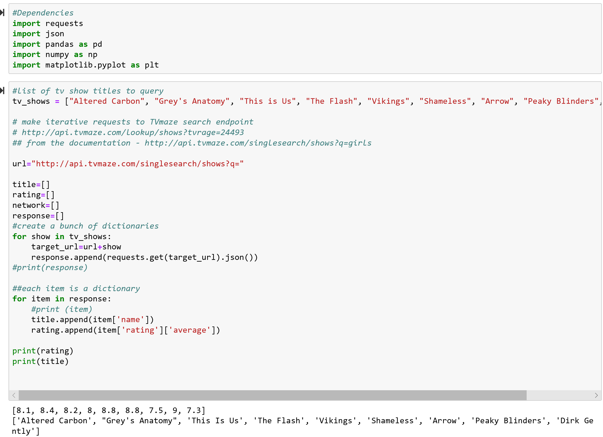

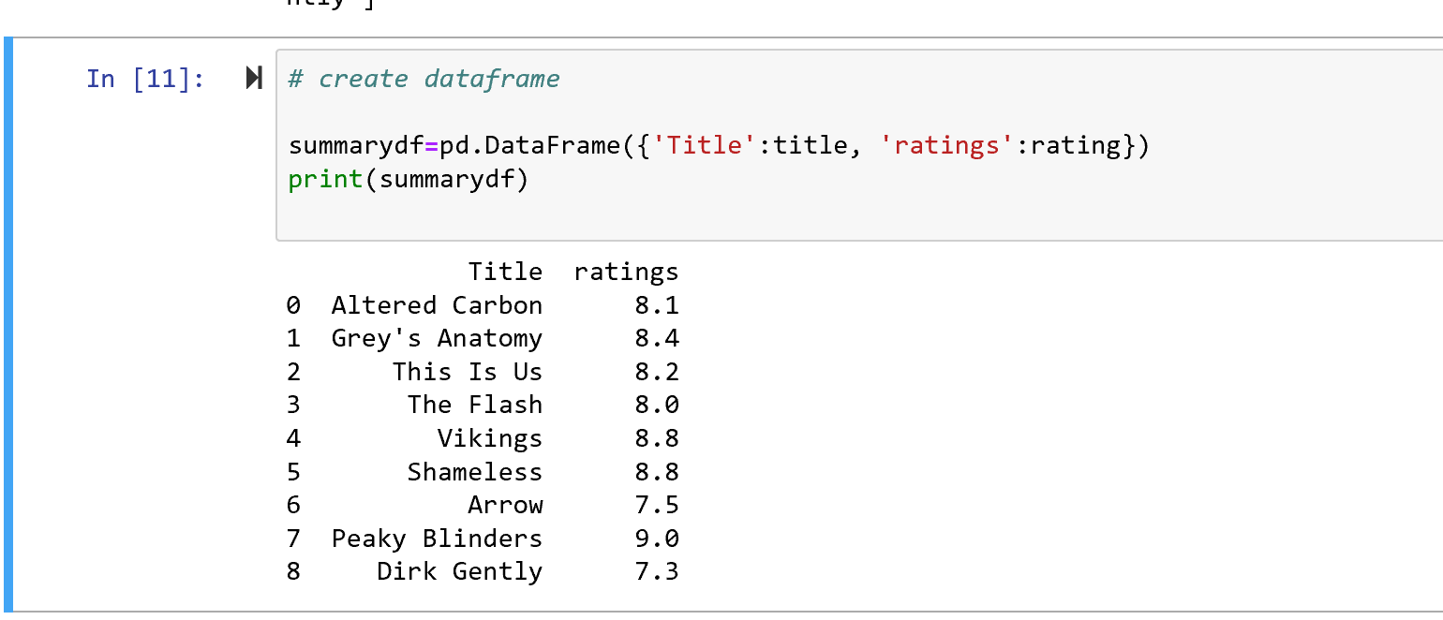

### Exercise 07 & 08- Exception handling

* Try and catch blocks of code to handle exceptions.

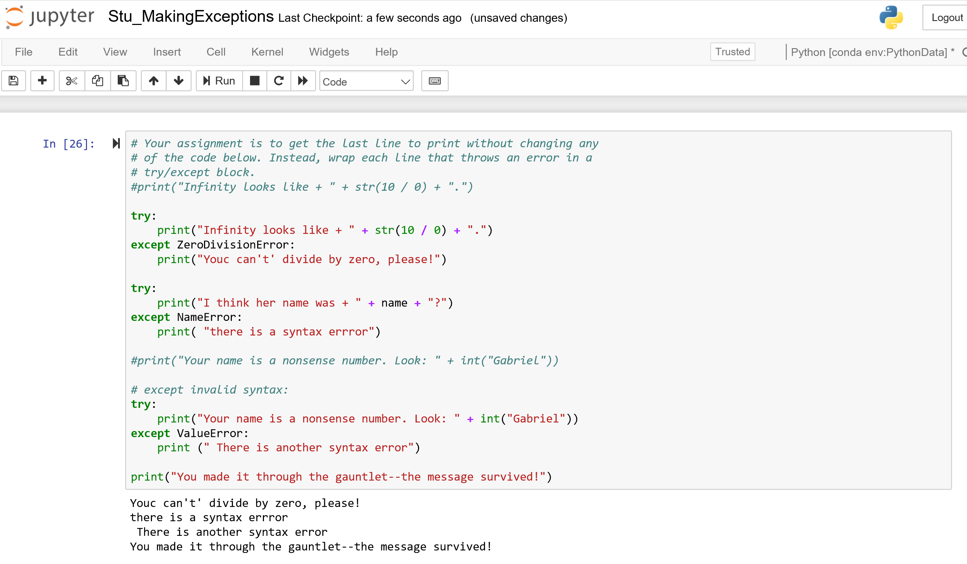

### Exercise 09 – importing API specific modules and using them to build URLs and other things.

**pip install openweathermapy**

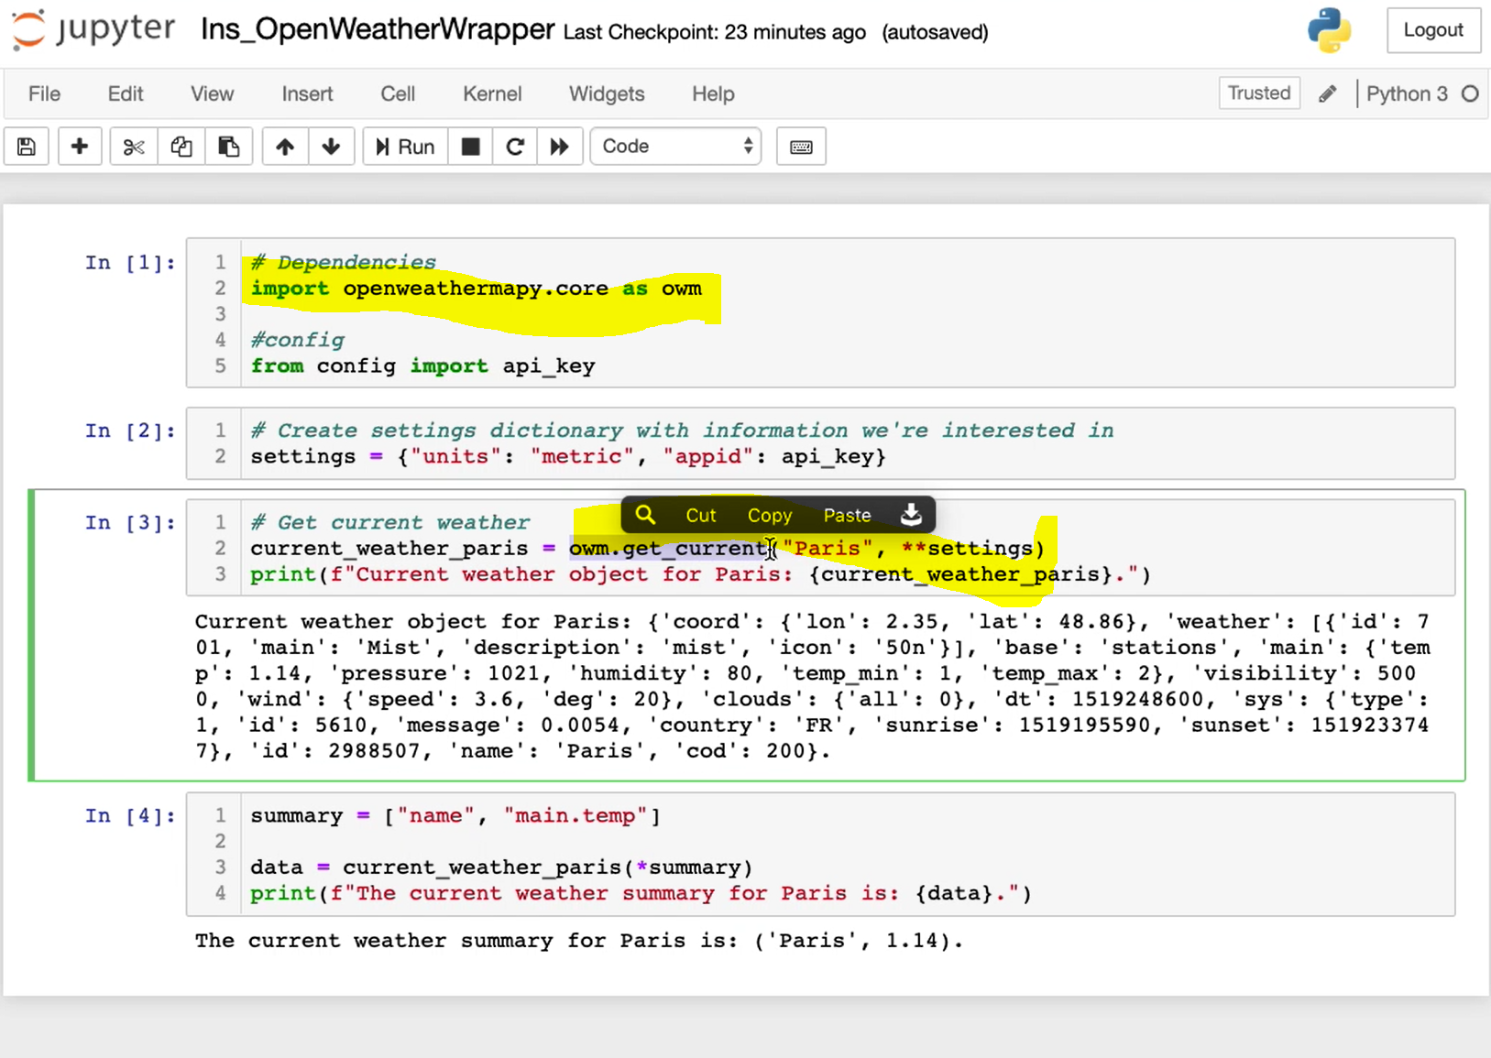

### Exercise 010 – importing API specific modules and using them to build URLs and other things.

Read from the CSV file and iterate through the cities. Calculate the values for each city by reading the JSON response from the API calls.

Code to read from the CSV file and change list of a list to flat list. Got invalid API key while trying to access web data, will talk to the instructors on Tuesday.

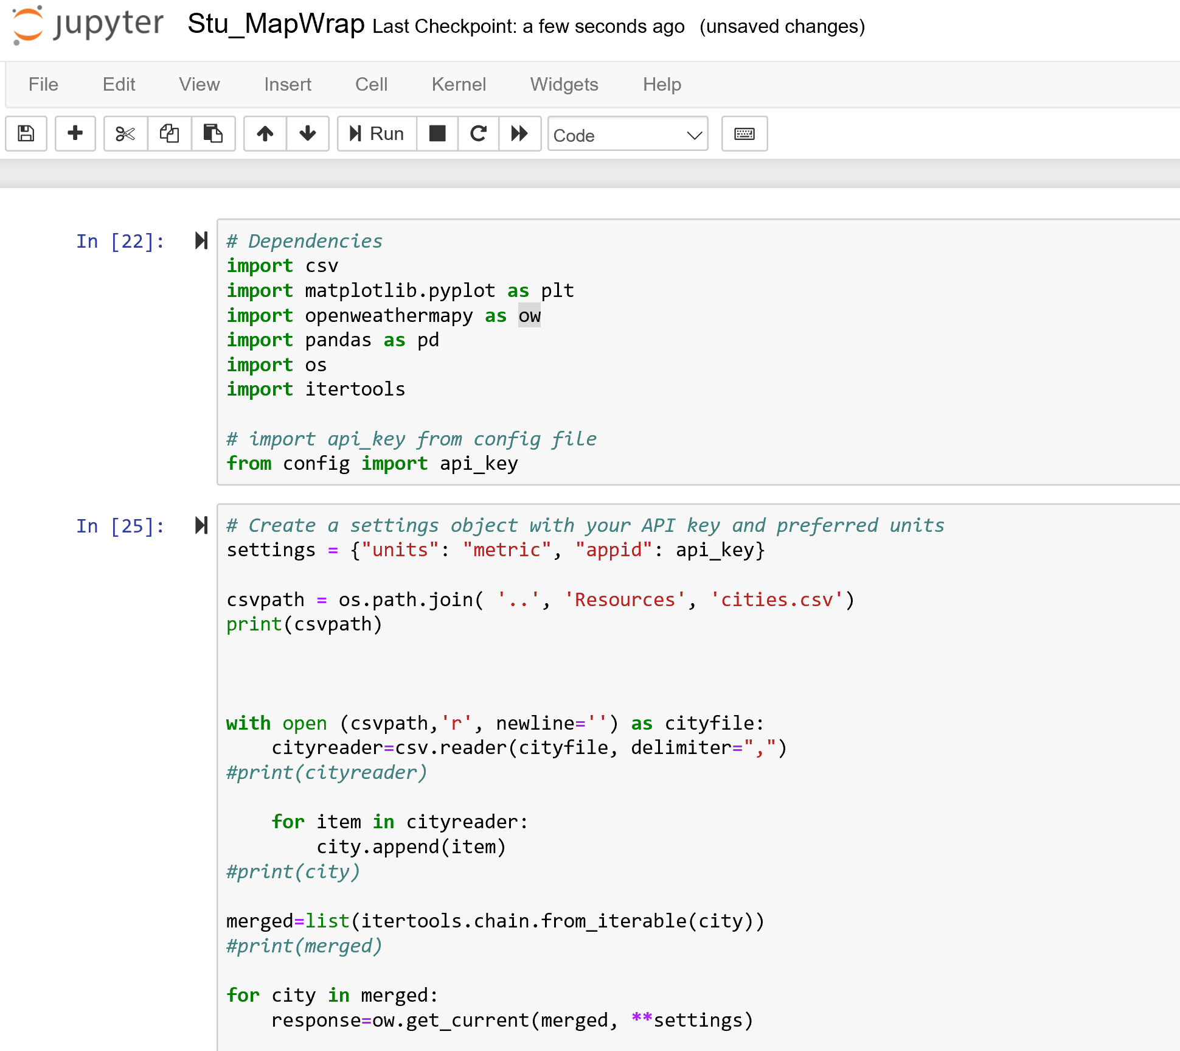

Exercise 011 - Ins_WorldBankAPI

The response object is an XML. Check if you can get JSON from the same API instead.

Exercise 013 –Citypy- Will be discussed next class.