SIMATS ENGINEERING

ASSESSMENT TOOL 2

COURSE NAME: Cryptography and Network Security COURSE CODE: CSA5116

COURSE OUTCOME COVERED

CO1: Apply classical encryption techniques using symmetric and asymmetric ciphers to encrypt and decrypt data for the ensuring data security. (BL3, BL4)

Assessment Tool Weightage: 20%

QUESTIONS: 5 Total Marks:50

Annexure A

CONCEPT MAPPING

Code of Conduct:

I U.Divya(192372277) certify that this submission is my original work and that I have adhered to the guidelines specified for this assessment.
I understand that any violation of academic integrity rules will result in disciplinary action.

Signature of the student: Divya
Annexure A

CONCEPT MAPPING

- Develop a concept map comparing substitution techniques: Caesar Cipher, Monoalphabetic Cipher, Vigenère Cipher and Hill Cipher. Perform the following tasks to connect based on: Key usage, Complexity and Security strength. Analyze which technique is most secure and why.
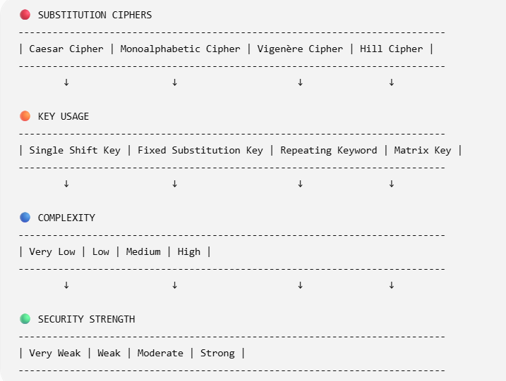

EXPLANATION

🔐 1. Caesar Cipher
- Key Usage: Single shift (e.g., +3)
- Complexity: Very low
- Security: Very weak
- Reason: Easy brute force (only 25 possibilities)
- Example: A → D

🔐 2. Monoalphabetic Cipher
- Key Usage: Fixed letter mapping
- Complexity: Low
- Security: Weak
- Reason: Frequency analysis can break it
- Example: A → Q, B → W

🔐 3. Vigenère Cipher
- Key Usage: Repeating keyword
- Complexity: Medium
- Security: Moderate
- Reason: Multiple shifts reduce frequency attack
- Example: Key = “KEY”

🔐 4. Hill Cipher
- Key Usage: Matrix (linear algebra)
- Complexity: High
- Security: Strong
- Reason: Uses mathematical transformations, harder to break
- Example: 2×2 or 3×3 matrix encryption

ANALYSIS

✅ Most Secure Technique: Hill Cipher

✔️ Why?
- Uses matrix multiplication
- Encrypts multiple letters at once
- No simple frequency patterns
- Large key space → difficult to brute force

FINAL COMPARISON LINE

Caesar < Monoalphabetic < Vigenère < Hill (Increasing Security)

- Construct a concept map for Classical Encryption Schemes: Substitution Techniques and Transposition Techniques. Perform the following tasks:
  - Show differences and similarities
    - Map how each affects the Data structure and Security level
    - Analyze which is more vulnerable to attacks and why
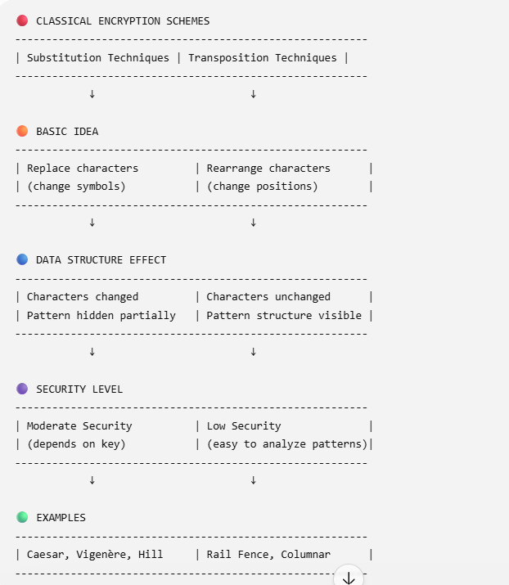

SIMILARITIES
- Both are classical encryption techniques
- Both use keys for encryption/decryption
- Both aim to protect data confidentiality
- Both are vulnerable to modern cryptanalysis

DIFFERENCES
Feature | Substitution | Transposition
Method | Replaces letters | Rearranges letters
Data Change | Changes symbols | Keeps symbols same
Pattern | Partially hidden | Often visible
Security | Higher | Lower

ANALYSIS

❗ More Vulnerable Technique: Transposition Cipher

✔️ Why?
- Does not change characters, only positions
- Original letter frequency remains same
- Easy to break using pattern analysis & anagrams

✔️ Substitution (Less vulnerable than transposition)
- Changes characters → hides original data
- But still breakable using frequency analysis

FINAL CONCLUSION
Transposition is more vulnerable than Substitution because it preserves original data patterns.

- Create a concept map connecting Steganography concepts: Data Hiding, Watermarking and Survivability. Perform the following tasks:
  - Show relationships between these concepts
  - Analyze how each contributes to secure communication
  - Include one real-world application for each
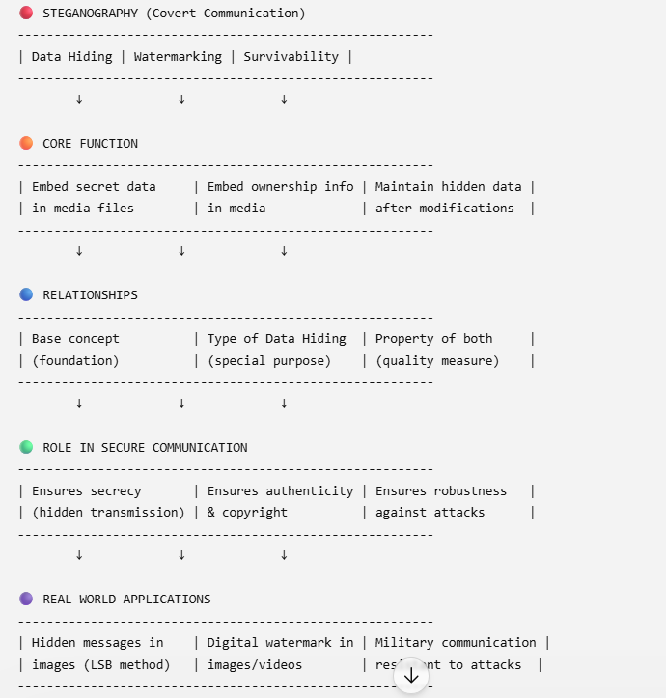

a) RELATIONSHIPS
Data Hiding → Main technique
Watermarking → Specialized form of Data Hiding
Survivability → Strength/quality of both techniques

b) CONTRIBUTION TO SECURE COMMUNICATION

1. Data Hiding
- Hides existence of communication
- Prevents attackers from detecting message
- 👉 Provides confidentiality

2. Watermarking
- Embeds ownership/identity into data
- Helps detect unauthorized usage
- 👉 Provides authentication & integrity

3. Survivability
- Ensures hidden data is not destroyed
- Resistant to compression, cropping, noise
- 👉 Provides robustness & reliability

c) REAL-WORLD APPLICATIONS
- Data Hiding: Secret communication using images (covert messaging)
- Watermarking: Copyright protection in movies, photos, music
- Survivability: Military or forensic data that must survive attacks

FINAL ANALYSIS
Secure Communication = Secrecy (Data Hiding) + Authenticity (Watermarking) + Robustness (Survivability)

- Draw a concept map linking number theory concepts used in cryptography: Modular Inverse, Extended Euclid Algorithm, Fermat’s Little Theorem, Euler’s Phi Function and Euler’s Theorem. Perform the following tasks:
  - Show how each concept is mathematically connected
  - Map their role in encryption/decryption
  - Analyze which concept is most critical for public key cryptography and justify
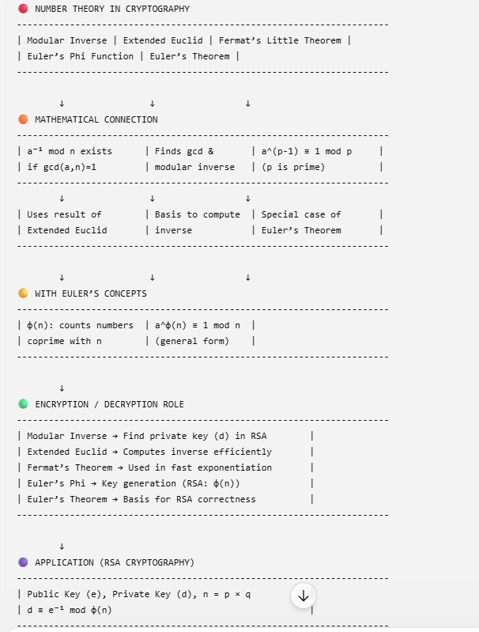

a) MATHEMATICAL CONNECTIONS
Extended Euclid → computes gcd & Modular Inverse
Modular Inverse → exists only if gcd(a,n)=1

Euler’s Phi → used in Euler’s Theorem
Euler’s Theorem → generalization of Fermat’s Theorem
Fermat’s Theorem → special case when n is prime

b) ROLE IN ENCRYPTION / DECRYPTION

Modular Inverse
- Used to compute private key (d)
- Critical in RSA:
👉 d ≡ e⁻¹ mod φ(n)

Extended Euclid Algorithm
- Efficient way to find:
  - gcd
  - modular inverse
- Used in key generation

Fermat’s Little Theorem
- Simplifies modular exponentiation
- Helps in encryption/decryption speed

Euler’s Phi Function (φ(n))
- Counts coprime integers
- Used in RSA key generation

Euler’s Theorem
- Mathematical foundation of RSA
- Ensures:
👉 Decryption recovers original message

c) MOST CRITICAL CONCEPT
Most Critical: Euler’s Phi Function (φ(n))

✔ Justification:
- Required to generate RSA keys
- Used to compute modular inverse (private key)
- Without φ(n), encryption/decryption cannot work properly

FINAL ANALYSIS
- Extended Euclid + Modular Inverse → Key computation
- Euler’s Phi + Euler’s Theorem → RSA foundation
- Fermat → optimization
👉 Together, they ensure secure and correct public key cryptography

RUBRICS FOR CALCULATION:

Criteria | Weighta ge | Level 4 –  Exemplary | Level 3 –  Proficient | Level 2 –  Developing | Level 1 –  Beginning

Understandi ng of Concepts | 25 | Demonstrates thorough understanding and effectively integrates multiple concepts/technolo  gies | Good  understandi ng with proper integration of most concepts | Basic understandin g; limited or partial integration | Poor understandin g; unable to integrate concepts
Experiment al Design | 30 | Well-planned, systematic implementation with optimal  solution | Correct implementat ion with minor issues | Basic  implementati on with errors or inefficiencies | Incorrect or incomplete  implementati on
Use of Tools | 20 | Effective and advanced use of tools/technologies with proper  configuration | Appropriate use of tools with correct execution | Limited or inconsistent use of tools | Incorrect or minimal use of tools
Analysis of Results | 15 | Insightful analysis with accurate interpretation and validation of results | Good analysis with reasonable interpretatio  n | Basic analysis with limited insights | Poor or incorrect analysis of results
Documentat ion | 10 | Clear, well-structured documentation with diagrams,  code, and results | Organized  documentati on with necessary details | Basic documentatio n with missing  details | Poor or incomplete documentatio n

