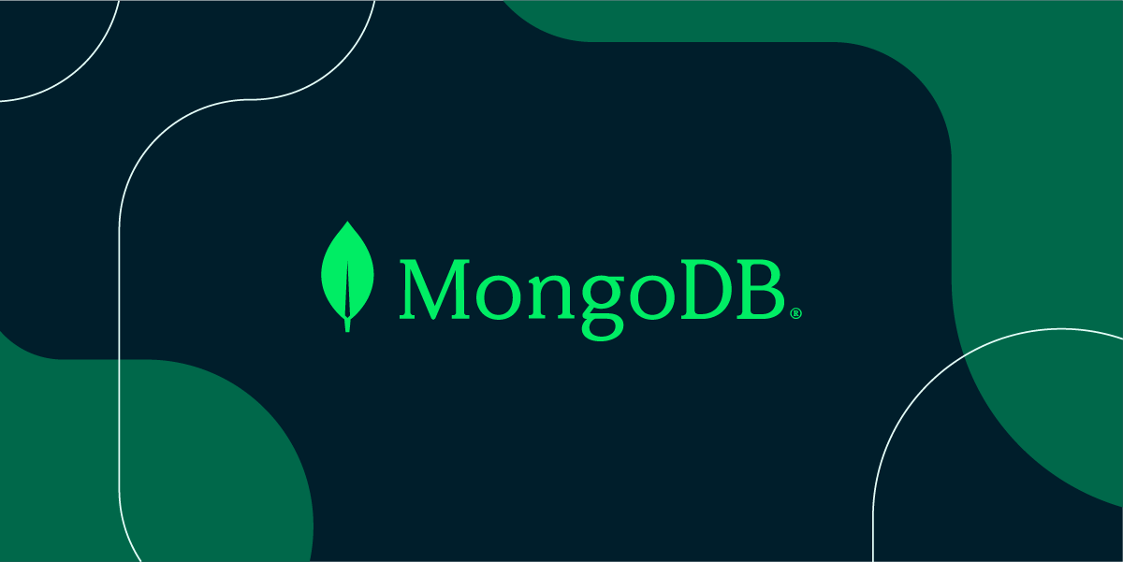

***Module – Node***

***Node with MongoDB***

***Q1. What is MongoDB.***

***ANS.***

MongoDB is a popular NoSQL database that stores data in a flexible, JSON like format called documents. Unlike traditional SQL database that uses tables and rows, MongoDB uses collections and documents. Which makes it more flexible and scalable, especially for handing large amounts of unstructured or semi–structured data.

***Why use*** ***MongoDB ?*** ***:*** For its flexibility, document-Oriented data model, scalability, performance and developer – friendly features.

***Q2. What is*** ***difference between mongo DB and SQL.***

***ANS.***

SQL :

SQL databases are ideal for structured data, complex queries, and scenarios where data integrity is critical.

Generally better for complex queries involving multiple joins, aggregate functions, and high data integrity.

**Vertical Scalability:** Traditionally scales vertically by adding more resources (CPU, RAM) to the existing server.

MongoDB:

MongoDB is better suited for handling unstructured data, fast development cycles, and scenarios requiring high scalability.

Often faster for simple queries and can handle large volumes of read/write operations efficiently.

**Horizontal Scalability:** Designed for horizontal scaling through sharding, which distributes data across multiple servers.

***Q3. Create database for online shopping app.***

***Ans.***

First create an Express.js project with an EJS template.

then Create a database, follow these steps:

const express = require('express');

const app = express();

// npm i mongodb // Step 1 - install mongodb

const { MongoClient } = require('mongodb'); // Step 2 - Require the MongoDB client from the mongodb package

const url = 'mongodb://localhost:27017/'; // Step 3 - Define the MongoDB connection URL (connecting to a local MongoDB server)

const path = require('path');

const client = new MongoClient(url); // Step 4 - Create a new instance of MongoClient to interact with the MongoDB database using the provided URL.

const dbName = 'onlineShopping'; // Step 5 - Define the name of the database that you want to use or create

app.set('view engine','ejs')

app.set('views', path.join(__dirname, 'views'));

app.use(express.urlencoded({extended: false }));

app.use(express.static('public'))

let db; // Step 6

const main = async ()=>{

await client.connect(); // Step 7 - Connect to the MongoDB database using the client instance; this is an asynchronous operation

console.log('connected')

db = client.db(dbName) // Step 8 - Assign the connected database to the 'db' variable, allowing further operations on the database

}

main()

app.get("/", (req, res) => {

res.send('hy')

})

app.listen(4000);

The database will not appear in MongoDB Compass if it's just been created but no collections or documents have been added.

***Q4. Create Require collections for online shopping app and documents.***

***i. User***

***ii. Product category***

***iii. Product***

***iv. Order***

***v. Review***

***Ans.***

Create all collections and add data from users

// Create User document

app.post('/add-user', (req, res) => {

// step-1 Access the 'users' collection from the connected database.

const usersCollection = db.collection('users'); // collection name = 'users' (check MongoDB Compass)

// step-2. Create a new user object with properties 'name', 'email', and 'password'.

// These properties are extracted from the request body, which contains the form data submitted by the user.

const newUser = { // create format

name: req.body.name, // Extract the 'name' field from the form data

email: req.body.email, // Extract the 'email' field from the form data

password: req.body.password // Extract the 'password' field from the form data

};

// step-3. The 'insertOne' method is used to add a single document (newUser) to the collection.

usersCollection.insertOne(newUser) // insert data

res.redirect('/')

});

// Similarly add all collection

// Create category document

app.post('/add-category', (req, res)=>{

const categoryCollection = db.collection('category');

const newCat = {

name: req.body.name,

description: req.body.description

};

categoryCollection.insertOne(newCat)

res.redirect('/category')

})

// Create product document

app.post('/add-product', (req, res)=>{

const productCollection = db.collection('product');

const newProduct = {

name: req.body.name,

price: req.body.price,

category: req.body.category,

description: req.body.description

};

productCollection.insertOne(newProduct)

res.redirect('/product')

})

// Create Order document

app.post('/add-order', (req, res)=>{

const orderCollection = db.collection('order');

const newOrder = {

userId: req.body.userId,

productId: req.body.productId,

quantity: req.body.quantity,

status: req.body.status

};

orderCollection.insertOne(newOrder)

res.redirect('/order')

})

// Create Review document

app.post('/add-review', (req, res)=>{

const reviewCollection = db.collection('review');

const newReview = {

productId: req.body.productId,

userId: req.body.userId,

rating: req.body.rating,

comment: req.body.comment

};

reviewCollection.insertOne(newReview)

res.redirect('/review')

})

***Q5. Write command to show all data from product collections and short in ascending order.***

***Ans.***

Show data in show-data page and shorting in ascending order

// Show and short data

app.get('/show-data', async (req,res)=>{

const showCollection = db.collection('product');

let products = await showCollection.find({}).sort({ name: 1 }).toArray();// This returns an array of products // sort() function use for shorting (short by name)

res.render('show-data', { products: products});// Pass the array to the view

})

<div class="container">

<a href="/product">Go back</a>

<h1>Product List</h1>

<div class="product-list">

*<*% products.forEach(product => { %>

<div class="product-item">

<h2 class="product-name">*<*%= product.name %></h2>

<p class="product-price">Price: $*<*%= product.price %></p>

<p class="product-category">Category: *<*%= product.category %></p>

<p class="product-description">*<*%= product.description %></p>

</div>

*<*% }) %>

</div>

</div>

***Q6. Update product price for particular product.***

***Ans.***

Add update page and Update product price and other data.

// update price

// step - 1 add old data on update page

app.get('/update/:id', async (req, res) => {

const productCollection = db.collection('product');

const productId = req.params.id; // Get the product ID from the URL

const product = await productCollection.findOne({ _id: new ObjectId(productId) }); // Use ObjectId to convert the string ID to an ObjectId

res.render('update', { product: product });

});

//step - 2 data updated and show

app.post('/update-product/:id',async (req, res) => {

const productCollection = db.collection('product');

const productId = req.params.id;

const updatedProduct = {price: req.body.price};

await productCollection.updateOne(

{ _id: new ObjectId(productId) }, // Find the product by ID

{ $set: updatedProduct } // Update the product fields

);

res.redirect('/show-data'); // Redirect back to the list of products

});

***Q7. Write command to delete particular document and collection.***

***Ans.***

Delete particular data in documents.

// delete collection

app.get('/delete/:id', async (req, res) => {

const productCollection = db.collection('product');

const productId = req.params.id;

await productCollection.deleteOne({ _id: new ObjectId(productId) }); // Use ObjectId to find the document by ID

res.redirect('/show-data')

})