1.write a SQL query to find Employees who have the biggest salary in their Department

WITH temp as(

SELECT d.dept_name Department,

e.emp_name as Employee,

e.salary as Salary,

RANK() over (PARTITION BY d.dept_name ORDER BY e.salary DESC) rank

FROM Department d

left JOIN Employee e

on d.dept_id = e.dept_id

)

select

Department,Employee, Salary

from temp

WHERE rank = 1

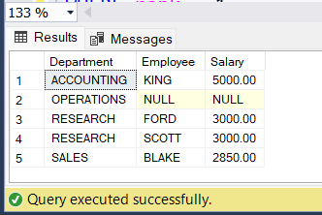

2.write a SQL query to find Departments that have less than 3 people in it

ANS.

SELECT s.dept_name, s.employees

FROM (

SELECT dept_name, ISNULL(count,0) as employees

FROM Department d

LEFT JOIN(

SELECT dept_id,COUNT(emp_id) as count

FROM Employee

GROUP BY dept_id) e

ON d.dept_id = e.dept_id

) s

WHERE s.employees<3

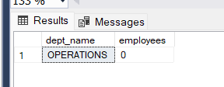

3.write a SQL query to find All Department along with the number of people there

ANS.

SELECT dept_name, ISNULL(count,0)

FROM Department d

LEFT JOIN(

SELECT dept_id,COUNT(emp_id) as count

FROM Employee

GROUP BY dept_id) e

ON d.dept_id = e.dept_id

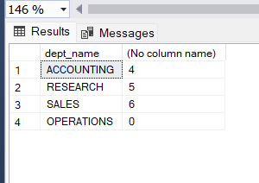

4.write a SQL query to find All Department along with the total salary there

SELECT dept_name, ISNULL(Total,0)

FROM Department d

LEFT JOIN(

SELECT dept_id,SUM(emp_id) as Total

FROM Employee

GROUP BY dept_id) e

ON d.dept_id = e.dept_id

