1.Create a stored procedure in the Northwind database that will calculate the average value of Freight for a specified customer.Then, a business rule will be added that will be triggered before every Update and Insert command in the Orders controller,and will use the stored procedure to verify that the Freight does not exceed the average freight. If it does, a message will be displayed and the command will be cancelled.

Ans.

CREATE PROCEDURE que1

AS

SELECT CustomerID, AVG(Freight) as AvgFreight

FROM Orders

GROUP BY CustomerID

GO

ALTER TRIGGER tr_que1_update

ON orders

INSTEAD OF UPDATE

AS

BEGIN

Declare @OrderID int

Declare @CustomerID varchar(50)

Declare @Freight money

Declare @AvgFreight money

Declare @t_ave TABLE(CustomerID nchar(5), AvgFreight money)

INSERT @t_ave

exec que1

Select * Into #Temptable FROM Inserted

While(Exists(Select OrderID from #TempTable))

Begin

Select TOP 1 @OrderID = OrderID, @CustomerID = CustomerID, @Freight=Freight

FROM #Temptable

SET @AvgFreight = (SELECT AvgFreight FROM @t_ave WHERE CustomerID = @CustomerID)

IF @Freight > @AvgFreight

BEGIN

RAISERROR ('ABOVE AVERAGE',16,1)

END

ELSE

BEGIN

UPDATE Orders SET Freight = @Freight WHERE OrderID=@OrderID

END

Delete from #TempTable where OrderID = @OrderID

End

END

ALTER TRIGGER tr_que1_insert

ON orders

INSTEAD OF INSERT

AS

BEGIN

Declare @OrderID int

Declare @CustomerID varchar(50)

Declare @Freight money

Declare @AvgFreight money

Declare @t_ave TABLE(CustomerID nchar(5), AvgFreight money)

INSERT @t_ave

exec que1

Select * Into #Temptable FROM Inserted

While(Exists(Select OrderID from #TempTable))

Begin

Select TOP 1 @OrderID = OrderID, @CustomerID = CustomerID, @Freight=Freight

FROM #Temptable

SET @AvgFreight = (SELECT AvgFreight FROM @t_ave WHERE CustomerID = @CustomerID)

IF @Freight > @AvgFreight

BEGIN

RAISERROR ('ABOVE AVERAGE',16,1)

END

ELSE

BEGIN

INSERT INTO Orders (CustomerID,EmployeeID,OrderDate,RequiredDate,ShippedDate,ShipVia,Freight,ShipName,ShipAddress,ShipCity,ShipRegion,ShipPostalCode,ShipCountry)

SELECT CustomerID,EmployeeID,OrderDate,RequiredDate,ShippedDate,ShipVia,Freight,ShipName,ShipAddress,ShipCity,ShipRegion,ShipPostalCode,ShipCountry

From Inserted

END

Delete from #TempTable where OrderID = @OrderID

End

END

CASE 1

UPDATE Orders SET Freight=60 WHERE OrderID = 10248

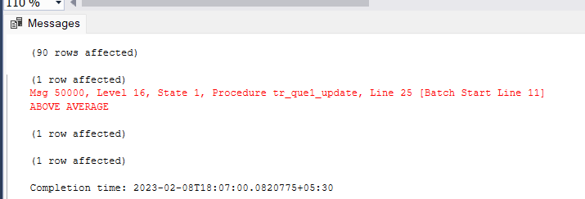

CASE 2

UPDATE Orders SET Freight=6 WHERE OrderID = 10248

SELECT * FROM Orders WHERE OrderID = 10248

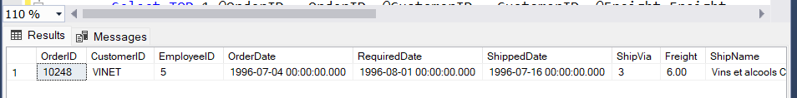

2.write a SQL query to Create Stored procedure in the Northwind database to retrieve Employee Sales by Country

CREATE PROC getsalesByCountry

@Country varchar(50)

AS

SELECT E.EmployeeID,COUNT(O.OrderID) as Orders

FROM Orders O

LEFT JOIN Employees E

ON E.EmployeeID = O.EmployeeID

WHERE E.Country = @Country

Group by E.EmployeeID

GO

exec getsalesByCountry 'USA'

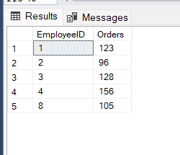

3.write a SQL query to Create Stored procedure in the Northwind database to retrieve Sales by Year

ALTER PROC getsalesByYear

@year int

AS

Select YEAR(OrderDate) as yearof,COUNT(OrderID) as Sales

from Orders

WHERE YEAR(OrderDate) = @year

Group By YEAR(OrderDate)

GO

getsalesByYear 1996

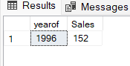

4. write a SQL query to Create Stored procedure in the Northwind database to retrieve Sales By Category

CREATE PROC getSalesByCategories

@Categories varchar(40)

AS

SELECT C.CategoryName, COUNT(Od.OrderID) as [Products]

FROM [Order Details] Od

LEFT JOIN Products P

ON Od.ProductID = P.ProductID

LEFT JOIN Categories C

ON P.CategoryID = C.CategoryID

WHERE C.CategoryName = @Categories

GROUP BY C.CategoryName

GO

getSalesByCategories 'Beverages'

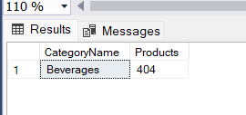

5. write a SQL query to Create Stored procedure in the Northwind database to retrieve Ten Most Expensive Products

CREATE PROC getExpensiveproducts

AS

SELECT TOP 10 ProductName

FROM Products

ORDER BY UnitPrice DESC

GO

getExpensiveproducts

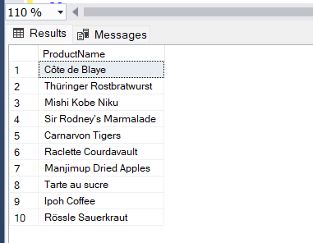

6. write a SQL query to Create Stored procedure in the Northwind database to insertCustomer Order Details

CREATE PROC addOrderDetails

@OrderID int,

@ProductID int,

@UnitPrice int,

@Quantity smallint,

@Discount real

AS

INSERT INTO [Order Details] (OrderID, ProductID,UnitPrice,Quantity,Discount)

VALUES (@OrderID, @ProductID, @UnitPrice, @Quantity, @Discount)

GO

addOrderDetails 10403,11,14,12,0

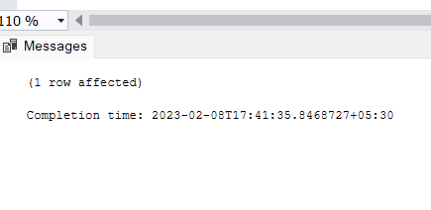

7. write a SQL query to Create Stored procedure in the Northwind database to update Customer Order Details

CREATE PROC updateOrderDetails

@OrderID int,

@ProductID int,

@UnitPrice int,

@Quantity smallint,

@Discount real

AS

UPDATE [Order Details]

SET OrderID = @OrderID,UnitPrice = @UnitPrice,Quantity = @Quantity,Discount=@Discount

WHERE OrderID = @OrderID

GO

updateOrderDetails 10403,11,15,16,0

