1. Write a query to get a Product list (id, name, unit price) where current products cost less than $20.

Ans.

SELECT ProductID,ProductName,UnitPrice FROM Products WHERE UnitPrice<20 AND Discontinued=0;

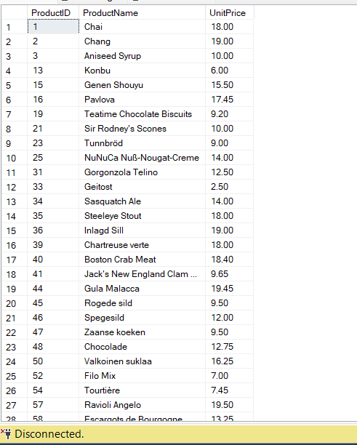

1. Write a query to get Product list (id, name, unit price) where products cost between $15 and $25

Ans.

SELECT ProductID,ProductName,UnitPrice FROM Products WHERE UnitPrice<=25 AND UnitPrice>=15;

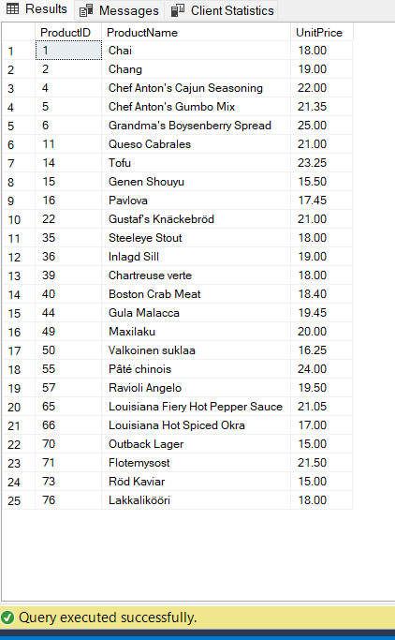

1. Write a query to get Product list (name, unit price) of above average price.

Ans.

SELECT ProductName,UnitPrice

FROM Products

WHERE UnitPrice > (SELECT AVG(UnitPrice) as Average FROM Products);

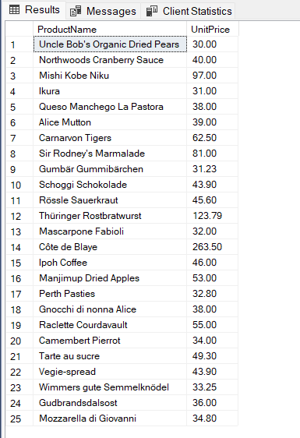

1. Write a query to get Product list (name, unit price) of ten most expensive products

SELECT TOP(10) ProductName,UnitPrice

FROM Products

ORDER BY UnitPrice DESC;

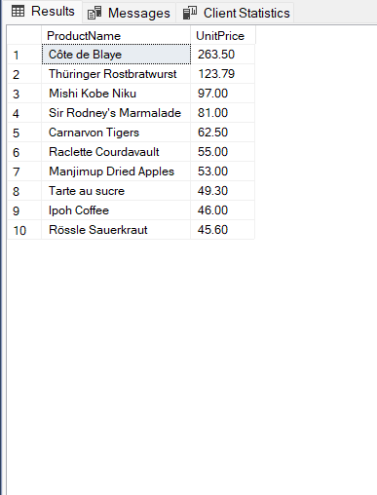

1. Write a query to count current and discontinued products

Ans.

SELECT Discontinued,COUNT(Discontinued) as NumberOfProducts

FROM Products

GROUP BY Discontinued;

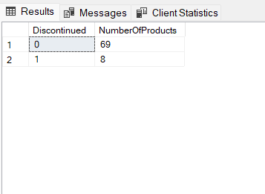

1. Write a query to get Product list (name, units on order , units in stock) of stock is less than the quantity on order

Ans.

SELECT ProductName,UnitsOnOrder,UnitsInStock

FROM Products

WHERE UnitsInStock<UnitsOnOrder;

