1. Login into AWS account
2. Select EC2 from Dashboard

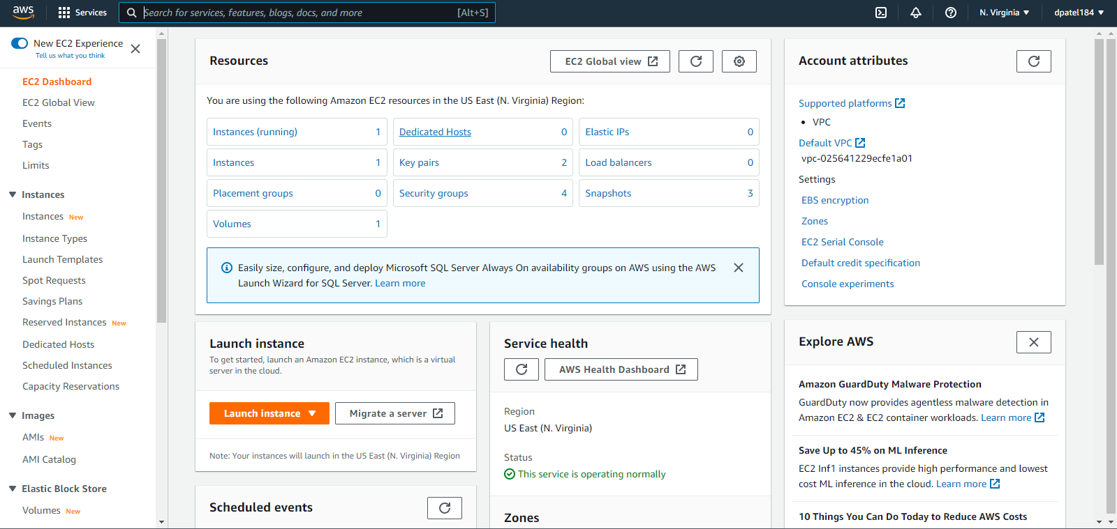

1. Click on Instances on left hand side, after that click on launch an instance
2. Give the name of your instance like mywebsite

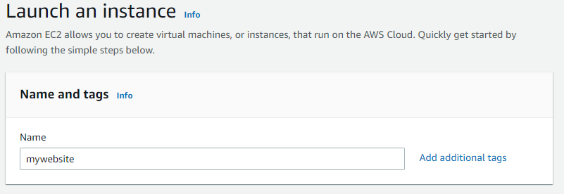

1. Select Application and OS Images (AMI) from Quick Start like Amazon Linux   
   Make sure it falls under free-tier

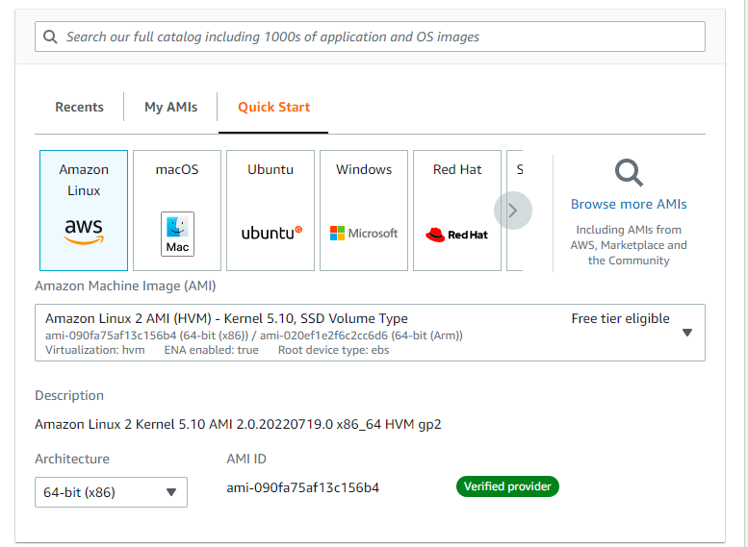

1. Leave the Instance type as it is of free tier

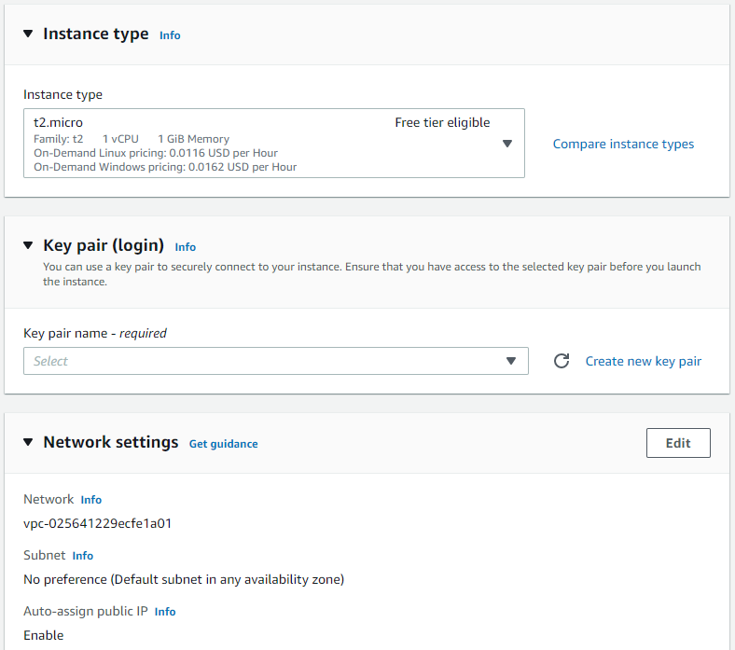

1. If you are creating the ec2 instance for first time create a key pair and download the .pem file
2. Change the network setting as per your requirements

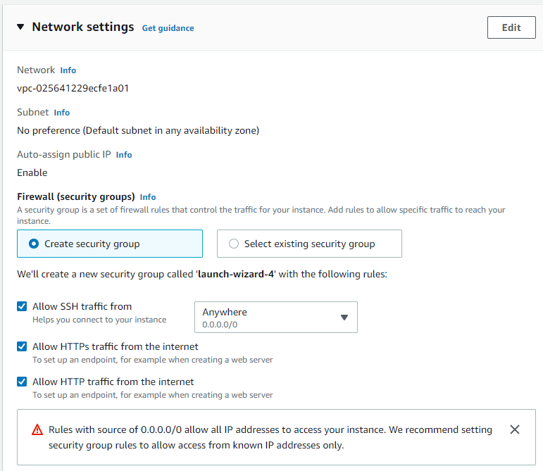

9. Click on Launch Instance

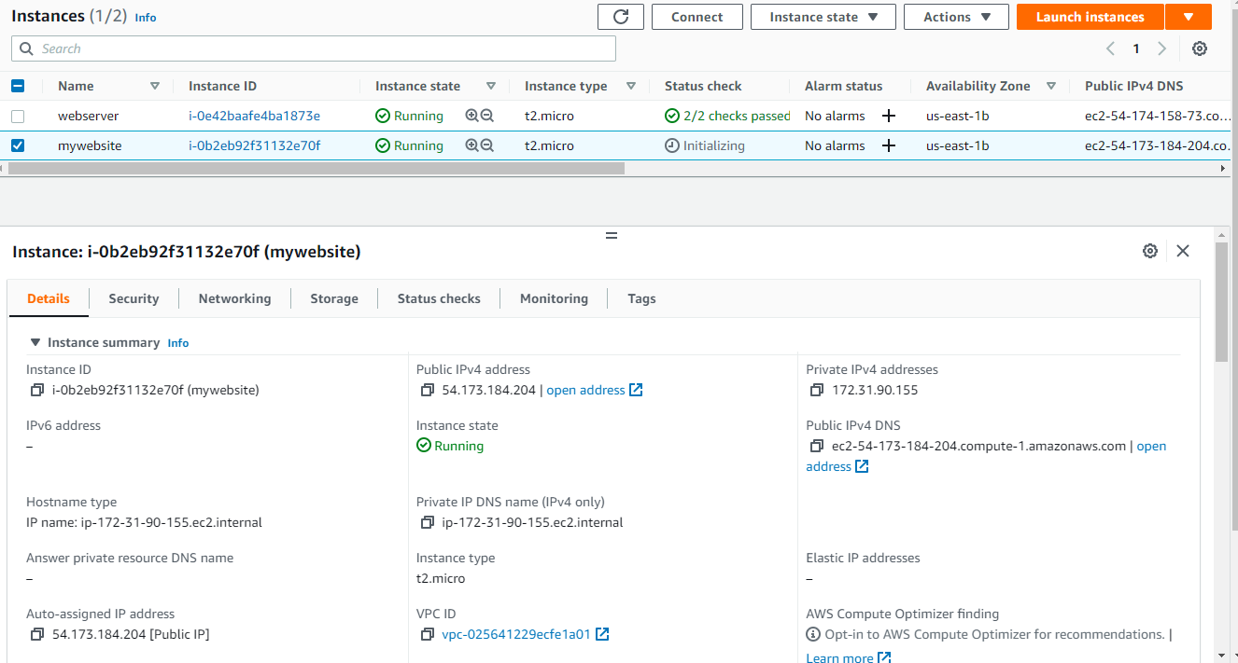

11. Select the instance you have created and click on connect the instance you will get various ways to connect to you instance

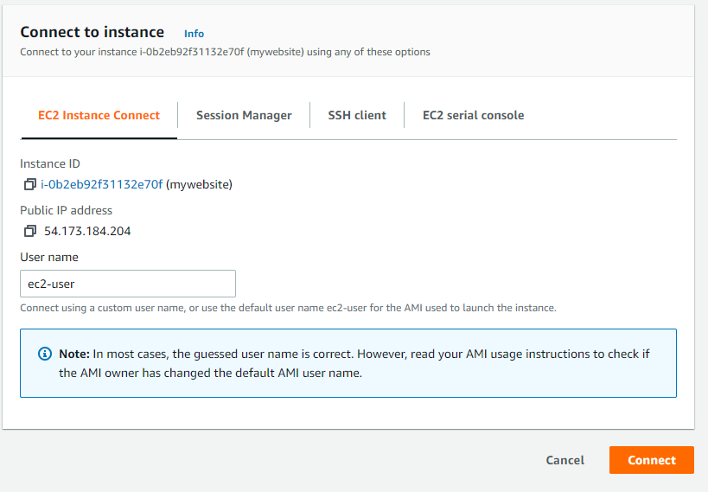  
10. Click on connect form EC2 Instance Connect, you can select the SSH Client and EC2 serial console also, however I have created ec2 instance connect

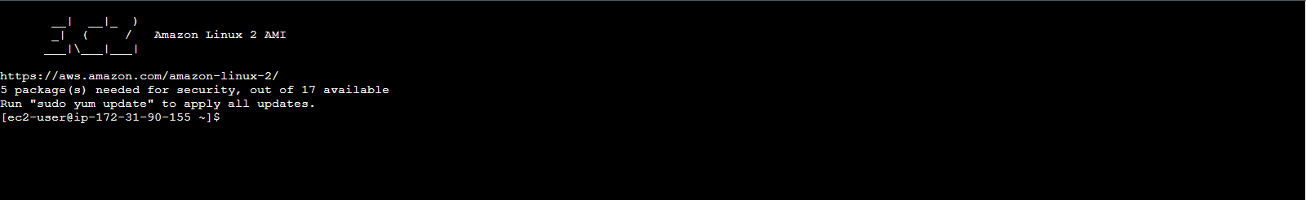

11. Once you are connected run the commands form script.sh