Final Project Report

Part A – Data Construction:

Discuss advice 2:

Yes. The atom’s normalization should take this into account.

Show two clean images and their corresponding noisy and corrupted versions

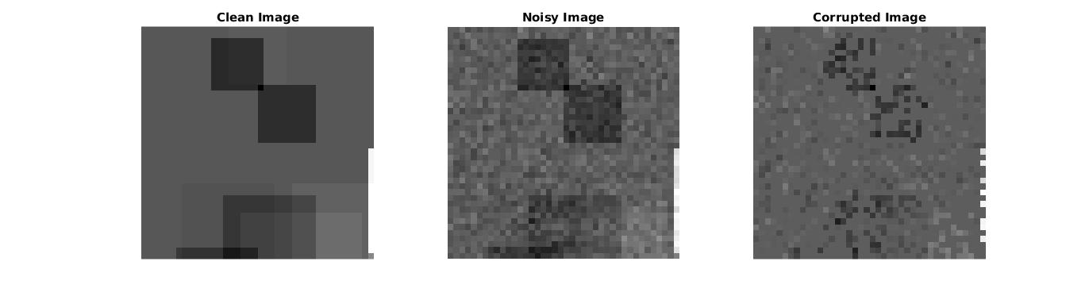

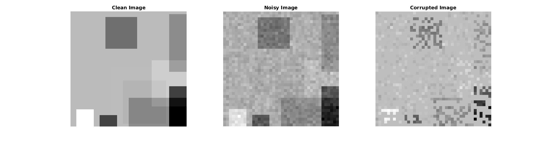

Part B – Inpainting by the Oracle Estimator

44.688

Insert average PSNR result of the Oracle estimator:

Show clean, noisy, corrupted and Oracle-based reconstruction:

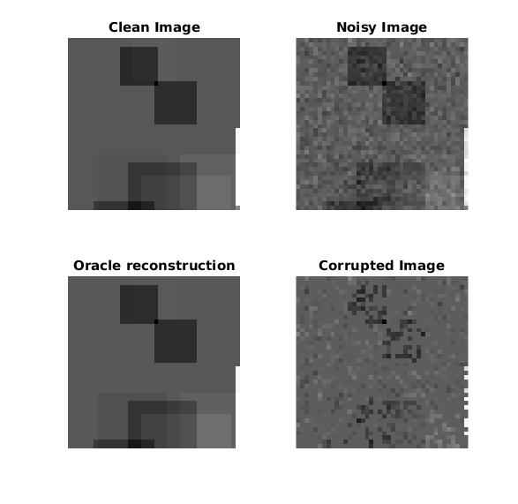

Part C – Inpainting by Greedy Pursuit

32.946

Insert average PSNR result of OMP:

Show clean, noisy, corrupted and OMP-based reconstruction:

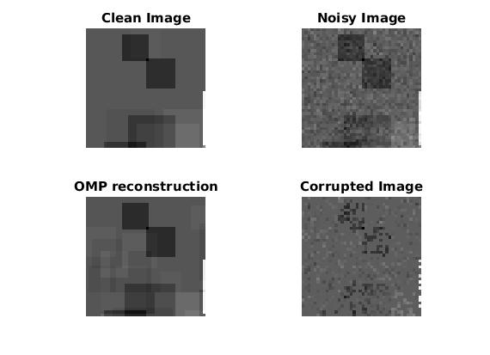

Compare between Oracle and OMP reconstructions:

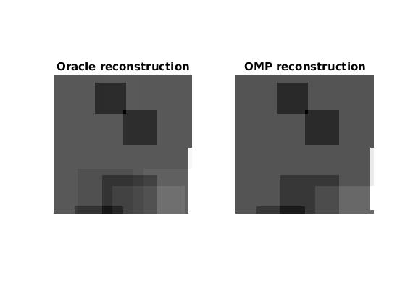

Discuss results of OMP and compare to Oracle performance:

Oracle has more details from the original image. OMP supressed some of the dimmer rectangles

Show average PSNR of OMP as a function of $k$

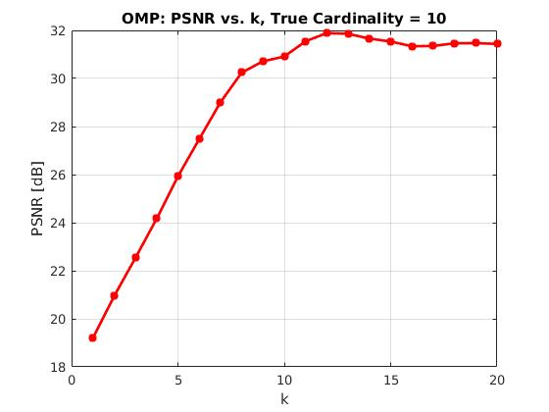

Discussion regarding the average PSNR as a function of $k$:

Part D – Inpainting by Basis Pursuit

32.922

Insert average PSNR result of Basis-Pursuit:

Show clean, noisy, corrupted and BP-based reconstruction:

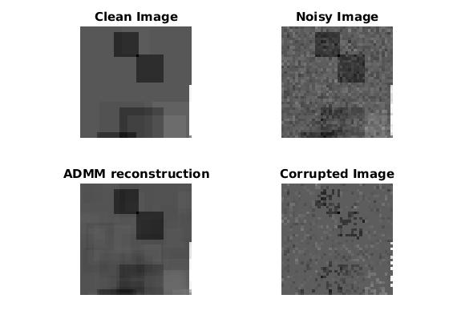

Compare between Oracle and OMP and BP reconstructions:

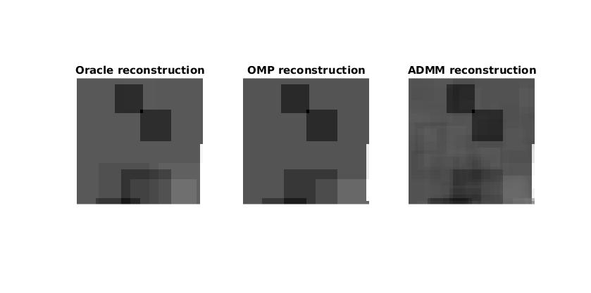

Discuss results of BP and compare to greedy methods and to the oracle performance:

BP-ADMM reconstruction added artificacts to the image and is noisier and blurrier than the Oracle and OMP reconstructions.

Show PSNR as a function of :

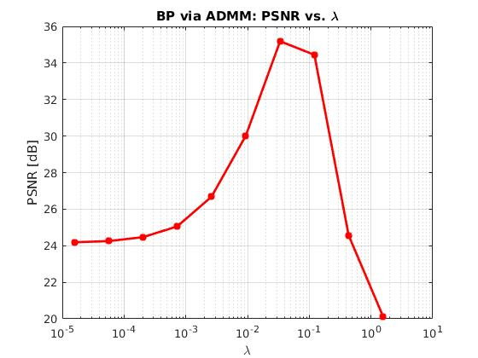

Discuss how  affects BP reconstruction:

Part E – Effect of Parameters

Show MSE as a function of and :

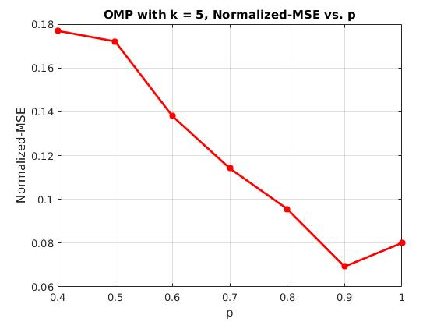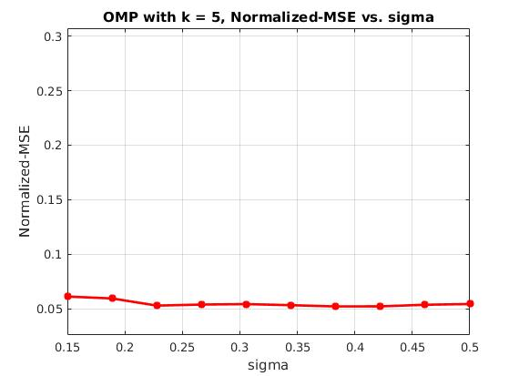

Discuss the effect of $p$:

Discuss the effect of $σ$: