Final Project Report

Part A – Data Construction:

Discuss advice 2:
Yes. The atom’s normalization should take this into account.

Show two clean images and their corresponding noisy and corrupted versions
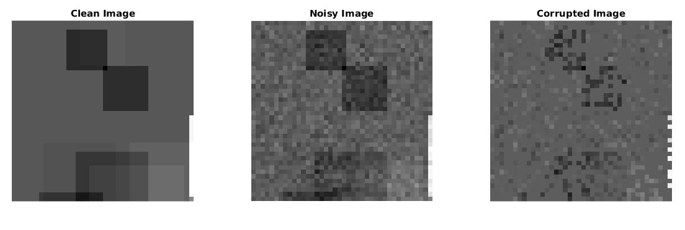
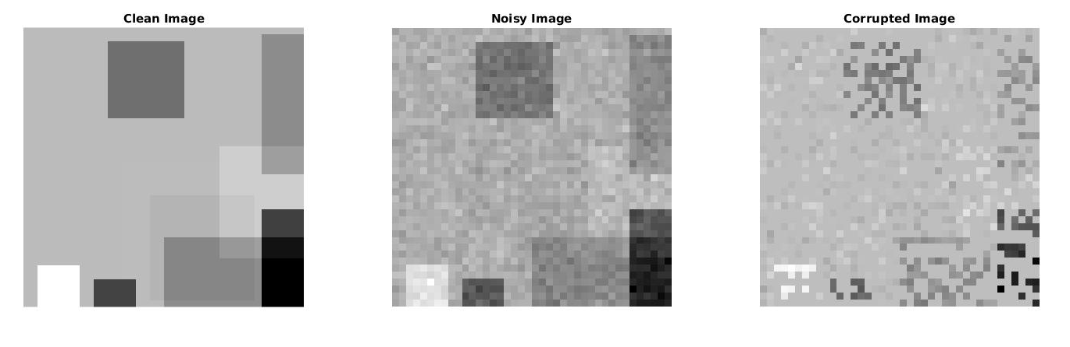
Part B – Inpainting by the Oracle Estimator
44.688
Insert average PSNR result of the Oracle estimator:

Show clean, noisy, corrupted and Oracle-based reconstruction:
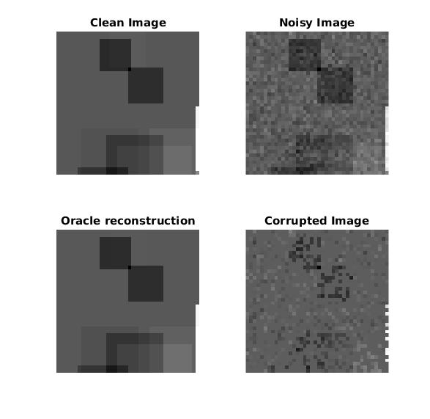

Part C – Inpainting by Greedy Pursuit
32.946
Insert average PSNR result of OMP:

Show clean, noisy, corrupted and OMP-based reconstruction:

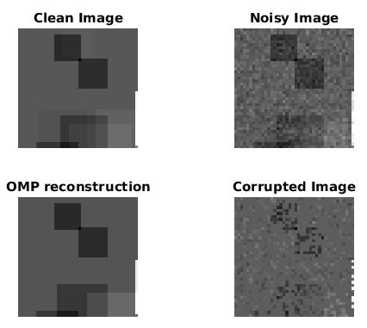
Compare between Oracle and OMP reconstructions:
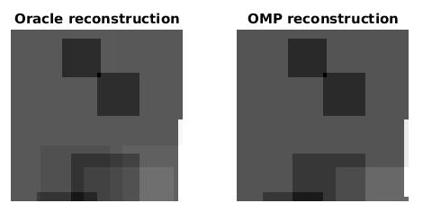

Discuss results of OMP and compare to Oracle performance:
Oracle has more details from the original image. OMP supressed some of the dimmer rectangles
Show average PSNR of OMP as a function of

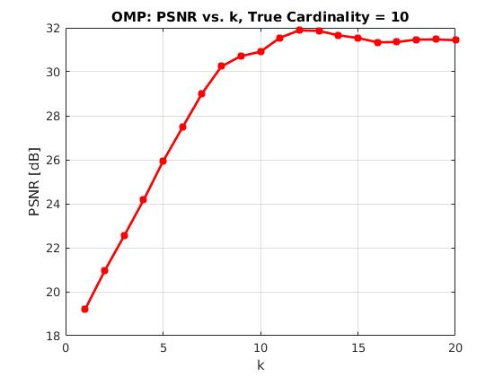

Discussion regarding the average PSNR as a function of :
The best PSNR value happends for a k=12, higher than the true cardinality. This happends because
Part D – Inpainting by Basis Pursuit
32.922
Insert average PSNR result of Basis-Pursuit:

Show clean, noisy, corrupted and BP-based reconstruction:

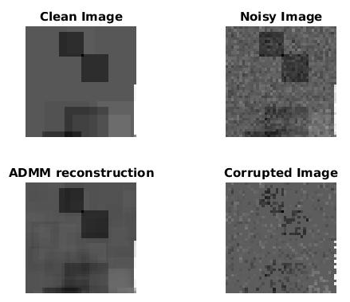
Compare between Oracle and OMP and BP reconstructions:

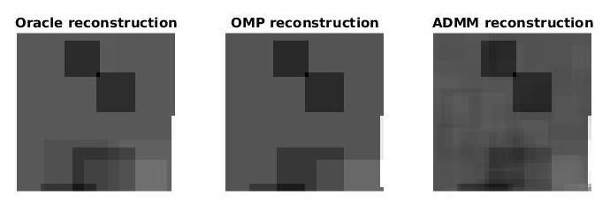

Discuss results of BP and compare to greedy methods and to the oracle performance:
BP-ADMM reconstruction added artificacts to the image and is noisier and blurrier than the Oracle and OMP reconstructions.

Show PSNR as a function of lambda:
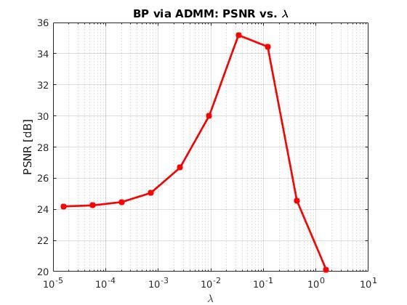

Discuss how lambda affects BP reconstruction:

Part E – Effect of Parameters

Show MSE as a function of and :
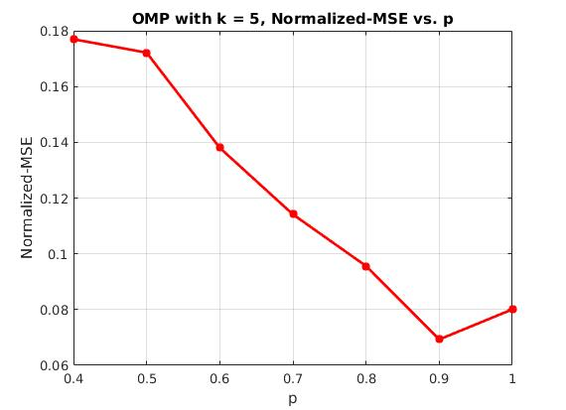
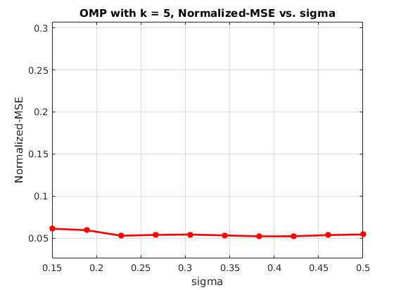

Discuss the effect of :

Discuss the effect of :

