Final Project Report

Part A – Data Construction:

Discuss advice 2:

The multiplication may create zero columns. Is this a problem? What does this mean, and how should it affect our recovery results? Make sure you are aware of this possibility and treat it well.
Not really. The atom’s normalization should take this situation into account so we just add an epsilon to avoid dividing by zero. Zero columns will be atoms that have no contribution to the reconstruction, so they will not be picked as solution atoms and they will not affect our recovery results.
Show two clean images and their corresponding noisy and corrupted versions

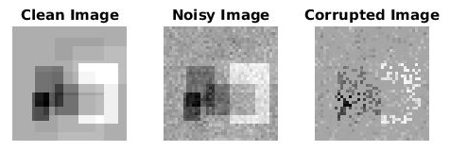
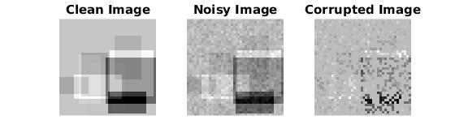
Part B – Inpainting by the Oracle Estimator
44.052
Insert average PSNR result of the Oracle estimator:

Show clean, noisy, corrupted and Oracle-based reconstruction:

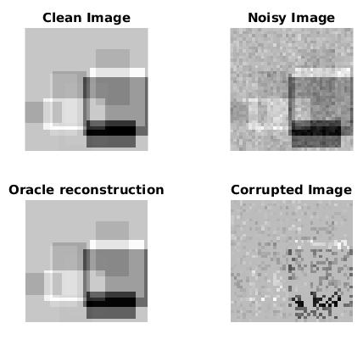
Part C – Inpainting by Greedy Pursuit
34.322
Insert average PSNR result of OMP:

Show clean, noisy, corrupted and OMP-based reconstruction:

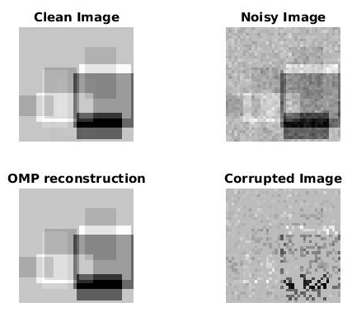
Compare between Oracle and OMP reconstructions:
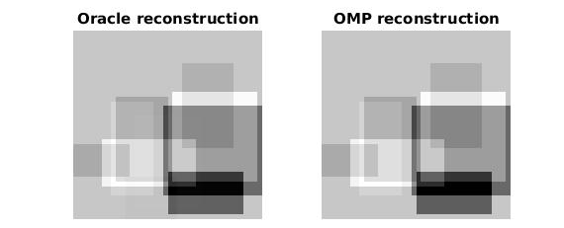
Discuss results of OMP and compare to Oracle performance:
Oracle one more detail from the original image. OMP suppressed a dimmer rectangle in the (mid-bottom).
Show average PSNR of OMP as a function of
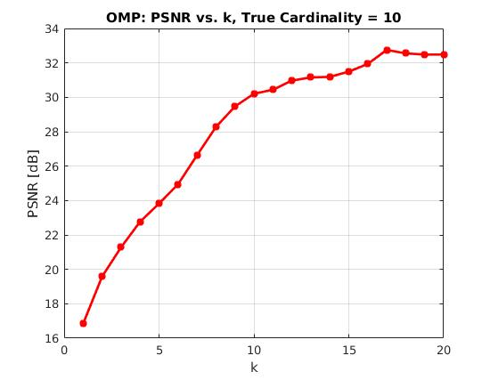

Discussion regarding the average PSNR as a function of :
The best PSNR value happends for a k=17, higher than the true cardinality of 10. This happens because when we add more atoms we compensate for the choice of wrong atoms or the error in the coefficients. After k=17 there is no improvement and might be actually fitting the noise – our model is overfitting the data.
Part D – Inpainting by Basis Pursuit
33.446
Insert average PSNR result of Basis-Pursuit:

Show clean, noisy, corrupted and BP-based reconstruction:

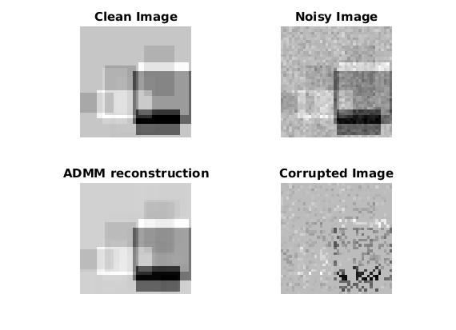
Compare between Oracle and OMP and BP reconstructions:

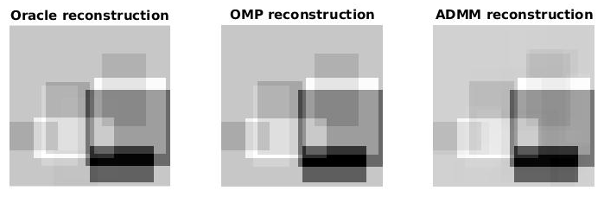

Discuss results of BP and compare to greedy methods and to the oracle performance:

BP-ADMM reconstruction added artificacts to the image and is noisier and blurrier than the Oracle and OMP reconstructions. Also it missed the dimmer details. This happens because ADMM chose more atoms with smaller coefficients. Also BP-ADMM takes muck longer to compute.
Show PSNR as a function of lambda:

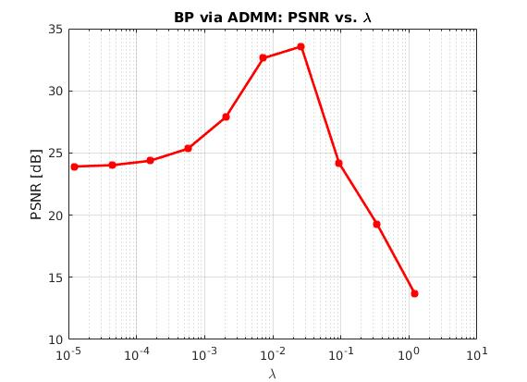

Discuss how lambda affects BP reconstruction:
Lambda controls the sparseness of the reconstruction.
Large lambda means more sparse and small lambda means closer to the input signal.
There is a lambda that optimizes the reconstruction and is between 0.007 and 0.02.

Part E – Effect of Parameters

Show MSE as a function of p and sigma:

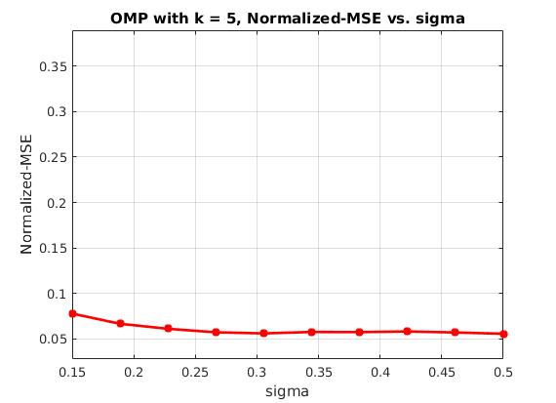
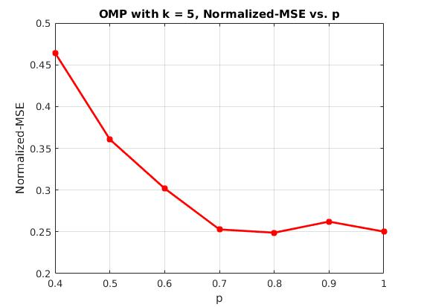

Discuss the effect of :
Norm-MSE decreases with the increase of p because a larger p means that more of the original image is present in the input. There are no significant improvements after 0.7

Discuss the effect of :
OMP Norm-MSE is not affect much by the amount of noise in the image. This is because the noise is always smaller than the L2-norm of the OMP-residual for k=5, this way OMP is not affected by the noise.

