Mid Project Report

Part A: Data Construction and Parameter-Setting:

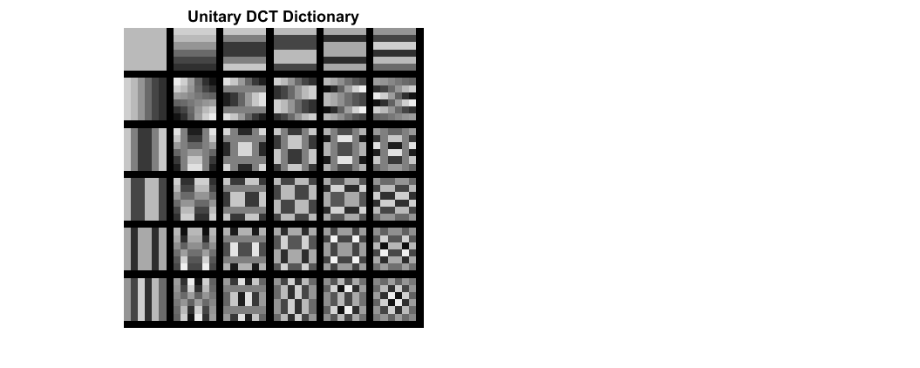

DCT dictionary

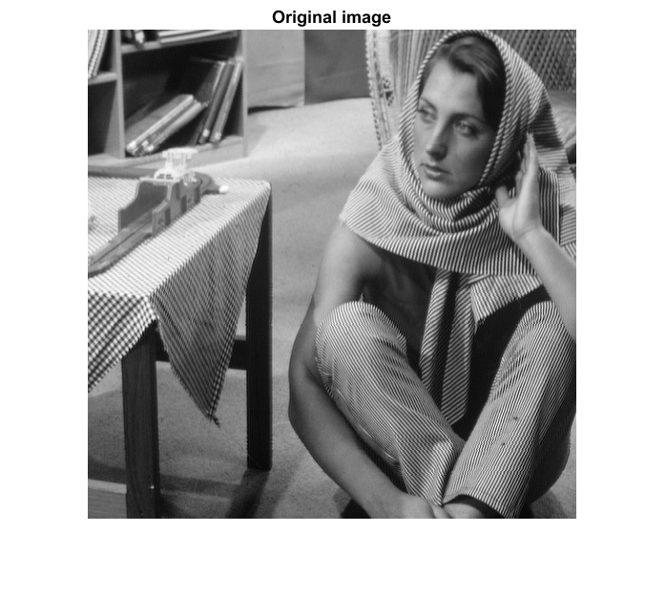

Barbara Image

Part B: Compute the Representation Error Obtained by the DCT Dictionary

100.11

Insert average MSE for train set:

100.70

Insert average MSE for test set:

4

Insert average number of non-zeros for train set:

4

Insert average number of non-zeros for test set:

Part C: Procrustes Dictionary Learning

The obtained learned dictionary:

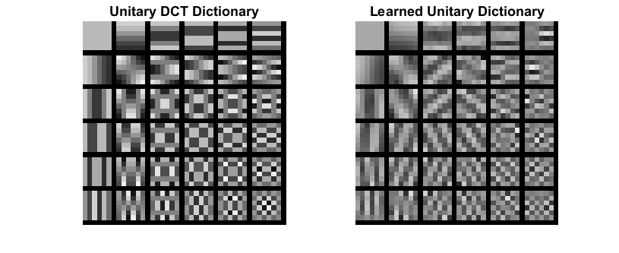

Learned dictionary

Discuss the obtained dictionary:

The learned dictionary matches the pattern (intensity, orientation and scale) of the fabrics and other characteristics in the image. Also, there was a bias correction to match the gray level intensity in the image.

Average MSE and number of non-zeros as a function of the iteration (train-set):

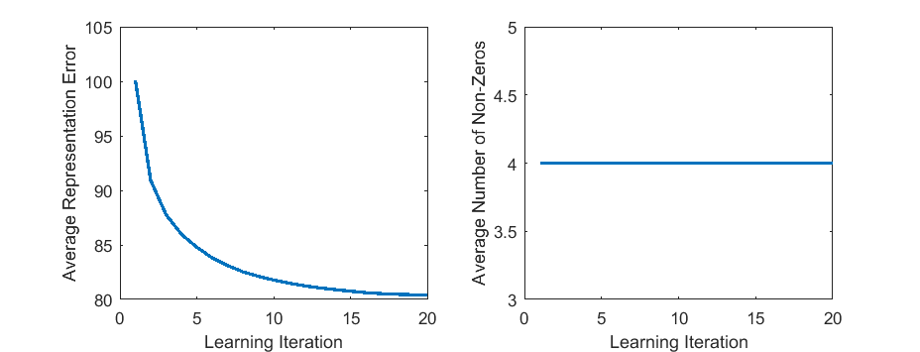

Average MSE vs. # iterations (left) Average # nonzeros vs. # iterations (right)

Discuss the obtained curves:

The average representation error decreased from around 100 to 80 in 20 iterations. It seems that provided more iterations, the error would keep decreasing significantly. The average cardinality was constant across all iterations.

81.51

Insert average MSE for test set:

Discuss the obtained MSE:

Like expected, the obtained average MSE for test set was slightly larger than the MSE for the train set (80.36). The learned dictionary seems to generalize well for the test patches of this image. The same cannot be said for images in general.

Compare the results of the DCT dictionary and the learned dictionary:

The learned dictionary performs better for this image than the DCT dictionary both for the train and test set.