Mid Project Report

Part C – Analyzing the results:

Figure from Matlab:

average relative 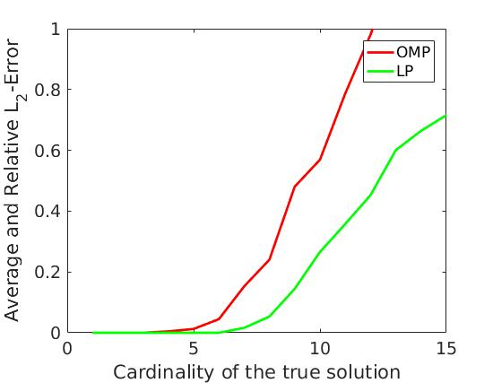 $l_{2}$ error

Figure from Matlab: 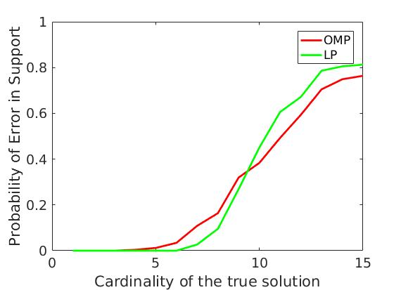

average support recovery error

Discuss the results below:

**L2-error** Basis pursuit (LP) is superior to OMP giving a reasonable error until the cardinality equals 7. For OMP that happens for a cardinality equal to 5. Also LP manages to have relative error less than at least until cardinality equal to 15.

Regarding the **support recovery error**, there is not a clear winner. However OMP presents a smaller error for larger cardinalities, which is better.