WARRANTY VAULT
Project Documentation Report

Technology Stack: MERN — MongoDB · Express.js · React · Node.js
Architecture: MVC Pattern with RESTful API
Version: v1.0
Date: April 2026
Status: Complete

1. Introduction — Scenario Based Case Study

1.1 Project Overview
Warranty Vault is a comprehensive web-based warranty management system designed to help users securely track, organize, and manage product warranties and maintenance records. It addresses the pervasive problem of losing track of warranty periods for purchased products, which frequently leads to missed benefit claims and expired coverage.

1.2 Problem Statement
Most consumers routinely struggle with the following challenges:
- Managing multiple warranties across diverse products such as electronics, appliances, and vehicles.
- Tracking warranty expiry dates manually, leading to missed claims and financial loss.
- Maintaining maintenance records for each product across its lifecycle.
- Receiving timely notifications about warranties nearing expiry.
- Organizing warranty documents and purchase invoices in a retrievable format.

1.3 Solution
Warranty Vault provides a centralized, secure platform where users can:
- Store and manage all product warranties in one location.
- Receive automated email and in-app notifications when warranties approach expiry.
- Track the maintenance history for each product.
- Access warranty details and status at any time from any device.
- Administrators can monitor system-wide usage and manage users.

1.4 Business Goals
- Reliable Solution: Provide users with a dependable warranty management tool.
- Reduce Stress: Eliminate confusion associated with manual warranty tracking.
- Informed Decisions: Enable users to make timely warranty claims.
- Automated Alerts: Generate notifications to prevent expired warranty benefits.
- Multi-user Management: Support role-based admin controls for system oversight.

2. System Requirements

2.1 Software Requirements
Backend Server
Package | Version | Purpose
Node.js | v14.0+ | JavaScript runtime environment
Express.js | v5.2.1 | Web application framework
MongoDB | Local / Atlas | NoSQL document database
Mongoose | v9.5.0 | MongoDB ODM for schema management
JWT (jsonwebtoken) | v9.0.3 | Authentication token generation
bcryptjs | v3.0.3 | Password hashing and security
Nodemailer | v8.0.6 | Email notification service
node-cron | v4.2.1 | Scheduled tasks for warranty checks
Multer | v2.1.1 | File upload handling for invoices
CORS | v2.8.6 | Cross-origin resource sharing
Morgan | v1.10.1 | HTTP request logging middleware
Dotenv | v17.4.2 | Environment configuration management

Frontend Client
Package | Version | Purpose
React | v19.2.5 | UI component library
Vite | v8.0.10 | Build tool and development server
React Router DOM | v7.14.2 | Client-side routing
Axios | v1.15.2 | HTTP client for API calls
Tailwind CSS | v4.2.4 | Utility-first CSS framework
Framer Motion | v12.38.0 | Animation library
Lucide React | v1.8.0 | Icon library

2.2 Hardware Requirements
Development (Minimum)
- CPU: Dual-core processor, 2.0 GHz or higher
- RAM: 4 GB minimum
- Storage: 500 MB for application files and dependencies
- Network: Stable internet connection for API and database access
Production (Recommended)
- CPU: Quad-core or higher processor
- RAM: 8 GB or higher
- Storage: 1 GB+ for application, logs, and uploaded files
- Database Server: Dedicated MongoDB server with 10 GB+ storage
- Server OS: Linux-based server — Ubuntu 20.04 LTS or higher

3. Project Architecture

3.1 Technical Architecture
Warranty Vault follows a three-tier architecture separating the client, API gateway, and database layers. The frontend (React + Vite) communicates with the Express.js backend via a RESTful HTTP API. The backend routes requests through middleware and controllers to MongoDB via Mongoose ODM.

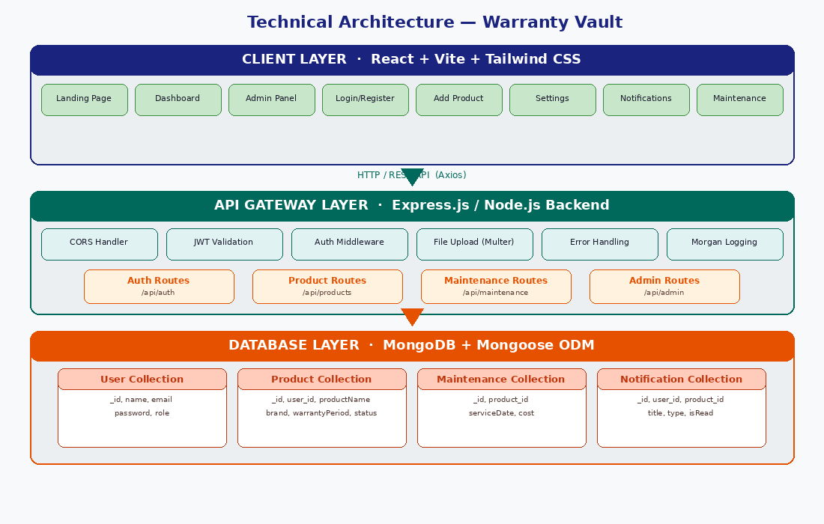
Figure 1: Three-Tier Technical Architecture — Client, API Gateway, and Database layers

3.2 ER Diagram — Entity Relationship Diagram
The ER diagram defines the logical structure of the MongoDB database. Four primary collections — User, Product, Maintenance, and Notification — are related through foreign key references.
Key relationships:
- User 1:M Product — One user can own many product warranty records.
- User 1:M Notification — One user receives many system notifications.
- Product 1:M Maintenance — One product can have multiple maintenance service records.
- Product 1:M Notification — A product can trigger multiple notifications over time.

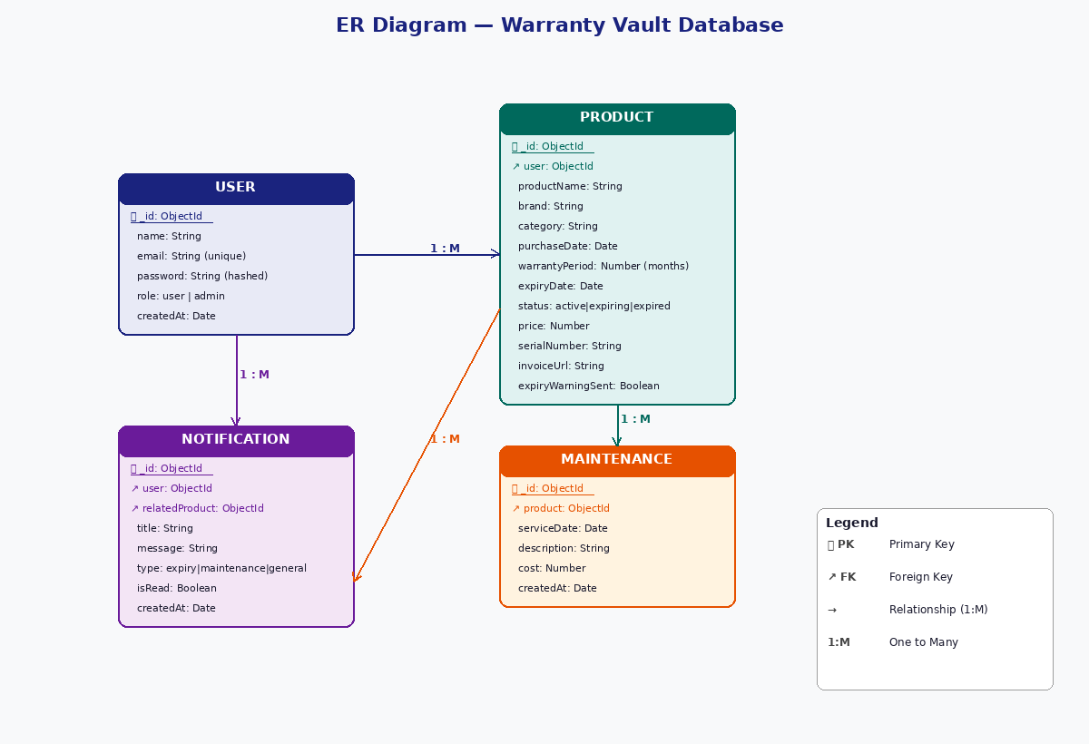
Figure 2: Entity Relationship Diagram — Warranty Vault Collections and Relationships

4. Key Features

1. User Authentication & Authorization
- Secure registration with strong password validation (8+ chars, uppercase, lowercase, number, special character).
- JWT-based stateless authentication tokens.
- Role-based access control: Regular User and Admin.
- Password hashing using bcryptjs with salt rounds.

2. Warranty Management
- Add product warranties with full details: brand, model, serial number, category.
- Automatic expiry date calculation from purchase date and warranty period.
- Invoice and warranty document upload (PDF/image, max 5 MB).
- Status tracking: Active, Expiring Soon (≤ 30 days), Expired.

3. Automated Warranty Expiry Alerts
- Daily cron job at 9:00 AM checks warranties expiring within 7 days.
- Email notifications sent via Nodemailer with branded HTML templates.
- In-app notification creation for each expiring warranty.
- Duplicate prevention using expiryWarningSent flag.

4. Maintenance Tracking
- Log service records for each product with date, description, and cost.
- View complete chronological maintenance history per product.
- Link every maintenance record to its parent product.

5. Dashboard & Analytics
- Real-time statistics: total assets, expiring soon, expired.
- Search by product name (case-insensitive regex).
- Filter by warranty status; paginated results (10 per page).
- Color-coded status badges for at-a-glance visibility.

6. Admin Dashboard
- System-wide statistics across all users and products.
- User management: view, edit roles, delete accounts.
- Monitor warranty expiry trends and user activity.
- Access system logs and email notification status.

5. Roles and Responsibilities

5.1 User Roles
Regular User
Responsibilities:
- Register and maintain account credentials.
- Add and manage personal product warranties.
- Track warranty statuses and expiry dates.
- Log maintenance activities.
- Review notifications and alerts.
Permissions:
- Create, read, update, delete own product warranties.
- View own notifications and maintenance records.
- Update own profile and password.

Admin User
Responsibilities:
- Oversee system health and functionality.
- Manage user accounts and permissions.
- Monitor warranty expiry trends across all users.
- Handle escalations and configure system settings.
Permissions:
- View admin dashboard with system-wide statistics.
- Manage users: view, edit roles, enable or disable accounts.
- Monitor all warranties across the system.
- Access audit logs and configure email notification settings.

5.2 User Flow Diagram
The following diagram illustrates the complete flow for both Regular User and Admin User, from authentication through to all core system actions.

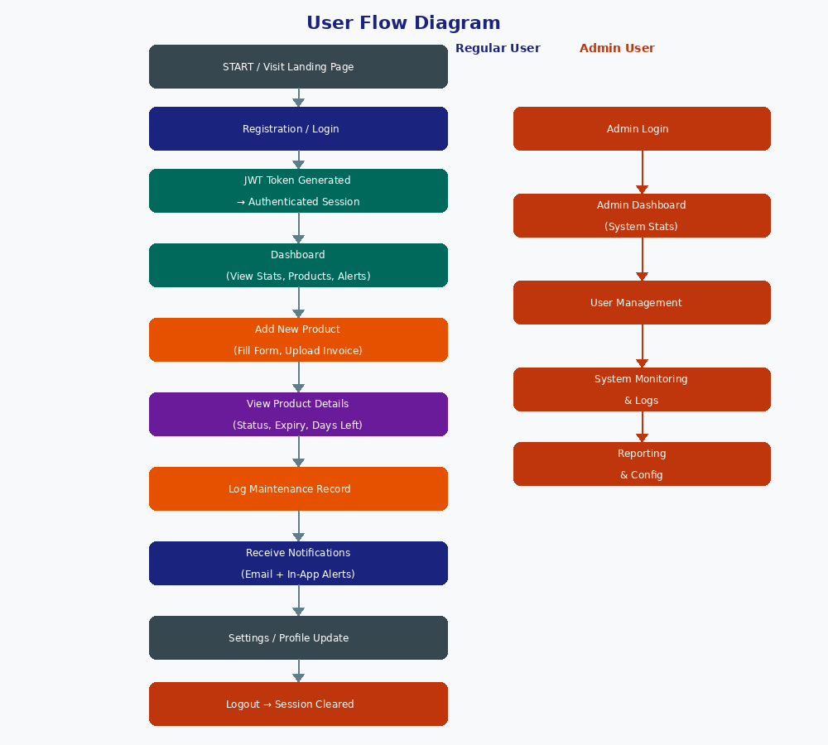
Figure 3: User Flow — Regular User (left) and Admin User (right)

5.3 Customer Journey
- Awareness: User discovers the platform via landing page and reviews feature overview.
- Registration: User creates account, email verification optional.
- Onboarding: Dashboard tutorial guides user to add their first product.
- Active Usage: User adds multiple products, manages warranties, tracks maintenance.
- Engagement: Daily/weekly dashboard visits, notification viewing, product updates.
- Retention: Timely alerts prevent warranty loss, easy management saves time.

6. MVC Pattern Implementation

6.1 Architectural Diagram
Warranty Vault strictly follows the Model-View-Controller (MVC) pattern. The Express.js router dispatches requests through middleware to controllers; controllers interact with Mongoose models; the React frontend serves as the View layer.

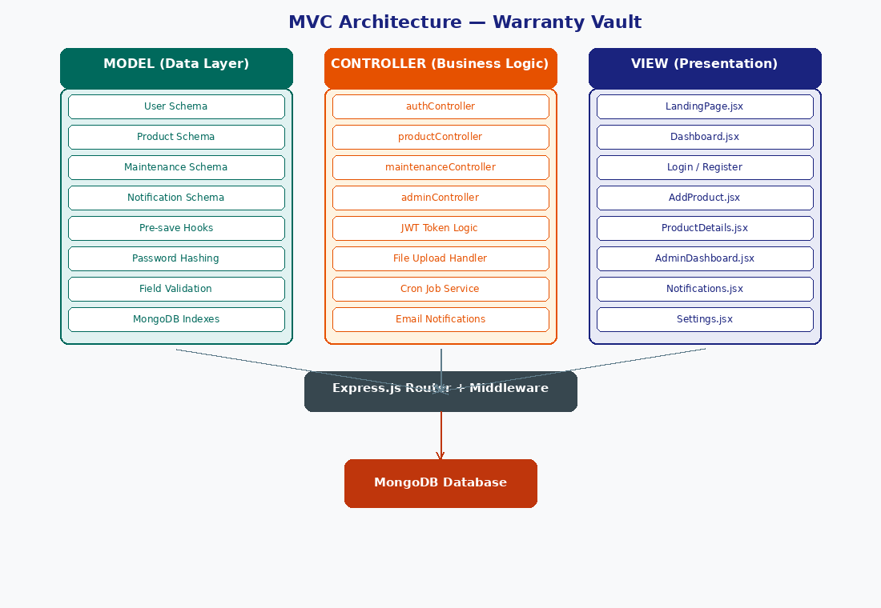
Figure 4: MVC Architecture — Model, Controller, and View layers with Express Router

6.2 Model Layer — Data Layer
The Model layer defines all MongoDB schemas using Mongoose, enforces validation, and handles pre-save hooks for automated business logic:
- User Schema: Stores user credentials; pre-save hook hashes passwords via bcryptjs.
- Product Schema: Stores warranty data; pre-save hook calculates expiryDate and auto-determines status.
- Maintenance Schema: Records service history linked to products via foreign key.
- Notification Schema: Stores in-app alerts with type, read status, and related product reference.

6.3 Controller Layer — Business Logic
Controllers handle HTTP request processing, input validation, model interactions, and response formatting. The four main controllers are:
authController
- registerUser — validates input, hashes password, returns JWT.
- loginUser — verifies credentials, generates token.
- updateUserProfile — updates name or password securely.

productController
- createProduct — handles file upload, calculates expiry, saves record.
- getProducts — applies search, filter, and pagination.
- updateProduct / deleteProduct — verifies ownership before mutation.
maintenanceController
- addMaintenance — creates service record linked to product.
- getMaintenance — returns history sorted by date.
adminController
- getSystemStats — aggregates user, product, and warranty counts.
- getUserList / updateUserRole / deleteUser — admin user management.

6.4 View Layer — API Routes & Frontend
Backend API Endpoints:
Endpoint | Description
POST /api/auth/register | Register new user
POST /api/auth/login | Authenticate user, return JWT
PUT /api/auth/profile | Update user profile
GET /api/products | List products with pagination & search
POST /api/products | Create new warranty record
PUT /api/products/:id | Update existing warranty
DELETE /api/products/:id | Delete warranty record
POST /api/maintenance | Log maintenance record
GET /api/maintenance/:productId | Get maintenance history
GET /api/admin/stats | System-wide statistics (admin)
GET /api/admin/users | All users list (admin)

7. Advantages of Using MVC in This Project

- Separation of Concerns: Each layer has a single, defined responsibility — models for data, controllers for logic, views for presentation. This makes the codebase easier to understand and maintain.
- Scalability: New features can be added by extending models or controllers without disrupting the presentation layer. The clear structure supports team-based development.
- Reusability: Models are reused across multiple controllers. Business logic in controllers can serve multiple client types (web, mobile, API consumers).
- Testability: Each layer can be unit-tested independently. Controllers can be tested without a UI; models can be tested without a server.
- Maintainability: Clear folder structure makes it straightforward to locate and fix bugs. Changes have localized impact on their respective layers.
- Parallel Development: Frontend developers work on React components independently of backend developers working on models and controllers.
- Security: Authentication is enforced in middleware, authorization in controllers, and data validation in Mongoose schemas — creating clear security boundaries.
- Technology Independence: The API-first design allows the frontend framework to be replaced without changing the backend. The REST API can serve mobile apps without modification.

8. Project Setup and Configuration

8.1 Creating the Project Structure
mkdir Warranty-Vault && cd Warranty-Vault
mkdir server client
git init
echo "node_modules/\n.env\nuploads/*\ndist/" > .gitignore

8.2 Client Setup — React with Vite
cd client
npm create vite@latest . -- --template react
npm install axios react-router-dom framer-motion lucide-react
npm install -D tailwindcss postcss autoprefixer
npx tailwindcss init -p
# .env.local
VITE_API_URL=http://localhost:5000/api
npm run dev # → http://localhost:5173
Client Directory Structure:
- client/src/pages/ — LandingPage, Login, Register, Dashboard, AddProduct, ProductDetails, AdminDashboard, Notifications, Settings
- client/src/components/ — Navbar, Sidebar, ProductCard, StatusBadge
- client/src/context/ — AuthContext (JWT state management)
- client/src/services/ — api.js (Axios instance with interceptors)

8.3 Server Setup — Node.js with Express
cd ../server
npm init -y
npm install express cors dotenv morgan mongoose bcryptjs jsonwebtoken multer node-cron nodemailer
npm install -D nodemon
# .env
PORT=5000
MONGO_URI=mongodb://localhost:27017/warranty-vault
JWT_SECRET=your_super_secret_jwt_key
EMAIL_HOST=smtp.ethereal.email
EMAIL_USER=your@email.com
npm run dev # → http://localhost:5000
Server Directory Structure:
- server/config/ — db.js (MongoDB connection)
- server/controllers/ — authController, productController, maintenanceController, adminController
- server/middleware/ — authMiddleware, errorMiddleware, uploadMiddleware
- server/models/ — User, Product, Maintenance, Notification schemas
- server/routes/ — authRoutes, productRoutes, maintenanceRoutes, adminRoutes
- server/utils/ — emailService, generateToken, warrantyHelper, cronJobs

9. Backend Development

9.1 Middleware Architecture
- authMiddleware.js — protect(): Extracts JWT from Authorization header, verifies signature, fetches user from DB, attaches to req.user.
- authMiddleware.js — admin(): Checks req.user.role === 'admin'; rejects with 403 if not.
- errorMiddleware.js: Centralized error handler formats all errors as JSON responses with appropriate HTTP status codes.
- uploadMiddleware.js: Multer configuration for invoice uploads — /uploads directory, 5 MB limit, image/PDF types only.

9.2 Database Schemas
Product Schema — Pre-save Hook Logic:
// Auto-calculated fields on save
expiryDate = purchaseDate + warrantyPeriod (months)
status = "expired" if expiryDate < today
| "expiring soon" if daysLeft <= 30
| "active" otherwise
Key Mongoose Indexes:
- User.email — unique index for fast authentication lookup.
- Product.user — compound index for efficient per-user product queries.
- Product.expiryDate — index for the daily cron job's expiry check.
- Notification.user + isRead — for filtering unread notifications.

9.3 Automated Cron Job — Warranty Expiry Checker
// Runs daily at 09:00 AM
cron.schedule('0 9 * * *', async () => {
const sevenDaysLater = new Date(Date.now() + 7 * 24 * 60 * 60 * 1000);
const products = await Product.find({
expiryDate: { $lte: sevenDaysLater, $gte: new Date() },
expiryWarningSent: false
}).populate('user');
for (const product of products) {
await sendExpiryEmail(product.user, product); // Nodemailer
await Notification.create({ ... }); // In-app
product.expiryWarningSent = true;
await product.save();
}
});

10. Frontend Development

10.1 Key Pages and Components
Component | Description
Dashboard.jsx | Displays user stats (total/expiring/expired), product grid, search, filter, and pagination. Calls GET /api/products.
AddProduct.jsx | Multi-field form for product creation with file upload. Validates required fields before POST /api/products.
ProductDetails.jsx | Shows warranty status, days remaining, maintenance history, and invoice. Supports edit and delete actions.
AdminDashboard.jsx | System statistics, user management table, and warranty analytics. Admin-only route protected by role check.
Notifications.jsx | Lists all in-app notifications with type, timestamp, and mark-as-read functionality.
Settings.jsx | Profile update and password change forms with validation.
AuthContext.jsx | React context providing user object, login/logout functions, and token persistence in localStorage.
api.js | Axios instance with base URL, request interceptor (adds JWT), and response interceptor (handles 401 auto-redirect).

10.2 Output Screens — UI Wireframes
The following wireframes illustrate the key screens: Landing Page, Login, Registration, User Dashboard, Admin Dashboard, and Product Details.

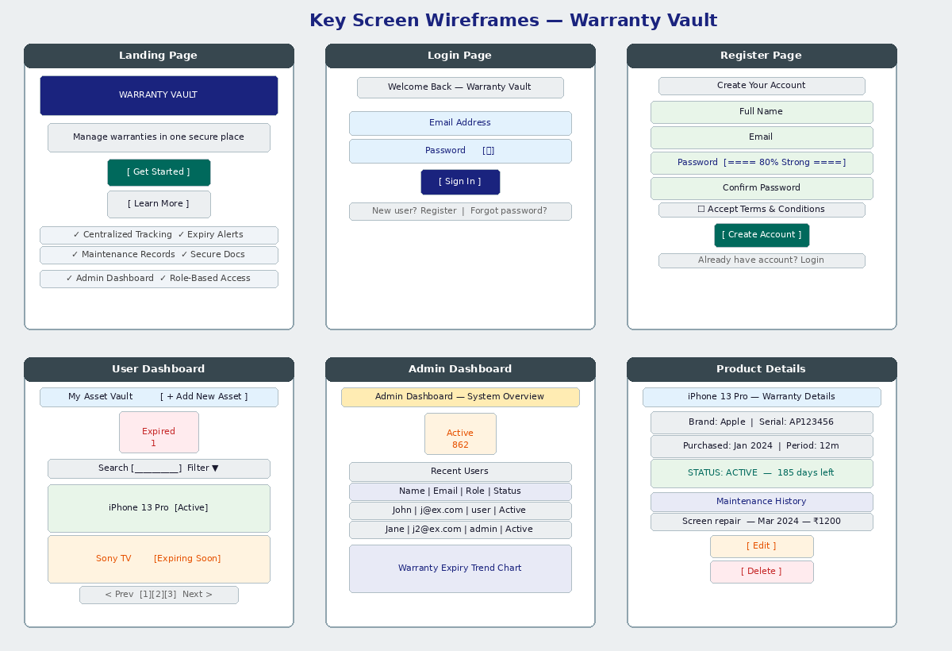
Figure 5: Key Screen Wireframes — Landing, Login, Register, Dashboard, Admin, Product Details

10.3 Authentication Flow
The diagram below shows the complete authentication lifecycle from user input through JWT generation to token-based API authorization.

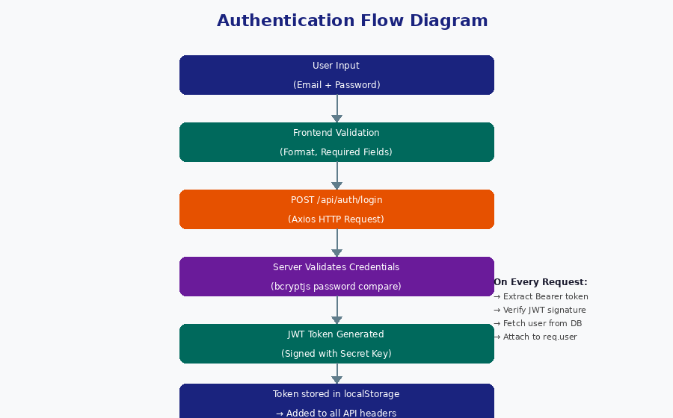
Figure 6: Authentication Flow — Input → Validation → JWT → Token-based Authorization

11. Additional Project Features

11.1 Automated Warranty Expiry Notifications
- Cron job runs daily at 9:00 AM using node-cron.
- Identifies warranties expiring within 7 days that have not yet received a warning.
- Sends HTML-formatted email with product details and expiry date via Nodemailer.
- Creates an in-app Notification document for the user.
- Sets expiryWarningSent = true to prevent duplicate alerts.

11.2 Email Service Integration
- Provider: Nodemailer with configurable SMTP (Ethereal for development, any SMTP for production).
- HTML email templates with warranty details, product name, and expiry date.
- Branded email headers with Warranty Vault identity.

11.3 File Upload Management
- Accepted types: JPEG, PNG, PDF (invoice or warranty document).
- Size limit: 5 MB per file.
- Storage: /uploads directory on server, served as static files.
- Filename format: timestamp + original filename to prevent collisions.
11.4 Search, Filtering, and Pagination
- Case-insensitive product name search via MongoDB regex.
- Filter by warranty status: active, expiring soon, expired.
- Paginated results — 10 products per page with page navigation.
- Results sorted by creation date (newest first).

12. Technical Specifications

12.1 Data Validation Strategy
Layer | Validation Approach
Frontend | Real-time input validation, password strength meter, required field checks before form submission.
Backend | Express controller validation: required fields, type checks, ownership verification.
Mongoose | Schema-level type enforcement, enum validation, min/max constraints, required flags.
Password | Minimum 8 characters, must include uppercase, lowercase, number, and special character.

12.2 Error Handling
- All async controller functions wrapped in try-catch blocks.
- Centralized errorMiddleware.js formats all errors as consistent JSON responses.
- Mongoose validation errors are caught and returned with meaningful messages.
- HTTP 401 responses from the API trigger automatic redirect to login on the frontend.

12.3 Performance Optimization
- Database indexes on email, user reference, and expiryDate fields for fast queries.
- Pagination limits result set to 10 records per request.
- React lazy loading for route-level code splitting.
- Browser caching for static assets served via Vite build.

13. Deployment Considerations

13.1 Frontend Deployment
- Build: npm run build creates optimized production bundle in /dist.
- Platforms: Vercel, Netlify, GitHub Pages, or AWS S3 + CloudFront.
- Environment: Update VITE_API_URL to the production backend URL.

13.2 Backend Deployment
- Platforms: Heroku, AWS EC2, DigitalOcean Droplet, or Railway.
- Database: Use MongoDB Atlas for a managed, scalable cloud database.
- Environment Variables: Set securely in the hosting platform — never commit .env to version control.
- SSL/TLS: Enforce HTTPS in production; configure SSL certificate on the server.

13.3 Security Best Practices
- Store all secrets (JWT_SECRET, email credentials, DB URI) in environment variables.
- Implement rate limiting on auth endpoints to prevent brute-force attacks.
- Use HTTPS-only in production with secure, HttpOnly cookies if applicable.
- Keep all npm dependencies updated; run npm audit regularly.
- Validate and sanitize all user input on the backend regardless of frontend checks.

14. Future Enhancements

- Mobile App: React Native version for iOS and Android.
- Two-Factor Authentication: TOTP-based 2FA for enhanced account security.
- Warranty Claims Integration: Direct claim submission portal linked to manufacturer APIs.
- PDF Report Generation: Download warranty summary reports via jsPDF or Puppeteer.
- Calendar View: Visual warranty timeline showing expiry dates on a monthly calendar.
- Bulk Import: CSV/Excel import to add multiple warranties at once.
- API Documentation: Swagger/OpenAPI interactive documentation for the REST API.
- Advanced Analytics: Charts for warranty value tracking and savings from claims.
- Backup Service: Automated cloud backup of warranty data and uploaded documents.
- Multi-language Support: i18n implementation for regional language support.

15. Conclusion

Warranty Vault is a production-ready, full-stack web application that successfully addresses the real-world problem of warranty tracking and management. Built on the MERN stack with a strict MVC architecture, the system provides a secure, scalable, and user-friendly platform that delivers measurable value to its users.
The application demonstrates best practices across the entire software development lifecycle:
- Database Design: Normalized MongoDB schemas with proper indexing and Mongoose validation.
- Authentication: JWT-based stateless authentication with bcryptjs password security.
- Automation: Cron-based expiry notifications eliminating manual monitoring.
- Architecture: MVC separation of concerns enabling independent development, testing, and scaling.
- User Experience: Responsive, animated UI with real-time status indicators and role-based access.

With its automated notification system, clean dashboard analytics, maintenance tracking, and admin management capabilities, Warranty Vault provides users with complete peace of mind regarding their product warranties. The scalable architecture and documented codebase also provide a strong foundation for the future enhancements outlined in Section 14.

— End of Report —

