**LAB 2**

**Aim:** Installation of HortonWorks Sandbox on Virtual Machine

**Procedure:**

1. Start the HortonWorks it shows the IP address of machine.

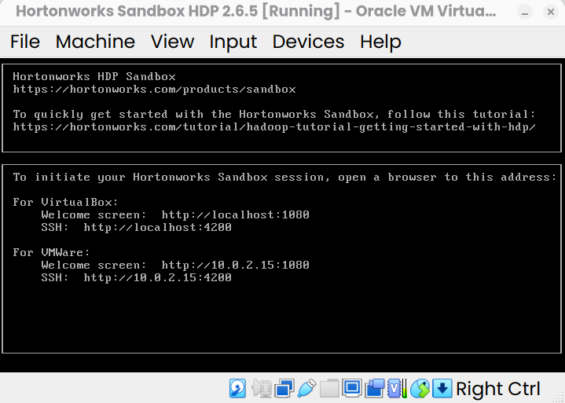

9. Navigate to [http://localhost:](http://localhost:1080/)4200

10. Use the username and password: maria_dev to login.

1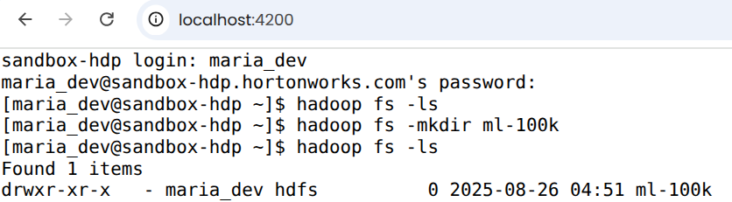1. Execute the following commands one-by-one:

** hadoop fs -ls**  
The command **hadoop fs -ls** is used to **list files and directories stored in Hadoop Distributed File System (HDFS)** or other supported file systems (like local FS, S3, etc., depending on configuration).

It also shows the metadata:

* File permissions
* Replication factor
* Owner & group
* File size (in bytes)
* Last modification date & time
* Path

** hadoop fs -mkdir ml-100k**  
The **hadoop fs -mkdir** command is used to **create new directories in Hadoop Distributed File System** **(HDFS)** (or any other file system supported by Hadoop, like S3, local FS, etc., depending on your configuration)

We will give the command for creating a directory for a movielens dataset  
  
** wget <http://media.sundog-soft.com/hadoop/ml-100k/u.data>**  
The above command is used to copy the data from web server to the Hadoop file system  
  
** ls**  
Give the command ls to see whether the data is downloaded  
Once it is downloaded, you will see the name as u.data  
  
** ls -la**

In **Linux**, ls -la lists **all files including hidden ones** (those starting with .), with detailed information (long format).

** hadoop fs -copyFromLocal u.data ml-100k/u.data**The file will get copied from local file system to the Hadoop named as u.data  
  
** hadoop fs -ls**The **hadoop fs -ls** command is used to **list files and directories in Hadoop Distributed File System (HDFS)** or in any other file system supported by Hadoop (like local FS, S3, etc., depending on configuration)  
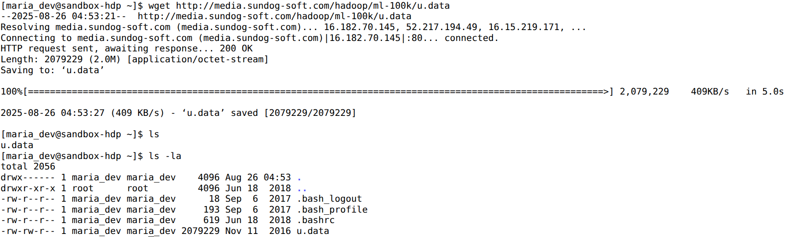  
** hadoop fs -rm ml-100k/u.data**  
**📌 Purpose**

* To **remove (delete) files** from HDFS.
* Works similar to Linux rm, but operates on HDFS.

** hadoop fs -rmdir ml-100k**  
The **hadoop fs -rmdir** command is used to **remove (delete) empty directories from HDFS**.  
**📌 Purpose**

* To delete **empty directories** in Hadoop Distributed File System (HDFS).
* It is similar to the Linux rmdir command.
* ⚠️ Unlike -rm -r, it **cannot delete directories that contain files or subdirectories**.

** hadoop fs -ls**  
The commands checks where the directory is removed from the hadoop

