Predicting Stock Market Trends Using Machine Learning and Deep Learning Algorithms Via Continuous and Binary Data a Comparative Analysis

In this paper author is evaluating performance of various machine learning algorithms to predict stock prices and author using 4 stock dataset and this dataset is using in normal values (continuous) and binary data (means convert stock values to binary data by using indicators which check If previous stock price less than current stock price then we will update dataset with 1 else -1).

Author using 9 traditional algorithms and 2 deep learning algorithms and below is the list

1. SVM
2. KNN
3. Decision Tree
4. Random Forest
5. Extreme Gradient Boosting
6. Ada Boost
7. Naïve Bayes
8. Logistic Regression
9. ANN

2 deep learning

1. LSTM
2. RNN

In above algorithms we are implementing all 9 from above list and LSTM implementing from deep learning

Below 2 dataset we are using to train and test all algorithms

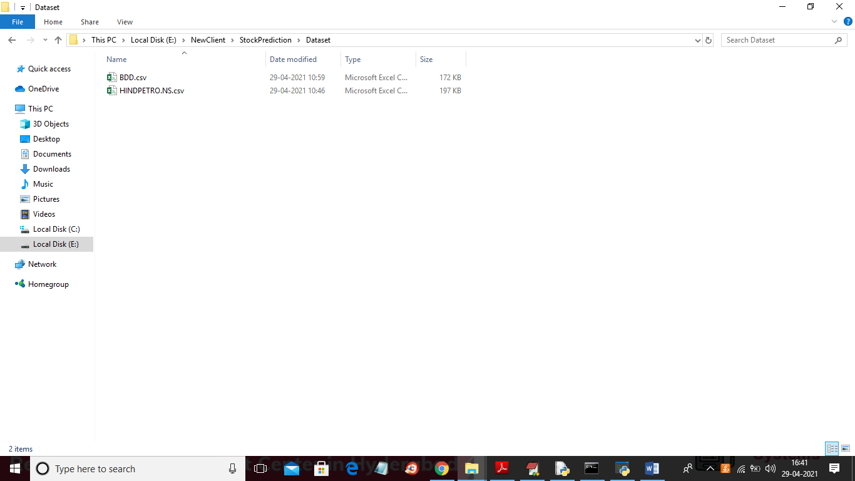

Below screen showing dataset contents

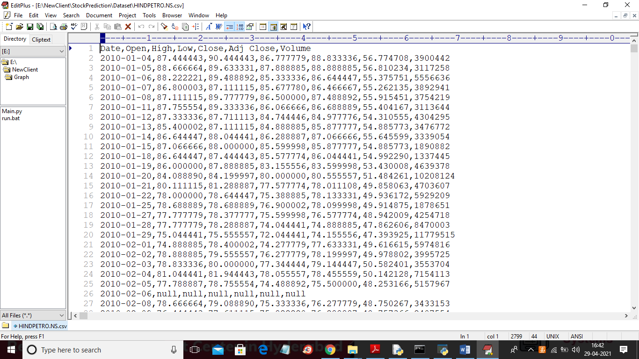

SCREEN SHOTS

To run project double click on ‘run.bat’ file to get below screen

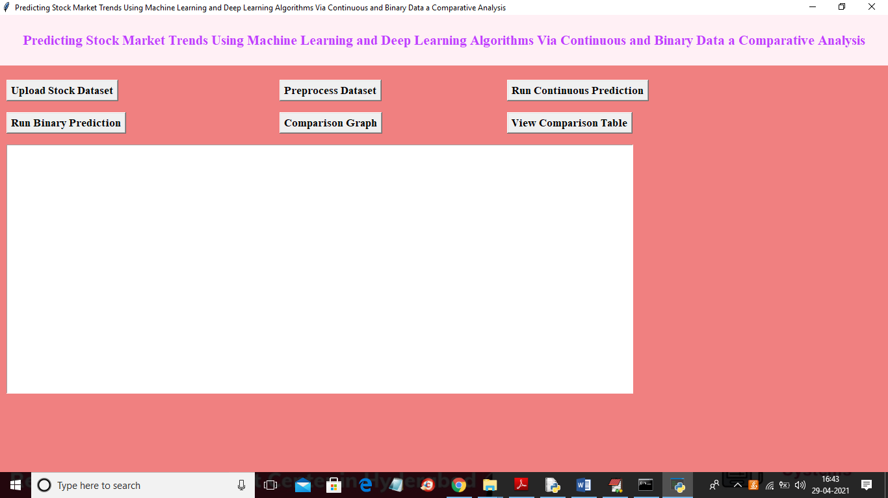

In above screen click on ‘Upload Stock Dataset’ button to load dataset

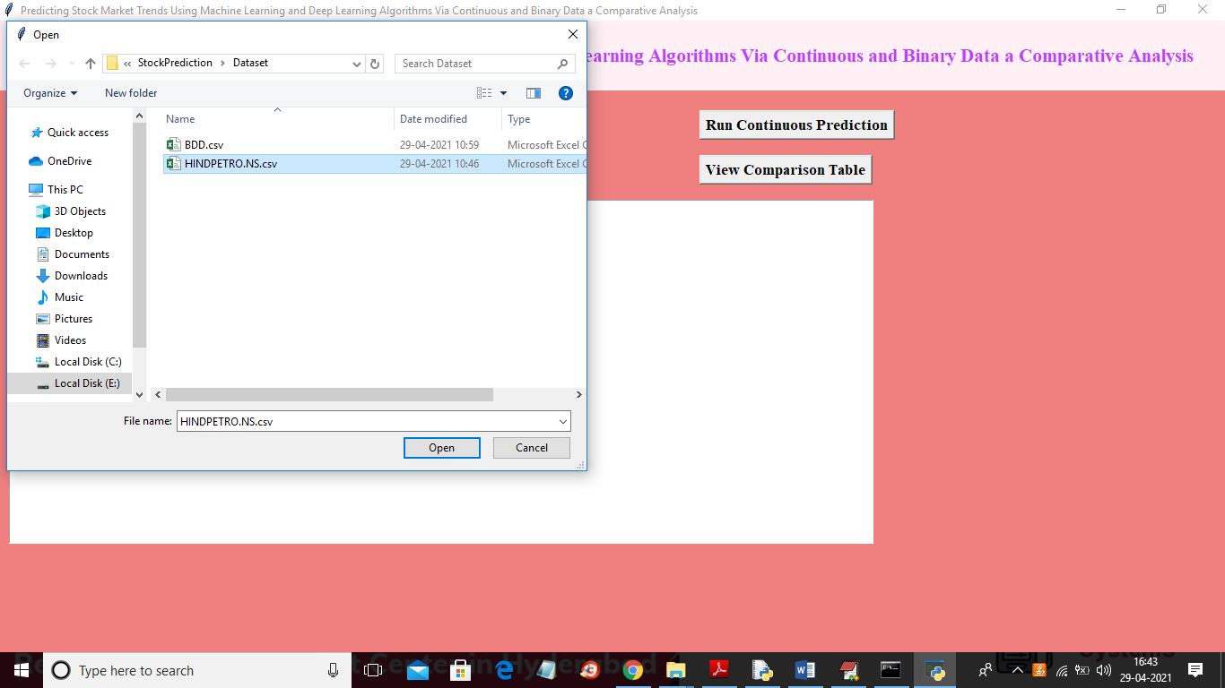

In above screen selecting and uploading “petrol” dataset and then click on ‘Open’ button to get below screen

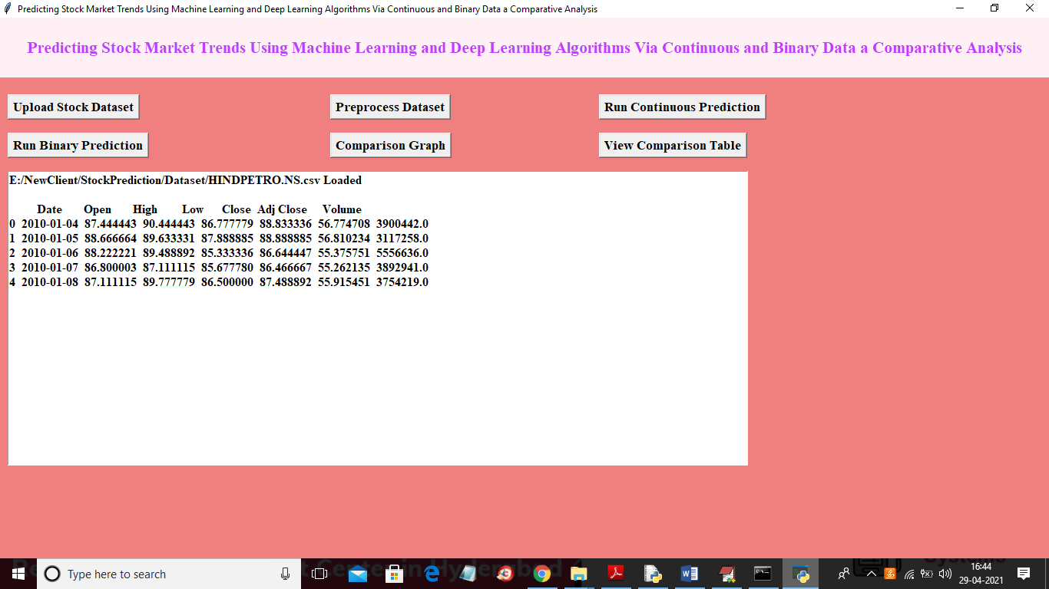

In above screen dataset loaded and dataset contains some missing values so to remove missing values and to split dataset into train and test part so click on ‘Preprocess Dataset’ button to get below screen

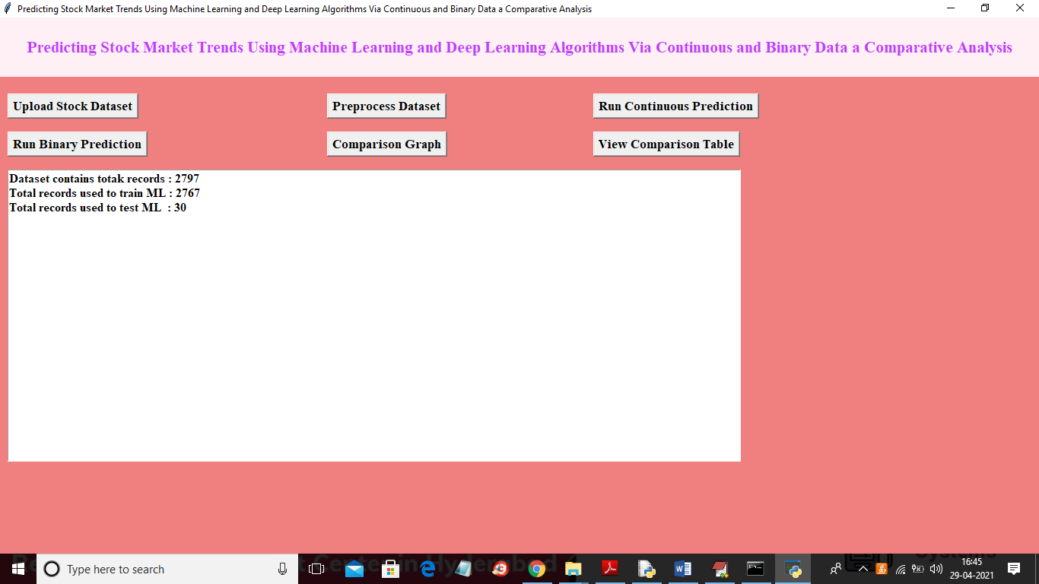

In above screen dataset contains total 2797 records and application using 2797 records for training and 30 records for testing and now train and test data is ready and now click on ‘Run Continuous Prediction’ button to train all algorithms with above dataset

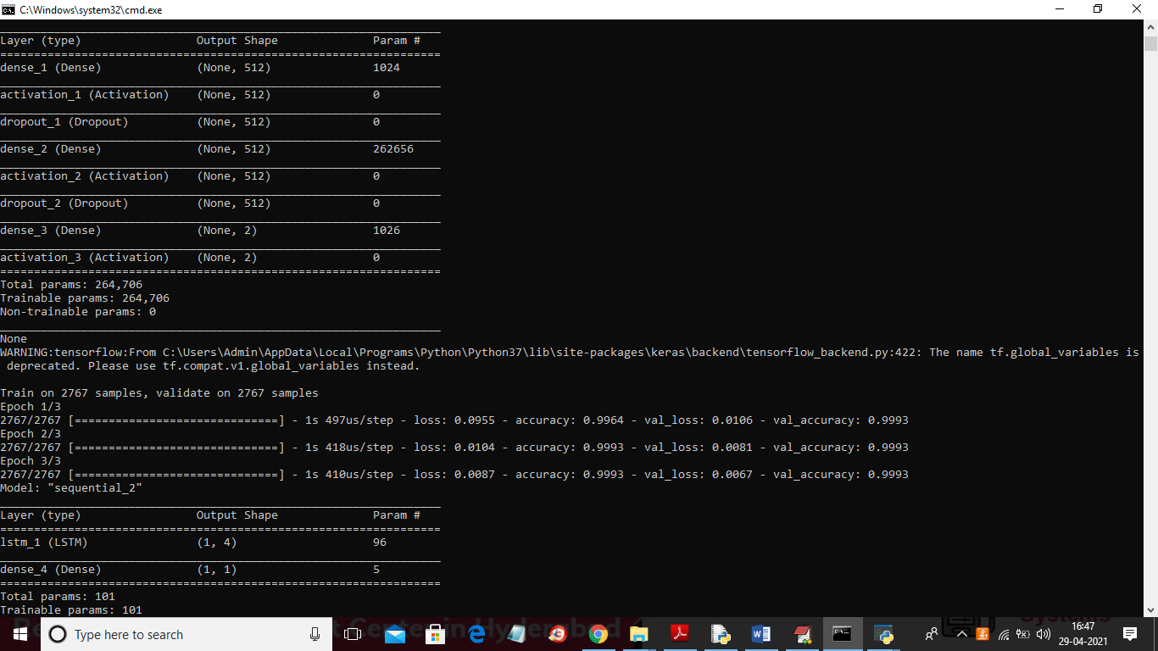

In above screen you can see we have created ANN and LSTM model and after building model will get predicted stock price for 30 test days

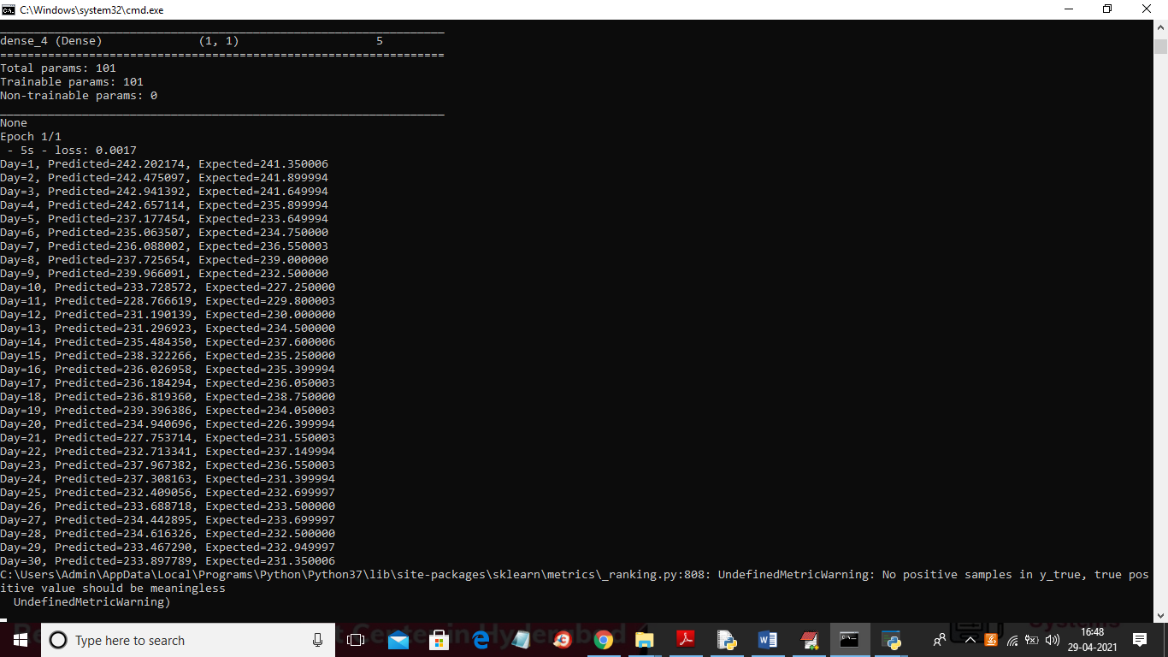

In above screen we can see actual and predicted values from day1 to 30 and we can check both prices are very close which means LSTM predicting accurate stock prices and above actual and predicted values we can see in below graph

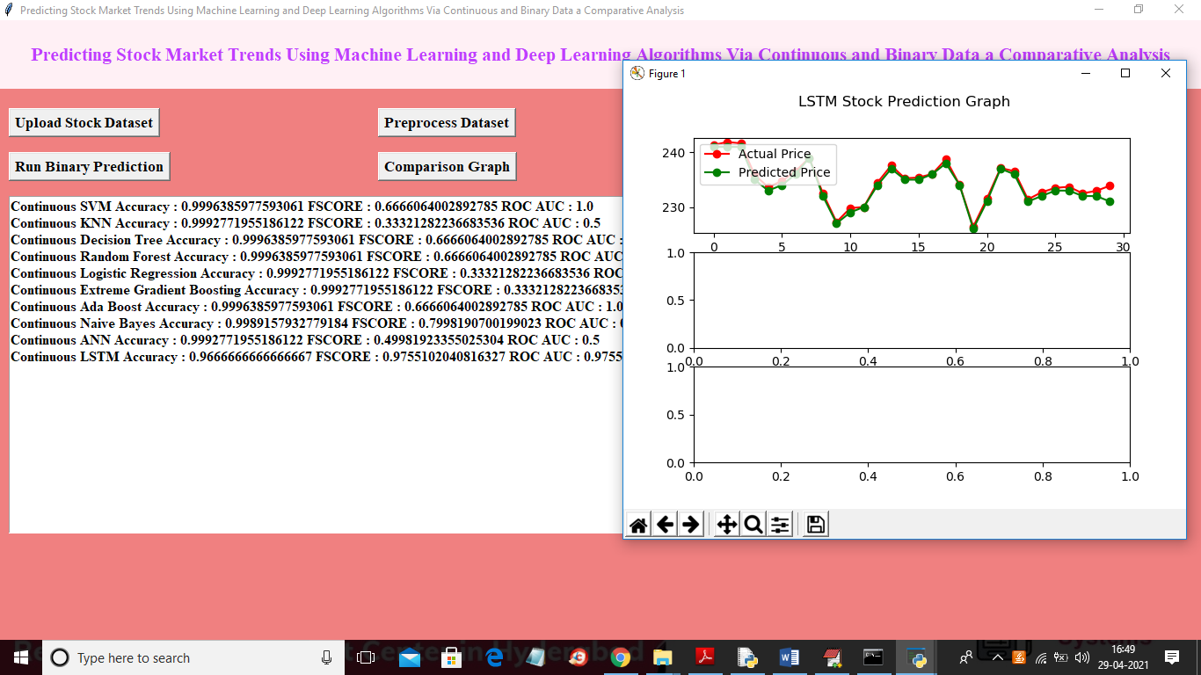

In above screen in text area we can see accuracy, FSCORE and ROC_AUC values for all algorithms using continuous data and in above graph we can see x-axis represents number of days and y-axis represents stock price and red line represents actual price and green line represents predicted price and we can see there is close difference between actual and predicted so LSTM performance is good and now click on ‘Run Binary Prediction’ button to convert dataset into binary values and then perform prediction

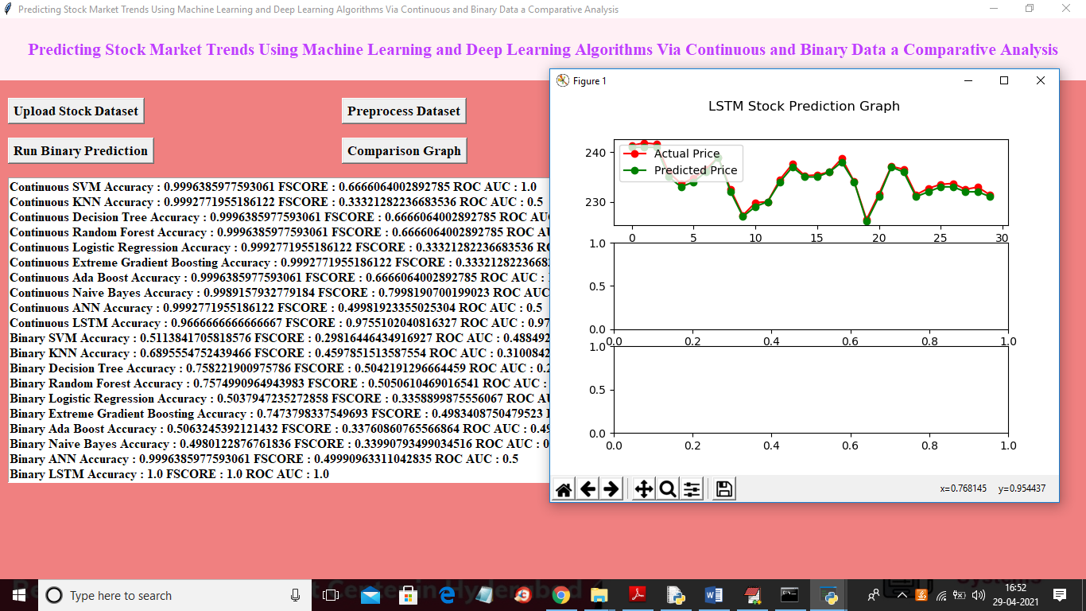

In above screen binary prediction also giving best result and in text area we can see LSTM accuracy is 1.0 which means 100% accurate. Now click on ‘Comparison Graph’ button to get graph between all algorithms

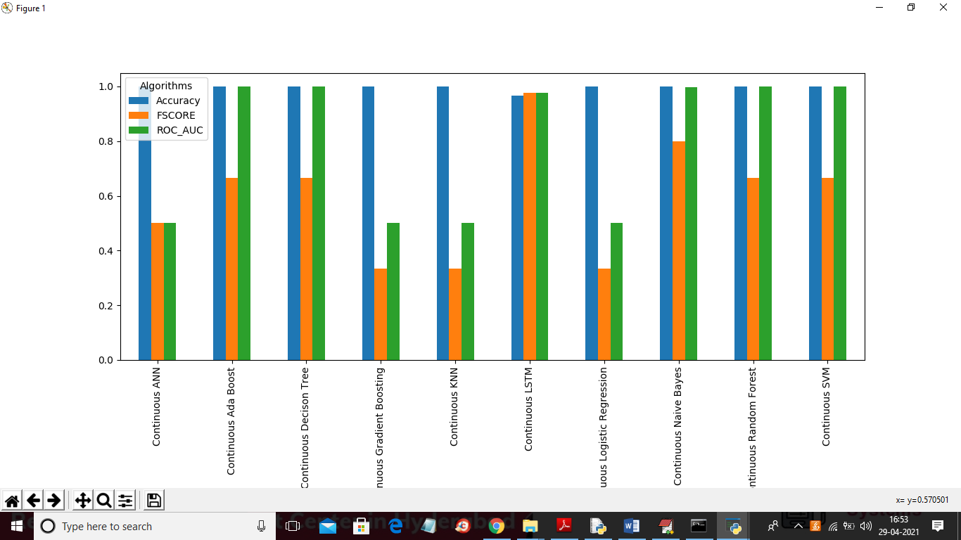

In above graph for continuous data ANN and LSTM is giving better result and now click on ‘View Comparison Table’ button to get below screen

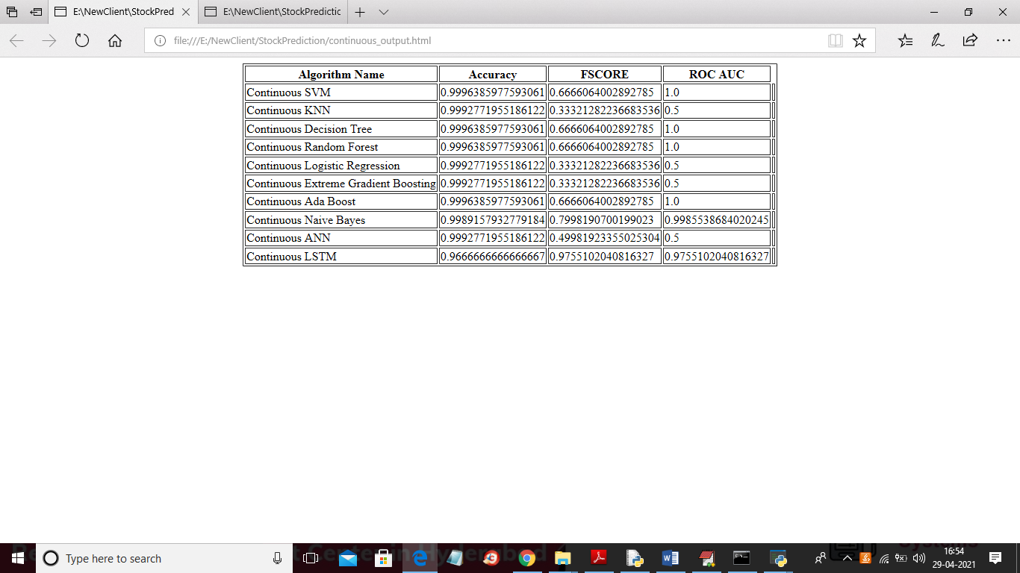

In above screen for continuous data LSTM FSCORE is high and below we can see binary data result

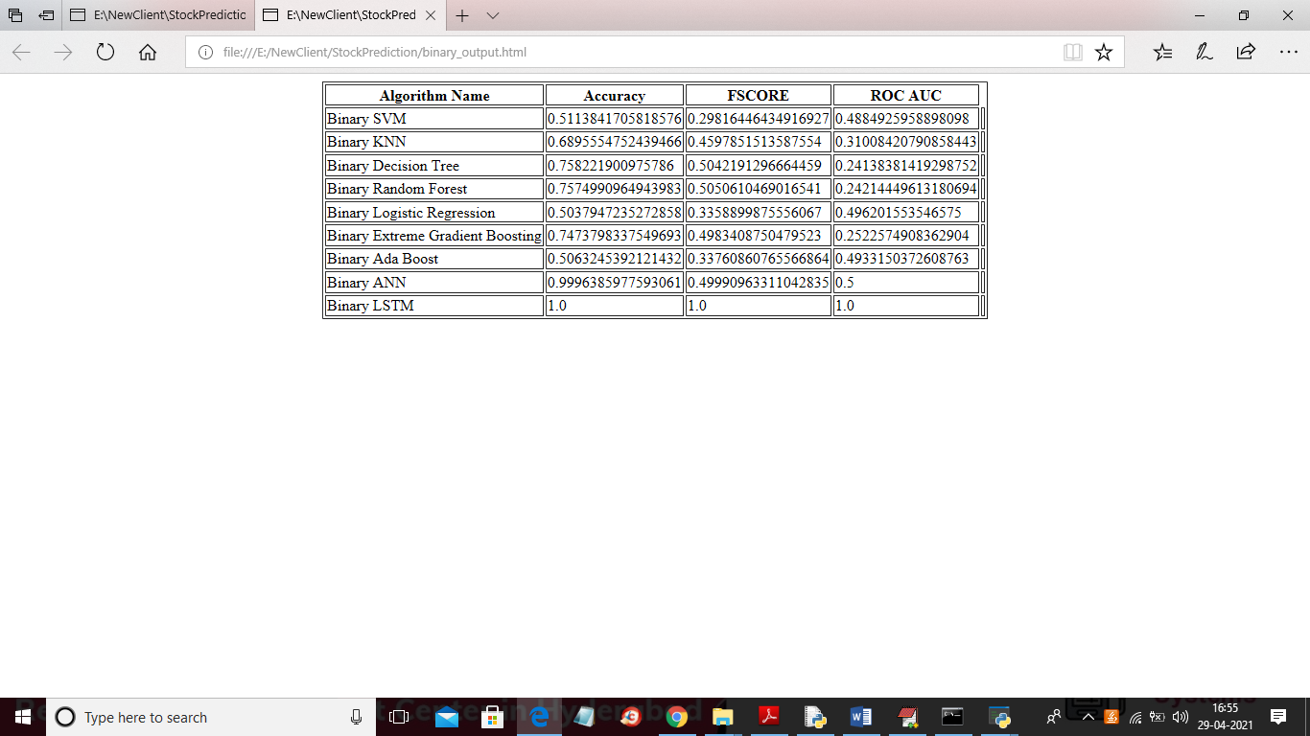

In above screen with binary data LSTM got 100% accuracy, FSCORE and ROC_AUC. Below is the binary data comparison graph between all algorithms

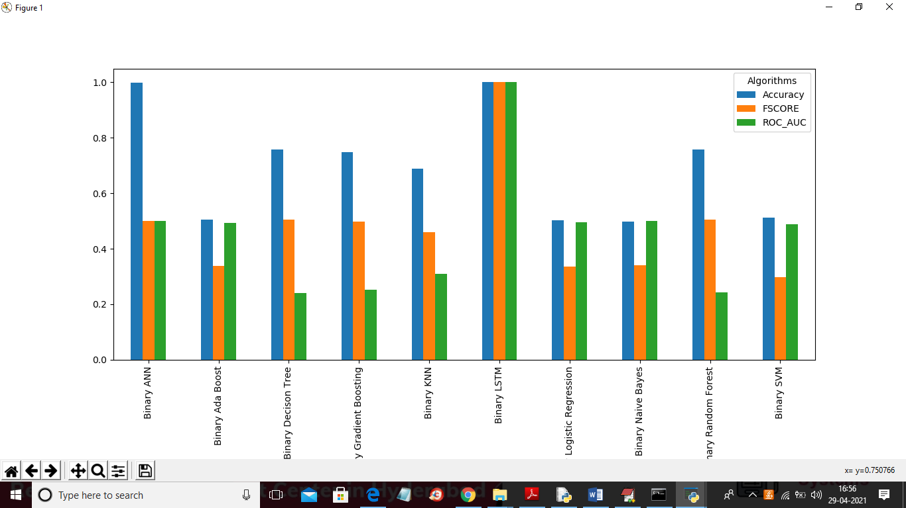

In above graph LSTM is giving better output result compare to all algorithms