Event Program Management Platform
Clone specification — Sessionboard “Program” module

Target | An open-source clone of the program side of Sessionboard, buildable in a weekend
Audience | The coding agent that will implement it
Primary source | Customer walkthrough video — transcript quoted throughout with timestamps, plus 20 screen captures
Secondary source | Sessionboard public product pages and documentation (learn.sessionboard.com)
Product version shown | Sessionboard v2 — appv2.sessionboard.com (forms and plans carry a “V2” badge)
Document version | v2 — rebuilt against the video screen captures

How to read this document
Every requirement traces back to something observable: a line in the transcript, or a screen in the capture set. Timestamps in the form 4:57 refer to the walkthrough video. Screenshots are the real product, captured from the video, and each caption names the specific elements worth reproducing.
Where the captures contradict what the vendor’s public documentation says, the captures win — they show the version the customer is actually paying for. Section 12 lists those corrections explicitly.
Scope in one line: Run a call for papers, collect submissions through a public form, have a committee score them, accept the winners, drag them onto a schedule, publish it. Nothing else.

1. Context
The customer runs a conference. They currently pay for Sessionboard and are evaluating whether a purpose-built replacement can do the job. In their own words, the entire lifecycle is:
“I run a conference and we get a lot of submissions for speakers, and people want to apply and we have to evaluate them and put them on the schedule and communicate with them and make them show up.” — 1:05

1.1 Commercial framing
Fact | Detail | Ref
Current spend under evaluation | Approximately $40,000 per year | 0:38
Category price range | $500 to $200,000 per year, or per event | 1:17
Named competitor | Sessionize — program only, no CRM or marketing | 1:35
Why Sessionboard is over-scoped | It also does CRM, marketing and CMS; the customer wants none of that | 1:35, 2:15
A specific vendor irritation | No self-guided tour — demo request only | 1:50

1.2 The success criterion
“It’s not about the fidelity to Sessionboard. It’s about filling the job to be done that fits it. I just care that we have an accepted industry-standard tool that we have open source and we can clone it in a weekend.” — 9:11 / 9:18
“The higher fidelity, the more usefulness. You are allowed to use your own judgment as to what this is.” — 5:44
Read that as: correctness of the workflow beats pixel-matching, but where this document shows you exactly what a screen looks like, match it — that detail was expensive to gather and it removes guesswork.

2. Scope

2.1 In scope
# | Module | Video ref
1 | Event settings and program configuration | 2:40
2 | Abstracts vs. Sessions — the two record types | 3:21
3 | Submission form builder — the centrepiece | 4:21–5:44
4 | Public submission wizard and submitter account creation | 5:54–6:46
5 | Submitter portal — status, submissions, profile, tasks | 6:52–7:35
6 | Evaluation plans and committee scoring | 7:43–8:08
7 | Accept / decline workflow | 8:08
8 | Agenda builder with conflict detection | 8:14
9 | Public agenda and embeddable widgets | 8:22–8:43
10 | Email to participants | 7:27

2.2 Out of scope — explicitly ruled out
Excluded | What the customer said
CRM | “we’re probably not really using the CRM side” — 2:15
Marketing | “not really using the marketing side” — 2:15
CMS beyond embeds | Only the embed feed is wanted — 2:15, 8:22
Payments | “we don’t really care about payment, so you can skip this one if you’re cloning it” — 5:15
Multi-language | “multi-language — we only care about English” — 5:28
AI features | “I don’t care about the AI workflow thing” — 9:18
Sponsors, exhibitors, invoices | Present in the product, never requested

Do not build these. If you have spare time, deepen the in-scope modules instead.

2.3 Marked optional
- Portal tasks — “that also is kind of optional, but it is very, very handy” — 7:12
- Form admin notifications — “this one also optional” — 5:36
- Reminder and thank-you emails — cheap to add, worth doing

3. Non-functional requirements
These are not boilerplate. They are the reason the customer is shopping in the first place — he complains about the incumbent’s speed four separate times and catches it failing validation twice, on camera.
“part of this I also don’t love is that it’s kind of slow” — 3:43
“this slowness is part of why I think you guys can probably do a better job than Sessionboard” — 4:11
“oh my god, this is so slow” — 7:12
“looks like it doesn’t even have full validation. Very nice.” — 5:04
Requirement | Target
Speed | Every admin list or table view interactive in under 500 ms. No full page reloads between program screens. Optimistic UI on status changes and drag-drop. Server-side pagination and indexed filters on every list.
Validation | Client and server validation on every field: required, min/max, length, email, URL, number range, file type and size. Inline errors, focus moves to the first failure, never lose input.
Sane limits | Participant minimums default to 1. The UI must reject min greater than max — see 4.4 for the exact bug the customer hit live.
Autosave | Evaluator scoring saves on selection. Public form drafts persist across sessions.
Public pages | The public form and public agenda are server-rendered and fast. They are what strangers judge.

4. Information architecture and routes
The customer asked that the clone match the real navigation and routes closely. This section is taken directly from the captures, so it is exact.

4.1 Admin shell
A left sidebar with grouped navigation, a global search bar (“Find or ask”, ⌘K), a View Portal button that switches the admin into the participant portal, a notifications bell, help, and an account avatar. An event switcher sits at the top of the sidebar showing the event name and its dates.
Group | Items
(top level) | Dashboard
Program | Overview
— Submissions | View All · Abstracts · Sessions · Files
— Collect & Review | Forms · Evaluation · Agenda · Invoices · Site
— Portals | Portals · Tasks · Forms · File Requests · Resources · Files
— Configure | Settings
CRM | out of scope
Marketing | out of scope
CMS | Overview · Embeds
(top level) | Reports · Studio · History · Event Team · Preview · Settings

Build note: Ship Dashboard, Program (all four groups) and CMS → Embeds. Leave the other top-level items out entirely rather than stubbing them — empty nav items read as broken.

4.2 Route map
Screen | Route
Submissions list | /event/{eventId}/sessions/submissions
Abstracts / Sessions filtered lists | /event/{eventId}/sessions/abstracts, /sessions/sessions
Forms index | /event/{eventId}/sessions/forms
Form editor | /event/{eventId}/sessions/forms/{formUuid}
Evaluation | /event/{eventId}/sessions/evaluation/plans
Agenda | /event/{eventId}/sessions/agenda
CMS overview | /event/{eventId}/cms
Embed editor | /event/{eventId}/cms/embeds/{embedUuid}
Public submission wizard | /submit/{eventSlug}/{formUuid}/step/{step}
Participant portal | /portals/{eventSlug}/{portalUuid}/{home|sessions|profile|tasks}

5. Domain model

5.1 Abstracts vs. Sessions
“the main lifecycle is that you have submissions, which can either be abstracts or videos, which are sort of applications to speak — and sessions, which are people who are pretty much guaranteed to speak, let’s say because they’re a sponsor.” — 3:21
Both are rows in one session table, discriminated by record_type. A form declares which type it produces.
 | `abstract` | `session`
Origin | Public submission form | Admin-created, or promoted from an accepted abstract
Needs evaluating | Yes | No — already guaranteed
Default status | Pending | Accepted
Reaches the agenda | Only once accepted | Immediately

5.2 Core entities
Entity | Purpose | Key columns
event | Tenant boundary; everything is scoped to it | name, slug, eventtype, websiteurl, location, timezone, startsat, endsat, theme, logourl, backgroundurl, submissionlimit, recordid_prefix
field_definition | The reusable field library — the backbone of the builder | eventid (null = global), entity (session|contact), name, type, description, options, validation, islocked
submission_form | One call for papers | name, recordtype, collectparticipants, publicslug, welcome copy, closeat, submissionlimit, allowdrafts, confirmation copy, success copy, is_open
form_step / form_field_instance | Wizard steps and the blocks inside them | step key, sectiontitle, pageheading, description; per-instance: customlabel, helptext, isrequired, position, conditionalrule, block_type
form_participant_role | Per-role min/max on a form | formid, role, enabled, mincount, maxcount (+ form-level totalmax)
session | The central record — abstract or session | recordtype, humanid, title, description, statusid, submittercontactid, source (form|manual), sourceformid, isdraft, capacity, ceucredits, clientsessionid, format, track, level, language, notifiedat, rating_avg
contact | One person per event; roles are relational | firstname, lastname, email, passwordhash, biography, headshoturl, salutation, honorific, pronouns, gender, links (linkedin, x, facebook, website)
session_participant | Join table carrying the role | sessionid, contactid, role (speaker|chairperson|moderator|submitter), isprimary, acceptancestatus, position
evaluation_plan | A committee review exercise | name, instructions, isopen, rounds, dueat per round, anonymized, ratingstyle, userubric, maxevals, sessionfilter, display_fields
evaluation | One evaluator’s verdict on one submission | planid, round, sessionid, evaluatorid, score, criterionscores, internalcomment, externalcomment, abstained
agenda_slot | Where and when a session happens | sessionid (unique), roomid, startsat, endsat
portal_task | Something a participant must do | type (task|filerequest|form), name, description, linkurl, dueat, extendeddueat, isrequired, target, assign_filter
embed | A published feed | name, enabled, format, type, styleoptions, filters, fieldoptions, cacherefreshedat

5.3 Statuses
Five built-in statuses. Admins can add custom ones, each mapped to one of the five categories so downstream logic (agenda visibility, portal wording) still works. Every status has a name, category, colour and sort order.
Status | Category | What the participant sees in their portal
Accepted | accepted | Accepted
Accept Queue | accepted_queue | Pending
Pending | pending | Pending — the default on submit
Decline Queue | decline_queue | Pending
Declined | declined | Declined

Critical behaviour: Changing a status sends no email. Notification is a separate, deliberate admin action. The submissions list carries a Notified column precisely because the two are decoupled.

5.4 Field types
text (255) · textarea (5,000) · wysiwyg (5,000) · number · currency · email · phone (US-only or international) · url · date · datetime · dropdown · multiselect · checkbox · radio · file · country · language.
Two properties are immutable after creation and the UI says so out loud: field type and field level (event field vs. global field). Enforce both.

6. Admin screens

6.1 Submissions list
Route /event/{eventId}/sessions/submissions. This is the admin’s home screen and the one the customer watched spin, so it carries the hardest performance budget in the build.
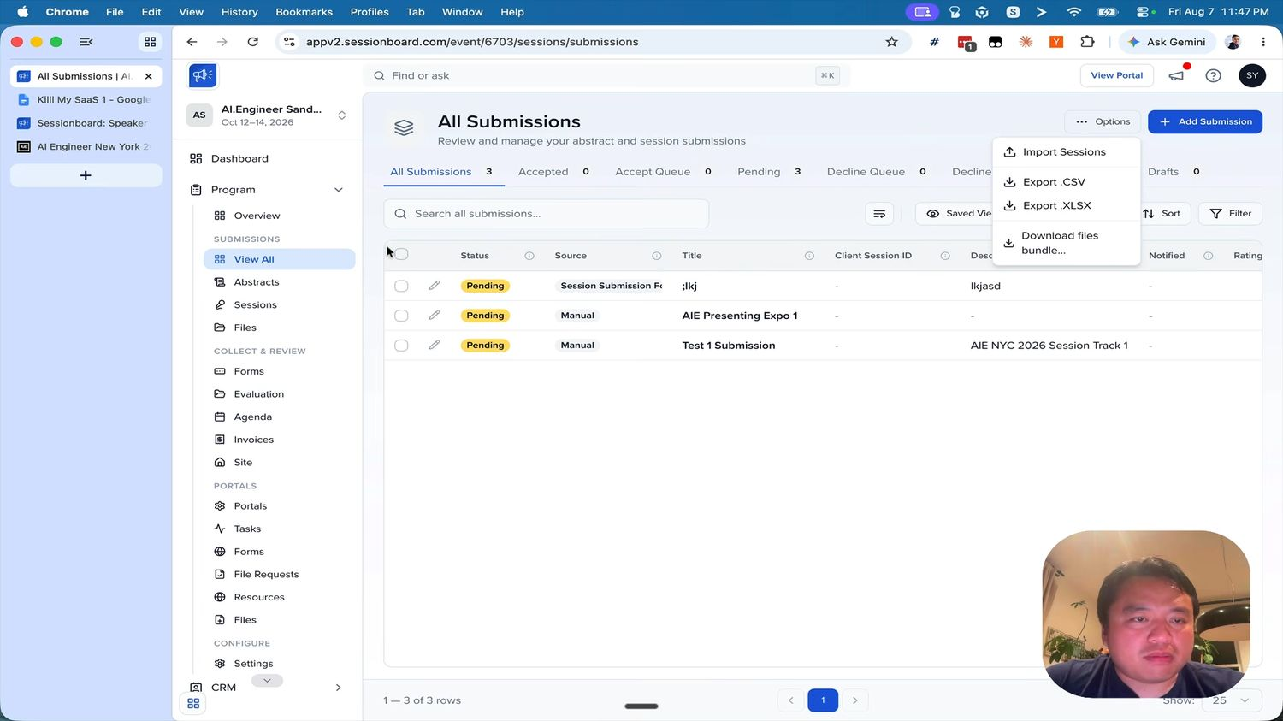
Figure 1 (3:57) — All Submissions. Note the status tabs with live counts, the Source column distinguishing form submissions from manual entries, the per-row pencil, and the Options menu: Import Sessions, Export .CSV, Export .XLSX, Download files bundle.

Required elements
- Header — title “All Submissions”, subtitle “Review and manage your abstract and session submissions”, an Options menu and a primary + Add Submission button.
- Status tabs with counts — All Submissions · Accepted · Accept Queue · Pending · Decline Queue · Declined · Drafts. Counts update live and drive the filter.
- Search across all submissions, plus Saved Views, Sort, Filter and a column-picker control.
- Columns — Status (coloured pill) · Source · Title · Client Session ID · Description · Notified · Rating. Each column header carries an info tooltip. Admins add any session or custom field as a column and save the view.
- Row actions — checkbox for bulk selection, pencil to open the record editor.
- Footer — “1 — 3 of 3 rows”, pagination, and a page-size selector defaulting to 25.

The Options menu
Action | Behaviour
Import Sessions | Upload CSV/XLSX, map columns to fields, preview, commit
Export .CSV / .XLSX | Exports the current view — respecting filters, sort and visible columns
Download files bundle | Zips uploaded files; offer grouping by submitter, by field or by record

Record editor
Opening a row gives tabs: Details (standard plus custom fields) · Participants (add, remove, reorder, set each person’s acceptance status) · Files · Evaluations (read-only score summary) · Schedule.

6.2 Forms index
Route /event/{eventId}/sessions/forms.
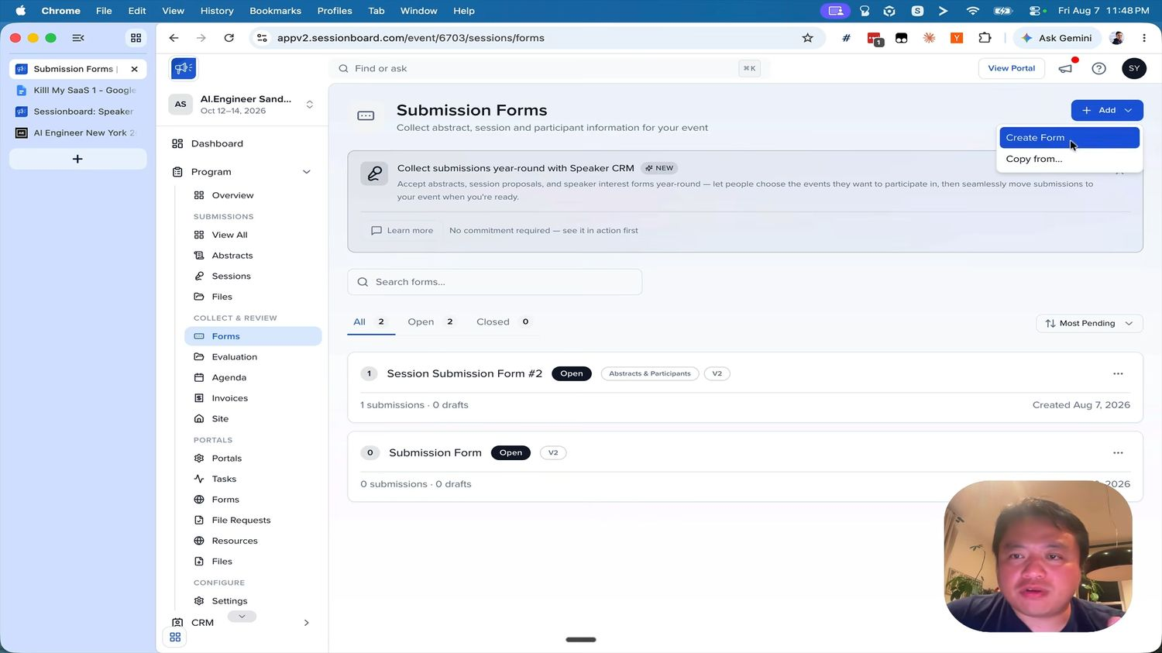
Figure 2 (4:32) — Submission Forms with the Add menu open: Create Form and “Copy from…”. Each form is a card, not a table row.
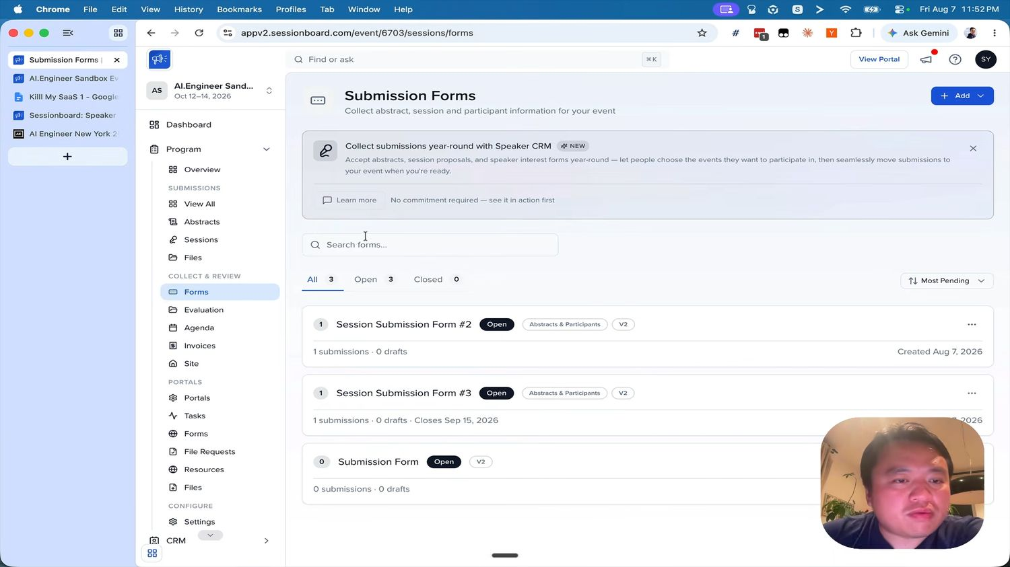
Figure 3 (7:41) — the same index with three forms. Form #3 shows the close date inline: “1 submissions · 0 drafts · Closes Sep 15, 2026”.
- Add is a split button — Create Form or Copy from… an existing form.
- Tabs with counts — All · Open · Closed. A sort control defaults to “Most Pending”.
- Search forms by name.
- Each card shows — a submission-count badge on the left, the form name, an Open or Closed pill, a content-type chip (for example “Abstracts & Participants”), a version chip, and a ⋯ menu.
- Second line — “N submissions · N drafts”, the close date when one is set, and the created date on the right.
The ⋯ menu should offer: Edit · View Submissions · View Draft Submissions · View Form · Copy Link · Duplicate · Delete.

6.3 Form builder — the centrepiece
“So you have like a form builder is what you’re being asked to build here. This is just a very fancy form builder. That’s all it is.” — 4:46
That is the clearest statement of the deliverable in the whole video. Everything else orbits this screen.

Shell
Header: Edit Session Form, the form name as a subtitle, and three actions — View Form (opens the public form in a new tab), Copy Link, Save. A left rail lists the wizard steps under the label FORM SETUP, with a green check on each completed step. A sticky footer carries Back and Next.

The seven steps
# | Step | Subtitle | In scope?
1 | Submission Setup | Submission type and participants | Yes
2 | Welcome Screen | Welcome message and terms | Yes
3 | Session / Abstract Information | Session or abstract questions | Yes
4 | Participant Information | Participant and contact fields | Yes
5 | Payments & Fees | Fees, gateway, and promo codes | No — skipped at 5:15
6 | Form Settings | Deadlines, limits, and success page | Yes
7 | Notifications | Admin alerts and email templates | Optional — 5:36

Note step 3 renames itself: it reads Session Information when the form collects sessions and Abstract Information when it collects abstracts.
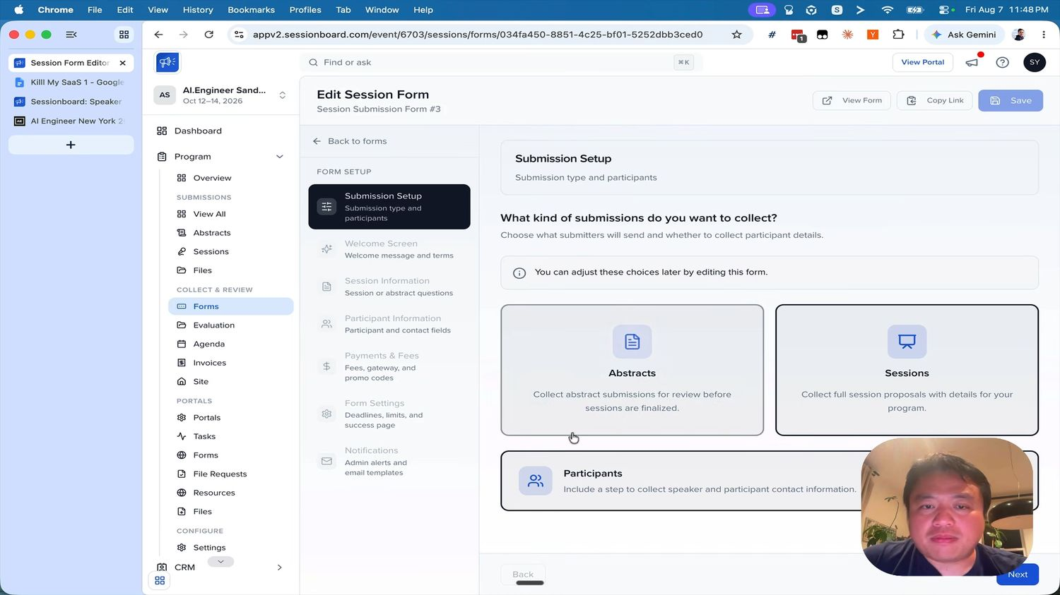
Figure 4 (4:34) — Step 1. “What kind of submissions do you want to collect?” with two large choice cards, Abstracts and Sessions, plus a separate Participants card toggling whether a participant step is included. The info bar reads “You can adjust these choices later by editing this form.”

Step 1 — Submission Setup
- Abstracts — “Collect abstract submissions for review before sessions are finalized.”
- Sessions — “Collect full session proposals with details for your program.”
- Participants — “Include a step to collect speaker and participant contact information.” When off, the form skips step 4 entirely and the public wizard drops its Participant step.
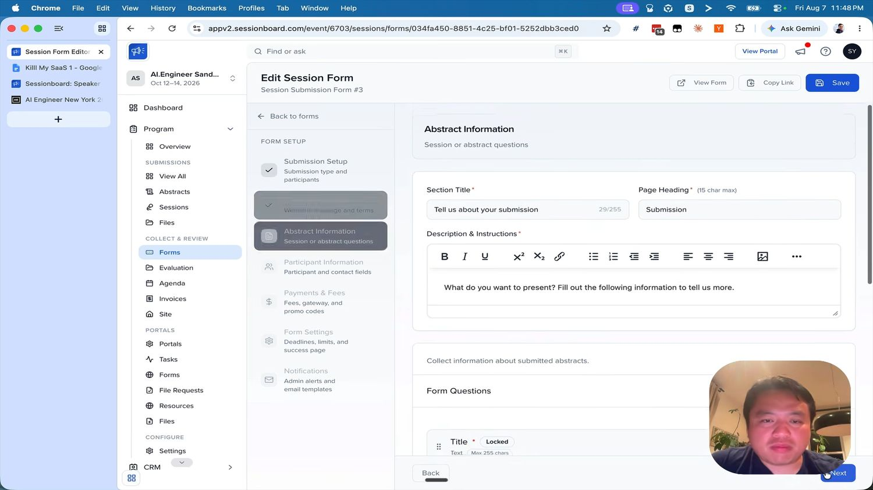
Figure 5 (4:41) — Step 3. Section Title with a live 29/255 counter, Page Heading capped at 15 characters, a rich-text Description & Instructions, then the Form Questions list. Title is marked required and Locked, and each row shows its type and limit — “Text · Max 255 chars”.

Step 3 — Session / Abstract Information
- Section Title — required, 255 characters, with a live counter.
- Page Heading — required, 15 characters maximum. It is the short label in the public wizard.
- Description & Instructions — required, rich text (bold, italic, underline, super/subscript, link, lists, indent, alignment, image).
- Form Questions — a drag-handled list. Each row shows the field name, a required asterisk, a Locked chip where applicable, and a type/limit summary.
- Locked fields cannot be removed or retyped. Title is locked on session forms.
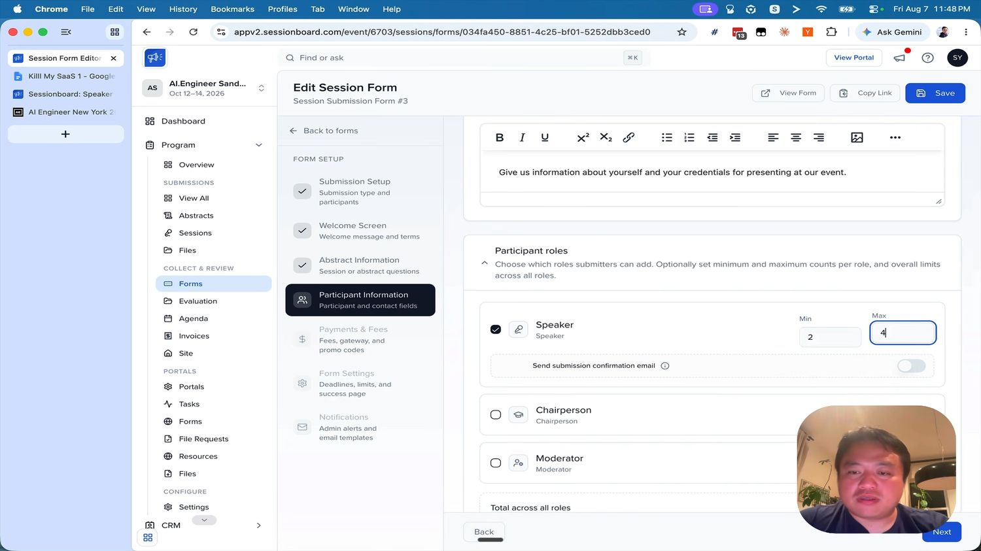
Figure 6 (4:57) — Step 4. Participant roles with a checkbox per role and independent Min and Max spinners: Speaker (min 2, max 4), Chairperson, Moderator, then a “Total across all roles” cap. This exact control produced the customer’s mistake sixty seconds later.

Step 4 — Participant Information
Two blocks. First, Participant roles: “Choose which roles submitters can add. Optionally set minimum and maximum counts per role, and overall limits across all roles.” Each of Speaker, Chairperson and Moderator has an enable checkbox and its own Min and Max. A Total across all roles cap sits underneath, and a Send submission confirmation email toggle sits inside the block.
Second, Form Questions for contact fields — the same list UI as step 3. First Name, Last Name and Email are locked and cannot be deleted.
The bug to not reproduce: At 6:46 the customer submits his own form and hits a hard stop, then says “that was stupid, obviously I should not have a minimum of two speakers.” Default every role minimum to 1, validate that min ≤ max on save, and warn when a minimum above 1 is set on a live form.

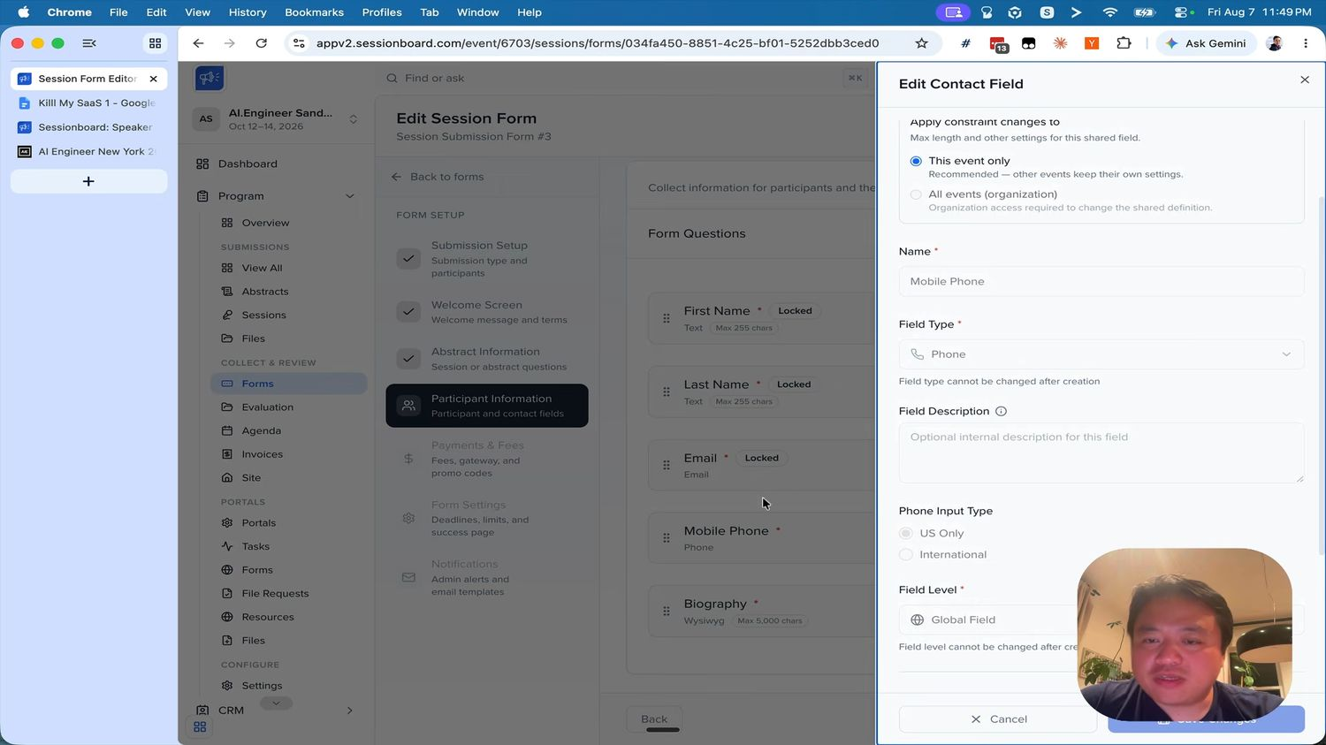
Figure 7 (5:12) — the Edit Field drawer. Note the scope selector at the top, the two “cannot be changed after creation” warnings, the type-specific options (Phone Input Type: US Only or International), and the locked standard fields behind it: First Name, Last Name, Email, Mobile Phone, Biography (Wysiwyg, max 5,000 chars).

The field editor drawer
Opens as a right-hand drawer over the builder. Fields:
Control | Detail
Apply constraint changes to | Radio: This event only (“Recommended — other events keep their own settings”) or All events (organization) (“Organization access required to change the shared definition”). This is how the platform avoids the classic shared-field footgun — copy it.
Name | Required
Field Type | Required. “Field type cannot be changed after creation.”
Field Description | Optional internal note; submitters never see it
Type-specific options | For example Phone Input Type — US Only or International
Field Level | Required. Event field or Global Field. “Field level cannot be changed after creation.”
Footer | Cancel and Save Changes

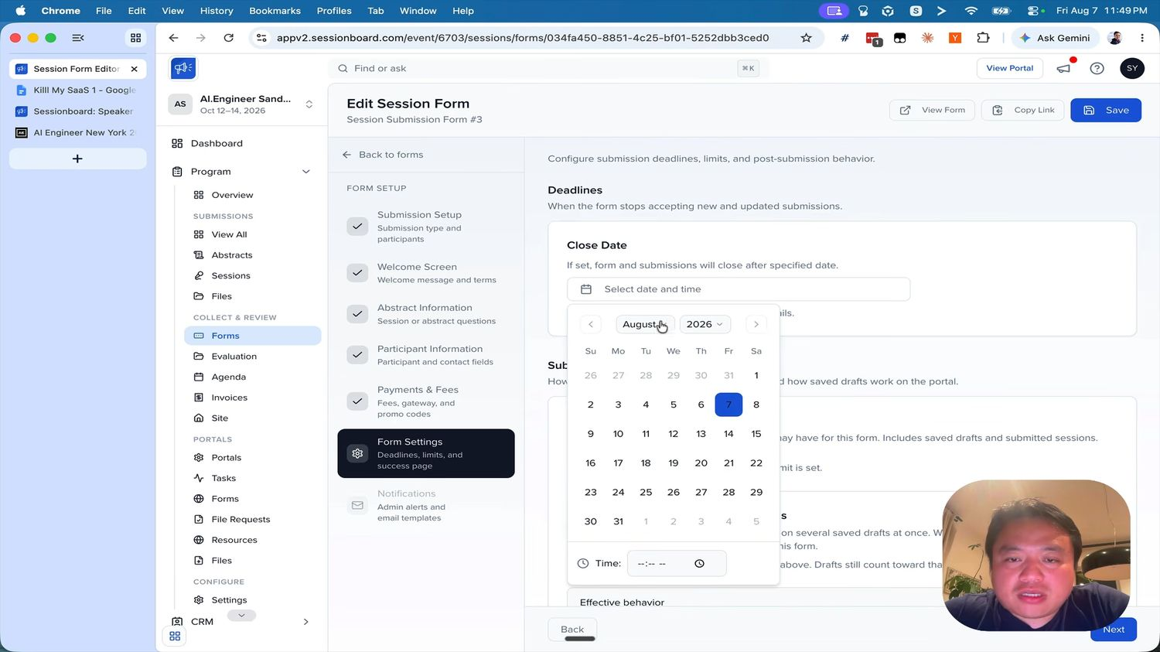
Figure 8 (5:22) — Step 6. Deadlines with a Close Date date-and-time picker, then submission limits, saved-draft behaviour, and an “Effective behavior” summary that spells out the combined result of the settings.

Step 6 — Form Settings
- Close Date — “If set, form and submissions will close after specified date.” Date and time. There is no open date; a form is live the moment its link is shared.
- Submission limit — per submitter, for this form. Drafts count toward the limit.
- Multiple draft submissions — whether a submitter may hold several saved drafts at once.
- Success page — post-submission copy.
- Effective behavior — a plain-language summary of what the current combination of settings actually does. Cheap to build, and it prevents exactly the class of mistake the customer made.

Acceptance criteria for the builder
- An admin creates a form from scratch, picks Abstracts with participants, adds three custom questions of different types, sets one conditional, sets a close date, and publishes — without leaving the builder.
- The public form renders every field type and enforces every validation rule, client and server side.
- Editing a shared field prompts for scope: this event only, or all events.
- Role minimums default to 1 and min > max is rejected at save time.
- Locked fields cannot be deleted, reordered out of position, or retyped.

7. Public submission wizard
Route /submit/{eventSlug}/{formUuid}/step/{step}. Public, no login needed to start. Branded, with a “Powered by …” footer.
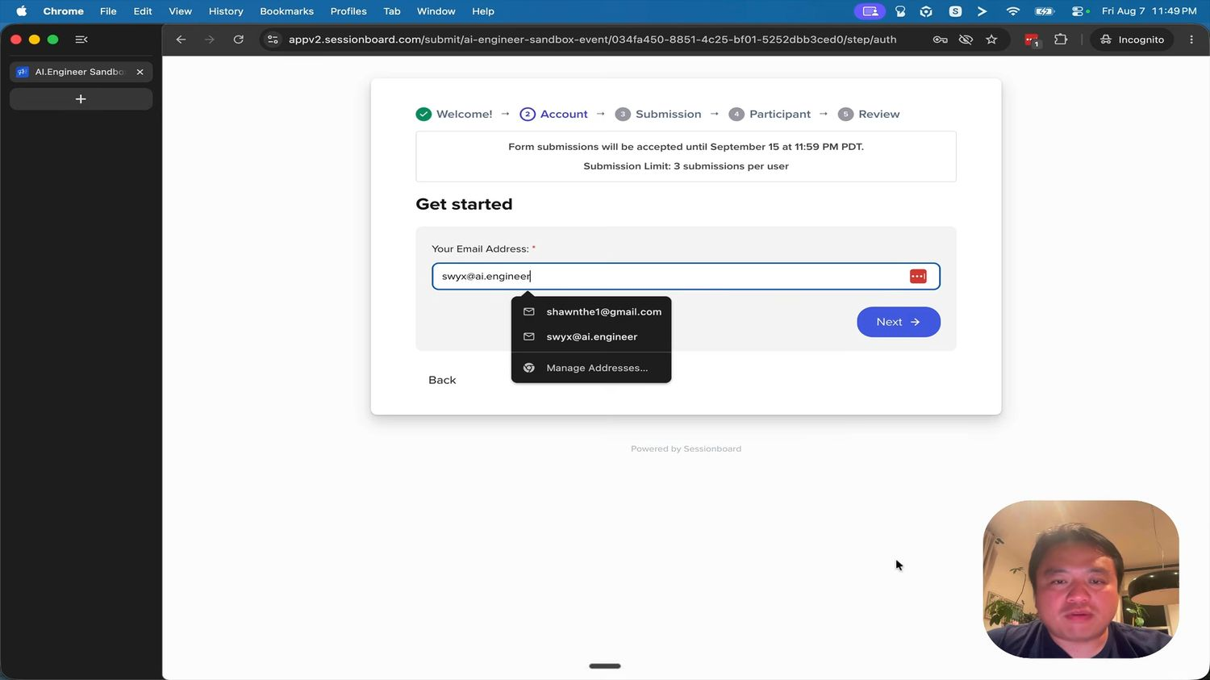
Figure 9 (6:06) — the public wizard. A five-step progress bar, a banner stating the deadline and the per-user submission limit, then the account step. The completed step turns into a green check.

7.1 The five steps
# | Step | Contents
1 | Welcome! | Event intro, welcome copy, terms
2 | Account | Email address, then password — create or sign in
3 | Submission | The session / abstract questions from builder step 3
4 | Participant | Repeatable participant blocks, bounded by the per-role min/max
5 | Review | Full summary, then submit

7.2 Required behaviour
- Deadline banner — “Form submissions will be accepted until September 15 at 11:59 PM PDT.” Render in the event timezone with the zone abbreviation shown.
- Limit banner — “Submission Limit: 3 submissions per user.”
- Account before content — the account step comes second, so every submission is owned by a portal identity from the start. An existing email prompts sign-in and attaches the submission to that account.
- Save as draft — allowed once a Title exists. A banner marks the record as a draft on return, the wizard offers to resume, and a Reset saved data control discards it.
- Close enforcement — after the close date the page shows a closed message and accepts nothing.
- Limit enforcement — a submitter at their cap gets a clear message, not a failed submit.
- Redirect — on success, offer the portal; auto-redirect after ten seconds if configured.
This is the validation screen. A stranger judges the whole product here. Validate on blur, validate on submit, keep entered data on error, and move focus to the first failing field.

8. Participant portal
Route /portals/{eventSlug}/{portalUuid}/…. A separate identity space from admin login.
“once you have a login, you can actually see your login with your speakers and your tasks. And this is an important part of it — whether or not you have been accepted or not. I think that’s a key part, as well as once you’ve been accepted, what tasks do you have to complete?” — 6:52 / 7:07
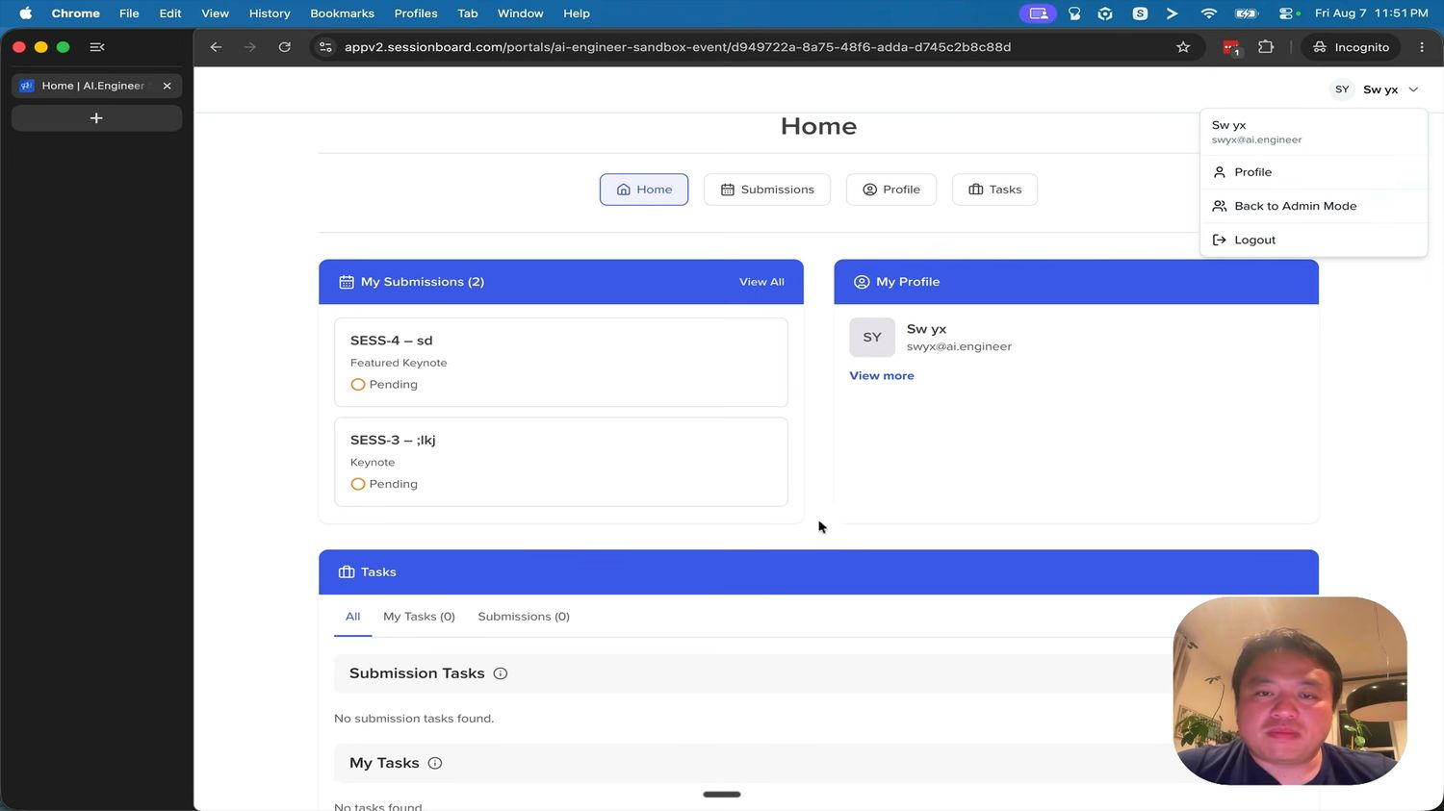
Figure 10 (6:57) — portal Home. Four pill tabs, a My Submissions card listing records as “SESS-4 — sd” with format and a status dot, a My Profile card, and a Tasks section split into Submission Tasks and My Tasks. The account menu carries Profile, Back to Admin Mode and Logout.

8.1 Navigation
Four centred pill tabs: Home · Submissions · Profile · Tasks. The account menu shows the person’s name and email, plus Profile, Back to Admin Mode (only when an admin is impersonating) and Logout.

8.2 Home
- My Submissions (n) with a View All link — each card shows the human ID and title (SESS-4 — sd), the session format, and a status pill with a coloured dot.
- My Profile — avatar, name, email, View more.
- Tasks — tabs All / My Tasks (n) / Submissions (n), then two grouped sections.
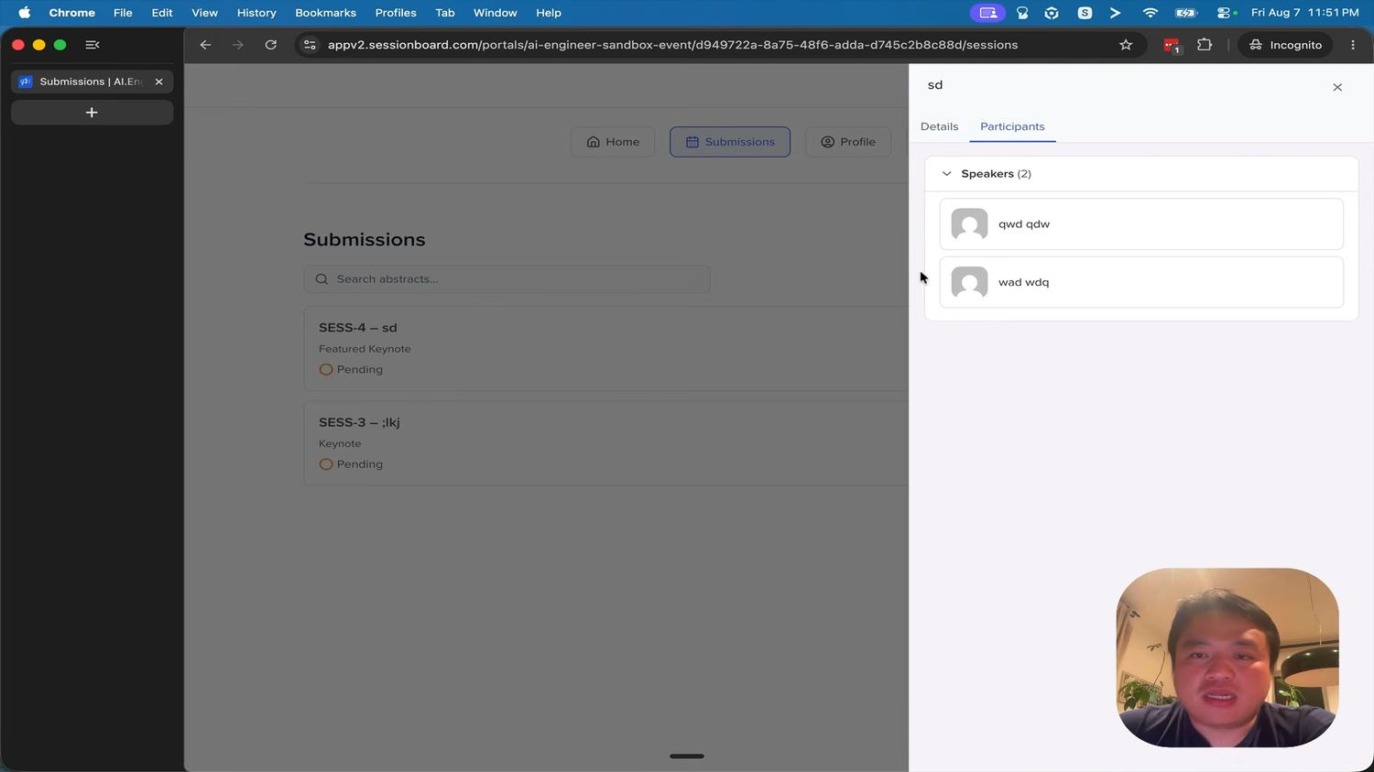
Figure 11 (7:24) — Submissions with a record open in a right drawer. Tabs Details and Participants; the Participants tab groups by role with a count, “Speakers (2)”, each with an avatar row.

8.3 Submissions
A searchable list (“Search abstracts…”) of the same cards. Selecting one opens a right drawer with Details and Participants tabs. Participants are grouped by role with a count in the header. Editing is allowed until the form closes, or later if the admin permits it.
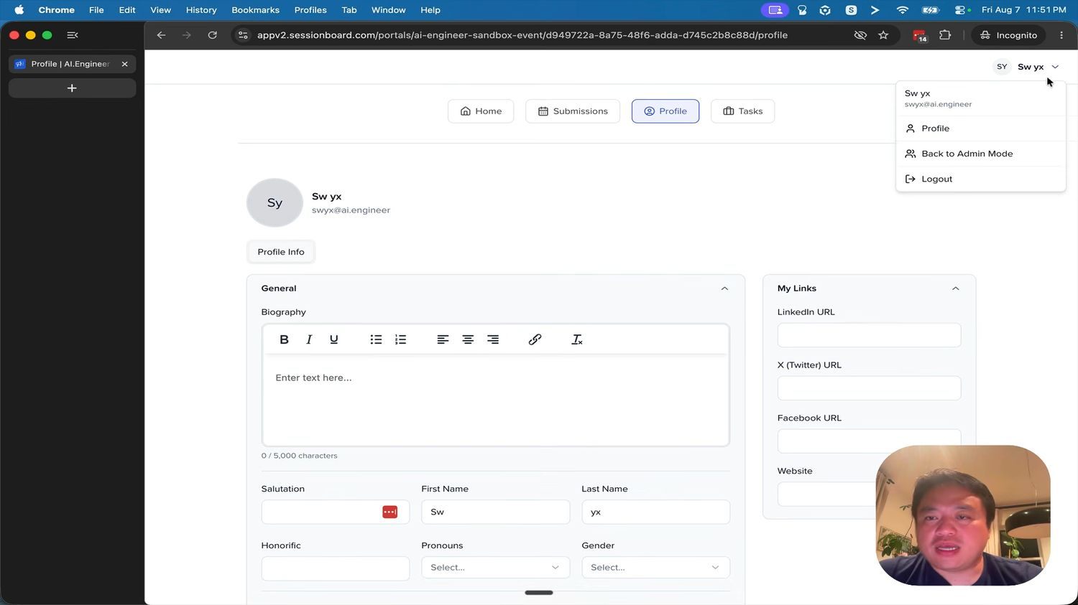
Figure 12 (7:33) — Profile. A General card leading with Biography as rich text and a 0 / 5,000 character counter, then Salutation, First Name, Last Name, Honorific, Pronouns, Gender. A My Links card holds LinkedIn, X (Twitter), Facebook and Website.

8.4 Profile
Biography leads, because it is the field the customer singled out:
“as well as you being able to update your own biography. This is a very important part of the overall submissions.” — 7:20
Layout: a Profile Info tab; a General card with the rich-text biography and a character counter, then name and identity fields; a My Links card for social URLs. The admin controls which fields are visible, locked or hidden per portal.
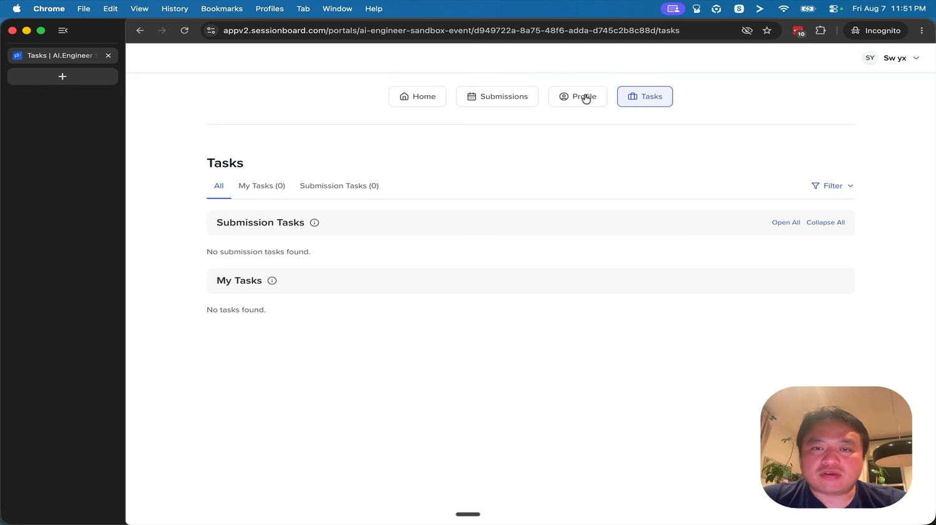
Figure 13 (7:32) — Tasks. Tabs All / My Tasks (0) / Submission Tasks (0), a Filter control, and two collapsible sections with Open All and Collapse All, each with a plain empty state.

8.5 Tasks
Two groupings: Submission Tasks (attached to a submission) and My Tasks (attached to the person). Each section collapses, with Open All and Collapse All. Three task types — plain task marked complete by hand, file request requiring upload and admin approval, and form collecting structured answers.
Icon | Meaning
Green check | Complete
Yellow clock | File uploaded, awaiting admin approval
Orange checklist | Assigned manually, not complete
Blue circle | Assigned via portal, not complete
Grey plus | Not assigned

9. Evaluations
Route /event/{eventId}/sessions/evaluation/plans.
“we can create evaluation plans on the admin side, on the conference committee side, and we can assign sessions to be evaluated by conference committees. So here we can say, all right, this team is evaluating whatever number of submissions, and as an evaluator I can look through all these things.” — 7:43
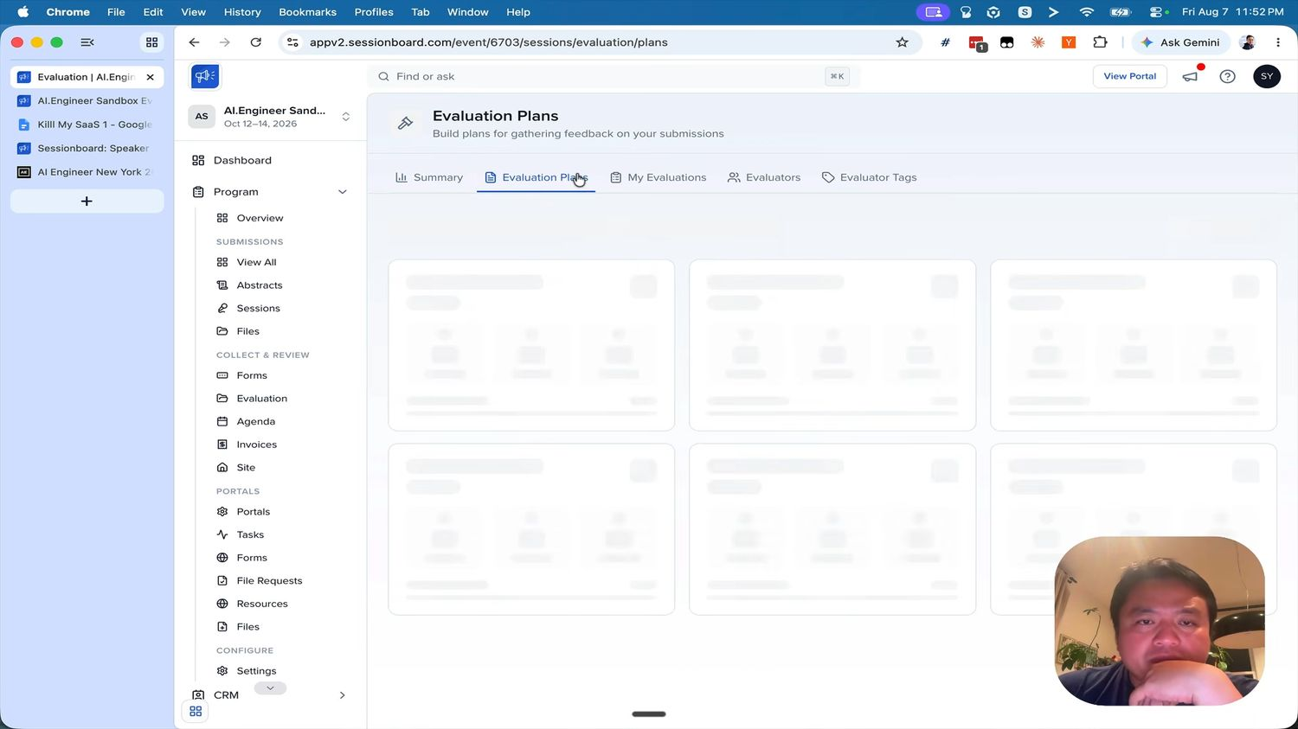
Figure 14 (7:51) — the Evaluation module’s five tabs: Summary, Evaluation Plans, My Evaluations, Evaluators, Evaluator Tags. Note also that this screen is caught mid-load showing skeleton cards — a good pattern to copy, and a reminder that the customer’s complaint was about how long these waits lasted.

9.1 Module tabs
Tab | Purpose
Summary | Dashboard of evaluation progress and scores across the event
Evaluation Plans | Create and manage plans
My Evaluations | The signed-in user’s own review queue — admins can evaluate too
Evaluators | People with the evaluator role on this event
Evaluator Tags | Tags used to assign evaluators by topic, track or expertise

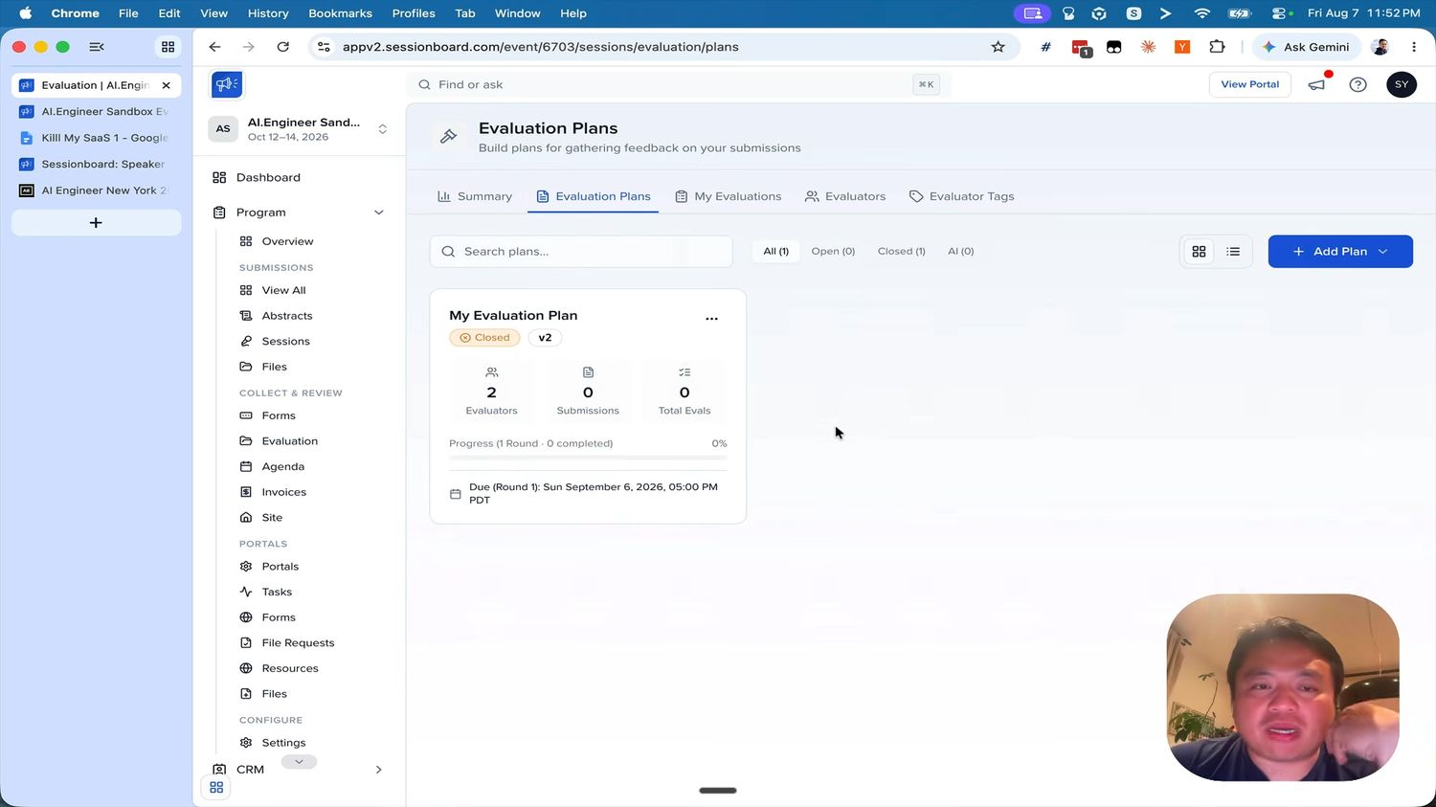
Figure 15 (7:54) — Evaluation Plans. Filter chips with counts, a grid/list toggle, an Add Plan split button, and a plan card carrying three stat tiles, a round-aware progress bar and a per-round due date.

9.2 Plans index
- Search plans, filter chips All (n) · Open (n) · Closed (n) · AI (n), a grid/list view toggle, and a primary + Add Plan split button.
- Plan card — name, an Open/Closed pill, a version chip, a ⋯ menu.
- Three stat tiles — Evaluators · Submissions · Total Evals.
- Progress — “Progress (1 Round · 0 completed)” with a percentage and bar.
- Due date per round — “Due (Round 1): Sun September 6, 2026, 05:00 PM PDT”.
Rounds are first-class. The card counts rounds and dates them individually, so model evaluation as plan → round → assignment → score, not a flat plan. A single-round plan is then just the common case.

9.3 Creating a plan
Group | Settings
Configuration | Name, instructions, open or closed, due date per round, anonymised review (hides participant names), reminders, whether evaluators can open uploaded files
Evaluators | Assign evaluators, optionally by tag. Evaluators must already exist on the event; assignments change only while the plan is closed
Session filters | Filter by any standard or custom session field to decide which submissions the plan covers — this is how “this team reviews these submissions” works
Display fields | Which session and participant fields evaluators see, plus custom evaluation questions
Grading | Rating scale, optional weighted rubric whose criteria must total 100%, and a cap on evaluations per submission. Locked once the plan is created — warn on the create screen

9.4 Evaluator experience
- Invitation email, magic link, land on the list of assigned plans.
- Open a plan to get a queue of assigned submissions.
- Read the instructions and the chosen display fields; participant names hidden if the plan is anonymised.
- Score against the scale or rubric — selections auto-save.
- Add comments, or abstain on a conflict of interest.
- Save & Next; a progress meter climbs to 100%.
Hard rules: evaluators see only their assignments, never each other’s scores, never the admin console, and cannot contact participants. Scores are never shown to submitters.

9.5 Summary dashboard
Top-line counts (evaluations submitted, sessions evaluated, active plans, unique evaluators), highest and lowest scoring session, a completion chart, average score by plan, a top-ten list, and a widest-spread list showing submissions where evaluators disagreed most. The last one is the genuinely useful one for a programme committee.

10. Agenda builder
Route /event/{eventId}/sessions/agenda.
“then we can add the accepted sessions in here for the agenda, on putting out publicly” — 8:14
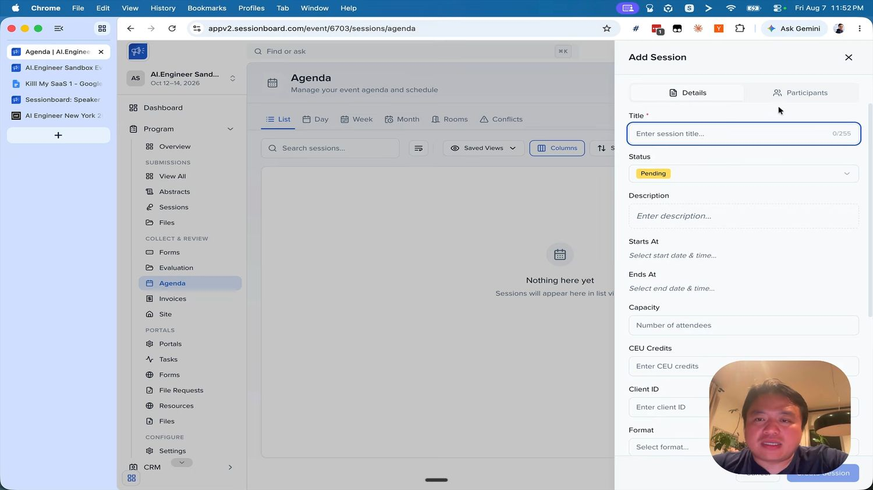
Figure 16 (8:18) — Agenda in List view with its six tabs, and the Add Session drawer open. Note that Conflicts is a peer tab, not a buried report, and that the drawer mirrors the record editor with Details and Participants.

10.1 Views
Six tabs: List · Day · Week · Month · Rooms · Conflicts. List is the default and shares the submissions-list chrome — search, Saved Views, Columns, Sort. The empty state reads “Nothing here yet”.
View | Purpose
List | Table of sessions with date, time and room columns
Day | Hourly timeline for a single day
Week | Seven-day calendar
Month | Month grid
Rooms | Rooms as columns, or as the x-axis via a timeline toggle; zoomable to fit all rooms
Conflicts | Every clash in one list, each with an Open action into the session editor

10.2 Scheduling
- An unscheduled tray of accepted sessions. Drag one onto the calendar to create its slot; drag to move, resize to change duration.
- Card colour driven by track by default, switchable to status, room, format, level or tag.
- Agenda settings — day start and end time, snap interval, which statuses appear, default duration per format, room visibility.
- Conflict detection — overlapping sessions in one room, and any participant double-booked across concurrent sessions. Conflicted cards carry a red dot.

10.3 Add Session drawer
Tabs Details and Participants. Details fields, in order: Title (required, 0/255 counter) · Status (pill dropdown, defaults to Pending) · Description · Starts At · Ends At · Capacity · CEU Credits · Client ID · Format · and the remaining program fields. Participants are added on the second tab. Title and Status are the only requirements to save.

11. Public output and embeds
“as well as obviously showing them or embedding them in some external environment where you can get the code, for example. And here it’s roughly how it should look. It’s a very standard sort of event display with everything all linked.” — 8:22 / 8:33
“Everything all linked” is the requirement: session links to its participants, each participant links back to their sessions, and both are crawlable.
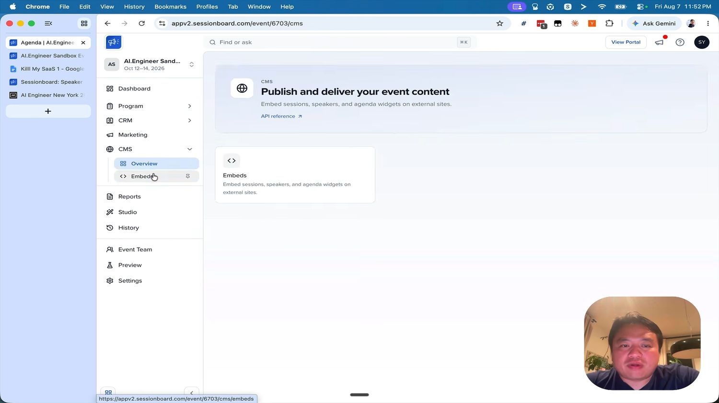
Figure 17 (8:27) — CMS overview. “Publish and deliver your event content — embed sessions, speakers, and agenda widgets on external sites”, with an API reference link and a single Embeds card.

11.1 Embed editor
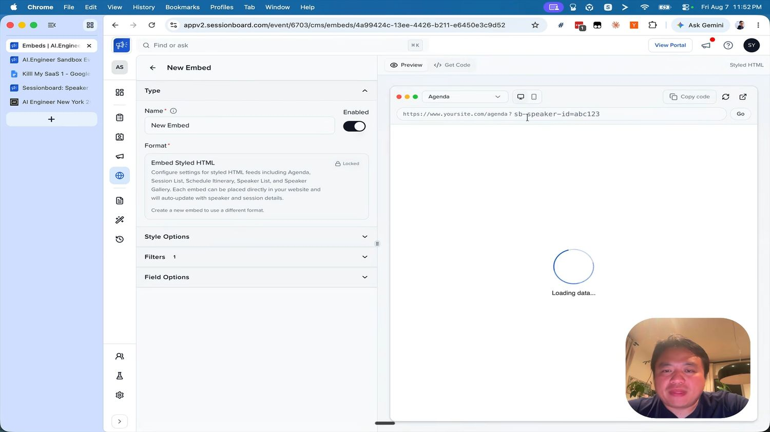
Figure 18 (8:34) — the embed editor. Left: Type (name, enabled toggle, locked format), Style Options, Filters with an active count, Field Options. Right: a Preview / Get Code switch over a browser mock with device toggles, a Copy code button, a cache refresh and an open-in-new-tab control.
Panel | Contents
Type | Name (required), an Enabled toggle, and the Format — shown Locked with the note “Create a new embed to use a different format.” Format choice is permanent
Style Options | Colours, layout and custom CSS
Filters | Restrict the feed — by track, status and so on. The panel header shows the active filter count
Field Options | Which fields appear on agenda, session and speaker cards. Required fields are locked

Formats to support: Styled HTML (one script tag, interactive), plain HTML (for the customer’s own CSS), JSON, and iCal. Within Styled HTML the widget types are Agenda, Session List, Schedule Itinerary, Speaker List and Speaker Gallery — selectable in the preview.
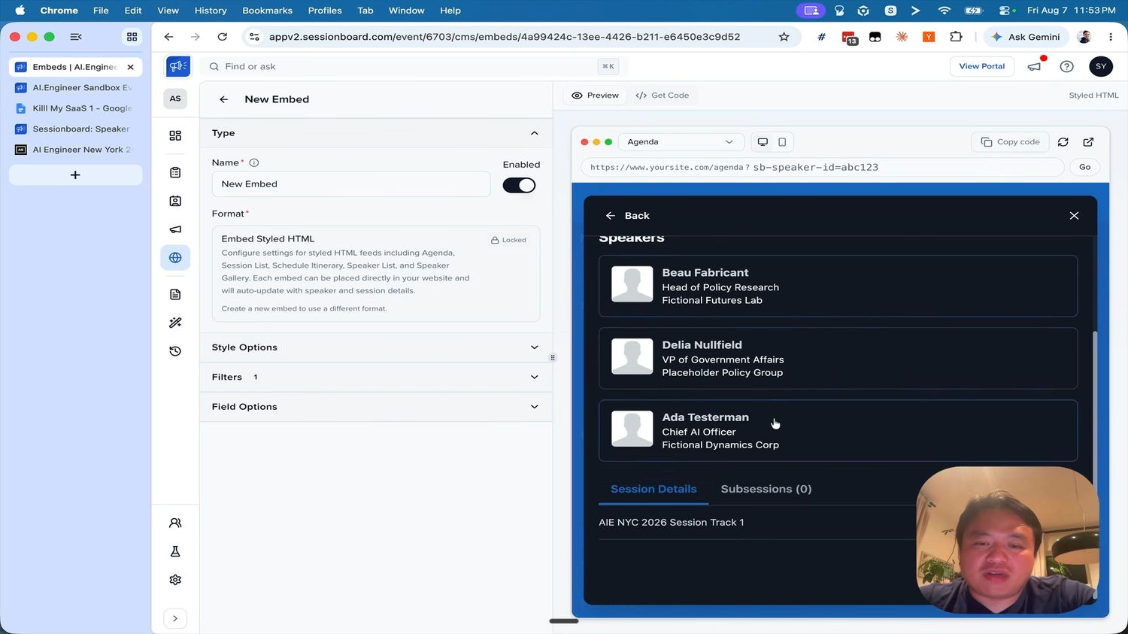
Figure 19 (8:43) — the live preview rendering a dark-themed agenda widget: a Speakers list with headshot, name, job title and company, and Session Details / Subsessions tabs beneath. This is the “everything all linked” display the customer described.
Deep links matter. The preview address bar reads https://www.yoursite.com/agenda?sb-speaker-id=abc123. The embed reads a query parameter and opens straight to that record, so a marketing page can link directly to one speaker. Small feature, large practical value — build it.

11.2 Public pages
- Agenda — grouped by day then time, showing room and track, filterable by day, track, format, room, level and tag, with free-text search over session titles and participant names.
- Speaker directory — alphabetical by last name, with headshot, name, title and company.
- Detail pages for each session and each participant, cross-linked.
- Only accepted sessions appear. Server-rendered, fast, with sensible OG tags.
Embeds cache; expose a manual Refresh cache action for when a change needs to appear immediately.

12. Corrections from the screen captures
The first draft of this specification was written from the transcript and the vendor’s public documentation. The captures corrected it in the following ways. If you read an earlier draft, these supersede it.
Topic | Earlier assumption | What the captures show
Product version | The classic UI documented publicly | Sessionboard v2 — different IA, wizard-based forms, V2 badges on forms and plans
Form builder shape | Four editable pages | Seven wizard steps with a checked-off left rail
Participant limits | A single speaker min and max | Per-role min and max for Speaker, Chairperson and Moderator, plus a total-across-all-roles cap
Participant step | Always present | Optional — toggled on in step 1, and it removes a public wizard step
Public form | A linear multi-page form | A five-step wizard with the account step second
Submission source | Not modelled | A first-class Source column: Manual vs. the originating form
Notification state | Not modelled | A Notified column on the submissions list
Shared-field edits | A warning | A scope choice — this event only, or all events
Immutability | Grading options only | Field type, field level and embed format are also permanent
Evaluation shape | Flat plans | Round-based, with per-round due dates and progress
Conflicts | A sub-report of the agenda | A peer tab alongside the five calendar views
Portal shape | A single dashboard | Four tabs, with tasks split into Submission Tasks and My Tasks
Page heading | Free text | Hard 15-character limit

13. Build plan

13.1 Suggested stack
Nothing in this document depends on the choice. A reasonable default: Next.js App Router with TypeScript, Postgres with Prisma or Drizzle, Tailwind with shadcn/ui, dnd-kit for both the builder and the agenda, TanStack Table for list views, Zod schemas shared between client and server so validation cannot drift, a transactional email provider, and S3-compatible storage for headshots and files.

13.2 Order of work
The dependency chain matters. Build downward, and if time runs out, cut from the bottom — a working 1 to 6 is a usable product, whereas a half-built 1 to 10 is not.
# | Milestone | Why here
1 | Event, auth, roles | Foundation for everything
2 | Field library and value storage | Every other module reads from it
3 | Form builder — seven steps | The centrepiece; spend the most time here
4 | Public wizard with drafts | Proves the builder actually works
5 | Submissions list, statuses, record editor | The admin’s daily screen
6 | Participant portal | Status visibility — “a key part”, per the customer
7 | Evaluation plans and evaluator UI | Depends on submissions existing
8 | Agenda builder and conflicts | Depends on accepted sessions
9 | Public pages and embeds | Depends on a scheduled agenda
10 | Email and notifications | Useful throughout, but never blocking

13.3 Roles to ship
Role | Access
Owner / Admin | Everything
Session Manager | Sessions and participants, optionally restricted by a saved filter such as one track
Evaluator | Only their evaluation queue; read-only on session data
Evaluator Session Manager | Evaluator, plus visibility of plan progress
Portal User | Their own portal only; auto-assigned to every contact

13.4 End-to-end acceptance test
One scenario that proves the build. Every step should feel instant.
- An admin creates an event, sets dates, timezone and logo.
- The admin builds a form: Abstracts with participants, welcome copy, five questions with one conditional, Speaker min 1 max 3, a close date two weeks out, drafts enabled.
- The admin copies the public link.
- In an incognito window a stranger opens the link, creates an account, fills in the submission and two participants, saves a draft, returns, completes it and submits. A confirmation email arrives.
- The submission appears in the admin list as Pending, Source shows the form name, and custom answers are available as columns.
- The admin creates an evaluation plan filtered to one track, assigns two evaluators, sets a rubric, opens it and notifies them.
- Each evaluator sees only their queue, scores, comments and saves; progress reaches 100%.
- The admin reviews the summary, sets the submission to Accepted, and sends an acceptance email. The Notified column updates.
- The submitter logs into the portal, sees Accepted, completes a headshot task and updates their biography.
- The admin drags the session onto the agenda. A deliberate double-booking raises a conflict, which the admin resolves from the Conflicts tab.
- The public agenda shows the session, linked to both participant profiles.
- The admin creates an embed, copies the code, and the same agenda renders on an external page — including a deep link straight to one speaker.

Appendix A — Screenshot index
Fig. | Time | Screen | Section
1 | 3:57 | All Submissions with Options menu | 6.1
2 | 4:32 | Submission Forms index, Add menu | 6.2
3 | 7:41 | Forms index with three forms | 6.2
4 | 4:34 | Builder step 1 — Submission Setup | 6.3
5 | 4:41 | Builder step 3 — Abstract Information | 6.3
6 | 4:57 | Builder step 4 — Participant roles | 6.3
7 | 5:12 | Edit Field drawer | 6.3
8 | 5:22 | Builder step 6 — Form Settings | 6.3
9 | 6:06 | Public wizard — Account step | 7
10 | 6:57 | Portal Home | 8.2
11 | 7:24 | Portal Submissions with drawer | 8.3
12 | 7:33 | Portal Profile | 8.4
13 | 7:32 | Portal Tasks | 8.5
14 | 7:51 | Evaluation module tabs | 9.1
15 | 7:54 | Evaluation plan card | 9.2
16 | 8:18 | Agenda with Add Session drawer | 10
17 | 8:27 | CMS overview | 11
18 | 8:34 | Embed editor | 11.1
19 | 8:43 | Embed live preview | 11.1

Appendix B — Sources
- Customer walkthrough video — transcript and 20 screen captures. All timestamps in this document refer to it.
- Sessionboard product pages — sessionboard.com: explore-the-platform, products/call-for-papers, pricing.
- Sessionboard public documentation — learn.sessionboard.com: submission forms, program settings, accept or decline submissions, agenda, evaluation plans, evaluator guide, evaluation summary, portals, portal forms, tasks, participant roles, standard fields, field types, event details, embeds, participant acceptance, team roles.

