Svarupa Assistant — 31-Dimension Agentic Technical Specification
Next-Generation Architecture for Multidimensional Self-Understanding
Svarupa Architecture Working Group
Version 7.1 · June 2026
Table of Contents

Document Control
Field | Value
Document | Svarupa Assistant — 31-Dimension Agentic Technical Specification
Version | 7.1 (adds §22 mapping & grounding audit; supersedes 18-Dim Spec v6.0)
Status | Architectural baseline for implementation and review
Audience | AI researchers, ML engineers, computational linguists, product architects, UX designers, future contributors
Predecessor | Svarupa_18dimension_technical_specifications (retained as historical reference)
Note on dimension count. This specification documents thirty (30) authoritative dimension narratives present in documentations/dimensions_new/, organized as an open registry designed to grow. The framework is named the 31-Dimension Framework to reserve an explicit, ratified slot (D31) for the next dimension. The architecture treats N as a parameter, not a constant; nothing in the design assumes the set is closed at 30 or 31. Section 19 (Extensibility) specifies exactly how D31 — and D32, D33, … — are admitted without redesign.
Revision note (v7.1). This version adds Section 22 — Dimension–Attribute–Status Mapping & Grounding, the result of a critical audit of the (dimension, attribute, status) triples against the live concept data and the source tradition. Section 22 is normative: it revises several layer→dimension primary assignments (reflected in §2.3 and §2.4), defines the canonical pole vocabulary and the crosswalk from the data’s legacy status schemes, and records which dimensions are not yet grounded in concept data. Where earlier prose conflicts with §22, §22 governs.

1. Executive Overview

1.1 Purpose of this document
This specification defines the next-generation architecture of the Svarupa Assistant: an AI system that helps human beings understand themselves through multiple complementary perspectives drawn from Indian wisdom traditions. It is the engineering counterpart to the thirty dimension narratives that constitute Svarupa’s knowledge base, and it is written to be implementable by an engineering team and durable as long-term architectural documentation.
The document is deliberately not a re-narration of the wisdom material. The dimension narratives remain the authoritative source for what each dimension means. This specification answers a different set of questions: how the system perceives a person’s expression across many dimensions at once; how independent analytical layers reason and disagree; how their outputs are integrated without being flattened; how confidence, contradiction and uncertainty are represented and propagated; and how the whole is rendered back to a person as an invitation to recognition rather than a verdict.

1.2 What is new relative to the 18-Dimension Specification
Version 7.0 is an evolution, not an extension. The 18-Dimension Specification (v6.0) established the agentic paradigm, the KUER media architecture, and the hybrid-ensemble mapping pipeline. Those foundations are preserved. The substantive changes are:
- A larger, restructured knowledge surface. The framework grows from 18 to 30 documented dimensions (with D31 reserved), and the dimensions are reorganized into seven families. Several previously separate dimensions are consolidated where the tradition treats them as one energetic system (for example, Prāṇa Vāyus, Chakras and Nāḍīs are unified as Subtle Energies), and a substantial body of Yoga-Sūtra and Vedāntic material (Kleśas, Vṛttis, Antarāyas, Brahmavihāras, Sādhana Chatuṣṭaya, the Non-Dual Vision, the Ways of Knowing, and the practice dimensions) is added.
- A redesigned analytical layer model. The seven analysis layers are re-specified from first principles, each grounded in a named research tradition, each with explicit inputs, outputs, algorithms, prompting strategy, validation, failure modes and explainability. Crucially, layers no longer pretend to address every dimension. Each layer declares the dimensions it is theoretically competent to assess; multidimensional understanding emerges from the collaboration of specialists, not from forcing every layer through every dimension.
- A first-class Integration Layer. Integration is redefined as synthesis, not averaging. The specification names the mechanisms — evidence accumulation, contradiction handling, confidence propagation, uncertainty management, insight synthesis and narrative generation — and gives each a concrete computational form.
- Confidence reframed as epistemic humility. Every confidence value in the system expresses confidence in the analytical process, never certainty about a person’s inner reality. This is enforced structurally: the data model separates relevance (how strongly a dimension is implicated) from process confidence (how much trust the pipeline places in its own reading), and the composer is forbidden from converting either into a claim of fact about the user.
- An explicitly extensible registry. Dimensions, layers and their bindings are data, not code. Adding a dimension is a knowledge-and-configuration operation; the orchestrator, fusion and integration layers are dimension-agnostic.

1.3 The architecture in one picture
Svarupa receives a natural-language expression and returns a multi-perspective Insight Card. Internally it runs seven analytical layers concurrently, fuses their dimensional readings through a calibrated ensemble, synthesizes the result into recognitions that preserve tension and paradox, and composes the response in stage- and culture-appropriate language under continuous safety oversight.
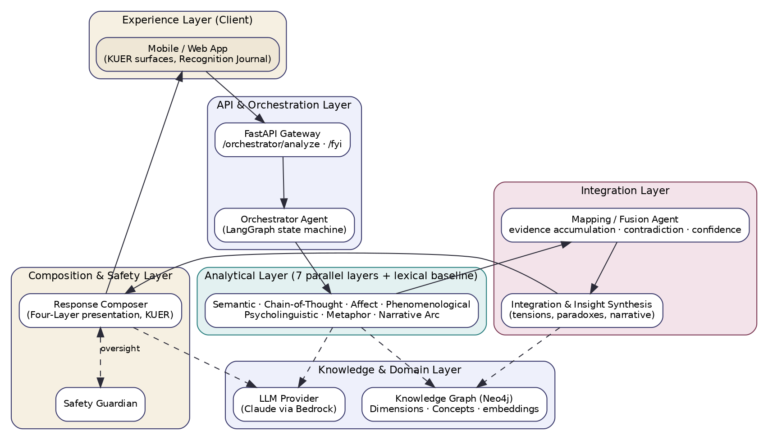
Figure 1 — Layered system architecture.
The remainder of this document specifies each band of Figure 1 in turn: the framework (Section 2 onward), the agents (Section 4), the pipeline (Section 5), the data and layer models (Sections 6–7), execution and communication (Sections 8–9), dependencies and confidence (Sections 10–12), the contracts that hold it together — schemas, APIs, knowledge graph, prompts (Sections 13–17) — and finally explainability, error handling, extensibility and the forward roadmap (Sections 18–21).

1.4 Design principles (normative)
The following principles are binding on every component. Where a technical choice would satisfy a functional requirement but violate one of these principles, the principle wins.
- Recognition, not diagnosis. Every layer emits observations, hypotheses and invitations — never labels, predictions or prescriptions. The user is the final authority on what resonates.
- Multi-perspective by construction. Complementary, overlapping, tense, paradoxical and even contradictory readings are retained. The system never manufactures agreement.
- Respect for human complexity. No reduction of a person to scores, types or a single story. Confidence is about the process, not the person.
- Layer independence. Each layer has defined responsibilities, inputs, outputs, algorithms and methods, and is independently useful.
- Meaningful integration. The Integration Layer synthesizes; it does not average.
- Extensible by design. New dimensions are admitted without redesign; N is a parameter.
- Scientific and computational rigor. Methods are grounded in affective computing, computational linguistics, psycholinguistics, computational phenomenology, narrative intelligence, computational metaphor theory, semantic analysis, explainable AI, multi-agent systems, knowledge graphs and LLMs.
- Philosophical integrity. Where choices exist, prefer the one that best supports epistemic humility, user agency, interpretability, transparency and reflective inquiry.

2. The 31-Dimension Framework

2.1 What a “dimension” is in Svarupa
A dimension is an interpretive lens — a self-contained perspective, drawn from a wisdom tradition, through which a person may recognize a pattern in their own experience. A dimension is not a classifier, a score, or a personality type. Formally, in this architecture a dimension is a registry entry with: a stable identifier, a name and traditional term, a family, a set of constructs (the sub-elements the tradition names), a canonical treatment of each construct across balance / excess / deficiency states, a body of source concepts (held in the knowledge graph), and a declared set of analytical-layer affinities describing which layers are competent to assess it.
This uniform shape is what makes the framework extensible: every dimension, however philosophically distinct, presents the same interface to the machinery around it.

2.2 The seven families
The thirty dimensions organize into seven families. Families are an organizing and routing convenience — they let the orchestrator reason about coverage and let the integration layer look for cross-family resonance — but they are not themselves analytical layers.
- Constitutional — the qualitative “material” of a person: elements, doshas, gunas, psychological constitution. (D1, D2, D3, D15)
- Consciousness & Embodiment — the layers and energetic anatomy in which experience is housed. (D4, D5, D6)
- Phenomenological — the structure of subjective experience itself. (D7)
- Affective (Rasa) — enduring and transient emotion. (D8, D9)
- Path & Practice — orientations to action and the disciplines that refine them. (D10, D11, D26, D30)
- Psychodynamic (Yoga-Sūtra mind-mechanics) — afflictions, mental modifications, obstacles, antidotes. (D19, D20, D21, D22)
- Karmic, Temporal & Developmental / Epistemic / Soteriological — the trajectories, lenses, ways of knowing, and the orienting vision and its practices. (D12, D13, D14, D16, D17, D18, D23, D24, D25, D27, D28, D29)

2.3 The dimension registry
The table below is the authoritative registry. Primary layer(s) names the analytical layer(s) chiefly responsible for assessing the dimension; Depends On lists upstream dimensions whose reading meaningfully conditions this one (see Section 10). Layer codes: SEM = Semantic Resonance, COT = Chain-of-Thought, AFF = Multi-Axis Affect, PHE = Phenomenological, PSY = Psycholinguistic, MET = Metaphor, NAR = Narrative Arc.
# | Dimension | Term | Family | Primary Layer(s) | Depends On
1 | Five Great Elements | Pañca Mahābhūtas | Constitutional | MET, PHE | —
2 | Three Gunas | Triguṇa — Sattva·Rajas·Tamas | Constitutional | AFF, PSY | —
3 | Sixteen Faces of Mind | Mānasika Prakṛti | Constitutional | COT | 2
4 | Seven Layers of Consciousness | Sapta Bhūmikā / Planes | Consciousness | PHE, COT | —
5 | Five Sheaths | Pañca Kośa | Consciousness | PHE, MET | 4
6 | Subtle Energies | Prāṇa Vāyus · Chakras · Nāḍīs | Consciousness | PHE, MET | 1, 5
7 | Phenomenological Dimensions | Phenomenology of Experience | Phenomenological | PHE | —
8 | Nine Enduring Emotions | Sthāyībhāvas | Affective | AFF | 7
9 | Thirty-Three Transient States | Vyabhicārībhāvas | Affective | AFF | 8, 2
10 | Paths of Engagement | Karma · Jñāna · Rāja · Bhakti | Path & Practice | NAR, COT | 3, 16
11 | Eightfold Refinement | Aṣṭāṅga Yoga | Path & Practice | COT | 10
12 | Architecture of Inner Life | Karma · Saṁskāra · Vāsanā · Eṣaṇā | Karmic & Temporal | NAR, PSY | —
13 | Cyclical Evolution of Consciousness | Kāla Chakra (individual) | Karmic & Temporal | NAR, COT | 12
14 | Yuga Cycles | Yuga (collective time) | Karmic & Temporal | NAR, COT | 13
15 | Tridosha | Vāta · Pitta · Kapha | Constitutional | PHE, MET | 1
16 | Inner Nature & Its Law | Svabhāva & Svadharma | Karmic & Temporal | NAR, COT | 3
17 | Three Lenses | Adhibhautika · Adhidaivika · Ādhyātmika | Perceptual & Epistemic | PSY | —
18 | Science of Cosmic Light | Jyotiṣ Śāstra | Cosmological | COT | —
19 | Five Afflictions | Pañca Kleśa | Psychodynamic | COT | —
20 | Five Modifications of Mind | Pañca Vṛtti | Psychodynamic | COT | 19
21 | The Nine Obstacles | Antarāyas | Psychodynamic | COT | 11
22 | Four Sublime Attitudes | Brahmavihāras | Psychodynamic | AFF, COT | —
23 | Fourfold Qualification | Sādhana Chatuṣṭaya | Ethical & Readiness | COT | —
24 | Divine & Demoniacal Endowments | Daivī & Āsurī Sampat | Ethical & Readiness | COT, AFF | —
25 | Upanishadic Meditations | Upāsanās & Vidyās | Soteriological | COT | 27
26 | The Embodied Path | Haṭha Disciplines | Path & Practice | COT | 6, 11
27 | The Non-Dual Vision | Advaita Darśana | Soteriological | COT | —
28 | The Ways of Knowing | Pramāṇa & Jñāna | Perceptual & Epistemic | COT | 17
29 | Anatomy of Bondage & Liberation | Bandha & Mokṣa | Soteriological | NAR, COT | 27
30 | Contemplative & Devotional Practice | Sādhanas | Path & Practice | COT | 25, 27

2.4 The layer–dimension affinity matrix
Not every layer assesses every dimension. The matrix below records, for each dimension, which layers are primary producers (●) and which are contributing producers (○). A blank cell means the layer does not assess that dimension at all — and that is by design. Forcing, say, the Metaphor Layer to score the Ways of Knowing would manufacture noise; restraint here is what keeps signals interpretable. The Semantic Resonance Layer is designed as a contributing recall mechanism for all thirty dimensions and is therefore shown as ○ broadly; it provides the baseline of “which dimensions are even in the neighbourhood of this expression.” (Per the §22 audit, this recall is currently effective only for the 17 grounded dimensions; see §22.3.) The assignments in this matrix incorporate the §22.4 revisions.
# | Dimension | SEM | COT | AFF | PHE | PSY | MET | NAR
1 | Five Great Elements | ○ | ○ |  | ● |  | ●
2 | Three Gunas | ○ | ○ | ● | ○ | ●
3 | Sixteen Faces of Mind | ○ | ● |  |  | ○
4 | Seven Layers of Consciousness | ○ | ● |  | ●
5 | Five Sheaths | ○ | ○ |  | ● |  | ●
6 | Subtle Energies | ○ | ○ |  | ● |  | ●
7 | Phenomenological Dimensions |  | ○ |  | ●
8 | Nine Enduring Emotions | ○ | ○ | ● | ○
9 | Thirty-Three Transient States | ○ | ○ | ● | ○
10 | Paths of Engagement | ○ | ● |  |  | ○ |  | ●
11 | Eightfold Refinement | ○ | ● |  |  |  |  | ○
12 | Architecture of Inner Life | ○ | ○ |  |  | ● |  | ●
13 | Cyclical Evolution of Consciousness | ○ | ● |  |  |  |  | ●
14 | Yuga Cycles | ○ | ● |  |  |  |  | ●
15 | Tridosha | ○ | ○ | ○ | ● |  | ●
16 | Inner Nature & Its Law | ○ | ● |  |  | ○ |  | ●
17 | Three Lenses | ○ | ○ |  |  | ●
18 | Science of Cosmic Light | ○ | ● |  |  |  |  | ○
19 | Five Afflictions | ○ | ● | ○ |  | ○
20 | Five Modifications of Mind | ○ | ● |  |  | ○
21 | The Nine Obstacles | ○ | ● | ○ |  | ○
22 | Four Sublime Attitudes | ○ | ● | ●
23 | Fourfold Qualification | ○ | ● |  |  | ○
24 | Divine & Demoniacal Endowments | ○ | ● | ● |  | ○
25 | Upanishadic Meditations | ○ | ●
26 | The Embodied Path | ○ | ● |  | ○
27 | The Non-Dual Vision | ○ | ●
28 | The Ways of Knowing | ○ | ● |  |  | ○
29 | Anatomy of Bondage & Liberation | ○ | ● |  |  |  |  | ●
30 | Contemplative & Devotional Practice | ○ | ● |  |  |  |  | ○

2.5 Dimension registry entries
Each entry below records the engineering-relevant facts for a dimension: its traditional source and family, its core constructs, the analytical layer(s) responsible for assessing it, its upstream dependencies and its downstream consumers. The full philosophical treatment of each dimension lives in the corresponding narrative in documentations/dimensions_new/, which remains authoritative.
D1 — Five Great Elements (Pañca Mahābhūtas)
Tradition source: Sāṁkhya, Āyurveda, Tantra. Family: Constitutional. Core constructs: Earth, Water, Fire, Air, Space — each in balance / excess / deficiency. Primary analytical layer(s): Metaphor Layer, Phenomenological Layer. Contributing layer(s): Semantic Resonance Layer, LLM Chain-of-Thought Layer. Upstream dependencies: none. Downstream consumers: Tridosha(15), Subtle Energies(6), Integration.
D2 — Three Gunas (Triguṇa — Sattva·Rajas·Tamas)
Tradition source: Bhagavad Gītā, Sāṁkhya. Family: Constitutional. Core constructs: Sattva (clarity), Rajas (activity), Tamas (inertia) as modes coloring all experience. Primary analytical layer(s): Multi-Axis Affect Layer, Psycholinguistic Layer. Contributing layer(s): Semantic Resonance Layer, LLM Chain-of-Thought Layer, Phenomenological Layer. Upstream dependencies: none. Downstream consumers: All dimensions (modulating prior); Integration.
D3 — Sixteen Faces of Mind (Mānasika Prakṛti)
Tradition source: Āyurveda, Vedic psychology. Family: Constitutional. Core constructs: 16 personality archetypes (7 sattvic, 6 rajasic, 3 tamasic) from guna combinations. Primary analytical layer(s): LLM Chain-of-Thought Layer. Contributing layer(s): Psycholinguistic Layer, Semantic Resonance Layer. Upstream dependencies: D2. Downstream consumers: Integration; Paths of Engagement(10).
D4 — Seven Layers of Consciousness (Sapta Bhūmikā / Planes)
Tradition source: Vedānta, Integral (Aurobindo). Family: Consciousness. Core constructs: Waking→psychic→transcendental (Turīya)→God→Unity→Cosmic consciousness planes. Primary analytical layer(s): Phenomenological Layer, LLM Chain-of-Thought Layer. Contributing layer(s): Semantic Resonance Layer. Upstream dependencies: none. Downstream consumers: Pancha Kosha(5); Integration.
D5 — Five Sheaths (Pañca Kośa)
Tradition source: Taittirīya Upaniṣad, Yoga. Family: Consciousness. Core constructs: Annamaya, Prāṇamaya, Manomaya, Vijñānamaya, Ānandamaya sheaths of embodiment. Primary analytical layer(s): Phenomenological Layer, Metaphor Layer. Contributing layer(s): Semantic Resonance Layer, LLM Chain-of-Thought Layer. Upstream dependencies: D4. Downstream consumers: Subtle Energies(6); Integration.
D6 — Subtle Energies (Prāṇa Vāyus · Chakras · Nāḍīs)
Tradition source: Yoga, Tantra, Upaniṣads. Family: Consciousness. Core constructs: 5 vāyus, 7 chakras, principal nāḍīs (Iḍā/Piṅgalā/Suṣumnā) — energetic anatomy. Primary analytical layer(s): Phenomenological Layer, Metaphor Layer. Contributing layer(s): Semantic Resonance Layer, LLM Chain-of-Thought Layer. Upstream dependencies: D1, D5. Downstream consumers: Integration; Hatha Disciplines(26).
D7 — Phenomenological Dimensions (Phenomenology of Experience)
Tradition source: Computational phenomenology, Yoga. Family: Phenomenological. Core constructs: Valence, arousal, clarity, self-location, agency, temporality, relational, somatic presence. Primary analytical layer(s): Phenomenological Layer. Contributing layer(s): LLM Chain-of-Thought Layer. Upstream dependencies: none. Downstream consumers: Affect(8,9); Integration (bridge dimension).
D8 — Nine Enduring Emotions (Sthāyībhāvas)
Tradition source: Nāṭyaśāstra, Rasa theory. Family: Affective. Core constructs: Rati, Hāsa, Śoka, Krodha, Utsāha, Bhaya, Jugupsā, Vismaya, Śama. Primary analytical layer(s): Multi-Axis Affect Layer. Contributing layer(s): Semantic Resonance Layer, LLM Chain-of-Thought Layer, Phenomenological Layer. Upstream dependencies: D7. Downstream consumers: Vyabhicaribhavas(9); Integration.
D9 — Thirty-Three Transient States (Vyabhicārībhāvas)
Tradition source: Nāṭyaśāstra, Rasa theory. Family: Affective. Core constructs: 33 transient bhāvas (e.g., Nirveda, Cintā, Harṣa, Garva) modulated by guna. Primary analytical layer(s): Multi-Axis Affect Layer. Contributing layer(s): Semantic Resonance Layer, LLM Chain-of-Thought Layer, Phenomenological Layer. Upstream dependencies: D8, D2. Downstream consumers: Integration (temporal weather).
D10 — Paths of Engagement (Karma · Jñāna · Rāja · Bhakti)
Tradition source: Bhagavad Gītā, Vedānta. Family: Path & Practice. Core constructs: Four mārgas / orientations to action, knowledge, integration, devotion. Primary analytical layer(s): Narrative Arc Layer, LLM Chain-of-Thought Layer. Contributing layer(s): Semantic Resonance Layer, Psycholinguistic Layer. Upstream dependencies: D3, D16. Downstream consumers: Practice dims(11,26,30); Integration.
D11 — Eightfold Refinement (Aṣṭāṅga Yoga)
Tradition source: Yoga Sūtras. Family: Path & Practice. Core constructs: Yama, Niyama, Āsana, Prāṇāyāma, Pratyāhāra, Dhāraṇā, Dhyāna, Samādhi. Primary analytical layer(s): LLM Chain-of-Thought Layer. Contributing layer(s): Semantic Resonance Layer, Narrative Arc Layer. Upstream dependencies: D10. Downstream consumers: Integration; developmental-readiness signals.
D12 — Architecture of Inner Life (Karma · Saṁskāra · Vāsanā · Eṣaṇā)
Tradition source: Vedic psychology, Yoga. Family: Karmic & Temporal. Core constructs: Action→impression→latent tendency→root craving closed loop. Primary analytical layer(s): Narrative Arc Layer, Psycholinguistic Layer. Contributing layer(s): Semantic Resonance Layer, LLM Chain-of-Thought Layer. Upstream dependencies: none. Downstream consumers: Cyclical Evolution(13); Integration.
D13 — Cyclical Evolution of Consciousness (Kāla Chakra (individual))
Tradition source: Vedic cosmology, Vedānta. Family: Karmic & Temporal. Core constructs: Descending (Pravṛtti) / nadir / ascending (Nivṛtti) arcs of individual evolution. Primary analytical layer(s): Narrative Arc Layer, LLM Chain-of-Thought Layer. Contributing layer(s): Semantic Resonance Layer. Upstream dependencies: D12. Downstream consumers: Yuga Cycles(14); Integration.
D14 — Yuga Cycles (Yuga (collective time))
Tradition source: Vedic cosmology. Family: Karmic & Temporal. Core constructs: Satya/Tretā/Dvāpara/Kali dharma-gradient; individual–age mismatch. Primary analytical layer(s): Narrative Arc Layer, LLM Chain-of-Thought Layer. Contributing layer(s): Semantic Resonance Layer. Upstream dependencies: D13. Downstream consumers: Integration (collective-context lens).
D15 — Tridosha (Vāta · Pitta · Kapha)
Tradition source: Āyurveda. Family: Constitutional. Core constructs: Movement, transformation, structure forces; Prakṛti vs Vikṛti. Primary analytical layer(s): Phenomenological Layer, Metaphor Layer. Contributing layer(s): Semantic Resonance Layer, LLM Chain-of-Thought Layer, Multi-Axis Affect Layer. Upstream dependencies: D1. Downstream consumers: Subtle Energies(6); Integration.
D16 — Inner Nature & Its Law (Svabhāva & Svadharma)
Tradition source: Bhagavad Gītā, Aurobindo. Family: Karmic & Temporal. Core constructs: Intrinsic nature and its aligned action; degree of inner/outer alignment. Primary analytical layer(s): Narrative Arc Layer, LLM Chain-of-Thought Layer. Contributing layer(s): Semantic Resonance Layer, Psycholinguistic Layer. Upstream dependencies: D3. Downstream consumers: Paths of Engagement(10); Integration.
D17 — Three Lenses (Adhibhautika · Adhidaivika · Ādhyātmika)
Tradition source: Tapatraya, Yāska. Family: Perceptual & Epistemic. Core constructs: Three attributional orientations to the source of experience/suffering. Primary analytical layer(s): Psycholinguistic Layer. Contributing layer(s): LLM Chain-of-Thought Layer, Semantic Resonance Layer. Upstream dependencies: none. Downstream consumers: Ways of Knowing(28); Integration.
D18 — Science of Cosmic Light (Jyotiṣ Śāstra)
Tradition source: Jyotiṣa. Family: Cosmological. Core constructs: Graha principles (Sūrya…Śani, Rāhu/Ketu) as phenomenological archetypes; daśā/gochara timing. Primary analytical layer(s): LLM Chain-of-Thought Layer. Contributing layer(s): Semantic Resonance Layer, Narrative Arc Layer. Upstream dependencies: none. Downstream consumers: Integration (archetypal-timing lens).
D19 — Five Afflictions (Pañca Kleśa)
Tradition source: Yoga Sūtras (Sādhana Pāda). Family: Psychodynamic. Core constructs: Avidyā, Asmitā, Rāga, Dveṣa, Abhiniveśa — the colorings beneath suffering. Primary analytical layer(s): LLM Chain-of-Thought Layer. Contributing layer(s): Psycholinguistic Layer, Multi-Axis Affect Layer, Semantic Resonance Layer. Upstream dependencies: none. Downstream consumers: Vrittis(20); Integration.
D20 — Five Modifications of Mind (Pañca Vṛtti)
Tradition source: Yoga Sūtras (Samādhi Pāda). Family: Psychodynamic. Core constructs: Pramāṇa, Viparyaya, Vikalpa, Nidrā, Smṛti — kinds of mental movement. Primary analytical layer(s): LLM Chain-of-Thought Layer. Contributing layer(s): Psycholinguistic Layer, Semantic Resonance Layer. Upstream dependencies: D19. Downstream consumers: Integration; cognition-quality signals.
D21 — The Nine Obstacles (Antarāyas)
Tradition source: Yoga Sūtras (I.30–31). Family: Psychodynamic. Core constructs: Nine distractions + companions that stall practice. Primary analytical layer(s): LLM Chain-of-Thought Layer. Contributing layer(s): Semantic Resonance Layer, Psycholinguistic Layer, Multi-Axis Affect Layer. Upstream dependencies: D11. Downstream consumers: Integration; practice-friction signals.
D22 — Four Sublime Attitudes (Brahmavihāras)
Tradition source: Yoga Sūtras (I.33), shared tradition. Family: Psychodynamic. Core constructs: Maitrī, Karuṇā, Muditā, Upekṣā as relational antidotes. Primary analytical layer(s): Multi-Axis Affect Layer, LLM Chain-of-Thought Layer. Contributing layer(s): Semantic Resonance Layer. Upstream dependencies: none. Downstream consumers: Integration; relational-stance signals.
D23 — Fourfold Qualification (Sādhana Chatuṣṭaya)
Tradition source: Vivekachūḍāmaṇi, Vedānta. Family: Ethical & Readiness. Core constructs: Viveka, Vairāgya, Ṣaṭ-Sampat (six treasures), Mumukṣutva. Primary analytical layer(s): LLM Chain-of-Thought Layer. Contributing layer(s): Semantic Resonance Layer, Psycholinguistic Layer. Upstream dependencies: none. Downstream consumers: Integration; readiness gating.
D24 — Divine & Demoniacal Endowments (Daivī & Āsurī Sampat)
Tradition source: Bhagavad Gītā 16. Family: Ethical & Readiness. Core constructs: Two trajectories of character built from foundational virtues. Primary analytical layer(s): LLM Chain-of-Thought Layer, Multi-Axis Affect Layer. Contributing layer(s): Semantic Resonance Layer, Psycholinguistic Layer. Upstream dependencies: none. Downstream consumers: Integration; character-trajectory signals.
D25 — Upanishadic Meditations (Upāsanās & Vidyās)
Tradition source: Principal Upaniṣads. Family: Soteriological. Core constructs: Contemplative re-identifications that relocate the sense of self. Primary analytical layer(s): LLM Chain-of-Thought Layer. Contributing layer(s): Semantic Resonance Layer. Upstream dependencies: D27. Downstream consumers: Integration; practice-recommendation context.
D26 — The Embodied Path (Haṭha Disciplines)
Tradition source: Haṭha Yoga Pradīpikā, Gheraṇḍa Saṁhitā. Family: Path & Practice. Core constructs: Cleansing, posture, locks/seals, kuṇḍalinī-work; saptāṅga ladder. Primary analytical layer(s): LLM Chain-of-Thought Layer. Contributing layer(s): Semantic Resonance Layer, Phenomenological Layer. Upstream dependencies: D6, D11. Downstream consumers: Integration; embodied-practice context.
D27 — The Non-Dual Vision (Advaita Darśana)
Tradition source: Upaniṣads, Aṣṭāvakra Gītā. Family: Soteriological. Core constructs: Mahāvākyas, the Fourth state, Self-in-all as the orienting view. Primary analytical layer(s): LLM Chain-of-Thought Layer. Contributing layer(s): Semantic Resonance Layer. Upstream dependencies: none. Downstream consumers: Bondage/Liberation(29); Integration (view lens).
D28 — The Ways of Knowing (Pramāṇa & Jñāna)
Tradition source: Upaniṣads, Gītā, Vedānta. Family: Perceptual & Epistemic. Core constructs: Higher/lower knowledge, discrimination, limits of the knower. Primary analytical layer(s): LLM Chain-of-Thought Layer. Contributing layer(s): Psycholinguistic Layer, Semantic Resonance Layer. Upstream dependencies: D17. Downstream consumers: Integration; epistemic-stance signals.
D29 — Anatomy of Bondage & Liberation (Bandha & Mokṣa)
Tradition source: Aṣṭāvakra Gītā, Vivekachūḍāmaṇi. Family: Soteriological. Core constructs: Superimposition mechanism; structures, stages, turning points of the journey. Primary analytical layer(s): Narrative Arc Layer, LLM Chain-of-Thought Layer. Contributing layer(s): Semantic Resonance Layer. Upstream dependencies: D27. Downstream consumers: Integration (trajectory synthesis).
D30 — Contemplative & Devotional Practice (Sādhanas)
Tradition source: Upaniṣads, Bhāgavatam, Gītā. Family: Path & Practice. Core constructs: Inquiry, Name, meditation, devotion, sacred action as the bridge to realization. Primary analytical layer(s): LLM Chain-of-Thought Layer. Contributing layer(s): Semantic Resonance Layer, Narrative Arc Layer. Upstream dependencies: D25, D27. Downstream consumers: Integration; practice-recommendation engine.

2.6 The reserved 31st dimension (D31)
The framework is named for thirty-one dimensions because the architecture deliberately keeps the registry open. D31 is a ratified but unfilled slot. It exists to make a point structurally rather than rhetorically: Svarupa’s understanding of a person is never complete, and the system must never behave as though its current set of lenses exhausts human experience. When a thirty-first dimension is authored, it is admitted through the procedure in Section 20 — author the narrative, register the entry (id, term, family, constructs, layer affinities, dependencies), seed the knowledge graph, and configure prompts — with no change to the orchestrator, fusion or integration code. Until then, D31 is surfaced in internal tooling as an explicit “reserved / not yet authored” entry so that no consumer mistakes the registry for a closed set.

3. System Architecture

3.1 Architectural style
Svarupa follows clean / hexagonal architecture: dependencies point inward, the domain core (dimensions, signals, insights) knows nothing of frameworks, and outer rings (API, persistence, LLM and graph adapters) depend on inner abstractions through ports. Layered on top of this is an agentic organization: the analytical work is performed by autonomous agents coordinated by an orchestrator, communicating through typed messages rather than shared mutable state.
The two views are complementary. Clean architecture governs where code may depend; the agentic model governs how work flows at runtime. Figure 1 (Section 1.3) shows the runtime bands; the dependency rule keeps the inner bands ignorant of the outer.

3.2 The bands of the system
Experience Layer (client). Mobile-first surfaces that present KUER content and host the Recognition Journal. The client never sees raw dimensional scores; it receives composed, stage-appropriate perspectives.
API & Orchestration Layer. A FastAPI gateway exposes the analysis endpoints and injects dependencies; the Orchestrator Agent, implemented as a LangGraph state machine, drives a single analysis from ingestion through composition.
Analytical Layer. Seven analytical layers run concurrently, plus a deterministic lexical baseline that provides cheap, transparent priors. Each layer is an autonomous agent that reads the prepared expression and emits typed DimensionalSignals for the dimensions it is competent to assess.
Integration Layer. The Mapping/Fusion Agent reconciles the seven layers’ signals into a single FusedRelevance per dimension; the Integration Agent then synthesizes fused relevances into Insights that explicitly carry tensions and paradoxes.
Composition & Safety Layer. The Response Composer renders insights as a KUER Insight Card in the appropriate presentation layer; the Safety Guardian provides continuous oversight, with authority to reframe or halt.
Knowledge & Domain Layer. A Neo4j knowledge graph holds dimensions, concepts, states, sources and their embeddings; the LLM provider (Claude via AWS Bedrock) serves reasoning and composition calls. Both are reached only through ports.

3.3 Cross-cutting concerns
Four concerns cut across every band and are specified where they live: traceability (every signal, fusion and insight carries provenance — Section 18), confidence (separated from relevance throughout — Section 12), safety (a guardian with veto — Sections 4 and 19), and configuration (dimensions, layers and bindings as data — Section 20).

4. Agent Architecture

4.1 Why agents
Two properties of the problem make an agentic decomposition natural. First, the analytical methods are genuinely heterogeneous — an embedding search, a chain-of-thought LLM call, and a psycholinguistic feature extractor share almost no machinery — so encapsulating each as an agent with a narrow contract keeps them independently testable and replaceable. Second, the philosophy requires that perspectives be able to disagree; modelling each analytical method as an autonomous agent that owns its own reading makes disagreement a first-class, inspectable outcome rather than a bug to be smoothed away.
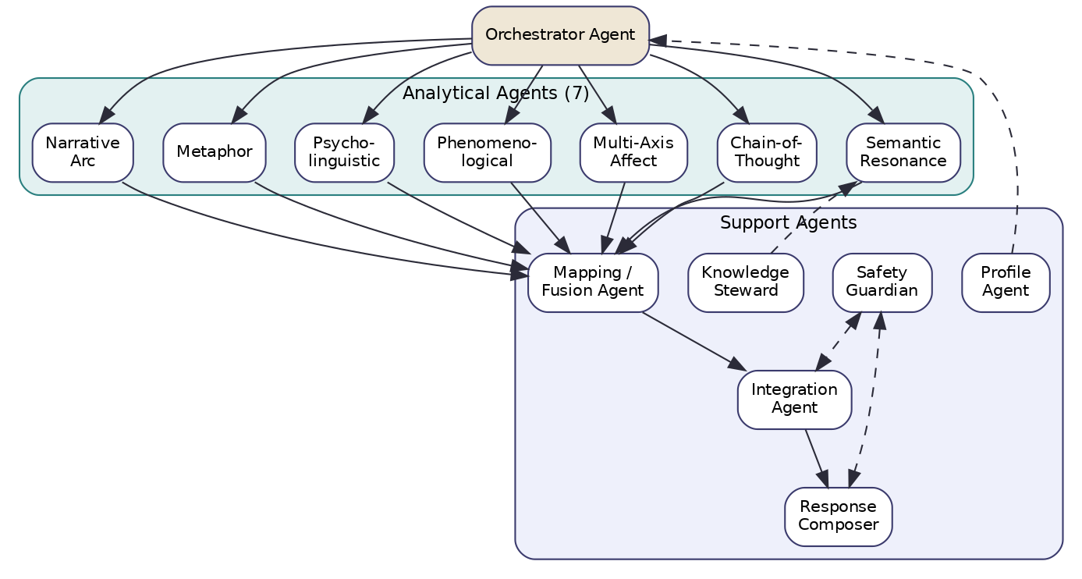
Figure 2 — Agent architecture: orchestrator, seven analytical agents, and support agents.

4.2 The agents and their contracts
Orchestrator Agent. Owns the lifecycle of a single analysis. Prepares the analysis text, runs the safety pre-screen, fans out to the analytical agents, collects their results (honouring per-layer timeouts), and hands off to fusion. It holds no analytical opinion of its own; its competence is coordination. Implemented as a LangGraph state machine (Section 8.2).
Seven Analytical Agents — Semantic Resonance, Chain-of-Thought, Multi-Axis Affect, Phenomenological, Psycholinguistic, Metaphor, Narrative Arc. Each accepts the prepared expression (plus, where relevant, the readings of dimensions it depends on) and returns DimensionalSignals only for the dimensions in its declared affinity set. Each is independently deployable and independently degradable. Section 7 specifies them in full.
Mapping / Fusion Agent. Consumes all DimensionalSignals and produces one FusedRelevance per implicated dimension, recording agreement, contradiction and the contributing layers. It performs reconciliation, not interpretation.
Integration Agent. Consumes FusedRelevances and produces Insights: cross-dimensional observations that preserve tension and paradox, each framed as an invitation. This is where multidimensional understanding is actually assembled.
Response Composer. Renders insights into a KUER Insight Card in one of the four presentation layers, with appropriate epistemic hedging. It may call the LLM; it may not invent dimensional content not present in the insights.
Safety Guardian. Runs before fan-out (crisis pre-screen) and after composition (framing review). It can divert to a resource/support path, demand a reframe, or halt. It is the one agent permitted to override others.
Knowledge Steward (support). Mediates all knowledge-graph access: concept retrieval, embedding search, and write-back of curated patterns. Keeps analytical agents ignorant of storage details.
Profile Agent (support). Supplies optional, user-controlled context (presentation-layer preference, prior pinned FYI text). Per the current runtime contract, stored personality traits shape downstream framing only and do not enter the seven-layer fusion unless the user pins them as analysis input — preserving the principle that the system reads the present expression, not a stored verdict about the person.

4.3 Autonomy boundaries
Autonomy is bounded by contract. An analytical agent is free in how it reaches its reading but bound in what it may emit (typed signals, within its affinity set, with provenance and process-confidence). No agent may emit a diagnosis, a prediction, or a prescription; the Safety Guardian and the schema both enforce this. Agents never write to each other’s state; all influence flows through typed messages routed by the orchestrator.

5. Processing Pipeline

5.1 Overview
A single analysis flows left to right: the expression is prepared, fanned out to seven concurrent layers, fused, integrated, composed and returned. Total wall-clock time approximates the slowest layer plus fusion, integration and composition, because the seven layers run in parallel.
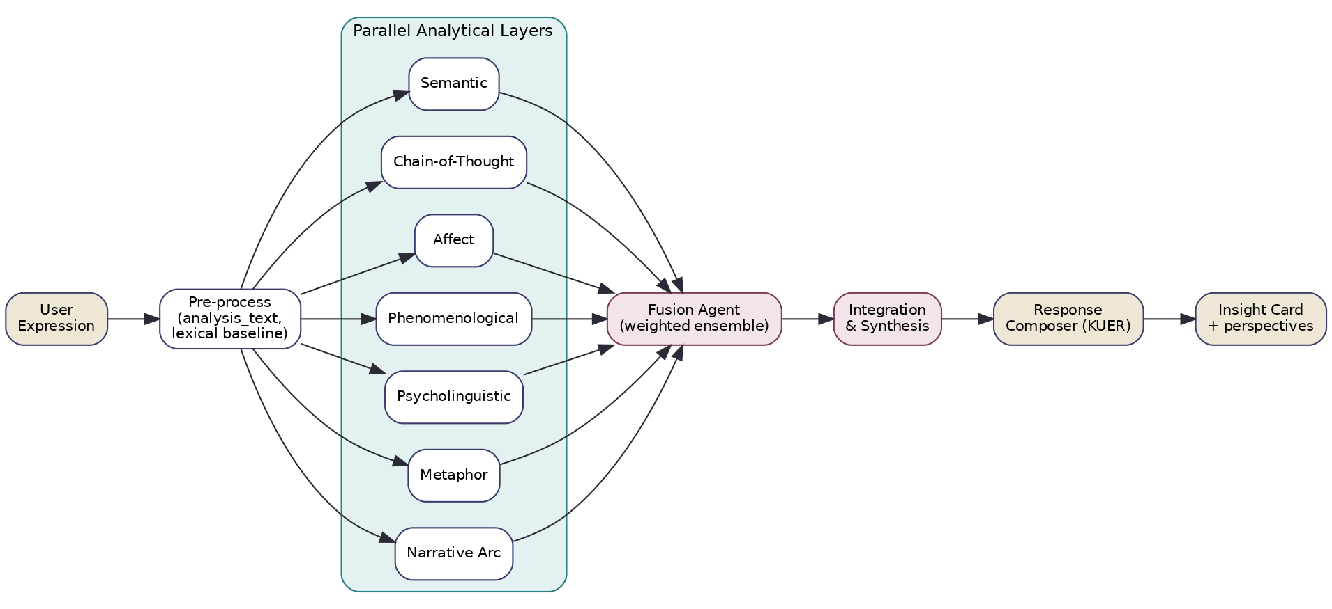
Figure 3 — Processing pipeline: parallel analytical layers feeding fusion, integration and composition.

5.2 Stages
Pre-process. The orchestrator concatenates raw_text with any non-empty pinned FYI paragraphs into a single analysis_text, computes the deterministic lexical baseline (keyword/concept hits per dimension, fully transparent and cheap), and attaches request options.
Parallel analytical layers. The single analysis_text is the input to all seven layers. Each runs under its own timeout and emits DimensionalSignals for its affinity set. A layer that errors or times out returns nothing; the pipeline degrades gracefully (Section 19).
Fusion. The Fusion Agent reconciles signals into FusedRelevance per dimension (Section 12).
Integration. The Integration Agent synthesizes fused relevances into Insights, deliberately retaining contradictions surfaced by fusion.
Composition. The Response Composer renders the insights as a KUER Insight Card in the chosen presentation layer; the Safety Guardian reviews framing before the response is returned and traced.

5.3 Latency budget (target)
Stage | Target (p50) | Notes
Pre-process + lexical baseline | < 50 ms | deterministic, in-process
Parallel layers | 1.5–3.0 s | bounded by Chain-of-Thought; others overlap
Fusion | < 100 ms | vectorized reconciliation
Integration | 0.8–2.0 s | one LLM synthesis call
Composition | 0.8–2.0 s | one LLM composition call
Safety review | < 300 ms | classifier + rules
Integration and composition can be merged into a single LLM call for latency-sensitive surfaces, at some cost to inspectability; the default keeps them separate for traceability.

6. Data Model

6.1 Core entities
Five entities carry an analysis from request to response. Their relationships are shown in Figure 4; their JSON schemas are given in full in Section 13.
Figure 4 — Core data entities and their flow.
AnalysisRequest. The unit of work: a request identifier, the user’s raw_text, any pinned fyi_paragraphs, an optional profile reference, and processing options (presentation-layer preference, latency mode, requested depth). It is immutable once accepted.
DimensionalSignal. A single layer’s reading of a single dimension. It names the producing layer, the dimension_id, a relevance in [0,1] (how strongly the layer sees this dimension implicated), a confidence in [0,1] (the layer’s trust in its own reading), an evidence list (spans, features, or reasoning fragments), and an optional state_hint (balance / excess / deficiency) with its own confidence. A layer emits signals only for its affinity set; absence is informative.
FusedRelevance. The reconciliation of all signals for one dimension: a fused relevance, a process_confidence, an agreement measure, a contradiction measure, and the list of contributing_layers. This is the object the integration layer reasons over.
Insight. A synthesized recognition spanning one or more dimensions: the dimension_ids involved, an observation (framed as something that may be present), an explicit tensions list (where dimensions pull in different directions), an invitation (a reflective prompt, never an instruction), and an insight-level confidence.
InsightCard. The composed response: the kuer_stage, the presentation_layer, an ordered list of perspectives (rendered insights), and provenance linking each perspective back to the insights, fused relevances and signals that produced it.

6.2 Invariants
The data model encodes the philosophy as invariants the rest of the system can rely on:
- Relevance and confidence are always separate fields. No code path may collapse them into a single “score”. Relevance answers how implicated; confidence answers how much we trust our reading.
- Confidence is process-scoped. Every confidence in the model is documented as confidence in the analytical process. There is no field anywhere that represents certainty about the user’s inner state.
- Absence is data. A dimension with no signals is recorded as “not assessed”, distinct from “assessed and found irrelevant”.
- Provenance is mandatory. Every FusedRelevance references its source signals; every Insight references its fused relevances; every InsightCard perspective references its insights. The chain is unbroken, enabling the explainability guarantees of Section 18.
- Tensions are retained, not resolved. The tensions field on Insight is a required (possibly empty) list; the integration step is forbidden from discarding a contradiction merely to make the card tidier.

6.3 Persistence
Requests, signals, fused relevances, insights and cards are persisted for traceability and offline calibration. The knowledge graph (Section 15) holds the comparatively static dimension/concept material. User-controlled profile data lives in a separate store under the Profile Agent and is never silently merged into analysis input.

7. Layer Architecture — the Redesigned Analytical Framework
This section re-specifies the seven analytical layers from first principles. It is the heart of the v7.0 evolution and the engineering expression of “multi-perspective by construction.” For each layer it gives: a conceptual foundation (purpose, research background, theoretical justification); a computational design (inputs, outputs, methodology, algorithms, prompting/LLM workflow, validation); its Svarupa integration (which dimensions it owns and why, relationships with other layers, shared information, agent interactions); an engineering specification (confidence estimation, failure modes, logging, traceability, explainability, scalability); and future enhancements.
A design rule governs the whole section: a layer assesses only the dimensions for which its method is theoretically competent. The figure below shows each layer with its primary dimensions; the affinity matrix in Section 2.4 is the authoritative binding.
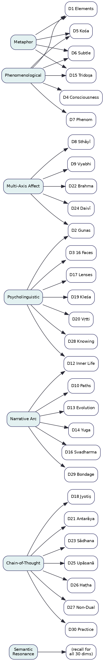
Figure 5 — Analytical layers and their primary dimensions.

7.1 Semantic Resonance Layer (SEM)
Conceptual foundation. Purpose: establish, cheaply and broadly, which dimensions are even in the semantic neighbourhood of an expression, so that the more expensive layers and the integration step have a recall floor. Research background: dense-vector semantic similarity and retrieval-augmented reasoning; sentence/embedding models; approximate nearest-neighbour search. Justification: keyword matching fails the moment a person uses colloquial or metaphorical language; embedding similarity captures meaning even when vocabulary diverges entirely from the tradition’s terms, which is the common case for Svarupa’s users.
Computational design. Inputs: analysis_text. Outputs: DimensionalSignals (contributing) for any of the thirty dimensions whose concept embeddings the expression resonates with. Methodology: embed the expression (Cohere embeddings via Bedrock), run vector search over (:Concept) nodes in Neo4j, aggregate concept hits to dimension-level relevance, and convert similarity distributions into per-dimension relevance and confidence. Algorithm: k-NN over the concept vector index; dimension relevance = a saturating aggregation (e.g. soft-max-weighted mean of top-k concept similarities mapped to that dimension); confidence rises with hit density and margin. Prompting: none — this layer is deterministic given the index. Validation: retrieval quality measured against a curated gold set of expression→dimension judgements; calibration of the similarity→relevance mapping via isotonic regression.
Svarupa integration. Dimensions: designed to contribute to all thirty as a recall mechanism; it is rarely the primary layer because resonance alone does not establish how a dimension is implicated. Current limitation (§22.3/22.6): concept embeddings exist for only the 17 grounded dimensions, so SEM presently has no recall for D17 and D19–D30 until their narratives are chunked into concept nodes and embedded. Relationships: it seeds the candidate set the other layers and integration consider; it is the safety net that prevents a dimension from being missed entirely because no specialist fired. Shared information: its per-dimension relevance is a prior that fusion down-weights when specialist layers disagree. Agent interactions: reads through the Knowledge Steward; never calls the LLM.
Engineering specification. Confidence: a function of top-k similarity margin and concept-hit density; low when hits are diffuse. Failure modes: embedding-service outage (fall back to lexical baseline), sparse index for a new dimension (flagged as low-coverage). Logging/traceability: the contributing concept nodes and their similarities are logged per signal. Explainability: “this resonated with concepts X, Y, Z belonging to dimension D.” Scalability: sub-100 ms with a warm ANN index; trivially horizontally scalable.
Future enhancements. Hybrid sparse-dense retrieval; per-family sub-indices; learned query expansion that paraphrases colloquial input toward concept space without leaking taxonomy to the user.

7.2 LLM Chain-of-Thought Layer (COT)
Conceptual foundation. Purpose: perform dimensional reading as an explicit reasoning task for the dimensions that require interpretive judgement rather than surface features — the soteriological, epistemic, practice and subtle psychodynamic dimensions. Research background: chain-of-thought and deliberate reasoning in LLMs; structured/constrained decoding; self-consistency. Justification: dimensions such as the Non-Dual Vision, the Ways of Knowing, the Kleśas or Sādhana Chatuṣṭaya are not detectable from word counts or affect axes; recognizing them requires reasoning about what an expression implies about a person’s relationship to knowledge, craving, or practice. An LLM prompted to reason step-by-step, then commit to structured per-dimension judgements, is the only tractable method.
Computational design. Inputs: analysis_text, the candidate dimension set from SEM, and the readings of any dependency dimensions. Outputs: DimensionalSignals (primary for D3, D18, D19, D20, D21, D23, D24, D25, D26, D27, D28, D29, D30; contributing widely — see the revised assignments in §22.4). Methodology: a structured prompt that asks the model to (1) reason about the expression, (2) for each candidate dimension judge relevance, state (balance/excess/deficiency) and supporting evidence, and (3) abstain explicitly when evidence is thin. Algorithm: constrained JSON output; optional self-consistency over n samples with agreement used as a confidence input. Prompting strategy: see Section 16 — a system contract enforcing recognition-not-diagnosis, a reasoning scaffold, and a strict output schema with a mandatory “insufficient evidence” option. Validation: rubric-based grading against expert annotations; abstention calibration (the model should decline when humans would).
Svarupa integration. Dimensions: primary for the interpretive dimensions where no feature-based layer is competent; contributing elsewhere as a reasoning cross-check. Relationships: it is the layer most able to articulate why a dimension is implicated, so its evidence strings are weighted heavily by the composer. Shared information: consumes dependency readings (e.g. it reads D27 Non-Dual Vision when assessing D29 Bondage & Liberation). Agent interactions: the heaviest LLM consumer; orchestrated under the budget controls of Section 17.
Engineering specification. Confidence: blends the model’s self-reported evidence strength with self-consistency agreement; capped to prevent overconfidence. Failure modes: hallucinated evidence (mitigated by requiring verbatim span citation), schema violation (repaired or dropped), latency spikes (per-call timeout, partial results). Logging: full prompt, reasoning trace and parsed output retained. Explainability: the reasoning trace is the explanation, surfaced (in summarized form) in provenance. Scalability: the latency-dominant layer; managed via batching candidate dimensions into one call and caching by expression hash.
Future enhancements. Per-dimension fine-tuned adapters; tool-augmented reasoning that lets the model consult the knowledge graph mid-reasoning; verifier models that check evidence citations.

7.3 Multi-Axis Affect Layer (AFF)
Conceptual foundation. Purpose: characterize the emotional texture of an expression along multiple axes and map it to the affective dimensions. Research background: affective computing; the Valence–Arousal–Dominance model; Plutchik’s wheel; aspect-based sentiment. Justification: Svarupa’s affective dimensions (the nine enduring emotions and thirty-three transient states) are far richer than positive/negative sentiment. A multi-axis representation — and an explicit bridge between Western affect models and the Rasa taxonomy — is needed to read them without flattening.
Computational design. Inputs: analysis_text; optionally the Phenomenological Layer’s valence/arousal readings (shared, see below). Outputs: DimensionalSignals primary for D8 (Sthāyībhāvas) and D9 (Vyabhicārībhāvas), contributing to D2 (Gunas), D19 (Kleśas — rāga/dveṣa only), D22 (Brahmavihāras), D24 (Daivī/Āsurī). It shares valence/arousal features with PHE but does not emit a D7 signal (§22.4). Methodology: score the expression on VAD and on a discrete-emotion set, perform aspect-based attribution (which target the emotion attaches to), then map the affect profile onto enduring vs transient bhāvas using a curated correspondence table and guna modulation. Algorithm: a fine-tuned multi-label affect classifier for axes and discrete emotions; a deterministic affect→bhāva mapping with guna-conditioned weighting; transient-vs-enduring discrimination via temporal-language cues shared with the Narrative layer. Prompting: optional LLM assist for subtle or mixed affect, otherwise model-based. Validation: against affect-annotated corpora and a Rasa-mapped gold set; inter-annotator agreement as a ceiling.
Svarupa integration. Dimensions: D8, D9 primary; D2, D22, D24 contributing. Why: these dimensions are about emotion; no other layer is competent to distinguish, say, Śoka-as-sacred-opening from Śoka-as-identity. (D19 contribution is limited to rāga/dveṣa as affective pulls; see §22.4.) Relationships: shares valence/arousal with the Phenomenological Layer (computed once, consumed by both) and temporal cues with the Narrative layer. Agent interactions: primarily model-based; LLM only for ambiguous cases.
Engineering specification. Confidence: classifier margin plus axis agreement; lowered for mixed/ambivalent affect. Failure modes: sarcasm and culturally specific affect (flagged, deferred to COT). Logging: axis scores, discrete-emotion distribution, and the affect→bhāva mapping path. Explainability: “the language carries high arousal and negative valence directed at the self, consistent with the excess pole of D9 Cintā.” Scalability: fast, batchable.
Future enhancements. Multimodal affect (voice/journaling cadence) where available; learned (rather than curated) affect→Rasa mapping trained on expert labels; appraisal-theory features.

7.4 Phenomenological Layer (PHE)
Conceptual foundation. Purpose: describe the structure of subjective experience — independent of its emotional content — along the phenomenological axes the tradition and modern computational phenomenology share. Research background: computational phenomenology; micro-phenomenology; the experiential primitives of valence, arousal, clarity, self-location, agency, temporality, relational quality and somatic presence. Justification: the same emotion can be lived with very different structure (located in the body vs observed from above; with agency vs without). The Phenomenological dimension (D7) is explicitly this structural description, and it is the bridge between the felt-quality dimensions and the rest of the system.
Computational design. Inputs: analysis_text. Outputs: DimensionalSignals primary for D7, and contributing to the embodiment/constitutional dimensions whose signature is a felt quality — D1 (Elements), D4 (Consciousness layers), D5 (Kośa), D6 (Subtle Energies), D15 (Tridoṣa). Methodology: extract the eight phenomenological axes from the expression; map characteristic axis-patterns onto the felt-quality dimensions (e.g. low somatic presence + diffuse self-location → Ākāśa/space signature; high heat/intensity language → Agni/Pitta signature). Algorithm: a span-level feature extractor for each axis (combining lexicon, syntactic and embedding features) plus a pattern-matcher to dimension signatures; LLM assist for self-location and agency, which resist surface features. Prompting: targeted micro-prompts for the harder axes. Validation: against phenomenologically annotated text; ablation of each axis’s contribution.
Svarupa integration. Dimensions: D7 primary; D1, D4, D5, D6, D15 contributing via felt-quality signatures. Note (§22.5): for D7 the layer emits per-axis values on natural scales, not balance/excess/deficiency poles, and for D4/D5 it emits a locus (which plane/kośa predominates), not a pole. Why: these constitutional/embodiment dimensions are recognized through how experience feels and is structured, which is precisely this layer’s competence. Relationships: shares valence/arousal with AFF; feeds MET (elemental/energetic metaphors corroborate phenomenological signatures). Agent interactions: mixed model + LLM.
Engineering specification. Confidence: per-axis extraction confidence aggregated; signature matches require multiple corroborating axes. Failure modes: terse expressions with little experiential content (low coverage, flagged). Logging: the eight axis values and the signature-match rationale. Explainability: “self-location is described as ‘watching from outside’, agency is low — a dissociated-above structure.” Scalability: moderate; LLM assist is the cost driver.
Future enhancements. A learned axis extractor trained on micro-phenomenological interviews; tighter coupling with MET so metaphor and phenomenology jointly identify elemental signatures.

7.5 Psycholinguistic Layer (PSY)
Conceptual foundation. Purpose: read the form of language — pronouns, agency, cognitive complexity, temporal orientation, coherence — as a window onto cognitive-constitutional dimensions. Research background: computational psycholinguistics; LIWC-style lexical analysis; discourse coherence; agency and attribution in narrative. Justification: how a person constructs sentences reveals dimensions that content alone hides. Passive constructions and external attribution implicate the Adhibhautika lens (D17); excessive first-person singular and rumination markers implicate Vṛtti/Saṁskāra dynamics (D20, D12); coherence vs fragmentation tracks the sattva–rajas–tamas gradient (D2).
Computational design. Inputs: analysis_text. Outputs: DimensionalSignals primary for D17 (Three Lenses) and, co-primary with AFF, D2 (Gunas, via coherence/agency); contributing features to D3, D12, D16, D19 (asmitā), D20 (vikalpa/smṛti) and D28 — all of which are COT-primary. PSY does not adjudicate archetype identity (D3) or valid-vs-erroneous cognition (D20). See the revised assignments in §22.4. Methodology: extract a fixed feature vector — pronoun distribution, agency ratio (agentive vs passive), causal/insight connective density, temporal orientation, lexical diversity, coherence — then map feature patterns to dimensions via interpretable rules and a calibrated linear model. Algorithm: deterministic feature extraction (dependency parse + lexicons) feeding a logistic mapping per dimension; fully white-box. Prompting: none. Validation: feature reliability against established psycholinguistic norms; mapping accuracy against a gold set.
Svarupa integration. Dimensions: as above. Why: these dimensions have linguistic signatures that are more reliable than content — agency and attribution are exactly what D17 is about. Relationships: shares temporal-orientation features with NAR; its agency reading cross-checks AFF’s aspect attribution. Agent interactions: fully local, no LLM, making it the most transparent layer.
Engineering specification. Confidence: feature reliability × mapping margin; short texts lower confidence sharply. Failure modes: very short or fragmentary input; non-native syntax (parser-robust features preferred). Logging: the full feature vector. Explainability: “82% passive constructions, external causal attribution — consistent with the Adhibhautika lens (D17).” Scalability: fast, deterministic, trivially scalable.
Future enhancements. Multilingual feature parity; idiolect normalization so the baseline adapts to a user’s habitual style over time (without storing content).

7.6 Metaphor Layer (MET)
Conceptual foundation. Purpose: mine and classify the metaphors a person uses, because metaphor reveals the conceptual structures underlying experience — and several Svarupa dimensions are natively metaphorical. Research background: conceptual metaphor theory (Lakoff & Johnson); computational metaphor identification; source-target mapping. Justification: elemental, energetic and structural metaphors map almost directly onto the Elements, Subtle Energies, Kośa and Tridoṣa dimensions. “I’m drowning,” “burnt out,” “stuck in mud,” “scattered to the winds” are not decoration; they are phenomenological reports in elemental language.
Computational design. Inputs: analysis_text. Outputs: DimensionalSignals primary for D1 (Elements), contributing to D5 (Kośa), D6 (Subtle Energies), D15 (Tridoṣa). Methodology: detect metaphorical spans, extract source–target pairs, classify sources into elemental/energetic/structural ontologies, and map to dimension signatures. Algorithm: a metaphor-identification model (sequence labelling) + a source-ontology classifier + a curated source→dimension mapping. Prompting: LLM assist for novel or extended metaphors the classifier misses. Validation: against metaphor-annotated corpora (e.g. VUA-style) and a Svarupa source-ontology gold set.
Svarupa integration. Dimensions: D1 primary; D5, D6, D15 contributing. Why: these dimensions’ surface expression in everyday language is metaphor. Relationships: corroborates PHE (a “drowning” metaphor + low agency + water-valence strengthens an Apas/Water signature); rarely fires alone, so fusion treats it as corroborating evidence. Agent interactions: model + occasional LLM.
Engineering specification. Confidence: metaphor-detection confidence × source-classification margin; single isolated metaphors yield modest confidence. Failure modes: dead/conventional metaphors over-firing (filtered by a conventionality lexicon). Logging: detected spans, source–target pairs, ontology labels. Explainability: “‘burning out’ → SOURCE fire/heat → Agni/Pitta signature (D1, D15).” Scalability: moderate.
Future enhancements. Cross-lingual metaphor ontologies; joint PHE–MET model for elemental signatures; tracking metaphor drift across a user’s journal entries as a recognition cue (user-visible, never stored as a label).

7.7 Narrative Arc Layer (NAR)
Conceptual foundation. Purpose: read an expression as part of a story over time — trajectories, loops, turning points — rather than a static snapshot, because several dimensions are inherently temporal/developmental. Research background: narrative intelligence; computational narratology; story-arc and life-pattern detection; agency-over-time. Justification: the karmic loop (D12), individual evolution (D13), yuga mismatch (D14), svadharma alignment (D16) and the bondage→liberation journey (D29) are trajectories. They cannot be read from a single sentence’s features; they require modelling the arc the person describes (recurrence, escalation, reversal, stagnation).
Computational design. Inputs: analysis_text, and where available the user’s recent (consented) journal history for cross-entry arc detection. Outputs: DimensionalSignals primary for D10 (Paths), D12, D13, D14, D16, D29; contributing to D11, D30. Methodology: segment the expression into events; detect temporal structure (linear, cyclical, stalled, reversal); detect recurrence/loop signatures for the karma–saṁskāra cycle; detect descent/nadir/ascent shape for evolution; detect inner-outer mismatch for svadharma. Algorithm: event segmentation + an arc classifier + loop/recurrence detectors; LLM assist for the more interpretive trajectory dimensions. Prompting: trajectory-focused prompts. Validation: against arc-annotated narratives; loop-detection precision on rumination corpora.
Svarupa integration. Dimensions: D10, D12, D13, D14, D16, D29 primary; D11, D30 contributing. Why: these are dimensions of time. Relationships: consumes temporal features shared by PSY and AFF; its trajectory reading is essential context for the Integration Layer’s narrative generation. Agent interactions: model + LLM; optionally reads consented history through the Profile Agent.
Engineering specification. Confidence: arc-classification confidence; single-snapshot inputs cap trajectory confidence (the layer is honest that one sentence rarely reveals an arc). Failure modes: present-tense snapshots with no temporal content (returns low-confidence or abstains). Logging: segmented events, detected arc shape, loop evidence. Explainability: “the expression describes a recurring return to the same conflict — a saṁskāra-loop signature (D12).” Scalability: moderate; cross-entry mode is heavier and runs only with consent.
Future enhancements. Longitudinal arc models over consented journals; turning-point detection to surface (gently, to the user) possible moments of change; causal-graph extraction for the eṣaṇā→vāsanā→karma→saṁskāra loop.

7.8 The lexical baseline (non-layer)
Beneath the seven layers sits the deterministic lexical baseline: keyword/concept extraction against per-dimension lexicons, inherited from the original L1 pipeline. It is not counted among the seven analytical layers because it is a transparent prior rather than an interpretive method, but it remains valuable: it is instant, fully explainable, and serves as the graceful-degradation floor when richer layers are unavailable (Section 19). Fusion treats it as a weak prior that specialist layers can override.

8. Execution Flow

8.1 End-to-end flow
A single analysis proceeds through nine steps. Steps 3–4 are concurrent; the rest are sequential. The flow degrades gracefully: a layer that fails simply contributes nothing.
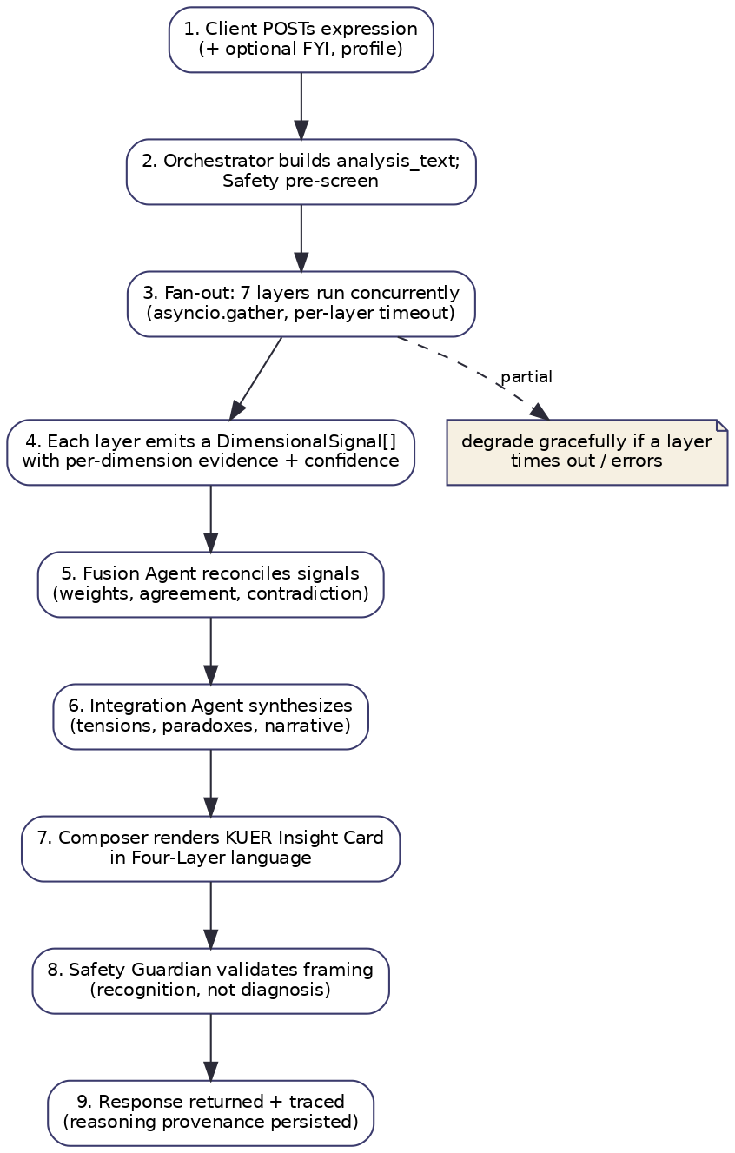
Figure 6 — Execution flow for a single analysis.
- The client POSTs an expression, optionally with pinned FYI text and a profile reference.
- The orchestrator builds analysis_text and the Safety Guardian runs a crisis pre-screen.
- The orchestrator fans out to the seven layers concurrently (asyncio.gather), each under its own timeout.
- Each layer emits DimensionalSignals for its affinity set, with evidence and process confidence.
- The Fusion Agent reconciles signals into FusedRelevance per dimension.
- The Integration Agent synthesizes Insights, preserving tensions and paradoxes.
- The Response Composer renders a KUER Insight Card in the chosen presentation layer.
- The Safety Guardian reviews the framing (recognition, not diagnosis) and may demand a reframe.
- The response is returned and the full provenance chain is persisted.

8.2 Orchestration as a state machine
The orchestrator is a LangGraph state machine. Modelling orchestration as explicit states (rather than imperative glue) makes the control flow inspectable, makes partial-failure handling declarative, and makes the safety diversions first-class transitions.
Figure 7 — Orchestration state machine.
The crisis transition from SAFETY_PRESCREEN short-circuits the analytical machinery entirely and routes to a resource/support response — the system never runs a multidimensional analysis on someone in acute crisis as though it were a puzzle to be solved.

8.3 Concurrency and timeouts
The seven layers run concurrently; total latency approximates the slowest layer (Chain-of-Thought) plus the sequential tail (fusion, integration, composition). Each layer has an independent timeout; the COLLECT state proceeds with whatever signals arrived, recording which layers were absent. This is the mechanism behind the latency budget in Section 5.3 and the degradation policy in Section 19.

9. Agent Communication

9.1 Message-passing model
Agents never share mutable state. All influence flows through typed, immutable messages routed by the orchestrator. Every message carries a request_id, a producer (agent + version), a timestamp, and a provenance reference. This discipline is what makes the system traceable and what lets any agent be swapped or re-run in isolation.

9.2 Message types
Message | From → To | Payload
AnalyzeCommand | Orchestrator → each Layer | analysis_text, candidate dimensions, dependency readings, options
SignalBatch | Layer → Fusion | DimensionalSignal[] for the layer’s affinity set
FusionResult | Fusion → Integration | FusedRelevance[] with agreement/contradiction
InsightSet | Integration → Composer | Insight[] with tensions and invitations
CardDraft | Composer → Safety | InsightCard draft
SafetyVerdict | Safety → Orchestrator | allow / reframe / divert / halt + rationale

9.3 Contracts and versioning
Each message type is a versioned schema (Section 13). A producing agent declares the schema version it emits; consumers validate on receipt and reject malformed messages rather than silently coercing them. Because layers emit only their affinity set, the SignalBatch from a given layer has a known, bounded shape, which simplifies validation and makes a missing layer obvious.

9.4 Why this preserves the philosophy
The communication model is not merely an engineering convenience; it enforces the multi-perspective principle. Because each layer’s reading travels as its own message and is reconciled — not overwritten — by fusion, disagreement survives transport. The Integration Agent receives the spread of readings, not a pre-collapsed consensus, which is exactly what lets it surface tension rather than hide it.

10. Inter-Layer Dependencies

10.1 Mostly independent, deliberately
The seven layers are designed to be maximally independent so they can run concurrently and fail independently. There are, however, a small number of information-sharing relationships where computing something once and sharing it is both cheaper and more coherent than computing it twice:
- Valence / arousal are computed by the Phenomenological Layer and consumed by the Multi-Axis Affect Layer (and vice-versa for cross-checking). Computing them once avoids two divergent valence readings.
- Temporal-orientation features are computed by the Psycholinguistic Layer and consumed by the Narrative Arc and Affect layers (transient vs enduring discrimination).
- The SEM candidate set scopes the work of COT and the integration step (which dimensions to reason about at all).
- Elemental signatures are jointly evidenced by Phenomenological and Metaphor layers; fusion treats their agreement as strong corroboration.

10.2 No analytical dependency
Critically, these are information-sharing relationships, not analytical-authority relationships. No layer’s judgement depends on another layer’s judgement; only shared features are reused. This keeps the layers epistemically independent — a precondition for treating their agreement as meaningful evidence in fusion (agreement between layers that secretly copied each other would be worthless).

10.3 Execution ordering
Because the only hard input dependency is SEM → (COT, integration) for candidate scoping, the practical execution order is: lexical baseline + SEM first (fast), then the remaining six layers concurrently with the shared features computed early in whichever layer owns them and published to a per-request feature cache. The orchestrator enforces this ordering through the state machine, not through implicit timing.

11. Dimension Dependencies

11.1 What a dimension dependency means
A dimension dependency D_a → D_b means that a meaningful reading of D_b is conditioned by the reading of D_a — not that D_b is computed from D_a mechanically, but that interpretation of D_b should be aware of D_a. For example, the sixteen psychological archetypes (D3) are built from guna combinations, so D2 (Gunas) conditions D3; the bondage→liberation trajectory (D29) only makes sense against the orienting Non-Dual Vision (D27).
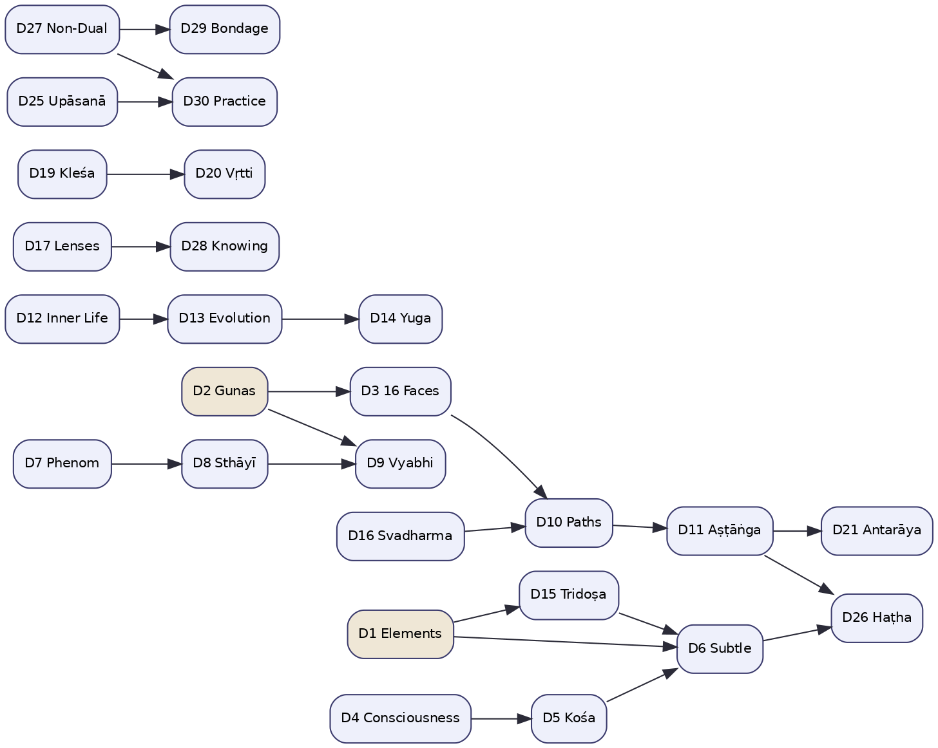
Figure 8 — Dimension dependency graph (selected edges).

11.2 Selected dependency chains
- Constitutional cascade: D2 (Gunas) → D3 (16 Faces); D1 (Elements) → D15 (Tridoṣa) → D6 (Subtle Energies); D4 (Consciousness) → D5 (Kośa) → D6.
- Affective cascade: D7 (Phenomenology) → D8 (Sthāyībhāvas) → D9 (Vyabhicārībhāvas), with D2 modulating D9.
- Path cascade: D3 and D16 → D10 (Paths) → D11 (Aṣṭāṅga) → D21 (Antarāyas); D6 + D11 → D26 (Haṭha).
- Temporal cascade: D12 (Inner Life) → D13 (Evolution) → D14 (Yuga).
- Soteriological cascade: D27 (Non-Dual Vision) → D29 (Bondage & Liberation); D25 + D27 → D30 (Practice).
- Epistemic cascade: D17 (Three Lenses) → D28 (Ways of Knowing); D19 (Kleśas) → D20 (Vṛttis).

11.3 How dependencies are honoured at runtime
Dependencies are declared as data in the registry (the Depends On column of Section 2.3). The orchestrator passes a dependency dimension’s reading into the prompt/context of the dependent dimension’s primary layer (almost always COT or NAR). Because dependencies form a directed acyclic graph, they impose a partial order the orchestrator can respect within the candidate-scoped reasoning step. The graph is acyclic by construction; a proposed new dimension that would introduce a cycle is rejected at registration (Section 20).

12. Confidence Propagation

12.1 The cardinal rule
Every confidence value in Svarupa expresses confidence in the analytical process, not certainty about the person. The canonical pole vocabulary every layer emits — {deficiency, balance, excess}, derived from the signal rather than copied from the legacy status fields — and the crosswalk from the data’s four legacy status schemes are specified in §22.2. This is restated here because confidence propagation is exactly where a careless design would betray the philosophy — by letting a high process-confidence read as “we are sure this is who you are.” The data model, the math and the composer all enforce the separation.
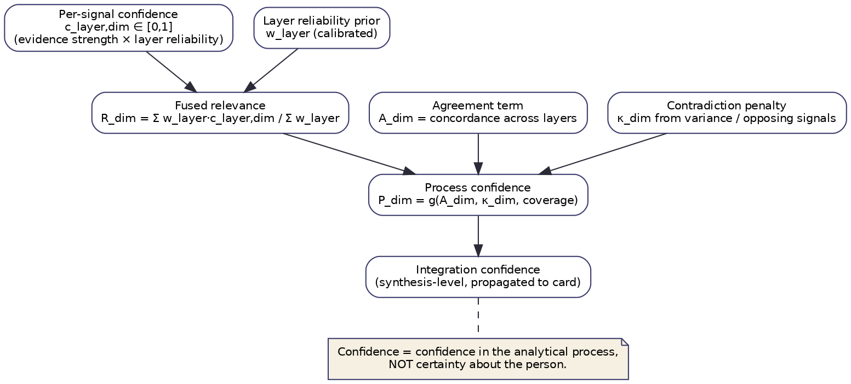
Figure 9 — Confidence propagation from per-signal to card level.

12.2 From signal to fused relevance
Each layer emits, per dimension, a relevance r_{l,d} and a process confidence c_{l,d}. The Fusion Agent computes a fused relevance as a reliability-weighted combination:
R_d = ( Σ_l w_l · c_{l,d} · r_{l,d} ) / ( Σ_l w_l · c_{l,d} )
where w_l is a calibrated layer-reliability prior (how trustworthy layer l has proven on held-out data, possibly per-family). It also computes:
- Agreement A_d: concordance of the contributing layers’ relevances (e.g. 1 − normalized dispersion). High agreement among independent layers is the strongest evidence the system has.
- Contradiction κ_d: the degree to which layers actively oppose each other (not merely differ in magnitude but point to incompatible states, e.g. one reads “excess”, another “deficiency”).

12.3 Process confidence
The fused process confidence is a function of agreement, contradiction and coverage:
P_d = g( A_d , κ_d , coverage_d )
monotonically increasing in agreement and coverage, decreasing in contradiction. Coverage reflects how many competent layers actually reported (a dimension assessed by one layer out of three competent ones is lower-coverage). Crucially, contradiction does not reduce relevance — a contradicted dimension may be highly relevant — it reduces confidence and is flagged for the integration step to surface as a tension.

12.4 Propagation to insights and the card
The Integration Agent carries R_d and P_d into each Insight, combining the process confidences of the dimensions an insight spans (the weakest link dominates, so a synthesis resting on a low-confidence dimension inherits that caution). The Composer then translates confidence into language, not numerals: high confidence licenses “you may notice…”, low confidence requires “it is possible that…”, and contradiction is voiced explicitly (“one reading suggests…, another points the other way”). The user never sees a bare confidence number presented as a fact about themselves.

12.5 Uncertainty management
Three kinds of uncertainty are tracked distinctly: aleatoric (the expression is genuinely ambiguous — surfaced as multiple perspectives), epistemic (the system lacks coverage — surfaced as humbler language and, optionally, an invitation to say more), and conflict (layers disagree — surfaced as an explicit tension). Conflating these would be a philosophical error as much as a statistical one; keeping them separate is what lets Svarupa be honest about why it is unsure.

13. JSON Schemas
The schemas below are the canonical wire format for the entities of Section 6 and the messages of Section 9. They are intentionally minimal and consistent: every relevance and confidence is a number in [0,1]; every object carries provenance; relevance and confidence are never merged.

13.1 DimensionalSignal
{
"$schema": "https://svarupa.ai/schemas/v7/dimensional_signal.json",
"type": "object",
"required": ["request_id", "layer", "dimension_id", "relevance", "confidence", "evidence"],
"properties": {
"request_id": { "type": "string", "format": "uuid" },
"layer": { "type": "string",
"enum": ["SEM","COT","AFF","PHE","PSY","MET","NAR","LEX"] },
"layer_version": { "type": "string" },
"dimension_id": { "type": "integer", "minimum": 1, "maximum": 31 },
"relevance": { "type": "number", "minimum": 0, "maximum": 1,
"description": "How strongly this layer sees the dimension implicated." },
"confidence": { "type": "number", "minimum": 0, "maximum": 1,
"description": "The layer's trust in its OWN reading (process, not the person)." },
"state_hint": {
"type": "object",
"properties": {
"state": { "type": "string", "enum": ["balance","excess","deficiency","unclear"] },
"confidence": { "type": "number", "minimum": 0, "maximum": 1 }
}
},
"evidence": {
"type": "array",
"items": {
"type": "object",
"required": ["kind","detail"],
"properties": {
"kind": { "type": "string",
"enum": ["span","feature","concept","reasoning","metaphor","arc"] },
"detail": { "type": "string" },
"span": { "type": "array", "items": { "type": "integer" }, "minItems": 2, "maxItems": 2 },
"weight": { "type": "number", "minimum": 0, "maximum": 1 }
}
}
},
"abstained": { "type": "boolean", "default": false },
"provenance": { "$ref": "#/definitions/provenance" }
}
}

13.2 FusedRelevance
{
"$schema": "https://svarupa.ai/schemas/v7/fused_relevance.json",
"type": "object",
"required": ["request_id","dimension_id","relevance","process_confidence",
"agreement","contradiction","contributing_layers"],
"properties": {
"request_id": { "type": "string", "format": "uuid" },
"dimension_id": { "type": "integer", "minimum": 1, "maximum": 31 },
"relevance": { "type": "number", "minimum": 0, "maximum": 1 },
"process_confidence": { "type": "number", "minimum": 0, "maximum": 1 },
"agreement": { "type": "number", "minimum": 0, "maximum": 1 },
"contradiction": { "type": "number", "minimum": 0, "maximum": 1 },
"coverage": { "type": "number", "minimum": 0, "maximum": 1 },
"state_distribution": {
"type": "object",
"properties": {
"balance": { "type": "number" },
"excess": { "type": "number" },
"deficiency": { "type": "number" }
}
},
"contributing_layers": { "type": "array", "items": { "type": "string" } },
"provenance": { "$ref": "#/definitions/provenance" }
}
}

13.3 Insight
{
"$schema": "https://svarupa.ai/schemas/v7/insight.json",
"type": "object",
"required": ["request_id","dimension_ids","observation","tensions","invitation","confidence"],
"properties": {
"request_id": { "type": "string", "format": "uuid" },
"dimension_ids": { "type": "array", "items": { "type": "integer" }, "minItems": 1 },
"observation": { "type": "string",
"description": "Framed as MAY be present. No diagnosis/prediction/prescription." },
"tensions": {
"type": "array",
"description": "Required (possibly empty). Contradictions are retained, not resolved.",
"items": {
"type": "object",
"properties": {
"between": { "type": "array", "items": { "type": "integer" } },
"description": { "type": "string" }
}
}
},
"invitation": { "type": "string",
"description": "A reflective prompt. Never an instruction." },
"confidence": { "type": "number", "minimum": 0, "maximum": 1 },
"provenance": { "$ref": "#/definitions/provenance" }
}
}

13.4 InsightCard
{
"$schema": "https://svarupa.ai/schemas/v7/insight_card.json",
"type": "object",
"required": ["request_id","kuer_stage","presentation_layer","perspectives"],
"properties": {
"request_id": { "type": "string", "format": "uuid" },
"kuer_stage": { "type": "string", "enum": ["knowledge","understanding","experience","realization"] },
"presentation_layer": { "type": "string",
"enum": ["universal","bridging","traditional","scholarly"] },
"perspectives": {
"type": "array",
"items": {
"type": "object",
"required": ["text","insight_ref"],
"properties": {
"text": { "type": "string" },
"insight_ref": { "type": "string" },
"epistemic_stance": { "type": "string",
"enum": ["tentative","moderate","resonant","contradictory"] }
}
}
},
"provenance": { "$ref": "#/definitions/provenance" }
}
}

13.5 Shared provenance definition
{
"definitions": {
"provenance": {
"type": "object",
"required": ["producer","timestamp"],
"properties": {
"producer": { "type": "string", "description": "agent@version" },
"timestamp": { "type": "string", "format": "date-time" },
"derived_from": { "type": "array", "items": { "type": "string" },
"description": "IDs of upstream objects (unbroken chain to source signals)." },
"model": { "type": "string", "description": "LLM id, if any" }
}
}
}
}

14. API Interfaces

14.1 Primary endpoint
POST /api/v1/orchestrator/analyze accepts an expression and returns a composed Insight Card with optional provenance.
Request
{
"raw_text": "I keep starting things and abandoning them; I feel scattered.",
"fyi_paragraphs": [],
"profile_ref": "usr_8f2c...",
"options": {
"presentation_layer": "universal",
"kuer_stage": "knowledge",
"latency_mode": "standard",
"include_provenance": true
}
}
Response (abridged)
{
"request_id": "b574...",
"card": {
"kuer_stage": "knowledge",
"presentation_layer": "universal",
"perspectives": [
{ "text": "You may notice a restless, scattering quality...",
"insight_ref": "ins_01", "epistemic_stance": "resonant" },
{ "text": "There is also a thread of beginnings without completion...",
"insight_ref": "ins_02", "epistemic_stance": "moderate" }
]
},
"provenance": {
"fused_relevance": [ { "dimension_id": 1, "relevance": 0.71, "process_confidence": 0.58 } ],
"insights": [ "ins_01", "ins_02" ]
}
}

14.2 Supporting endpoints
Endpoint | Purpose
POST /api/v1/orchestrator/fyi | Authenticated; composes “for-your-information” prose using user-controlled profile context for tone/framing only.
POST /api/v1/mapping-agent/map | Returns the fused dimensional relevance map without composition (for research/debugging).
POST /api/v1/vector-search/search | Raw semantic search over concept nodes.
GET /api/v1/dimensions | Returns the dimension registry (data-driven; reflects D31 when authored).
GET /api/v1/analysis/{id}/provenance | Full provenance chain for a past analysis (explainability).

14.3 Contract principles
The API never exposes a bare per-dimension “score” to end-user surfaces; relevance/confidence are available only on the research and provenance endpoints, and even there are labelled as process metrics. All endpoints are versioned under /v1; schema evolution follows the additive-only rule (Section 20). Authentication is required for any endpoint that reads user profile data.

15. Knowledge Graph Integration

15.1 Why a graph
Svarupa’s knowledge is inherently relational: concepts belong to dimensions, dimensions relate to one another, patterns span dimensions, and every concept is anchored to source text. A property graph (Neo4j) models this directly and supports both symbolic traversal (dependencies, cross-dimension patterns) and vector search (concept embeddings) in one store.
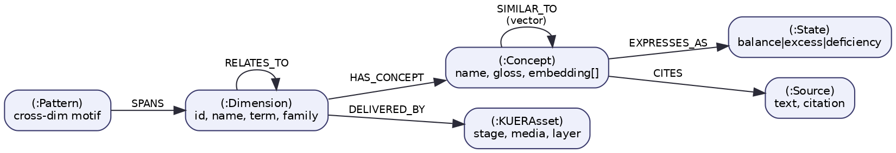
Figure 10 — Knowledge graph schema (node and relationship types).

15.2 Node and relationship types
- (:Dimension) — id, name, term, family. The registry, as graph nodes.
- (:Concept) — name, gloss, embedding[]. The retrievable units; each carries a vector for semantic search.
- (:State) — balance | excess | deficiency. How a concept is lived across the canonical spectrum.
- (:Source) — text, citation. The scriptural/commentarial anchor for a concept.
- (:Pattern) — a curated cross-dimensional motif the Integration Agent can recognize and the Knowledge Steward can write back.
- (:KUERAsset) — a piece of content tagged by KUER stage, media and presentation layer.
Relationships: HAS_CONCEPT, EXPRESSES_AS (→ State), CITES (→ Source), RELATES_TO (Dimension↔Dimension, typed by the dependency edges of Section 11), SPANS (Pattern→Dimension), DELIVERED_BY (Dimension→KUERAsset), and SIMILAR_TO (Concept↔Concept, vector-derived).

15.3 How the layers use the graph
The Semantic Resonance Layer runs vector search over (:Concept) embeddings and aggregates hits up HAS_CONCEPT to dimension relevance. The Chain-of-Thought Layer can (in the tool-augmented variant) traverse RELATES_TO to bring a dependency dimension’s concepts into context. The Integration Agent matches fused relevances against (:Pattern) nodes to recognize cross-dimensional motifs. The Composer pulls (:KUERAsset) nodes for the chosen stage and presentation layer. All access is mediated by the Knowledge Steward agent.

15.4 Curation and write-back
The graph is curated by domain experts; the Knowledge Steward is the only writer. Recognized patterns can be promoted to (:Pattern) nodes through a human-in-the-loop review, so the system’s cross-dimensional vocabulary grows under expert control rather than drifting automatically. This is the structural home of the “continuous learning” capability without sacrificing cultural integrity.

16. Prompt Architecture

16.1 Layered prompt contract
Every LLM call in Svarupa — whether a Chain-of-Thought reading, an integration synthesis, or a composition — is built from a fixed three-part contract:
- The Svarupa system contract (constant): the non-negotiable rules — recognition not diagnosis; no labels, predictions or prescriptions; the user is the authority; preserve tension; epistemic humility; no taxonomy leakage to end users. This block is identical across all calls and is version-controlled as the single source of philosophical truth in prose form.
- The task scaffold (per call-type): the reasoning structure for the specific job (e.g. “reason about the expression, then judge each candidate dimension, then abstain where evidence is thin”).
- The structured output schema (per call-type): a strict JSON schema with a mandatory abstention path, validated on return.

16.2 Recognition-preserving prompting
The system contract does real work. It forbids second-person verdicts (“you are…”), requires hedged framing for low confidence, and requires that contradictions be voiced rather than smoothed. For the Chain-of-Thought layer it additionally requires verbatim span citation for every claimed piece of evidence, which both improves faithfulness and gives the explainability layer real spans to show.

16.3 Per-call-type scaffolds
Call type | Scaffold goal | Output
COT dimensional reading | Reason → per-dimension judgement with evidence → abstain | DimensionalSignal[]
Integration synthesis | Cluster fused relevances → name cross-dim observations → surface tensions → form invitations | Insight[]
Composition | Render insights into KUER stage + presentation layer, with epistemic stance | InsightCard
FYI prose | Shape tone/framing using user-controlled context, no taxonomy leakage | prose

16.4 Prompt versioning and evaluation
Prompts are versioned artifacts with their own evaluation suite (gold expressions, rubric grading, abstention calibration, and a “philosophy regression” set that checks for diagnostic-language leakage). A prompt change cannot ship without passing the philosophy-regression set — the structural guarantee that performance optimization never erodes the mission.

17. LLM Orchestration

17.1 Where the LLM is used
The LLM (Claude via AWS Bedrock) is used in exactly three places: the Chain-of-Thought layer (and optional assist in AFF/PHE/MET/NAR), the Integration synthesis, and the Composition. Everything else — semantic search, psycholinguistic features, fusion math — is deterministic and LLM-free. This containment keeps cost and latency predictable and keeps most of the pipeline fully transparent.

17.2 Budget and concurrency controls
The Chain-of-Thought layer is the dominant cost. It is controlled by: candidate batching (all candidate dimensions assessed in one structured call rather than one call per dimension), caching by (analysis_text hash, prompt version), per-call timeouts with partial-result tolerance, and an optional self-consistency budget (n-samples) enabled only for high-stakes surfaces. Integration and Composition are single calls each; they may be fused into one call under latency_mode: "fast".

17.3 Model abstraction
The LLM is reached through a provider port (ILLMProvider) so the model can be swapped or routed per call-type (a smaller model for composition, a stronger model for integration) without touching agent logic. Every call records the model id in provenance.

17.4 Degradation
If the LLM provider is unavailable, the pipeline degrades to the deterministic layers (SEM, PSY, lexical baseline, model-based AFF) and returns a reduced card that is explicit about its reduced scope, rather than failing. Recognition-not-diagnosis makes this graceful: a smaller set of honestly-hedged perspectives is a coherent, mission-aligned response, not a broken one.

18. Explainability Strategy

18.1 Explainability as a mission requirement
For most systems explainability is a feature; for Svarupa it is constitutive. A system whose purpose is recognition must be able to show the person why a perspective was offered, so they can test it against their own experience rather than accept it on authority. Explainability is therefore designed in, via the unbroken provenance chain (Section 6.2) rather than reconstructed after the fact.

18.2 Three audiences, three depths
- End users receive recognition-oriented explanation woven into the perspective itself: “you may notice a scattering quality” is followed, on request, by “this is suggested by phrases like ‘I keep starting things’.” No taxonomy, no scores — just the textual grounding that lets them judge resonance.
- Researchers / curators receive the full provenance: which layers fired, their relevances and process confidences, the fused values, agreement and contradiction, and the LLM reasoning traces (via GET /analysis/{id}/provenance).
- Auditors receive the same plus the prompt versions, model ids and the philosophy-regression results in effect at the time.

18.3 What every perspective can answer
By construction, the system can answer for any perspective shown: which dimension(s) it rests on; which layers contributed and how much; what textual evidence grounded it; how confident the process was and why (agreement/contradiction/coverage); and whether any tension was present. This is the operational meaning of XAI in Svarupa — not a saliency heatmap, but a traceable account from words to perspective.

19. Error Handling

19.1 Graceful degradation, not failure
The pipeline is built so that almost nothing is fatal. Because the seven layers are independent and the composition is honest about scope, the system can lose components and still return a coherent, mission-aligned response.
Failure | Behaviour
A layer times out / errors | It contributes no signals; fusion proceeds; coverage for affected dimensions drops, lowering process confidence; the card is unaffected except in honesty of hedging.
Embedding service down | SEM falls back to the lexical baseline; recall narrows; flagged in provenance.
LLM provider down | Pipeline degrades to deterministic layers; reduced-scope card returned (Section 17.4).
Knowledge graph unavailable | Cached concept set used if present; otherwise SEM degrades to lexical; integration pattern-matching skipped.
Schema-invalid agent message | Rejected, not coerced; treated as that producer being absent.
Safety pre-screen positive | Analytical pipeline short-circuited; resource/support path taken.

19.2 Error taxonomy
All errors extend a base SvarupaException with subtypes for transport, provider, validation, and safety. Errors carry the request_id and the failing component so degradation decisions are made on typed conditions, not string matching. Partial results are first-class: the COLLECT state records exactly which layers were present.

19.3 The safety path is not an error
The crisis short-circuit is deliberately modelled as a normal transition, not an exception. Conflating “this person needs support” with “something broke” would be both an engineering and an ethical mistake; the state machine treats the support path as a legitimate, well-formed outcome of an analysis.

20. Extensibility Guidelines

20.1 N is a parameter
The single most important extensibility property is that the orchestrator, fusion and integration code are dimension-agnostic. They iterate over the registry; they contain no hard-coded list of dimensions and no if dimension == X logic. Adding a dimension is therefore a knowledge-and-configuration change, not a code change.

20.2 Admitting a new dimension (the D31 procedure)
- Author the narrative in documentations/dimensions_new/ (the authoritative source of meaning).
- Register the entry: id, name, term, family, constructs, balance/excess/deficiency treatment, layer affinities (which layers are competent — primary/contributing), and dependencies (must not introduce a cycle in the dependency DAG).
- Seed the knowledge graph: create the (:Dimension), its (:Concept) nodes with embeddings, (:State) and (:Source) links, and any RELATES_TO edges.
- Configure prompts: add the dimension to the relevant layer scaffolds (usually COT and/or NAR); no change to the system contract.
- Add evaluation data: gold expressions for the new dimension so calibration and the philosophy-regression suite cover it.
- Calibrate: fit the layer-reliability weights and the relevance mapping for the new dimension on held-out data.
No change to the orchestrator, fusion or integration code is required at any step. The same procedure adds D32, D33 and beyond.

20.3 Adding or revising a layer
A new analytical layer implements the layer port (accept analysis_text + context, emit DimensionalSignal[] for a declared affinity set, report process confidence and provenance), declares its affinities, and is added to the fan-out and to fusion’s reliability-weight table. Because fusion weights are calibrated, a new or weak layer cannot destabilize the ensemble — it earns influence as it proves reliable.

20.4 Schema evolution
Wire schemas evolve additively: new optional fields only; no field is repurposed or removed within a major version. Consumers ignore unknown fields. Breaking changes require a new /v2 and a migration window.

21. Future Evolution Strategy

21.1 Near-term
- Calibrated layer-reliability priors learned per family from a growing gold set, replacing hand-set fusion weights.
- Tool-augmented Chain-of-Thought that consults the knowledge graph mid-reasoning, improving faithfulness on dependency-heavy dimensions.
- Joint phenomenology–metaphor model for elemental signatures (D1, D5, D6, D15).
- Abstention calibration so layers decline as readily as expert annotators would.

21.2 Medium-term
- Longitudinal narrative intelligence over consented journals: arc and turning-point detection that surfaces (gently, to the user) possible movement over time — always as recognition, never as a tracked “score”.
- Pattern library growth via human-in-the-loop promotion of recognized cross-dimensional motifs to (:Pattern) nodes.
- Per-call-type model routing to optimize the cost/quality frontier.
- Multilingual parity for the deterministic layers (PSY, lexical) and the embeddings.

21.3 Long-term
- Per-dimension adapters (small fine-tuned models) for the interpretive dimensions, reducing reliance on a single large model.
- User-steerable perspective selection — letting people foreground the families that speak to them, deepening agency.
- Formal uncertainty propagation (e.g. Bayesian or conformal) replacing the heuristic confidence functions of Section 12, with calibration guarantees.
- The reserved D31 and its successors, authored as the tradition and the user community reveal which lenses are most needed next.

21.4 KUER as the delivery substrate
All of the above is delivered through the KUER architecture — Knowledge → Understanding → Experience → Realization — which matches media and depth to the person’s stage and never forces a single path.
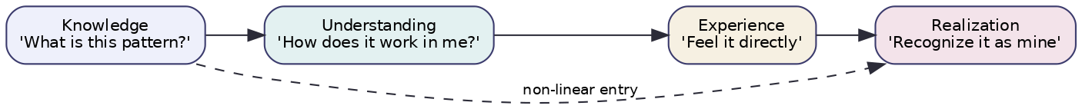
Figure 11 — KUER delivery stages with non-linear entry.
The architecture’s job is to make recognition possible; KUER’s job is to make it reachable. Together they express the single commitment from which everything in this document descends: to help a person recognize their own essential nature — svarūpa — rather than to tell them who they are.

22. Dimension–Attribute–Status Mapping & Grounding (v7.1 Audit)
This section is the outcome of a critical audit of the (dimension, attribute, status) triples that the analytical layers depend on, conducted against the live concept data (svarupa_companion_v2.svarupa_concept_merged, mirrored locally in documentations/descriptions/) and the source narratives, cross-checked with the primary tradition (Nāṭyaśāstra; Caraka Saṁhitā; Yoga Sūtras). It corrects errors discovered in the first-pass layer mappings and is normative: where the assignments here differ from earlier prose in this document or in the layer specifications, this section governs.

22.1 The status-scheme problem
The dimension data does not use one status vocabulary. It uses four mutually incompatible schemes, and one dimension (D7) even mixes two of them internally. These schemes are not interchangeable, and — critically — the most common one (negative/neutral/positive) is a health-valence axis that collapses the excess and deficiency poles into a single “negative” bucket, which is precisely the distinction the wisdom narratives (and the users’ self-recognition) depend on.
Scheme | Vocabulary | Axis it actually encodes | Dimensions using it
Equilibrium | balanced / excessive / deficient | the true three-pole intensity axis | D1, D6 (vāyus), D15
Channel-state | balanced / blocked / overactive | equilibrium, renamed | D6 (chakras, nāḍīs)
Intensity | high / medium / low | magnitude of presence (not pole) | D2, D3, D11, D14, D16, part of D7
Health-valence | negative / neutral / positive | skillful↔dysfunctional (collapses excess+deficiency) | D4, D5, D8, D9, D10, part of D7
Astrological | benefic / malefic / neutral | value verdict (conflicts with recognition-not-diagnosis) | D18
None | — | (no status field present) | D13
Worked evidence (krodha, D8). In the data, krodha · positive = focused, well-regulated anger that acts cleanly (this is balance); krodha · negative = anger suppressed and pushed down (this is deficiency). The excess pole — explosive rage — has no row at all. So positive ≠ excess (it is balance), and negative is whichever maladaptive pole the curator chose, with the other pole simply absent. A layer cannot recover {balance, excess, deficiency} by reading this field.

22.2 Canonical pole vocabulary (normative)
All layers emit a single canonical pole, {deficiency, balance, excess}, derived from the signal (intensity + direction + context), never copied from the legacy status field. The legacy fields are retained only as source labels and are crosswalked as follows:
Legacy value | Canonical pole | Rule
positive / balanced | balance | the cultivated/proportionate expression
neutral / medium | balance (baseline) | everyday proportionate presence
negative | excess or deficiency | disambiguated by measured intensity: high/dysregulated → excess; low/suppressed/absent → deficiency
high | excess (if maladaptive) or balance | intensity alone is not a pole; combine with valence/context
low | deficiency | depletion/absence where presence is warranted
blocked | deficiency | (channel-state)
overactive | excess | (channel-state)
benefic / malefic | balance / (excess or deficiency) | reframe — emit functional tone, never a “malefic” verdict
Exceptions that are not poles at all (see 22.5): phenomenological axes (continua), consciousness/kośa loci (categorical), guṇa proportions (3-way mixture), and evolutionary/yuga states (arc phase / mismatch).

22.3 Grounding status of the dimension data
A layer can only be validated on a dimension for which concept data exists. The audit found that concept rows (attributes and status) exist for only 17 of 30 dimensions. The remaining thirteen are narrative-only: they have authored narratives but no (:Concept) nodes, no attributes in the merged table, and — decisively — no embeddings, which is why the Semantic Resonance layer currently has zero recall for them (22.5). One dimension (D13) has attributes but no status field; one (D12) is only partially covered.
Legend: grounded = attributes + status present; partial = subset present; attrs only = attributes but no status; narrative-only = no concept rows. Footnotes: * D7 mixes two status schemes; † D9 has 30 of the canonical 33 states (missing vrīḍā, vyādhi, vitarka); ‡ D16 attributes conflate varṇa and plane-of-being taxonomies and omit brāhmaṇa.
# | Dimension | Grounding | Legacy status scheme in data | Canonical pole emitted
1 | Five Great Elements | grounded | balanced / excessive / deficient | deficiency / balance / excess (derived)
2 | Three Gunas | grounded | high / medium / low | deficiency / balance / excess (derived)
3 | Sixteen Faces of Mind | grounded | high / medium / low | deficiency / balance / excess (derived)
4 | Seven Layers of Consciousness | grounded | negative / neutral / positive | deficiency / balance / excess (derived)
5 | Five Sheaths | grounded | negative / neutral / positive | deficiency / balance / excess (derived)
6 | Subtle Energies | grounded | balanced/excessive/deficient · balanced/blocked/overactive | deficiency / balance / excess (derived)
7 | Phenomenological Dimensions | grounded (mixed scheme) | MIXED (high/med/low + neg/neu/pos) | deficiency / balance / excess (derived)
8 | Nine Enduring Emotions | grounded | negative / neutral / positive | deficiency / balance / excess (derived)
9 | Thirty-Three Transient States | grounded (30/33 — incomplete) | negative / neutral / positive | deficiency / balance / excess (derived)
10 | Paths of Engagement | grounded | negative / neutral / positive | deficiency / balance / excess (derived)
11 | Eightfold Refinement | grounded | high / medium / low | deficiency / balance / excess (derived)
12 | Architecture of Inner Life | partial (samskaras subset) | mixed (per sub-construct) | deficiency / balance / excess (derived)
13 | Cyclical Evolution of Consciousness | attrs only, no status | NONE (no status field) | deficiency / balance / excess (derived)
14 | Yuga Cycles | grounded | high / medium / low | deficiency / balance / excess (derived)
15 | Tridosha | grounded | balanced / excessive / deficient | deficiency / balance / excess (derived)
16 | Inner Nature & Its Law | grounded (attrs conflate varṇa+planes) | high / medium / low | deficiency / balance / excess (derived)
17 | Three Lenses | narrative-only (no concept rows) | — (narrative: balanced/excess/deficient) | deficiency / balance / excess (derived)
18 | Science of Cosmic Light | grounded | benefic / malefic / neutral | deficiency / balance / excess (derived)
19 | Five Afflictions | narrative-only (no concept rows) | — (narrative: balanced/excess/deficient) | deficiency / balance / excess (derived)
20 | Five Modifications of Mind | narrative-only (no concept rows) | — (narrative) | deficiency / balance / excess (derived)
21 | The Nine Obstacles | narrative-only (no concept rows) | — (narrative) | deficiency / balance / excess (derived)
22 | Four Sublime Attitudes | narrative-only (no concept rows) | — (narrative) | deficiency / balance / excess (derived)
23 | Fourfold Qualification | narrative-only (no concept rows) | — (narrative) | deficiency / balance / excess (derived)
24 | Divine & Demoniacal Endowments | narrative-only (no concept rows) | — (narrative) | deficiency / balance / excess (derived)
25 | Upanishadic Meditations | narrative-only (no concept rows) | — (narrative) | deficiency / balance / excess (derived)
26 | The Embodied Path | narrative-only (no concept rows) | — (narrative) | deficiency / balance / excess (derived)
27 | The Non-Dual Vision | narrative-only (no concept rows) | — (narrative) | deficiency / balance / excess (derived)
28 | The Ways of Knowing | narrative-only (no concept rows) | — (narrative) | deficiency / balance / excess (derived)
29 | Anatomy of Bondage & Liberation | narrative-only (no concept rows) | — (narrative) | deficiency / balance / excess (derived)
30 | Contemplative & Devotional Practice | narrative-only (no concept rows) | — (narrative) | deficiency / balance / excess (derived)

22.4 Revised layer→dimension assignments
The audit revised several primary assignments that the first-pass registry over-claimed. These changes are already reflected in the registry table (§2.3) and the affinity matrix (§2.4); they are summarized here with rationale.
Dimension | Was (primary) | Now (primary) | Now (contributing) | Why changed
D3 Sixteen Faces | PSY, COT | COT | PSY (features) | Assigning a 16-way archetype needs holistic reasoning; PSY supplies agency/social features but cannot adjudicate Sarpa- vs Śakuni-rājasika from form.
D7 Phenomenology | PHE (+AFF contrib) | PHE | COT | AFF shares valence/arousal as features but must not emit a D7 signal (double-count). PHE emits axes, not poles (22.5).
D17 Three Lenses | PSY, COT | PSY | COT | Attribution locus (external/fate/internal) is directly measurable in language — PSY’s strongest genuine fit.
D19 Kleśas | COT, PSY | COT | PSY (asmitā), AFF (rāga/dveṣa) | Root reading is interpretive (COT); PSY/AFF contribute only specific markers.
D20 Vṛttis | PSY, COT | COT | PSY (vikalpa/smṛti) | Pramāṇa-vs-viparyaya is a truth judgment, not a language feature; PSY contributes only abstraction/memory markers.
D28 Ways of Knowing | PSY, COT | COT | PSY (cognitive complexity) | Epistemic stance is interpretive; PSY contributes complexity markers.
D2 Guṇas | AFF, PSY | AFF + PSY (co-primary) | — | Retained, but with a mandatory de-duplication of feature sets (PSY = form; AFF = tone) so fusion’s agreement math stays valid.

22.5 Per-layer corrections
Phenomenological (PHE). D7 is the primary correction: phenomenological axes are continua, not equilibrium poles. PHE emits per-axis values on natural scales — bipolar valence (unpleasant↔pleasant), [0,1] arousal/clarity/agency/somatic-presence, and categorical self-location / temporal / orientation / relational-quality — and only then maps axis-patterns onto the felt-quality dimensions (D1, D15 as poles ✓ grounded; D5, D4 as locus not pole). The data’s D7 is internally inconsistent (4 axes high/med/low, 5 axes neg/neu/pos) and carries both orientation and temporal (9 axes vs the 8 named in §7.4) — reconcile to a single per-axis schema.
Psycholinguistic (PSY). Demoted from primary on D3, D19, D20, D28 (above); promoted to sole primary on D17. PSY’s honest outputs are measurable linguistic features (pronoun/agency ratios, causal-connective density, coherence, temporal orientation), which support D2 (form), D12 (rumination/loop markers, with NAR), D16 (role/agency language), and supply features to COT for the reasoning-heavy dimensions. PSY must not claim to score archetype identity or valid-vs-erroneous cognition.
Metaphor (MET). Scope is correct (D1 primary; D5/D6/D15 contributing). Two rules added: (1) D1↔D15 de-duplication — elemental and doṣa metaphor signatures overlap (air↔vāta, fire↔pitta, earth/water↔kapha); fusion must treat them as correlated, not independent corroboration; (2) emit element/doṣa presence at high confidence but pole at lower confidence, since metaphor signals which quality more reliably than how much.
Narrative Arc (NAR). Two dimensions output the wrong object. D13 has no status field; NAR emits an arc phase (descending / nadir / ascending), not a pole. D14 (Yuga) profiles are soul-age × current-age combinations that are not derivable from a single expression; NAR emits only the individual–collective mismatch signal, with the specific profile supplied by user context, not inferred. D12 is co-primary with PSY (loop arc vs rumination markers); D16, D29 are strong NAR fits (D29 narrative-only).
LLM Chain-of-Thought (COT). Now the primary home for the interpretive dimensions (D3, D18–D30 cluster), most of which are narrative-only — so COT carries the bulk of the un-validated load and requires expert gold sets before its confidence can be calibrated. Two specific corrections: (1) D18 (Jyotiṣ) is archetypal-motif only — a real chart needs birth data the text does not contain; COT reads graha themes (Śani→limitation, Maṅgala→drive), and the benefic/malefic vocabulary is reframed to functional tone to honour recognition-not-diagnosis; (2) COT adopts the new dimensions’ clean narrative triple (balanced/excess/deficient) as its canonical pole, which is better grounded than the legacy DB schemes.
Semantic Resonance (SEM). The audit found SEM’s headline promise — a recall floor for all dimensions — is currently false: embeddings exist only for the 17 grounded dimensions, so D17 and D19–D30 are invisible to semantic search. SEM correctly emits relevance only (no pole/state_hint). The fix is data-side (22.6), not code-side.

22.6 Remediation actions (prioritized)
- [High] Seed concept data + embeddings for the 13 narrative-only dimensions (D17, D19–D30) by chunking their narratives into (:Concept) units. This single action restores SEM recall and gives every other layer a retrieval anchor and a validation target for those dimensions.
- [High] Canonicalize status to {deficiency, balance, excess} at the data layer, retaining the legacy fields as crosswalked source labels (22.2). Give D13 a status vocabulary; reframe D18’s benefic/malefic to functional tone.
- [High] Complete D9 to the canonical 33 by adding vrīḍā, vyādhi, vitarka (the narrative already covers vrīḍā); reconcile the registry name with the count.
- [Medium] Fix D7 in data — one per-axis schema; resolve the orientation/temporal redundancy.
- [Medium] Clean D16 attributes — separate the varṇa and plane-of-being taxonomies; restore brāhmaṇa.
- [Medium] Encode de-duplication rules in fusion for correlated signatures: D1↔D15 (MET/PHE), D2 guṇa (AFF/PSY), valence/arousal (AFF/PHE).
- [Low] Add gold-standard evaluation sets for the COT-primary narrative-only dimensions so their confidence can be calibrated rather than assumed.

Appendix A — Mermaid Diagram Sources
The figures in this document were rendered for print fidelity. Their editable Mermaid sources are provided here so maintainers can regenerate or modify them. (Per the documentation standard, diagrams are kept as source-of-truth Mermaid plus a rendered image.)

A.1 Figure 1 — System architecture
flowchart TB
subgraph EXP[Experience Layer]
MOB[Mobile / Web App: KUER, Recognition Journal]
end
subgraph API[API & Orchestration]
GW[FastAPI Gateway] --> ORCH[Orchestrator Agent / LangGraph]
end
subgraph AN[Analytical Layer]
L[Semantic · CoT · Affect · Phenomenological · Psycholinguistic · Metaphor · Narrative]
end
subgraph INT[Integration Layer]
FUSE[Mapping / Fusion Agent] --> ISYN[Integration & Insight Synthesis]
end
subgraph RESP[Composition & Safety]
COMP[Response Composer / KUER] --- SAFE[Safety Guardian]
end
subgraph KNOW[Knowledge & Domain]
KG[(Knowledge Graph / Neo4j)]
LLM[[LLM / Claude via Bedrock]]
end
MOB --> GW --> ORCH --> L --> FUSE
ISYN --> COMP --> MOB
L -.-> KG
L -.-> LLM
ISYN -.-> KG
COMP -.-> LLM

A.2 Figure 3 — Processing pipeline
flowchart LR
IN[User Expression] --> PRE[Pre-process: analysis_text + lexical baseline]
PRE --> SEM & COT & AFF & PHE & PSY & MET & NAR
SEM & COT & AFF & PHE & PSY & MET & NAR --> FUSE[Fusion Agent]
FUSE --> ISYN[Integration & Synthesis] --> COMP[Composer / KUER] --> OUT[Insight Card]

A.3 Figure 7 — Orchestration state machine
stateDiagram-v2
[*] --> INGEST
INGEST --> SAFETY_PRESCREEN
SAFETY_PRESCREEN --> FAN_OUT_LAYERS
SAFETY_PRESCREEN --> SAFETY_REVIEW: crisis → resource path
FAN_OUT_LAYERS --> COLLECT
COLLECT --> FUSE: partial ok
FUSE --> INTEGRATE --> COMPOSE --> SAFETY_REVIEW
SAFETY_REVIEW --> COMPOSE: reframe
SAFETY_REVIEW --> [*]

A.4 Figure 9 — Confidence propagation
flowchart TB
A[Per-signal relevance r and confidence c] --> D[Fused relevance R_d = Σ w·c·r / Σ w·c]
W[Calibrated layer reliability w_l] --> D
AG[Agreement A_d] --> P[Process confidence P_d = g A,κ,coverage]
KK[Contradiction κ_d] --> P
D --> P --> G[Integration & card-level confidence → language, not numbers]

A.5 Figure 11 — KUER delivery
flowchart LR
K[Knowledge: what is this pattern?] --> U[Understanding: how does it work in me?]
U --> E[Experience: feel it directly] --> R[Realization: recognize it as mine]
K -. non-linear entry .-> R

Appendix B — Historical Mapping: 18 → 30 Dimensions
This appendix records the relationship to the predecessor 18-Dimension Framework for migration and continuity. It is historical context; the registry in Section 2.3 is authoritative.
v6.0 (18-dim) construct | v7.0 (30-dim) treatment
Pañca Mahābhūtas | D1 (unchanged)
Trigunas | D2 (unchanged; now also a modulating prior)
Ayurvedic Doshas | D15 Tridoṣa
Manasika Prakriti | D3 Sixteen Faces
Consciousness States | D4 Seven Layers
Pancha Koshas | D5
Prana Vayus + Chakras + Nadis | Consolidated into D6 Subtle Energies
Phenomenological dimensions | D7
Sthayibhavas / Vyabhicaribhavas | D8 / D9
Four Yogas | D10 Paths of Engagement
Ashtanga | D11 Eightfold Refinement
Samskara patterns | Absorbed into D12 Architecture of Inner Life (Karma·Saṁskāra·Vāsanā·Eṣaṇā)
Evolutionary state | D13 Cyclical Evolution
Yuga consciousness | D14 Yuga Cycles
Svadharma alignment | D16 Svabhāva & Svadharma
Adhyatmic/Adhidaivic/Adhibhautic | D17 Three Lenses
Jyotish | D18
(new in v7.0) | D19 Kleśas, D20 Vṛttis, D21 Antarāyas, D22 Brahmavihāras, D23 Sādhana Chatuṣṭaya, D24 Daivī/Āsurī Sampat, D25 Upāsanās & Vidyās, D26 Haṭha Disciplines, D27 Non-Dual Vision, D28 Ways of Knowing, D29 Bondage & Liberation, D30 Contemplative & Devotional Practice
(reserved) | D31 — ratified, not yet authored

Appendix C — Worked Example: One Expression, End to End
This appendix traces a single expression through the whole pipeline. It is illustrative — the numbers are plausible, not measured — and is included so engineers and reviewers can see how the principles of Sections 6–17 behave concretely, and how the same machinery preserves multiplicity rather than collapsing it.

C.1 The expression
“I keep starting things and abandoning them. Lately I feel scattered, like I can’t land anywhere, and there’s this low hum of dread that I’m wasting my life.”

C.2 Pre-process
The orchestrator builds analysis_text (no pinned FYI here), computes the lexical baseline (hits: “scattered”, “can’t land”, “dread”, “wasting”), runs the safety pre-screen — the language is distressed but not crisis-level, so the analysis proceeds — and scopes a candidate dimension set from SEM.

C.3 What each layer sees
- Semantic Resonance (SEM). Resonates with concepts under D1 (Air/Vāyu — “scattered”, “can’t land”), D7 (low valence, restlessness), D12 (starting/abandoning loop), D9 (dread as a transient state), D16 (“wasting my life” → svadharma mismatch). Emits broad, modest-relevance contributing signals — the recall floor.
- Multi-Axis Affect (AFF). VAD: negative valence, elevated arousal, low dominance. Discrete: anxiety/dread, mild despair. Maps to D9 Cintā/Viṣāda (anxiety–despair continuum) at excess, and a thread of D8 Bhaya (fear) baseline. Primary signals for D8, D9.
- Phenomenological (PHE). Axes: valence negative, arousal high, agency low, self-location “can’t land” (diffuse), somatic “low hum” (vague, pervasive). Pattern → Vāyu/Air signature (D1), restless Prāṇa (D6), a Manomaya-sheath dwelling (D5). Primary for D7; contributing to D1, D5, D6.
- Psycholinguistic (PSY). High first-person singular, moderate passivity, low agency ratio, present-focused rumination markers, mild fragmentation. → rajas-leaning guna texture (D2), Vṛtti turbulence (D20), an Inner-Life loop signature (D12). Primary for D2, D12, D20.
- Metaphor (MET). “Scattered”, “can’t land”, “low hum” → SOURCE = air/wind, groundlessness. → Vāyu/Air (D1), unsettled energy (D6). Corroborates PHE.
- Narrative Arc (NAR). Detects a recurrence/loop (“keep starting and abandoning”) and an inner–outer mismatch (“wasting my life”). → karma–saṁskāra loop (D12), svadharma misalignment (D16). Primary for D12, D16.
- Chain-of-Thought (COT). Reasons that the expression implies restlessness without rootedness, a craving-for-arrival, and a quiet existential doubt; judges D12 (eṣaṇā/vāsanā loop) relevant at excess, D16 (svadharma) relevant, D19 (Kleśa: abhiniveśa/dread, asmitā) plausibly present, and abstains on the soteriological dimensions (D27/D29) for lack of evidence. Cites verbatim spans for each.

C.4 Fusion
Dim | Contributing layers | Relevance R | Agreement | Contradiction | Process conf.
D1 Elements (Air) | PHE●, MET●, SEM○ | 0.74 | high | low | 0.66
D12 Inner Life (loop) | NAR●, PSY●, COT●, SEM○ | 0.81 | high | low | 0.72
D16 Svadharma | NAR●, COT●, SEM○ | 0.63 | moderate | low | 0.51
D9 Vyabhicārī (Cintā) | AFF●, SEM○ | 0.70 | (single primary) | n/a | 0.48
D7 Phenomenology | PHE● | 0.68 | n/a | low | 0.55
D2 Gunas (rajas) | PSY●, SEM○ | 0.60 | n/a | low | 0.47
D19 Kleśa | COT● | 0.44 | n/a | low | 0.35
Note how agreement among independent layers (D1 from PHE+MET; D12 from NAR+PSY+COT) yields higher process confidence, while single-layer readings (D9, D2, D19) are honestly lower-confidence. No dimension is contradicted here; in a different expression, a layer reading “excess” against another’s “deficiency” would raise κ and lower confidence without lowering relevance.

C.5 Integration
The Integration Agent clusters these into two or three recognitions, preserving the tension between them:
- Recognition 1 (D12 + D1 + D7): a restless, air-like scattering and a loop of starting-and-leaving — high confidence.
- Recognition 2 (D16): a quieter question of whether the life being lived matches an inner nature — moderate confidence, offered more tentatively.
- Tension surfaced: the scattering (D1/D12) reads as something to settle, while the svadharma thread (D16) reads as something that may be legitimately unsettled — the dread might be signal, not just symptom. The system does not resolve this; it offers both.

C.6 Composition (Knowledge stage, Universal layer)
"You may notice a restless, scattering quality lately — a sense of starting things and not quite landing. That pattern of beginning and leaving can become a loop that feeds itself. (This is suggested by phrases like ‘I keep starting things and abandoning them’ and ‘I can’t land anywhere.’)
There may also be a quieter thread underneath — a question of whether the life you’re in fits who you actually are. It’s possible the restlessness is partly that question asking to be heard, rather than only something to fix.
Which of these, if either, rings true to your own sense of things?"
No diagnosis. No prescription. Relevance and confidence shaped the language (the first recognition is stated more firmly than the second), the tension is voiced rather than hidden, and the closing returns authority to the person.

C.7 What the provenance endpoint would return
The full chain — every layer’s signal with spans, the fusion table of C.4, the two insights with their tension, and the two composed perspectives with their insight_refs — is retrievable via GET /api/v1/analysis/{id}/provenance, satisfying the explainability guarantees of Section 18.

Appendix D — Glossary
Affinity set — the dimensions a given layer is competent to assess; a layer emits signals only within its set.
Balance / Excess / Deficiency — the canonical three-state spectrum across which every dimension’s constructs are interpreted.
Construct — a named sub-element of a dimension (e.g. the five elements within D1).
Dimension — an interpretive lens from a wisdom tradition, registered with a uniform interface; not a classifier or type.
DimensionalSignal — one layer’s reading of one dimension (relevance + process confidence + evidence).
Family — one of seven organizing groups of dimensions; a routing and coverage aid, not an analytical layer.
FusedRelevance — the reconciliation of all signals for a dimension, with agreement, contradiction and coverage.
Insight — a synthesized cross-dimensional recognition that retains tensions and is framed as an invitation.
KUER — Knowledge → Understanding → Experience → Realization; the content-delivery architecture.
Layer (analytical) — one of seven autonomous analytical methods (SEM, COT, AFF, PHE, PSY, MET, NAR).
Lexical baseline — the deterministic keyword/concept prior; a transparent floor, not one of the seven layers.
Presentation layer — the cultural/linguistic register of the response (universal, bridging, traditional, scholarly).
Process confidence — confidence in the analytical process; never certainty about the person.
Provenance — the unbroken chain linking a perspective back through insights, fused relevances and signals to source spans.
Recognition (not diagnosis) — the foundational stance: observations and invitations, never labels, predictions or prescriptions.
Relevance — how strongly a dimension is implicated by an expression; always kept separate from confidence.
Svarūpa — “one’s own essential nature”; the principle that insight arises through self-recognition.
Tension — a retained contradiction between dimensional readings, surfaced rather than resolved.
End of specification.

