Svarupa Assistant — Analytical Layers Technical Specification
Implementation-Grade Specifications for the Seven Analytical Layers
Svarupa Architecture Working Group
Version 1.0 (draft) · June 2026 · companion to the 31-Dimension Technical Specification v7.0
Table of Contents
Document Control 1
How to Read This Document 1
Layer 1 — Multi-Axis Affect Analysis 1
Layer 2 — Phenomenological Analysis 1
Layer 3 — Psycholinguistic Analysis 1
Layer 4 — Metaphor Analysis 1
Layer 5 — Narrative Arc Analysis 1
Layer 6 — LLM Chain-of-Thought Analysis 1
Layer 7 — Semantic Resonance Analysis 1

Document Control
Field | Value
Document | Svarupa Analytical Layers Technical Specification
Version | 1.0 (complete — all seven layers)
Companion to | Svarupa_31dimension_technical_specification v7.0 (architecture)
Audience | AI researchers, solution architects, senior ML/NLP engineers
Intent | Each layer chapter is implementable without external documentation
Data grounding | Dimension attributes/concepts sourced from documentations/descriptions/ (mirrors svarupa_companion_v2.svarupa_concept_merged) and the 30 dimension narratives
Status. This document contains complete 13-section chapters for all seven analytical layers — Multi-Axis Affect, Phenomenological, Psycholinguistic, Metaphor, Narrative Arc, LLM Chain-of-Thought, and Semantic Resonance — authored to one identical template and incorporating the normative mapping corrections of the 31-Dimension Technical Specification §22 (Dimension–Attribute–Status Mapping & Grounding).

How to Read This Document
Each analytical layer is specified as a self-contained chapter using one fixed 13-section template: (1) Layer Overview, (2) Applicability to Svarupa, (3) Mapping to the 31-Dimension Framework, (4) Input Specification, (5) Output Specification, (6) Processing Workflow, (7) Algorithms & Computational Methodology, (8) LLM Orchestration, (9) Score Generation Methodology, (10) Explainability, (11) Integration with Other Layers, (12) Engineering Considerations, (13) Future Evolution.
The chapters share a small set of conventions, defined once below, so that each chapter remains complete without repeating boilerplate. Where a chapter relies on a shared convention it names it explicitly.

Conventions and Common Foundations
Dimension identifiers. Dimensions are referenced as D1…D30, with D31 reserved (see the architecture spec §2.6). Layer codes are SEM, COT, AFF, PHE, PSY, MET, NAR, plus LEX for the deterministic lexical baseline.
The analytical-layer contract. Every layer is an autonomous agent implementing one port:
class IAnalyticalLayer(Protocol):
code: str # e.g. "AFF"
version: str # semver, recorded in provenance
affinity: set[int] # dimension ids this layer may assess
def analyze(self, ctx: LayerContext) -> list[DimensionalSignal]: ...
A layer MUST emit DimensionalSignals only for dimensions in its affinity set, MUST attach provenance and a process-confidence to every signal, and MUST NOT emit any label, prediction, prescription, or claim of certainty about the person. Absence of a signal for an in-affinity dimension is meaningful (“assessed, not implicated”) and is distinguished from out-of-affinity (“not assessed”).
Relevance vs confidence (cardinal rule). Two numbers are always kept separate. relevance ∈ [0,1] = how strongly the dimension is implicated by the expression. confidence ∈ [0,1] = the layer’s trust in its own reading — confidence in the process, never certainty about the person. No field anywhere collapses the two.
Shared signal envelope. All layers emit the same DimensionalSignal schema (architecture spec §13.1). The canonical fields are request_id, layer, layer_version, dimension_id, relevance, confidence, state_hint{state,confidence}, evidence[], abstained, provenance. Chapter §5 of each layer specifies the layer-specific shape of evidence[] and any intermediate artifacts; the envelope itself is invariant.
State poles. Dimensions are interpreted across a three-state spectrum. The narratives use balance / excess / deficiency; the svarupa_concept_merged data uses per-dimension status vocabularies (e.g. positive / neutral / negative, high / medium / low, balanced / excessive / deficient, balanced / overactive / blocked). Each layer chapter maps the data’s status vocabulary onto the canonical {balance, excess, deficiency} triple used in state_hint.
Confidence math (shared primitives). Layers compute confidence from three reusable primitives, combined per-layer in §9:
- evidence strength e ∈ [0,1] — how much in-text support a reading has;
- internal agreement a ∈ [0,1] — concordance among a layer’s own sub-signals (axes, samples, sub-features);
- coverage v ∈ [0,1] — how much of the competent method actually fired (e.g. enough text, model available).
The default combiner is confidence = clip(w_e·e + w_a·a + w_v·v, 0, 1) with per-layer weights, capped to avoid overconfidence on thin input. Fusion later re-weights each layer by a calibrated reliability prior w_layer (architecture spec §12).
Infrastructure baseline (all layers). Python 3.11+ services behind FastAPI; async execution via asyncio.gather under per-layer timeouts; Neo4j (concepts + embeddings) reached only through the Knowledge Steward; LLM = Claude via AWS Bedrock behind an ILLMProvider port; structured LLM output via constrained JSON with schema validation; OpenTelemetry traces, structured JSON logs, and per-request provenance persisted for replay. These are assumed by every chapter and not re-stated.
Reproducibility (all LLM use). LLM calls set temperature ≤ 0.2 for scoring, pin a model_id and prompt_version (both recorded in provenance), validate output against a JSON Schema, and (for scoring calls) use self-consistency over n samples with majority/median aggregation. Determinism is preferred wherever a task does not require reasoning.

Layer 1 — Multi-Axis Affect Analysis

1. Layer Overview
What this layer is. The Multi-Axis Affect layer (code AFF) is the system’s emotion-reading specialist. It characterizes the affective texture of a user’s expression along several continuous and categorical axes simultaneously — not a single positive/negative sentiment, but a multi-dimensional portrait of feeling — and maps that portrait onto the dimensions of Svarupa that are themselves about emotion: the nine enduring emotions (Sthāyībhāvas, D8) and the thirty-three transient states (Vyabhicārībhāvas, D9), with contributing readings of the guṇa coloration of affect (D2), the relational sublime attitudes (D22), and the affective signature of the divine/demoniacal endowments (D24).
What problem it solves. Ordinary sentiment analysis collapses the entire emotional life of a sentence into one number on one axis. That is catastrophic for Svarupa, whose affective dimensions distinguish, for example, Śoka-as-sacred-opening from Śoka-as-identity-collapse, or Rati-as-generous-presence from Rati-as-obsessive-clinging. The problem this layer solves is rich, multi-axis, target-aware affect detection that can be mapped onto a culturally specific emotional taxonomy (Rasa theory) without flattening — and that distinguishes enduring emotional dispositions from transient weather.
Why it is important for Svarupa. Emotion is the most common surface on which users present their inner life (“I feel scattered,” “there’s a low hum of dread”). For a large fraction of expressions, affect is the primary signal — the one that most directly grounds a recognition the user will feel as true. No other layer can do this job: the Phenomenological layer reads the structure of experience but not its emotional content; the Psycholinguistic layer reads the form of language; the Chain-of-Thought layer reasons but is expensive and less calibrated for fine affect gradients. The Affect layer is the only one designed to read emotion as emotion.
How it contributes to multidimensional self-understanding. It supplies the emotional “voice” in the multi-perspective chorus. By distinguishing the durable from the transient and by reading guṇa coloration, it lets the Integration layer place a momentary feeling against a person’s enduring emotional ground — e.g. recognizing that today’s anxiety (transient Cintā) sits atop a baseline of fear-orientation (Bhaya) — which is exactly the kind of layered self-recognition Svarupa exists to enable.
Theoretical and research foundations. (1) Dimensional affect — the Valence–Arousal–Dominance (VAD) model (Russell; Mehrabian) representing emotion as continuous axes. (2) Categorical affect — Plutchik’s wheel and Ekman’s basic emotions for discrete emotion families. (3) Appraisal theory (Scherer) for how affect attaches to targets and situations. (4) Aspect-based sentiment analysis for target-aware emotion attribution. (5) Rasa theory (Bharata’s Nāṭyaśāstra; Abhinavagupta) as the indigenous taxonomy of enduring (sthāyī) and transient (vyabhicāri) emotional states, which is the layer’s output ontology. The layer’s core scientific contribution is a principled bridge from (1)–(4) onto (5).
Limitations and assumptions. The layer assumes the expression contains affective content (it abstains gracefully when it does not). It is text-only in v1 (no prosody or physiology), so it cannot detect affect carried purely by voice or face. It is vulnerable to irony, sarcasm and culturally specific display rules, which it detects as ambiguity and escalates to LLM assist rather than guessing. It reads affect from language, which is a report of feeling, not feeling itself — consistent with Svarupa’s stance, its outputs are framed as what the expression carries, never as a verdict on what the person is.

2. Applicability to Svarupa
Aspects of human experience captured. The felt, evaluative tone of experience: what a person is moved by, toward, or away from; the intensity and direction of feeling; whether an emotion is a passing weather-front or a settled climate; and the quality (sattvic clarity, rajasic agitation, tamasic heaviness) that colors the emotion.
Svarupa objectives supported. Recognition over diagnosis: affect readings are offered as “the language carries…,” inviting the user to test resonance. Multi-perspective understanding: affect is one voice among seven, deliberately allowed to agree or disagree with, say, the Narrative layer. Respect for complexity: by separating enduring from transient and by surfacing mixed/ambivalent affect rather than forcing a single label, the layer preserves emotional ambiguity instead of resolving it.
How it complements the other layers. It shares the valence and arousal axes with the Phenomenological layer (computed once, cross-checked), and temporal cues with the Narrative layer (used to decide enduring vs transient). It provides the emotional content that the Chain-of-Thought layer can reason about for the soteriological dimensions, and it gives the Integration layer the affective grounding for recognitions that other layers can only gesture at.
Why it cannot be replaced by another layer. Replacing AFF with the Chain-of-Thought layer would be possible in principle but is wrong in practice: fine-grained affect gradients (the difference between Viṣāda and Dainya, despair vs wretchedness) are better served by calibrated affect models than by an LLM’s free reasoning, and doing every expression’s emotion through the LLM is cost- and latency-prohibitive. Replacing it with the Semantic layer fails because embedding similarity finds topically emotional concepts but does not measure the affect actually present. AFF is irreducible: it is the only layer that quantifies emotion along principled axes and maps it to the Rasa taxonomy.

3. Mapping to the 31-Dimension Framework
This layer is primary for D8 and D9 and contributing for D2, D22 and D24. It deliberately does not assess the other 25 dimensions (rationale below). Attribute names are taken from svarupa_concept_merged / the dimension narratives.
Dimension | Attributes Used | Features Extracted | Output Variables | Confidence basis
D8 Sthāyībhāvas (primary) | rati, hāsa, śoka, krodha, utsāha, bhaya, jugupsā, vismaya, śama | VAD vector, discrete-emotion distribution, target, durability cue (trait-language, habitual framing) | per-attribute relevance + state pole (neg/neu/pos → deficiency/balance/excess), dominant sthāyī | classifier margin × axis-agreement × durability evidence
D9 Vyabhicārībhāvas (primary) | nirveda, viṣāda, cintā, dainya, harṣa, garva, asūyā, amarṣa, āvega, capalatā, dhṛti, mati, smṛti, vibodha, glāni, jaḍatā, moha, mada, … (30 states) | VAD vector, discrete emotion, transience cue (state-language, recency, situational trigger), intensity | per-state relevance + pole, dominant transient state(s) | classifier margin × transience evidence × coverage
D2 Trigunas (contributing) | sattva, rajas, tamas | arousal level, emotional volatility, affect-coherence, drive vs inertia language | guṇa weighting of the affect (rajas↑ with agitation, tamas↑ with heaviness, sattva↑ with equanimity) | derived; lower than primary, used to modulate D8/D9
D22 Brahmavihāras (contributing) | maitrī, karuṇā, muditā, upekṣā | other-directed affect, valence toward others’ fortune/suffering, equanimity markers | relational-stance affect signal | contributing; primary reading is COT
D24 Daivī/Āsurī Sampat (contributing) | abhayam (fearlessness), akrodha (non-anger), dayā (compassion), … vs anger, harshness | presence/absence of fear, anger, compassion as character-tone | affective character-trajectory signal | contributing; primary reading is COT
Attributes analyzed vs ignored. For D8/D9 the layer analyzes the emotional attributes and their poles and durability/transience; it ignores the dimensions’ soteriological or developmental implications (e.g. what Śama means for liberation — that is COT’s concern). For D2 it reads only the affective manifestation of the guṇas (agitation/heaviness/equanimity), not their cognitive (PSY) or phenomenological (PHE) manifestations. For D22/D24 it reads only the felt tone (is there warmth? fear? anger?), leaving the ethical/relational judgement to COT.
Why the other dimensions are excluded. Constitutional-energetic dimensions (D1 Elements, D5 Kośa, D6 Subtle Energies, D15 Tridoṣa) are recognized through felt-quality structure and metaphor, owned by PHE/MET — affect axes alone cannot place an “Air” vs “Earth” signature. D3 (16 Faces), D12 (Inner Life), D17 (Three Lenses), D20 (Vṛttis), D28 (Ways of Knowing) are cognitive/linguistic and belong to PSY. D4 (Consciousness), D7 (Phenomenology) are structural (PHE). D10–D11, D13–D14, D16, D18, D23, D25–D27, D29–D30 are path, temporal, epistemic or soteriological and require reasoning (COT) or trajectory modelling (NAR). Forcing AFF to score these would manufacture noise; restraint is what keeps its signals trustworthy. (Per the architecture’s design rule, a layer assesses only the dimensions for which its method is competent.)

4. Input Specification
Inputs consumed.
- User query / expression — required; the prepared analysis_text (raw text plus any pinned FYI paragraphs) produced by the orchestrator.
- Conversation history — optional, last k turns; used only to disambiguate referents and tense, never to override the present expression.
- Previous analytical outputs — optional shared features: valence/arousal from PHE and temporal_cues from NAR if already computed this request (per-request feature cache). The layer recomputes them if absent.
- Knowledge Graph entities — D8/D9/D2 attribute glosses and exemplar concepts, fetched via the Knowledge Steward, used to align the discrete-emotion set to Rasa attributes.
- User profile — not consumed as analysis input (per the persona contract); presentation preferences are irrelevant to affect detection.
- Metadata — request_id, locale/language, latency mode.
- Context window — the expression plus up to k prior turns; bounded to a token budget (default 2k tokens).
- External knowledge sources — none at runtime (affect lexicons/models are bundled).
Input JSON schema.
{
"$schema": "https://svarupa.ai/schemas/v1/affect_input.json",
"type": "object",
"required": ["request_id", "analysis_text", "candidate_dimensions"],
"properties": {
"request_id": { "type": "string", "format": "uuid" },
"analysis_text": { "type": "string", "minLength": 1 },
"locale": { "type": "string", "default": "en" },
"conversation_history": {
"type": "array",
"items": { "type": "object",
"properties": { "role": {"type":"string"}, "text": {"type":"string"} } }
},
"shared_features": {
"type": "object",
"properties": {
"valence": { "type": "number", "minimum": -1, "maximum": 1 },
"arousal": { "type": "number", "minimum": 0, "maximum": 1 },
"temporal_cues": { "type": "array", "items": { "type": "string" } }
}
},
"candidate_dimensions": { "type": "array", "items": { "type": "integer" },
"description": "From SEM; AFF intersects this with its affinity {8,9,2,22,24}." },
"kg_context": { "type": "object",
"description": "Attribute glosses for D8/D9/D2 keyed by attribute name." },
"options": {
"type": "object",
"properties": {
"latency_mode": { "type": "string", "enum": ["fast","standard","deep"] },
"enable_llm_assist": { "type": "boolean", "default": true }
}
}
}
}

5. Output Specification
The layer emits a list of DimensionalSignals (shared envelope) plus an optional intermediate block for traceability. Outputs include analytical observations (the affect profile), per-dimension relevance and state poles, supporting evidence (spans + axis values + the emotion→attribute mapping path), confidence values, and the intermediate VAD/discrete-emotion artifacts.
Output JSON schema (layer-specific).
{
"$schema": "https://svarupa.ai/schemas/v1/affect_output.json",
"type": "object",
"required": ["request_id", "layer", "signals"],
"properties": {
"request_id": { "type": "string", "format": "uuid" },
"layer": { "const": "AFF" },
"layer_version": { "type": "string" },
"signals": {
"type": "array",
"items": {
"type": "object",
"required": ["dimension_id","relevance","confidence","evidence"],
"properties": {
"dimension_id": { "type": "integer", "enum": [8,9,2,22,24] },
"relevance": { "type": "number", "minimum": 0, "maximum": 1 },
"confidence": { "type": "number", "minimum": 0, "maximum": 1 },
"attribute_scores": {
"type": "array",
"items": {
"type": "object",
"properties": {
"attribute": { "type": "string" },
"relevance": { "type": "number", "minimum": 0, "maximum": 1 },
"state": { "type": "string", "enum": ["balance","excess","deficiency","unclear"] }
}
}
},
"state_hint": {
"type": "object",
"properties": {
"state": { "type": "string", "enum": ["balance","excess","deficiency","unclear"] },
"confidence": { "type": "number", "minimum": 0, "maximum": 1 }
}
},
"evidence": {
"type": "array",
"items": {
"type": "object",
"required": ["kind","detail"],
"properties": {
"kind": { "type": "string", "enum": ["span","axis","emotion","mapping_path"] },
"detail": { "type": "string" },
"span": { "type": "array", "items": {"type":"integer"}, "minItems":2, "maxItems":2 },
"weight": { "type": "number", "minimum": 0, "maximum": 1 }
}
}
},
"abstained": { "type": "boolean", "default": false }
}
}
},
"intermediate": {
"type": "object",
"properties": {
"vad": { "type": "object",
"properties": { "valence":{"type":"number"}, "arousal":{"type":"number"}, "dominance":{"type":"number"} } },
"discrete_emotions": { "type": "object",
"additionalProperties": { "type": "number" } },
"targets": { "type": "array", "items": { "type": "string" } },
"durability": { "type": "string", "enum": ["enduring","transient","mixed","unknown"] },
"llm_assist_used": { "type": "boolean" },
"self_consistency": { "type": "object",
"properties": { "samples":{"type":"integer"}, "agreement":{"type":"number"} } }
}
},
"provenance": { "$ref": "https://svarupa.ai/schemas/v7/provenance.json" }
}
}

6. Processing Workflow
The layer executes an eight-step pipeline with one decision point (ambiguity → LLM assist) and one validation gate (schema/range), with a deterministic lexical-affect fallback.
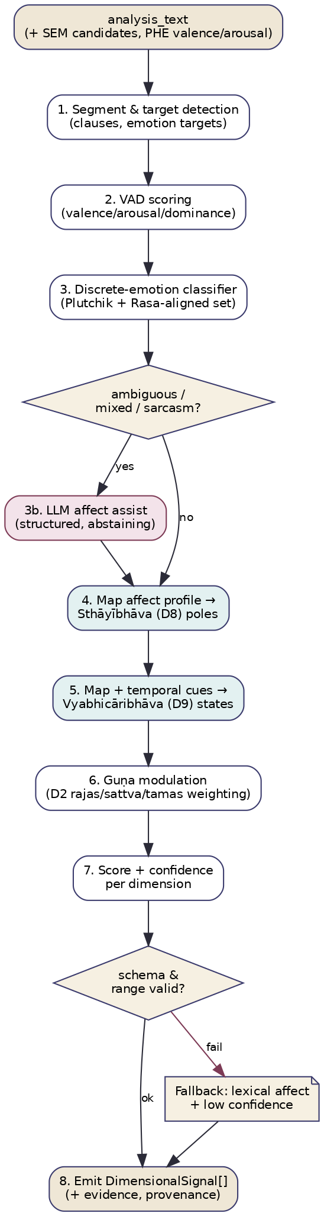
Figure A1 — Multi-Axis Affect processing workflow.
Steps. (1) Segment & target detection — split into clauses and detect emotion targets (self, other, situation) for aspect-based attribution. (2) VAD scoring — score valence/arousal/dominance (reuse PHE’s valence/arousal if present). (3) Discrete-emotion classification — multi-label probabilities over a Plutchik+Rasa-aligned emotion set. (4) Ambiguity decision — if mixed/ambivalent/ironic affect is detected (low classifier margin, contradiction between VAD and discrete emotion, sarcasm markers), invoke (3b) LLM affect assist with a strict schema; otherwise proceed. (5) Map → D8 poles — map the affect profile onto Sthāyībhāva attributes and poles, using the durability cue. (6) Map + temporal → D9 states — map onto Vyabhicāribhāva transient states using transience/temporal cues shared from NAR. (7) Guṇa modulation — derive the D2 contributing signal and use it to weight D8/D9 (rajas amplifies agitation states, tamas heaviness states, sattva equanimity states). (8) Score + confidence, validate, emit — compute per-dimension relevance/confidence and state_hint, validate against schema and ranges; on validation failure use the lexical-affect fallback at reduced confidence; emit signals with evidence and provenance.
Decision points. Ambiguity gate (step 4); validation gate (step 8). Validation steps. range checks ([0,1], VAD bounds), schema validation, attribute-name validation against the registry, and a monotonicity check (a state=excess requires arousal/intensity above the balance band). Intermediate outputs. VAD vector, discrete-emotion distribution, targets, durability label — all persisted in intermediate. Error handling / retry / fallback. model error → one retry then lexical fallback; LLM-assist schema failure → up to two repairs then drop the assist and proceed model-only; total failure → emit nothing (the layer is simply absent, lowering coverage downstream) rather than emit a guess.

7. Algorithms and Computational Methodology
Methods used. Statistical/ML classification (VAD regressor + multi-label discrete-emotion classifier), rule-based aspect/target extraction and pole mapping, a curated emotion→Rasa-attribute correspondence table, knowledge-graph lookup for attribute glosses, prompt-engineered LLM assist for ambiguous cases, and feature engineering for durability/transience. No KG traversal beyond attribute lookup; no embedding similarity (that is SEM’s job).
Core algorithm (pseudocode).
function analyze_affect(ctx):
text = ctx.analysis_text
clauses, targets = segment_and_targets(text) # NLP: clause split + ABSA targets
vad = ctx.shared_features.vad or vad_model(text) # reuse PHE if present
demo = discrete_emotion_model(text) # multi-label probs (Plutchik+Rasa)
durability = durability_cue(text, ctx.history, ctx.shared_features.temporal_cues)
if is_ambiguous(vad, demo, text): # low margin / VAD-emotion conflict / irony
assist = llm_affect_assist(text, schema=AFFECT_ASSIST_SCHEMA) # §8
demo, vad = reconcile(demo, vad, assist) # assist overrides on conflict, logged
signals = []
# D8 enduring emotions
d8 = map_to_attributes(demo, vad, table=EMO2STHAYI, durability=durability, prefer="enduring")
signals += build_signal(8, d8, evidence=spans+axes+paths)
# D9 transient states
d9 = map_to_attributes(demo, vad, table=EMO2VYABHI, durability=durability, prefer="transient",
temporal=ctx.shared_features.temporal_cues)
signals += build_signal(9, d9, evidence=...)
# D2 guna modulation (contributing) + apply to D8/D9
guna = guna_from_affect(vad, demo, volatility(text))
signals += build_signal(2, guna, contributing=True)
signals = modulate(signals, guna) # rajas/tamas/sattva weighting
# D22 / D24 contributing (felt-tone only)
signals += relational_tone(demo, targets) if intersects(ctx.candidate, {22,24})
for s in signals: s.confidence = affect_confidence(s) # §9
return [s for s in signals if validate(s)] or lexical_fallback(text)
Emotion→attribute correspondence (excerpt). The bridge table maps discrete emotions and VAD regions onto Rasa attributes, e.g. fear/anxiety + (neg valence, high arousal) → D8:bhaya and → D9:cintā/trāsa; sadness + (neg valence, low arousal, situational) → D9:viṣāda/dainya, + (enduring) → D8:śoka; serenity + (neutral valence, low arousal, equanimity markers) → D8:śama and → D9:dhṛti. The table is curated by domain experts, versioned, and unit-tested against gold examples; it is the single editable artifact that defines the Western-affect↔Rasa bridge.
Feature engineering. Durability/transience features: trait vs state language (“I am an anxious person” vs “I feel anxious today”), habitual adverbs (“always/lately”), situational triggers, and recency from temporal cues. Volatility: variance of clause-level valence. Target features: ABSA heads (self/other/situation) for D22/D24 other-directedness.

8. LLM Orchestration
The Affect layer is model-first, LLM-assisted: most expressions are handled by deterministic affect models, and the LLM is invoked only for the ambiguity cases the models flag. This keeps cost and latency low while reserving reasoning for where it adds value.
Why an LLM is needed at all. Three affect phenomena resist calibrated classifiers: (a) irony/sarcasm (surface affect inverts intended affect), (b) mixed/ambivalent affect (“relieved but guilty”), and (c) culturally specific or idiomatic affect. For these, an LLM’s contextual reasoning meaningfully outperforms a classifier. Could it be deterministic? For ~80–90% of expressions, yes — and it is. The LLM handles only the flagged remainder.
Reasoning strategy. Constrained, single-shot reasoning with a strict output schema and self-consistency (n=3 in deep mode, n=1 in fast). No free-form chain-of-thought is returned to the user; the model reasons internally and emits structured JSON. Model capabilities required. Strong affective/pragmatic comprehension; reliable JSON adherence; good calibration of an explicit “uncertain/abstain” option. A mid-tier Claude model suffices; routing can select a smaller model in fast mode.

8.1 LLM call: Affect Assist
Field | Specification
Purpose | Resolve ambiguous/ironic/mixed affect and (optionally) confirm the dominant Rasa attribute.
System prompt | The Svarupa system contract (recognition-not-diagnosis; no labels about the person; voice uncertainty) + “You are an affect-analysis component. Read only the affect carried by the text. Output JSON only.”
Input prompt | The clause(s) flagged ambiguous, the model’s VAD + top discrete emotions, detected targets, and the candidate Rasa attribute set for D8/D9 with one-line glosses (from KG).
Expected output | JSON: {valence, arousal, dominance, emotions:[{label,prob}], irony:bool, mixed:bool, dominant_attribute_d8, dominant_attribute_d9, pole, confidence, abstain:bool}.
Output validation | JSON Schema validation; ranges in [0,1]/[-1,1]; attribute names must exist in the registry; abstain=true permitted and respected.
Retry logic | Up to 2 repair attempts on schema failure (re-prompt with the validation error); then drop the assist and proceed model-only.
Hallucination mitigation | Closed attribute vocabulary (model may only choose from supplied attributes); require a verbatim span justifying each chosen attribute; reject any attribute not in the candidate set.
Confidence estimation | assist_conf = agreement_across_samples × min(evidence_span_present, model_self_conf).
Cost | One short call (~300–600 input tokens, ~150 output); invoked for the ambiguous minority only. Cached by (clause_hash, prompt_version).
Latency | ~0.4–0.9 s/sample; n=3 samples issued concurrently. Bounded by per-call timeout; on timeout, model-only result is used.

8.2 Interaction sequence
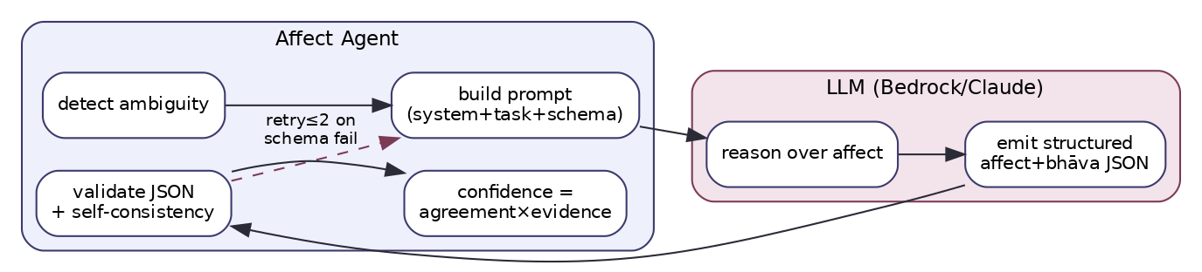
Figure A2 — Affect Agent ↔ LLM interaction for the assist path.
The Mermaid source (sequence form) is provided for maintainers:
sequenceDiagram
participant ORCH as Orchestrator
participant AFF as Affect Agent
participant MOD as Affect Models (VAD+discrete)
participant LLM as LLM (Bedrock/Claude)
ORCH->>AFF: AnalyzeCommand(analysis_text, candidates)
AFF->>MOD: vad(text), discrete_emotions(text)
MOD-->>AFF: VAD vector, emotion probs
alt ambiguous / ironic / mixed
AFF->>LLM: AffectAssist(clauses, vad, emotions, attrs) x n samples
LLM-->>AFF: structured affect JSON (or abstain)
AFF->>AFF: validate schema, self-consistency, reconcile
else clear
AFF->>AFF: use model result directly
end
AFF->>AFF: map→D8/D9, guna-modulate, score+confidence
AFF-->>ORCH: SignalBatch(DimensionalSignal[] for {8,9,2,22,24})

9. Score Generation Methodology
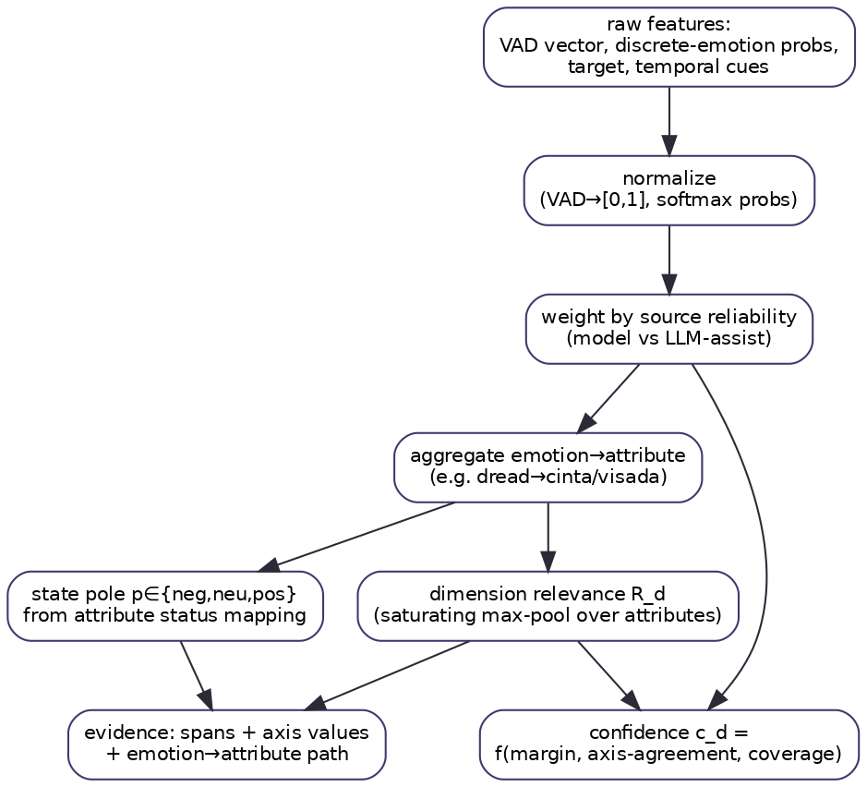
Figure A3 — Affect score-generation pipeline, from raw features to per-dimension relevance, pole, confidence and evidence.
Raw feature extraction. VAD vector (v,a,d); discrete-emotion probability vector p over the emotion set; target labels; durability label; clause-valence series (for volatility).
Normalization. Valence mapped from [-1,1] to [0,1] as v' = (v+1)/2; arousal/dominance already [0,1]; p is softmax-normalized; volatility σ min-max scaled per typical range.
Weight assignment. Each emotion→attribute edge in the bridge table carries a weight m(e,attr) ∈ [0,1] (curated, then calibrated on gold data). Source-reliability weight ρ_src distinguishes model-derived (ρ=1.0) from LLM-assist-derived (ρ set by assist confidence) contributions.
Attribute aggregation. Per attribute attr of a dimension:
score(attr) = saturate( Σ_e ρ_src · p(e) · m(e, attr) ), where saturate(x)=1−e^{−γx} (γ tuned so a single strong emotion yields ~0.6–0.7).
Dimension-level relevance. Soft max-pool over the dimension’s attributes (a dimension is relevant if any of its emotions is strongly present, but multiple raise it):
R_d = (1−λ)·max_attr score(attr) + λ·mean_attr score(attr), λ≈0.25.
State pole. Each attribute’s status (from svarupa_concept_merged: negative/neutral/positive) maps to {deficiency, balance, excess} via a per-dimension table; the pole is chosen by the sign/intensity of the affect (e.g. high-arousal negative valence on krodha → excess; flattened affect on rati → deficiency). state_hint reports the dominant attribute’s pole and its confidence.
Guṇa modulation. With guṇa weights (g_s,g_r,g_t) from the D2 contributing signal, agitation-family D9 states are scaled by (1+β·g_r), heaviness-family by (1+β·g_t), equanimity-family by (1+β·g_s), β≈0.3, renormalized.
Confidence computation. Using the shared primitives (How-to-Read): evidence e = max evidence weight present; internal agreement a = axis–emotion concordance (1 − |sign(v’)−sign(dominant emotion valence)|) blended with self-consistency agreement when LLM-assist was used; coverage v = function of text length and whether required models ran. Then
confidence = clip(0.45·e + 0.35·a + 0.20·v, 0, 1), capped at 0.9 for single-clause inputs.
Evidence accumulation. Evidence items accumulate per signal: the triggering spans, the VAD/emotion values, and the explicit mapping_path (emotion → bridge edge → attribute). Contradiction handling. Within the layer, VAD↔discrete-emotion contradiction triggers the LLM assist; if still unresolved, the layer lowers confidence and reports state=unclear rather than picking a side. Across layers, contradiction is left for fusion to surface as a tension (the layer never reconciles with other layers itself). Missing-data handling. Missing shared features are recomputed; missing emotion content yields abstained=true with no fabricated score. Uncertainty propagation. The (relevance, confidence) pair travels unchanged into fusion; the layer never pre-multiplies them, preserving the separation that lets fusion weight by calibrated reliability.
LLM score consistency / reproducibility. Temperature ≤0.2; closed vocabulary; self-consistency over n samples with median VAD and majority attribute; prompt_version + model_id pinned and logged; the bridge table is deterministic, so identical inputs yield identical mappings; assist results cached by clause hash.

10. Explainability
Every affect signal is explainable end to end. Supporting evidence: the exact spans that carried the affect, with character offsets. Traceability: the unbroken chain span → VAD/emotion → bridge edge → attribute → relevance/pole, persisted in evidence and intermediate. Feature attribution: each contributing emotion’s share of an attribute’s score is recoverable from ρ·p(e)·m(e,attr). Confidence explanation: confidence decomposes into its e/a/v terms, each reportable (“confidence is moderate because evidence is strong but the text is short”). Alternative interpretations: when affect is mixed, the layer emits the competing attributes with their scores rather than collapsing to one — the raw material for the Integration layer to voice a tension. Human-readable reasoning: a templated rationale, e.g. “‘low hum of dread’ (chars 41–58) → fear/anxiety, negative valence + low-moderate arousal → D9 cintā (transient, situational) at the excess pole; confidence 0.58 (strong evidence, short text).” No score is ever emitted without such a trace.

11. Integration with Other Layers
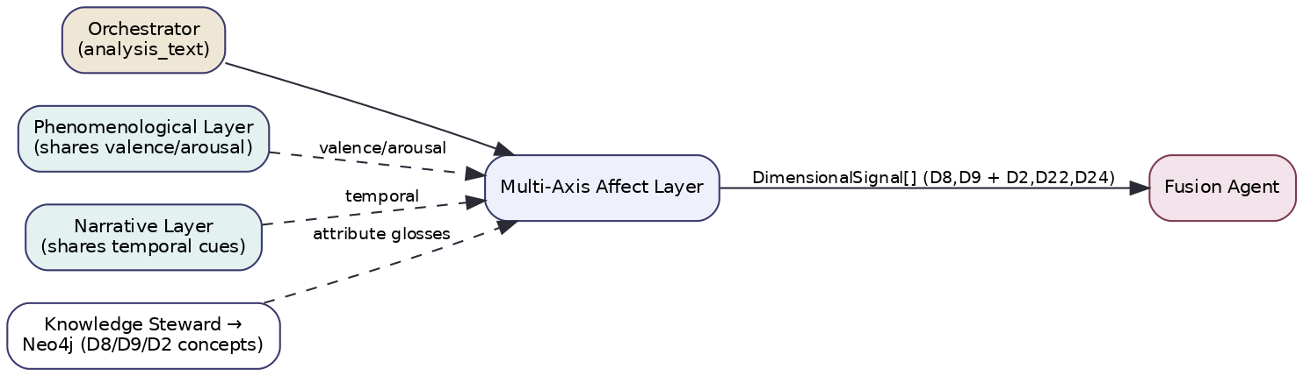
Figure A4 — Affect layer integration and data flow.
Upstream dependencies. The orchestrator (provides analysis_text and SEM candidates); optionally the Phenomenological layer (shared valence/arousal) and the Narrative layer (shared temporal_cues) via the per-request feature cache; the Knowledge Steward (attribute glosses for D8/D9/D2). None of these are authority dependencies — only features are shared, never judgements — so AFF remains epistemically independent for fusion’s agreement math.
Downstream consumers. The Fusion Agent (consumes AFF’s DimensionalSignals for D8, D9 and the contributing D2/D22/D24); through fusion, the Integration Agent (uses AFF’s enduring-vs-transient distinction to layer momentary feeling against baseline) and the Composer (turns affect evidence into recognition language).
Shared data structures. The DimensionalSignal envelope; the per-request FeatureCache (valence/arousal/temporal); the versioned EMO2STHAYI / EMO2VYABHI bridge tables. Agent interactions / message passing. Receives AnalyzeCommand, returns SignalBatch (architecture spec §9); all messages typed, versioned, provenance-stamped. Knowledge-graph updates. AFF is read-only against the KG; any newly validated emotion→attribute correspondences are proposed to curators (human-in-the-loop) and only the Knowledge Steward writes them back. Orchestration workflow. Runs concurrently with the other six layers under its own timeout; publishes shared features it computes first (valence/arousal) so PHE/NAR can reuse them.

12. Engineering Considerations
Performance. Model path p50 ≈ 80–150 ms (CPU/GPU classifier); assist path adds ~0.4–0.9 s when triggered (minority of requests). Scalability. Stateless; horizontally scalable behind the layer port; affect models served from a shared inference endpoint with batching. Parallel execution. Runs in the orchestrator’s asyncio.gather; the n self-consistency samples are issued concurrently. Caching. Clause-level affect cache; LLM-assist cache by (clause_hash, prompt_version); bridge-table results are pure functions and memoizable. Memory. Bounded by the loaded affect models (hundreds of MB) shared across workers. Token optimization. LLM assist sends only flagged clauses and a compact candidate-attribute list, not the whole expression or taxonomy. Cost optimization. Model-first design caps LLM spend; fast mode disables assist; aggressive caching for repeated/edited expressions. Monitoring. Per-signal confidence distribution, assist-trigger rate, abstention rate, fusion-time agreement of AFF with other layers (a drift signal). Logging. Structured logs of VAD/emotion vectors, mapping paths, assist usage, validation failures — all under request_id. Observability. OpenTelemetry spans per step (segment/VAD/discrete/assist/map/score); golden-transaction replay from persisted intermediate. Versioning. layer_version (code), prompt_version, bridge_table_version, model_id independently versioned and recorded in provenance. Testing strategy. Unit tests for the bridge table and pole mapping; calibration tests against an affect-and-Rasa gold set (target macro-F1 on dominant attribute, calibration error on confidence); abstention tests (must decline on affect-free text); a philosophy-regression test asserting no output contains diagnostic/second-person verdict language; property tests (relevance/confidence in range; excess pole implies above-band intensity).

13. Future Evolution
Research opportunities. A learned (rather than curated) emotion→Rasa bridge trained on expert-labelled data, with the curated table as prior; appraisal-theory features for finer target/agency-aware affect; better enduring-vs-transient discrimination via longitudinal modelling. New AI techniques. Instruction-tuned small affect models that natively emit Rasa attributes, removing most LLM-assist calls; uncertainty-aware classifiers (evidential/Bayesian heads) for principled confidence. Better models. Multilingual affect parity so the layer works in the user’s own language; on-device lightweight models for privacy. Additional dimensions / multimodality. Optional prosody and journaling-cadence signals where the client provides them, extending affect beyond text; possible contribution to D19 (Kleśa: rāga/dveṣa as affect-pull) once validated. Alternative algorithms. Replace the saturating aggregation with a learned aggregator; replace heuristic guṇa modulation with a trained model. Future architectural improvements. Promote the shared valence/arousal computation into a tiny pre-layer consumed by both AFF and PHE, eliminating duplicate work and guaranteeing a single source of truth for those axes.

Layer 2 — Phenomenological Analysis

1. Layer Overview
What this layer is. The Phenomenological layer (code PHE) reads the structure of subjective experience — independent of its emotional content or linguistic form. Where the Affect layer asks “what is felt,” PHE asks “how is experience organized”: its valence and intensity, how clearly it is perceived, whether the person is located inside or outside their experience, whether they act or are acted upon, how time is lived, how connected they feel, and how present the body is. It is the system’s specialist in the architecture of a moment of consciousness.
What problem it solves. Two people can report the same emotion yet live it in completely different structures — grief experienced as a bodily ache one is immersed in, versus grief observed from a detached distance with no felt body at all. Content-based analysis cannot tell these apart, yet the difference is decisive for self-recognition and is exactly what dimension D7 names. PHE solves the problem of producing a structured, multi-axis description of lived experience that the rest of the system can use as the bridge between raw emotion and the constitutional/embodiment dimensions.
Why it is important for Svarupa. D7 (the Phenomenological Dimensions) is explicitly a bridge dimension — it expresses subjective experience in a vocabulary that requires no belief in any metaphysical system, which is essential to Svarupa’s commitment to meet users wherever they are. Just as importantly, the felt-quality dimensions of the wisdom traditions (Elements, Doṣas, Sheaths, Subtle Energies) are recognized through their phenomenological signature: “scattered, ungrounded, can’t land” is the phenomenology of an Air/Vāta excess. PHE is what makes those traditional lenses reachable from ordinary experience.
How it contributes to multidimensional self-understanding. It provides the structural skeleton onto which other layers’ readings are hung. The Affect layer says fear; PHE says the fear is observed from above, with low agency and an absent body — and together they support a far more precise recognition than either alone. It also supplies the shared valence/arousal features that keep AFF and PHE from producing two divergent readings of the same axes.
Theoretical and research foundations. (1) Phenomenology (Husserl, Merleau-Ponty) and its empirical operationalization in micro-phenomenology (Petitmengin) and neurophenomenology (Varela). (2) Dimensional models of experience — valence/arousal as core affect axes (Russell), agency and sense-of-ownership from cognitive science, interoception/somatic-presence research. (3) The Indian contemplative analysis of experiential qualities (sukha–duḥkha valence; the felt textures the narratives describe). The layer’s contribution is a computational operationalization of eight–nine experiential axes that are simultaneously faithful to phenomenology and mappable to the tradition’s felt-quality dimensions.
Limitations and assumptions. It assumes the expression carries experiential content; terse or purely factual text yields low coverage and the layer abstains. Several axes (self-location, agency) resist surface features and require LLM assist. It reads structure as reported in language — a description of experience, not the experience itself — and frames outputs accordingly. It is text-only in v1.

2. Applicability to Svarupa
Aspects of human experience captured. The form of a lived moment: pleasant/unpleasant tone, activation, perceptual clarity, sense of agency, where the “I” is located relative to experience, temporal orientation, relational connectedness, and bodily presence.
Svarupa objectives supported. Recognition over diagnosis — structural descriptions (“experience is observed from a distance”) are inherently invitational, not evaluative. Multi-perspective — PHE’s structural voice frequently complements or tensions with AFF’s content voice. Respect for complexity — by describing structure on continua rather than assigning categories, it resists reduction.
How it complements the other layers. It shares valence/arousal with AFF (computed once); it feeds elemental/energetic signatures to MET for cross-checking; it gives COT the structural context that makes interpretive readings (e.g. dissociation in a soteriological frame) better grounded. It is the only layer that converts felt experience into the axis vocabulary D7 requires.
Why it cannot be replaced by another layer. AFF reads content, not structure; PSY reads linguistic form, not lived structure; COT could reason about structure but at far higher cost and with weaker calibration on fine axis gradients. The agency/self-location distinction — central to recognizing dissociation, flow, or embodiment — has no home in any other layer. PHE is irreducible.

3. Mapping to the 31-Dimension Framework
PHE is primary for D7 and contributing to D1, D4, D5, D6, D15. Per the §22 audit, D7 outputs per-axis values on natural scales, not balance/excess/deficiency poles; D1/D15 receive a pole; D4/D5 receive a locus; D6 an energy-state.
Dimension | Role | Attributes Used | Features Extracted | Output Variables | Status/scale emitted
D7 Phenomenology | primary | valence, arousal, clarity, agency, self_location, temporal, orientation, relational_quality, somatic_presence (9) | per-axis lexical+syntactic+embedding features | 9 axis values | per-axis (bipolar valence; [0,1] arousal/clarity/agency/somatic; categorical self_location/temporal/orientation/relational) — not a pole
D1 Elements | contributing | air, earth, fire, water, ether | axis-pattern → elemental signature | element relevance + pole | balance/excess/deficiency ✓ grounded
D15 Tridoṣa | contributing | vāta, pitta, kapha | movement/heat/heaviness signature | doṣa relevance + pole | balance/excess/deficiency ✓ grounded
D6 Subtle Energies | contributing | vāyus, chakras, nāḍīs | energetic-flow signature | energy relevance + state | balanced/blocked/overactive→canonical ✓
D5 Pañca Kośa | contributing | annamaya…ānandamaya | dwelling-layer signature | kośa locus | locus distribution (not pole) ✓
D4 Consciousness | contributing | waking…cosmic | clarity/self-location signature | plane locus | categorical locus (not pole)
Attributes ignored. PHE ignores the content of emotion (AFF), the linguistic form (PSY), and the soteriological meaning of consciousness states (COT). For D4 it reads only the experiential signature of the predominant plane (clarity, self-location), not its metaphysical status.
Why others are excluded. Affective dimensions (D8/D9) are content, not structure. Path/temporal/epistemic/soteriological dimensions (D10–D14, D16–D30) are not read from the structure of a single moment. Constitutional D2 (guṇa) and D3 (archetype) are tone/form, owned by AFF/PSY. Restraint keeps PHE’s axes interpretable.

4. Input Specification
Inputs: the prepared analysis_text (required); optional last-k conversation turns (referent/tense disambiguation); the per-request feature cache (PHE publishes valence/arousal here for AFF/NAR; consumes none required); KG glosses for D1/D5/D6/D15 signatures via the Knowledge Steward; metadata (request_id, locale, latency mode). User profile is not consumed as analysis input. Context window: expression + up to k turns, ≤2k tokens. No external sources at runtime.
{
"$schema": "https://svarupa.ai/schemas/v1/phe_input.json",
"type": "object",
"required": ["request_id","analysis_text","candidate_dimensions"],
"properties": {
"request_id": { "type":"string","format":"uuid" },
"analysis_text": { "type":"string","minLength":1 },
"locale": { "type":"string","default":"en" },
"conversation_history": { "type":"array","items": {"type":"object",
"properties":{"role":{"type":"string"},"text":{"type":"string"}}}},
"candidate_dimensions": { "type":"array","items":{"type":"integer"},
"description":"AFF/PHE intersect with PHE affinity {7,1,4,5,6,15}." },
"kg_context": { "type":"object","description":"signature glosses for D1/D5/D6/D15." },
"options": { "type":"object","properties":{
"latency_mode": {"type":"string","enum":["fast","standard","deep"]},
"enable_llm_assist": {"type":"boolean","default":true}}}
}
}

5. Output Specification
Outputs: the nine axis values (the analytical observation), per-contributing-dimension signatures with relevance and pole/locus, evidence (spans + axis values + signature-match rationale), confidence, and the intermediate axis vector.
{
"$schema": "https://svarupa.ai/schemas/v1/phe_output.json",
"type": "object",
"required": ["request_id","layer","axes","signals"],
"properties": {
"request_id": {"type":"string","format":"uuid"},
"layer": {"const":"PHE"},
"layer_version": {"type":"string"},
"axes": {
"type":"object",
"required":["valence","arousal","clarity","agency","somatic_presence",
"self_location","temporal","orientation","relational_quality"],
"properties":{
"valence": {"type":"number","minimum":-1,"maximum":1},
"arousal": {"type":"number","minimum":0,"maximum":1},
"clarity": {"type":"number","minimum":0,"maximum":1},
"agency": {"type":"number","minimum":0,"maximum":1},
"somatic_presence": {"type":"number","minimum":0,"maximum":1},
"self_location": {"type":"string","enum":["embodied","observer","dissociated","diffuse","unclear"]},
"temporal": {"type":"string","enum":["past","present","future","timeless","mixed"]},
"orientation": {"type":"string","enum":["approach","avoid","neutral","conflicted"]},
"relational_quality": {"type":"string","enum":["connected","isolated","merged","ambivalent","na"]},
"axis_confidence": {"type":"object","additionalProperties":{"type":"number"}}
}
},
"signals": {
"type":"array",
"items":{"type":"object","required":["dimension_id","relevance","confidence","evidence"],
"properties":{
"dimension_id":{"type":"integer","enum":[7,1,4,5,6,15]},
"relevance":{"type":"number","minimum":0,"maximum":1},
"confidence":{"type":"number","minimum":0,"maximum":1},
"state_hint":{"type":"object","properties":{
"state":{"type":"string","enum":["balance","excess","deficiency","locus","unclear"]},
"detail":{"type":"string"},"confidence":{"type":"number"}}},
"evidence":{"type":"array","items":{"type":"object",
"properties":{"kind":{"type":"string","enum":["span","axis","signature"]},
"detail":{"type":"string"},"span":{"type":"array","items":{"type":"integer"}}}}},
"abstained":{"type":"boolean","default":false}}}
},
"provenance": {"$ref":"https://svarupa.ai/schemas/v7/provenance.json"}
}
}

6. Processing Workflow
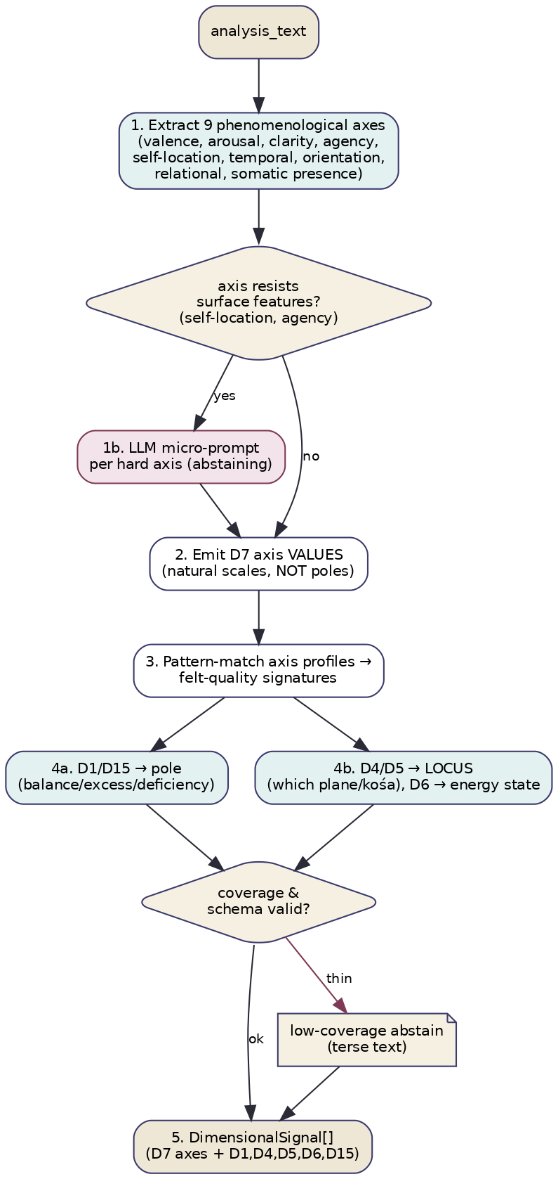
Figure B1 — Phenomenological processing workflow.
- Extract the nine axes (lexicon + dependency features + embeddings). (2) For axes that resist surface features (self-location, agency), invoke an LLM micro-prompt that returns a categorical/continuous value with abstention. (3) Emit D7 axis values on their natural scales — never coerced to a pole. (4a) Pattern-match axis profiles to felt-quality signatures and emit D1/D15 poles; (4b) emit D4/D5 locus and D6 energy-state. (5) Validate coverage and schema; on thin/terse input, abstain at low confidence. Decision points: hard-axis LLM branch; coverage gate. Validation: axis ranges, schema, signature requires ≥2 corroborating axes. Error handling: model error → one retry → lexical-only axes at reduced confidence; LLM-assist timeout → mark those axes unclear. Fallback: emit whatever axes were computed; never fabricate a signature.

7. Algorithms and Computational Methodology
Methods: feature engineering per axis (lexical, syntactic/dependency, embedding), a span-level axis extractor, a deterministic signature pattern-matcher, KG gloss lookup, and targeted LLM assist. No KG traversal beyond glosses; no embedding search (SEM’s job).
function analyze_phenomenology(ctx):
text = ctx.analysis_text
axes = {}
for ax in NINE_AXES:
axes[ax] = extract_axis(text, ax) # lexicon+syntax+embedding regressor/classifier
for ax in HARD_AXES: # self_location, agency
if axes[ax].confidence < THRESH and ctx.enable_llm_assist:
axes[ax] = llm_axis_assist(text, ax) # §8
publish_shared(ctx.cache, valence=axes.valence, arousal=axes.arousal)
signals = [ build_d7_signal(axes) ] # axis values, NOT a pole
for dim, sig_fn in [(1,elemental),(15,dosha),(6,energetic)]:
s = sig_fn(axes) # signature → relevance + pole
if s.relevance > MIN: signals.append(with_pole(dim, s))
for dim, loc_fn in [(5,kosha_locus),(4,plane_locus)]:
s = loc_fn(axes)
if s.relevance > MIN: signals.append(with_locus(dim, s))
for s in signals: s.confidence = phe_confidence(s, axes) # §9
return [s for s in signals if validate(s)] or low_coverage_abstain()
Signature patterns (excerpt). Air/Vāta: high arousal + low somatic-presence + diffuse self-location + future/scattered temporal → element=air/doṣa=vāta, pole by intensity. Fire/Pitta: high arousal + approach-orientation + heat lexicon + high agency-with-edge → pitta. Earth/Kapha: low arousal + high somatic-presence + present/stuck temporal → kapha. Manomaya dwelling: high mental-axis activity, low somatic presence → kośa locus = manomaya. Each pattern requires multiple corroborating axes; single-axis matches are rejected.

8. LLM Orchestration
PHE is model-first; the LLM assists only the two hard axes (self-location, agency) and only when the deterministic extractor is low-confidence.
Why an LLM. Self-location (“watching myself from outside”) and agency (“things just happen to me”) are pragmatic/figurative and resist lexicon/syntax features. Deterministic alternative? Yes for the other seven axes; those never call the LLM. Strategy. Single constrained call per hard axis (batched), strict schema, abstention allowed. Capabilities. Pragmatic comprehension + reliable JSON; a small/mid model suffices.
Field | Specification
Purpose | Resolve self-location and/or agency when surface features are inconclusive.
System prompt | Svarupa contract (recognition; describe the experience as reported, not the person) + “You classify experiential structure. JSON only.”
Input prompt | The clause(s), the candidate axis with its enum, and the low-confidence extractor guess.
Output | {axis, value, confidence, abstain} (value from the axis enum / [0,1]).
Validation | Schema; value ∈ enum/range; abstain respected.
Retry | ≤2 repairs on schema failure, then mark axis unclear.
Hallucination mitigation | Closed enum; require a verbatim span; reject out-of-enum values.
Confidence | samples_agreement × span_present.
Cost/Latency | One short batched call for the hard axes; ~0.3–0.7 s; cached by clause hash; skipped in fast.
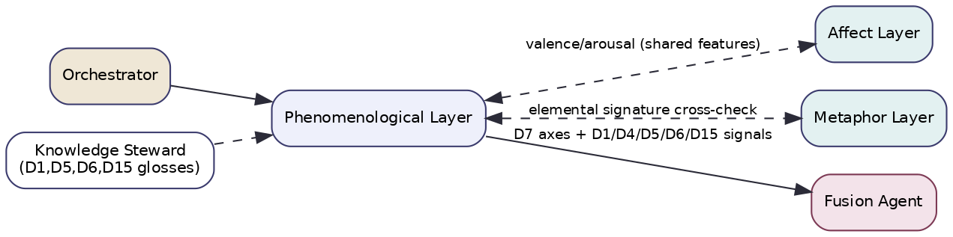
Figure B2 — Phenomenological layer integration and shared features.

9. Score Generation Methodology
Axis extraction → normalization. Each axis regressor/classifier returns a value + confidence; valence kept bipolar, intensities in [0,1], categorical axes as enums with a probability distribution. No pole for D7 — the axis values are the output.
Signature scoring (contributing dims). A signature S has a set of axis predicates with weights w_i. Signature match: m_S = Σ_i w_i · sat(axis_i matches predicate) over satisfied predicates, normalized by Σ w_i. Dimension relevance R_d = max_S m_S over that dimension’s signatures. Pole (D1/D15/D6): from the intensity/direction of the matched axes (e.g. air-signature with very high arousal + very low grounding → excess). Locus (D4/D5): emit a distribution over planes/kośas, not a pole.
Confidence. Using shared primitives: evidence e = corroborating-axis count / required; agreement a = consistency among the axes composing a signature; coverage v = fraction of axes successfully extracted (text length-sensitive). confidence = clip(0.4·e + 0.35·a + 0.25·v, 0, 1), hard-capped for terse inputs. Contradiction: conflicting axes within a signature lower its match and confidence; cross-layer contradiction is left for fusion. Missing data: unextracted axes are unclear, never imputed. Uncertainty: axis-confidences propagate into signature confidence and on to fusion unchanged. Reproducibility: deterministic extractors are pure; LLM-assist uses temperature ≤0.2, closed enums, pinned prompt_version/model_id.

10. Explainability
Every signal traces span → axis value(s) → signature predicate(s) → dimension relevance/pole-or-locus. Feature attribution: each axis’s contribution to a signature is w_i-weighted and reportable. Confidence decomposes into e/a/v. Alternative interpretations: when two signatures match comparably (e.g. air vs vāta — see the de-duplication note), both are surfaced. Human-readable: “agency 0.2 (low), self-location ‘observer’, somatic-presence 0.15 (absent) → a dissociated-above structure (D7); these also corroborate an Air/Vāta excess signature (D1, conf 0.52).” D7 axis values are themselves the explanation — no opaque score.

11. Integration with Other Layers
Upstream: orchestrator (text, candidates); Knowledge Steward (signature glosses). Downstream: Fusion (D7 axes + D1/D4/D5/D6/D15 signals); Integration (structural context for synthesis). Shared structures: PHE publishes valence/arousal to the per-request feature cache for AFF and NAR (single source of truth for those axes); shares elemental signatures with MET for mutual corroboration. Agent interactions/messaging: AnalyzeCommand → SignalBatch, typed/versioned/provenance-stamped. KG updates: read-only; new signature patterns proposed to curators. Orchestration: runs concurrently; computes shared axes early and publishes them so AFF/NAR can reuse rather than recompute (eliminating divergent valence readings).

12. Engineering Considerations
Performance: p50 ≈ 100–200 ms model path; +0.3–0.7 s when hard-axis assist fires. Scalability: stateless, horizontally scalable; axis extractors served from a shared endpoint. Parallelism: axes extracted in parallel; runs inside the orchestrator gather. Caching: axis cache by text hash; assist cache by clause hash. Memory: bounded by axis models. Token/cost: assist sends only the flagged clause + one axis enum; disabled in fast. Monitoring: axis-value distributions, hard-axis assist rate, abstention rate, AFF/PHE valence agreement (drift). Logging: the nine axes + signature rationale under request_id. Observability: spans per axis; replay from the persisted axis vector. Versioning: layer_version, axis-model versions, signature-table version, prompt_version. Testing: axis-extractor calibration vs annotated text; signature unit tests; abstention on affect-free text; property tests (ranges, signature requires ≥2 axes); philosophy-regression (no second-person verdicts).

13. Future Evolution
A learned axis extractor trained on micro-phenomenological interview corpora; a joint PHE–MET model so phenomenology and metaphor identify elemental signatures together (reducing the D1↔D15 ambiguity); evidential/Bayesian axis heads for calibrated confidence; optional interoception/somatic signals from wearables (with consent) to ground the somatic-presence axis beyond text; multilingual axis parity; and longitudinal tracking of a user’s habitual phenomenological “baseline” (without storing content) so deviations become gentle recognition cues.

Layer 3 — Psycholinguistic Analysis

1. Layer Overview
What this layer is. The Psycholinguistic layer (code PSY) reads the form of language rather than its content — pronoun distribution, agency and voice, causal and insight connectives, temporal orientation, lexical diversity, and discourse coherence — and maps these measurable linguistic features onto the dimensions that have a reliable linguistic signature. It is the system’s fully deterministic, white-box specialist.
What problem it solves. How a person constructs sentences reveals dimensions that what they say conceals. “It happened to me, there was nothing I could do” and “I decided to walk away” report similar events but opposite attribution locus and agency — and that difference is precisely dimension D17 (the Three Lenses). Content analysis misses it; PSY measures it directly from grammar. The problem PSY solves is extracting stable, interpretable, language-form features and mapping them to the dimensions where form is more diagnostic than content.
Why it is important for Svarupa. It is the most transparent layer in the system — no model opacity, no LLM, every output traceable to a counted feature — which makes it the backbone of Svarupa’s explainability promise. It owns D17 (attribution locus is a grammatical fact) and co-owns the linguistic reading of D2 (sattva/rajas/tamas show up as coherence, drive, and inertia in language). It supplies trustworthy features to the reasoning-heavy layers without itself overreaching.
How it contributes to multidimensional self-understanding. It adds the “voice of grammar” to the chorus. Passive constructions and external causal attribution implicate the Ādhibhautika lens; first-person-singular saturation with rumination markers implicates saṁskāra loops; fragmentation vs coherence tracks the guṇa gradient. These are recognitions a person can verify by re-reading their own words.
Theoretical and research foundations. (1) Computational psycholinguistics and LIWC-style lexical analysis (Pennebaker) linking function-word use to psychological state. (2) Agency / attribution theory (Heider; locus-of-control research) operationalized through voice and causal grammar. (3) Discourse coherence models (Centering theory; coherence metrics). (4) The tradition’s own linking of language quality to guṇa (sattvic clarity, rajasic agitation, tamasic dullness). The contribution is an interpretable feature→dimension mapping that is deliberately white-box.
Limitations and assumptions. Features need enough text — very short inputs sharply lower confidence. It assumes reasonably well-formed input and is sensitive to language/locale (features must be re-validated per language). It reads correlates, not causes: high first-person density is a marker, never a diagnosis. It cannot adjudicate meaning (it does not know if a belief is true), which is why it contributes features to COT for the interpretive dimensions rather than scoring them itself.

2. Applicability to Svarupa
Aspects of human experience captured. Self-positioning (agent vs patient), where causation is placed (self/world/fate), how attention is distributed across time, how organized or fragmented thought is, and how self-referential the discourse is.
Svarupa objectives supported. Transparency — its white-box nature makes every claim auditable, the strongest possible support for recognition-not-diagnosis. Multi-perspective — the grammatical voice often diverges from the affective one, which fusion preserves as tension. User agency — features point back to the user’s own words, returning authority to them.
How it complements other layers. It shares temporal-orientation features with NAR and AFF; its agency reading cross-checks AFF’s aspect attribution; it supplies attribution/complexity features to COT for D3, D19, D20, D28. It is the only layer whose evidence is countable rather than inferred.
Why it cannot be replaced by another layer. An LLM (COT) could infer agency but at higher cost, lower reproducibility, and without countable evidence; AFF reads tone, not voice; PHE reads experienced agency, not grammatical agency (related but distinct). Attribution locus (D17) has no other natural home. PSY is irreducible — and uniquely cheap and transparent.

3. Mapping to the 31-Dimension Framework
Per the §22 audit, PSY is primary for D17 and co-primary (with AFF) for D2; for D3, D12, D16, D19, D20, D28 it is contributing features only — those dimensions are COT-primary (or NAR-primary for D12/D16). PSY does not adjudicate archetype identity or valid-vs-erroneous cognition.
Dimension | Role | Attributes Used | Features Extracted | Output Variables | Status/grounding
D17 Three Lenses | primary | ādhibhautika, adhidaivika, ādhyātmika | causal-attribution locus (external/fate/internal), voice | lens distribution + dominant lens | canonical pole derived; ⚠ narrative-only
D2 Guṇas | co-primary (w/ AFF) | sattva, rajas, tamas | coherence, agency, drive vs inertia language | guṇa proportional weights (form-based) | high/med/low → proportional; ✓ grounded
D12 Inner Life | contributing | karma/saṁskāra/vāsanā/eṣaṇā | rumination / loop / craving markers | loop-marker features → NAR/COT | ◑ partial (samskaras)
D16 Svadharma | contributing | role/plane attributes | role-language, agency-in-role | alignment features → NAR | ✓ (attrs messy)
D19 Kleśas | contributing | asmitā only | first-person saturation, self-reference density | asmitā feature → COT | ⚠ narrative-only
D20 Vṛttis | contributing | vikalpa, smṛti only | abstraction/hypotheticals; past-reference | cognition-type features → COT | ⚠ narrative-only
D28 Ways of Knowing | contributing | — | cognitive-complexity (causal/insight density) | complexity feature → COT | ⚠ narrative-only
D3 16 Faces | contributing | (16 archetypes) | agency, social-orientation features | features → COT (adjudicates) | ✓ grounded
Attributes ignored. PSY ignores emotional content (AFF), experiential structure (PHE), and the truth of cognition (it measures vikalpa as abstraction-frequency, not whether a thought is valid pramāṇa vs erroneous viparyaya — that is COT). For D2 it reads only the linguistic manifestation, deliberately disjoint from AFF’s tonal manifestation (de-duplication, §22.6).
Why others are excluded. Felt-quality, affective, metaphorical, temporal-trajectory, and soteriological dimensions have no reliable language-form signature distinct from content; forcing them onto PSY would invent signal. PSY restricts itself to dimensions where grammar is genuinely diagnostic.

4. Input Specification
Inputs: analysis_text (required); optional conversation history (coreference); the feature cache (PSY publishes temporal-orientation features for NAR/AFF); KG glosses for D17/D2 (minimal — PSY is largely self-contained); metadata. No user-profile analysis input, no external sources, no LLM context window (deterministic).
{
"$schema":"https://svarupa.ai/schemas/v1/psy_input.json",
"type":"object",
"required":["request_id","analysis_text","candidate_dimensions"],
"properties":{
"request_id":{"type":"string","format":"uuid"},
"analysis_text":{"type":"string","minLength":1},
"locale":{"type":"string","default":"en"},
"conversation_history":{"type":"array","items":{"type":"object",
"properties":{"role":{"type":"string"},"text":{"type":"string"}}}},
"candidate_dimensions":{"type":"array","items":{"type":"integer"},
"description":"intersect with PSY affinity {17,2,12,16,19,20,28,3}."},
"options":{"type":"object","properties":{
"min_tokens":{"type":"integer","default":12,"description":"below this, confidence is capped low"}}}
}
}

5. Output Specification
Outputs: the full feature vector (the analytical observation and the evidence), per-dimension signals (D17, D2 as full signals; others as feature contributions), confidence, and the intermediate parse artifacts.
{
"$schema":"https://svarupa.ai/schemas/v1/psy_output.json",
"type":"object",
"required":["request_id","layer","features","signals"],
"properties":{
"request_id":{"type":"string","format":"uuid"},
"layer":{"const":"PSY"},
"layer_version":{"type":"string"},
"features":{
"type":"object",
"properties":{
"pronoun_dist":{"type":"object","additionalProperties":{"type":"number"}},
"agency_ratio":{"type":"number","minimum":0,"maximum":1},
"passive_ratio":{"type":"number","minimum":0,"maximum":1},
"causal_external":{"type":"number"},"causal_internal":{"type":"number"},"causal_fate":{"type":"number"},
"insight_connectives":{"type":"number"},
"temporal_orientation":{"type":"object","properties":{
"past":{"type":"number"},"present":{"type":"number"},"future":{"type":"number"}}},
"lexical_diversity":{"type":"number"},
"coherence":{"type":"number","minimum":0,"maximum":1}
}
},
"signals":{
"type":"array",
"items":{"type":"object","required":["dimension_id","relevance","confidence","evidence","mode"],
"properties":{
"dimension_id":{"type":"integer","enum":[17,2,12,16,19,20,28,3]},
"mode":{"type":"string","enum":["signal","feature_contribution"]},
"relevance":{"type":"number","minimum":0,"maximum":1},
"confidence":{"type":"number","minimum":0,"maximum":1},
"detail":{"type":"object","description":"e.g. lens distribution / guna weights / feature payload"},
"evidence":{"type":"array","items":{"type":"object",
"properties":{"kind":{"const":"feature"},"name":{"type":"string"},
"value":{"type":"number"},"span":{"type":"array","items":{"type":"integer"}}}}},
"abstained":{"type":"boolean","default":false}}}
},
"provenance":{"$ref":"https://svarupa.ai/schemas/v7/provenance.json"}
}
}

6. Processing Workflow
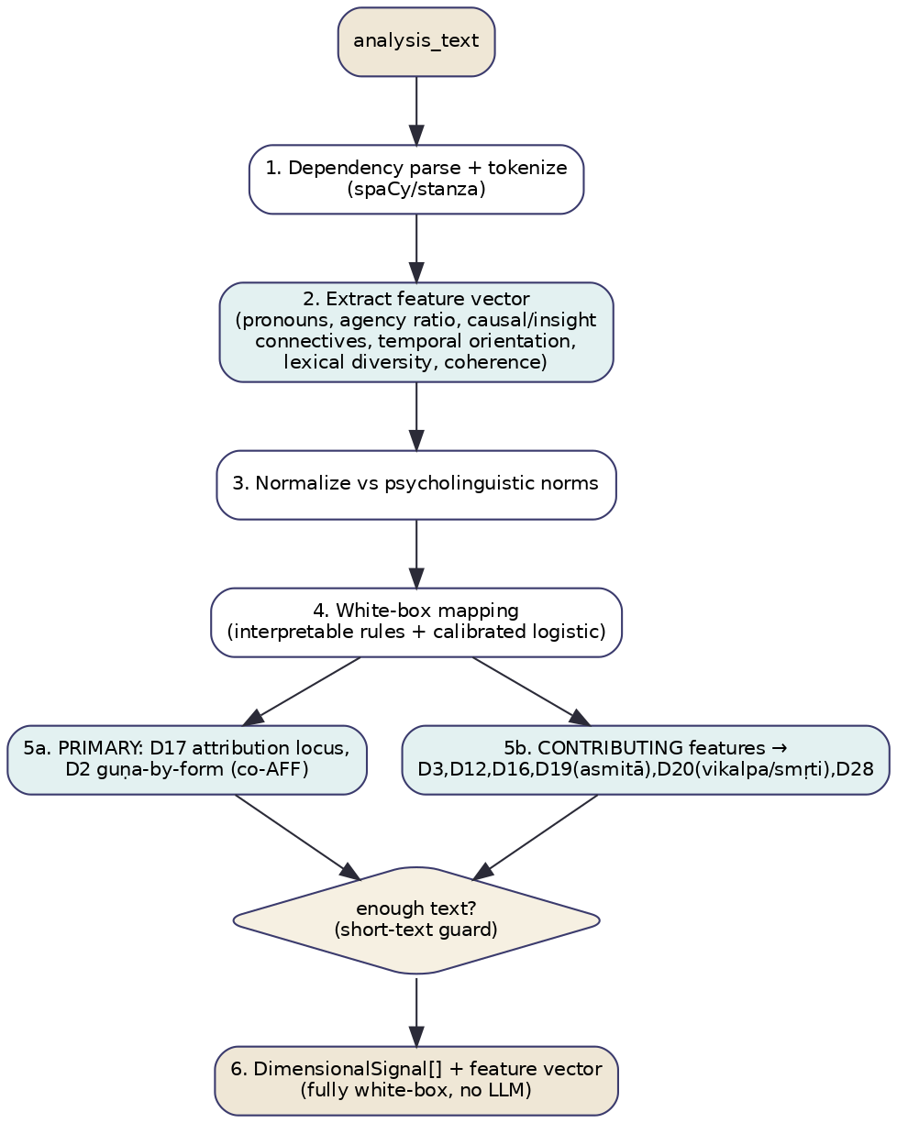
Figure C1 — Psycholinguistic feature pipeline.
- Dependency-parse and tokenize. (2) Extract the fixed feature vector. (3) Normalize against psycholinguistic norm tables. (4) Apply the white-box mapping (interpretable rules + a calibrated logistic per dimension). (5a) Emit signals for D17 (lens distribution) and D2 (form-based guṇa weights); (5b) emit feature contributions for D3/D12/D16/D19/D20/D28. (6) Validate; the short-text guard caps confidence when token count is low. Decision point: short-text guard. Validation: feature ranges, schema, mapping monotonicity. Error handling: parser failure → fall back to regex/lexicon features at reduced confidence; never call an LLM. Fallback: emit whatever features parsed; abstain on dimensions whose required features are missing.

7. Algorithms and Computational Methodology
Methods: deterministic NLP (dependency parse, POS, coreference), lexicon counts (LIWC-style categories), discourse-coherence metrics, interpretable rule + calibrated-logistic mapping. No embeddings, no KG traversal, no LLM — by design.
function analyze_psycholinguistic(ctx):
doc = parse(ctx.analysis_text) # spaCy/stanza
f = {}
f.pronoun_dist = count_pronouns(doc)
f.agency_ratio = agentive_subjects(doc) / clauses(doc)
f.passive_ratio = passive_clauses(doc) / clauses(doc)
f.causal_* = classify_causal_attributions(doc) # internal/external/fate
f.insight_conn = count(INSIGHT_CONNECTIVES, doc) # "because, realize, understand"
f.temporal_orient= tense_distribution(doc)
f.lexical_div = mtld(doc)
f.coherence = entity_grid_coherence(doc)
publish_shared(ctx.cache, temporal=f.temporal_orient)
signals = []
signals += d17_lens(f) # external→adhibhautika, fate→adhidaivika, internal→adhyatmika
signals += d2_guna_form(f) # coherence→sattva, drive/agitation→rajas, dullness/passivity→tamas
for dim in [3,12,16,19,20,28]:
signals += feature_contribution(dim, f) # NOT a full score; payload for COT/NAR
for s in signals: s.confidence = psy_confidence(s, tokens(doc))
return [s for s in signals if validate(s)]
Mapping detail (D17). lens = softmax([causal_external, causal_fate, causal_internal]); dominant lens = argmax; pole (over/under-reliance on one lens) derived from concentration of the distribution (a near-degenerate distribution → excess of that lens). Mapping detail (D2, form): sattva-weight ∝ coherence × insight-connectives; rajas-weight ∝ agency × agitation-lexicon × clause-rate; tamas-weight ∝ passivity × low-diversity × present-stuck temporal; normalized to a 3-way proportion (not a pole; see §22.5).

8. LLM Orchestration
PSY makes no LLM calls. This is a deliberate architectural choice, not an omission. Every PSY output is a counted, reproducible linguistic feature; introducing an LLM would sacrifice determinism, reproducibility, auditability, latency, and cost for no accuracy gain on feature extraction. Could the task be deterministic? It already is, entirely. Where interpretation beyond features is needed (e.g. adjudicating a 16-way archetype for D3, or valid-vs-erroneous cognition for D20), PSY hands its features to COT, which owns the LLM reasoning. This separation keeps the transparent layer transparent and confines model opacity to the one layer (COT) whose task genuinely requires it. There are therefore no prompts, no retries, no hallucination surface, and no LLM cost or latency attributable to PSY.

9. Score Generation Methodology
Feature extraction → normalization. Raw counts normalized per token / per clause and z-scored against locale-specific norm tables (so “high first-person” is relative to a baseline, not absolute). Weighting. Each dimension’s mapping carries calibrated weights fit on a gold set (logistic regression coefficients are themselves the interpretable weights). Aggregation. D17/D2 aggregate features into a distribution/proportion; contributing dims package the relevant features with a relevance estimate. Confidence. e = feature reliability (are the required features present and above noise floor), a = agreement among features pointing the same way (e.g. passive-ratio and external-causal both high), v = coverage (token count vs min_tokens). confidence = clip(0.4·e + 0.3·a + 0.3·v, 0, 1), sharply capped below min_tokens. Contradiction: features that disagree (high agency and high passivity in different clauses) lower confidence and are reported as mixed. Missing data: absent features → that dimension abstains. Uncertainty: feature-level reliabilities propagate into signal confidence. Reproducibility: fully deterministic — identical input yields identical output; model weights are versioned; no sampling anywhere.

10. Explainability
PSY is the gold standard for explainability: every signal is backed by named, counted features with their spans. Feature attribution is exact (logistic coefficients × feature values). Confidence decomposes into e/a/v. Alternative interpretations: when a feature pattern is ambiguous (e.g. high first-person could be asmitā or healthy ownership), both are reported with the disambiguating feature noted. Human-readable: “82% passive constructions; external causal attribution in 4/5 clauses → Ādhibhautika lens dominant (D17, conf 0.74). Evidence: ‘it was done to me’ (chars 10–24), ‘there was nothing I could do’ (chars 50–77).” Nothing is inferred that cannot be pointed at in the text.

11. Integration with Other Layers
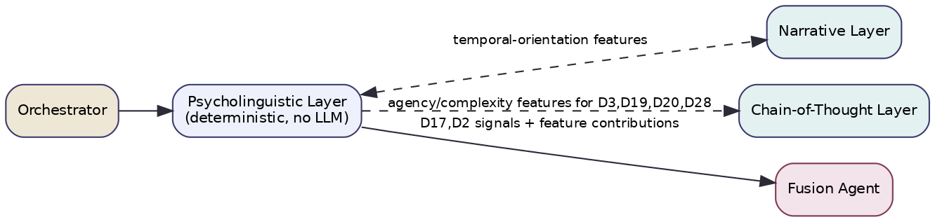
Figure C2 — Psycholinguistic layer integration (deterministic; feeds features to NAR and COT).
Upstream: orchestrator (text, candidates). Downstream: Fusion (D17, D2 signals); COT (feature contributions for D3, D19, D20, D28); NAR (D12 loop markers, D16 alignment features); Composer (countable evidence for grounded recognition language). Shared structures: publishes temporal_orientation to the feature cache for NAR/AFF; consumes nothing required (fully self-contained). Agent interactions/messaging: AnalyzeCommand → SignalBatch; feature-contribution messages are typed distinctly (mode: feature_contribution) so consumers know they are inputs, not scores. KG updates: none (read-light). Orchestration: runs concurrently; cheapest and fastest layer, so it returns early and its features are available to later-finishing layers via the cache.

12. Engineering Considerations
Performance: p50 ≈ 30–80 ms (parse-bound); the fastest layer. Scalability: trivially horizontal; CPU-only. Parallelism: features extracted in parallel; no external calls to serialize on. Caching: parse + feature cache by text hash. Memory: small (parser + lexicons). Token/cost: zero LLM cost. Monitoring: feature distributions, short-text abstention rate, locale coverage, fusion-agreement of PSY signals. Logging: the full feature vector + spans under request_id. Observability: spans per pipeline stage; replay from persisted features. Versioning: layer_version, parser version, lexicon version, mapping-weights version, norm-table version. Testing: feature-reliability tests vs psycholinguistic norms; mapping accuracy vs gold; locale regression; property tests (ranges, determinism — same input → byte-identical output); philosophy-regression (no verdict language). Determinism makes PSY uniquely easy to test exhaustively.

13. Future Evolution
Multilingual feature parity (re-validated lexicons and parsers per language) so PSY works in the user’s own tongue; learned-but-interpretable mappings (e.g. monotonic GAMs) that keep auditability while improving accuracy; idiolect normalization so the baseline adapts to a user’s habitual style over time without storing content; richer discourse features (rhetorical-structure parsing) for D28; and a feature-importance dashboard exposed to curators to refine the feature→dimension mappings as gold data grows.

Layer 4 — Metaphor Analysis

1. Layer Overview
What this layer is. The Metaphor layer (code MET) detects the metaphors a person uses, extracts their source–target structure, classifies the source into a small ontology (elemental, energetic, structural), and maps that onto the dimensions whose everyday expression is metaphorical. “I’m drowning,” “burnt out,” “stuck in the mud,” “scattered to the winds” are not ornament — they are phenomenological reports delivered in elemental language.
What problem it solves. Several Svarupa dimensions (the Five Elements above all) rarely appear in literal vocabulary; users almost never say “my Vāyu is excessive,” but they constantly say “I can’t land.” Keyword and even affect analysis miss this; the meaning lives in the figurative layer. MET solves the problem of systematically mining and classifying metaphor so these natively-metaphorical dimensions become detectable from natural speech.
Why it is important for Svarupa. Metaphor is one of the most direct windows onto how a person conceptualizes their experience, and the elemental/energetic dimensions are conceptual structures the tradition already framed metaphorically. MET turns a “drowning” into evidence for a Water/Apas signature — a recognition that often lands with users precisely because it uses their own image back to them.
How it contributes to multidimensional self-understanding. It corroborates and sharpens the phenomenological reading: a “drowning” metaphor + low agency + water-valence is far stronger evidence for an Apas/Water excess than any one of those alone. It contributes the imaginal voice to the chorus, frequently confirming (and occasionally contradicting) the structural reading from PHE.
Theoretical and research foundations. (1) Conceptual Metaphor Theory (Lakoff & Johnson) — metaphor as cross-domain mapping that structures thought, not just language. (2) Metaphor identification — MIP/MIPVU procedures and corpora (VU Amsterdam) for reliable detection. (3) Source–target / conceptual-domain analysis for extracting the underlying mapping. (4) The tradition’s elemental/energetic ontology as the target taxonomy. The contribution is a source-ontology aligned to Svarupa’s felt-quality dimensions plus a disciplined detection→classification→mapping pipeline.
Limitations and assumptions. Conventional/dead metaphors (“grasp an idea”) must be filtered or they over-fire; MET assumes a conventionality lexicon. Single isolated metaphors yield only modest confidence. Metaphor signals which quality more reliably than how much (pole inference is weaker than presence inference). It is text-only and language-specific (metaphor ontologies differ across languages). It reads imagery, not the person — outputs are framed as what the language evokes.

2. Applicability to Svarupa
Aspects of human experience captured. The imaginal/conceptual framing of experience — the implicit source domains (water, fire, weight, space, blockage, flow) through which a person renders their inner state.
Svarupa objectives supported. Recognition — reflecting a person’s own metaphor back (“you said ‘drowning’”) is among the most resonant, least diagnostic moves available. Multi-perspective — the imaginal reading complements PHE’s structural and AFF’s affective readings. Cultural bridging — elemental metaphor is near-universal, helping the traditional dimensions land without jargon.
How it complements other layers. It corroborates PHE’s elemental/energetic signatures (shared evidence), gives MET-specific imagery to the Composer for resonant phrasing, and rarely fires alone — fusion treats it as corroborating rather than standalone evidence.
Why it cannot be replaced by another layer. SEM finds topically watery concepts but does not detect that “drowning” is a metaphor mapping overwhelm→water; PHE infers structure but not the source domain; COT could but expensively and without systematic source classification. The source-domain mapping is MET’s alone.

3. Mapping to the 31-Dimension Framework
MET is primary for D1 and contributing for D5, D6, D15. All four are grounded in concept data. A mandatory D1↔D15 de-duplication rule applies (their metaphor signatures overlap).
Dimension | Role | Attributes Used | Features Extracted | Output Variables | Status/grounding
D1 Elements | primary | earth, water, fire, air, ether | metaphor source domain (weight/flow/heat/wind/space) | element presence + pole | balance/excess/deficiency ✓; presence high-conf, pole lower-conf
D15 Tridoṣa | contributing | vāta, pitta, kapha | movement/heat/structure source metaphors | doṣa presence + pole | ✓; dedupe vs D1
D6 Subtle Energies | contributing | vāyus, chakras, nāḍīs | blockage/drain/flow metaphors | energy presence + state | ✓ (blocked/overactive→canonical)
D5 Pañca Kośa | contributing | annamaya…ānandamaya | layer/location metaphors (“in my head”, “heavy body”) | kośa locus hint | ✓ (thin evidence)
Attributes ignored. MET ignores literal content, affect intensity (AFF), and grammatical form (PSY). For D6 it reads only energy-metaphor (blocked/drained/flowing), not the full chakra semantics (COT). Why others excluded. Dimensions without a reliable metaphorical surface — affective (D8/D9 are content), psychodynamic, temporal, epistemic, soteriological — would force spurious source→dimension mappings. MET stays narrow on purpose. (Future: D27/D29 carry dense bondage/veil/awakening metaphors MET could contribute once those dimensions are grounded.)
The D1↔D15 de-duplication rule (normative). Elemental and doṣic source domains overlap almost completely: wind↔vāta, heat/fire↔pitta, earth-water/weight↔kapha. A single “scattered to the winds” therefore evidences both D1:air and D15:vāta. MET emits both signals but tags them correlated_group: "air-vata"; fusion must not treat correlated signals as independent corroboration (otherwise one metaphor double-counts). See §22.6.

4. Input Specification
Inputs: analysis_text (required); optional conversation history (extended-metaphor tracking across turns); KG glosses for the source→dimension ontology; metadata. No user-profile analysis input. Context window: expression + up to k turns, ≤2k tokens.
{
"$schema":"https://svarupa.ai/schemas/v1/met_input.json",
"type":"object",
"required":["request_id","analysis_text","candidate_dimensions"],
"properties":{
"request_id":{"type":"string","format":"uuid"},
"analysis_text":{"type":"string","minLength":1},
"locale":{"type":"string","default":"en"},
"conversation_history":{"type":"array","items":{"type":"object",
"properties":{"role":{"type":"string"},"text":{"type":"string"}}}},
"candidate_dimensions":{"type":"array","items":{"type":"integer"},
"description":"intersect with MET affinity {1,5,6,15}."},
"kg_context":{"type":"object","description":"source-ontology → dimension glosses."},
"options":{"type":"object","properties":{
"enable_llm_assist":{"type":"boolean","default":true},
"conventionality_threshold":{"type":"number","default":0.6}}}
}
}

5. Output Specification
Outputs: detected metaphors (analytical observation), per-dimension presence/pole signals with correlated_group tags, evidence (spans + source–target pairs + ontology labels), confidence, and intermediate metaphor records.
{
"$schema":"https://svarupa.ai/schemas/v1/met_output.json",
"type":"object",
"required":["request_id","layer","metaphors","signals"],
"properties":{
"request_id":{"type":"string","format":"uuid"},
"layer":{"const":"MET"},
"layer_version":{"type":"string"},
"metaphors":{
"type":"array",
"items":{"type":"object","required":["span","source","target","ontology"],
"properties":{
"text":{"type":"string"},
"span":{"type":"array","items":{"type":"integer"},"minItems":2,"maxItems":2},
"source":{"type":"string"},"target":{"type":"string"},
"ontology":{"type":"string","enum":["elemental","energetic","structural","other"]},
"conventionality":{"type":"number","minimum":0,"maximum":1},
"novel":{"type":"boolean"}}}
},
"signals":{
"type":"array",
"items":{"type":"object","required":["dimension_id","relevance","confidence","evidence"],
"properties":{
"dimension_id":{"type":"integer","enum":[1,5,6,15]},
"relevance":{"type":"number","minimum":0,"maximum":1},
"presence_confidence":{"type":"number","minimum":0,"maximum":1},
"pole_confidence":{"type":"number","minimum":0,"maximum":1},
"confidence":{"type":"number","minimum":0,"maximum":1},
"state_hint":{"type":"object","properties":{
"state":{"type":"string","enum":["balance","excess","deficiency","unclear"]},
"confidence":{"type":"number"}}},
"correlated_group":{"type":"string","description":"e.g. air-vata; fusion de-dups within a group."},
"evidence":{"type":"array","items":{"type":"object",
"properties":{"kind":{"type":"string","enum":["span","mapping_path"]},
"detail":{"type":"string"},"span":{"type":"array","items":{"type":"integer"}}}}}}}
},
"provenance":{"$ref":"https://svarupa.ai/schemas/v7/provenance.json"}
}
}

6. Processing Workflow
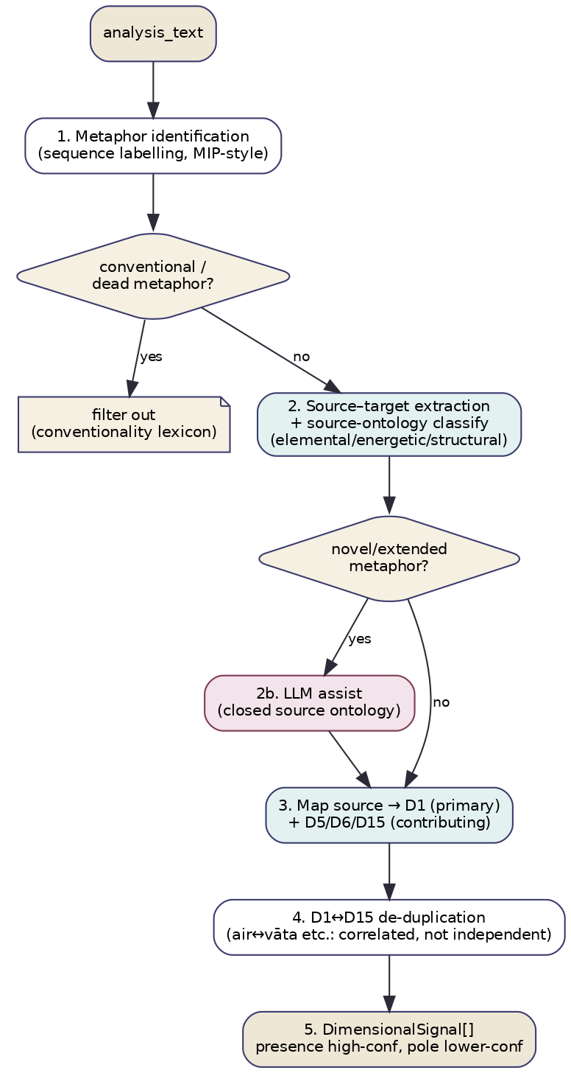
Figure D1 — Metaphor processing workflow.
- Identify metaphorical spans (sequence labelling, MIP-style). (2) Filter conventional/dead metaphors via a conventionality lexicon/threshold. (3) Extract source–target pairs and classify the source into the ontology; for novel/extended metaphors the classifier misses, (2b) invoke LLM assist with a closed source ontology. (3) Map source→D1 (primary) and D5/D6/D15 (contributing). (4) Apply the D1↔D15 de-duplication tagging. (5) Emit signals with separate presence and pole confidences. Decision points: conventionality filter; novelty→LLM branch. Validation: schema, ontology-label closure, span validity. Error handling: detector failure → lexicon-based metaphor cues at low confidence; LLM-assist schema failure → ≤2 repairs then drop the assisted metaphor. Fallback: emit literal-cue-based element hints at low confidence rather than nothing.

7. Algorithms and Computational Methodology
Methods: sequence-labelling metaphor detection, conventionality lexicon, source-ontology classifier, curated source→dimension mapping, optional LLM assist, KG gloss lookup. No KG traversal beyond glosses; no embedding search.
function analyze_metaphor(ctx):
spans = detect_metaphors(ctx.analysis_text) # MIP-style sequence labeller
spans = [s for s in spans if conventionality(s) < ctx.threshold] # drop dead metaphors
metaphors = []
for s in spans:
src, tgt = extract_source_target(s)
onto = classify_source(src) # elemental/energetic/structural
if onto == "other" and is_novel(s) and ctx.enable_llm_assist:
onto, src = llm_metaphor_assist(s, ONTOLOGY) # §8, closed vocabulary
metaphors.append((s, src, tgt, onto))
signals = map_to_dimensions(metaphors, table=SOURCE2DIM) # D1 primary; D5/D6/D15 contributing
signals = tag_correlated_groups(signals) # air-vata, fire-pitta, earth/water-kapha
for sig in signals:
sig.presence_confidence = f(detect_conf, count, novelty)
sig.pole_confidence = g(source_valence, intensity) # weaker than presence
sig.confidence = combine(sig.presence_confidence, sig.pole_confidence)
return [s for s in signals if validate(s)]
Source→dimension table (excerpt). water/drowning/flood→D1:water (+D15:kapha when weight/sluggish), fire/burning/burnt-out→D1:fire (+D15:pitta), wind/scattered/blown→D1:air (+D15:vāta), earth/stuck/rooted/heavy→D1:earth (+D15:kapha), space/empty/vast→D1:ether; blocked/drained/flowing→D6 energy; “in my head”/“heavy body”→D5 kośa locus. Each edge carries a curated weight; the table is the single editable artifact defining the imaginal→dimension bridge.

8. LLM Orchestration
MET is model-first, LLM-assisted for the long tail of novel/extended metaphor the detector or classifier cannot resolve.
Why an LLM. Creative, extended, or culturally specific metaphors (“my week was a slow tide going out”) fall outside trained detectors; an LLM resolves source domain from context. Deterministic alternative? Yes for conventional and lexicon-covered metaphor (the majority). Strategy. One constrained call per unresolved metaphor (batched), closed source ontology, abstention allowed. Capabilities. Figurative-language comprehension + JSON adherence; small/mid model suffices.
Field | Specification
Purpose | Resolve the source domain (and confirm metaphoricity) for novel/extended metaphors.
System prompt | Svarupa contract + “You analyze figurative language. Choose a source domain ONLY from the supplied list, or abstain. JSON only.”
Input prompt | The metaphorical span in context + the closed source-ontology list with glosses.
Output | {is_metaphor, source, target, ontology, confidence, abstain}.
Validation | Schema; source/ontology must be in the supplied list; abstain respected.
Retry | ≤2 repairs on schema failure, then drop the metaphor.
Hallucination mitigation | Closed ontology; require the verbatim span; reject invented domains.
Confidence | agreement × span_present × (1 − conventionality).
Cost/Latency | Short calls for the novel minority only; ~0.3–0.7 s; cached by span hash; off in fast.
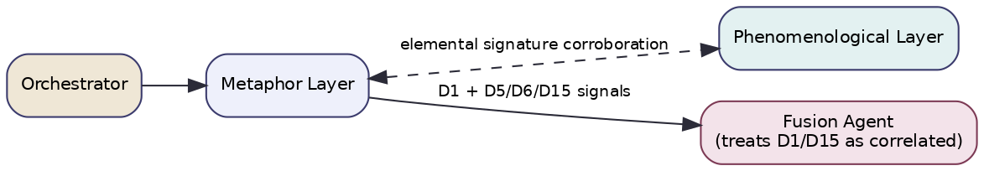
Figure D2 — Metaphor layer integration (corroborates PHE; fusion de-dups correlated signals).

9. Score Generation Methodology
Feature extraction. Per metaphor: detection confidence, conventionality, source domain, count of reinforcing metaphors. Normalization. Conventionality and detection scores in [0,1]; counts saturated. Weighting. Each source→dimension edge weight m(src,dim); novelty and reinforcement up-weight. Aggregation. R_d = saturate(Σ_metaphor m(src,d) · detect_conf · (1−conventionality)). Two confidences (key MET feature): presence_confidence (is this dimension implicated) is high when multiple non-conventional metaphors agree; pole_confidence (excess vs deficiency) is derived from source valence/intensity and is systematically lower — a “parched” (water-deficiency) vs “drowning” (water-excess) distinction is real but less certain than the water-presence itself. The combined confidence weights presence over pole. Contradiction: opposing source domains for the same dimension lower confidence. Missing data: no metaphors → abstain. Correlated-group handling: signals in the same group (air-vata) carry the tag so fusion discounts redundant corroboration. Reproducibility: deterministic detector + table; LLM-assist at temperature ≤0.2 with closed ontology and pinned versions; assist cached by span hash.

10. Explainability
Every signal traces span → source–target → ontology → source→dimension edge → relevance/pole. The user-facing form is especially resonant because it quotes their own image: “‘burning out’ (chars 12–22) → source domain FIRE/HEAT → Agni/Fire and Pitta signatures (D1, D15; presence conf 0.71, pole ‘excess’ conf 0.5).” Feature attribution: each metaphor’s contribution to a dimension is its m·detect·(1−conv) term. Separate presence/pole confidences are reported so a reader sees what we’re sure of (the element) vs what we’re less sure of (the pole). Alternative interpretations and the correlated_group are surfaced so the D1/D15 overlap is transparent rather than hidden.

11. Integration with Other Layers
Upstream: orchestrator (text, candidates); Knowledge Steward (source-ontology glosses). Downstream: Fusion (D1 + D5/D6/D15 signals, with correlated_group tags it must honour); PHE (mutual corroboration of elemental signatures); Composer (the user’s own imagery for resonant phrasing). Shared structures: the versioned SOURCE2DIM table; the elemental-signature exchange with PHE. Agent interactions/messaging: AnalyzeCommand → SignalBatch. KG updates: read-only; newly validated source→dimension edges proposed to curators. Orchestration: runs concurrently; because it rarely fires alone, it is weighted as corroborating evidence and its absence is unremarkable.

12. Engineering Considerations
Performance: p50 ≈ 120–250 ms model path; +0.3–0.7 s when assist fires (minority). Scalability: stateless, horizontal; detector on shared endpoint. Parallelism: metaphor records processed in parallel; assist calls concurrent. Caching: metaphor-record cache by text hash; assist cache by span hash. Memory: detector + ontology classifier. Token/cost: assist sends only the span + closed ontology; off in fast. Monitoring: metaphor-detection rate, conventional-filter rate, assist rate, D1/D15 correlated-group frequency (dedup health), pole-vs-presence confidence gap. Logging: metaphor records (span, source, target, ontology) under request_id. Observability: spans per stage; replay from metaphor records. Versioning: layer_version, detector version, conventionality-lexicon version, SOURCE2DIM version, prompt_version. Testing: detection vs VUA-style annotations; source-classification accuracy vs a Svarupa ontology gold set; dead-metaphor suppression tests; de-duplication tests (one metaphor must not double-count D1+D15 in fusion); philosophy-regression.

13. Future Evolution
Cross-lingual metaphor ontologies so users’ native imagery is read directly; a joint PHE–MET model that identifies elemental signatures from phenomenology and metaphor together, resolving the D1↔D15 ambiguity at the source; tracking metaphor drift across a user’s journal entries (with consent) as a gentle recognition cue (“your images have shifted from fire to water”); extension to D27/D29 bondage/awakening metaphors once those dimensions are grounded; and a learned source→dimension mapping that augments the curated table with expert-labelled data.

Layer 5 — Narrative Arc Analysis

1. Layer Overview
What this layer is. The Narrative Arc layer (code NAR) reads an expression as part of a story over time rather than a static snapshot. It segments events, detects temporal structure (linear, cyclical, stalled, reversal), recognizes recurrence/loops, descent–nadir–ascent shapes, and inner–outer mismatches, and maps these onto the dimensions that are inherently trajectories.
What problem it solves. Some dimensions cannot be read from a single sentence’s features because they are about movement through time: the karma→saṁskāra loop (D12), individual evolution (D13), the soul/age mismatch (D14), svadharma (mis)alignment (D16), and the bondage→liberation journey (D29). “I keep starting things and abandoning them” is not an affect or a metaphor — it is a loop. NAR solves the problem of detecting arcs, loops, and turning points that only appear when the expression is read as narrative.
Why it is important for Svarupa. Much of the tradition’s deepest insight is developmental — about where one is on a path and which way one is moving. Recognitions like “this is a recurring return to the same conflict” or “the restlessness may be a life that no longer fits” require trajectory reading. NAR is what lets Svarupa speak to direction, not just state.
How it contributes to multidimensional self-understanding. It provides the temporal/biographical voice and is the essential input to the Integration layer’s narrative generation. A momentary feeling (AFF) placed against a detected loop (NAR) yields a layered recognition neither could give alone.
Theoretical and research foundations. (1) Narrative intelligence and computational narratology — event extraction, story-arc modelling, plot-unit analysis. (2) Sentiment/agency trajectories over text (narrative arc detection à la Reagan et al.). (3) Rumination and recurrence research (loops as a marker of stuck processing). (4) The tradition’s developmental maps (pravṛtti/nivṛtti arcs; bandha→mokṣa). The contribution is a trajectory-extraction pipeline aligned to Svarupa’s developmental dimensions, with honest handling of single-snapshot inputs.
Limitations and assumptions. A single present-tense snapshot rarely reveals an arc; NAR caps trajectory confidence accordingly and abstains when there is no temporal content. Cross-entry arc detection requires consented history. Several target dimensions are interpretive and narrative-only (ungrounded), needing LLM assist and expert gold sets. It infers trajectory from a telling, which is a construction, not the life itself — framed as such.

2. Applicability to Svarupa
Aspects of human experience captured. Movement over time: recurrence, escalation, reversal, stagnation, descent and ascent, and the gap between who one is and the life one is living.
Svarupa objectives supported. Recognition — naming a loop or a turning point invites reflection on direction without prescribing. Multi-perspective — the trajectory reading often reframes a momentary state (“the dread may be a signal, not only a symptom”). Respect for complexity — it holds open whether an unsettled trajectory is a problem to fix or a change asking to happen.
How it complements other layers. It consumes temporal features from PSY and AFF (transient vs enduring), provides arc context to Integration, and supplies the developmental framing that COT reasons within for D29/D30. It is the only layer that models change over time.
Why it cannot be replaced by another layer. AFF/PHE/PSY/MET all read a moment; SEM reads similarity; only NAR models the sequence. Loop detection (central to D12) and mismatch detection (central to D14/D16) have no other home. NAR is irreducible.

3. Mapping to the 31-Dimension Framework
NAR is primary for D10, D12, D13, D14, D16, D29 and contributing for D11, D30. Per the §22 audit, D13 emits an arc phase (no status data exists), and D14 emits a mismatch signal only (its profiles are not text-derivable). D12 is co-primary with PSY.
Dimension | Role | Attributes Used | Features Extracted | Output Variables | Status/grounding
D12 Inner Life | primary (co-PSY) | karma/saṁskāra/vāsanā/eṣaṇā | loop/recurrence, craving-cycle | loop signature + pole | balance/excess/deficiency; ◑ partial
D13 Cyclical Evolution | primary | descent/nadir/ascent arcs | arc-shape, directionality | arc PHASE (descending/nadir/ascending) | ⚠ no status field → phase, not pole
D14 Yuga | primary | soul-age × current-age profiles | individual–collective mismatch theme | mismatch SIGNAL only | ✓ attrs, but profile not text-derivable
D16 Svadharma | primary | svabhāva/role/plane | inner–outer alignment trajectory | alignment + mismatch | ✓ (attrs messy)
D29 Bondage/Liberation | primary | superimposition; journey stages | journey-stage trajectory | stage estimate | ⚠ narrative-only (LLM-assisted)
D10 Paths of Engagement | primary (co-COT) | karma/jñāna/yoga/bhakti | engagement-mode across the story | path orientation | ✓ grounded
D11 Aṣṭāṅga | contributing | eight limbs | developmental-stage cues | readiness features → COT | ✓ grounded
D30 Practice | contributing | sādhana families | practice-trajectory cues | features → COT | ⚠ narrative-only
Attributes ignored. NAR ignores momentary affect intensity (AFF), metaphor source (MET), and linguistic micro-features except the temporal ones it consumes. For D14 it deliberately ignores the specific yuga-profile assignment (not inferable) and reads only the mismatch theme. Why others excluded. Constitutional, affective, energetic, and epistemic dimensions are state- or form-based, not trajectory-based; reading them as arcs would invent structure. NAR restricts to dimensions of time.

4. Input Specification
Inputs: analysis_text (required); consented recent journal history for cross-entry arcs (optional, via Profile Agent); the feature cache (consumes temporal_orientation from PSY, durability/temporal_cues from AFF); KG glosses for D10/D12/D16; metadata. User profile history is consumed only with explicit consent and only for arc detection.
{
"$schema":"https://svarupa.ai/schemas/v1/nar_input.json",
"type":"object",
"required":["request_id","analysis_text","candidate_dimensions"],
"properties":{
"request_id":{"type":"string","format":"uuid"},
"analysis_text":{"type":"string","minLength":1},
"locale":{"type":"string","default":"en"},
"shared_features":{"type":"object","properties":{
"temporal_orientation":{"type":"object"},
"temporal_cues":{"type":"array","items":{"type":"string"}}}},
"history":{"type":"array","description":"opt-in prior entries (text+timestamp) for cross-entry arcs",
"items":{"type":"object","properties":{"text":{"type":"string"},"ts":{"type":"string"}}}},
"consent_history":{"type":"boolean","default":false},
"candidate_dimensions":{"type":"array","items":{"type":"integer"},
"description":"intersect with NAR affinity {10,12,13,14,16,29,11,30}."},
"options":{"type":"object","properties":{
"enable_llm_assist":{"type":"boolean","default":true}}}
}
}

5. Output Specification
Outputs: segmented events + detected arc (analytical observation), per-dimension signals (with phase/mismatch where applicable), evidence (event spans + arc rationale), confidence (trajectory-capped for snapshots), intermediate arc artifacts.
{
"$schema":"https://svarupa.ai/schemas/v1/nar_output.json",
"type":"object",
"required":["request_id","layer","arc","signals"],
"properties":{
"request_id":{"type":"string","format":"uuid"},
"layer":{"const":"NAR"},
"layer_version":{"type":"string"},
"arc":{"type":"object","properties":{
"events":{"type":"array","items":{"type":"object",
"properties":{"text":{"type":"string"},"span":{"type":"array","items":{"type":"integer"}},
"order":{"type":"integer"}}}},
"shape":{"type":"string","enum":["linear","cyclical","stalled","reversal","ascending","descending","none"]},
"loop_detected":{"type":"boolean"},
"single_snapshot":{"type":"boolean"}}},
"signals":{
"type":"array",
"items":{"type":"object","required":["dimension_id","relevance","confidence","evidence"],
"properties":{
"dimension_id":{"type":"integer","enum":[10,12,13,14,16,29,11,30]},
"relevance":{"type":"number","minimum":0,"maximum":1},
"confidence":{"type":"number","minimum":0,"maximum":1},
"output_kind":{"type":"string","enum":["pole","phase","mismatch","orientation","stage","features"]},
"value":{"type":"object","description":"e.g. phase=ascending; mismatch=0.7; pole=excess"},
"evidence":{"type":"array","items":{"type":"object",
"properties":{"kind":{"type":"string","enum":["event","arc","loop","span"]},
"detail":{"type":"string"},"span":{"type":"array","items":{"type":"integer"}}}}},
"abstained":{"type":"boolean","default":false}}}
},
"provenance":{"$ref":"https://svarupa.ai/schemas/v7/provenance.json"}
}
}

6. Processing Workflow
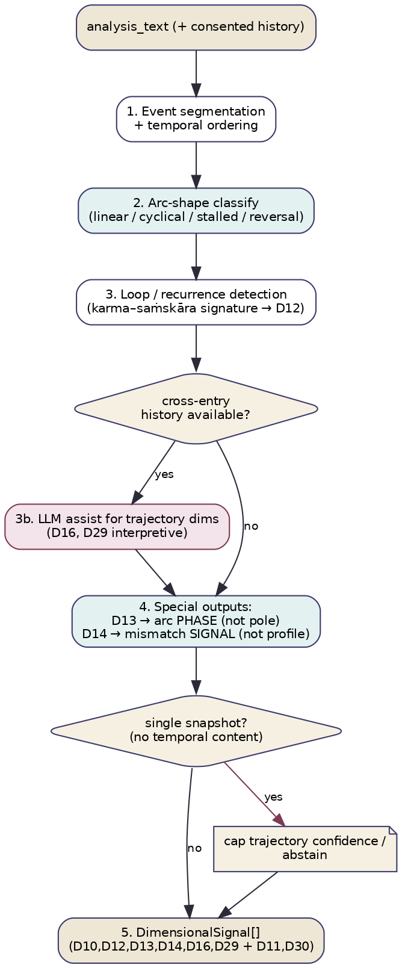
Figure E1 — Narrative Arc processing workflow.
- Segment events and order them temporally. (2) Classify arc shape. (3) Detect loops/recurrence (D12 signature). (3b) For interpretive trajectory dimensions (D16, D29), invoke LLM assist; use consented cross-entry history when available. (4) Produce special outputs: D13 arc phase, D14 mismatch signal. (5) Emit signals; if single_snapshot (no temporal content), cap trajectory confidence or abstain. Decision points: history-available branch; snapshot guard. Validation: event ordering sanity, schema, output-kind correctness per dimension. Error handling: segmentation failure → treat as snapshot (low confidence); LLM-assist failure → emit only the deterministically detectable arc. Fallback: emit arc shape + loop flag even when dimension mapping is uncertain.

7. Algorithms and Computational Methodology
Methods: event segmentation (discourse + verb-frame parsing), arc-shape classification (sequence model over clause-level sentiment/agency), loop/recurrence detection (self-similarity over event embeddings + lexical cues like “again/keep/always”), inner–outer mismatch detection (comparison of stated values vs described circumstances), LLM assist for interpretive dims, optional cross-entry alignment.
function analyze_narrative(ctx):
events = segment_events(ctx.analysis_text) # ordered event list
snapshot = (len(events) <= 1 and no_temporal(ctx.shared_features))
shape = classify_arc(events, ctx.shared_features.temporal_orientation)
loop = detect_loop(events) # recurrence/self-similarity + "keep/again/always"
signals = []
signals += d12_loop(loop, events) # pole from loop severity (co-PSY)
signals += d13_phase(shape) # PHASE: descending/nadir/ascending (no pole!)
signals += d14_mismatch(events, ctx) # MISMATCH signal only (no profile)
signals += d16_alignment(events) # inner-outer alignment trajectory
signals += d10_path(events) # engagement mode (co-COT)
if intersects(ctx.candidate, {29,16,30}) and ctx.enable_llm_assist:
signals = augment_with_llm(signals, events, ctx.history if ctx.consent_history else None)
for s in signals:
s.confidence = nar_confidence(s, snapshot) # trajectory-capped if snapshot
if snapshot and s.output_kind in {"phase","mismatch","stage"}: s.confidence *= SNAPSHOT_CAP
return [s for s in signals if not (snapshot and s.relevance < MIN)]
Loop detection (D12). Compute pairwise semantic similarity across events; a high-similarity recurrence plus recurrence lexicon (“keep, again, always, back to”) signals a saṁskāra-loop; loop severity (frequency × stuckness) sets the pole (excess = tightly repeating; deficiency = no continuity/fragmentation). Mismatch (D14/D16). Compare value/identity statements (“I’m someone who…”) against described circumstances/actions; divergence magnitude = mismatch signal.

8. LLM Orchestration
NAR is hybrid: deterministic for arc shape and loop detection; LLM-assisted for the interpretive trajectory dimensions (D16 svadharma, D29 bondage→liberation, D30 practice context) which are narrative-only and resist feature rules.
Why an LLM. Recognizing a bondage→liberation stage or a svadharma mismatch from a life-telling is interpretive reasoning, not pattern counting. Deterministic alternative? Arc shape and loops, yes (and they stay deterministic); the interpretive stage estimates, no. Strategy. One constrained call summarizing the detected arc + events, asking for stage/mismatch judgement with abstention; optional inclusion of consented history. Capabilities. Long-context reasoning; reliable JSON; careful abstention.
Field | Specification
Purpose | Estimate interpretive trajectory (D16 mismatch, D29 journey-stage, D30 practice context) from the detected arc.
System prompt | Svarupa contract (recognition; no prediction of the future; describe the trajectory in the telling) + “Output JSON only; abstain if the arc is too thin.”
Input prompt | Ordered events, detected arc shape + loop flag, relevant dimension glosses, and (if consented) a compact history summary.
Output | {dimension_id, output_kind, value, evidence_spans, confidence, abstain}.
Validation | Schema; output_kind matches dimension; spans verbatim; abstain respected.
Retry | ≤2 repairs, then emit deterministic-only arc.
Hallucination mitigation | Forbid future prediction; require event-span citation; closed dimension set.
Confidence | self_consistency × evidence × (snapshot ? cap : 1).
Cost/Latency | One call per request when interpretive dims are candidates; ~0.8–1.6 s; cached by (arc-hash, prompt_version); off in fast.
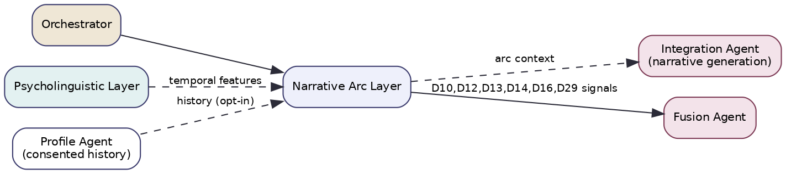
Figure E2 — Narrative Arc integration (consumes temporal features; feeds Integration’s narrative generation).

9. Score Generation Methodology
Feature extraction. Events, arc shape, loop severity, mismatch magnitude, directionality. Normalization. Loop/mismatch scores in [0,1]; arc shape categorical. Output kinds (key NAR feature): dimensions emit different kinds — D12/D16 a pole/alignment, D13 a phase, D14 a mismatch scalar, D29 a stage. The schema’s output_kind makes this explicit so fusion/integration interpret each correctly. Relevance vs confidence. Relevance = strength of the trajectory signal; confidence = trust in the reading, hard-capped for single snapshots (the layer is honest that one sentence rarely reveals an arc). Aggregation. Loop severity → D12 pole; arc directionality → D13 phase; value–circumstance divergence → D14/D16 mismatch. Confidence. e = event/temporal evidence present; a = consistency of arc indicators (shape, loop, directionality agree); v = coverage (snapshot vs multi-event vs cross-entry). confidence = clip(0.4·e + 0.3·a + 0.3·v, 0,1) × snapshot_cap. Contradiction: conflicting directionality lowers confidence. Missing data: snapshot → abstain on trajectory dims. Uncertainty: snapshot-capping is the principal uncertainty mechanism; it is recorded in evidence (“single snapshot — trajectory inferred weakly”). Reproducibility: deterministic arc/loop detection; LLM-assist at temperature ≤0.2, closed dimension set, pinned versions, cached.

10. Explainability
Every signal traces to ordered event spans and the arc rationale. For D12: the specific recurring events and the recurrence cue words. For D13: the directional evidence behind the phase. For D14/D16: the value statement and the circumstance it diverges from. Confidence decomposes into e/a/v and explicitly flags snapshot-capping. Alternative interpretations: when an unsettled trajectory could be “problem to resolve” vs “change asking to happen,” both are emitted as the raw material for an Integration-level tension. Human-readable: “events: ‘started a course’ → ‘quit’ → ‘started a project’ → ‘quit’; recurrence cue ‘keep’; loop severity 0.8 → saṁskāra-loop (D12, excess, conf 0.7). This is a multi-event telling, not a snapshot.”

11. Integration with Other Layers
Upstream: orchestrator (text, candidates); PSY/AFF (temporal features via cache); Profile Agent (consented history). Downstream: Fusion (D10/D12/D13/D14/D16/D29 signals with output_kind); Integration Agent (NAR’s arc is the primary input to narrative synthesis); COT (developmental context for D29/D30). Shared structures: the per-request feature cache (temporal); the event/arc record. Agent interactions/messaging: AnalyzeCommand → SignalBatch; cross-entry history fetched through the Profile Agent only with consent_history=true. KG updates: read-only; recognized cross-dimensional motifs (e.g. a common loop pattern) proposed to curators as (:Pattern) candidates. Orchestration: runs concurrently; cross-entry mode runs only with consent and may exceed the standard timeout (handled as a deep-mode option).

12. Engineering Considerations
Performance: p50 ≈ 200–400 ms deterministic; +0.8–1.6 s with interpretive LLM assist; cross-entry mode heavier. Scalability: stateless for single-entry; cross-entry needs consented-history fetch (cached). Parallelism: event/arc detection parallel to other layers. Caching: arc-record cache by text hash; assist cache by arc-hash; history summaries cached per user (consented). Memory: segmentation + arc models. Token/cost: assist sends a compact event list + arc, not raw history; off in fast. Monitoring: snapshot rate, loop-detection precision, assist rate, abstention rate, cross-entry usage. Logging: events, arc shape, loop/mismatch scores under request_id. Observability: spans per stage; replay from arc records. Versioning: layer_version, segmenter version, arc-model version, prompt_version. Testing: arc-classification vs annotated narratives; loop-detection precision on rumination corpora; mismatch tests; snapshot-cap tests (single sentence must not yield high trajectory confidence); consent-gating tests; philosophy-regression (no future prediction).

13. Future Evolution
Longitudinal arc models over consented journals with explicit turning-point detection surfaced gently to the user; causal-graph extraction of the eṣaṇā→vāsanā→karma→saṁskāra loop (D12) for richer recognition; better single-snapshot calibration so the layer knows exactly when to stay silent; a learned mismatch detector for D16; grounding of D29/D30 via seeded concept data (removing reliance on LLM-only reading); and integration with the (:Pattern) library so recurring cross-user arcs become curated, recognizable motifs.

Layer 6 — LLM Chain-of-Thought Analysis

1. Layer Overview
What this layer is. The Chain-of-Thought layer (code COT) performs dimensional reading as an explicit reasoning task. For the dimensions that cannot be detected from surface features — the subtle psychodynamic, ethical, epistemic, and soteriological lenses — it prompts a large language model to reason step-by-step about what an expression implies, then commit to structured, evidence-cited, per-dimension judgements with a mandatory option to abstain.
What problem it solves. Dimensions like the Five Kleśas, the Non-Dual Vision, the Ways of Knowing, or Sādhana Chatuṣṭaya are not detectable by counting words, scoring affect, or matching metaphors. Recognizing whether an expression implies avidyā (mistaking the impermanent for the permanent) or a readiness for inquiry requires reasoning about meaning. COT solves the problem of interpretive dimensional reading that no feature-based layer can perform.
Why it is important for Svarupa. It is the only layer competent for the contemplative heart of the framework — the dimensions that carry Svarupa’s deepest recognitions. It is also the layer most able to articulate why a dimension is implicated, so its evidence is weighted heavily by the Composer when forming recognition language.
How it contributes to multidimensional self-understanding. It adds the reasoning voice, integrating cues other layers surface (an affect, a loop, an attribution) into an interpretation of subtle dimensions, while remaining one perspective among seven — free to agree, tension, or abstain.
Theoretical and research foundations. (1) Chain-of-thought and deliberate reasoning in LLMs (Wei et al.) and self-consistency (Wang et al.). (2) Constrained / structured decoding for reliable JSON. (3) Faithfulness and evidence attribution (require verbatim citation; verifier models). (4) The primary contemplative texts themselves (Yoga Sūtras, Upaniṣads, Gītā, Vivekachūḍāmaṇi) as the interpretive ground, encoded in prompts and (increasingly) the knowledge graph. The contribution is a recognition-preserving reasoning protocol with calibrated abstention.
Limitations and assumptions. It is the most expensive and slowest layer and the hardest to calibrate — and it carries the framework’s largest ungrounded load (most of its dimensions are narrative-only, lacking concept data and gold sets). It is susceptible to hallucinated evidence (mitigated by mandatory span citation and closed vocabularies) and to over-confidence (mitigated by self-consistency and capping). It reasons about a text, not a person, and is bound by the system contract never to diagnose, predict, or prescribe.

2. Applicability to Svarupa
Aspects of human experience captured. The interpretive and contemplative layers of experience: the colorings beneath suffering (kleśas), the quality of one’s relationship to knowing, readiness for practice, character trajectory, the orienting view, and the felt stage of the inner journey.
Svarupa objectives supported. Recognition over diagnosis — enforced in the system contract and the output schema (mandatory abstention, no verdicts). Multi-perspective — COT is explicitly allowed to disagree with feature layers. Epistemic humility — abstention is a first-class output; the layer is rewarded for declining when evidence is thin.
How it complements other layers. It consumes the candidate set from SEM, features from PSY/AFF/NAR, and dependency readings (e.g. it reads D27 when assessing D29). It provides interpretations the feature layers cannot, and its articulate evidence strings feed the Composer.
Why it cannot be replaced by another layer. No feature-based method can read avidyā or the non-dual view from text; SEM finds related concepts but cannot judge implication; the feature layers are competent only on their own signatures. COT is irreducible for the interpretive dimensions — and, by confining LLM use to this layer, it keeps the rest of the system transparent and cheap.

3. Mapping to the 31-Dimension Framework
Per the §22 audit, COT is primary for the interpretive cluster — D3 (archetype adjudication), D18, D19, D20, D21, D23, D24, D25, D26, D27, D28, D29, D30 — and contributing elsewhere as a reasoning cross-check. Most of these are narrative-only (no concept data) and adopt the narratives’ clean balanced/excess/deficient triple.
Dimension | Role | Attributes Used | Features/Cues Used | Output Variables | Status/grounding
D19 Kleśas | primary | avidyā, asmitā, rāga, dveṣa, abhiniveśa | AFF(rāga/dveṣa), PSY(asmitā), reasoning | per-kleśa relevance + pole | balanced/excess/deficient; ⚠ narrative-only
D20 Vṛttis | primary | pramāṇa, viparyaya, vikalpa, nidrā, smṛti | PSY(vikalpa/smṛti) + reasoning (valid vs error) | per-vṛtti relevance + pole | ⚠ narrative-only
D21 Antarāyas | primary | 9 obstacles + companions | reasoning over practice-friction cues | obstacle relevance + pole | ⚠ narrative-only
D23 Sādhana Chatuṣṭaya | primary | viveka, vairāgya, ṣaṭ-sampat, mumukṣutva | readiness reasoning | qualification relevance + pole | ⚠ narrative-only
D24 Daivī/Āsurī | primary (AFF contrib) | virtue/vice set | AFF(fear/anger/compassion) + reasoning | character-trajectory + pole | ⚠ narrative-only
D25 Upāsanās/Vidyās | primary | meditation families | re-identification reasoning | relevance + pole | ⚠ narrative-only
D26 Haṭha | primary | cleansing/posture/locks/kuṇḍalinī | embodied-practice reasoning | relevance + pole | ⚠ narrative-only
D27 Non-Dual Vision | primary | mahāvākyas, fourth state, self-in-all | view-recognition reasoning | relevance + pole | ⚠ narrative-only
D28 Ways of Knowing | primary (PSY contrib) | higher/lower knowledge, discrimination | PSY(complexity) + reasoning | epistemic-stance + pole | ⚠ narrative-only
D29 Bondage/Liberation | primary (NAR contrib) | superimposition, stages | NAR(stage) + reasoning | stage + pole | ⚠ narrative-only
D30 Practice | primary | sādhana families | reasoning + NAR cues | relevance + pole | ⚠ narrative-only
D3 16 Faces | primary | 16 archetypes | PSY features + reasoning | archetype distribution | ✓ grounded
D18 Jyotiṣ | primary | graha archetypes | reasoning over archetypal motifs | functional-tone motif | ✓ attrs; archetypal only
D18 correction (normative). Real jyotiṣ requires a birth chart, which is not present in a text expression. COT therefore reads D18 strictly as archetypal graha motif (e.g. Śani→limitation/discipline themes, Maṅgala→drive/aggression), never as an astrological reading, and the legacy benefic/malefic vocabulary is reframed to functional tone because “malefic” is a verdict that violates recognition-not-diagnosis.
Attributes ignored. COT does not score the feature-owned dimensions (D1, D7, D8, D9 it only cross-checks) and does not attempt chart-accurate jyotiṣ. Why others excluded. The constitutional, affective, phenomenological, metaphorical, and temporal-trajectory dimensions are better and more cheaply served by their specialist layers; COT defers to them and reasons only where reasoning is required.

4. Input Specification
Inputs: analysis_text (required); the SEM candidate set (scopes which dimensions to reason about); feature contributions from PSY/AFF/NAR (via the feature cache / signal bus); dependency-dimension readings (e.g. D27 for D29); KG concept context for candidate dimensions (glosses, exemplars) via the Knowledge Steward; metadata. User profile is not analysis input.
{
"$schema":"https://svarupa.ai/schemas/v1/cot_input.json",
"type":"object",
"required":["request_id","analysis_text","candidate_dimensions"],
"properties":{
"request_id":{"type":"string","format":"uuid"},
"analysis_text":{"type":"string","minLength":1},
"candidate_dimensions":{"type":"array","items":{"type":"integer"},
"description":"from SEM; intersected with COT affinity (interpretive cluster)."},
"feature_contributions":{"type":"object",
"description":"PSY/AFF/NAR feature payloads keyed by dimension_id."},
"dependency_readings":{"type":"object",
"description":"fused/partial readings of upstream dims (e.g. D27 for D29)."},
"kg_context":{"type":"object","description":"per-candidate concept glosses + exemplars."},
"options":{"type":"object","properties":{
"self_consistency_n":{"type":"integer","default":3},
"latency_mode":{"type":"string","enum":["fast","standard","deep"]},
"model_id":{"type":"string"}}}
}
}

5. Output Specification
Outputs: per-dimension structured judgements (relevance, pole, evidence, abstention), a summarized reasoning trace (for provenance), confidence (self-consistency-based), and intermediate sampling artifacts.
{
"$schema":"https://svarupa.ai/schemas/v1/cot_output.json",
"type":"object",
"required":["request_id","layer","signals"],
"properties":{
"request_id":{"type":"string","format":"uuid"},
"layer":{"const":"COT"},
"layer_version":{"type":"string"},
"model_id":{"type":"string"},
"prompt_version":{"type":"string"},
"signals":{
"type":"array",
"items":{"type":"object","required":["dimension_id","relevance","confidence","evidence","abstained"],
"properties":{
"dimension_id":{"type":"integer"},
"relevance":{"type":"number","minimum":0,"maximum":1},
"confidence":{"type":"number","minimum":0,"maximum":1},
"state_hint":{"type":"object","properties":{
"state":{"type":"string","enum":["balance","excess","deficiency","unclear"]},
"attribute":{"type":"string"},"confidence":{"type":"number"}}},
"evidence":{"type":"array","items":{"type":"object","required":["kind","detail"],
"properties":{"kind":{"type":"string","enum":["reasoning","span"]},
"detail":{"type":"string"},
"span":{"type":"array","items":{"type":"integer"}}}}},
"abstained":{"type":"boolean"},
"reasoning_summary":{"type":"string","description":"short, for provenance; not user-facing verbatim"}}}
},
"self_consistency":{"type":"object","properties":{
"samples":{"type":"integer"},"agreement_by_dim":{"type":"object","additionalProperties":{"type":"number"}}}},
"provenance":{"$ref":"https://svarupa.ai/schemas/v7/provenance.json"}
}
}

6. Processing Workflow
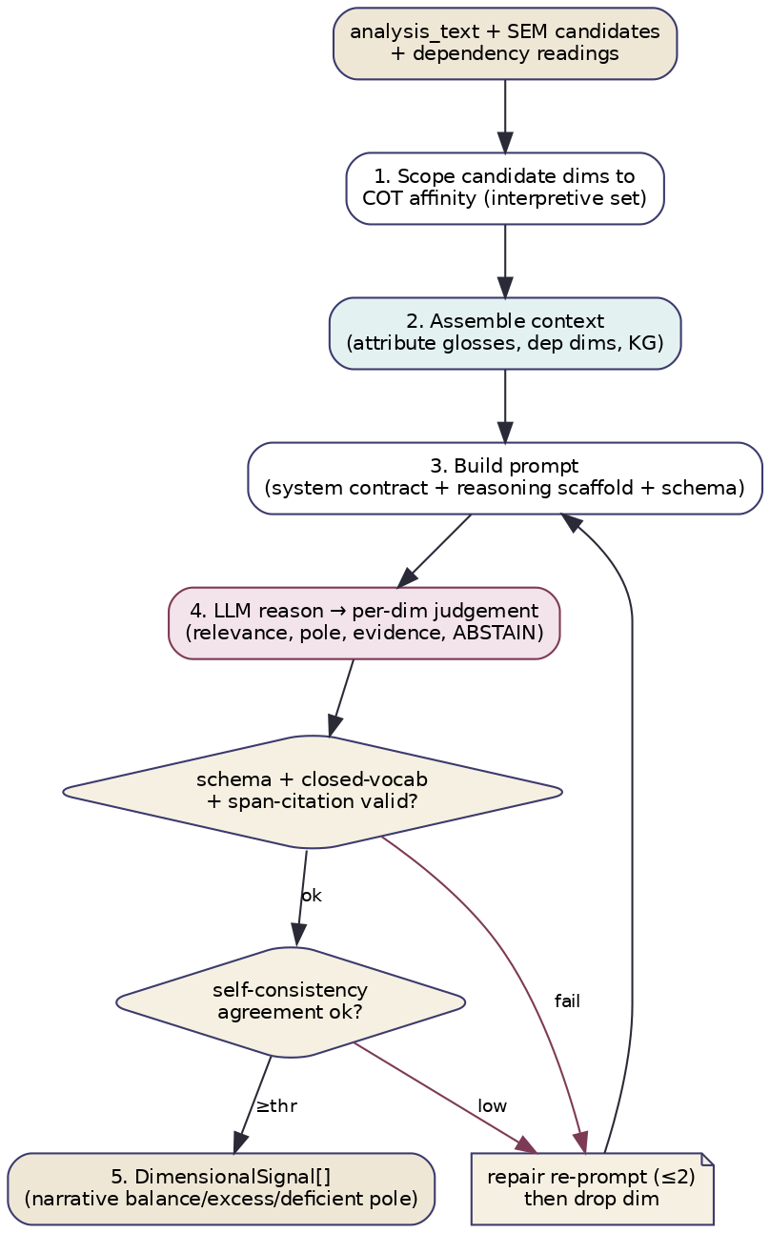
Figure F1 — Chain-of-Thought processing workflow.
- Scope SEM candidates to the COT affinity (interpretive set). (2) Assemble context — candidate glosses, dependency readings, relevant feature contributions, KG concepts. (3) Build the prompt (system contract + reasoning scaffold + strict schema). (4) Call the LLM to reason and emit per-dimension judgements with mandatory abstention. (5) Validate (schema, closed vocabulary, verbatim span citation); self-consistency over n samples sets confidence; on validation failure, repair-reprompt (≤2) then drop the offending dimension. Decision points: schema/citation validity; self-consistency threshold. Validation: JSON schema, attribute names in registry, every claimed evidence span must exist verbatim in the text. Error handling: timeout → return partial (whatever validated); provider error → layer absent (coverage drops). Fallback: if the LLM is unavailable, COT emits nothing and the pipeline degrades to feature layers (architecture spec §17.4).

7. Algorithms and Computational Methodology
Methods: prompt engineering (layered contract), constrained JSON decoding, self-consistency sampling, evidence-citation verification, optional tool-augmented KG lookup, multi-agent collaboration (consumes other layers’ features; defers to specialists). Little is “deterministic” here by nature — the task is reasoning — but everything around the call is deterministic and validated.
function analyze_cot(ctx):
cands = intersect(ctx.candidate_dimensions, COT_AFFINITY)
if not cands: return []
context = assemble(cands, ctx.kg_context, ctx.dependency_readings, ctx.feature_contributions)
prompt = build_prompt(SYSTEM_CONTRACT, REASONING_SCAFFOLD, OUTPUT_SCHEMA, ctx.analysis_text, context)
samples = []
for i in range(ctx.self_consistency_n): # concurrent
out = llm(prompt, temperature=0.2, schema=OUTPUT_SCHEMA)
out = validate_or_repair(out, max_repairs=2) # schema+vocab+span-citation
if out: samples.append(out)
signals = aggregate_self_consistency(samples) # median relevance, majority pole, agreement→conf
for s in signals:
if not cite_exists(s.evidence, ctx.analysis_text): s.drop() # anti-hallucination
if s.agreement < ABSTAIN_THR: s.abstained = True
return signals
Self-consistency aggregation. For each dimension across n samples: relevance = median; pole = majority (ties → unclear); confidence rises with cross-sample agreement and falls if any sample abstained. Dimensions where samples disagree strongly are emitted as low-confidence or abstained rather than forced.

8. LLM Orchestration
COT is the system’s primary and heaviest LLM consumer; this section is its core. (Other layers use the LLM only as occasional assist; COT is an LLM reasoning task.)
Why an LLM is necessary. The interpretive dimensions require judging what an expression implies about a person’s relationship to knowledge, craving, practice, or the self — a reasoning task with no feature-based proxy. Could it be deterministic? No; that is precisely why these dimensions are routed here rather than to a feature layer. Reasoning strategy. Internal chain-of-thought (not returned to the user) → structured per-dimension commitment → self-consistency vote. Model capabilities required. Strong contemplative/pragmatic comprehension, reliable constrained-JSON output, and well-calibrated abstention.

8.1 The single dimensional-reasoning call
Field | Specification
Purpose | Reason about the expression and judge each candidate interpretive dimension (relevance, pole, evidence) or abstain.
System prompt | The Svarupa system contract (recognition-not-diagnosis; no labels/predictions/prescriptions about the person; the user is the authority; preserve tension; voice uncertainty; no taxonomy leakage) + role (“You are an interpretive analysis component; reason internally, output JSON only”).
Input prompt | The expression; the candidate dimensions with one-line glosses and their balanced/excess/deficient descriptions; dependency readings; relevant feature contributions; KG exemplars.
Expected output | Per-dimension {relevance, state, attribute, evidence[{span,detail}], abstain} strictly conforming to schema.
Output validation | JSON-Schema validation; attribute/pole vocabularies closed to the registry; every evidence span must appear verbatim in the text; abstain honoured.
Retry logic | ≤2 repair re-prompts citing the exact validation error; then drop the failing dimension (not the whole call).
Hallucination mitigation | Closed vocabularies; mandatory verbatim span citation; forbid future prediction; optional verifier pass; self-consistency discards lone hallucinated claims.
Confidence estimation | Cross-sample agreement × evidence-span presence; capped (≤0.85 for narrative-only dimensions lacking gold calibration).
Cost considerations | One batched call covers all candidate dimensions (not one call per dimension); self-consistency = n concurrent samples (n=1 fast, 3 standard, 5 deep); cached by (analysis_text hash, candidate set, prompt_version, model_id).
Latency considerations | The latency-dominant layer (~1.5–3 s); samples issued concurrently; per-call timeout yields partial results.

8.2 Interaction sequence
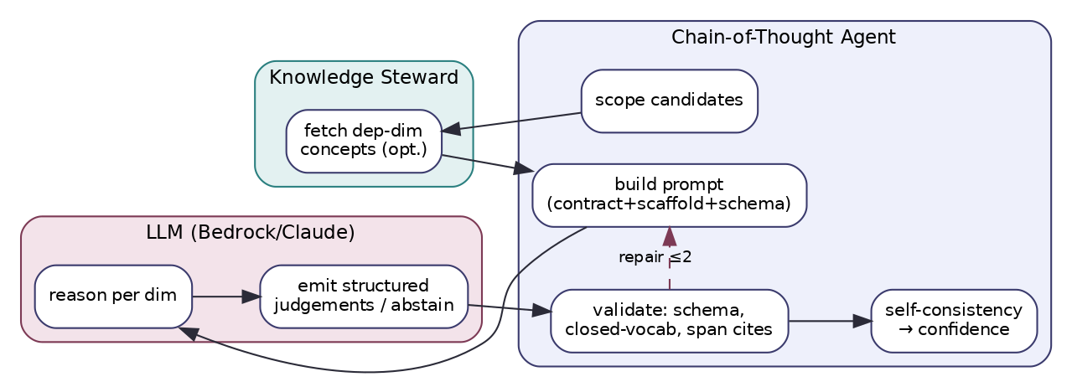
Figure F2 — Chain-of-Thought ↔ Knowledge Steward ↔ LLM interaction.
Mermaid source (sequence form) for maintainers:
sequenceDiagram
participant ORCH as Orchestrator
participant COT as Chain-of-Thought Agent
participant KS as Knowledge Steward
participant LLM as LLM (Bedrock/Claude)
ORCH->>COT: AnalyzeCommand(text, candidates, features, deps)
COT->>KS: fetch concept glosses + dependency concepts (optional)
KS-->>COT: glosses, exemplars
COT->>LLM: reason+judge (system contract+scaffold+schema) x n samples
LLM-->>COT: structured per-dim judgements / abstain
COT->>COT: validate schema+vocab+verbatim citations; repair<=2
COT->>COT: self-consistency vote -> relevance, pole, confidence
COT-->>ORCH: SignalBatch(interpretive-cluster signals)

8.3 Tool-augmented variant (optional)
In deep mode COT may traverse RELATES_TO mid-reasoning to pull a dependency dimension’s concepts (e.g. consult D27 while assessing D29), improving faithfulness on dependency-heavy dimensions at additional latency.

9. Score Generation Methodology
LLM-generated scores — design. Because scores come from an LLM, the discipline is in the scaffolding. Prompt design: the scaffold forces reason→judge→abstain and requires per-dimension evidence; the schema admits an explicit “insufficient evidence.” Structured-output validation: strict JSON Schema; closed attribute/pole vocabularies; verbatim span citation enforced. Score consistency: self-consistency over n samples (median relevance, majority pole). Randomness minimization: temperature ≤0.2; fixed prompt; pinned model. Reproducibility: model_id + prompt_version recorded; results cached by content hash; given the same inputs and cache, output is stable.
Aggregation & confidence. relevance = median across samples; pole = majority; confidence = clip(agreement × evidence_present, 0, cap), with cap = 0.85 for narrative-only dimensions (honest discount for lack of gold calibration) and higher once gold sets exist. Evidence accumulation: verbatim spans + a short reasoning summary per dimension. Contradiction handling: intra-COT (across samples) → low confidence/abstain; inter-layer → left for fusion to surface as tension. Missing-data handling: thin evidence → abstain (rewarded, not penalized). Uncertainty propagation: relevance/confidence pass to fusion unchanged; the narrative-only cap is itself a propagated uncertainty. Calibration: abstention is calibrated against expert annotations (the model should decline where humans would).

10. Explainability
COT’s reasoning is its explanation — but disciplined: each signal carries verbatim evidence spans plus a concise reasoning_summary (the internal chain-of-thought is not exposed verbatim to users, only summarized in provenance). Feature attribution: which feature contributions and dependency readings informed a judgement are recorded. Confidence explanation: the self-consistency agreement and evidence presence are reported (“3/3 samples agreed; two verbatim spans”). Alternative interpretations: disagreeing samples are retained as the basis for an Integration tension. Human-readable: “The expression treats a changing circumstance as a permanent threat to the self (‘I’ll never recover’) → avidyā/abhiniveśa coloring (D19), excess pole; 3/3 samples; evidence ‘I’ll never recover’ (chars 30–45). Confidence 0.7 (capped: dimension not yet gold-calibrated).”

11. Integration with Other Layers
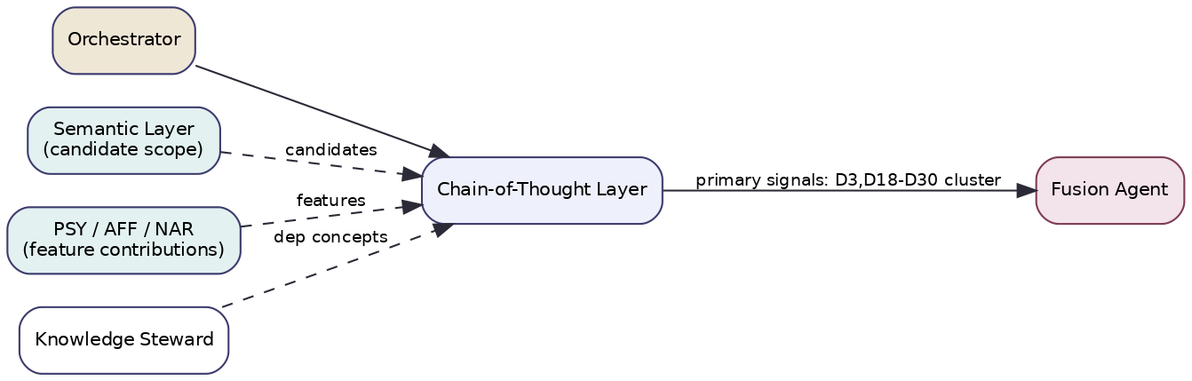
Figure F3 — Chain-of-Thought layer integration (scoped by SEM; fed features by PSY/AFF/NAR).
Upstream: SEM (candidate scope); PSY/AFF/NAR (feature contributions); fusion/partial readings of dependency dimensions; Knowledge Steward (concepts). Downstream: Fusion (interpretive-cluster signals); Integration (COT’s articulate evidence is prime material for synthesis); Composer (evidence strings → recognition language). Shared structures: the signal bus / feature cache; the system-contract prompt block (versioned, shared with Integration/Composer). Agent interactions/messaging: AnalyzeCommand → SignalBatch; dependency readings injected by the orchestrator respecting the dimension DAG. KG updates: read-only at runtime; can propose (:Pattern) candidates from recurring cross-dimensional reasoning, curator-gated. Orchestration: runs concurrently but is the critical-path layer; its timeout governs the parallel-stage budget; degrades to absence on provider failure.

12. Engineering Considerations
Performance: p50 ≈ 1.5–3 s (model-bound); dominates wall-clock. Scalability: bound by LLM throughput/quota; horizontal at the agent layer, vertical at the provider; candidate batching is the key lever (one call, many dimensions). Parallelism: self-consistency samples concurrent; COT concurrent with other layers. Caching: by (text hash, candidate set, prompt_version, model_id); high hit rate for edited/repeated expressions. Memory: light (stateless agent; state is in the prompt). Token optimization: compact glosses, candidate-scoped prompts, no full taxonomy in-prompt; summaries not full history. Cost optimization: model routing (smaller model in fast), self-consistency budget by mode, aggressive caching; COT is the main cost center and the main optimization target. Monitoring: abstention rate, self-consistency agreement, citation-validation failure rate, per-dimension confidence distribution, cost/latency per call. Logging: full prompt, raw samples, parsed/validated output, repair attempts — under request_id. Observability: spans for assemble/call/validate/vote; replay from persisted prompt+samples. Versioning: layer_version, prompt_version (incl. the system contract), model_id, scaffold version — all in provenance. Testing: rubric-graded accuracy vs expert annotations; abstention calibration; philosophy-regression (no diagnostic/second-person/predictive language) as a release gate; citation-faithfulness tests (every span must exist); schema-conformance fuzzing.

13. Future Evolution
Per-dimension fine-tuned adapters (small models specialized for, e.g., kleśa reading) to cut reliance on one large model and reduce cost; tool-augmented reasoning as the default (KG consultation mid-reasoning) for dependency-heavy dimensions; verifier models that check evidence citations automatically; gold-standard evaluation sets for every narrative-only dimension so the confidence cap can be lifted with justification; grounding those dimensions via seeded concept data (shared with SEM); and structured “deliberation” protocols (debate/critique) for the most subtle dimensions (D27, D29) where single-pass reasoning is weakest.

Layer 7 — Semantic Resonance Analysis

1. Layer Overview
What this layer is. The Semantic Resonance layer (code SEM) is the system’s recall mechanism. It embeds the user’s expression into a dense vector space and searches the knowledge graph’s concept embeddings to find which dimensions an expression resonates with — establishing, cheaply and broadly, the candidate set that the more expensive layers and the integration step then work within. It assesses which dimensions are in play, not how they are expressed.
What problem it solves. Keyword matching fails the moment a user speaks colloquially or metaphorically — which is almost always. “I can’t get off the couch and nothing seems worth doing” contains none of the tradition’s vocabulary, yet resonates strongly with tamas, kapha, and styāna concepts. SEM solves the recall problem: ensuring no relevant dimension is missed simply because the user didn’t use its words, by matching meaning rather than surface form.
Why it is important for Svarupa. It is the safety net of the whole pipeline. Specialist layers are precise but narrow; if no specialist fires for a dimension that is genuinely present, SEM is what still surfaces it as a candidate. It also scopes the expensive COT reasoning to a relevant subset, controlling cost.
How it contributes to multidimensional self-understanding. It guarantees breadth — that the multidimensional reading considers every dimension the expression could plausibly touch — while leaving depth to the specialists. It contributes a prior of relevance across the whole framework that fusion then refines.
Theoretical and research foundations. (1) Dense-vector semantic similarity and sentence/passage embeddings. (2) Approximate nearest-neighbour (ANN) retrieval over vector indices. (3) Retrieval-augmented architectures (retrieve-then-reason). (4) Calibration of similarity to relevance (isotonic/Platt). The contribution is a concept-level retrieval scheme aligned to the dimension registry, with aggregation from concept hits to dimension relevance.
Limitations and assumptions (critical). SEM can only recall dimensions that have concept embeddings in the graph. Per the §22 audit, embeddings currently exist for 17 of 30 dimensions; D17 and D19–D30 have no concept nodes and therefore zero recall until their narratives are chunked and embedded. SEM measures topical resonance, not implication — it cannot establish how a dimension is implicated, which is why it is never a primary layer and never emits a pole or state_hint. It assumes a warm, well-curated vector index.

2. Applicability to Svarupa
Aspects of human experience captured. The semantic neighbourhood of an expression — which themes and concepts it is “near,” independent of exact wording.
Svarupa objectives supported. Multi-perspective completeness — SEM ensures the candidate set spans the whole framework so no perspective is silently dropped. Recognition — by surfacing candidates rather than verdicts, it is inherently non-diagnostic. Efficiency in service of depth — by scoping COT, it makes the expensive interpretive reasoning affordable.
How it complements other layers. It runs first (with the lexical baseline) and seeds the candidate set for COT and Integration; it provides a relevance prior that fusion down-weights when specialist layers disagree. It is the only layer with a view of all dimensions at once.
Why it cannot be replaced by another layer. Specialist layers are bound to their affinity sets and would never surface a dimension outside them; the lexical baseline is brittle to vocabulary; COT could enumerate but at prohibitive cost. SEM’s broad, cheap, meaning-based recall is irreplaceable as the system’s net.

3. Mapping to the 31-Dimension Framework
SEM is contributing to all dimensions and primary for none. It emits relevance only — never a pole, attribute-state, or state_hint. Its effective coverage is currently limited by the grounding gap.
Dimension group | Role | What SEM uses | Features | Output | Recall status
17 grounded dims (D1–D16 grounded subset, D18) | contributing (recall) | (:Concept) embeddings per dimension | expression embedding; k-NN similarity; concept→dimension aggregation | per-dimension relevance + matched concepts | ✓ active
13 narrative-only dims (D17, D19–D30) | contributing (recall) — intended | — (no concept nodes yet) | — | none until seeded | ⚠ no recall (remediation §22.6 item 1)
Attributes used / ignored. SEM uses concept embeddings and their dimension membership; it ignores attribute poles, status, affect, form, metaphor, and trajectory — by design, those are the specialists’ province. It does not attempt to say which attribute or state is present, only which dimension resonates.
Why it does not “exclude” dimensions. Unlike the specialist layers, SEM’s restraint is not about excluding dimensions but about limiting its claim: it asserts only resonance, not interpretation. Its current inability to recall 13 dimensions is a data gap, not a design choice, and is the top remediation item.

4. Input Specification
Inputs: analysis_text (required); the knowledge-graph vector index and (:Concept)/(:Dimension) nodes (via the Knowledge Steward); embedding-service access (Cohere via Bedrock); metadata (locale, latency mode). No conversation history required (resonance is computed on the current expression, optionally concatenated with pinned FYI per the orchestrator). No user-profile analysis input. No LLM.
{
"$schema":"https://svarupa.ai/schemas/v1/sem_input.json",
"type":"object",
"required":["request_id","analysis_text"],
"properties":{
"request_id":{"type":"string","format":"uuid"},
"analysis_text":{"type":"string","minLength":1},
"locale":{"type":"string","default":"en"},
"options":{"type":"object","properties":{
"top_k":{"type":"integer","default":50,"description":"concept neighbours to retrieve"},
"min_similarity":{"type":"number","default":0.25},
"index_namespace":{"type":"string","default":"concepts_v1"}}}
}
}

5. Output Specification
Outputs: per-dimension relevance with the matched concept evidence (the candidate set), a coverage flag per dimension (recall available or not), confidence (from hit density/margin), and intermediate retrieval artifacts. No pole, no state_hint.
{
"$schema":"https://svarupa.ai/schemas/v1/sem_output.json",
"type":"object",
"required":["request_id","layer","signals"],
"properties":{
"request_id":{"type":"string","format":"uuid"},
"layer":{"const":"SEM"},
"layer_version":{"type":"string"},
"embedding_model":{"type":"string"},
"signals":{
"type":"array",
"items":{"type":"object","required":["dimension_id","relevance","confidence","evidence"],
"properties":{
"dimension_id":{"type":"integer","minimum":1,"maximum":31},
"relevance":{"type":"number","minimum":0,"maximum":1},
"confidence":{"type":"number","minimum":0,"maximum":1},
"recall_available":{"type":"boolean","description":"false for un-embedded dims"},
"evidence":{"type":"array","items":{"type":"object",
"properties":{"kind":{"const":"concept"},
"concept":{"type":"string"},"similarity":{"type":"number"},
"node_id":{"type":"string"}}}}}}
},
"intermediate":{"type":"object","properties":{
"query_vector_id":{"type":"string"},
"top_concepts":{"type":"array","items":{"type":"object",
"properties":{"concept":{"type":"string"},"dimension_id":{"type":"integer"},"similarity":{"type":"number"}}}},
"uncovered_dimensions":{"type":"array","items":{"type":"integer"},
"description":"dims with no embeddings (recall gap)"}}},
"provenance":{"$ref":"https://svarupa.ai/schemas/v7/provenance.json"}
}
}

6. Processing Workflow
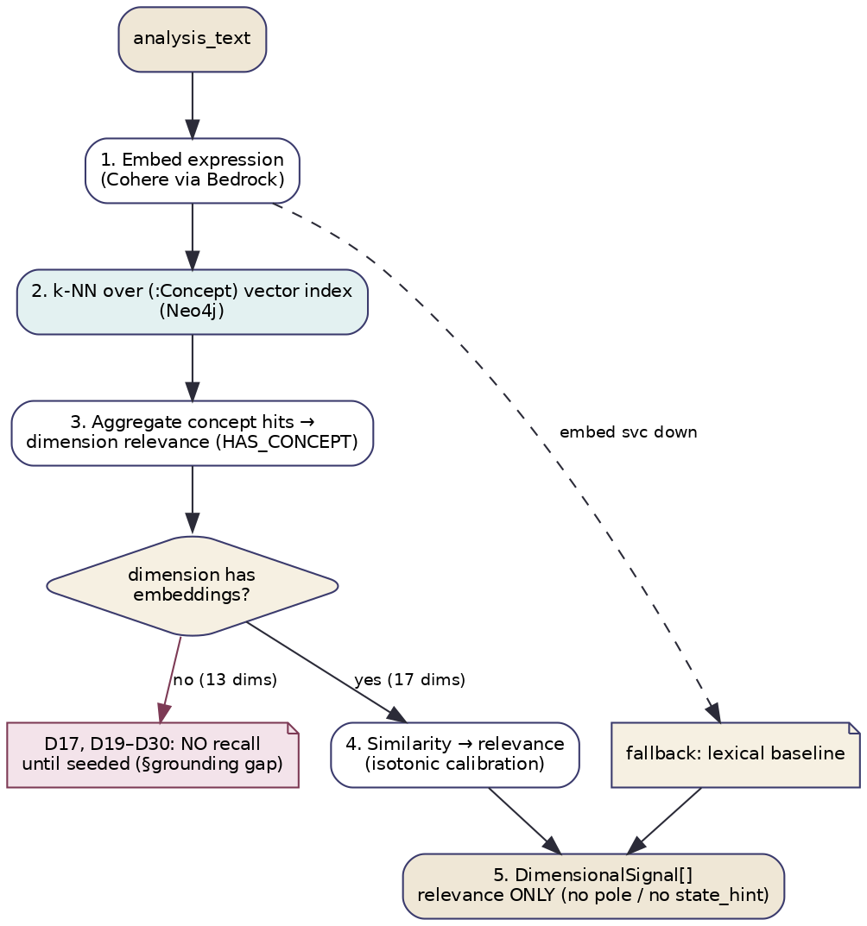
Figure G1 — Semantic Resonance retrieval workflow (with the grounding-gap branch).
- Embed the expression (Cohere via Bedrock). (2) k-NN search over the (:Concept) vector index in Neo4j. (3) Aggregate concept hits up HAS_CONCEPT to per-dimension relevance. (4) For dimensions with no embeddings (the 13 narrative-only), mark recall_available=false and record them in uncovered_dimensions — no fabricated relevance. (5) Calibrate similarity→relevance (isotonic) and emit relevance-only signals. Decision point: per-dimension coverage check. Validation: similarity thresholds, schema, relevance range. Error handling: embedding-service outage → fall back to the deterministic lexical baseline (reduced recall, flagged); index unavailable → use cached concept set if present, else lexical fallback. Fallback: always degrade to lexical recall rather than fail.

7. Algorithms and Computational Methodology
Methods: embedding generation, ANN vector search, knowledge-graph aggregation (concept→dimension), similarity calibration. Deterministic given the index; no LLM, no reasoning.
function analyze_semantic(ctx):
q = embed(ctx.analysis_text) # Cohere embed-* via Bedrock
hits = ann_search(index, q, top_k=ctx.top_k, min_sim=ctx.min_similarity) # Neo4j vector index
by_dim = group_by_dimension(hits) # via HAS_CONCEPT
signals = []
for dim in ALL_DIMENSIONS:
if dim not in embedded_dimensions(index):
signals.append(uncovered(dim)); continue # recall_available=false, no relevance
chits = by_dim.get(dim, [])
rel = calibrate(aggregate_similarity(chits)) # soft-max-weighted mean of top concept sims
conf = f(hit_density(chits), margin(chits))
signals.append(relevance_signal(dim, rel, conf, evidence=chits)) # NO pole / NO state_hint
return signals
Aggregation. Per dimension, take the top-m concept similarities, apply a soft-max-weighted mean (so a few strong hits dominate but several moderate hits still register), then map through a calibrated monotone function to relevance. Confidence. Rises with hit density (many concepts of the dimension matched) and margin (clear separation from background similarity); low and diffuse hits → low confidence prior that fusion can override.

8. LLM Orchestration
SEM makes no LLM calls. It uses an embedding model (Cohere via Bedrock) for vectorization, which is not a generative LLM call — there is no prompt, no reasoning, no generation, and thus no hallucination surface, retry-on-content, or output-parsing risk. The task is deterministic given the index: the same expression and index yield the same neighbours and the same relevance. This is appropriate because recall is a similarity problem, not a reasoning problem; introducing an LLM would add cost and nondeterminism for no benefit. (The downstream COT layer is where generative reasoning lives; SEM merely scopes its candidate set.)

9. Score Generation Methodology
Raw features. Concept-level cosine similarities from ANN search. Normalization. Similarities are already bounded; background similarity is estimated and subtracted to reduce a “everything is a little similar” bias. Weighting. Top-m concepts per dimension, soft-max weighted by similarity. Aggregation. relevance_raw_d = Σ softmax(sim_i)·sim_i over the dimension’s top concepts; relevance_d = calibrate(relevance_raw_d) via an isotonic regression fit on a gold set of expression→dimension judgements. No pole/state scoring — SEM does not compute attribute states. Confidence. confidence_d = g(hit_density_d, margin_d); diffuse/low-density hits yield low confidence. Contradiction handling. Not applicable within SEM (it makes no interpretive claims to contradict); cross-layer, fusion down-weights SEM where specialists disagree. Missing-data handling. Un-embedded dimensions → recall_available=false, never a guessed relevance. Uncertainty propagation. SEM’s relevance is explicitly a prior; fusion treats it as the weakest, most overridable source. Reproducibility. Deterministic given a fixed index version; embedding_model and index_namespace recorded in provenance; calibration model versioned.

10. Explainability
Every relevance is backed by the specific concept nodes that matched and their similarities: “resonated with concepts ‘inertia’, ‘heaviness’, ‘unwillingness to act’ (sims 0.71/0.66/0.62) belonging to D2 Tamas and D15 Kapha → relevance 0.68.” Feature attribution: each concept’s contribution to a dimension’s relevance is its soft-max weight × similarity. Confidence explanation: reported via hit density and margin. Alternative interpretations: SEM naturally surfaces several candidate dimensions with their evidence, which is exactly the multi-perspective seed. Coverage honesty: dimensions it cannot recall are explicitly listed (uncovered_dimensions) rather than silently scored zero — a crucial transparency given the grounding gap.

11. Integration with Other Layers
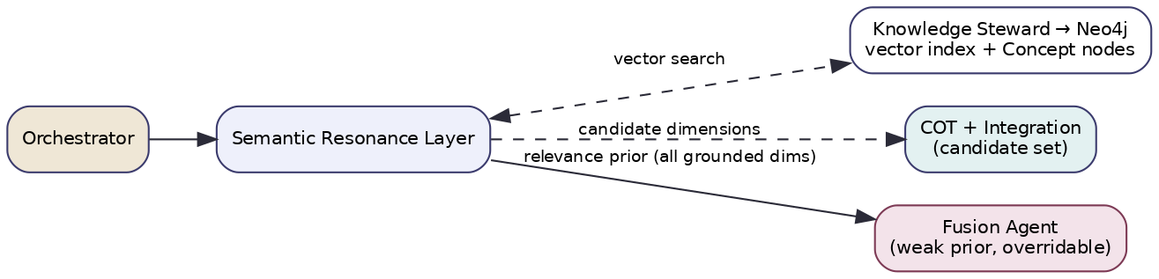
Figure G2 — Semantic Resonance integration (scopes COT’s candidate set; weak prior to Fusion).
Upstream: orchestrator (the prepared expression); Knowledge Steward → Neo4j (vector index, concept/dimension nodes); embedding service. Downstream: COT and the Integration step (SEM’s candidate set scopes which dimensions they consider); Fusion (SEM relevance as a weak, overridable prior). Shared structures: the candidate-dimension set (consumed widely); the concept-evidence records. Agent interactions/messaging: AnalyzeCommand → SignalBatch (relevance-only); reads through the Knowledge Steward exclusively. Knowledge-graph updates: read-only at runtime; the seeding of new concept embeddings (remediation) is a curator/Knowledge-Steward write operation, not a runtime SEM action. Orchestration: runs first alongside the lexical baseline so its candidate set is available before COT begins; fast enough to be on the critical path’s front, not its tail.

12. Engineering Considerations
Performance: p50 < 100 ms with a warm ANN index (embedding call dominates). Scalability: embedding endpoint and vector index scale independently; trivially horizontal. Parallelism: runs concurrently with all layers; itself parallelizable across index shards. Caching: expression-embedding cache by text hash; per-dimension recall cache; warm index. Memory: dominated by the vector index (served by Neo4j, not in the agent). Token/cost: one embedding call per request (cheap); no generative tokens. Cost optimization: embedding cache; batch embedding for Excel/offline modes. Monitoring: recall coverage (% dimensions embedded — should rise to 30/30 after seeding), hit density distribution, fallback-to-lexical rate, calibration drift, candidate-set size feeding COT. Logging: query vector id, top concepts + similarities, uncovered dimensions — under request_id. Observability: spans for embed/search/aggregate; replay from top_concepts. Versioning: embedding_model, index_namespace/version, calibration-model version, layer_version. Testing: retrieval quality (recall@k, MRR) vs a gold expression→dimension set; calibration error on similarity→relevance; coverage tests that assert which dimensions are embedded (a release check that flags the grounding gap); fallback tests (embedding outage → lexical recall); determinism tests (fixed index → identical results).

13. Future Evolution
Top priority: seed (:Concept) nodes + embeddings for the 13 narrative-only dimensions (chunk their narratives into concept units), closing the recall gap so SEM delivers its promised all-dimension floor. Beyond that: hybrid sparse-dense retrieval (combine lexical and vector for robustness); per-family sub-indices for sharper aggregation; learned query expansion that paraphrases colloquial input toward concept space without leaking taxonomy to the user; multilingual embeddings for native-language recall; periodic re-embedding as concept curation evolves; and feedback-trained calibration using which SEM candidates the specialists ultimately confirmed.

