Svarupa Assistant — Architecture Review & Recommendations
Critical Evaluation of the 31-Dimension Architecture, with a Prioritized Remediation Roadmap
Svarupa Architecture Working Group
Version 1.0 · June 2026 · companion to the 31-Dimension Technical Specification v7.1
Table of Contents

1. Executive Summary
This document is a deliberately critical review of the next-generation Svarupa architecture defined in the 31-Dimension Technical Specification (v7.1) and the Analytical Layers Specification (v1.0). Its job is not to praise the design but to find where it is redundant, over-complex, under-grounded, hard to scale, or hard to maintain — and to propose concrete, prioritized fixes.
The architecture is fundamentally sound: a dimension-agnostic registry, seven independent analytical layers, synthesis-not-averaging integration, and a confidence model that protects the recognition-not-diagnosis philosophy. The problems are concentrated in three places. First, data grounding: 13 of 30 dimensions have no concept data and no embeddings, so the Semantic layer cannot recall them and the reasoning layer cannot be calibrated on them. Second, conceptual redundancy: the framework’s 30 dimensions contain several tightly-overlapping clusters (Yoga-Sūtra psychodynamics, Vedāntic soteriology, practice systems) and at least one pair that should be formally correlated (Elements/Tridoṣa) and one pair that could be merged (Evolution/Yuga). Third, cost and calibration: the Chain-of-Thought layer dominates latency and cost and carries the framework’s least-calibrated load.
We make sixteen recommendations (R1–R16), four of which are high-priority and low-effort and should be done first: seed the missing embeddings, canonicalize the status vocabulary, complete the 33 vyabhicāribhāvas, and encode the fusion de-duplication rules. The single most consequential structural recommendation (R12) is to adopt a two-tier dimension model — a small set of macro-lenses with sub-dimensions — which tames the redundancy and complexity without losing the tradition’s richness.

2. Scope and Method
The review covers the dimension framework, the analytical layers, the agentic runtime, the fusion/integration/confidence machinery, the knowledge graph, and the forward AI roadmap. It draws on: the §22 Dimension–Attribute–Status audit; the per-layer specifications; the live concept data (svarupa_concept_merged / documentations/descriptions/); and the source narratives. Each recommendation carries a rationale, expected benefits, implementation complexity, and a priority (High / Medium / Low). Recommendations are collected in the register in §6 and plotted by priority and effort in Figure 2.

3. Findings — Dimensions

3.1 Redundant and overlapping dimensions
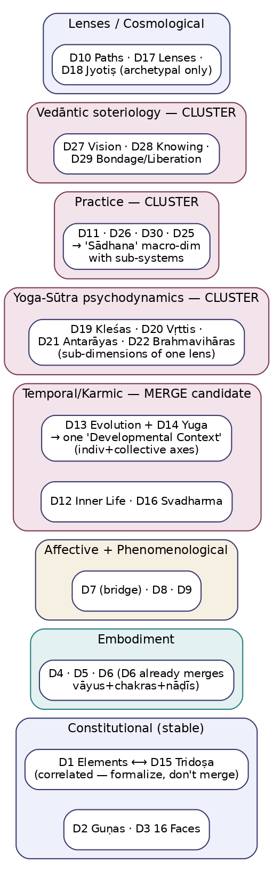
Figure 1 — Dimension clusters with merge, split, and correlation candidates.
The 30 dimensions are not independent; several clusters share most of their conceptual surface:
- Elements (D1) ⟷ Tridoṣa (D15). Their signatures are near-isomorphic (air↔vāta, fire↔pitta, earth/water↔kapha), and both are read by the same layers (PHE, MET). They are not truly two independent pieces of evidence; treating them as such double-counts. They should be formally correlated, not merged — the tradition distinguishes them and users recognize both — but fusion must know they are dependent (R8).
- Yoga-Sūtra psychodynamics (D19 Kleśas, D20 Vṛttis, D21 Antarāyas, D22 Brahmavihāras). These four are facets of one Patañjalian model of the mind’s movements and afflictions; they share sources, vocabulary, and the COT-primary reading. As separate top-level dimensions they invite repetitive, overlapping signals.
- Vedāntic soteriology (D27 Non-Dual Vision, D28 Ways of Knowing, D29 Bondage/Liberation). A single Advaitic arc — view, epistemology, and the path between bondage and freedom — split into three dimensions that almost always co-activate.
- Practice systems (D11 Aṣṭāṅga, D25 Upāsanās, D26 Haṭha, D30 Contemplative/Devotional). Four overlapping “how one practices” dimensions.
- Temporal/karmic (D12 Inner Life, D13 Evolution, D14 Yuga, D16 Svadharma). Related developmental-time dimensions; D13 and D14 are explicitly dependency-linked and both NAR-primary.

3.2 Merge opportunities
- D13 (Cyclical Evolution) + D14 (Yuga) → one “Developmental Context” dimension with an individual-arc axis and a collective-age axis. Rationale: they are dependency-linked, share the NAR-primary reading, and D14’s profiles are not independently text-derivable anyway (§22). Benefit: removes a non-recoverable dimension while preserving the individual–collective mismatch insight. Complexity: Medium (registry + narrative reconciliation). Priority: Medium. (R6)
- Within clusters, rather than merging away distinct lenses, adopt the two-tier model (R12): keep the macro-lens as the dimension and demote tightly-overlapping members to sub-dimensions. This is the principled alternative to lossy merges.

3.3 Split opportunities
- D6 (Subtle Energies) already merges three sub-systems (vāyus, chakras, nāḍīs). This is the right call for recall, but for users who want energetic granularity it could expose its three sub-systems as sub-dimensions under the two-tier model — split within the dimension, not into new top-level dimensions.
- D12 (Inner Life) bundles four constructs (karma, saṁskāra, vāsanā, eṣaṇā) with genuinely different dynamics; expose them as sub-dimensions for clearer signals.
- D16 (Svadharma) data conflates two taxonomies (varṇa types and planes-of-being) and omits brāhmaṇa; split the attribute set into its two coherent taxonomies (data-quality fix, §22.6 item 5).

3.4 Unnecessary analytical complexity
A flat list of 30 heavily-overlapping dimensions is more complex than the underlying conceptual structure warrants. The complexity manifests as: redundant signals from co-activating dimensions, a larger candidate set for COT (cost), and a harder integration problem (more pairwise tensions to reason about). R12 (two-tier model) is the primary remedy: ~10–12 macro-lenses, each with sub-dimensions, reduces top-level cardinality while preserving every concept. A secondary item: D18 (Jyotiṣ) delivers low value from text (archetypal motif only) and risks the recognition-not-diagnosis line; gate it behind optional birth-chart input rather than running it on every expression (R7).

4. Findings — Capabilities, Scale, Maintainability

4.1 Missing analytical capabilities
- Calibrated confidence. The confidence functions are currently heuristic; there is no calibration guarantee. (R5)
- Gold-standard evaluation for the 13 narrative-only dimensions, without which COT’s reading of them cannot be trusted or improved. (R4)
- Longitudinal / cross-session modeling. NAR’s most valuable trajectory work (turning points, drift) needs consented history modeling that does not yet exist. (R14)
- Multimodal signals (voice prosody, journaling cadence, optional wearables) for affect and phenomenology. (R11)
- A user-facing uncertainty/coverage surface so people see when the system is unsure or out of coverage.

4.2 Scalability concerns
- COT is the bottleneck — the only layer whose latency and cost scale with model calls and with candidate-set size. Mitigations: candidate batching (already specified), caching, model routing, and per-dimension adapters to offload the large model (R9). The two-tier model (R12) also shrinks the candidate set.
- SEM grounding gap (R1) means recall scales to only 17 dimensions today.
- Fusion/integration scale well (vectorized math + one or two LLM calls); no concern.

4.3 Maintainability issues
- Four incompatible status schemes plus one dimension (D13) with none — a standing source of mapping bugs. Canonicalize (R2).
- Data grounding gap for 13 dimensions (R1) makes large parts of the framework un-testable.
- Bridge tables (emotion→Rasa, source→dimension, signature patterns) are the right pattern but must be versioned, owned, and gold-tested (already specified; keep enforced).
- The registry-as-data design is a genuine maintainability strength; preserve it (no if dimension == X anywhere).

5. Findings — Runtime (Agents, Orchestration, Confidence, KG)

5.1 Agent optimization
- Shared valence/arousal pre-layer (R13): compute these once in a tiny pre-step consumed by both AFF and PHE, eliminating duplicate work and guaranteeing a single source of truth (today they “share” via a cache, which is fragile).
- Fast-mode call fusion (R10): merge the Integration and Composition LLM calls under latency_mode: fast for latency-sensitive surfaces, at a known cost to inspectability.

5.2 Orchestration improvements
- The LangGraph state machine and partial-result handling are sound. Add dependency-DAG-aware scheduling so dependency dimensions are read before dependents within the candidate-scoped reasoning step (the DAG exists in the registry; schedule against it explicitly).

5.3 Confidence propagation improvements
- Replace heuristic confidence with learned, calibrated layer-reliability priors and, longer term, conformal or Bayesian uncertainty with coverage guarantees (R5, R16). Keep the existing, philosophically important separation of aleatoric / epistemic / conflict uncertainty.

5.4 Knowledge Graph integration opportunities
- Seed concept nodes + embeddings for the 13 ungrounded dimensions (R1) — unblocks SEM and gives every layer a retrieval anchor and validation target. Highest-leverage single action in this review.
- Tool-augmented COT (R9-adjacent): let COT traverse RELATES_TO mid-reasoning for dependency-heavy dimensions.
- Pattern library (R15): promote recognized cross-dimensional motifs to curated (:Pattern) nodes via human-in-the-loop review, growing the system’s vocabulary without uncontrolled drift.
- Store the canonical status (R2) and the dependency DAG as first-class graph properties.

5.5 Future AI capabilities
- Per-dimension fine-tuned adapters (R9); multimodal encoders (R11); conformal prediction for calibrated, guaranteed uncertainty (R16); active learning that trains SEM calibration and fusion weights from which candidates the specialists ultimately confirm; and structured deliberation (debate/critique) for the subtlest dimensions (D27, D29).

6. Recommendations Register
Priority and effort are plotted in Figure 2; the register gives rationale, benefit, and complexity for each.
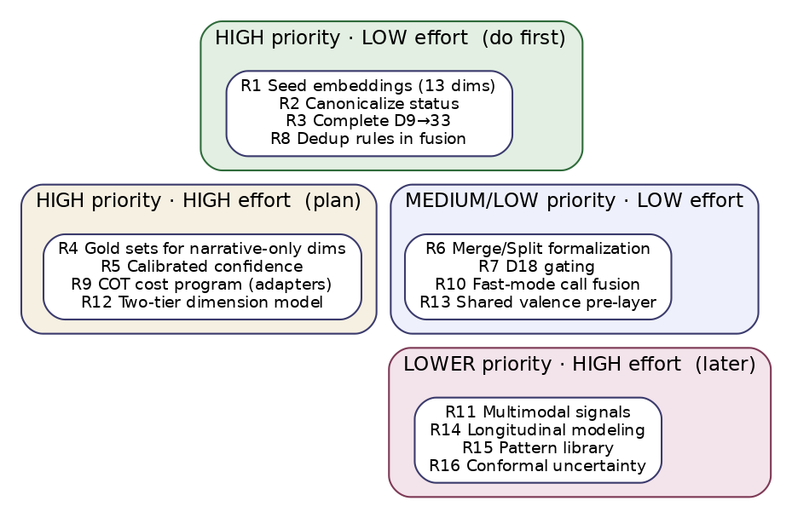
Figure 2 — Recommendations by priority and implementation effort.
ID | Recommendation | Rationale | Expected benefit | Complexity | Priority
R1 | Seed concept nodes + embeddings for the 13 narrative-only dims | SEM has zero recall for D17, D19–D30 today | Restores all-dimension recall; anchors every layer | Low–Med | High
R2 | Canonicalize status to {deficiency, balance, excess} | 4 incompatible schemes + 1 with none | Removes a whole class of mapping bugs | Low–Med | High
R3 | Complete D9 to the canonical 33 (add vrīḍā, vyādhi, vitarka) | Data has 30; name says 33; narrative has vrīḍā | Correctness; consistency | Low | High
R4 | Build gold-standard eval sets for narrative-only dims | COT’s heaviest load is un-calibrated | Trustworthy, improvable interpretive reading | High | High
R5 | Replace heuristic confidence with calibrated priors | No calibration guarantee today | Honest, comparable confidence | High | High
R6 | Merge D13+D14 → “Developmental Context”; split D12/D16 attributes | Redundancy; D14 not text-derivable; D16 conflated | Fewer non-recoverable dims; cleaner data | Medium | Medium
R7 | Gate D18 (Jyotiṣ) behind optional chart input; archetypal-only from text | Low text value; verdict-language risk | Cost saved; philosophy protected | Low | Medium
R8 | Encode de-duplication rules in fusion (D1↔D15; D2 AFF/PSY; valence AFF/PHE) | Correlated signals double-count | Correct evidence accumulation | Low | High
R9 | COT cost program: per-dim adapters, routing, tool-augmented reasoning | COT dominates cost/latency | Lower cost; better faithfulness | High | High
R10 | Fast-mode fusion of Integration + Composition calls | Two LLM calls on the tail | Lower latency for fast surfaces | Low | Medium
R11 | Multimodal signals (voice, cadence, opt-in wearables) | Text misses prosodic/somatic affect | Richer affect/phenomenology | High | Low
R12 | Two-tier dimension model (macro-lenses + sub-dimensions) | Flat 30 over-states real cardinality; clusters overlap | Less complexity/cost; preserves richness | High | High
R13 | Shared valence/arousal pre-layer | AFF/PHE duplicate the axes | Single source of truth; less compute | Low | Medium
R14 | Longitudinal cross-session modeling (consented) | NAR’s best work needs history | Turning-point & drift recognition | High | Low–Med
R15 | Curated (:Pattern) library with human-in-the-loop write-back | Cross-dim motifs are recomputed each time | Reusable, curated recognitions | Medium | Medium
R16 | Conformal / Bayesian uncertainty | Heuristic uncertainty lacks guarantees | Calibrated, defensible uncertainty | High | Low

7. Phased Roadmap
Phase 1 — Foundations (now; mostly data/config). R1 (seed embeddings), R2 (canonical status), R3 (complete D9), R8 (fusion de-dup). These are low-effort, high-impact, and unblock everything else. Net effect: the framework becomes fully grounded, internally consistent, and double-count-free.
Phase 2 — Trust & structure. R12 (two-tier model), R4 (gold sets), R5 (calibrated confidence), R6 (merge/split), R7 (D18 gating). These make the framework simpler, testable, and honestly calibrated.
Phase 3 — Scale & cost. R9 (COT cost program), R10 (fast-mode), R13 (shared pre-layer), R15 (pattern library). These make it affordable at a million users.
Phase 4 — Frontier. R11 (multimodal), R14 (longitudinal), R16 (conformal). Higher-effort capability expansions once the core is solid.

8. Risks and Trade-offs
- Two-tier model (R12) risks under-surfacing a sub-dimension a user would have recognized; mitigate by letting sub-dimensions still produce signals that roll up to their macro-lens, so granularity is preserved internally even if the top-level UI is simpler.
- Merging D13+D14 (R6) risks flattening a distinction some practitioners value; mitigate by keeping individual-arc and collective-age as explicit axes within the merged dimension.
- Seeding embeddings (R1) from narratives risks importing the narratives’ own emphasis biases; mitigate with curator review of the chunked concept set.
- Calibration (R4/R5) depends on expert-annotated gold data, which is expensive to produce; treat gold-set creation as a standing program, not a one-off.
- Philosophy guardrail: every recommendation must pass the philosophy-regression suite; none may introduce diagnostic, predictive, or prescriptive behavior. R7 (D18 reframing) and R5 (confidence-as-process) are explicitly philosophy-protective.
End of review.

