Svarupa — Dimensional Mapping & AI/UX Analysis
From Alternative Mapping Strategies to the Realized Seven-Layer Ensemble
Svarupa AI & Design
Version 2.0 · June 2026 (updated for the 31-Dimension architecture)
Table of Contents

0. What Changed in This Update
The original document proposed alternatives to keyword-based “Layer 1” mapping — embeddings, LLM reasoning, affect analysis, narrative, metaphor, psycholinguistics, phenomenology. Those proposals have now been realized as the canonical seven-layer analytical ensemble. This version therefore (1) replaces “proposed alternatives” with the implemented architecture, (2) updates the user journey and UX architecture to the 31-Dimension Framework, (3) describes the real analytical pipeline and layer interactions, (4) updates the dimension-mapping approach per the §22 mapping audit, and (5) revises the visualization and interaction-flow strategy.

1. From Keywords to a Seven-Layer Ensemble
Keyword extraction fails whenever users speak colloquially or metaphorically — which is almost always. The architecture’s answer is not a single better method but a parallel ensemble of seven independent analytical layers, each competent for the dimensions where its method is theoretically appropriate, fused into one multi-perspective map:
Layer | Method | Primary dimensions (post-audit)
Semantic Resonance | dense-vector recall over concept embeddings | recall for all (contributing)
Multi-Axis Affect | VAD + discrete emotion → Rasa | D8, D9
Phenomenological | 9 experiential axes | D7 (+ felt-quality signatures)
Psycholinguistic | LIWC-style form features | D17, D2 (co)
Metaphor | source-domain mining | D1 (+ D5/D6/D15)
Narrative Arc | arc/loop/mismatch detection | D10, D12, D13, D14, D16, D29
LLM Chain-of-Thought | structured reasoning | interpretive cluster (D3, D18–D30)
The keyword baseline is retained as a cheap, transparent lexical prior and graceful-degradation floor — not discarded, but demoted to one weak input among many.

2. The Analytical Pipeline
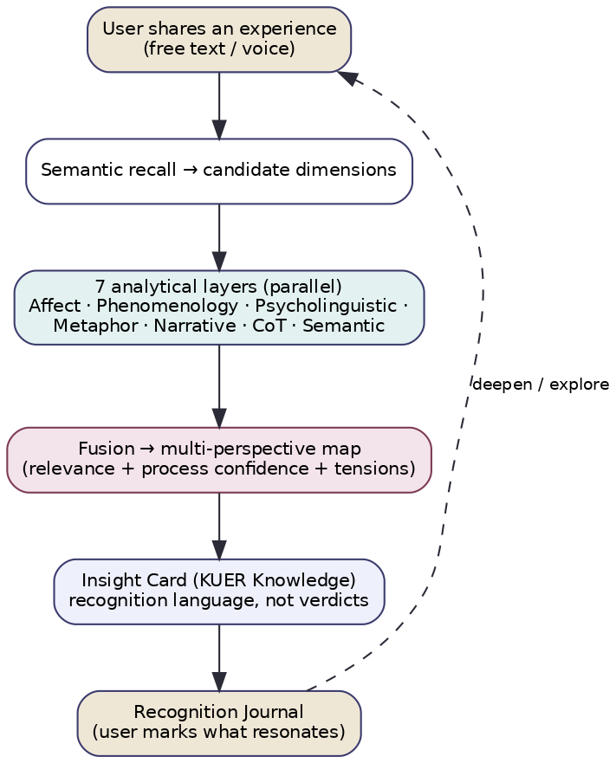
Figure 1 — User experience over the analytical pipeline.
A single interaction flows: express → semantic recall (candidate dimensions) → seven layers in parallel → fusion (relevance + process-confidence + tensions) → Insight Card → Recognition Journal. Key properties that matter for UX:
- Parallelism keeps latency near that of the slowest layer (Chain-of-Thought), so the experience stays responsive.
- Fusion synthesizes, it does not average — complementary and contradictory readings both survive into the UI.
- Confidence is about the process, never the person — the UI must render it as hedged language, not a score on the user.

3. Layer Interactions (what designers must know)
- Affect ⟷ Phenomenology share valence/arousal (one source of truth) — so the UI never shows two different “mood” readings.
- Psycholinguistic → Chain-of-Thought / Narrative supplies countable features (agency, attribution, temporal orientation) that ground the reasoning layers; these are the most explainable signals and should be surfaced first in “why this?” views.
- Metaphor ⟷ Phenomenology corroborate elemental signatures; the UI can quote the user’s own metaphor (“you said ‘drowning’”) as the most resonant evidence.
- Semantic scopes the expensive reasoning and guarantees breadth; its current recall gap (13 dimensions lack embeddings) means some dimensions can be under-surfaced until the data is seeded — a known limitation to design around (show coverage honestly).

4. Dimension Mapping (updated per the §22 audit)
The mapping from signals to dimensions now follows the corrected, canonical rules:
- Every layer emits relevance (how implicated) separately from process-confidence (trust in the reading).
- The canonical pole is {deficiency, balance, excess}, derived from the signal, not copied from the legacy negative/neutral/positive status fields (which collapse excess and deficiency).
- Each layer maps only the dimensions it is competent for; the UI should not imply that every layer “scored” every dimension.
- Correlated signatures (Elements↔Tridoṣa; guṇa across Affect/Psycholinguistic; valence across Affect/Phenomenology) are de-duplicated so the visualization does not over-weight a doubly-counted theme.

5. User Journey
- Invitation to express. A calm, open prompt (“What’s present for you?”) accepting free text or voice. No forms, no quizzes.
- Reading. The ensemble runs; a brief, honest “considering several perspectives…” state (no fake precision).
- Recognition. One Insight Card in the Knowledge stage — a resonant perspective in plain language, with a “does this ring true?” toggle, and a second card when a real tension exists.
- Exploration (optional). The user can pull a perspective into Understanding (story/audio), Experience (a small practice), or open “why this?” to see their own words that grounded it.
- Recognition Journal. The user marks what resonated, in their words — building a private record with no scores.
- Return. Gentle, infrequent, user-controlled re-engagement; over time (consented) the system may surface possible drift as a recognition cue.

6. UX Architecture
- Surface 1 — Express: input (text/voice), zero friction, no taxonomy shown.
- Surface 2 — Insight Card(s): the Knowledge-stage recognition, confidence-shaped wording, tension-aware.
- Surface 3 — Constellation: a live, multi-perspective map of the current reading (below).
- Surface 4 — Why this?: explainability — the user’s own phrases, the contributing layers, the process-confidence in plain terms.
- Surface 5 — Deepen: KUER paths (Understanding / Experience).
- Surface 6 — Recognition Journal: longitudinal, score-free, user-owned.

7. Visualization Strategy
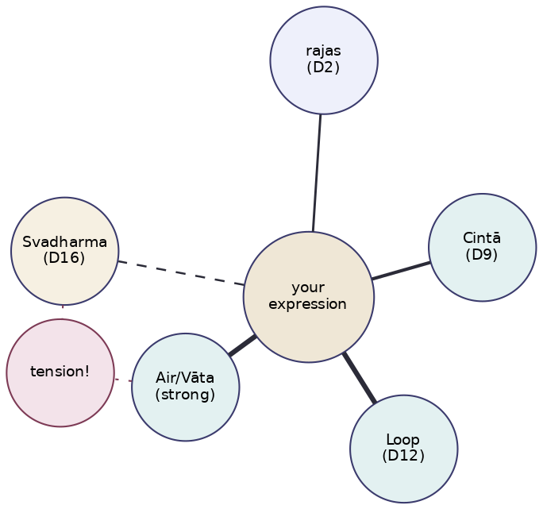
Figure 2 — The Constellation: a multi-perspective dimension map.
Replace any single-gauge or “personality result” visualization with a Constellation: the user’s expression at the center, implicated dimensions arranged around it with proximity encoding relevance, line weight encoding process-confidence, and explicit tension markers where perspectives disagree. This visualization is the literal rendering of the philosophy — multiplicity, weighted honestly, with contradictions shown rather than resolved. Design rules: no leaderboards, no percentile-against-others, no single “type” badge, and a one-tap path from any node to its grounding evidence. Color encodes family (constitutional, affective, temporal, etc.), not good/bad.

8. Interaction Flow Principles
- Recognition prompts over calls-to-action. Every result ends with a question the user answers for themselves.
- Progressive disclosure. Knowledge first; Understanding/Experience only on pull.
- Honest uncertainty. Low-confidence readings are visibly softer; coverage gaps are stated, not hidden.
- Tensions are interactive. The user can hold both sides of a contradiction; the UI never forces a pick.
- Explainability is one tap away from any claim.
- Anti-addictive by construction. No streaks, autoplay-next, or infinite scroll; the loop closes on insight, not on time-on-app.

9. Implementation Notes for Design & Engineering
- Render confidence as language and line-weight, never as a number on the person.
- Treat the correlated_group tags from fusion as a de-duplication instruction in the Constellation.
- Surface recall_available=false dimensions honestly (don’t imply zero relevance where the system simply has no coverage yet).
- Keep the four-layer presentation range (universal → bridging → traditional → scholarly) as a user-selectable depth, defaulting to universal.
- All longitudinal features are consent-gated and reversible.

