Svarupa Assistant — UI/UX & Adoption Analysis
Psychology-Informed Design, Dashboards, and Adoption Strategy for the 31-Dimension Framework
Svarupa Product, UX & Behavioral Design
Version 2.0 · June 2026 (updated for the 31-Dimension architecture)
Table of Contents

0. What Changed in This Update
This version updates the UI/UX and adoption strategy to the next-generation system: the 31-Dimension Framework, the realized seven-layer analytical ensemble, and the canonical recognition-not-diagnosis mapping (Technical Specification §22). It revises the user experience, dashboard concepts, product messaging, feature set, user journeys, adoption strategy, and competitive positioning accordingly. The earlier “alternative mapping approaches” section is now superseded by the implemented ensemble (see the Mapping & AI/UX Analysis, v2.0); this document focuses on experience and adoption.

1. The Core Psychological Driver
The single most powerful driver of engagement is the desire to understand oneself. Personality systems (Myers-Briggs, Enneagram, astrology apps) exploit this with simplified, flattering, fixed labels. Svarupa serves the same drive without the reduction: it offers multiple complementary perspectives, honestly weighted, that the user recognizes (or not) in their own experience. This is more demanding than a label — and far more durable, because recognition the user arrives at themselves is owned, not imposed.
The design consequence: the product’s job is to make recognition possible, not to deliver verdicts. Every screen either invites an expression, offers a perspective as an invitation, or records what the user has recognized. Nothing asserts who the user “is.”

2. UX Principles (psychology- and therapy-informed)
- Autonomy support over compliance. Borrow from motivational interviewing and self-determination theory: ask, reflect, invite — never instruct. Each result ends with “does this resonate?”, returning authority to the user.
- Reflective, not reactive. Unlike feeds engineered for reactivity, Svarupa’s pacing is contemplative: one perspective at a time, calm motion, no autoplay-next.
- Hold complexity. Therapy tolerates ambivalence; so does Svarupa. Contradictory perspectives are presented together, not resolved.
- Safety first. A safety layer detects acute distress and diverts to support resources rather than running an analysis; the UI never gamifies vulnerable states.
- No dark patterns. No streaks, no loss-aversion nudges, no manufactured urgency, no social comparison. Engagement is earned by value.

3. Product Messaging
- Primary promise: “Understand yourself through many lenses — and decide for yourself what’s true.”
- Differentiator line: “Not a personality type. A set of perspectives you can recognize.”
- Trust line: “No scores. No labels. No selling your attention.”
- Depth line: “From a first glimpse to a lasting recognition — at your pace” (the KUER ladder).
- Avoid: clinical/diagnostic language, predictive claims, and any phrasing that implies the app knows the user better than they know themselves.

4. The Dashboard
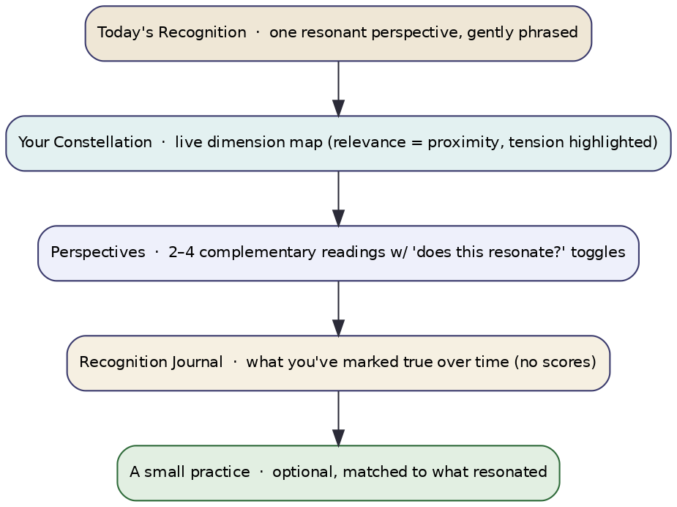
Figure 1 — Home dashboard concept.
The home surface is organized around recognition, not metrics:
- Today’s Recognition — one resonant perspective from the latest reading, gently phrased, with a “does this fit?” toggle.
- Your Constellation — a live, multi-perspective map of the current reading (relevance = proximity, process-confidence = line weight, tensions highlighted). Tapping any node opens “why this?” with the user’s own words.
- Perspectives — 2–4 complementary readings, each with a resonance toggle; tensions shown as paired cards.
- Recognition Journal — what the user has marked true over time, in their words, with no scores or progress bars.
- A small practice — optional, matched to what resonated, easy to skip.
Explicitly not on the dashboard: a “personality result,” a percentage, a streak counter, a comparison to other users, or any single badge. The absence of these is a feature and should be visible in the product’s calm.

5. Feature Set (updated)
- Express (text/voice): zero-friction input; no quizzes or forms.
- Multi-perspective Insight Cards: confidence-shaped, tension-aware, recognition-framed.
- The Constellation: the signature visualization of multiplicity.
- Why this? (explainability): the user’s own phrases and the contributing layers behind any perspective.
- KUER depth paths: Understanding (story/audio), Experience (micro-practices), Realization (journal).
- Recognition Journal: longitudinal, score-free, user-owned; consented drift cues over time.
- Presentation-layer selector: universal → bridging → traditional → scholarly, defaulting to universal.
- Safety & support: crisis-aware diversion to resources; never gamified.

6. User Journeys
New user (first session). Opens to a single calm prompt → shares a few sentences → receives one resonant Insight Card with a “does this fit?” toggle → optionally taps “why this?” and sees their own words reflected → marks it (or not) in the Journal. Success = one genuine recognition, not feature breadth.
Returning user. Opens to Today’s Recognition and the Constellation → explores a tension or pulls a perspective into Understanding/Experience → adds to the Journal. Success = deepening, not frequency.
Depth-seeking user. Switches presentation layer to traditional/scholarly → follows KUER from Knowledge through Experience → uses the Journal longitudinally. Success = sustained, self-directed inquiry.

7. Adoption Strategy
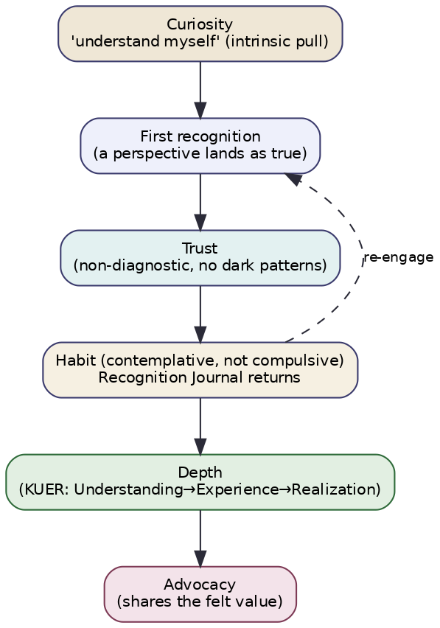
Figure 2 — Adoption as a contemplative loop, not a growth funnel.
The adoption model is a contemplative loop, not an extraction funnel:
- Curiosity — the intrinsic “understand myself” pull (the most durable acquisition driver; lean into authentic, non-hyped messaging).
- First recognition — the activation moment is a perspective landing as true. Optimize onboarding for one real recognition, not for feature tours.
- Trust — built by visible honesty (confidence, tensions, no dark patterns, no ads). Trust is the conversion engine here.
- Habit (contemplative) — the Recognition Journal and gentle re-engagement create return without compulsion.
- Depth — KUER progression deepens value over time, supporting retention and premium conversion through value, not gating tricks.
- Advocacy — users who feel genuinely understood share the felt experience; word-of-mouth is the primary growth channel for a trust-based product.
Acquisition. Content-led (the Knowledge-stage micro-content doubles as honest marketing); partnerships with contemplative/therapeutic communities; no manipulative growth loops. Retention. Depth and trust, measured by recognitions marked and self-reported insight, not session count. Monetization. Premium depth (Understanding/Experience libraries, longitudinal Journal) without compromising the free tier’s integrity; ad-free, always.

8. Metrics (recognition-aligned, not engagement-maximizing)
Measure what the philosophy values: recognitions marked as resonant, return-for-depth (KUER stage progression), self-reported insight/helpfulness, trust indicators (opt-in retention, low complaint/uninstall after honest-uncertainty moments), and safety efficacy. Explicitly avoid optimizing time-on-app, streaks, or daily-active-as-a-goal — these would corrupt the product’s reason to exist.

9. Competitive Positioning
Dimension of comparison | Typical personality/wellness apps | Svarupa
Output | a fixed type/label | many complementary perspectives
Stance | confident verdict | honest, confidence-aware invitation
Handling of contradiction | hidden/flattened | preserved and shown
Engagement model | streaks, notifications, dark patterns | contemplative loop, anti-addictive
Monetization | ads / data / FOMO gating | value-based premium, ad-free
Depth | one framework | 31 dimensions × 7 analytical layers
Explainability | opaque | user’s own words on tap
Cultural grounding | borrowed/simplified | primary-source authentic, multi-register
Svarupa’s positioning is the anti-label self-understanding product: deeper, more honest, and ethically differentiated in a market increasingly distrustful of manipulative design and overconfident AI.

10. Risks & Guardrails
- Over-delivery of perspectives can overwhelm; default to one Knowledge-stage card and disclose more only on pull.
- Honesty can feel less “magical” than a confident label; mitigate with craft — calm, beautiful, resonant phrasing — so honesty reads as depth, not hedging.
- Coverage gaps (the 13 ungrounded dimensions) must be shown honestly, not hidden behind false confidence.
- Vulnerable users: the safety layer takes precedence over any engagement consideration, always.
- Every UX decision passes the same test as the engine: does it support recognition, agency, and the user’s own authority? If not, it does not ship.

