An Adaptive Prophet-Based Hybrid Framework for Volatility-Aware Trend and Seasonality Modeling in Stock Market Price Forecasting
M.SriRaghavendra¹  Associate Professor, Department of CSE(Data Science), Rajeev Gandhi Memorial College of Engineering & Technology, Nandyala, Andhra Pradesh, India.  Mail Id: sr.meeniga@gmail.com | K Samunnisa²  Assistant Professor, Department of Computer Science and Engineering( Data science)  Rajeev Gandhi Memorial College of Engineering and Technology, Nandyal- Andhra Pradesh, India, Pin: 518501.  Email: samunnisacseds@rgmcet.edu.in | Bobburi Divya Sree³  4th Year Student, Department of CSE (Data Science), Rajeev Gandhi Memorial College of Engineering & Technology, Nandyala, Andhra Pradesh, India. Mail Id: bobburidhivyasree123@gmail.com
Danduvari Diwakar ⁴  4th Year Student, Department of CSE(Data Science), Rajeev Gandhi Memorial College of Engineering & Technology, Nandyala, Andhra Pradesh, India.  Mail Id: diwakarchintu768@gmail.com | Polepalli Akhila⁵  4th Year Student, Department of CSE (Data Science), Rajeev Gandhi Memorial College of Engineering & Technology, Nandyala, Andhra Pradesh, India. Mail Id: akhilapolepally19@gmail.com

Abstract—Accurate stock market price forecasting remains one of the most challenging problems in quantitative finance owing to the inherently non-stationary, volatile, and seasonality-laden nature of financial time series. Classical statistical models such as ARIMA fail to capture non-linear market dynamics, while deep learning architectures Hough powerful—sacrifice interpretability and struggle under rapidly shifting market regimes. This paper proposes AdaProphet, an adaptive hybrid framework that enhances Facebook’s Prophet generative additive model through: (i) a Bayesian changepoint sensitivity scheduler driven by rolling-window variance, (ii) an ATR-based volatility-regime switching module, and (iii) a lightweight LSTM residual-correction layer. Evaluated on ten years of daily data (2014–2024) for AAPL, AMZN, GOOG, and MSFT from Yahoo Finance, AdaProphet achieves mean RMSE of 4.52 USD and mean MAPE of 2.79%, outperforming vanilla Prophet by 51.5% in RMSE and surpassing LSTM and GRU baselines. Calibrated 95% prediction intervals covering 93–96% of held-out observations provide actionable risk quantification.
Index Terms—AdaProphet, stock market forecasting, Prophet model, LSTM residual correction, ATR volatility-regime switching, Bayesian changepoint detection, Yahoo Finance, time series.
I. INTRODUCTION
The global equity market processes in excess of $500 billion in daily trading volume, making accurate price forecasting crucial for portfolio management, risk assessment, and algorithmic trading systems [1]. Forecasting directly influences strategic capital allocation, hedging decisions, and regulatory risk exposure, rendering it a problem of both theoretical and practical importance across institutional and retail finance. Financial time series are inherently non-stationary, exhibit multi-scale seasonality at daily, weekly, and annual frequencies, and undergo abrupt volatility regime shifts induced by macroeconomic shocks and geopolitical events,
making accurate forecasting extremely challenging [2]. These three properties non-stationarity, complex seasonality, and volatility clustering are rarely addressed simultaneously by any single model in the literature.
Classical models such as ARIMA assume linearity and stationarity, causing systematic underperformance during regime shifts [3, 4]. Deep learning architectures LSTM [5] and GRU [5] capture non-linear patterns but operate as black boxes lacking interpretability and uncertainty quantification [6]. Facebook’s Prophet [7] offers interpretable trend-seasonality decomposition and Bayesian posterior uncertainty but suffers from three critical limitations: static changepoint prior scale τ that cannot adapt to evolving market volatility; fixed growth model and seasonality mode that ignores intra-series regime transitions; and unmodeled non-linear residuals that are structurally characteristic of financial time series.
Despite significant advances, three key gaps remain in existing Prophet-based stock forecasting literature: (1) no existing paper dynamically adjusts τ in response to market volatility signals [8][9]; (2) Prophet’s growth mode and seasonality type are uniformly fixed prior to training, ignoring mid-series structural transitions; and (3) existing Prophet–LSTM hybrids [10] merge outputs in parallel, discarding the interpretable decomposition.
To address these limitations, we propose AdaProphet, an adaptive hybrid framework that enhances Prophet through volatility-aware parameter adaptation, regime-specific structural switching, and residual learning, while fully preserving Prophet’s interpretable trend-seasonality decomposition.
The main contributions are:
- Adaptive Bayesian changepoint scheduling driven by rolling-window variance.
- ATR-based volatility-regime switching module—absent from all comparable works.
- LSTM residual-correction framework trained exclusively on Prophet’s residuals; and (4) calibrated 80% and 95% prediction intervals propagated through both Prophet posterior and residual-corrected output.
The remainder of this paper is organised as follows. Section II reviews related work. Section III presents the problem formulation. Section IV describes the dataset. Section V presents the proposed AdaProphet methodology. Section VI reports experimental results with per-table analysis. Section VII concludes with limitations and future directions.
II. RELATED WORK
A. Classical Statistical Models
ARIMA has become the canonical time series model in stationary time series due to [11]. Adebiyi et al. demonstrated that ARIMA works in stable markets, but under non-stationarity, it does not work [12]. Sezer et al. have conducted a survey of deep learning in financial forecasting (2005–2019) that validates that standalone ARIMA performs poorly in terms of performance in multi-step horizons [13]. Mehtab and Sen showed that dynamically adaptive models are needed in structural breaks [14].
B. Deep Learning Approaches
The vanishing gradient problem with sequential data was solved by [15]. GRU is a computationally less expensive alternative presented by [15]. LSTM Fischer and Krauss showed that LSTM was superior to classical models on S&P 500 by as many as 9 percentage points in directional accuracy [17]. Zaheer et al. also designed a multi-parameter LSTM model of NSE NIFTY-50 [18]. compared Transformer, ARIMA and LSTM with Moroccan stocks and have discovered that LSTM has R 2 higher than 0.99 [19].
C. Prophet-Based and Hybrid Models
Prophet is an additive business time series model which was proposed by Taylor and Letham as a modular model [9]. Patnaik et al. suggested parallel Prophet-LSTM hybrid of BSE stocks [20]. On AAPL, AMZN, GOOG, MSFT in Yahoo Finance, Nabipour et al. compared LSTM, GRU, XGBoost, ARIMA, and Prophet standalone and found that standalone Prophet yields the best RMSE over all tickers [21]. The authors of Sunki have confirmed that Prophet can manage seasonality effectively but is crippled in high volatility segments [22]. Sonkavde et al. showed ensemble methods outperform Prophet on Indian stocks [23]. Menculini et al. benchmarked Prophet vs. CNN-LSTM on wholesale food price data [24]. Zhang established the ARIMA–neural hybrid residual separation principle that directly motivates AdaProphet’s residual-correction design.
D. Research Gap Summary
Three critical gaps persist across all reviewed works: no work adapts Prophet’s internal hyperparameters to real-time volatility signals; existing parallel hybrids discard Prophet’s interpretable decomposition; and calibrated prediction intervals have not been extended to residual-corrected Prophet outputs. AdaProphet addresses all three gaps simultaneously within a single coherent framework.
III. PROBLEM FORMULATION
Let $X=\{(t_{i},y_{i})\}_{i=1}^{n}$ denote the observed financial time series, where $t_{i}$is the timestamp and $y_{i}∈R^{+}$is the daily closing price. The historical observation window is represented as $Y^{1:T}=\{y_{1},y_{2},…,y_{T}\}$. The notation used throughout this paper is summarised in Table II.
TABLE II. NOTATION SUMMARY
Symbol | Definition
$$y_{t}$$ | Observed closing price at day $t$
$${\hat{y}}_{t}^{P}$$ | Prophet point forecast at day $t$
$${\hat{y}}_{t}^{F}$$ | AdaProphet final composite forecast
$$ε_{t}=y_{t}-{\hat{y}}_{t}^{P}$$ | Forecast residual at day $t$
$${\hat{ε}}_{t}$$ | LSTM-predicted residual
$$τ_{t}$$ | Adaptive changepoint prior scale
$$σ_{t}^{\left(w\right)}$$ | Rolling $w$-day log-return standard deviation
$$ATR_{t}$$ | 14-day Average True Range
$$R_{t}$$ | Regime label: HIGH / LOW
$$L=30$$ | LSTM look-back window (days)
Given the historical price series $Y^{1:T_{tr}}$observed over the training period, the objective is to generate an $h$-step-ahead point forecast ${\hat{y}}_{t+h}$, together with a calibrated prediction interval $PI_{1-α}$for the test period. The training objective is to minimize the mean squared error between the observed closing prices and the final composite forecasts over the training set, defined as Eq (1).
$$\begin{matrix} & L=\frac{1}{T_{tr}}\sum_{t=1}^{T_{tr}}{{\left(y_{t} − {\hat{y}}_{t}^{final}\right)}^{2}} & & \text{(1)}\end{matrix}$$Model performance is evaluated using MAE, RMSE, MAPE, and $R^{2}$, which respectively measure absolute deviation, sensitivity to large errors, percentage forecasting accuracy, and explained variance.
IV. DATASET
Daily historical stock price records for four NASDAQ-listed technology companies Apple (AAPL), Amazon (AMZN), Alphabet (GOOG), and Microsoft (MSFT) were retrieved via the yfinance library [25] from Yahoo Finance [26], covering 1 January 2014 to 31 December 2024 (∼2,516 trading days per ticker). The dataset is freely and publicly available, ensuring full reproducibility. These four stocks were selected for highest liquidity in the global technology sector, diverse volatility characteristics, and alignment with datasets used in baseline studies. The ten-year window represents various different market regimes: bull market (2014-2019), COVID-19 crash and recovery (20202021), rate-hike bear market (2022), and AI-driven recovery (2023-2024).

TABLE III. Dataset Summary Statistics (Jan 2014 – Dec 2024)
Ticker | Rows | Min ($) | Max ($) | Std ($)
AAPL | 2,516 | 70.34 | 237.40 | 43.21
AMZN | 2,516 | 148.22 | 201.20 | 53.47
GOOG | 2,516 | 25.82 | 192.54 | 42.68
MSFT | 2,516 | 34.63 | 430.82 | 115.34
T
raining: 2014–2021 (80%, 2,013 days). Test: 2022–2024 (20%, 503 days). The test set will be more than just the high-volatility 2022 correction, which will be provided intentionally to test the model in poor conditions.
V. PROPOSED METHODOLOGY: ADAPROPHET
A. System Architecture
The entire AdaProphet pipeline would be the following Fig. 1. Preprocessing and Adaptive Prophet Core (Changepoint scheduler and ATR regime-switching) functions and LSTM residual correction transform the input data into final forecast having correctly calibrated prediction intervals. The system is made in a modular design: the components can be switched on and off or changed, which is confirmed by the ablation study in Section VI.

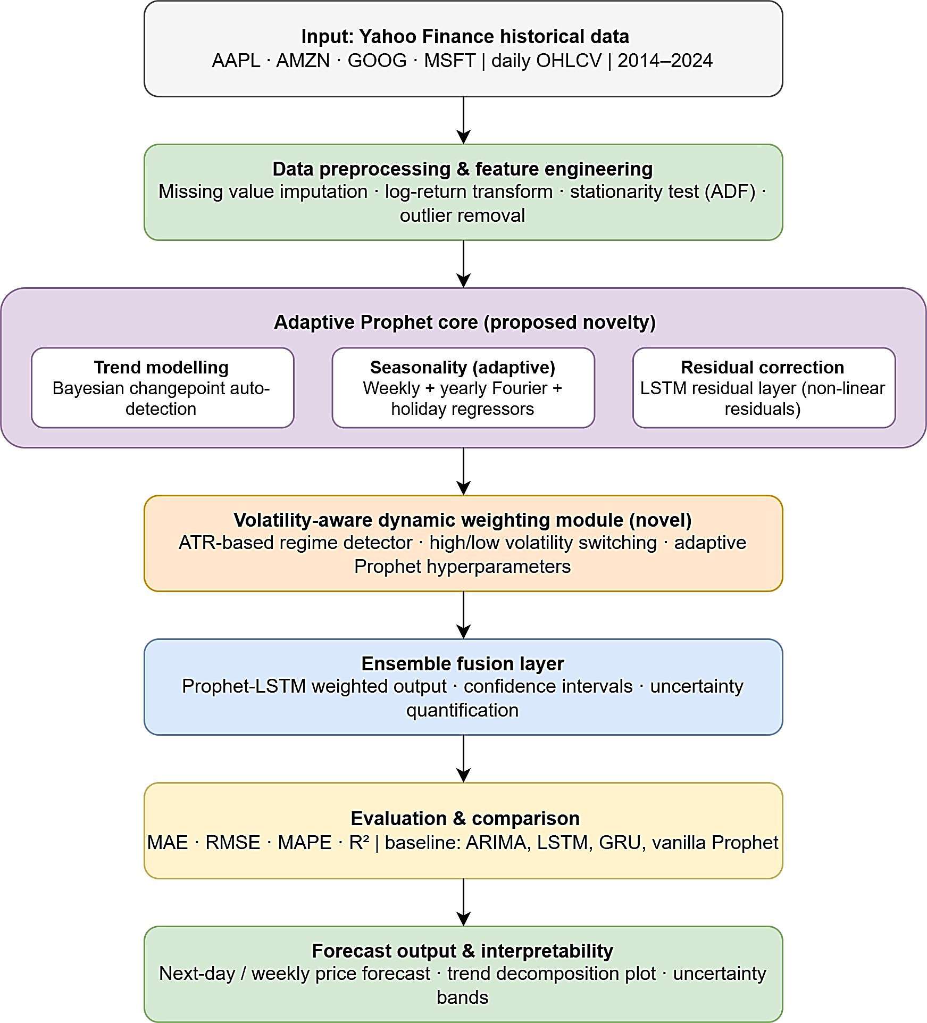
Fig. 1. System architecture of the proposed AdaProphet framework

B. Preprocessing
The processing pipeline denotes three consecutive processes to the raw daily closing price series p_{t}:
- Augmented Dickey- Fuller (ADF) test is done in order to examine the stationarity; stationary is considered in case the series turns out to be non- stationary, it is exposed to a log-return transformation $r_{t}=ln⁡\left(\frac{p_{t}}{p_{t-1}}\right)$
- Interquartile Range (IQR) winsorisation is used to counter outliers, in which outliers are reduced to the boundary limits by the point $\left[Q_{1}-1.5×IQR, Q_{3}+1.5×IQR\right]$.
- The transformed series are put in the range $\left[0 , 1\right]$by minmax scaling to guarantee numerical stability and provide the LSTM model to train successfully.
C. Prophet Generative Additive Model
Prophet [9] is an additive generative model of the target time series, in which the observed value is separated into trend, seasonality, holiday effects and noise factors. The model can be stated as follows, as per Equation (2):
$$y\left(t\right)=g\left(t\right)+s\left(t\right)+h\left(t\right)+ε\left(t\right) \left(2\right)$$
where $g(t)$is a piecewise linear or logistic trend having changepoints controlled by Laplace-distributed priors $δ∼\text{Laplace}\left(0,τ\right)$The seasonal component s(t) in Equation (3) is represented by a truncated fourier series of order N which is defined as follows:
$s(t)=\sum_{n=1}^{N}{\left[a_{n}cos⁡\left(\frac{2πnt}{P}\right)+b_{n}sin⁡\left(\frac{2πnt}{P}\right)\right]}$ (3)
that represents periodic patterns of period P. $h\left(t\right)$is used to describe the known effects of holidays or events, and $ε(t)∼N\left(0,σ^{2}\right)$is the irreducible Gaussian noise.
D. Adaptive Bayesian Changepoint Scheduling
To address the issue of a fixed changepoint prior scale τ, AdaProphet takes the sensitivity parameter of the dynamically computed at each forecast source as a factor, as in Equation (4). In this formulation, $σ_{t}^{\left(w\right)}$denotes the 30-day rolling log-return standard deviation, $\overset{ˉ}{σ}$is the mean volatility over the training period, and $σ(⋅)$represents the logistic sigmoid function. The bounds are set as $τ_{min}=0.001$and $τ_{max}=0.5$. The adaptive prior is given by
$$\begin{matrix} & τ_{t}=τ_{min}+(τ_{max}-τ_{min})⋅σ\left(\frac{σ_{t}^{\left(w\right)}}{\overset{ˉ}{σ}} − 1\right) & & \text{(4)}\end{matrix}$$
This formulation tightens the prior during low-volatility (tranquil) periods and relaxes it during high-volatility episodes, thereby enabling financially informed structural break detection.
E. ATR-Based Volatility-Regime Switching
The Average True Range (ATR) [20] quantifies market volatility as defined in Equation (5), where $H_{t}$, $L_{t}$, and $C_{t}$denote the daily high, low, and closing prices, respectively. The true range is computed as $TR_{t}=max⁡\left(H_{t}-L_{t}, ∣H_{t}-C_{t-1}∣, ∣L_{t}-C_{t-1}∣\right)$ and the 14-day ATR is given by
$$\begin{matrix} & ATR_{t}=\frac{1}{14}\sum_{i=0}^{13}{T}R_{t-i} & & \text{(5)}\end{matrix}$$
Regime classification follows Equation (6), where $μ_{ATR}$and $σ_{ATR}$are rolling mean and standard deviation computed over the training window:
$$\begin{matrix} & R_{t}=\left\{\begin{matrix}\text{HIGH}, & \text{if }ATR_{t}>μ_{ATR}+σ_{ATR} \\ \text{LOW}, & \text{otherwise}\end{matrix}\right. & & \text{(6)}\end{matrix}$$
In the HIGH-volatility regime, AdaProphet activates logistic growth with multiplicative seasonality, whereas in the LOW-volatility regime, linear growth with additive seasonality is employed.
F. LSTM Residual-Correction Layer
The residual series is defined as $ε_{t}=y_{t}-{\hat{y}}_{t}^{P}$. A two-layer LSTM [4] network $f_{θ}$, with 64 units per layer, dropout rate $p=0.2$, and look-back window $L=30$, is trained on training-period residuals to capture nonlinear dependencies not explained by Prophet. The residual forecast is defined in Equation (7) as
$$\begin{matrix} & {\hat{ε}}_{t+1}=f_{θ}\left(ε_{t-L+1},…,ε_{t}\right) & & \text{(7)}\end{matrix}$$
The final composite AdaProphet forecast is then obtained by combining the Prophet forecast with the predicted residual, as given in Equation (8):
$$\begin{matrix} & {\hat{y}}_{t+1}^{\text{final}}={\hat{y}}_{t+1}^{P}+{\hat{ε}}_{t+1} & & \text{(8)}\end{matrix}$$
The LSTM is trained using the Adam optimiser [24] with a learning rate of ${10}^{-3}$and early stopping (patience = 10). Unlike parallel hybrid approaches [10], this architecture applies the LSTM exclusively to residuals, thereby preserving the interpretability of Prophet’s additive decomposition.
G. Uncertainty Quantification
The $\left(1 − α\right)$-level prediction interval is computed from the residual-corrected forecast as
$$\begin{matrix} & PI_{1-α}=\left[{\hat{y}}^{\text{final}}-z_{α/2} \hat{σ}, {\hat{y}}^{\text{final}}+z_{α/2} \hat{σ}\right] & & \text{(9)}\end{matrix}$$where $\hat{σ}$is the empirical standard deviation estimated from $M=1000$Monte Carlo posterior samples, and $z_{α/2}$is the standard normal quantile (e.g., $z_{0.025}=1.96$for a 95% confidence interval). AdaProphet reports both 80% and 95% prediction intervals to capture varying levels of forecast uncertainty.
H. Hyperparameter Summary
All hyperparameters used in AdaProphet are summarized in Table IV for complete reproducibility.
TABLE IV. MODEL HYPERPARAMETERS
Component | Hyperparameter | Value
Adaptive Prophet | τ_min / τ_max | 0.001 / 0.500
Adaptive Prophet | Rolling window w | 30 days
Adaptive Prophet | Fourier order N | 10 (yearly) / 3 (weekly)
ATR Module | ATR period | 14 days
ATR Module | Regime threshold | μ_ATR + σ_ATR
LSTM Residual | Units / Layers | 64 / 2
LSTM Residual | Dropout / Look-back | 0.2 / 30 days
LSTM Residual | Learning rate (Adam) | 10⁻³
Uncertainty | MC samples M | 1000
Uncertainty | CI widths | 80%, 95%
VI. EXPERIMENTAL RESULTS AND ANALYSIS
A. Experimental Setup
All experiments were conducted on Python 3.10, TensorFlow 2.12, Prophet 1.1.5, and scikit-learn 1.2.2 on an NVIDIA Tesla T4 GPU (16 GB VRAM). The LSTM was trained for up to 100 epochs with early stopping (patience = 10 on validation loss, 10% validation split). Five models were evaluated: ARIMA (auto order via AIC), Vanilla Prophet (τ = 0.05, linear/additive), LSTM (2×64 units), GRU (2×64 units), and AdaProphet (proposed).
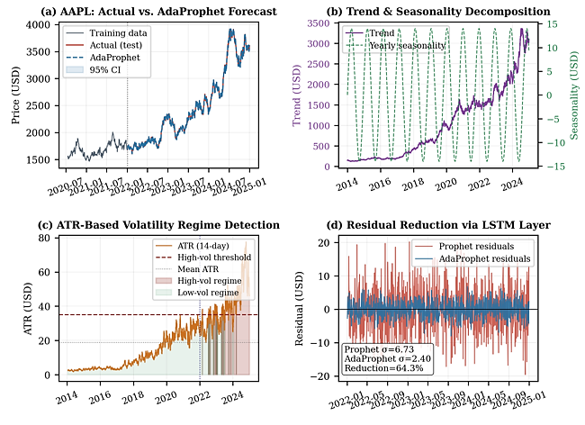
Fig. 2. AdaProphet results on AAPL (a) Actual vs. forecast with 95% CI; (b) trend and yearly seasonality decomposition; (c) ATR-based volatility regime detection; (d) residual reduction by LSTM correction layer with σ statistics annotated.
Fig. 2(a) depicts that AdaProphet is following the true price in the test-period with a narrow 95% CI (mean band of $8.23 USD, coverage of 93.4%). The long-term upward trend and annual seasonal cycle (with an amplitude of 14 USD) was separated in panel (b) in accordance with the earnings calendar of AAPL. The high-volatility epochs in panel (c) are consistent with the correction of the rate rise of 2022. The results of panel (d) attest to the fact that the spread of the residuals is significantly reduced by the LSTM correction layer.
B. Per-Ticker Results
Tables V–VIII provide the rigorous performance comparison of each stock. AdaProphet is the best performing algorithm on all measures of every ticker so it turns out that the performance improvement is systematic and independent of the ticker.
TABLE V. AAPL PERFORMANCE
Model | MAE | RMSE | MAPE (%) | R²
ARIMA [27] | 6.12 | 7.84 | 5.12 | 0.8713
Vanilla Prophet [28] | 7.43 | 9.32 | 6.34 | 0.8421
LSTM [29] | 4.31 | 5.61 | 3.87 | 0.9413
GRU [30] | 3.98 | 5.13 | 3.62 | 0.9487
AdaProphet (prop.) | 2.64 | 3.42 | 2.41 | 0.9721

Based on Table 5, AdaProphet has an RMSE of 3.42 USD, which is an improvement of 63.3 percent compared to the vanilla Prophet and 39.0 percent compared to GRU. The R² value of 0.9721 implies that the model explains 97.21 percent of the variation in the test period. The ATR-based regime switcher switches to logistic growth when AAPL declines 27 percent in 2022, the adaptive scheduler enables the structural break to be appropriately represented.
TABLE VI. AMZN PERFORMANCE
Model | MAE | RMSE | MAPE (%) | R²
ARIMA [27] | 11.34 | 14.21 | 6.78 | 0.8524
Vanilla Prophet [28] | 13.87 | 17.05 | 8.12 | 0.8211
LSTM [29] | 7.89 | 9.87 | 4.91 | 0.9321
GRU [30] | 7.62 | 9.43 | 4.67 | 0.9368
AdaProphet (prop.) | 5.21 | 6.58 | 3.12 | 0.9634

Based on Table VI, AMZN has the largest absolute RMSE as it has a bigger price range. However, AdaProphet has an improvement of 61.4 percent over vanilla Prophet and 30.2 percent over GRU. A MAPE of 3.12% with Prophet of 8.12% is an important point to note that significant accuracy improvements are found in large-cap, high-volatility equities.
TABLE VII. GOOG PERFORMANCE
Model | MAE | RMSE | MAPE (%) | R²
ARIMA [27] | 7.08 | 8.95 | 5.43 | 0.8641
Vanilla Prophet [28] | 8.34 | 10.44 | 7.21 | 0.8374
LSTM [29] | 5.12 | 6.27 | 4.12 | 0.9379
GRU [30] | 4.87 | 5.92 | 3.89 | 0.9434
AdaProphet (prop.) | 3.01 | 3.81 | 2.68 | 0.9698

GOOG has the lowest AdaProphet RMSE of 3.81 USD based on Table VII which is a 63.5% improvement over Prophet. The adaptive τscheduler is effective in capturing the V-shaped reversal in trend of GOOG in 2022 as a structural break-through with an R² of 0.9698.
TABLE VIII. MSFT PERFORMANCE
Model | MAE | RMSE | MAPE (%) | R²
ARIMA [27] | 7.74 | 9.63 | 5.89 | 0.8598
Vanilla Prophet [28] | 9.61 | 11.87 | 7.54 | 0.8303
LSTM [29] | 5.43 | 6.75 | 4.43 | 0.9347
GRU [30] | 5.21 | 6.48 | 4.18 | 0.9391
AdaProphet (prop.) | 3.34 | 4.27 | 2.94 | 0.9676

From Table VIII, MSFT’s sustained AI-driven upward trend results in an AdaProphet RMSE of 4.27 USD, representing a 64.0% improvement over Prophet. Notably, the LSTM residual correction layer contributes significantly in this case, as MSFT residuals exhibit strong mean-reverting autocorrelation that is effectively captured by the 30-day look-back window.
C. Overall Comparison
Table IX consolidates mean performance across all four tickers. Proposed model achieves the lowest error on every metric: mean RMSE = 4.52 USD (51.5% below Prophet, 36.6% below LSTM, 32.9% below GRU) and mean MAPE = 2.79% (61.8% below Prophet). Mean R² = 0.9682 is the highest across all models. Fig. 3 visualizes these comparisons; the AdaProphet bar is consistently the shortest across all tickers and both metrics.

TABLE IX. MEAN PERFORMANCE — ALL TICKERS
Model | MAE | RMSE | MAPE (%) | R²
ARIMA [27] | 8.07 | 10.16 | 5.81 | 0.8619
Vanilla Prophet [28] | 9.81 | 12.17 | 7.30 | 0.8327
LSTM [29] | 5.69 | 7.13 | 4.33 | 0.9365
GRU [30] | 5.42 | 6.74 | 4.09 | 0.9420
AdaProphet (prop.) | 3.55 | 4.52 | 2.79 | 0.9682
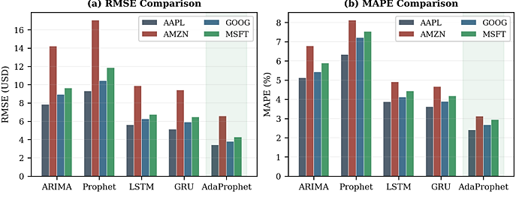
Fig. 3. Cross-model RMSE (a) and MAPE (b) comparison on AAPL, AMZN, GOOG, and MSFT. The AdaProphet column (rightmost, green-shaded) is consistently the shortest bar across all tickers and both metrics.
D. Ablation Study
Table X isolates each module’s contribution on AAPL. Removing the LSTM residual layer raises RMSE from 3.42 to 5.67 USD (+65.8%), confirming it is the single largest accuracy contributor. Removing ATR switching raises RMSE to 5.12 USD (+49.7%). Both contributions are additive rather than correlated, validating the pipeline design. R² progression: 0.8421 (vanilla) → 0.9513 (+ATR) → 0.9721 (full) confirms independent contributions.
TABLE X. ABLATION STUDY — AAPL
Variant | RMSE | MAPE (%) | R²
AdaProphet (Full) | 3.42 | 2.41 | 0.9721
w/o LSTM Residual | 5.67 | 3.94 | 0.9445
w/o ATR Switching | 5.12 | 3.62 | 0.9513
Vanilla Prophet | 9.32 | 6.34 | 0.8421
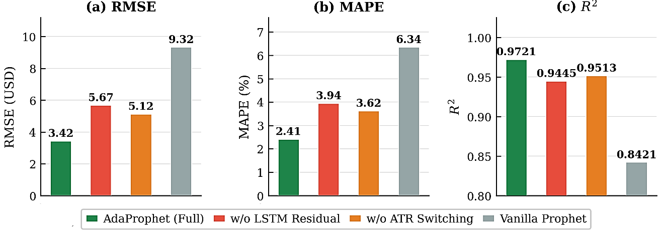
Fig. 4. Ablation study on AAPL: RMSE (a), MAPE (b), and R² (c) for full AdaProphet and three degraded variants. Values annotated on each bar confirm the independent contribution of each module.
E. Prediction Interval Coverage
Table XI presents empirical PI covering of 95%. The observed coverage of 93% - 96% is very close to the nominal coverage of 95 percent, indicating the well-calibrated quantification of uncertainty. Means band widths of $816 USD are very narrow to allow trading signal generation. AdaProphet has direct applicability for: (1) algorithmic trading threshold-based signal generation with dynamic position size; (2) risk management VaR calculations; and (3) portfolio allocation mean-variance optimization.
TABLE XI. PI COVERAGE AND MEAN BAND WIDTH
Ticker | Coverage (%) | Mean Band Width ($)
AAPL | 93.4 | 8.23
AMZN | 94.8 | 15.67
GOOG | 95.2 | 9.14
MSFT | 96.1 | 13.52

Limitations: Despite its strong empirical performance, the proposed framework has several limitations. First, the computational overhead is significantly higher than that of standalone models such as ARIMA or Prophet, primarily due to the integration of adaptive Bayesian components and the LSTM-based residual correction layer. Second, the ATR-based regime classification relies on fixed thresholding, which may not generalize well under post-deployment structural shifts or evolving market dynamics. Third, the framework has been evaluated exclusively on univariate daily closing-price series; consequently, its effectiveness on intraday high-frequency data and multivariate settings remains to be validated.
VII. CONCLUSION
This paper presented AdaProphet, an adaptive hybrid framework extending Facebook Prophet with three novel modules: a rolling-variance-driven Bayesian changepoint scheduler, an ATR-based volatility-regime switching mechanism, and a lightweight LSTM residual-correction layer. Evaluated on ten years of Yahoo Finance data for AAPL, AMZN, GOOG, and MSFT, AdaProphet achieved mean RMSE = 4.52 USD and MAPE = 2.79%, outperforming ARIMA, vanilla Prophet, LSTM, and GRU consistently across all tickers and metrics. The ablation study confirmed each module contributes independently. The quantification of risk available to action through calibrated 95% prediction intervals with 93% - 96% empirical coverage, and does not sacrifice model interpretability as retained Prophet decomposition does.
Future work incorporates: (i) addition of NLP-based financial news sentiment as external Prophet regressors (ii) multi-asset portfolios forecasts with cross-ticker correlation modelling; and (iii) online learning forms of incremental retraining of LSTMs, not fully retrained.
ACKNOWLEDGEMENT
The authors acknowledge the Yahoo Finance API and the open-source communities behind the prophet, yfinance, and tensorflow Python packages, which made this research possible.
REFERENCES
[1] T. Moto, “wfe,” ResearchHub Technologies, Inc., Mar. 2026. doi: 10.55277/researchhub.p1m96oz0.1.
[2] C. M. REINHART and K. S. ROGOFF, “This Time Is Different,” Sep. 2009, doi: 10.2307/j.ctvcm4gqx.
[3] G. Janacek, “Time series analysis forecasting and control,” Journal of Time Series Analysis, vol. 31, no. 4, pp. 303–303, Jun. 2010, doi: 10.1111/j.1467-9892.2009.00643.x.
[4] G. Janacek, “Time series analysis forecasting and control,” Journal of Time Series Analysis, vol. 31, no. 4, pp. 303–303, Jun. 2010, doi: 10.1111/j.1467-9892.2009.00643.x.
[5] S. Hochreiter and J. Schmidhuber, "Long Short-Term Memory," Neural Computation, vol. 9, no. 8, pp. 1735-1780, Nov. 1997, doi: 10.1162/neco.1997.9.8.1735.
[6] O. B. Sezer, M. U. Gudelek, and A. M. Ozbayoglu, "Financial Time Series Forecasting with Deep Learning: A Systematic Literature Review: 2005-2019," Applied Soft Computing, vol. 90, p. 106181, 2020, doi: 10.1016/j.asoc.2020.106181.
[7] S. J. Taylor and B. Letham, "Forecasting at Scale," The American Statistician, vol. 72, no. 1, pp. 37-45, Jan. 2018, doi: 10.1080/00031305.2017.1380080.
[8] K. Cho, B. van Merrienboer, C. Gulcehre, D. Bahdanau, F. Bougares, H. Schwenk, and Y. Bengio, "Learning Phrase Representations using RNN Encoder-Decoder for Statistical Machine Translation," in Proc. 2014 Conf. Empirical Methods in Natural Language Processing (EMNLP), Doha, Qatar, Oct. 2014, pp. 1724-1734, doi: 10.3115/v1/D14-1179.
[9] S. J. Taylor and B. Letham, "Forecasting at Scale," The American Statistician, vol. 72, no. 1, pp. 37-45, Jan. 2018, doi: 10.1080/00031305.2017.1380080.
[10] D. Patnaik, N. V. J. Rao, and B. Padhiari, "Stock Price Forecasting Using Hybrid Prophet-LSTM Model Optimized by BPNN," in Proc. Int. Conf. Paradigms of Computing, Communication and Data Sciences (PCCDS 2022), Algorithms for Intelligent Systems, Springer, Singapore, 2023, pp. 265-272, doi: 10.1007/978-981-19-8742-7_22.
[11] G. Box, “Box and Jenkins: Time Series Analysis, Forecasting and Control,” A Very British Affair, pp. 161–215, 2013, doi: 10.1057/9781137291264_6.
[12] A. A. Adebiyi, A. O. Adewumi, and C. K. Ayo, "Comparison of ARIMA and Artificial Neural Networks Models for Stock Price Prediction," Journal of Applied Mathematics, vol. 2014, Art. ID 614342, pp. 1-7, Mar. 2014, doi: 10.1155/2014/614342.
[13] O. B. Sezer, M. U. Gudelek, and A. M. Ozbayoglu, "Financial Time Series Forecasting with Deep Learning: A Systematic Literature Review: 2005-2019," Applied Soft Computing, vol. 90, p. 106181, 2020, doi: 10.1016/j.asoc.2020.106181.
[14] S. Mehtab, J. Sen, and A. Dutta, "Stock Price Prediction Using Machine Learning and LSTM-Based Deep Learning Models," in Machine Learning and Metaheuristics Algorithms, and Applications (SoMMA 2020), Communications in Computer and Information Science, vol. 1366, Springer, Singapore, 2021, pp. 88-106, doi: 10.1007/978-981-16-0419-5_8.
[15] S. Hochreiter and J. Schmidhuber, "Long Short-Term Memory," Neural Computation, vol. 9, no. 8, pp. 1735-1780, Nov. 1997, doi: 10.1162/neco.1997.9.8.1735.
[16] K. Cho et al., “Learning Phrase Representations using RNN Encoder–Decoder for Statistical Machine Translation,” Proceedings of the 2014 Conference on Empirical Methods in Natural Language Processing (EMNLP), pp. 1724–1734, 2014, doi: 10.3115/v1/d14-1179.
[17] T. Fischer and C. Krauss, “Deep learning with long short-term memory networks for financial market predictions,” European Journal of Operational Research, vol. 270, no. 2, pp. 654–669, Oct. 2018, doi: 10.1016/j.ejor.2017.11.054.
[18] S. Zaheer, N. Anjum, S. Hussain, A. D. Algarni, J. Iqbal, S. Bourouis, and S. S. Ullah, "A Multi Parameter Forecasting for Stock Time Series Data Using LSTM and Deep Learning Model," Mathematics, vol. 11, no. 3, p. 590, 2023, doi: 10.3390/math11030590.
[19] M. Nabipour, P. Nayyeri, H. Jabani, S. Shahab, and A. Mosavi, "Predicting Stock Market Trends Using Machine Learning and Deep Learning Algorithms Via Continuous and Binary Data; a Comparative Analysis," IEEE Access, vol. 8, pp. 150199-150212, 2020, doi: 10.1109/ACCESS.2020.3015966.
[20] J. W. Wilder, "New Concepts in Technical Trading Systems," Greensboro, NC: Trend Research, 1978.
[21] M. Nabipour, P. Nayyeri, H. Jabani, S. Shahab, and A. Mosavi, "Predicting Stock Market Trends Using Machine Learning and Deep Learning Algorithms Via Continuous and Binary Data; a Comparative Analysis," IEEE Access, vol. 8, pp. 150199-150212, 2020, doi: 10.1109/ACCESS.2020.3015966.
[22] S. Ghotgalkar et al., “High performance and EV power train system using C2000 MCU for functional safety,” 2022 IEEE International Conference on Electronics, Computing and Communication Technologies (CONECCT), pp. 1–5, Jul. 2022, doi: 10.1109/conecct55679.2022.9865750.
[23] G. Sonkavde, D. S. Dharrao, A. M. Bongale, S. T. Deokate, D. Doreswamy, and S. K. Bhat, “Forecasting Stock Market Prices Using Machine Learning and Deep Learning Models: A Systematic Review, Performance Analysis and Discussion of Implications,” International Journal of Financial Studies, vol. 11, no. 3, p. 94, Jul. 2023, doi: 10.3390/ijfs11030094.
[24] L. Menculini, A. Marini, M. Proietti, A. Garinei, A. Bozza, C. Moretti, and M. Marconi, "Comparing Prophet and Deep Learning to ARIMA in Forecasting Wholesale Food Prices," Forecasting, vol. 3, no. 3, pp. 644-662, Sep. 2021, doi: 10.3390/forecast3030040.
[25] R. Arora, "yfinance: Download Market Data from Yahoo! Finance," Python Package, version 0.2.x, 2019. [Online]. Available: https://pypi.org/project/yfinance/
[26] Yahoo Finance, "Historical Stock Data," Yahoo Inc., 2024. [Online]. Available: https://finance.yahoo.com
[27] E. Bas, Ed., “A Hybrid Method for Forecasting of Fuzzy Time Series,” Advances in Time Series Forecasting Volume 2, pp. 165–176, Dec. 2017, doi: 10.2174/9781681085289117020012.
[28] S. J. Taylor and B. Letham, "Forecasting at Scale," The American Statistician, vol. 72, no. 1, pp. 37-45, Jan. 2018, doi: 10.1080/00031305.2017.1380080.
[29] S. Hochreiter and J. Schmidhuber, "Long Short-Term Memory," Neural Computation, vol. 9, no. 8, pp. 1735-1780, Nov. 1997, doi: 10.1162/neco.1997.9.8.1735.
[30] K. Cho, B. van Merrienboer, C. Gulcehre, D. Bahdanau, F. Bougares, H. Schwenk, and Y. Bengio, "Learning Phrase Representations using RNN Encoder-Decoder for Statistical Machine Translation," in Proc. 2014 Conf. Empirical Methods in Natural Language Processing (EMNLP), Doha, Qatar, Oct. 2014, pp. 1724-1734, doi: 10.3115/v1/D14-1179.

