Electronic Voting System
Software Requirements Specification

2017 MANIT Computer Science Department
Amit Singh 151112251
Rishi Raj 151112249
Prajal Jain 151112239

Description of Project
Document no: 1
version: 1.0
CONTACT: MANIT
EMAIL: prajaljain45@gmail.com

INTRODUCTION TO SOFTWARE ENGINEERING AND THEIR BASIC DEVELOPMENT PHASES

DEFINITION:-
Software engineering is an establishment and use of sound engineering principles in order to obtain economically software that is reliable and works efficiently on real machines. (By Fritz Bauer (NAU69)).

CHARACTERISTICS:-
- Software is developed or engineered, it is not manufactured.
- Software does not wear out.
- Software continues to be custom built.

FACTORS DETERMINING THE NATURE OF SOFTWARE APPLICATIONS:-
- Information content-
Content refers to the meaning and form of incoming and outgoing information.
- Information determinacy-
It refers to the predictability of the order and timing of information. On this basis, the nature of the software application may be determinant or indeterminant.

BASIC DEVELOPMENT PHASES:-

The generic phases of software engineering:
- Definition phase
- System or information engineering
- Software project planning
- Requirement analysis
- Development phase
- Software design
- Code generation
- Software testing
- Support phase
- Correction
- Adaption
- Enhancement
- Prevention

Problem Statement Of E-Voting System :-

In “ONLINE VOTING SYSTEM” a voter can use his\her voting right to cast vote in BMC elections. He\She has to fill a registration form to register himself\herself. All the entries stored in VOTER DATABASE are checked by the Administrator. If all the entries are correct then a USER ID and PASSWORD is assigned to the voter, by using that ID and PASSWORD he\she can login to cast his/her vote.
ONLINE VOTING SYSTEM contains-:
- Voter database.
- Candidate database
- Administrator database
- Voter’s vote in a database.
- Calculation of total number of votes.

Various operational works that are done in the system are:-
- Recording information of the Voter in Voter database.
- Checking of information filled by voter by an administrator.
- Discard the false information.

Implementation:-
- Maintaining voter’s Identification.
- Providing online voting management.
- Provide voter information to ADMINISTRARTOR.
- ADMINISTRATOR maintains the complete information of voter.
- Candidate can apply for Candidature.
- Voter can give his\her vote from any part of city
- Voter’s information in database.
- Voter’s vote in a database.
- Calculation of total number of votes.
- Displaying the Election Result.

CASE STUDY:-

- The objective of Online voting system is to help the organization in automating the whole manual process of voting.
- The main objective is to develop a system that makes accurate & efficient decisions in different tasks at different time in different situations. The existing system is manual so members of the unit generally face a lot of hardships. So there is a need to automate the whole process so as to make it more easy and accurate.
- System should support multi-user environment.
- Various outputs (reports) should be available online any time.
- System should be able to handle extremely large volumes of data (i.e. Large database support)

Table of Contents of SRS Document:
1. Introduction 3
1.1 Purpose 3
1.2 Scope 3
1.3 Definitions, Acronyms and Abbreviations 3
1.4 References 3
1.5 Overview 3
2. Overall Description 4
2.1 Product Perspective 4
2.2 Product Functions 4
2.3 User Characteristics 4
2.4 General Constraints 6
2.3 Assumptions and Dependencies 6
3. Data Flow Diagram 7
4. Class Diagram 8
5. Specific Requirements 9
5.1 External Interface Requirements
5.1.1 User interfaces……………………………………………………………………………………………………………………….9
5.1.2 Hardware Interfaces………………………………………………………………………………………………………………9
5.1.3 Software Interfaces……………………………………………………………………………………………………………….9
5.1.4 Communications Interfaces……………………………………………………………………………………………………9
5.2 Functional Requirements 9
5.3 Performance Requirements 11
5.4 Design Constraints 11
5.5 Attributes 12
5.6 Other Requirements 12
6. Data Dictionary 13
Software Requirements Specification

Introduction

1.1 Purpose
This Software Requirements Specification (hitherto referenced as SRS) document describes the behavior and requirements of the “Electronic Voting System” web application.
This system provides an online tool for the clients to vote.

1.2 Scope
This SRS document applies to the initial version (release 1.0) of the “Electronic Voting System” web application.

1.3 Definitions, Acronyms and Abbreviations
The following is a list of terms, acronyms and abbreviations used by the “Electronic Voting System” software package and related documentation.
Admin: An administrator.
Ballot: A round of voting, or the particular record of a voter’s choices.
Candidate: A person who seeks or is nominated for an office.
Cast: The process by which one votes.
Database: A collection of data arranged for ease and speed of retrieval or search.
Election: The selection of a person or persons for office by vote, or a public vote on a proposed submittal.
Poll: The place where votes are taken.
Tabulate: To count votes.
Voter: One who votes, a member of the electorate, or a citizen with the right to vote.

1.4 References
https://www.w3schools.com/
https://www.youtube.com/

1.5 Overview
The remainder of this document gives an Overall Description as well as the Specific Requirements of the application, the Data Flow Diagram (DFD) and the Class Diagram needed for the analysis and design of the “Electronic Voting System” software package. All diagrams conform to UML standards.

Overall Description

2.1 Product Perspective
In the past, the election was conducted by means of paper ballots. But as technology becomes more
prevalent in society, tedious operations like conducting and tallying a paper ballot voting
system become obsolete.
Electronic voting is something that is in hot debate on the national level. With the recent
troubles that have come with certain paper ballot systems in recent elections, many feel
that a secure and reliable electronic voting system could prevent such problems from
occurring in the future. However, whether or not a national system that is secure and
reliable is possible is yet to be determined. But on a smaller scale, such as a general
student body election at a relatively small private university, security and reliability
measures are not as difficult to implement.

2.2 Product Functions
The software's main function is to conduct an election of officials using the internet to
allow people to vote. The functions of the systems relate specifically either to the process
of a person casting a vote or an administrator running the election.
. Here, the voter will be asked to log in to the system.
The system should verify that the voter has not voted yet and then bring them to an
instruction page. After the voter accepts the terms of the votes and understands how to
vote, he/she will be brought to the voting page. This page should list the positions and
candidates. After the voter has selected the candidates he/she would like to vote for,
the system should check the validity of the vote and bring up a confirmation page.

2.3 User Characteristics

2.3.1 Stakeholder Needs
- ID of Need 1
Description: A login page is required to validate the user
- ID of Need 2
Description: Administrator will be connected to the Admin Page.
- ID of Need 3
Description: Administrator will be able to see the list of the voters and candidates.
- ID of Need 4
Description: Users will register for election purpose by filling registration form.
- ID of Need 5
Description: Users will vote.
- ID of Need 6
Description: The system will allow voter to view current result status .
- ID of Need 7
Description: The system will allow Administrator to stop the election process.

2.3.2 Actor Survey

ID of Actor 1
Name: Voter
Description: The person who interacts with the online application to vote
ID of Actor 2
Name: Administrator
Description: The person who interacts with the online application to manage the elections.
ID of Actor 3
Name: Database Server
Description: This is the server where we host the data.
ID of Actor 4
Name: Server
Description: This is the server where we host the web based application.
ID of Actor 5
Name: Network
Description: This application requires Network connection from the Server.

ID of Actor 6
Name: Internet
Description: This application requires internet connection from the Server.

ID of Actor 7
Name: Ballot SQL File
Description: Ballot SQL Files are required to be able to keep the saved ballot details.
ID of Actor 8
Name: PHP Files
Description: PHP Files are required to maintain the back-end of the web application at the server side.
ID of Actor 9
Name: HTML and CSS Files
Description: HTML and CSS Files are required to be able to design the front-end of the web application.

2.4 General Constraints
The software will be web-based and will need to function on a variety of operating
systems to allow voters as widespread access as possible.
Because the election will be web-based, vote verification by user is difficult. Ideally, the
user could have their voted printed right before them to verify and turn in. However,
when the votes are tabulated at a separate location, this is not possible. Instead, the
system should allow the user to verify their vote at this separate location using the paper
trail.

2.5 Assumptions and Dependencies
- The Database system is fully functional and has enough space for at least one vote.
- The voter has stable internet connection during voting session

Data Flow Diagram (DFD)

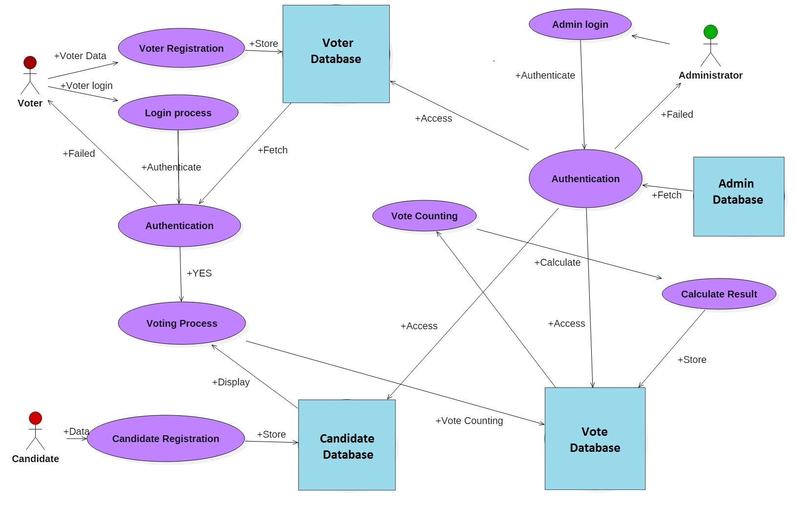

Class Diagram

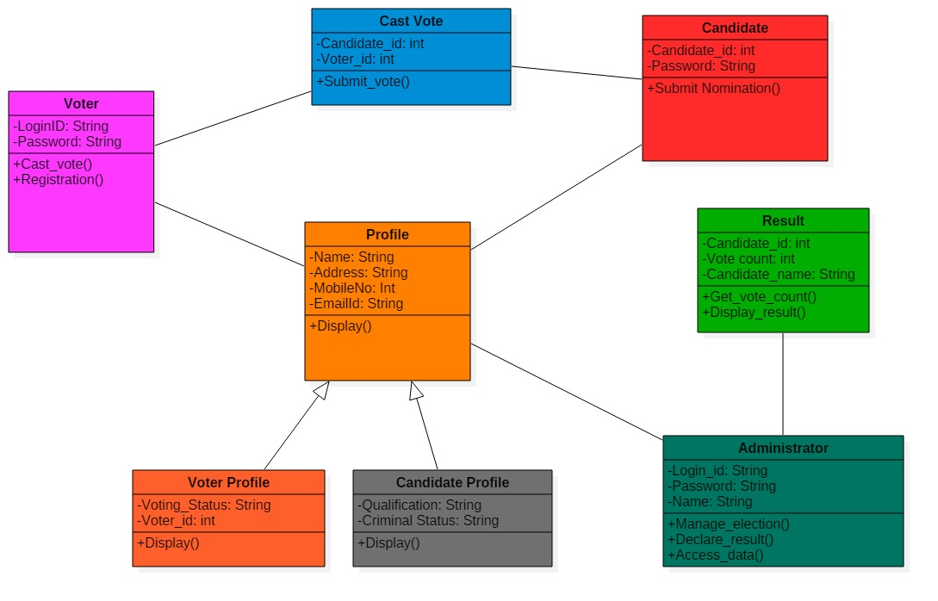

Specific Requirements

External Interfaces

User Interfaces

The user interface will be a home page with option to sign in and sign up. Sign page will include username and password to access user profile. Sign option will enable new user to register in the website.

Hardware Interfaces

As this application is a web based application, thus only a latest web browser is required as a hardware interface to be able to run it. It is assumed that web server is in a secure environment with necessary firewall and required network setting done.

Software Interfaces

The “Study Buddy” software will interface with a local SQL database for verifying username and password during sign in process and store the users details during sign-up process . Commands for interfacing, connecting and writing data entries will be the same as any standard SQL client-server application.

Communication Interfaces
None

Functional Requirements

5.2.1 Mode 1

To feature: 5.2.1.1
Title: Create a username entry box
Description: Have this username field limited to 15 characters entry.

To feature: 5.2.1.2
Title: Create a password entry box
Description: Have this password field limited to 15 characters entry and hidden text field

5.2.2 Mode 2

To Feature: 5.2.2.1
Title: Administrator page setup
Description: Administrator will need to have access to e-voting administrative pages.
To Feature: 5.2.2.2
Title: Tally Vote link
Description: Administrator will need to have access to tally the votes.

5.2.3 Mode 3

To Feature: 5.2.3.1
Title: Voter list link
Description: Administrators has access to all the registered voter data.
To Feature: 5.2.3.1
Title: Candidate list link
Description: Administrators has access to all the registered candidate data.

5.2.4 Mode 4

To Feature: 5.2.4.1
Title: Voter and Candidate Registration data
Description: All the new Voter and Candidate data is loaded into the database

5.2.5 Mode 5

To Feature: 5.2.5.1
Title: Cast Vote
Description: Vote counter is incremented in the candidate table of the database

5.2.6 Mode 6

To Feature: 5.2.6.1
Title: Result page
Description: Any voter can see the current result status

5.2.7 Mode 7

To Feature: 5.2.7.1
Title: Stop Election
Description: The administrator can stop the Voting process any time .

5.3 Performance Requirement
The “Electronic Voting System” software package will perform all functions with minimal delay from the time of the initial request.

5.4 Design Constraints
Voting system will be an online application and it can run from a machine that has an internet access. For the web services setup, Xampp/Wampp and MySQL required. Preferred web server’s operating system is Windows. Internet connectivity is required. The online e-voting application needs to be designed for a non- technical user. It should have specific instructions online. Non-technical users will be involved in testing to make sure that they can complete the process without any problems. Database access and web services access are required

5.5 Attributes

5.5.1 Usability
- A voter may only cast a ballot if they are eligible to vote.
- A voter may only cast one (1) ballot per election.

5.5.2 Reliability
- The “Electronic Voting System” software will be available for voter use only during normal poll hours. During this time it shall be operational for as long as is possible.
- Administrators will have 24 hour access to the system.
- The software will only accommodate one user at a time. No simultaneous use of the system by multiple voters, administrators, or a combination thereof shall be allowed.

5.5.3 Supportability
The “Electronic Voting System” software shall have a clear and easily maintainable interface for managing election specific updates.

5.6 Other Requirements
None

Data Dictionary

Table Name | Admin
Purpose | Stores the Admin login credentials
Primary Key | uname
Foreign Key | NA

Admin table
No | Field name | Constraint | Data type | Size | Description
1 | fname | None | Varchar | 255 | First name
2 | lname | None | Text |  | Lastname
3 | uname | Primary key | Varchar | 255 | Admin Username which is the primary key of the table
4 | pass | None | Varchar | 255 | Password for admin
5  6  7 | gender  mob  email | None  None  None | Varchar  Bigint  Varchar | 10  255  255 | Gender  Mobile no  Email id

Candidate Table

Table Name | Candidate
Purpose | Stores the Candidate details
Primary Key | uname
Foreign Key | NA
No | Field name | Constraint | Data type | Size | Description
1 | fname | None | Varchar | 255 | First name
2 | lname | None | Text |  | Lastname
3 | uname | Primary key | Varchar | 255 | Admin Username which is the primary key of the table
4 | pass | None | Varchar | 255 | Password for admin
5  6  7  8  9  10  11  12 | gender  mob  email  dob  cid  vcount  image  cpos | None  None  None  None  Unique  None  None  Unique | Varchar  Bigint  Varchar  Date  Varchar  Varchar  Varchar  Int | 10  255  255  255  255  255  255 | Gender  Mobile no  Email id  Date of Birth  Candidate Identification no  No of Votes Obtained  Candidate Photo

Voter table

Table Name | Voter
Purpose | Stores the Voter details
Primary Key | uname
Foreign Key | NA
No | Field name | Constraint | Data type | Size | Description
1 | fname | None | Varchar | 255 | First name
2 | lname | None | Text |  | Lastname
3 | uname | Primary key | Varchar | 255 | Voter Username which is the primary key of the table
4 | pass | None | Varchar | 255 | Password for voter login
5  6  7  8  9  10 | gender  mob  email  dob  voterid  vstatus | None  None  None  None  Unique  None | Varchar  Bigint  Varchar  Date  Varchar  Varchar | 10  255  255  255  255 | Gender  Mobile no  Email id  Date of Birth  Voter  Identification no  Flag to Indicate whether voter has voted or not

