1.Create side Menu with Bar and pie chart Widgets

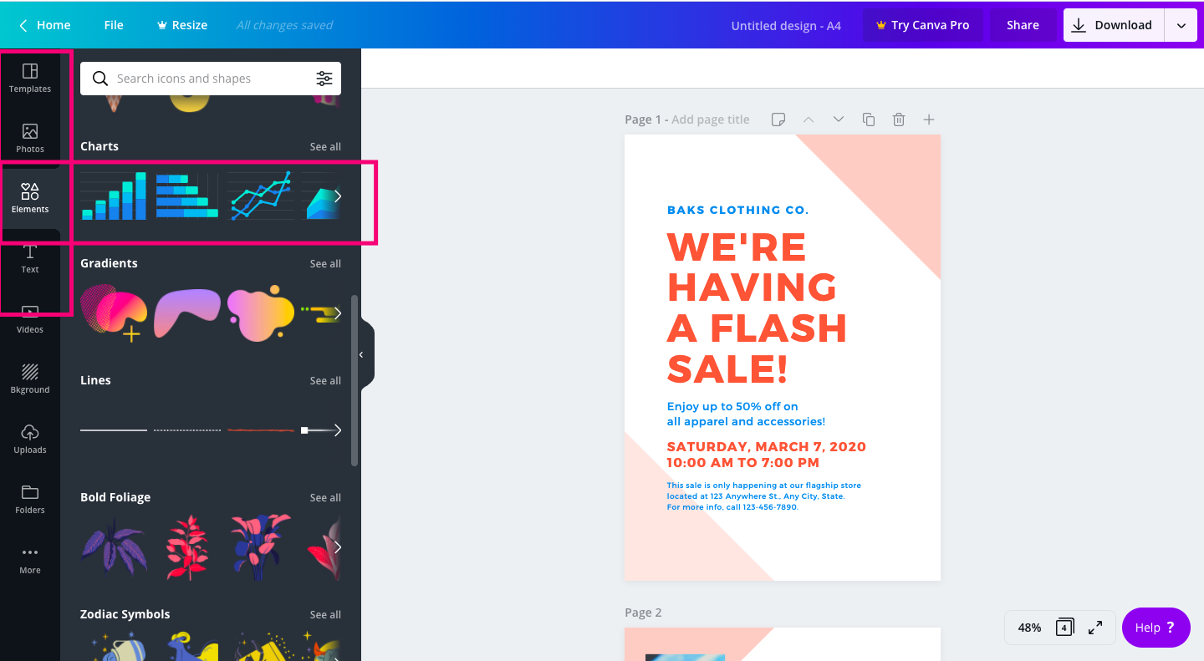

2.create A4 Sheet layout

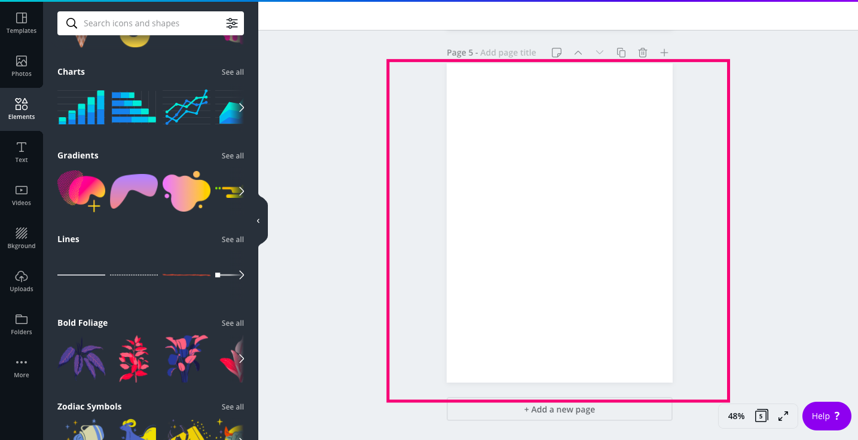

3.Drag and Drop Bar or Pie Chart Widget

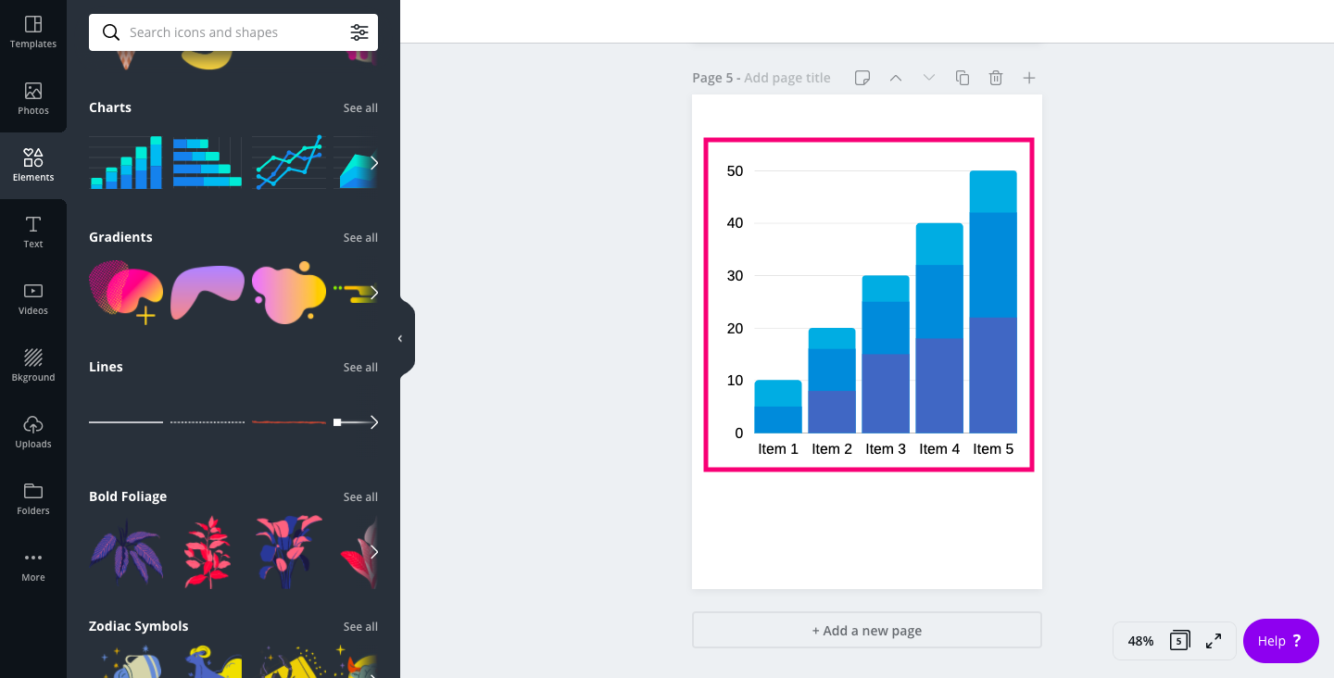

4.Move around A4 Sheet and place it anywhere in A4 Sheet layout

