1.Create a directory "exercise" inside your home directory and create nested(dir1/dir2/dir3) directory structure inside "excerise" with single command.

ttnd@ttnd-TravelMate-P257-M:/home$ sudo mkdir exercise
ttnd@ttnd-TravelMate-P257-M:/home$ cd exercise/
ttnd@ttnd-TravelMate-P257-M:/home/exercise$ sudo mkdir -p dir1/dir2/dir3

2.Create two empty files inside dir: emptyFile1,emptyFile2 in single command and Remove the dir2 direcroty

ttnd@ttnd-TravelMate-P257-M:/home/exercise/dir1/dir2/dir3$ sudo touch emptyFile1.txt emptyFile2.txt
ttnd@ttnd-TravelMate-P257-M:/home/exercise/dir1$ sudo rm -rf dir2

3.Create one file file.txt containing text "hello world" and save it.

ttnd@ttnd-TravelMate-P257-M:/home/dir1$ echo hello world > file.txt
ttnd@ttnd-TravelMate-P257-M:/home/dir1$ cat file.txt
hello world

4.Find a "passwd" file using find command inside /etc. copy this files as passwd_copy and then rename this file as passwd_backup.

ttnd@ttnd-TravelMate-P257-M:/$ sudo find /etc -name passwd
/etc/pam.d/passwd
/etc/cron.daily/passwd
/etc/passwd
ttnd@ttnd-TravelMate-P257-M:/etc$ sudo cp passwd passwd_copy
ttnd@ttnd-TravelMate-P257-M:/etc$ mv passwd_copy passwd_backup

5.Try reading passwd_backup file in multiple tools: less,more,cat,strings etc and find the difference in their usage.

CAT
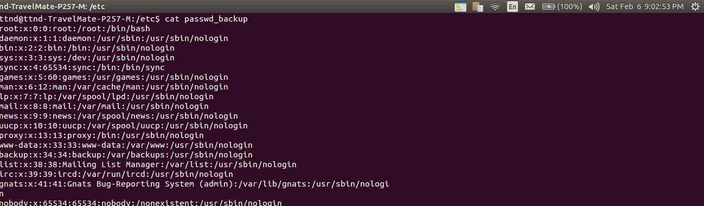

MORE
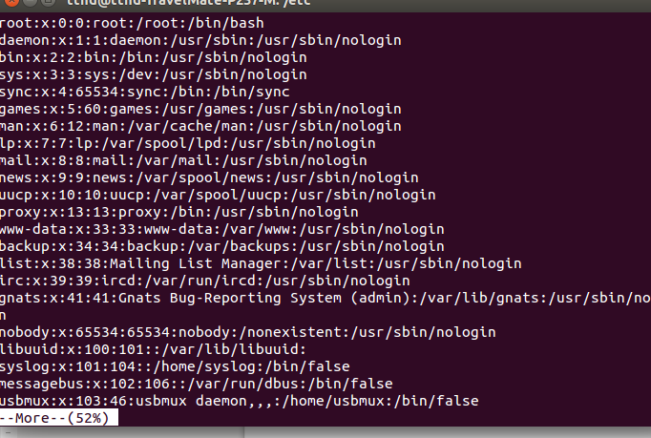

LESS
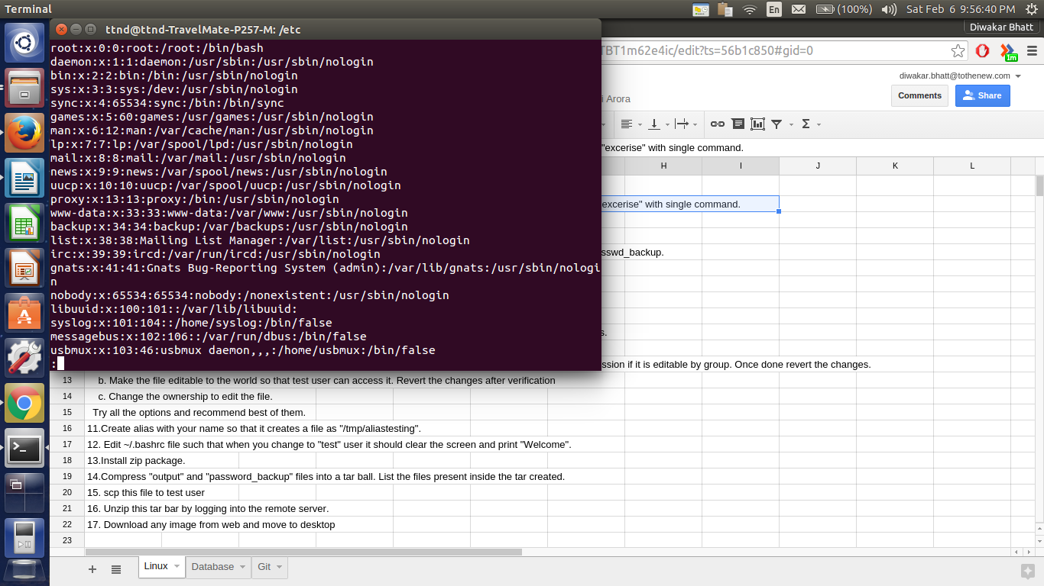
STRINGS

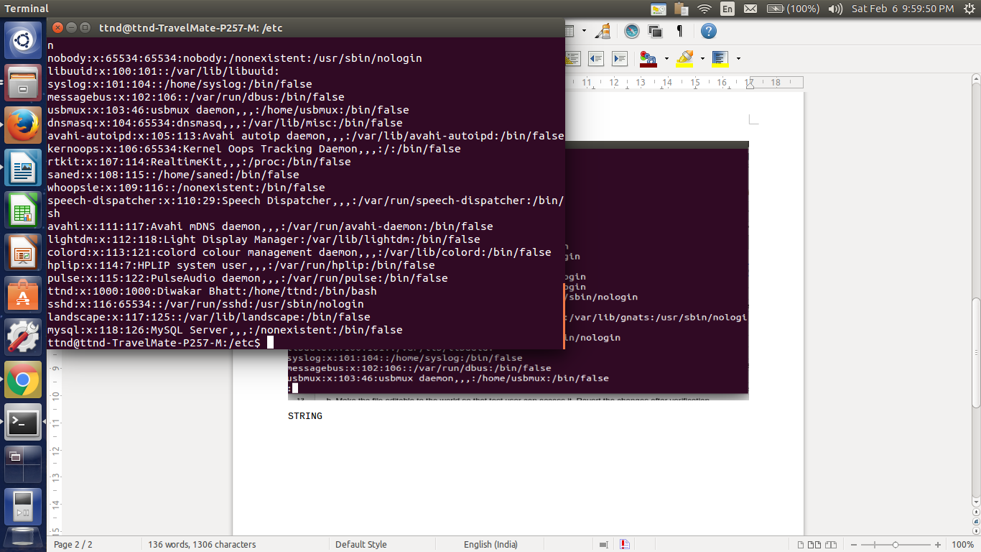

6.Find out the number of line in password_backup containing "/bin/false".

ttnd@ttnd-TravelMate-P257-M:/etc$ grep "/bin/false" passwd_backup|wc -l
16

7.Redirect the output of the above commands into file "output".

ttnd@ttnd-TravelMate-P257-M:/etc$ sudo grep "/bin/false" passwd_backup|wc -l>>output.txt
ttnd@ttnd-TravelMate-P257-M:/etc$ cat output.txt
16

8.Create a "test" user,create its password and find out its uid and gid.

ttnd@ttnd-TravelMate-P257-M:/etc$ sudo useradd test
ttnd@ttnd-TravelMate-P257-M:/etc$ sudo passwd test
Enter new UNIX password:
Retype new UNIX password:
passwd: password updated successfully
ttnd@ttnd-TravelMate-P257-M:/etc$ id -u test
1001
ttnd@ttnd-TravelMate-P257-M:/etc$ id -g test
1001

9.Login as test user and edit the "output" file created above. Since the permission wont allow you to save the changes.

test@ttnd-TravelMate-P257-M:/etc$ cat output.txt
cat: output.txt: Permission denied

10. Configure such that test user can edit it.

a. Add group owner of the "output" file as the secondary secondary group of testuser and check/change the "output" file permission if it is editable by group. Once done revert the changes.

test@ttnd-TravelMate-P257-M:/etc$ sudo chgrp test output .txt

b. Make the file editable to the world so that test user can access it. Revert the changes after verification

test@ttnd-TravelMate-P257-M:/etc$ sudo chmod 777 output.txt

c. Change the ownership to edit the file.

test@ttnd-TravelMate-P257-M:/etc$ sudo chown :test output.txt

11.Create alias with your name so that it creates a file as "/tmp/aliastesting".

ttnd@ttnd-TravelMate-P257-M:/etc$ alias diwakar=”touch /tmp/aliastesting.txt”

12. Edit ~/.bashrc file such that when you change to "test" user it should clear the screen and print "Welcome".

ADD THESE LINES TO THE START OF ".bashrc" file in /home/test

clear
echo "Welcome"

13.Install zip package.

ttnd@ttnd-TravelMate-P257-M:/etc$ dpkg -i openssh-server

14.Compress "output" and "password_backup" files into a tar ball. List the files present inside the tar created.

ttnd@ttnd-TravelMate-P257-M:/etc$ sudo tar -cvf compressed.tar passwd_backup output.txt
passwd_backup
output.txt
ttnd@ttnd-TravelMate-P257-M:/etc$ sudo tar -tvf compressed.tar
-rwxrwxrwx root/root 2027 2016-02-01 15:06 passwd_backup
-rwxrwx--- root/test 6 2016-02-06 22:18 output.txt

15. scp this file to test user

scp compressed.tar test@localhost

16. Unzip this tar bar by logging into the remote server.

ssh test@localhost
test@localhost's password:
Welcome
test@ttnd-TravelMate-P257-M:~$ tar -zxvf compressed.tar
output
etc/passwd_backup

17. Download any image from web and move to desktop

ttnd@ttnd-TravelMate-P257-M:~/Desktop$ wget -p /home/ttnd/Desktop http://www.unixstickers.com/image/cache/data/stickers/pivotal/Groovy.sh-600x600.png
/home/ttnd/Desktop: Scheme missing.
--2016-02-07 11:12:37-- http://www.unixstickers.com/image/cache/data/stickers/pivotal/Groovy.sh-600x600.png
Resolving www.unixstickers.com (www.unixstickers.com)... 188.226.233.13
Connecting to www.unixstickers.com (www.unixstickers.com)|188.226.233.13|:80... connected.
HTTP request sent, awaiting response... 200 OK
Length: 83070 (81K) [image/png]
Saving to: ‘www.unixstickers.com/image/cache/data/stickers/pivotal/Groovy.sh-600x600.png’

100%[======================================>] 83,070 124KB/s in 0.7s

2016-02-07 11:12:39 (124 KB/s) - ‘www.unixstickers.com/image/cache/data/stickers/pivotal/Groovy.sh-600x600.png’ saved [83070/83070]

FINISHED --2016-02-07 11:12:39--
Total wall clock time: 1.6s
Downloaded: 1 files, 81K in 0.7s (124 KB/s)

