BUSINESS REPORT
Insurance Claim Prediction — Stage 4
Dashboard, Held-Out Predictions & Management Recommendations
58,592  Total policies | 3,748  Observed claims | 6.40%  Observed claim rate | 11,719  Held-out policies | 0.647  Test ROC-AUC

1. Executive Summary
The Stage 4 objective is to convert the insurance claim modelling work into a management-ready decision framework. The final workflow scores the held-out test set, attaches a claim probability and risk level to each policy, and combines those model outputs with descriptive portfolio analytics.
The dataset contains 58,592 policies with an observed claim rate of 6.40%. The held-out test set contains 11,719 policies and also has a 6.40% observed claim rate, confirming that the stratified split preserved the target distribution.
The Tuned Decision Tree is the selected model. It achieved test ROC-AUC 0.647, recall 0.652 and F1 0.157, outperforming Logistic Regression on discrimination and claim capture. Because precision is only 0.089, the model should be used for prioritisation and decision support rather than fully automated underwriting decisions.

2. Problem Statement, Business Context & Success Metrics
The business problem is to identify policies with elevated probability of an insurance claim so that underwriting, risk review and prevention resources can be focused where they are most valuable.
- Discrimination: ROC-AUC on unseen data.
- Claim capture: recall for the claim class.
- Operational balance: precision and F1 at the selected threshold.
- Stability: cross-validation mean and standard deviation.
- Actionability: probability-based risk levels for review prioritisation.
- Governance: calibration, drift, subgroup performance and false-positive/false-negative monitoring.

3. Data Summary & Preprocessing Overview
Metric | Value
Dataset size | 58,592 rows × 49 modelling columns
Observed claim rate | 6.40%
Numerical features | 37
Categorical features | 11
Held-out test set | 11,719 policies
Held-out observed claim rate | 6.40%

Identifiers and outcome variables were excluded from modelling. Feature reduction followed the documented correlation/VIF, variance, leakage and redundancy diagnostics. Engineered variables included High_Risk_Driver_Flag, safety_equipment_count and power_to_weight_ratio.

4. Key EDA Findings

4.1 Claim Distribution
The held-out set contains 10,969 no-claim policies and 750 claim policies. The observed claim rate is 6.40%, confirming material class imbalance.
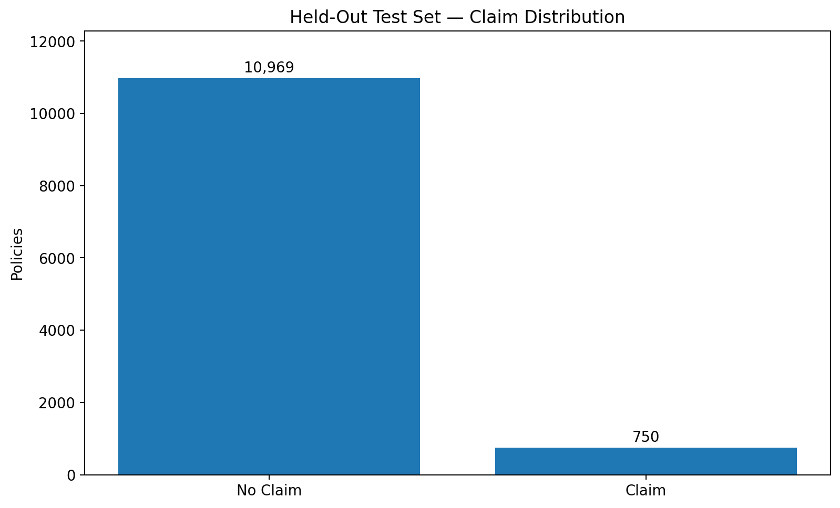
Figure 1. Claim distribution on the held-out test set.

4.2 Model-Generated Risk Levels
The prediction output assigns each held-out policy a claim probability and a four-level risk classification. The realised claim rate increases monotonically from Low through Very High, providing direct evidence that the model risk tiers are useful for prioritisation on unseen data.
Risk level | Policies | Share of test set | Average probability | Actual claim rate
Low | 4,687 | 39.99% | 0.316 | 3.39%
Medium | 4,102 | 35.00% | 0.539 | 7.22%
High | 1,758 | 15.00% | 0.597 | 9.10%
Very High | 1,172 | 10.00% | 0.643 | 11.52%

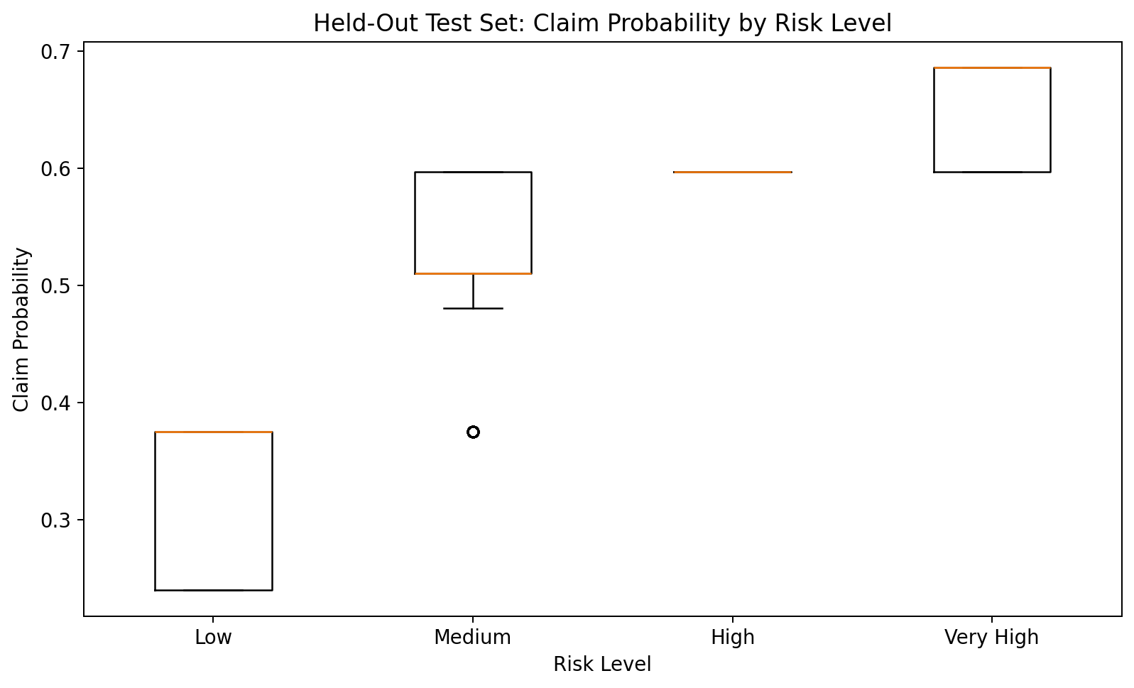
Figure 2. Claim-probability distribution by model risk level.
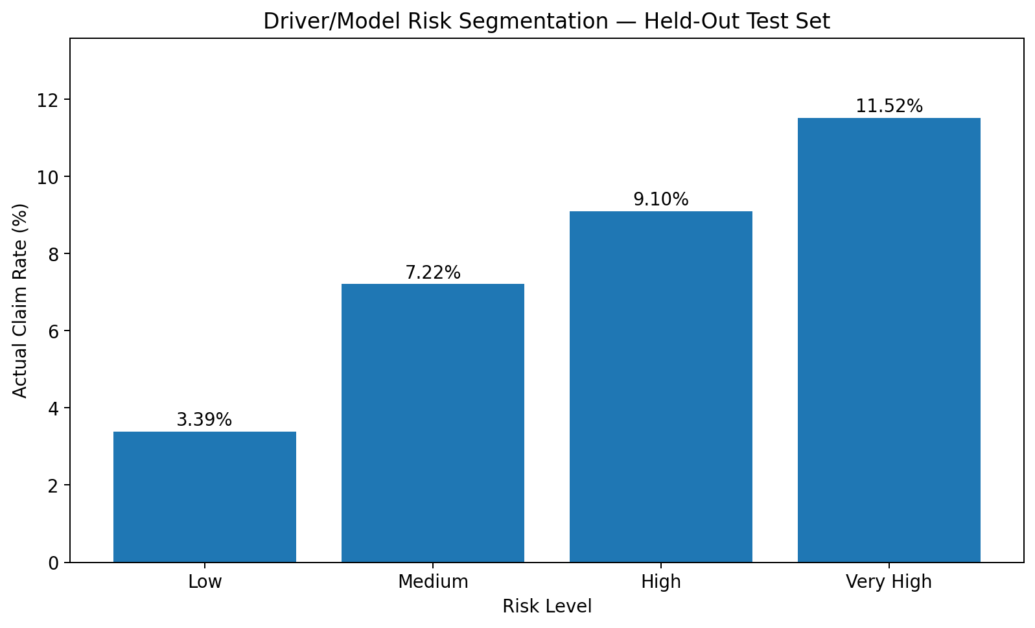
Figure 3. Realised claim rate by model risk level.

4.3 Driver Risk Segmentation
The broader descriptive driver-risk segmentation is not monotonic: Lower Risk has the highest observed claim rate at 6.83%, followed by Moderate Risk at 6.45% and High Risk at 5.65%. Therefore, the descriptive label should not be treated as a validated claim-risk ranking by itself.
Driver segment | Policies | Observed claim rate
High Risk | 10,038 | 5.65%
Lower Risk | 13,433 | 6.83%
Moderate Risk | 35,121 | 6.45%

4.4 NCAP Safety Rating
Observed claim rates vary modestly across NCAP ratings. Rating 5 is highest at 6.68%, while rating 0 is lowest at 6.24%. The spread is small, so NCAP should be treated as contextual evidence rather than a standalone rule.
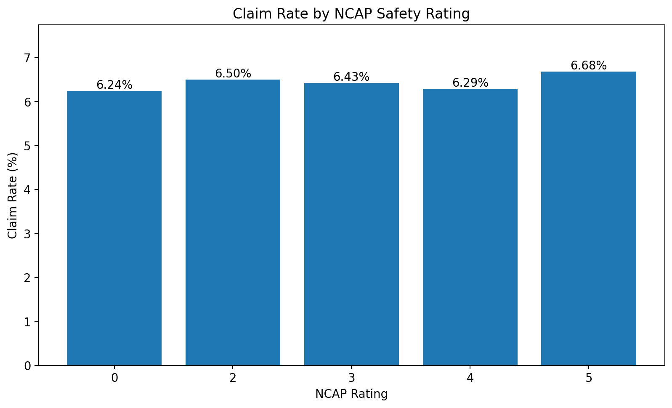
Figure 4. Claim rate by NCAP safety rating.

4.5 Speed-Alert Analysis
The observed claim rate is 4.13% for speed-alert=0 and 6.41% for speed-alert=1. Because the alert=0 group contains only 363 policies, this association should be validated on additional data before becoming an underwriting rule.

5. Feature Engineering & Explainability
- High_Risk_Driver_Flag — interpretable combined driver/vehicle-safety signal.
- safety_equipment_count — aggregates binary safety-equipment indicators.
- power_to_weight_ratio — captures vehicle performance relative to vehicle weight.
SHAP analysis identifies policy_tenure and age_of_car as the strongest contributors by mean absolute SHAP value, followed by vehicle characteristics such as gross_weight, cylinder and height. These are predictive associations, not causal effects.
Top feature | Mean absolute SHAP
policy_tenure | 0.097058
age_of_car | 0.038058
gross_weight | 0.013351
cylinder | 0.012989
height | 0.012534

6. Model Results & Final Model Selection
Model | CV ROC-AUC | Test ROC-AUC | Test Recall | Test Precision | Test F1
Logistic Regression | 0.610 ± 0.007 | 0.586 | 0.547 | 0.080 | 0.140
Tuned Decision Tree | 0.638 ± 0.015 | 0.647 | 0.652 | 0.089 | 0.157

The Tuned Decision Tree is selected because it provides stronger unseen-data ranking and claim capture: ROC-AUC 0.647 versus 0.586 and recall 0.652 versus 0.547 for Logistic Regression. Its CV ROC-AUC is 0.638 ± 0.015.
The main operational trade-off is low precision. The model is therefore best used as a triage engine that focuses human attention rather than as an autonomous decision-maker.

7. Final Prediction Output
The required prediction_output.csv has been generated from the held-out test predictions. It contains policy ID, actual class, predicted class, claim probability and model risk level for all 11,719 held-out policies.
Risk level | Policies | Share | Actual claim rate
Low | 4,687 | 39.99% | 3.39%
Medium | 4,102 | 35.00% | 7.22%
High | 1,758 | 15.00% | 9.10%
Very High | 1,172 | 10.00% | 11.52%

Very High and High risk should form the first review queues because they have the highest realised claim rates. Medium risk can receive secondary review, while Low risk can receive lower manual-review priority, subject to calibration and business-policy validation.

8. Dashboard & Management Use
Dashboard element | Decision use
Total Policies / Total Claims / Claim Rate | Monitor portfolio scale and claim burden.
Predicted Risk Level | Prioritise manual review and underwriting attention.
Claim Probability | Provide a graded risk signal rather than a binary flag.
Claim Distribution | Show class imbalance and portfolio context.
Driver Risk Segmentation | Compare descriptive segments with realised outcomes.
NCAP Analysis | Monitor safety-rating claim patterns.
Speed Alert Analysis | Investigate safety/behaviour associations cautiously.

9. Business Implications & Recommendations

9.1 Underwriting
- Use model probability and risk level to prioritise review rather than fully automated accept/reject decisions.
- Apply additional underwriting checks to High and Very High risk policies where other evidence supports the model signal.
- Select thresholds using an explicit cost matrix balancing missed claims against manual-review workload.

9.2 Pricing & Portfolio Management
- Use predicted risk as one input to actuarial segmentation, subject to calibration, regulatory and fairness review.
- Compare realised claim/loss experience by predicted-risk tier before implementing risk-based pricing changes.
- Do not rely on descriptive driver-risk labels alone when their observed claim relationship is not monotonic.

9.3 Prevention & Risk Management
- Use safety-related signals to identify targeted prevention opportunities.
- Validate interventions using subsequent outcomes rather than assuming causality.
- Investigate the speed-alert relationship further with a larger and more balanced sample.

9.4 Model Governance
- Monitor ROC-AUC, recall, precision, F1 and probability calibration after deployment.
- Monitor population and feature drift over time.
- Track false positives and false negatives as thresholds change.
- Assess subgroup performance and fairness before consequential automated use.
- Revalidate on future/temporal data.

10. Limitations & Next Steps
- Observational data does not establish causality.
- Class imbalance makes accuracy insufficient as a standalone metric.
- The Decision Tree has useful recall but relatively low precision, which can create a large review workload.
- Probability calibration should be explicitly assessed before interpreting probabilities as expected claim frequencies.
- External or temporal validation is needed before production deployment.
- Thresholds should be selected using business costs and available underwriting capacity.
- Subgroup/fairness analysis should be completed before production use.

11. Conclusion
The Stage 4 results support a practical risk-prioritisation use case. On unseen data, realised claim incidence rises from Low to Very High model risk, providing a clear management signal. The recommended operating model is human-in-the-loop underwriting, with model probability and risk level used to focus attention and descriptive analytics used as supporting context.

Appendix — Held-Out Test Results
 | Predicted 0 | Predicted 1
Actual 0 | 5286 | 5683
Actual 1 | 202 | 548

The held-out set contains 11,719 observations: 10,969 non-claims and 750 claims. The model captures 548 of the 750 actual claims at the evaluated threshold.

