A Project Report

On

**Rento**

Submitted in Partial Fulfillment of the Requirement of Project – VII (BIT) of

Bachelor of Information Technology

**Submitted To:**



Purbanchal University Biratnagar,

Nepal

**Submitted By:**

Diwakar Shrestha (371997)

Mani Maharjan (371999)

Anit Shrestha (371988)

KANTIPUR CITY COLLEGE

Putalisadak, Kathmandu

Date: Jan. 22 2021

A project report

On

**Rento**

Submitted in partial fulfillment of the requirement of

Project - VII (BIT) of

Bachelor of Information Technology

**Submitted to:**



Purbanchal University Biratnagar,

Nepal

**Submitted By**

Diwakar Shrestha (371997)

ManiMaharjan (371999)

Anit Shrestha (371988)

**Project Supervisor**

**Ashim KC**

**Lecturer**

KANTIPUR CITY COLLEGE

Putalisadak, Kathmandu

**TOPIC APPROVAL SHEET**

It is hereby informed that the topic selected by Mani Maharjan, Diwakar Shrestha and Anit Shrestha of BIT VII semester for their semester project has been found suitable and as per the credit assigned by Purbanchal University (PU), Biratnagar, Nepal.

The Project Committee has approved the following topic and supervisor for the above-mentioned students.

Topic Approved: **Rento**

_ _ _ _ _ _ _ _ _ _ _

**Bikash Neupane**

Program Coordinator, BCA & BIT

_ _ _ _ _ _ _ _

**Ashim KC**

Asst. Program Coordinator, BCA & BIT

**CERTIFICATE FROM THE SUPERVISOR**

This is to certify that the project entitled **“Rento”** submitted by Mani Maharjan, Diwakar Shrestha and Anit Shrestha to the Department of Information Technology, School of Science and Technology at Kantipur City College, Kathmandu, Nepal towards the requirement for BIT378CO Project VII of is an original work carried out by them under my supervision and guidance.

Signature:

_ _ _ _ _ _ _ _ _ _ _

**Ashim KC**

Department of Information Technology

Kantipur City College

(Project Supervisor)

**Place**: Kantipur City College, Putalisadak, Kathmandu.

**Date**:

# ACKNOWLEDGEMENT

We would like to express our gratitude to the **Purbanchal University**, **IT Department** of **Kantipur City College** (KCC) College for providing us the opportunity to ensure our knowledge in the field of web development through the assignment of this project.

In spite of our effort and hard work the project would not have been successfully completed with the heartfelt assistance and guidance of our friends, seniors and teachers. We would like to thank each and every one who directly and indirectly provide the helping hands for the successful completion of this project.

Finally, we thank the **KCC IT Department** as well who deserve a good appreciation from us for providing resources to complete our project. We even thank **Mr. AshimKC, Mr. Bikash Neupane** all for sincere guidance and supervision in every possible manner despite the lack of time.

Thanks

Group Member (Symbol No : )

Mani Maharjan (371999)

Diwakar Shrestha (371997)

Anit Shrestha (371988)

# ABSTRACT

Nowadays for any business to compete in the market needs an online platform or a website. This project entitled “Rento”, is a website for providing a platform to rent rooms or search available rooms which will create an online platform for house owners of different places. The idea of “Rento'' is to provide an online platform for room owners and room seekers.

The Project “Rento” is designed with HTML, CSS, Python, Bootstrap as front end and MONGO, python and Django as backend. There is use of different style sheets and boot straps for completing this project. Since this project is a project without the provision of any budget, the internet is used as a prime source of collection of data and information.

# LIST OF FIGURES

|  |  |
| --- | --- |
| **Figure** | **Page no.** |
| System Development Model | 6 |
| Context Diagram | 9 |
| Data Flow Diagram | 10-11 |
| ER Diagram | 12 |
| Use Case Diagram | 13 |

# LIST OF TABLES

# 

|  |  |  |
| --- | --- | --- |
| **Table No.** | **Table Name** | **Page Number** |
| 1 | Assignment of roles and Responsibilities | 2 |
| 2 | Organization of document | 2-3 |
| 3 | Functional Requirement | 7 |
| 4 | Non-Functional Requirement | 7 |

# 

Table of Contents

ACKNOWLEDGEMENT 1

ABSTRACT 2

LIST OF FIGURES 3

LIST OF TABLES 4

CHAPTER 1: INTRODUCTION 1

1.1 PROBLEM STATEMENT 1

1.2 OBJECTIVE OF PROJECT 1

1.3 FEATURES OF PROJECT 1

1.4 ASSIGNMENT OF ROLES AND RESPONSIBILITIES 2

1.5 ORGANIZATION OF DOCUMENT 2

CHAPTER 2: EXISTING SYSTEM OVERVIEW 4

2.1 Existing System 4

2.1.1 Rental Nepal (www.rentalnepal.com) 4

2.1.2 Gharbheti (www.gharbheti.com) 4

2.2 Proposed System 4

CHAPTER 3: SYSTEM ANALYSIS 6

3.1 SYSTEM DEVELOPMENT MODEL 6

3.2 REQUIREMENT SPECIFICATION 7

3.2.1 Functional Requirements 7

3.2.2 Non-Functional Requirements 7

3.3 FEASIBILITY STUDY 8

3.3.1 Technical Feasibility 8

3.3.2 Economic Feasibility 8

CHAPTER 4: SYSTEM DESIGN 9

4.1 CONTEXT DIAGRAM AND DATA FLOW DIAGRAM 9

4.1.1 CONTEXT LEVEL DFD 9

4.1.2 DFD LEVEL 1 10

4.1.3 DFD LEVEL 2 (3.0) 11

4.2 Entity Relationship Diagram (ER-Diagram) 12

4.3 USE CASE DIAGRAM 13

CHAPTER 5: SYSTEM DEVELOPMENT AND IMPLEMENTATION 14

5.1 Programming platform and implementation (Tools and technologies) 14

5.1.1 Frontend Tools: 14

5.1.2 Backend Tools: 14

5.1.3 Development tools: 14

5.2 Operating Environment 14

5.3 Testing and Debugging 15

CHAPTER 6: CONCLUSION AND FUTURE ENHANCEMENT 18

6.1 Conclusion 18

6.2 Future Enhancement 18

References 19

Appendixes 20

Apendix1: Screenshots 20

Apendix2: Gantt Chart 23

# CHAPTER 1: INTRODUCTION

Rento is a website for providing a platform to rent rooms or search available rooms which will create an online platform for house owners of different places. To find a room in any place a person has to travel on foot house by house and also room providers are not gaining any room seekers attention for their empty rooms, so this website is being developed with the motive of making the work of room providers and room seekers easier.

## 1.1 PROBLEM STATEMENT

The problem occurred before having Rento includes:

* room seeker had to visit different places on foot house by house for searching rooms, even the middle man who shows rooms charges huge amount before showing rooms
* room owners were not being able to gain attention from any room seekers and rooms of house are left empty without making any incomes

## 1.2 OBJECTIVE OF PROJECT

* To create platform to rent room for room owners and find room for room seekers

## 1.3 FEATURES OF PROJECT

* Room owner gets to add rooms detail and manage rooms setting either to make private (if room is not empty) or public (if room is empty)
* Rooms seekers can search for rooms in the location they wish by using filter bar
* Room owners also are able to maintain their rent detail sheets to manage their rent
* Room seeker can give feedback for rooms and rooms detail provided by room owner
* Room owner can feature their rooms

## 1.4 ASSIGNMENT OF ROLES AND RESPONSIBILITIES

|  |  |  |
| --- | --- | --- |
| **Member Name** | **Symbol No.** | **Role Assigned** |
| Mani Maharajan | 371999 | Requirement Analysis, System design, Coding, Testing, documentation |
| Diwakar Shrestha | 371997 | Requirement Analysis, System Design, Coding, Testing, documentation |
| Anit Shrestha | 371988 | Requirement Analysis, System Design, Coding, Testing, documentation |

## 1.5ORGANIZATION OF DOCUMENT

This documentation is categorized into 5 various chapters and each chapter contains various sub-chapter.

|  |  |  |
| --- | --- | --- |
| Chapter | Heading | Contents |
| Chapter 1 | Introductions | * 1. Introduction   2. Problem Statement   3. Objectives   4. Features   5. Organization of document |
| Chapter 2 | Literature Review | 2.1 Existing System  2.2 Proposed system |
| Chapter 3 | System Analysis | 3.1 Interface Requirements  3.2 Functional Requirement  3.3 Non-Functional Requirement  3.4 Feasibility Study |
| Chapter 4 | System Design | 4.1 System Architecture  4.2 Context and Data flow diagram  4.3 Use-Case diagram  4.4 Sequence diagram  4.5 Database design |
| Chapter 5 | System development and implementation | 5.1 Programming platform and implementation, Tools and technologies  5.2 Operating Environment  5.3 Testing and debugging  5.3 Implementation and Result Analysis |
| Chapter 6 | Conclusion and Future Enhancement | 6.1 Conclusion  6.2 Limitation  6.3 Future Enhancements |

# CHAPTER 2: EXISTING SYSTEM OVERVIEW

## 2.1 Existing System

### 2.1.1 Rental Nepal (www.rentalnepal.com)

Rental Nepal is real estate system which deals with the rental services such as buying and selling houses, office spaces, apartments, shutters and shops, rooms, and lands. User who register in this website has access to add the properties of different types with properties details, images and google map location and user who is seeking for room gets access to enquiry form for room they want.

**PROS**

* includes all types of properties to add or search and also has service to get featured
* provides features like video links, photos, sharing in social media, comment and more

**CONS**

* not so user focused and user are not given ability to search by location filters

### 2.1.2 Gharbheti ([www.gharbheti.com](http://www.gharbheti.com))

Gharbeti is another real estate system similar to Rental Nepal here user can register as a investor to the properties or properties owner who wants to post their properties and the room seekers can find room, book, visit and move-in if they like.

**PROS**

* includes all types of properties and also has feature to advertise
* room seeker can book and get field visit

**CONS**

* website has functional issues
* owner cannot have direct contact with room seeker which may cause problem to visit the site

## 2.2 Proposed System

Rento is a real estate system which deals with the room renting services anddeveloped to facilitate the room owner and room seeker. User can either be room owner and room seeker,if usersareroom owner then they can add the properties detail including videos links and photos, and if they are room seeker then they can enquire directly with room owner. User to post properties on must create account and login. They have also ability to manage properties and also set room to public (if room is available for rent) and private (if room is full), if they don’t want to remove room that is pack. Also, if owner want to manage the account of their room rentals system provides them a default rent management system of website. If user is room seeker then they can also enquire in properties without having account by providing details and they has also ability to provide rating and report for fake room details.

# CHAPTER 3: SYSTEM ANALYSIS

Before starting software development process, system analysis is important part as we need to be clear which system development model is to be followed to develop software then the requirement specification is to be collected following the steps of system development model, so this part gives all the information about system development model used, requirements analysis and specification.

## 3.1 SYSTEM DEVELOPMENT MODEL

As this is an academic project, we do not have proper requirement specification and the requirement might be changing and the project might have to be redesigned so we used prototyping model. Figure is prototyping model which is used when actual project is being developed.

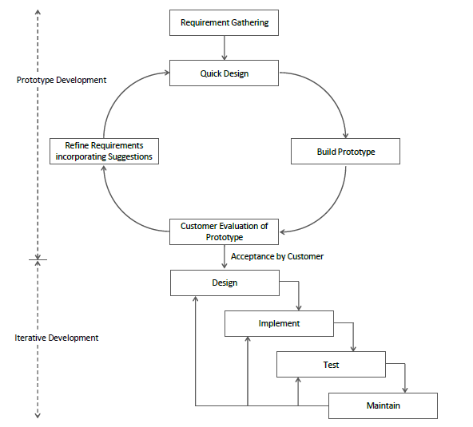

Fig:- System Development Model

## 3.2 REQUIREMENT SPECIFICATION

### 3.2.1 Functional Requirements

|  |  |  |
| --- | --- | --- |
| Requirement Name | Requirement Statement | Must/Want |
| Add room | New member shall be able to sign up and add their rooms | must |
| Show rooms | Website shall have the page “Rooms” to show the rooms added by users | must |
| Search room | Website should have search filter to search the room on required location | must |
| Enquire | User shall be able to enquire on the room detail page | must |
| Manage room | User who is registered shall be able to manage the properties added | must |
| Manage rent account | Website should provide a rent management system to registered user | must |

### 3.2.2 Non-Functional Requirements

|  |  |  |
| --- | --- | --- |
| Requirement Name | Requirement Statement | Must/Want |
| Compatibility | The website shall support all browsers and also should be responsive on smart mobile devices | must |
| Maintainability | Website shall be able to be modified to adapt the changing environment | must |
| Usability | User shall be provided a guide to use the system | must |
| Security | User shall be able to hide or show their detail and their data must be protected | must |

## 3.3 FEASIBILITY STUDY

As this is the academic project the feasibility study is performed being based on the academic requirements and we followed following feasibility studies for the projects.

### 3.3.1 Technical Feasibility

As to develop any projects hardware and software’s are the basic things that we need as we are the bit students all three of our team member have laptops with windows operating system so there is no problem for develop of the software. We willbe able to install all the development tools required in our machine so this project is technically feasible.

### 3.3.2 Economic Feasibility

As this is our academic project we have our college to support us on any cost if required but the tools and technology we will be using for this project are all free of cost and the effort we provide in the project is evaluated by our academic score so we think this project is economically feasible

# CHAPTER 4: SYSTEM DESIGN

## 4.1 CONTEXT DIAGRAM AND DATA FLOW DIAGRAM

### 4.1.1 CONTEXT LEVEL DFD

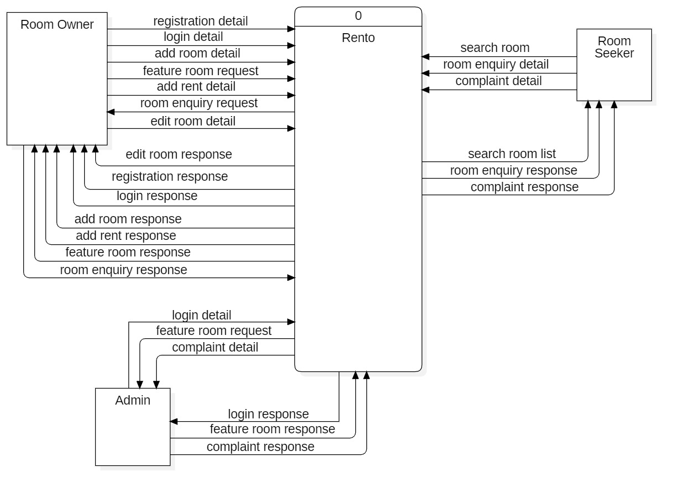

Fig:- Context Diagram

### 4.1.2 DFD LEVEL 0

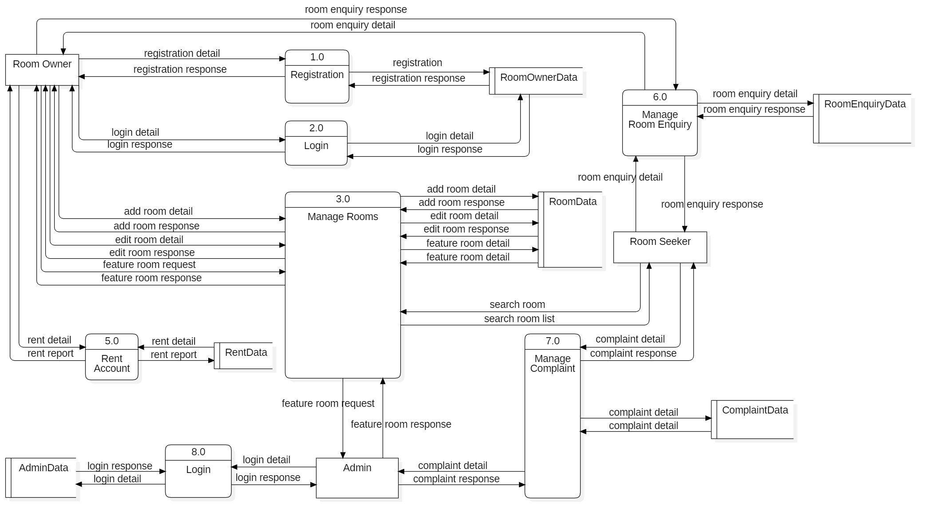

Fig:- Level 0 DFD

### 4.1.3 DFD LEVEL 1 (3.0)

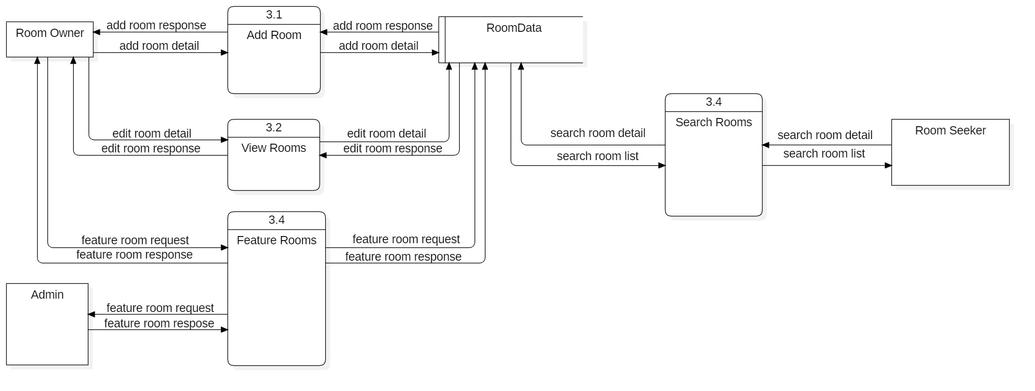

Fig:- Level 1 DFD

## 4.2 Entity Relationship Diagram (ER-Diagram)

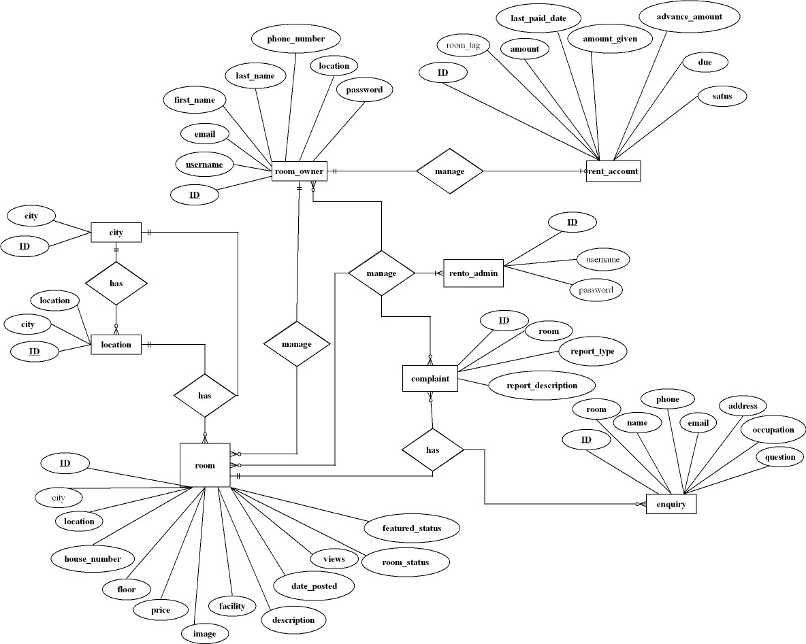

Fig :- ER Diagram

## 4.3 USE CASE DIAGRAM

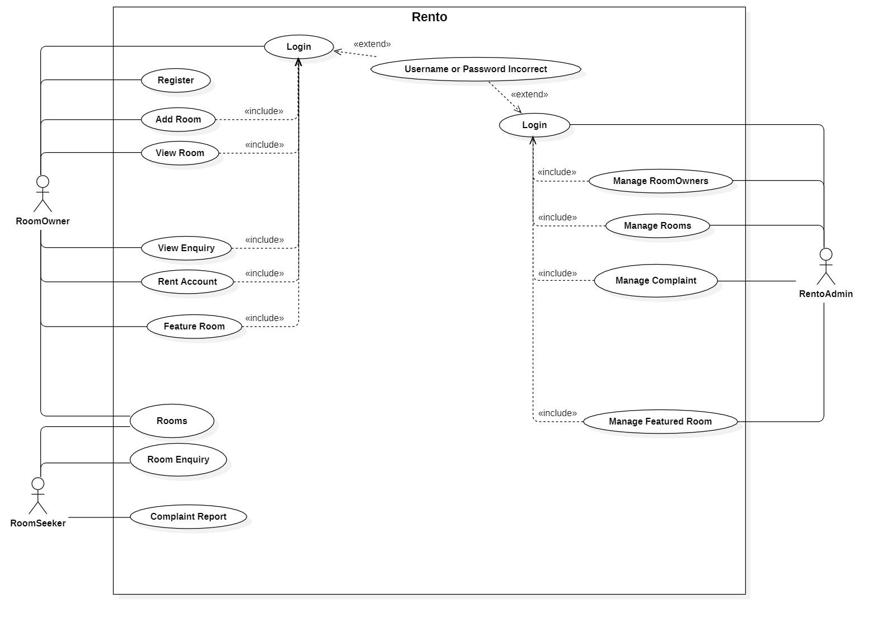

Fig :- Use Case Diagram

# CHAPTER 5: SYSTEM DEVELOPMENT AND IMPLEMENTATION

## 5.1 Programming platform and implementation (Tools and technologies)

### 5.1.1 Frontend Tools:

* + HTML, CSS, BOOTSTRAP
  + PYTHON, DJANGO

### 5.1.2 Backend Tools:

* + PYTHON, DJANGO
  + SQLITE

### 5.1.3 Development tools:

* + VISUAL STUDIO CODE

## 5.2 Operating Environment

Application was tested and developed in windows 8.1/10 with 4/8GB RAM and i5/i7 intel processor

## 5.3 Testing and Debugging

|  |  |
| --- | --- |
| Test case | 3 |
| Test objective | To check whether rooms is added or not |
| Test data | Entering required room data |
| Expected result | Rooms should be added to the database |
| Test result | Rooms added to the database successfully |
| Conclusion | Expected result matches actual result |

|  |  |
| --- | --- |
| Test case | 1 |
| Test objective | To check whether Sign Up is successful |
| Test data | Entering required data for sign up |
| Expected result | User should be registered into the database |
| Test result | User registered to the database |
| Conclusion | Expected result matches actual result |

|  |  |
| --- | --- |
| Test case | 2 |
| Test objective | To check whether login is successful |
| Test data | Entering username and password |
| Expected result | User should be logged into the system |
| Test result | User is logged in to the system |
| Conclusion | Expected result matches actual result |

|  |  |
| --- | --- |
| Test case | 4 |
| Test objective | To check weather rooms are displayed or not |
| Test data | None |
| Expected result | Rooms from database should be displayed on the rooms tab |
| Test result | All the public and non-blocked rooms are successfully displayed |
| Conclusion | Expected result matches actual result |

|  |  |
| --- | --- |
| Test case | 5 |
| Test objective | To delete room |
| Test data | User should delete a room |
| Expected result | Selected room should be removed from the database |
| Test result | Selected room was successfully removed from the database |
| Conclusion | Expected result matches actual result |

|  |  |
| --- | --- |
| Test case | 6 |
| Test objective | To list a room as featured room |
| Test data | User should request for feature room and admin should approve it |
| Expected result | Rooms selected to be featured by the admin should be displayed in homepage |
| Test result | Selected room was successfully updated as featured room in the database and displayed in home screen |
| Conclusion | Expected result matches actual result |

|  |  |
| --- | --- |
| Test case | 7 |
| Test objective | To check whether the admin can block/delete user/room |
| Test data | Admin should select a user/room to be blocked or deleted |
| Expected result | Selected user/room should be removed from database if deleted or flagged as blocked if blocked |
| Test result | Selected user/room was successfully removed from database if deleted or was flagged as blocked if blocked |
| Conclusion | Expected result matches actual result |

|  |  |
| --- | --- |
| Test case | 8 |
| Test objective | To check if all rooms are in rent account and if user is able input rent information |
| Test data | User should select rent tab to create rent account and enter rent information |
| Expected result | Rent account should be created for user and rent information should be updated in database |
| Test result | Rent account was created successfully for user and rent information was updated successfully |
| Conclusion | Expected result matches actual result |

# CHAPTER 6: CONCLUSION AND FUTURE ENHANCEMENT

## 6.1 Conclusion

This project is a web-based application for room seekers to find a suitable room for themselves and room owners to advertise their availed room space to room seekers. This project will help owners to maintain and update their rooms posted and set them to private or public depending if the rooms are given in rent or not. This app also helps admin to monitor and maintain their users and rooms and allows them to delete any misleading or ill advanced rooms and users.

## 6.2 Limitations

Despite the hard works and efforts, this system still lacks some simple yet good features, such as:

* Room seeker are not able to book the room instead they can only enquire and wait for room owner’s response
* Room seekers cannot see the exact location of room as there is not any pinned map location

## 6.3 Future Enhancement

Application can be updated in the future by adding following features

* Direct payment from the website itself
* Full chat system for the owner and room seeker
* Live notification system for the room owner

# References

AKJASIM. (n.d.). *cb_dj_dependent_dropdown*. Retrieved 2021, from GitHub: https://github.com/akjasim/cb_dj_dependent_dropdown

DFSQ. (n.d.). *Confirm deletion in modal*. Retrieved 2021, from stackoverflow: https://stackoverflow.com/questions/8982295/confirm-deletion-in-modal-dialog-using-twitter-bootstrap

Freitas, V. (2021). *How to Paginate with Django*. Retrieved from https://simpleisbetterthancomplex.com/tutorial/2016/08/03/how-to-paginate-with-django.html

Gale, V. (n.d.). *Get user group in a template*. Retrieved 2021, from stackoverflow: https://stackoverflow.com/questions/1052531/get-user-group-in-a-template/17087532

Jobelle. (n.d.). *How get the src value from the img clicked*. Retrieved 2021, from stackoverflow: https://stackoverflow.com/questions/34992165/how-get-the-src-value-from-the-img-clicked?answertab=oldest#tab-top

Lemayzeur. (n.d.). *pass value to bootstrap modal form with django*. Retrieved 2021, from stacoverflow: https://stackoverflow.com/questions/50196148/pass-value-to-bootstrap-modal-form-with-django

MAXG203. (n.d.). Retrieved 2021, from GITHUB: https://github.com/maxg203/Django-Tutorials/blob/master/home/views.py

Olexiy, Z. (n.d.). *How to calculate diff between two dates in django*. Retrieved 2021, from stackoverflow: https://stackoverflow.com/questions/41229963/how-to-calculate-diff-between-two-dates-in-django

# Appendixes

## Apendix1: Screenshots

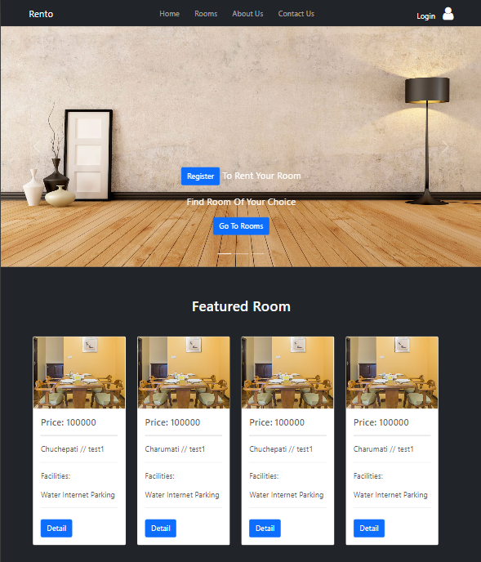

Home screen

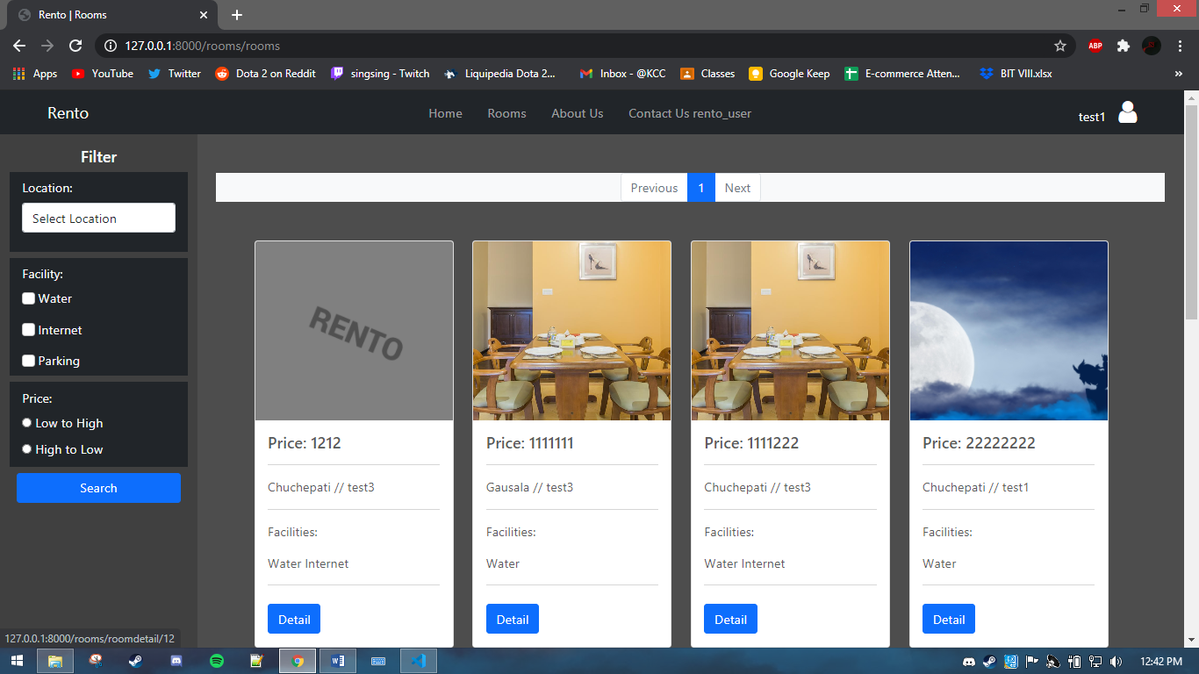

Room page

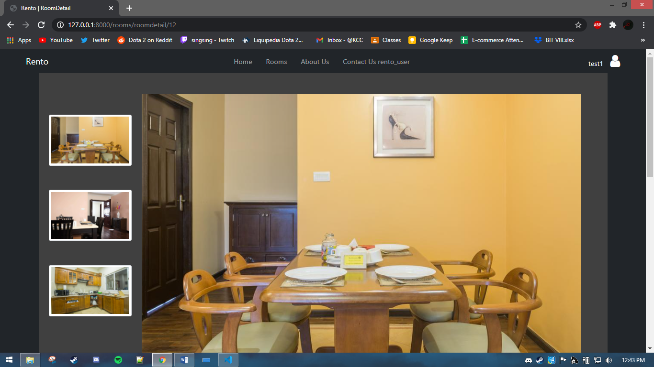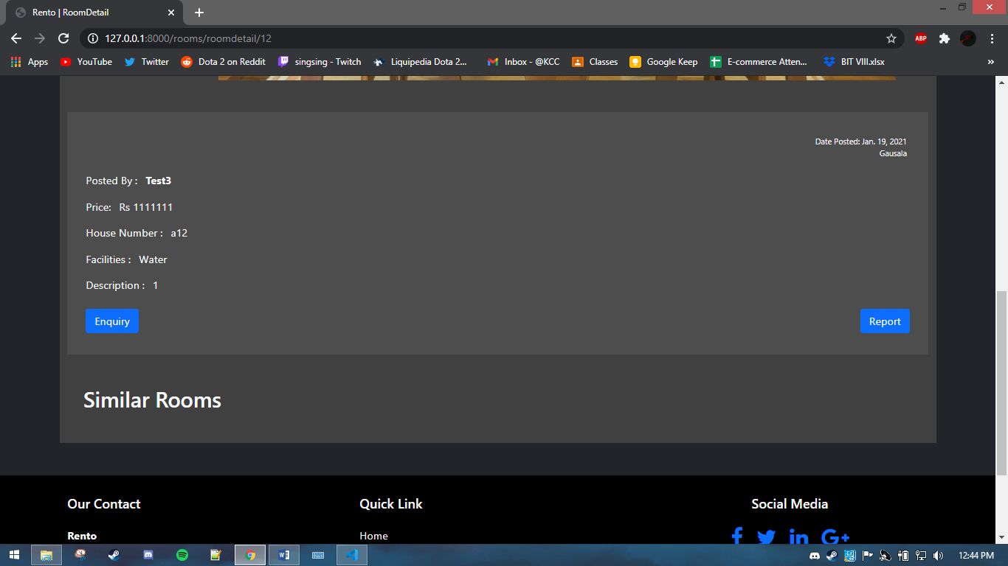

Room detail page

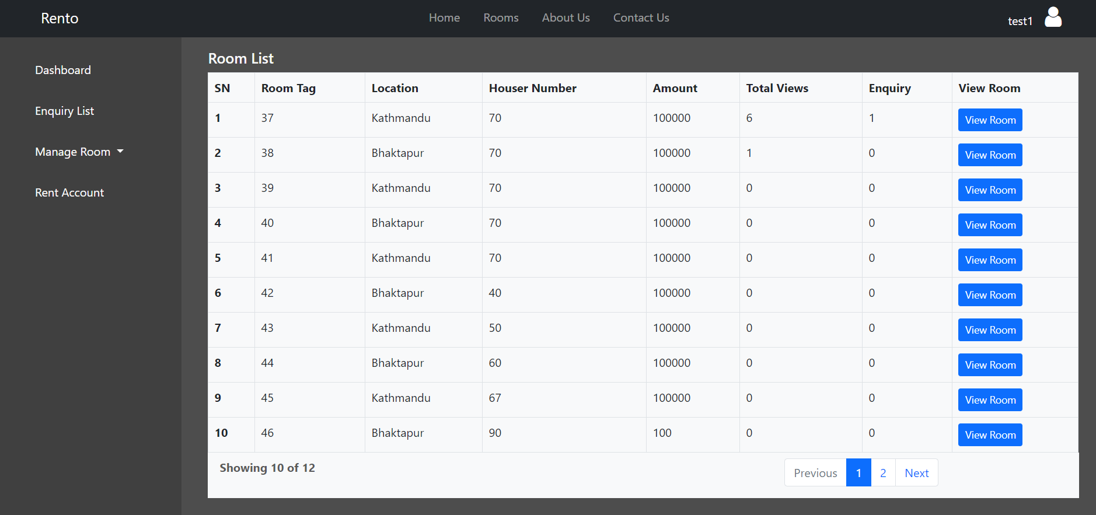

User dashboard

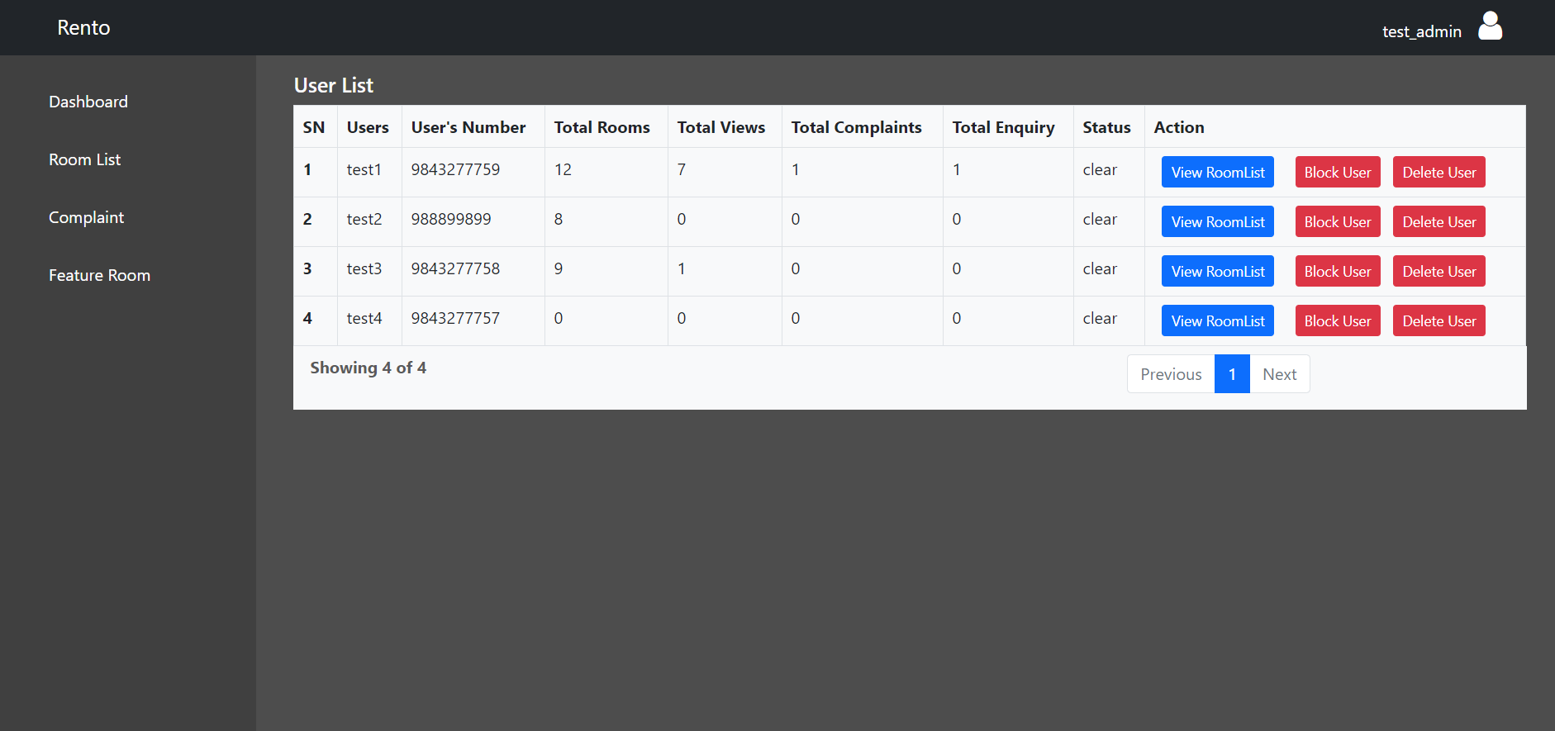

Admin dashboard

## Apendix2: Gantt Chart

