Mrunalini P. Diwale

NUID - 001220897

**Banking Management System**

A bank needs to maintain a database of customers who can open account in a bank, take the facility of depositing money, withdraw money, transfer funds, take help like getting loan, investing in mutual funds, getting credit card/debit card facilities. A database should be maintained for customer’s accounts and their transaction history. The bank should maintain a database of its branches, employees, managers, customers and the facilities provided by the bank. Create a database which would serve this purpose.

Database Used - MySQL

**ER Diagram first version (Before Normalization)**

Transaction

Account_ID (PK)

DateTime

Cust_ID (FK)

Transaction_Type

Accounts

Account_ID (PK)

Branch_ID(FK)

Account_Type (FK)

Customer_ID (FK)

Account_Type_ID

Account_Type_Name

Bank Branches

Branch_ID (PK)

Bank_ID (FK)

Location

Contact Information

Bank

Bank_ID (PK)

Bank_Name

Bank Facility

ID (PK)

Facility_Name

Cust_ID(FK)

Departments

Dept_ID (PK)

Dept_Name

Customers

Cust_ID (PK)

Persons

ID (PK)

First_Name

Last_Name

Address

Email

Contact Number

Employees

EMP_ID (PK)

Dept_ID (FK)

Manager_ID

Title_Type_ID

Title_Type_Name

**ER Diagram (After Normalization)**

In Employees table, Title_Type_Name is dependent on Titile_Type_ID. Hence, removing transitive dependency, create a separate table with Title_Type_Name and Titile_Type_ID.

In Table Accounts, Account_Type_Name is dependent on Account_Type_ID. Hence, removing transitive dependency, create a separate table with Account_Type_ID and Account_Type_Name.

In tables where there is many to many relations, a separate bridge table is created making both the keys together as primary key.

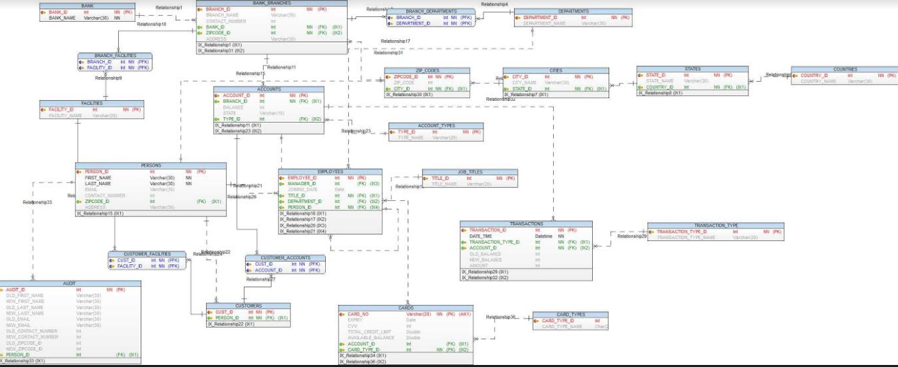

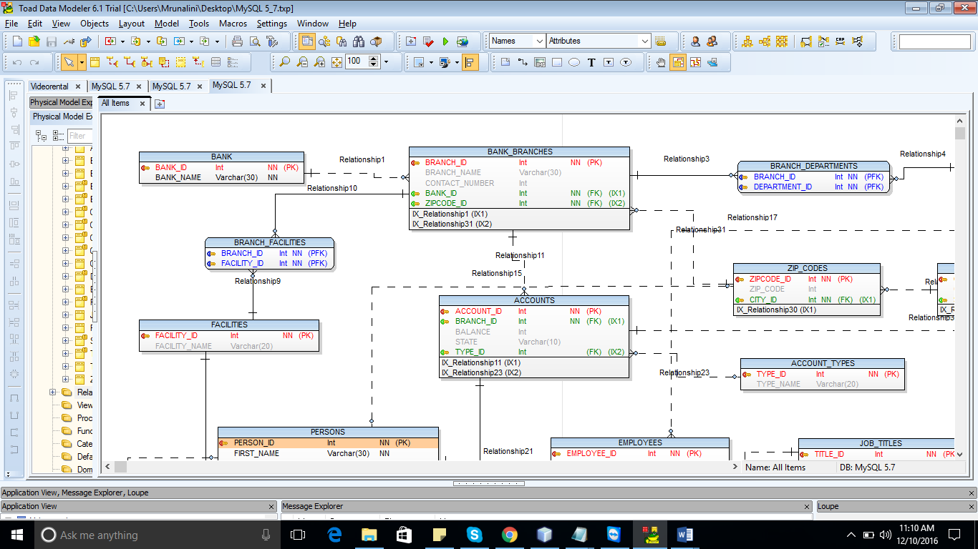

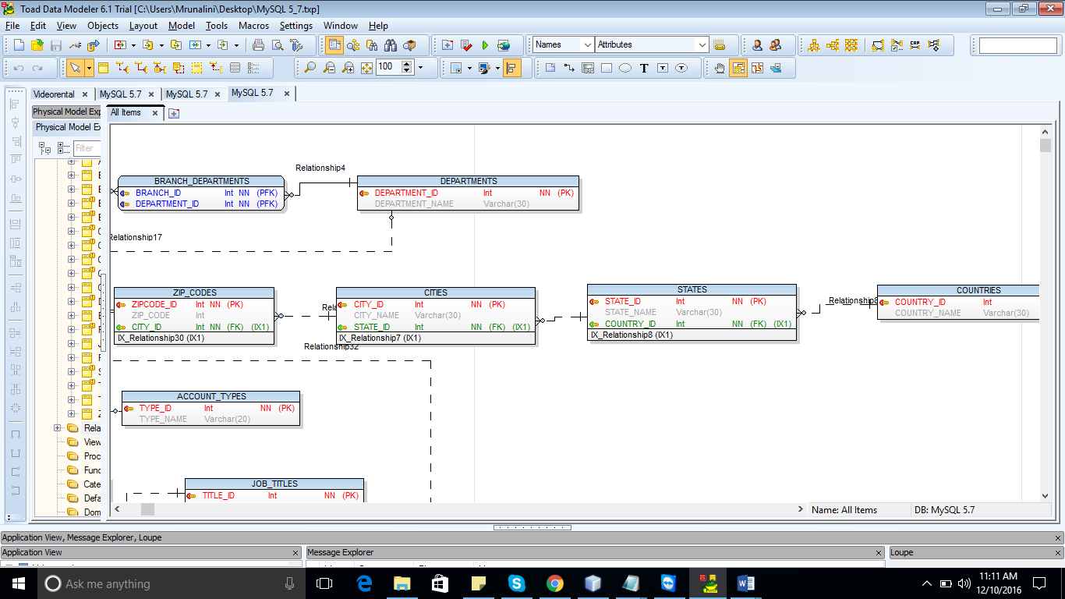

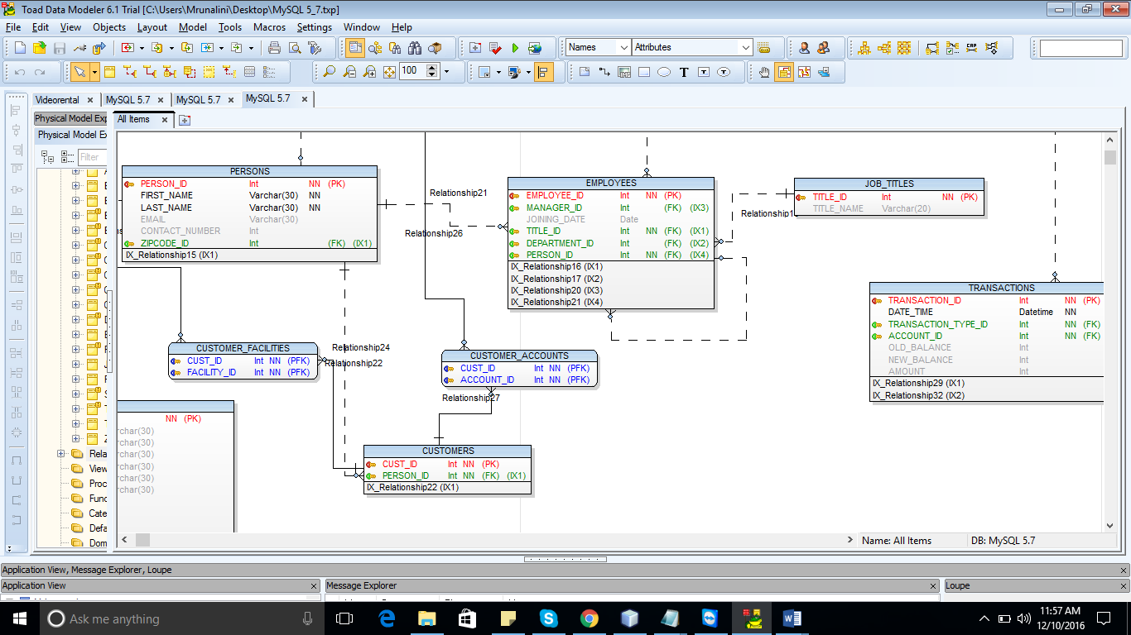

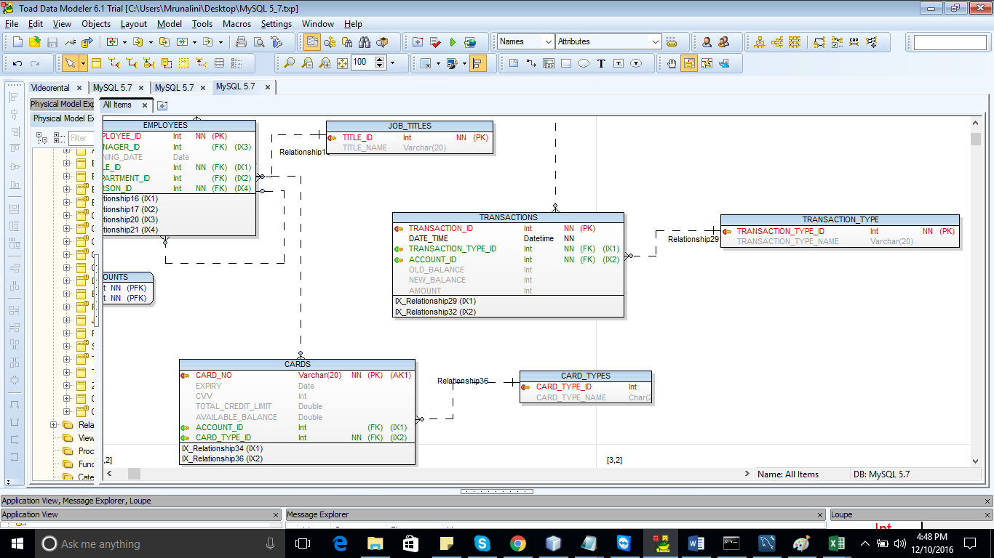

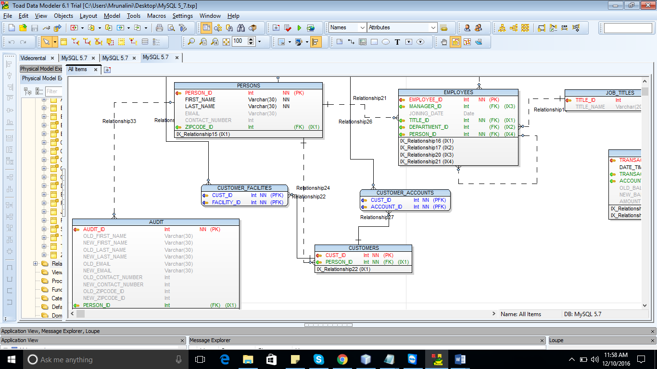

1. **Show the fund transfer from one account to another.**

**Stored Procedure for Fund Transfer**

DELIMITER $$

CREATE DEFINER=`root`@`localhost` PROCEDURE `FundTransfer`(FromAccountID INT, ToAccountID INT, Amount INT)

BEGIN

UPDATE accounts set BALANCE = BALANCE - Amount

WHERE ACCOUNT_ID = FromAccountID;

UPDATE accounts set BALANCE = BALANCE + Amount

WHERE ACCOUNT_ID = ToAccountID;

END

**Before:**

select * from accounts

WHERE Account_ID = 1;

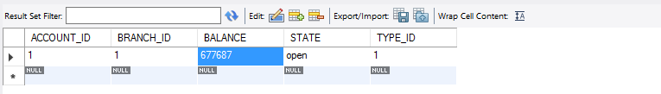

select * from accounts

WHERE Account_ID = 2;

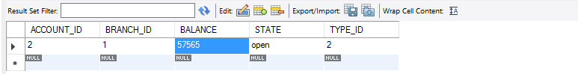

**After the Stored procedure is called**

CALL FundTransfer(1,2,500);



500 transferred from ACCOUNT_ID = 1 to ACCOUNT_ID = 2.

select * from accounts

WHERE Account_ID = 1;

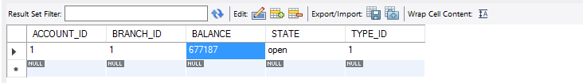

select * from accounts

WHERE Account_ID = 2;

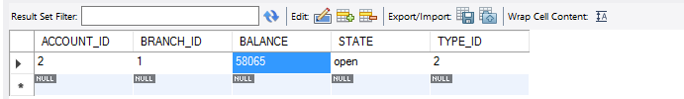

1. **Show Withdraw from an account.**

**Stored Procedure for Withdraw**

DELIMITER $$

CREATE DEFINER=`root`@`localhost` PROCEDURE `withdraw`(AccountId INT, Amount INT)

BEGIN

DECLARE balcanceamount INT;

SELECT BALANCE INTO balcanceamount FROM accounts

WHERE ACCOUNT_ID = AccountId;

IF balcanceamount > Amount THEN

UPDATE accounts SET BALANCE = BALANCE - Amount

WHERE ACCOUNT_ID = AccountId;

END IF;

END

**Before the stored procedure is called:**

select * from accounts

WHERE Account_ID = 4;

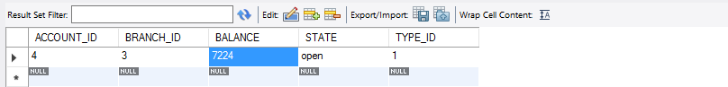

**After the Stored procedure is called:**

CALL withdraw (4,300);

Amount of 300 got deducted from ACCOUNT_ID = 4.

select * from accounts

WHERE Account_ID = 4;

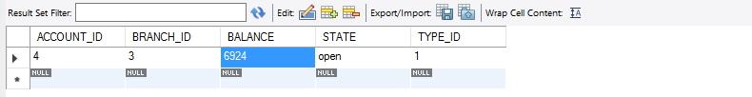

1. **Show the procedure to deposit amount into an account.**

**Stored Procedure to Deposit**

DELIMITER $$

CREATE DEFINER=`root`@`localhost` PROCEDURE `deposit`(AccountId INT, Amount INT)

BEGIN

UPDATE accounts SET BALANCE = BALANCE + Amount

WHERE ACCOUNT_ID = AccountId;

END

**Before calling the stored procedure:**

select * from accounts

WHERE Account_ID = 4;



**After calling the stored procedure:**

CALL deposit (4,500);

Amount of 500 is deposited into the account with ACCOUNT_ID = 4.

select * from accounts

WHERE Account_ID = 4;

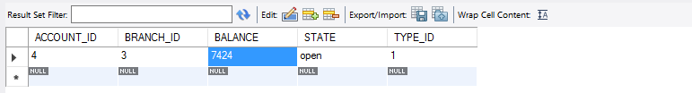

1. **Show how the transaction table is maintained.**

Whenever there is any update in the balance of accounts table, there should be an entry in the transaction table to show all the details of the action taken place along with the timestamp.

**TRIGGER to update transaction table**

DELIMITER |

CREATE trigger tr_insert_transaction

AFTER UPDATE ON accounts

FOR EACH row

BEGIN

DECLARE TYPE_ID INT;

DECLARE AMOUNT INT;

IF OLD.BALANCE > NEW.BALANCE THEN

SET TYPE_ID = 2;

SET AMOUNT = OLD.BALANCE - NEW.BALANCE;

ELSE

SET TYPE_ID = 1;

SET AMOUNT = NEW.BALANCE - OLD.BALANCE;

END IF;

INSERT INTO transactions

(

DATE_TIME,

Transaction_Type_ID,

Account_ID,

AMOUNT,

OLD_BALANCE,

NEW_BALANCE)

VALUES (

CURRENT_TIMESTAMP (),

TYPE_ID,

OLD.Account_ID,

AMOUNT,

OLD.Balance,

NEW.Balance);

END;

|

After the above 3 stored procedures are called, each time there is an entry in the transaction table with TRNSACTION_ID autoincremented.

(Note: During Fund Transfer, there is withdraw from account and deposit in one account. Hence two transaction entries are created.)

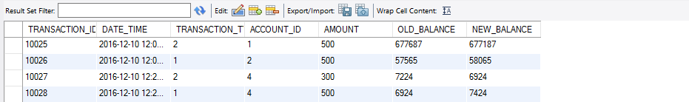

1. **Show the procedure when a card (Debit/Credit) is swiped**.

When a debit card is swiped, balance from the account associated with the debit card is deducted. Transaction is maintained in the transaction table.

When a credit card is swiped, balance from the credit card limit is deducted.

**Stored Procedure:**

DELIMITER $$

CREATE DEFINER=`root`@`localhost` PROCEDURE `card_swipe`(cardNo Varchar(20), Amount INT )

BEGIN

DECLARE CARD_TYPE INT;

DECLARE ACC_ID INT;

SELECT ACCOUNT_ID, CARD_TYPE_ID

INTO ACC_ID , CARD_TYPE

FROM CARDS

WHERE CARD_NO = cardNo;

IF CARD_TYPE = 1 THEN

UPDATE ACCOUNTS

SET BALANCE = BALANCE - Amount

WHERE ACCOUNT_ID = ACC_ID;

ELSE

UPDATE CARDS

SET AVAILABLE_BALANCE = AVAILABLE_BALANCE - Amount

WHERE CARD_NO = cardNo;

END IF;

END

**Before calling stored procedure:**

select * from accounts

WHERE account_id = 1;

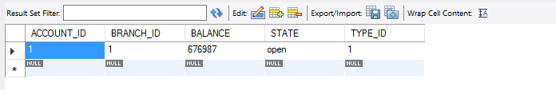

When a debit card is swiped:

CALL card_swipe(3099383746,200);

select * from accounts

WHERE account_id = 1;

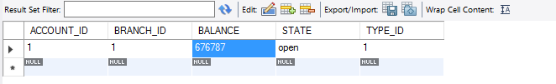

SELECT * from transactions;

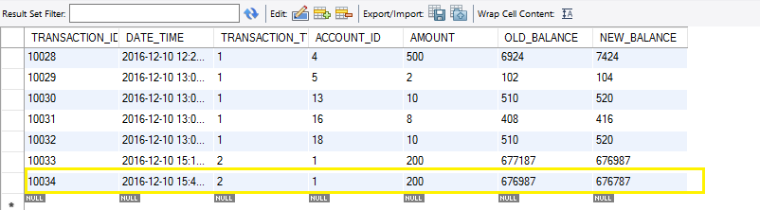

When a credit card is swiped,

CALL card_swipe(8746798541,200);

**Before:**

Select * from cards;

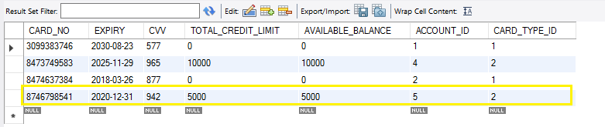

**After:**

Available balance is updated.

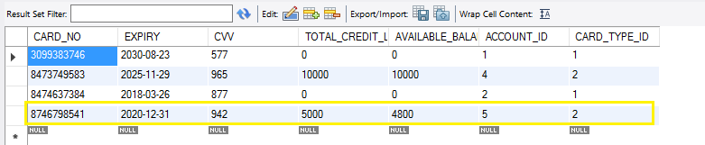

1. **Show the procedure to make the payment to the credit card.**

**Stored Procedure:**

DELIMITER $$

CREATE DEFINER=`root`@`localhost` PROCEDURE `credit_payment`(cardNo Varchar(20), Amount INT)

BEGIN

DECLARE CARD_TYPE INT;

DECLARE ACC_ID INT;

SELECT ACCOUNT_ID, CARD_TYPE_ID

INTO ACC_ID , CARD_TYPE

FROM CARDS

WHERE CARD_NO = cardNo;

IF CARD_TYPE = 2 THEN

UPDATE CARDS

SET AVAILABLE_BALANCE = AVAILABLE_BALANCE + Amount

WHERE CARD_NO = cardNo;

END IF;

END

**Before calling the stored procedure**:

Select * from cards;



**After calling the stored procedure:**

CALL credit_payment(8746798541,200);

Select * from cards;

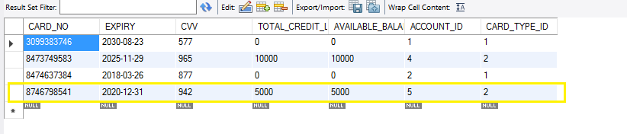

1. **Find bank accounts which are in open state and have balance under 1000$**

select ACCOUNT_ID, STATE, BALANCE from accounts

WHERE STATE = 'open'

and BALANCE < 6000

ORDER BY BALANCE;

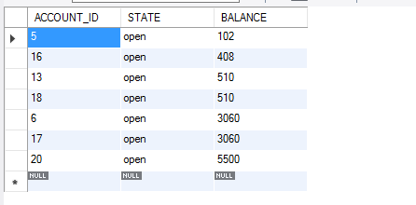

1. **Find the average balance of all the accounts at any branch.**

A stored procedure is created which takes an input Branch_ID and finds the average balance of all accounts at that branch.

**Stored Procedure**

DELIMITER $$

CREATE DEFINER=`root`@`localhost` PROCEDURE `avg_balance_of_all_accounts`(branchID INT)

BEGIN

SELECT b.branch_Name, avg(Balance) AS 'Average of Balance'

FROM accounts a

INNER JOIN bank_branches b

ON a.branch_ID = b.branch_ID

AND a.branch_ID = branchID;

END

select * from accounts

WHERE Branch_ID = 3;

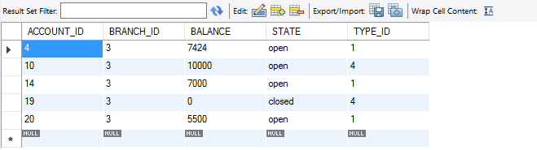

**After calling the Stored Procedure:**

CALL avg_balance_of_all_accounts(4);

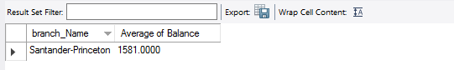

1. **Find all the branches which offer loan.**

SELECT DISTINCT c.Branch_Name AS Branch_Name

FROM accounts a

INNER JOIN account_types b

ON a.Type_ID = b.Type_ID

inner JOIN bank_branches c

ON a.BRANCH_ID = c.Branch_ID

WHERE b.Type_ID = 3;

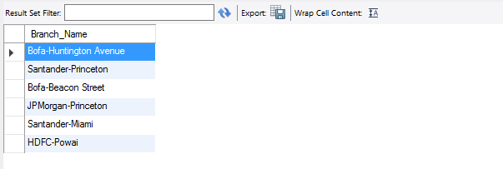

1. **Find the number of customers with more than one loan.**

SELECT a.Cust_ID, COUNT(*) AS number_of_loans

from customer_accounts a

INNER JOIN accounts c

ON a.Account_ID = c.Account_ID

WHERE c.Type_ID = 3

GROUP BY Cust_ID

HAVING count (*) > 1;

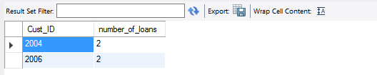

1. **Find the number of accounts in each branch of all the banks.**

SELECT c.bank_name, b.branch_name, a.Branch_ID, count(*) AS NumberOfAccounts

FROM ACCOUNTS a

inner JOIN bank_branches b

ON a.Branch_ID = b.Branch_ID

INNER JOIN bank c

ON b.Bank_ID = c.Bank_ID

GROUP BY Branch_ID;

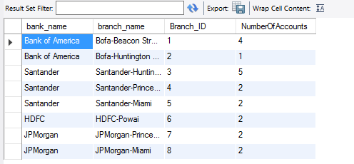

1. **Find the transactions of all the customers in a certain time period.**

A View is created and data is selected from it.

CREATE **VIEW** TransactionsBetweenGivenDates AS

SELECT c.Cust_ID, p.First_Name AS 'Customer Name' , t.Transaction_ID, tt.transaction_Type_Name,t.ACCOUNT_ID , t.AMOUNT, t.Date_Time

FROM transactions t

INNER JOIN transaction_type tt

ON t.Transaction_Type_ID = tt.Transaction_Type_ID

INNER JOIN customer_accounts c

ON t.account_ID = c.account_ID

INNER JOIN customers cu

ON c.Cust_ID = cu.Cust_ID

INNER JOIN persons p

ON cu.Person_ID = p.Person_ID

ORDER BY Cust_ID;

To find the transactions between the given dates:

SELECT * FROM TransactionsBetweenGivenDates

WHERE DATE_TIME between '2016-12-09 00:00:00' AND '2016-12-10 00:00:00';

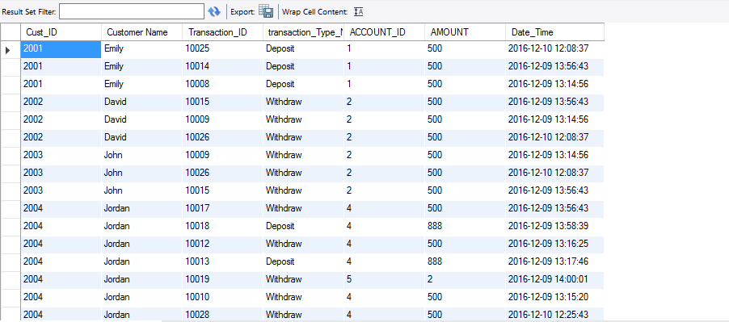

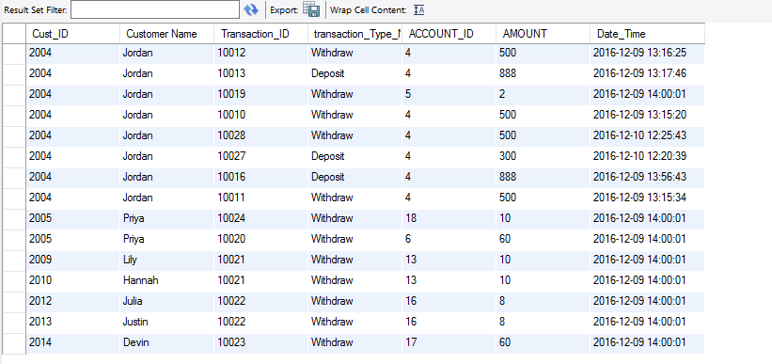

1. **Find the top banks based on the number of accounts.**

**CREATE VIEW** TopBanks AS

SELECT c.bank_name, b.branch_name, a.Branch_ID, count(*) AS NumberOfAccounts

FROM ACCOUNTS a

inner JOIN bank_branches b

ON a.Branch_ID = b.Branch_ID

INNER JOIN bank c

ON b.Bank_ID = c.Bank_ID

GROUP BY Branch_ID;

SELECT bank_name, SUM(NumberOfAccounts) AS NumberOfAccounts

FROM TopBanks

GROUP BY bank_name

ORDER BY NumberOfAccounts DESC;

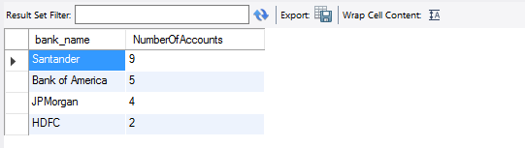

1. **Find the departments of all the employees.**

SELECT p.First_Name AS 'Employee Name', e.employee_ID, d.department_name

FROM employees e

INNER JOIN departments d

ON e.department_ID = d.department_ID

INNER JOIN persons p

ON e.Person_ID = p.Person_ID

ORDER BY employee_ID;

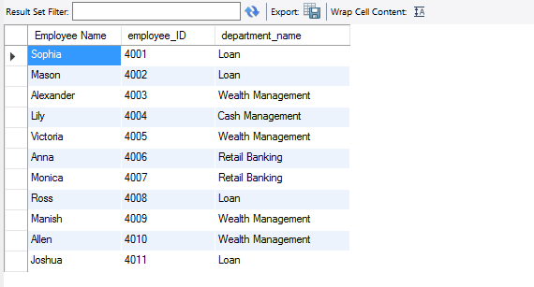

1. **Find the number of accounts having balance greater than average balance of all the accounts**.

SELECT COUNT(ACCOUNT_ID) FROM accounts

WHERE BALANCE >= (SELECT avg(Balance) FROM accounts);

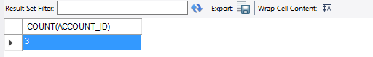

1. **Find the largest total account balance of any branch.**

SELECT MAX(Total_Balance) AS Larget_Total

FROM (SELECT Branch_ID, SUM(BALANCE) AS Total_Balance

FROM accounts

GROUP BY Branch_ID)

AS totals

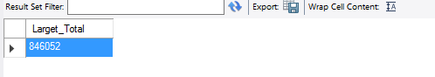

1. **Maintain the audit table for any change in the information of customers or employees of the bank.**

DELIMITER |

CREATE trigger tr_insert_audit

AFTER UPDATE ON persons

FOR EACH row

BEGIN

INSERT INTO audit

(

PERSON_ID,

DATE_TIME,

OLD_FIRST_NAME,

NEW_FIRST_NAME,

OLD_LAST_NAME,

NEW_LAST_NAME,

OLD_EMAIL,

NEW_EMAIL,

OLD_CONTACT_NUMBER,

NEW_CONTACT_NUMBER,

OLD_ZIPCODE_ID,

NEW_ZIPCODE_ID

)

VALUES (

OLD.PERSON_ID,

CURRENT_TIMESTAMP(),

OLD.FIRST_NAME,

NEW.FIRST_NAME,

OLD.LAST_NAME,

NEW.LAST_NAME,

OLD.EMAIL,

NEW.EMAIL,

OLD.CONTACT_NUMBER,

NEW.CONTACT_NUMBER,

OLD.ZIPCODE_ID,

NEW.ZIPCODE_ID);

END;

|

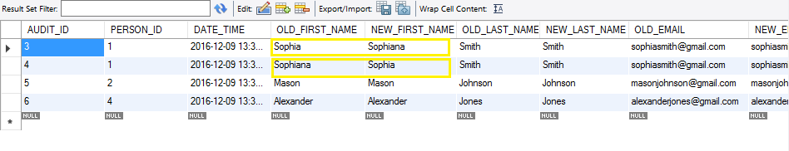

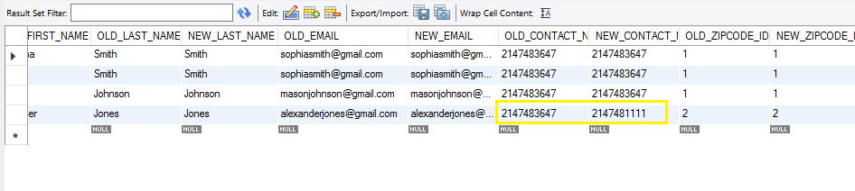

1. **Add 2% interest to all the bank account balances with a balance of 3000$ or less.**

UPDATE accounts

SET BALANCE = BALANCE*1.02

WHERE balance <= 3000

AND state = 'open'

AND ACCOUNT_ID > 0;

**Before:**

SELECT * FROM accounts

WHERE Balance < 3000;

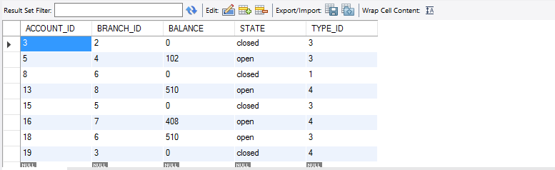

After:

SELECT * FROM accounts

WHERE Balance < 3000;

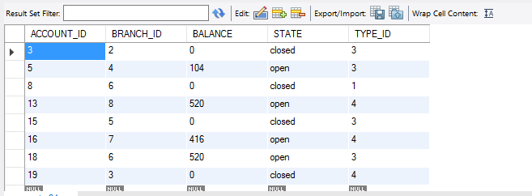

1. **Find the number of customers having joint accounts.**

SELECT COUNT(ACCOUNT_ID) - COUNT(DISTINCT(ACCOUNT_ID))

FROM customer_accounts;

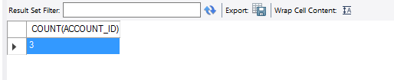

1. **Find the number of employees who are managers of some other employees**.

SELECT COUNT(DISTINCT(MANAGER_ID))

from employees;

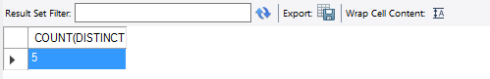

**APPENDIX**

CREATE DATABASE IF NOT EXISTS `bank` /*!40100 DEFAULT CHARACTER SET latin1 */;

USE `bank`;

-- MySQL dump 10.13 Distrib 5.6.13, for Win32 (x86)

--

-- Host: 127.0.0.1 Database: bank

-- ------------------------------------------------------

-- Server version 5.6.33

/*!40101 SET @OLD_CHARACTER_SET_CLIENT=@@CHARACTER_SET_CLIENT */;

/*!40101 SET @OLD_CHARACTER_SET_RESULTS=@@CHARACTER_SET_RESULTS */;

/*!40101 SET @OLD_COLLATION_CONNECTION=@@COLLATION_CONNECTION */;

/*!40101 SET NAMES utf8 */;

/*!40103 SET @OLD_TIME_ZONE=@@TIME_ZONE */;

/*!40103 SET TIME_ZONE='+00:00' */;

/*!40014 SET @OLD_UNIQUE_CHECKS=@@UNIQUE_CHECKS, UNIQUE_CHECKS=0 */;

/*!40014 SET @OLD_FOREIGN_KEY_CHECKS=@@FOREIGN_KEY_CHECKS, FOREIGN_KEY_CHECKS=0 */;

/*!40101 SET @OLD_SQL_MODE=@@SQL_MODE, SQL_MODE='NO_AUTO_VALUE_ON_ZERO' */;

/*!40111 SET @OLD_SQL_NOTES=@@SQL_NOTES, SQL_NOTES=0 */;

--

-- Table structure for table `account_types`

--

DROP TABLE IF EXISTS `account_types`;

/*!40101 SET @saved_cs_client = @@character_set_client */;

/*!40101 SET character_set_client = utf8 */;

CREATE TABLE `account_types` (

`TYPE_ID` int(11) NOT NULL,

`TYPE_NAME` varchar(20) DEFAULT NULL,

PRIMARY KEY (`TYPE_ID`)

) ENGINE=InnoDB DEFAULT CHARSET=latin1;

/*!40101 SET character_set_client = @saved_cs_client */;

--

-- Dumping data for table `account_types`

--

LOCK TABLES `account_types` WRITE;

/*!40000 ALTER TABLE `account_types` DISABLE KEYS */;

INSERT INTO `account_types` VALUES (1,'Savings'),(2,'Checking'),(3,'Loan'),(4,'Fixed deposits'),(5,'Recurring Deposits');

/*!40000 ALTER TABLE `account_types` ENABLE KEYS */;

UNLOCK TABLES;

--

-- Table structure for table `accounts`

--

DROP TABLE IF EXISTS `accounts`;

/*!40101 SET @saved_cs_client = @@character_set_client */;

/*!40101 SET character_set_client = utf8 */;

CREATE TABLE `accounts` (

`ACCOUNT_ID` int(11) NOT NULL,

`BRANCH_ID` int(11) NOT NULL,

`BALANCE` int(11) DEFAULT NULL,

`STATE` varchar(10) DEFAULT NULL,

`TYPE_ID` int(11) DEFAULT NULL,

PRIMARY KEY (`ACCOUNT_ID`),

KEY `IX_Relationship11` (`BRANCH_ID`),

KEY `IX_Relationship23` (`TYPE_ID`),

CONSTRAINT `Relationship11` FOREIGN KEY (`BRANCH_ID`) REFERENCES `bank_branches` (`BRANCH_ID`),

CONSTRAINT `Relationship23` FOREIGN KEY (`TYPE_ID`) REFERENCES `account_types` (`TYPE_ID`)

) ENGINE=InnoDB DEFAULT CHARSET=latin1;

/*!40101 SET character_set_client = @saved_cs_client */;

--

-- Dumping data for table `accounts`

--

LOCK TABLES `accounts` WRITE;

/*!40000 ALTER TABLE `accounts` DISABLE KEYS */;

INSERT INTO `accounts` VALUES (1,1,676787,'open',1),(2,1,58065,'open',2),(3,2,0,'closed',3),(4,3,7424,'open',1),(5,4,104,'open',3),(6,4,3060,'open',2),(7,5,8999,'open',1),(8,6,0,'closed',1),(9,1,10800,'open',3),(10,3,10000,'open',4),(11,1,100000,'open',3),(12,7,8000,'open',3),(13,8,520,'open',4),(14,3,7000,'open',1),(15,5,0,'closed',3),(16,7,416,'open',4),(17,8,3060,'open',2),(18,6,520,'open',3),(19,3,0,'closed',4),(20,3,5500,'open',1);

/*!40000 ALTER TABLE `accounts` ENABLE KEYS */;

UNLOCK TABLES;

/*!50003 SET @saved_cs_client = @@character_set_client */ ;

/*!50003 SET @saved_cs_results = @@character_set_results */ ;

/*!50003 SET @saved_col_connection = @@collation_connection */ ;

/*!50003 SET character_set_client = utf8 */ ;

/*!50003 SET character_set_results = utf8 */ ;

/*!50003 SET collation_connection = utf8_general_ci */ ;

/*!50003 SET @saved_sql_mode = @@sql_mode */ ;

/*!50003 SET sql_mode = 'NO_ENGINE_SUBSTITUTION' */ ;

DELIMITER ;;

/*!50003 CREATE*/ /*!50017 DEFINER=`root`@`localhost`*/ /*!50003 trigger tr_insert_transaction

AFTER UPDATE ON accounts

FOR EACH row

BEGIN

DECLARE TYPE_ID INT;

DECLARE AMOUNT INT;

IF OLD.BALANCE > NEW.BALANCE THEN

SET TYPE_ID = 2;

SET AMOUNT = OLD.BALANCE - NEW.BALANCE;

ELSE

SET TYPE_ID = 1;

SET AMOUNT = NEW.BALANCE - OLD.BALANCE;

END IF;

INSERT INTO transactions

(

DATE_TIME,

Transaction_Type_ID,

Account_ID,

AMOUNT,

OLD_BALANCE,

NEW_BALANCE)

VALUES (

CURRENT_TIMESTAMP(),

TYPE_ID,

OLD.Account_ID,

AMOUNT,

OLD.Balance,

NEW.Balance);

END */;;

DELIMITER ;

/*!50003 SET sql_mode = @saved_sql_mode */ ;

/*!50003 SET character_set_client = @saved_cs_client */ ;

/*!50003 SET character_set_results = @saved_cs_results */ ;

/*!50003 SET collation_connection = @saved_col_connection */ ;

--

-- Table structure for table `audit`

--

DROP TABLE IF EXISTS `audit`;

/*!40101 SET @saved_cs_client = @@character_set_client */;

/*!40101 SET character_set_client = utf8 */;

CREATE TABLE `audit` (

`AUDIT_ID` int(11) NOT NULL AUTO_INCREMENT,

`PERSON_ID` int(11) NOT NULL,

`DATE_TIME` datetime DEFAULT NULL,

`OLD_FIRST_NAME` varchar(30) NOT NULL,

`NEW_FIRST_NAME` varchar(30) NOT NULL,

`OLD_LAST_NAME` varchar(30) NOT NULL,

`NEW_LAST_NAME` varchar(30) NOT NULL,

`OLD_EMAIL` varchar(30) DEFAULT NULL,

`NEW_EMAIL` varchar(30) DEFAULT NULL,

`OLD_CONTACT_NUMBER` int(11) DEFAULT NULL,

`NEW_CONTACT_NUMBER` int(11) DEFAULT NULL,

`OLD_ZIPCODE_ID` int(11) DEFAULT NULL,

`NEW_ZIPCODE_ID` int(11) DEFAULT NULL,

PRIMARY KEY (`AUDIT_ID`),

KEY `PERSON_ID` (`PERSON_ID`),

CONSTRAINT `audit_ibfk_1` FOREIGN KEY (`PERSON_ID`) REFERENCES `persons` (`PERSON_ID`)

) ENGINE=InnoDB AUTO_INCREMENT=7 DEFAULT CHARSET=latin1;

/*!40101 SET character_set_client = @saved_cs_client */;

--

-- Dumping data for table `audit`

--

LOCK TABLES `audit` WRITE;

/*!40000 ALTER TABLE `audit` DISABLE KEYS */;

INSERT INTO `audit` VALUES (3,1,'2016-12-09 13:31:15','Sophia','Sophiana','Smith','Smith','sophiasmith@gmail.com','sophiasmith@gmail.com',2147483647,2147483647,1,1),(4,1,'2016-12-09 13:31:45','Sophiana','Sophia','Smith','Smith','sophiasmith@gmail.com','sophiasmith@gmail.com',2147483647,2147483647,1,1),(5,2,'2016-12-09 13:31:45','Mason','Mason','Johnson','Johnson','masonjohnson@gmail.com','masonjohnson@gmail.com',2147483647,2147483647,1,1),(6,4,'2016-12-09 13:34:04','Alexander','Alexander','Jones','Jones','alexanderjones@gmail.com','alexanderjones@gmail.com',2147483647,2147481111,2,2);

/*!40000 ALTER TABLE `audit` ENABLE KEYS */;

UNLOCK TABLES;

--

-- Table structure for table `bank`

--

DROP TABLE IF EXISTS `bank`;

/*!40101 SET @saved_cs_client = @@character_set_client */;

/*!40101 SET character_set_client = utf8 */;

CREATE TABLE `bank` (

`BANK_ID` int(11) NOT NULL,

`BANK_NAME` varchar(30) NOT NULL,

PRIMARY KEY (`BANK_ID`)

) ENGINE=InnoDB DEFAULT CHARSET=latin1;

/*!40101 SET character_set_client = @saved_cs_client */;

--

-- Dumping data for table `bank`

--

LOCK TABLES `bank` WRITE;

/*!40000 ALTER TABLE `bank` DISABLE KEYS */;

INSERT INTO `bank` VALUES (1,'Bank of America'),(2,'Santander'),(3,'HDFC'),(4,'JPMorgan');

/*!40000 ALTER TABLE `bank` ENABLE KEYS */;

UNLOCK TABLES;

--

-- Table structure for table `bank_branches`

--

DROP TABLE IF EXISTS `bank_branches`;

/*!40101 SET @saved_cs_client = @@character_set_client */;

/*!40101 SET character_set_client = utf8 */;

CREATE TABLE `bank_branches` (

`BRANCH_ID` int(11) NOT NULL,

`BRANCH_NAME` varchar(30) DEFAULT NULL,

`CONTACT_NUMBER` int(11) DEFAULT NULL,

`BANK_ID` int(11) NOT NULL,

`ZIPCODE_ID` int(11) NOT NULL,

PRIMARY KEY (`BRANCH_ID`),

KEY `IX_Relationship1` (`BANK_ID`),

KEY `IX_Relationship31` (`ZIPCODE_ID`),

CONSTRAINT `Relationship1` FOREIGN KEY (`BANK_ID`) REFERENCES `bank` (`BANK_ID`),

CONSTRAINT `Relationship31` FOREIGN KEY (`ZIPCODE_ID`) REFERENCES `zip_codes` (`ZIPCODE_ID`)

) ENGINE=InnoDB DEFAULT CHARSET=latin1;

/*!40101 SET character_set_client = @saved_cs_client */;

--

-- Dumping data for table `bank_branches`

--

LOCK TABLES `bank_branches` WRITE;

/*!40000 ALTER TABLE `bank_branches` DISABLE KEYS */;

INSERT INTO `bank_branches` VALUES (1,'Bofa-Beacon Street',2147483647,1,1),(2,'Bofa-Huntington Avenue',2147483647,1,2),(3,'Santander-Huntington Avenue',2147483647,2,2),(4,'Santander-Princeton',2147483647,2,3),(5,'Santander-Miami',2147483647,2,4),(6,'HDFC-Powai',2147483647,3,5),(7,'JPMorgan-Princeton',2147483647,4,3),(8,'JPMorgan-Miami',2147483647,4,4);

/*!40000 ALTER TABLE `bank_branches` ENABLE KEYS */;

UNLOCK TABLES;

--

-- Table structure for table `branch_departments`

--

DROP TABLE IF EXISTS `branch_departments`;

/*!40101 SET @saved_cs_client = @@character_set_client */;

/*!40101 SET character_set_client = utf8 */;

CREATE TABLE `branch_departments` (

`BRANCH_ID` int(11) NOT NULL,

`DEPARTMENT_ID` int(11) NOT NULL,

PRIMARY KEY (`BRANCH_ID`,`DEPARTMENT_ID`),

KEY `Relationship4` (`DEPARTMENT_ID`),

CONSTRAINT `Relationship3` FOREIGN KEY (`BRANCH_ID`) REFERENCES `bank_branches` (`BRANCH_ID`),

CONSTRAINT `Relationship4` FOREIGN KEY (`DEPARTMENT_ID`) REFERENCES `departments` (`DEPARTMENT_ID`)

) ENGINE=InnoDB DEFAULT CHARSET=latin1;

/*!40101 SET character_set_client = @saved_cs_client */;

--

-- Dumping data for table `branch_departments`

--

LOCK TABLES `branch_departments` WRITE;

/*!40000 ALTER TABLE `branch_departments` DISABLE KEYS */;

INSERT INTO `branch_departments` VALUES (1,1),(3,1),(5,1),(7,1),(8,1),(1,2),(3,2),(4,2),(6,2),(8,2),(2,3),(3,3),(6,3),(7,3),(8,3),(2,4),(3,4),(4,4),(5,4),(6,4),(7,4),(8,4),(1,5),(2,5),(3,5),(5,5),(8,5);

/*!40000 ALTER TABLE `branch_departments` ENABLE KEYS */;

UNLOCK TABLES;

--

-- Table structure for table `branch_facilities`

--

DROP TABLE IF EXISTS `branch_facilities`;

/*!40101 SET @saved_cs_client = @@character_set_client */;

/*!40101 SET character_set_client = utf8 */;

CREATE TABLE `branch_facilities` (

`BRANCH_ID` int(11) NOT NULL,

`FACILITY_ID` int(11) NOT NULL,

PRIMARY KEY (`BRANCH_ID`,`FACILITY_ID`),

KEY `Relationship9` (`FACILITY_ID`),

CONSTRAINT `Relationship10` FOREIGN KEY (`BRANCH_ID`) REFERENCES `bank_branches` (`BRANCH_ID`),

CONSTRAINT `Relationship9` FOREIGN KEY (`FACILITY_ID`) REFERENCES `facilities` (`FACILITY_ID`)

) ENGINE=InnoDB DEFAULT CHARSET=latin1;

/*!40101 SET character_set_client = @saved_cs_client */;

--

-- Dumping data for table `branch_facilities`

--

LOCK TABLES `branch_facilities` WRITE;

/*!40000 ALTER TABLE `branch_facilities` DISABLE KEYS */;

INSERT INTO `branch_facilities` VALUES (1,1),(2,1),(5,1),(6,1),(8,1),(1,2),(2,2),(3,2),(4,2),(6,2),(7,2),(1,3),(2,3),(6,3),(7,3),(8,3),(2,4),(4,4),(5,4),(7,4),(2,5),(3,5),(4,5),(6,5),(8,5);

/*!40000 ALTER TABLE `branch_facilities` ENABLE KEYS */;

UNLOCK TABLES;

--

-- Table structure for table `card_types`

--

DROP TABLE IF EXISTS `card_types`;

/*!40101 SET @saved_cs_client = @@character_set_client */;

/*!40101 SET character_set_client = utf8 */;

CREATE TABLE `card_types` (

`CARD_TYPE_ID` int(11) NOT NULL,

`CARD_TYPE_NAME` varchar(20) DEFAULT NULL,

PRIMARY KEY (`CARD_TYPE_ID`)

) ENGINE=InnoDB DEFAULT CHARSET=latin1;

/*!40101 SET character_set_client = @saved_cs_client */;

--

-- Dumping data for table `card_types`

--

LOCK TABLES `card_types` WRITE;

/*!40000 ALTER TABLE `card_types` DISABLE KEYS */;

INSERT INTO `card_types` VALUES (1,'Debit Card'),(2,'Credit Card');

/*!40000 ALTER TABLE `card_types` ENABLE KEYS */;

UNLOCK TABLES;

--

-- Table structure for table `cards`

--

DROP TABLE IF EXISTS `cards`;

/*!40101 SET @saved_cs_client = @@character_set_client */;

/*!40101 SET character_set_client = utf8 */;

CREATE TABLE `cards` (

`CARD_NO` varchar(20) NOT NULL,

`EXPIRY` date NOT NULL,

`CVV` int(11) NOT NULL,

`TOTAL_CREDIT_LIMIT` double DEFAULT NULL,

`AVAILABLE_BALANCE` double DEFAULT NULL,

`ACCOUNT_ID` int(11) NOT NULL,

`CARD_TYPE_ID` int(11) NOT NULL,

PRIMARY KEY (`CARD_NO`),

KEY `ACCOUNT_ID` (`ACCOUNT_ID`),

KEY `CARD_TYPE_ID` (`CARD_TYPE_ID`),

CONSTRAINT `cards_ibfk_1` FOREIGN KEY (`ACCOUNT_ID`) REFERENCES `accounts` (`ACCOUNT_ID`),

CONSTRAINT `cards_ibfk_2` FOREIGN KEY (`CARD_TYPE_ID`) REFERENCES `card_types` (`CARD_TYPE_ID`)

) ENGINE=InnoDB DEFAULT CHARSET=latin1;

/*!40101 SET character_set_client = @saved_cs_client */;

--

-- Dumping data for table `cards`

--

LOCK TABLES `cards` WRITE;

/*!40000 ALTER TABLE `cards` DISABLE KEYS */;

INSERT INTO `cards` VALUES ('3099383746','2030-08-23',577,0,0,1,1),('8473749583','2025-11-29',965,10000,10000,4,2),('8474637384','2018-03-26',877,0,0,2,1),('8746798541','2020-12-31',942,5000,5000,5,2);

/*!40000 ALTER TABLE `cards` ENABLE KEYS */;

UNLOCK TABLES;

--

-- Table structure for table `cities`

--

DROP TABLE IF EXISTS `cities`;

/*!40101 SET @saved_cs_client = @@character_set_client */;

/*!40101 SET character_set_client = utf8 */;

CREATE TABLE `cities` (

`CITY_ID` int(11) NOT NULL,

`CITY_NAME` varchar(30) DEFAULT NULL,

`STATE_ID` int(11) NOT NULL,

PRIMARY KEY (`CITY_ID`),

KEY `IX_Relationship7` (`STATE_ID`),

CONSTRAINT `Relationship7` FOREIGN KEY (`STATE_ID`) REFERENCES `states` (`STATE_ID`)

) ENGINE=InnoDB DEFAULT CHARSET=latin1;

/*!40101 SET character_set_client = @saved_cs_client */;

--

-- Dumping data for table `cities`

--

LOCK TABLES `cities` WRITE;

/*!40000 ALTER TABLE `cities` DISABLE KEYS */;

INSERT INTO `cities` VALUES (1,'Boston',1),(2,'Jersey City',2),(3,'Miami',3),(4,'Mumbai',4);

/*!40000 ALTER TABLE `cities` ENABLE KEYS */;

UNLOCK TABLES;

--

-- Table structure for table `countries`

--

DROP TABLE IF EXISTS `countries`;

/*!40101 SET @saved_cs_client = @@character_set_client */;

/*!40101 SET character_set_client = utf8 */;

CREATE TABLE `countries` (

`COUNTRY_ID` int(11) NOT NULL,

`COUNTRY_NAME` varchar(30) DEFAULT NULL,

PRIMARY KEY (`COUNTRY_ID`)

) ENGINE=InnoDB DEFAULT CHARSET=latin1;

/*!40101 SET character_set_client = @saved_cs_client */;

--

-- Dumping data for table `countries`

--

LOCK TABLES `countries` WRITE;

/*!40000 ALTER TABLE `countries` DISABLE KEYS */;

INSERT INTO `countries` VALUES (1,'USA'),(2,'India');

/*!40000 ALTER TABLE `countries` ENABLE KEYS */;

UNLOCK TABLES;

--

-- Table structure for table `customer_accounts`

--

DROP TABLE IF EXISTS `customer_accounts`;

/*!40101 SET @saved_cs_client = @@character_set_client */;

/*!40101 SET character_set_client = utf8 */;

CREATE TABLE `customer_accounts` (

`CUST_ID` int(11) NOT NULL,

`ACCOUNT_ID` int(11) NOT NULL,

PRIMARY KEY (`CUST_ID`,`ACCOUNT_ID`),

KEY `Relationship26` (`ACCOUNT_ID`),

CONSTRAINT `Relationship26` FOREIGN KEY (`ACCOUNT_ID`) REFERENCES `accounts` (`ACCOUNT_ID`),

CONSTRAINT `Relationship27` FOREIGN KEY (`CUST_ID`) REFERENCES `customers` (`CUST_ID`)

) ENGINE=InnoDB DEFAULT CHARSET=latin1;

/*!40101 SET character_set_client = @saved_cs_client */;

--

-- Dumping data for table `customer_accounts`

--

LOCK TABLES `customer_accounts` WRITE;

/*!40000 ALTER TABLE `customer_accounts` DISABLE KEYS */;

INSERT INTO `customer_accounts` VALUES (2001,1),(2002,2),(2003,2),(2004,3),(2004,4),(2004,5),(2005,6),(2005,7),(2006,9),(2007,10),(2006,11),(2008,12),(2009,13),(2010,13),(2011,14),(2012,15),(2012,16),(2013,16),(2014,17),(2005,18),(2002,19),(2014,20);

/*!40000 ALTER TABLE `customer_accounts` ENABLE KEYS */;

UNLOCK TABLES;

--

-- Table structure for table `customer_facilities`

--

DROP TABLE IF EXISTS `customer_facilities`;

/*!40101 SET @saved_cs_client = @@character_set_client */;

/*!40101 SET character_set_client = utf8 */;

CREATE TABLE `customer_facilities` (

`CUST_ID` int(11) NOT NULL,

`FACILITY_ID` int(11) NOT NULL,

PRIMARY KEY (`CUST_ID`,`FACILITY_ID`),

KEY `Relationship25` (`FACILITY_ID`),

CONSTRAINT `Relationship24` FOREIGN KEY (`CUST_ID`) REFERENCES `customers` (`CUST_ID`),

CONSTRAINT `Relationship25` FOREIGN KEY (`FACILITY_ID`) REFERENCES `facilities` (`FACILITY_ID`)

) ENGINE=InnoDB DEFAULT CHARSET=latin1;

/*!40101 SET character_set_client = @saved_cs_client */;

--

-- Dumping data for table `customer_facilities`

--

LOCK TABLES `customer_facilities` WRITE;

/*!40000 ALTER TABLE `customer_facilities` DISABLE KEYS */;

INSERT INTO `customer_facilities` VALUES (2001,1),(2002,1),(2003,1),(2005,1),(2007,1),(2008,1),(2011,1),(2001,2),(2005,2),(2007,2),(2008,2),(2010,2),(2013,2),(2003,3),(2005,3),(2009,3),(2012,3),(2013,3),(2002,4),(2003,4),(2005,4),(2006,4),(2009,4),(2010,4),(2011,4),(2004,5),(2006,5),(2007,5),(2009,5),(2011,5),(2014,5);

/*!40000 ALTER TABLE `customer_facilities` ENABLE KEYS */;

UNLOCK TABLES;

--

-- Table structure for table `customers`

--

DROP TABLE IF EXISTS `customers`;

/*!40101 SET @saved_cs_client = @@character_set_client */;

/*!40101 SET character_set_client = utf8 */;

CREATE TABLE `customers` (

`CUST_ID` int(11) NOT NULL,

`PERSON_ID` int(11) NOT NULL,

PRIMARY KEY (`CUST_ID`),

KEY `IX_Relationship22` (`PERSON_ID`),

CONSTRAINT `Relationship22` FOREIGN KEY (`PERSON_ID`) REFERENCES `persons` (`PERSON_ID`)

) ENGINE=InnoDB DEFAULT CHARSET=latin1;

/*!40101 SET character_set_client = @saved_cs_client */;

--

-- Dumping data for table `customers`

--

LOCK TABLES `customers` WRITE;

/*!40000 ALTER TABLE `customers` DISABLE KEYS */;

INSERT INTO `customers` VALUES (2001,3),(2002,6),(2003,8),(2004,12),(2005,14),(2006,15),(2007,16),(2008,17),(2009,19),(2010,20),(2011,22),(2012,23),(2013,24),(2014,25);

/*!40000 ALTER TABLE `customers` ENABLE KEYS */;

UNLOCK TABLES;

--

-- Table structure for table `departments`

--

DROP TABLE IF EXISTS `departments`;

/*!40101 SET @saved_cs_client = @@character_set_client */;

/*!40101 SET character_set_client = utf8 */;

CREATE TABLE `departments` (

`DEPARTMENT_ID` int(11) NOT NULL,

`DEPARTMENT_NAME` varchar(30) DEFAULT NULL,

PRIMARY KEY (`DEPARTMENT_ID`)

) ENGINE=InnoDB DEFAULT CHARSET=latin1;

/*!40101 SET character_set_client = @saved_cs_client */;

--

-- Dumping data for table `departments`

--

LOCK TABLES `departments` WRITE;

/*!40000 ALTER TABLE `departments` DISABLE KEYS */;

INSERT INTO `departments` VALUES (1,'Loan'),(2,'Wealth Management'),(3,'Cash Management'),(4,'Retail Banking '),(5,'Wire transfer operations');

/*!40000 ALTER TABLE `departments` ENABLE KEYS */;

UNLOCK TABLES;

--

-- Table structure for table `employees`

--

DROP TABLE IF EXISTS `employees`;

/*!40101 SET @saved_cs_client = @@character_set_client */;

/*!40101 SET character_set_client = utf8 */;

CREATE TABLE `employees` (

`EMPLOYEE_ID` int(11) NOT NULL,

`MANAGER_ID` int(11) DEFAULT NULL,

`JOINING_DATE` date DEFAULT NULL,

`TITLE_ID` int(11) NOT NULL,

`DEPARTMENT_ID` int(11) DEFAULT NULL,

`PERSON_ID` int(11) NOT NULL,

PRIMARY KEY (`EMPLOYEE_ID`),

KEY `IX_Relationship16` (`TITLE_ID`),

KEY `IX_Relationship17` (`DEPARTMENT_ID`),

KEY `IX_Relationship20` (`MANAGER_ID`),

KEY `IX_Relationship21` (`PERSON_ID`)

) ENGINE=InnoDB DEFAULT CHARSET=latin1;

/*!40101 SET character_set_client = @saved_cs_client */;

--

-- Dumping data for table `employees`

--

LOCK TABLES `employees` WRITE;

/*!40000 ALTER TABLE `employees` DISABLE KEYS */;

INSERT INTO `employees` VALUES (4001,0,'2013-12-12',1,1,1),(4002,1,'2014-06-03',3,1,2),(4003,0,'2011-05-07',4,2,4),(4004,0,'2008-08-20',3,3,5),(4005,4,'2009-04-07',2,2,7),(4006,0,'2015-04-01',3,4,9),(4007,9,'2016-03-30',2,4,10),(4008,2,'2013-06-18',2,1,11),(4009,4,'2007-08-27',3,2,13),(4010,4,'2015-03-23',3,2,18),(4011,2,'0000-00-00',1,1,21);

/*!40000 ALTER TABLE `employees` ENABLE KEYS */;

UNLOCK TABLES;

--

-- Table structure for table `facilities`

--

DROP TABLE IF EXISTS `facilities`;

/*!40101 SET @saved_cs_client = @@character_set_client */;

/*!40101 SET character_set_client = utf8 */;

CREATE TABLE `facilities` (

`FACILITY_ID` int(11) NOT NULL,

`FACILITY_NAME` varchar(20) DEFAULT NULL,

PRIMARY KEY (`FACILITY_ID`)

) ENGINE=InnoDB DEFAULT CHARSET=latin1;

/*!40101 SET character_set_client = @saved_cs_client */;

--

-- Dumping data for table `facilities`

--

LOCK TABLES `facilities` WRITE;

/*!40000 ALTER TABLE `facilities` DISABLE KEYS */;

INSERT INTO `facilities` VALUES (1,'Fixed Deposits'),(2,'Mutual Funds'),(3,'ATM'),(4,'Online Banking'),(5,'Cash Credit');

/*!40000 ALTER TABLE `facilities` ENABLE KEYS */;

UNLOCK TABLES;

--

-- Table structure for table `job_titles`

--

DROP TABLE IF EXISTS `job_titles`;

/*!40101 SET @saved_cs_client = @@character_set_client */;

/*!40101 SET character_set_client = utf8 */;

CREATE TABLE `job_titles` (

`TITLE_ID` int(11) NOT NULL,

`TITLE_NAME` varchar(20) DEFAULT NULL,

PRIMARY KEY (`TITLE_ID`)

) ENGINE=InnoDB DEFAULT CHARSET=latin1;

/*!40101 SET character_set_client = @saved_cs_client */;

--

-- Dumping data for table `job_titles`

--

LOCK TABLES `job_titles` WRITE;

/*!40000 ALTER TABLE `job_titles` DISABLE KEYS */;

INSERT INTO `job_titles` VALUES (1,'Clerk'),(2,'Officer'),(3,'Manager'),(4,'Senior Manager');

/*!40000 ALTER TABLE `job_titles` ENABLE KEYS */;

UNLOCK TABLES;

--

-- Table structure for table `persons`

--

DROP TABLE IF EXISTS `persons`;

/*!40101 SET @saved_cs_client = @@character_set_client */;

/*!40101 SET character_set_client = utf8 */;

CREATE TABLE `persons` (

`PERSON_ID` int(11) NOT NULL,

`FIRST_NAME` varchar(30) NOT NULL,

`LAST_NAME` varchar(30) NOT NULL,

`EMAIL` varchar(30) DEFAULT NULL,

`CONTACT_NUMBER` int(11) DEFAULT NULL,

`ZIPCODE_ID` int(11) DEFAULT NULL,

PRIMARY KEY (`PERSON_ID`),

KEY `IX_Relationship15` (`ZIPCODE_ID`),

CONSTRAINT `Relationship15` FOREIGN KEY (`ZIPCODE_ID`) REFERENCES `zip_codes` (`ZIPCODE_ID`)

) ENGINE=InnoDB DEFAULT CHARSET=latin1;

/*!40101 SET character_set_client = @saved_cs_client */;

--

-- Dumping data for table `persons`

--

LOCK TABLES `persons` WRITE;

/*!40000 ALTER TABLE `persons` DISABLE KEYS */;

INSERT INTO `persons` VALUES (1,'Sophia','Smith','sophiasmith@gmail.com',2147483647,1),(2,'Mason','Johnson','masonjohnson@gmail.com',2147483647,1),(3,'Emily','Williams','emilywilliams@gmail.com',2147483647,1),(4,'Alexander','Jones','alexanderjones@gmail.com',2147481111,2),(5,'Lily','Brown','lilybrown@gmail.com',2147483647,2),(6,'David','Davis','daviddavis@gmail.com',2147483647,2),(7,'Victoria','Miller','victoriamiller@gmail.com',2147483647,2),(8,'John','Taylor','johntaylor@gmail.com',2147483647,2),(9,'Anna','Thomas','annathomas@gmail.com',2147483647,3),(10,'Monica','Russel','monicarussel@gmail.com',2147483647,3),(11,'Ross','Green','rossgreen@gmail.com',2147483647,4),(12,'Jordan ','Martin','jordanmartin@gmail.com',2147483647,4),(13,'Manish','Malhotra','manishmalhotra@gmail.com',2147483647,5),(14,'Priya','Deshpande','priyadeshpande@gmail.com',2147483647,5),(15,'Ashwini','Ratnaparkhi','ashwiniratnaparkhi@gmail.com',2147483647,5),(16,'Radha ','Deodhar','radhadeodhar@gmail.com',2147483647,5),(17,'Neha ','Shetty','nehashetty@gmail.com',2147483647,5),(18,'Allen ','Green','allengreen@gmail.com',2147483647,3),(19,'Lily','Taylor','lilytaylor@gmail.com',2147483647,3),(20,'Hannah','Clark','hannahclark@gmail.com',2147483647,3),(21,'Joshua','Lee','joshualee@gmail.com',2147483647,4),(22,'Benjamin','Hall','benjaminhall@gmail.com',2147483647,4),(23,'Julia','King','juliaking@gmail.com',2147483647,4),(24,'Justin','Baker','justinbaker@gmail.com',2147483647,1),(25,'Devin','Parker','devinparker@gmail.com',2147483647,2);

/*!40000 ALTER TABLE `persons` ENABLE KEYS */;

UNLOCK TABLES;

/*!50003 SET @saved_cs_client = @@character_set_client */ ;

/*!50003 SET @saved_cs_results = @@character_set_results */ ;

/*!50003 SET @saved_col_connection = @@collation_connection */ ;

/*!50003 SET character_set_client = utf8 */ ;

/*!50003 SET character_set_results = utf8 */ ;

/*!50003 SET collation_connection = utf8_general_ci */ ;

/*!50003 SET @saved_sql_mode = @@sql_mode */ ;

/*!50003 SET sql_mode = 'NO_ENGINE_SUBSTITUTION' */ ;

DELIMITER ;;

/*!50003 CREATE*/ /*!50017 DEFINER=`root`@`localhost`*/ /*!50003 trigger tr_insert_audit

AFTER UPDATE ON persons

FOR EACH row

BEGIN

INSERT INTO audit

(

PERSON_ID,

DATE_TIME,

OLD_FIRST_NAME,

NEW_FIRST_NAME,

OLD_LAST_NAME,

NEW_LAST_NAME,

OLD_EMAIL,

NEW_EMAIL,

OLD_CONTACT_NUMBER,

NEW_CONTACT_NUMBER,

OLD_ZIPCODE_ID,

NEW_ZIPCODE_ID

)

VALUES (

OLD.PERSON_ID,

CURRENT_TIMESTAMP(),

OLD.FIRST_NAME,

NEW.FIRST_NAME,

OLD.LAST_NAME,

NEW.LAST_NAME,

OLD.EMAIL,

NEW.EMAIL,

OLD.CONTACT_NUMBER,

NEW.CONTACT_NUMBER,

OLD.ZIPCODE_ID,

NEW.ZIPCODE_ID);

END */;;

DELIMITER ;

/*!50003 SET sql_mode = @saved_sql_mode */ ;

/*!50003 SET character_set_client = @saved_cs_client */ ;

/*!50003 SET character_set_results = @saved_cs_results */ ;

/*!50003 SET collation_connection = @saved_col_connection */ ;

--

-- Table structure for table `states`

--

DROP TABLE IF EXISTS `states`;

/*!40101 SET @saved_cs_client = @@character_set_client */;

/*!40101 SET character_set_client = utf8 */;

CREATE TABLE `states` (

`STATE_ID` int(11) NOT NULL,

`STATE_NAME` varchar(30) DEFAULT NULL,

`COUNTRY_ID` int(11) NOT NULL,

PRIMARY KEY (`STATE_ID`),

KEY `IX_Relationship8` (`COUNTRY_ID`),

CONSTRAINT `Relationship8` FOREIGN KEY (`COUNTRY_ID`) REFERENCES `countries` (`COUNTRY_ID`)

) ENGINE=InnoDB DEFAULT CHARSET=latin1;

/*!40101 SET character_set_client = @saved_cs_client */;

--

-- Dumping data for table `states`

--

LOCK TABLES `states` WRITE;

/*!40000 ALTER TABLE `states` DISABLE KEYS */;

INSERT INTO `states` VALUES (1,'Masachussets',1),(2,'New Jersey',1),(3,'Florida',1),(4,'Maharashtra',2);

/*!40000 ALTER TABLE `states` ENABLE KEYS */;

UNLOCK TABLES;

--

-- Temporary table structure for view `topbanks`

--

DROP TABLE IF EXISTS `topbanks`;

/*!50001 DROP VIEW IF EXISTS `topbanks`*/;

SET @saved_cs_client = @@character_set_client;

SET character_set_client = utf8;

/*!50001 CREATE TABLE `topbanks` (

`bank_name` tinyint NOT NULL,

`branch_name` tinyint NOT NULL,

`Branch_ID` tinyint NOT NULL,

`NumberOfAccounts` tinyint NOT NULL

) ENGINE=MyISAM */;

SET character_set_client = @saved_cs_client;

--

-- Table structure for table `transaction_type`

--

DROP TABLE IF EXISTS `transaction_type`;

/*!40101 SET @saved_cs_client = @@character_set_client */;

/*!40101 SET character_set_client = utf8 */;

CREATE TABLE `transaction_type` (

`TRANSACTION_TYPE_ID` int(11) NOT NULL,

`TRANSACTION_TYPE_NAME` varchar(20) DEFAULT NULL,

PRIMARY KEY (`TRANSACTION_TYPE_ID`)

) ENGINE=InnoDB DEFAULT CHARSET=latin1;

/*!40101 SET character_set_client = @saved_cs_client */;

--

-- Dumping data for table `transaction_type`

--

LOCK TABLES `transaction_type` WRITE;

/*!40000 ALTER TABLE `transaction_type` DISABLE KEYS */;

INSERT INTO `transaction_type` VALUES (1,'Withdraw'),(2,'Deposit');

/*!40000 ALTER TABLE `transaction_type` ENABLE KEYS */;

UNLOCK TABLES;

--

-- Table structure for table `transactions`

--

DROP TABLE IF EXISTS `transactions`;

/*!40101 SET @saved_cs_client = @@character_set_client */;

/*!40101 SET character_set_client = utf8 */;

CREATE TABLE `transactions` (

`TRANSACTION_ID` int(11) NOT NULL AUTO_INCREMENT,

`DATE_TIME` datetime NOT NULL,

`TRANSACTION_TYPE_ID` int(11) NOT NULL,

`ACCOUNT_ID` int(11) NOT NULL,

`AMOUNT` int(11) NOT NULL,

`OLD_BALANCE` int(11) NOT NULL,

`NEW_BALANCE` int(11) NOT NULL,

PRIMARY KEY (`TRANSACTION_ID`),

KEY `IX_Relationship29` (`TRANSACTION_TYPE_ID`),

KEY `IX_Relationship32` (`ACCOUNT_ID`)

) ENGINE=InnoDB AUTO_INCREMENT=10035 DEFAULT CHARSET=latin1;

/*!40101 SET character_set_client = @saved_cs_client */;

--

-- Dumping data for table `transactions`

--

LOCK TABLES `transactions` WRITE;

/*!40000 ALTER TABLE `transactions` DISABLE KEYS */;

INSERT INTO `transactions` VALUES (10001,'2016-12-07 10:33:35',1,4,500,10948,11448),(10002,'2016-12-07 10:34:55',1,4,500,11448,11948),(10003,'2016-12-07 10:35:41',1,4,500,11948,12448),(10004,'2016-12-07 10:35:57',2,4,888,12448,11560),(10005,'2016-12-07 10:36:17',2,1,500,675187,674687),(10006,'2016-12-07 10:36:17',1,2,500,60065,60565),(10007,'2016-12-07 10:36:35',1,3,500,0,500),(10008,'2016-12-09 13:14:56',2,1,500,678687,678187),(10009,'2016-12-09 13:14:56',1,2,500,56565,57065),(10010,'2016-12-09 13:15:20',1,4,500,7888,8388),(10011,'2016-12-09 13:15:34',1,4,500,8388,8888),(10012,'2016-12-09 13:16:25',1,4,500,8888,9388),(10013,'2016-12-09 13:17:46',2,4,888,9388,8500),(10014,'2016-12-09 13:56:43',2,1,500,678187,677687),(10015,'2016-12-09 13:56:43',1,2,500,57065,57565),(10016,'2016-12-09 13:56:43',2,4,888,8500,7612),(10017,'2016-12-09 13:56:43',1,4,500,7612,8112),(10018,'2016-12-09 13:58:39',2,4,888,8112,7224),(10019,'2016-12-09 14:00:01',1,5,2,100,102),(10020,'2016-12-09 14:00:01',1,6,60,3000,3060),(10021,'2016-12-09 14:00:01',1,13,10,500,510),(10022,'2016-12-09 14:00:01',1,16,8,400,408),(10023,'2016-12-09 14:00:01',1,17,60,3000,3060),(10024,'2016-12-09 14:00:01',1,18,10,500,510),(10025,'2016-12-10 12:08:37',2,1,500,677687,677187),(10026,'2016-12-10 12:08:37',1,2,500,57565,58065),(10027,'2016-12-10 12:20:39',2,4,300,7224,6924),(10028,'2016-12-10 12:25:43',1,4,500,6924,7424),(10029,'2016-12-10 13:07:48',1,5,2,102,104),(10030,'2016-12-10 13:07:48',1,13,10,510,520),(10031,'2016-12-10 13:07:48',1,16,8,408,416),(10032,'2016-12-10 13:07:48',1,18,10,510,520),(10033,'2016-12-10 15:17:54',2,1,200,677187,676987),(10034,'2016-12-10 15:40:37',2,1,200,676987,676787);

/*!40000 ALTER TABLE `transactions` ENABLE KEYS */;

UNLOCK TABLES;

--

-- Temporary table structure for view `transactionsbetweengivendates`

--

DROP TABLE IF EXISTS `transactionsbetweengivendates`;

/*!50001 DROP VIEW IF EXISTS `transactionsbetweengivendates`*/;

SET @saved_cs_client = @@character_set_client;

SET character_set_client = utf8;

/*!50001 CREATE TABLE `transactionsbetweengivendates` (

`Cust_ID` tinyint NOT NULL,

`Customer Name` tinyint NOT NULL,

`Transaction_ID` tinyint NOT NULL,

`transaction_Type_Name` tinyint NOT NULL,

`ACCOUNT_ID` tinyint NOT NULL,

`AMOUNT` tinyint NOT NULL,

`Date_Time` tinyint NOT NULL

) ENGINE=MyISAM */;

SET character_set_client = @saved_cs_client;

--

-- Table structure for table `zip_codes`

--

DROP TABLE IF EXISTS `zip_codes`;

/*!40101 SET @saved_cs_client = @@character_set_client */;

/*!40101 SET character_set_client = utf8 */;

CREATE TABLE `zip_codes` (

`ZIPCODE_ID` int(11) NOT NULL,

`ZIP_CODE` int(11) DEFAULT NULL,

`CITY_ID` int(11) NOT NULL,

PRIMARY KEY (`ZIPCODE_ID`),

KEY `IX_Relationship30` (`CITY_ID`),

CONSTRAINT `Relationship30` FOREIGN KEY (`CITY_ID`) REFERENCES `cities` (`CITY_ID`)

) ENGINE=InnoDB DEFAULT CHARSET=latin1;

/*!40101 SET character_set_client = @saved_cs_client */;

--

-- Dumping data for table `zip_codes`

--

LOCK TABLES `zip_codes` WRITE;

/*!40000 ALTER TABLE `zip_codes` DISABLE KEYS */;

INSERT INTO `zip_codes` VALUES (1,2108,1),(2,2116,1),(3,8540,2),(4,33101,3),(5,440029,4);

/*!40000 ALTER TABLE `zip_codes` ENABLE KEYS */;

UNLOCK TABLES;

--

-- Final view structure for view `topbanks`

--

/*!50001 DROP TABLE IF EXISTS `topbanks`*/;

/*!50001 DROP VIEW IF EXISTS `topbanks`*/;

/*!50001 SET @saved_cs_client = @@character_set_client */;

/*!50001 SET @saved_cs_results = @@character_set_results */;

/*!50001 SET @saved_col_connection = @@collation_connection */;

/*!50001 SET character_set_client = utf8 */;

/*!50001 SET character_set_results = utf8 */;

/*!50001 SET collation_connection = utf8_general_ci */;

/*!50001 CREATE ALGORITHM=UNDEFINED */

/*!50013 DEFINER=`root`@`localhost` SQL SECURITY DEFINER */

/*!50001 VIEW `topbanks` AS select `c`.`BANK_NAME` AS `bank_name`,`b`.`BRANCH_NAME` AS `branch_name`,`a`.`BRANCH_ID` AS `Branch_ID`,count(0) AS `NumberOfAccounts` from ((`accounts` `a` join `bank_branches` `b` on((`a`.`BRANCH_ID` = `b`.`BRANCH_ID`))) join `bank` `c` on((`b`.`BANK_ID` = `c`.`BANK_ID`))) group by `a`.`BRANCH_ID` */;

/*!50001 SET character_set_client = @saved_cs_client */;

/*!50001 SET character_set_results = @saved_cs_results */;

/*!50001 SET collation_connection = @saved_col_connection */;

--

-- Final view structure for view `transactionsbetweengivendates`

--

/*!50001 DROP TABLE IF EXISTS `transactionsbetweengivendates`*/;

/*!50001 DROP VIEW IF EXISTS `transactionsbetweengivendates`*/;

/*!50001 SET @saved_cs_client = @@character_set_client */;

/*!50001 SET @saved_cs_results = @@character_set_results */;

/*!50001 SET @saved_col_connection = @@collation_connection */;

/*!50001 SET character_set_client = utf8 */;

/*!50001 SET character_set_results = utf8 */;

/*!50001 SET collation_connection = utf8_general_ci */;

/*!50001 CREATE ALGORITHM=UNDEFINED */

/*!50013 DEFINER=`root`@`localhost` SQL SECURITY DEFINER */

/*!50001 VIEW `transactionsbetweengivendates` AS select `c`.`CUST_ID` AS `Cust_ID`,`p`.`FIRST_NAME` AS `Customer Name`,`t`.`TRANSACTION_ID` AS `Transaction_ID`,`tt`.`TRANSACTION_TYPE_NAME` AS `transaction_Type_Name`,`t`.`ACCOUNT_ID` AS `ACCOUNT_ID`,`t`.`AMOUNT` AS `AMOUNT`,`t`.`DATE_TIME` AS `Date_Time` from ((((`transactions` `t` join `transaction_type` `tt` on((`t`.`TRANSACTION_TYPE_ID` = `tt`.`TRANSACTION_TYPE_ID`))) join `customer_accounts` `c` on((`t`.`ACCOUNT_ID` = `c`.`ACCOUNT_ID`))) join `customers` `cu` on((`c`.`CUST_ID` = `cu`.`CUST_ID`))) join `persons` `p` on((`cu`.`PERSON_ID` = `p`.`PERSON_ID`))) order by `c`.`CUST_ID` */;

/*!50001 SET character_set_client = @saved_cs_client */;

/*!50001 SET character_set_results = @saved_cs_results */;

/*!50001 SET collation_connection = @saved_col_connection */;

/*!40103 SET TIME_ZONE=@OLD_TIME_ZONE */;

/*!40101 SET SQL_MODE=@OLD_SQL_MODE */;

/*!40014 SET FOREIGN_KEY_CHECKS=@OLD_FOREIGN_KEY_CHECKS */;

/*!40014 SET UNIQUE_CHECKS=@OLD_UNIQUE_CHECKS */;

/*!40101 SET CHARACTER_SET_CLIENT=@OLD_CHARACTER_SET_CLIENT */;

/*!40101 SET CHARACTER_SET_RESULTS=@OLD_CHARACTER_SET_RESULTS */;

/*!40101 SET COLLATION_CONNECTION=@OLD_COLLATION_CONNECTION */;

/*!40111 SET SQL_NOTES=@OLD_SQL_NOTES */;

-- Dump completed on 2016-12-10 18:15:50



