# Task-2

**Q-2. Difference between Copy by value and copy by reference**

Copy by value in JavaScript means that when a variable is copied to another variable, a new memory location is created for the new variable and the same value of that of the old variable is stored in the new memory location. Changing of one variable does not change the other variable. Primitive data types are copied by value.

Copy by reference means that when one variable is copied to another variable, instead of creating a new memory space, the same memory address is referenced by both the variables. So, both the variable point to the same memory location and changing the values in one variable alters the value in other variables as well. Composite datatypes (arrays, objects) are copied by reference.

**Q-3. How to copy by value a composite datatype.**

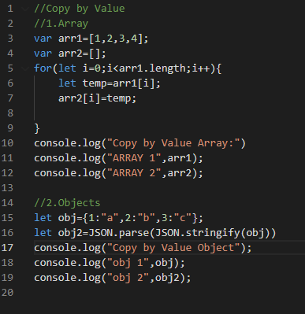

Output (in console):

