Questions.

1. Find all the information about each film
2. Find the title of each film
3. Find the director of each film
4. Find the title and director of each film
5. Find the title and year of each film
6. Find the movie with a row id of 6
7. Find the movies released in the years between 2000 and 2010
8. Find the movies not released in the years between 2000 and 2010
9. Find the first 5 Pixar movies and their release year
10. Find all the Toy Story movies
11. Find all the movies directed by John Lasseter
12. Find all the movies (and director) not directed by John Lasseter
13. Find all the WALL-* movies
14. List the last four Pixar movies released (ordered from most recent to least)
15. List the first five Pixar movies sorted alphabetically
16. List the next five Pixar movies sorted alphabetically

Outputs:

1.Code:db.cinema.find({}).pretty();

Output:

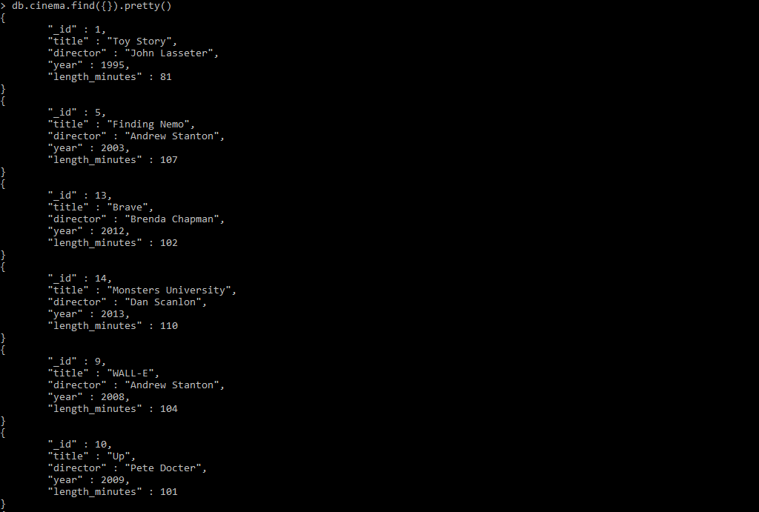

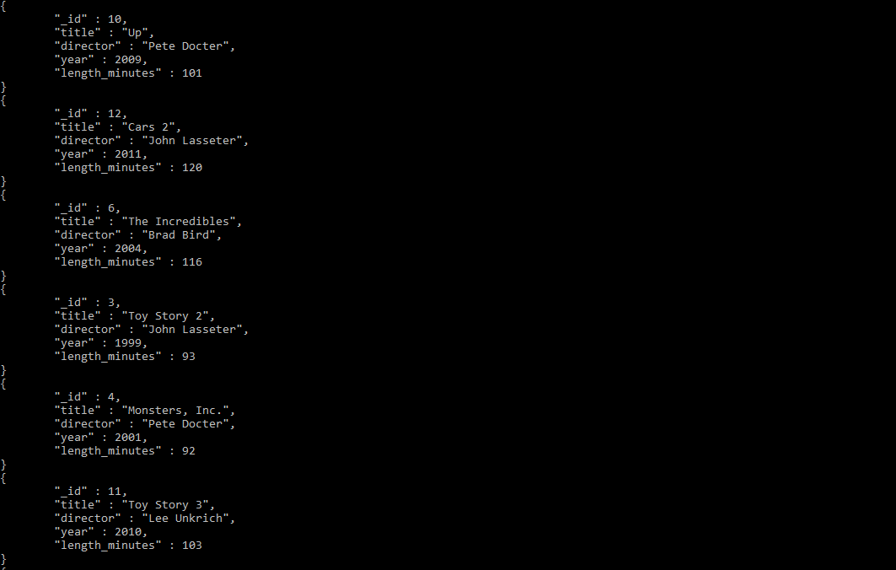

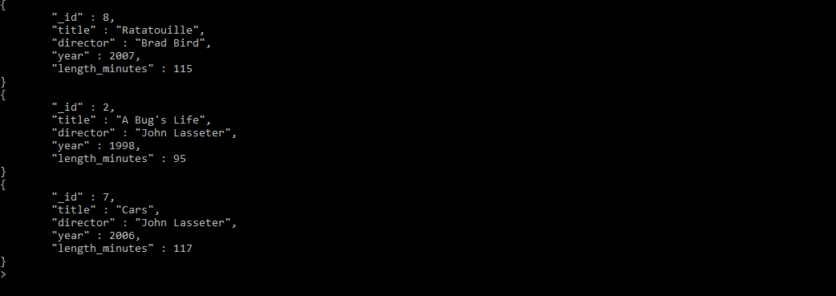

2.Code:db.cinema.find({},{“title”:1,”_id”:0}).pretty();

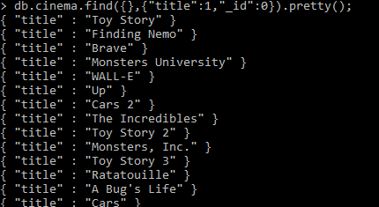

3.Code: db.cinema.find({},{"_id":0,"director":1}).pretty();

Output:

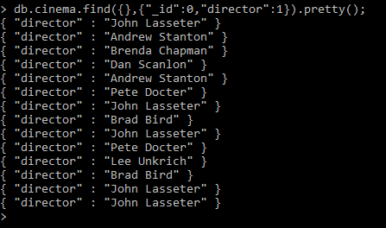

4.Code: db.cinema.find({},{"_id":0,"title":1,"director":1}).pretty();

Output:

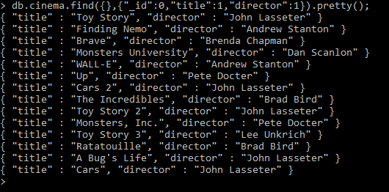

5.Code: db.cinema.find({},{"_id":0,"title":1,"year":1}).pretty();

Output:

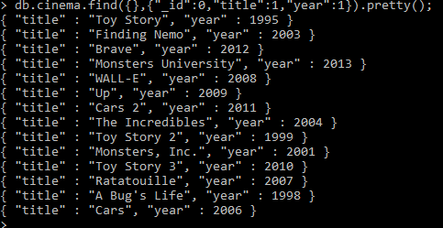

6.Code: db.cinema.find({"_id":6},{"_id":1,"title":1}).pretty();

Output:

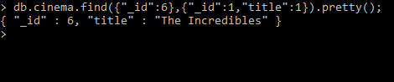

7.Code: db.cinema.find({$and:[{year:{$gt:2000}},{year:{$lt:2010}}]});

Output:

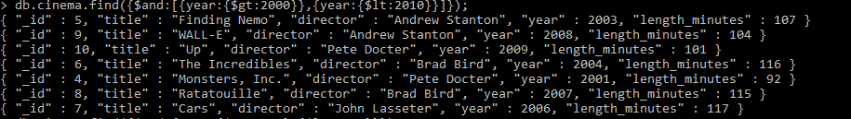

8.Code: db.cinema.find({$or:[{year:{$lt:2000}},{year:{$gt:2010}}]});

Output:

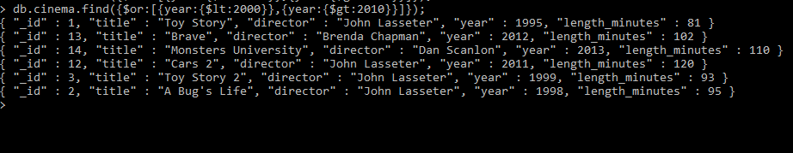

9.Code: db.cinema.find({},{"title":1,"year":1}).sort({"year":1}).limit(5);

Output:

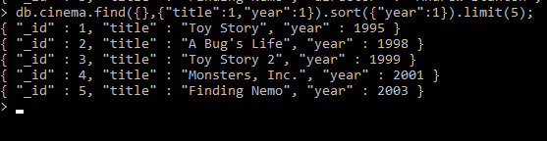

10.Code: db.cinema.find({"title":{$regex:/^Toy Story/}});

Output:

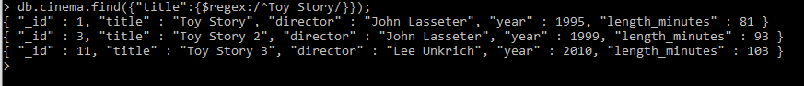

11.Code: db.cinema.find({"director":"John Lasseter"});

Output:

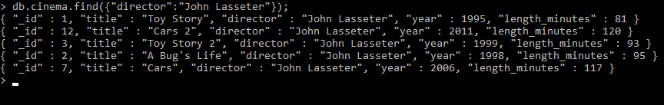

12.Code: db.cinema.find({"director":{$not:/^John Lasseter/}},{"_id":0,"title":1,"director":1});

Output:

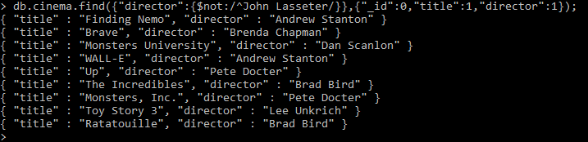

13.Code: db.cinema.find({"title":{$regex:/^WALL-/}});

Output:



14.Code: db.cinema.find({},{"year":1,"title":1}).sort({"year":-1}).skip(db.cinema.count()-4);

Output:

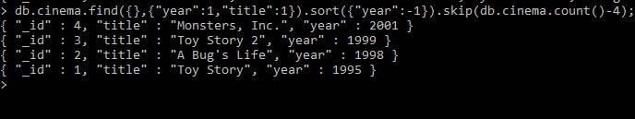

15.Code: db.cinema.find().sort({"title":1}).limit(5);

Output:

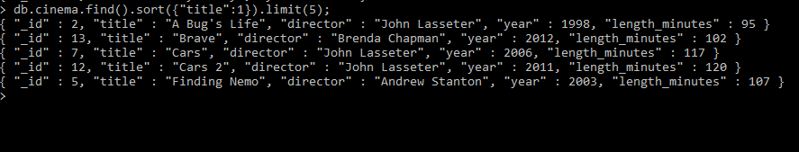

16.Code: db.cinema.find().sort({"title":1}).skip(5).limit(5);

Output:

