Questions:

1. Find all the students whos age is between 21 - 30
2. Find all students whos age is between 21 - 30 and height is greater than 5

Answers.

1.Code: db.students.find({"age":{$gt:21,$lt:30}}).pretty();

Output:

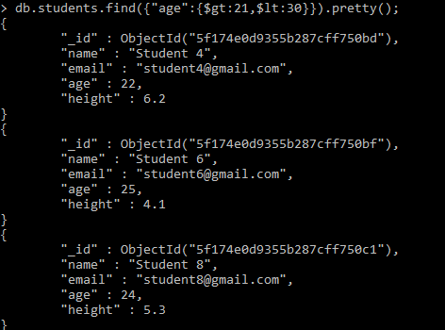

2.Code: db.students.find({"age":{$gt:21,$lt:30},"height":{$gt:5}}).pretty();

Output:

