BusinessAnalyticswithR_Project-01
#Part I
#There are 20 files with .dat extention. You have to read all the files in to single dataframe.
#Code
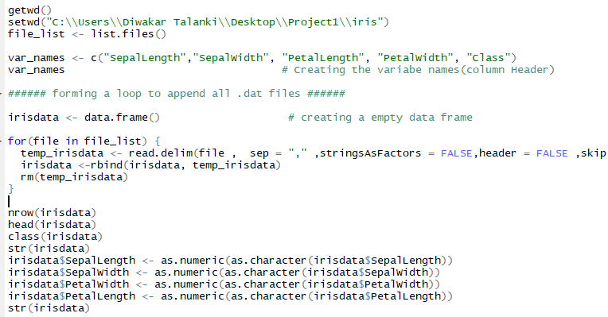
#Output
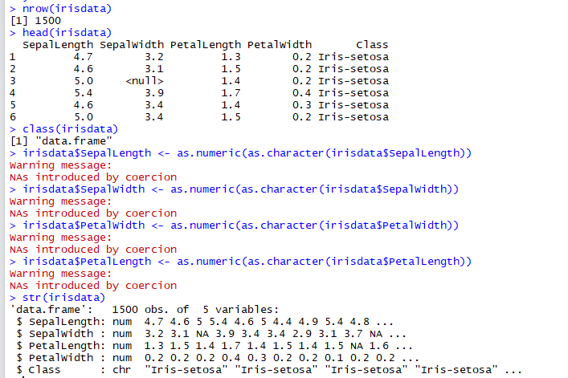
#Part II
#The data is present in xml format, with file name, iris.xml. Your task is to read the XML data and store it
#in the data frame df.

R code:

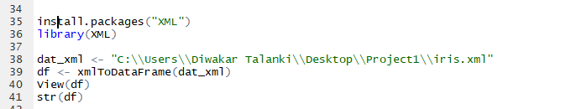
Output:

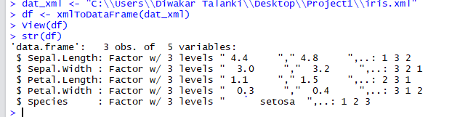
#Part III
#Convert the iris data into the JSON format and read the data in JSON format and convert it into
#dataframe "iris_data".

R code:
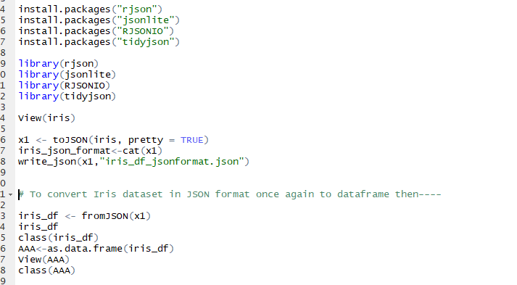
Output:
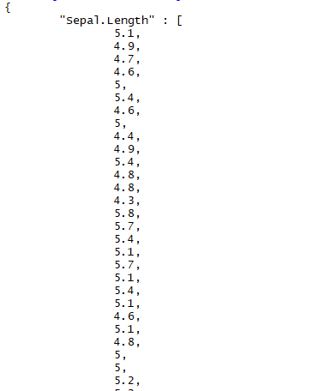
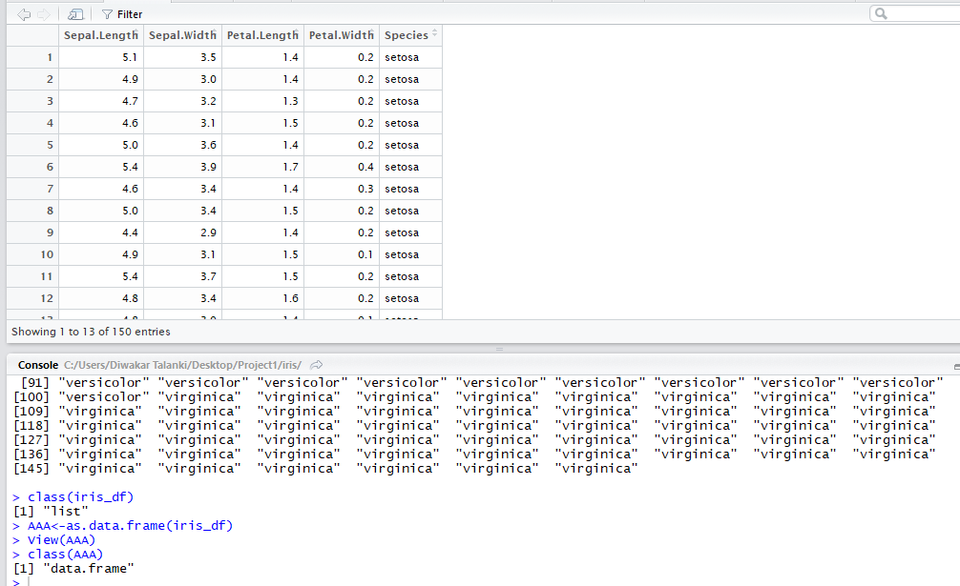
# --------------------------Match-----------------------

# matches() isa function from dplyr package.
# It works only on Column names or Variable Names having exact "search-string" matches
# within the given dataframe.
# It is case-sensitive.
# It does NOT search for matching strings within the rows of the given dataframe.i.e. it
# does not search for matching strings within the given character values.
# In brief, it works only on Variables/Columns having the exact string matches.

# Syntax:
select(data, matches("search_string"))

select(iris, matches("Petal"))

# Herein the two column names viz. ---- Petal.Length and Petal.Width are selected
# as per the given argument.

#######################################################################################

# --------------------------Filter--------------------------------
# filter() is a function from dplyr package.
# Use filter() to find rows where conditions are true
# It filter (subset) rows.
# It is equivalent to WHERE from SQL.

# Syntax:
filter(.data, ...)

#Useful filter functions
# . ==, >, >= etc
# . &, |, !, xor()
# . is.na()
# . between(), near()

# filter() for a single criteria
# It searches for the specified criteria within the rows as follows:---

filter(iris, Species == "versicolor")

filter(iris, Sepal.Length < 4.5)
filter(iris,Petal.Length>6)

# filter() for a multiple criteria
# It searches for the specified criteria within the rows as follows:---

filter(iris, Sepal.Length == "NA" | Petal.Length == 4.5)

filter(iris, Petal.Length >=6.5 ,Species == "virginica")

# Or--
# Using filter()to find value(s) by using piping operator as follows:---

iris %>%
select(Sepal.Length, Petal.Length,Species) %>%
filter(Species == "setosa")

iris %>%
select(Petal.Length,Sepal.Width,Species) %>%
filter(Petal.Length>= 4.5 & Sepal.Width<=2.5,Species == "versicolor")

# In the below-mentioned code, in order to exclude Species starting with letters/character values "SE"--

iris %>%
select(Sepal.Length,Sepal.Width,Species) %>%
filter(Species != "SE" & Sepal.Length >= 6.9)%>%
summarise(mean(Sepal.Width, na.rm = TRUE))

##################################################################################################

# ---------------------Arrange-------------------------------------

# arrange() arranges rows by the variable names or in simple terms---sorts the data.
# It forms a part of dplyr package.
# By default arrange() sorts the rows in an ascending order
# In case if descending values are desired then arrange() needs to be combined with desc().
#arrange() is eq1uivalent to ORDER BY in SQL

# Syntax:
#arrange(data_frame, variable(s)_to_sort)
# or
#data_frame %>% arrange(variable(s)_to_sort)
# To sort a variable in descending order, use desc(x).

arrange(iris, Petal.Length, Petal.Width)

arrange(iris, Petal.Length, desc(Petal.Width))
arrange(iris, Sepal.Width, desc(Petal.Width))

# By using arrange_all() then-----

arrange_all(iris, desc)

# OR By using Pipe Operator---

iris %>%
select(Petal.Length,Petal.Width,Species) %>%
arrange(Petal.Length, desc(Petal.Width)) %>%
filter(Petal.Length<= 3.5)

iris %>%
select(Sepal.Length,Sepal.Width,Species) %>%
arrange(Sepal.Length, desc(Sepal.Width)) %>%
filter(Species!= 'setosa' & Sepal.Width<=2.5)

######################################################################################

# ---------------------Rename---------------------------------

#Syntax:
rename(.data, ...)

rename(iris, petal_length = Petal.Length)
rename(iris, petal_width = Petal.Width)
rename(iris, Sepal_length = Sepal.Length)
rename(iris, Sepal_width = Sepal.Width)

# OR----

rename_demo<- rename(iris,petal_length = Petal.Length, petal_width = Petal.Width,Sepal_length = Sepal.Length, Sepal_Width=Sepal.Width)
View(rename_demo)

# OR-----

library(dplyr)
iris %>%
as_data_frame %>%
rename(petalLth = Petal.Length)

# OR ----

rename_demo_B <- rename(iris, Sepal.Wth = Sepal.Width, Species_Varieties=Species)
View(rename_demo_B)
######################################################################################

# -----------------------Mutate-----------------------------------
# Syntax:
mutate(.data, ...)

# Newly created variables are available immediately
iris_data_calc<- iris %>% as_tibble() %>% mutate(
Sepal.Area = (Sepal.Length * Sepal.Width),
Petal.Area=(Petal.Length * Petal.Width))
View(iris_data_calc)

# Using mutuate() to create Ranks based on Sepal.Area:-----

Rank_Sepal_Area<-iris_data_calc %>% mutate(rank=dense_rank(desc(Sepal.Area)))
View(Rank_Sepal_Area)
iris_sepal_ranking<-arrange(Rank_Sepal_Area, rank)

View(iris_sepal_ranking)

# Using mutuate() to create Ranks based on Petal.Area:----

Rank_Petal_Area<-iris_data_calc %>% mutate(rank=dense_rank(desc(Petal.Area)))
View(Rank_Petal_Area)
iris_petal_ranking<-arrange(Rank_Petal_Area, rank)

View(iris_petal_ranking)

# mutate() is also used to remove variables and modify
# the existing variables
iris %>% as_tibble() %>% mutate(
Petal.Length = NULL,
Petal.Width = Petal.Width * 0.016
)

Outputs:
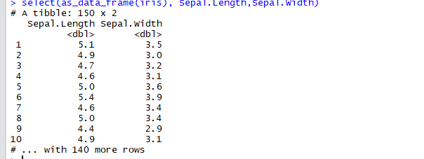
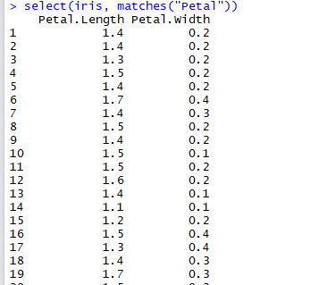
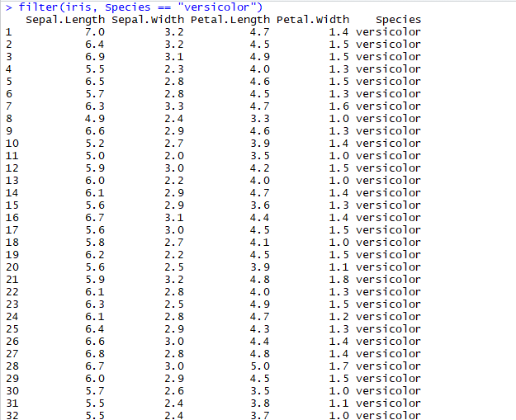
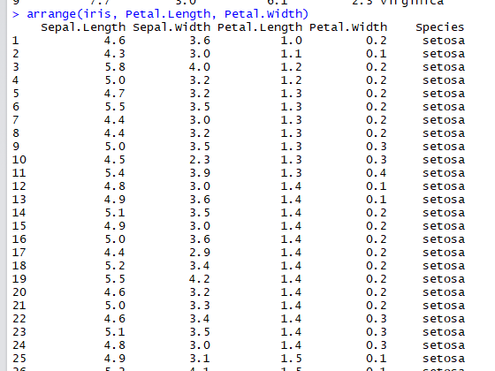

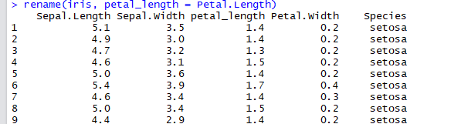
#Part V
#Print the summary of iris_data
Code

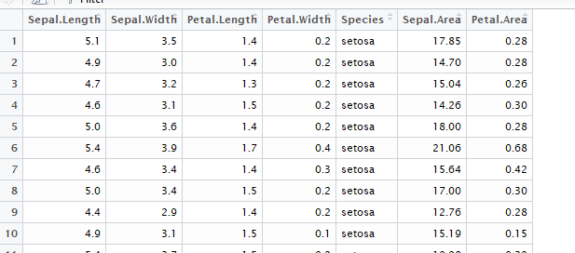
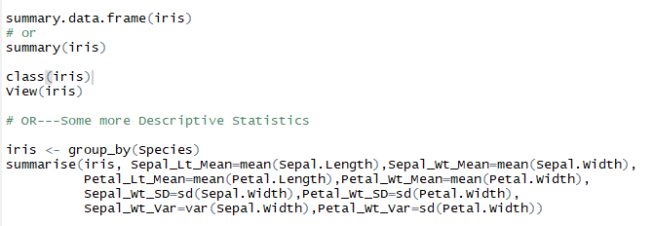
Output:

