R Software Installation (Latest Version: R-3.4.0)

R -Base installation done and here is the console.

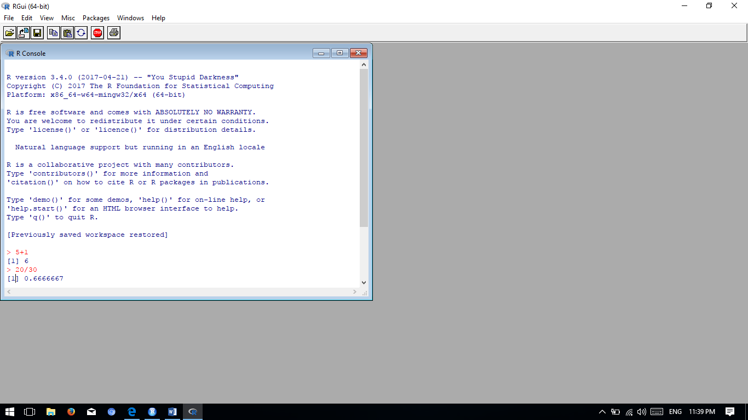

R- Studio window.

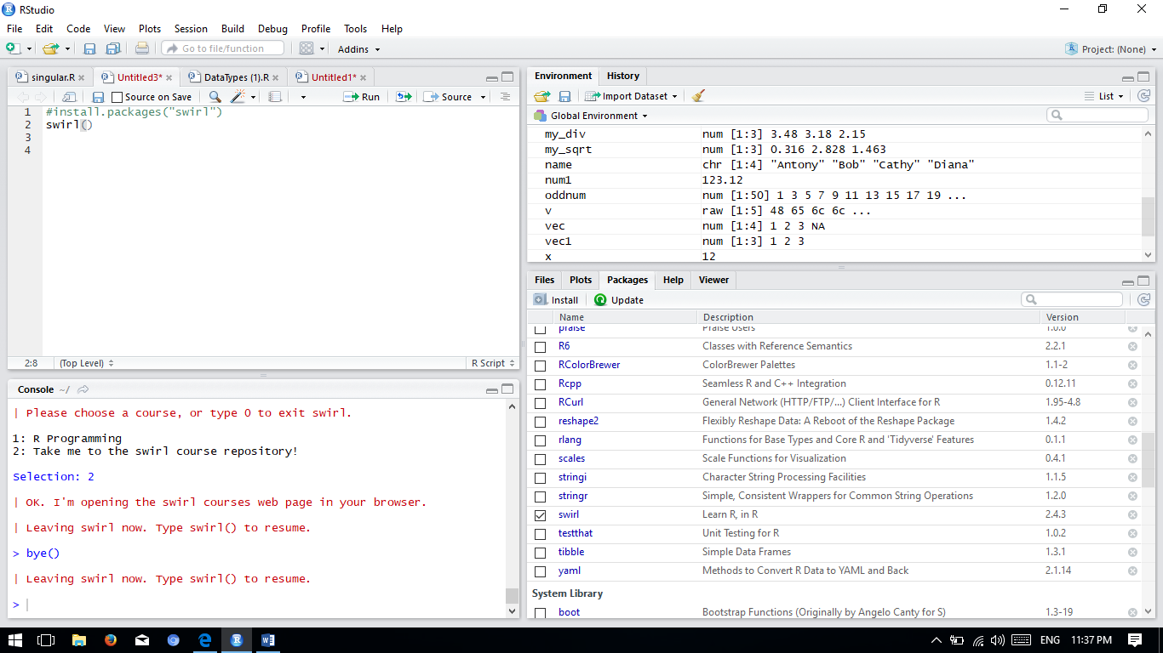

Next would be installing a package called swirl, using which we can learn R within R console.

Loaded swirl package using library(swirl) and completing the introductory course.

Below is the screen shot for the same.

