**Session4_Assignment1_Basic_Operations_with_R**

1. Creating Vectors
2. (b) (c) (d)

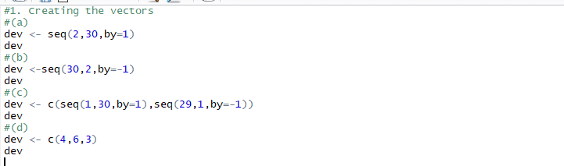

Output:

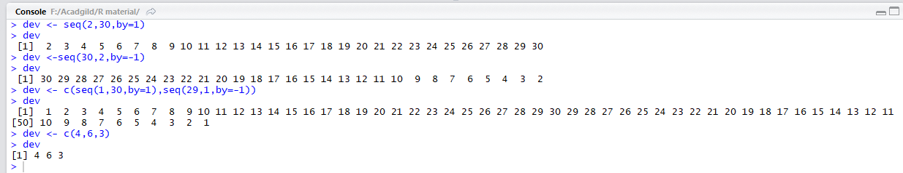

For (e) (f) and (g) code and Output :

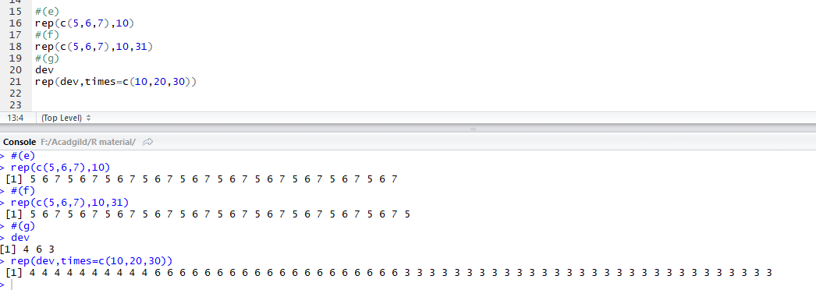

1. Creating vector of values of eX sin(x) at x = 3,3.1,3.2,3.3 ,……6

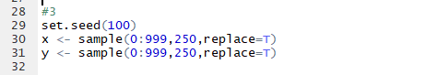

Output :

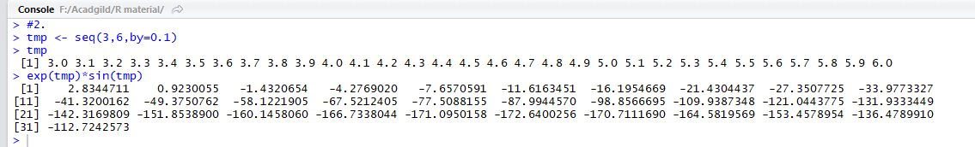

1. (a) (b) (c) code

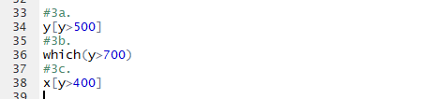

Output:

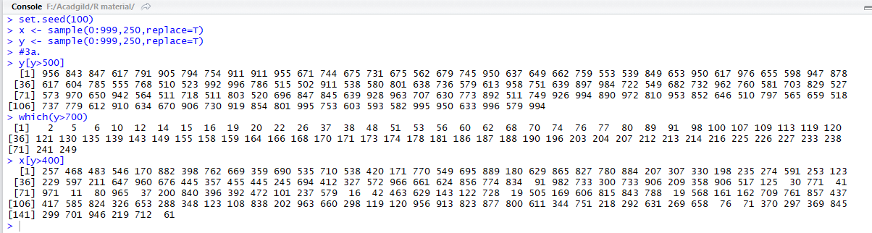

(d) (e) (f) codes

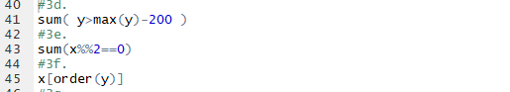

Output:

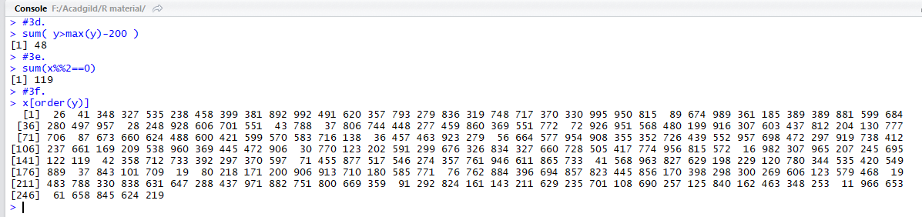

(g) code and output

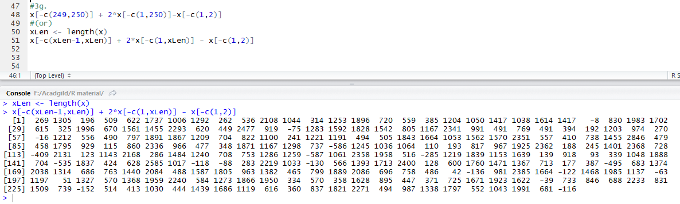

4(a) and (b) code and output

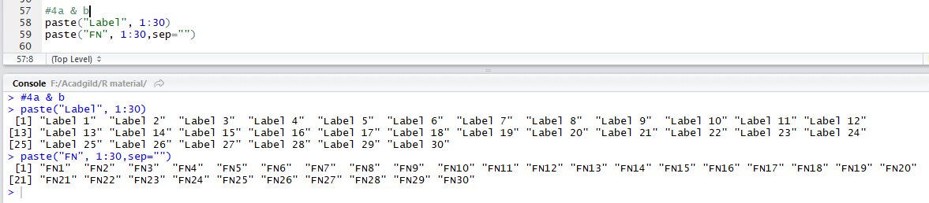

5. Compound Interest code and output

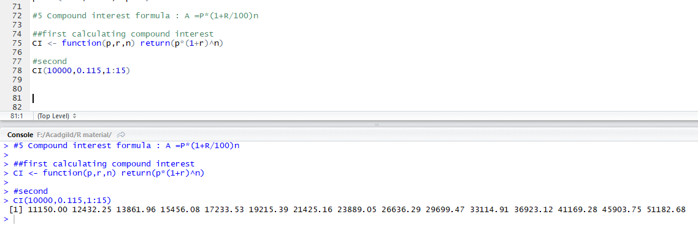

6. Generating matrices

