**Bigdata_Session1_Assignment1.1**

1. Below is screen shot after importing the Acadgild VM

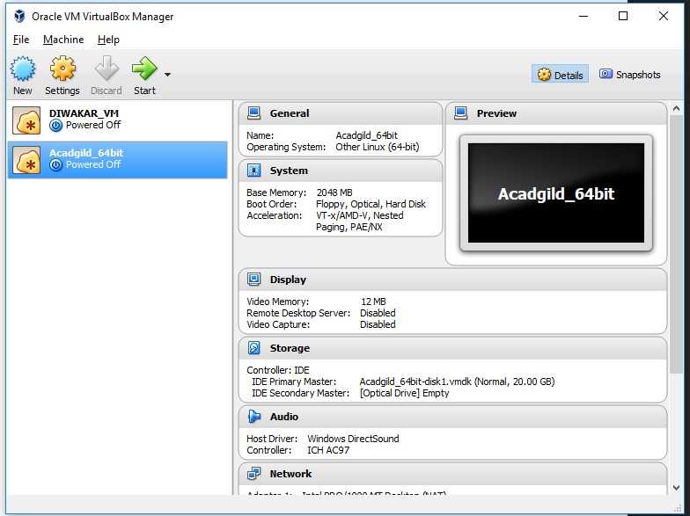

1. Starting Namenode, Datanode, Jobhistory , resourcemanager.

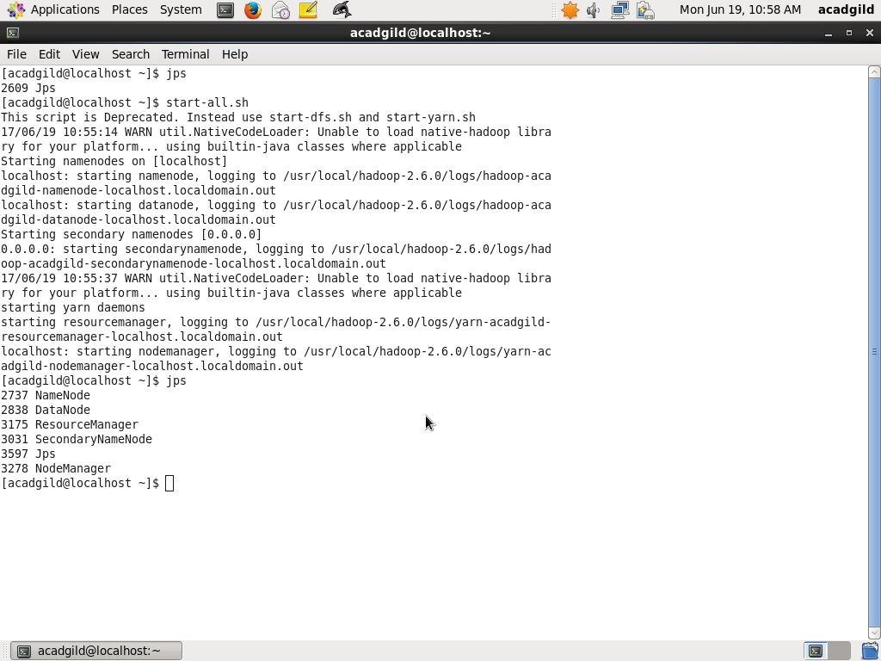

1. Starting all nodes manually

