**Linux Commands**

1. Pwd: pwd (print working directory) command writes full pathname of current working directory to the standard output. The command is a shell built-in in most Unix shells such as Bourne shell, ash, bash, ksh, and zsh

Ex: /home/acadgild

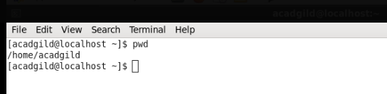

1. vi: The default editor that comes with the UNIX operating system is called vi (**vi**sual editor).

The UNIX vi editor is a full screen editor and has two modes of operation:

1. *Command mode* commands which cause action to be taken on the file, and
2. *Insert mode* in which entered text is inserted into the file.

In the command mode, every character typed is a command that does something to the text file being edited; a character typed in the command mode may even cause the vi editor to enter the insert mode. In the insert mode, every character typed is added to the text in the file; pressing the <Esc> (*Escape*) key turns off the Insert mode.

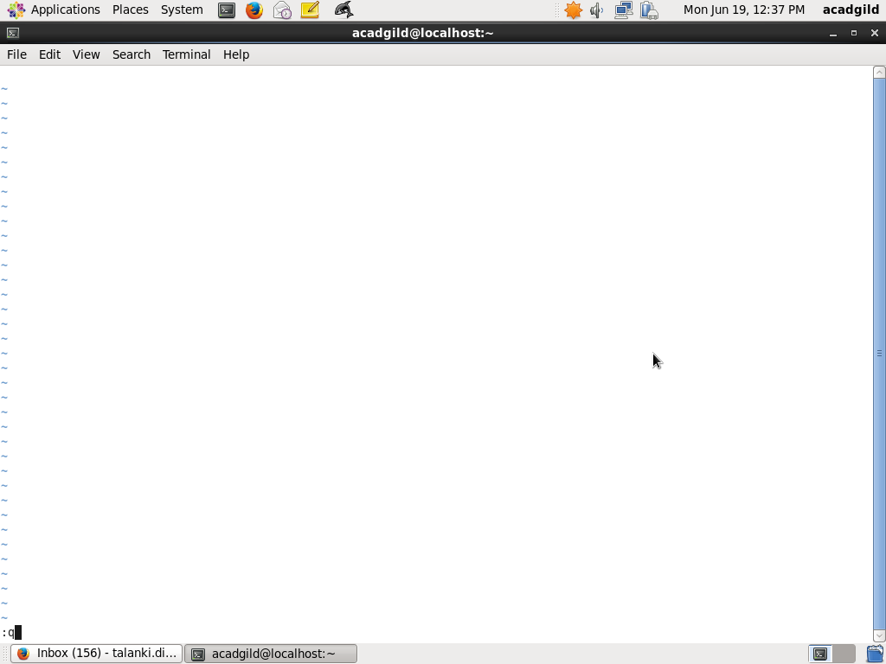

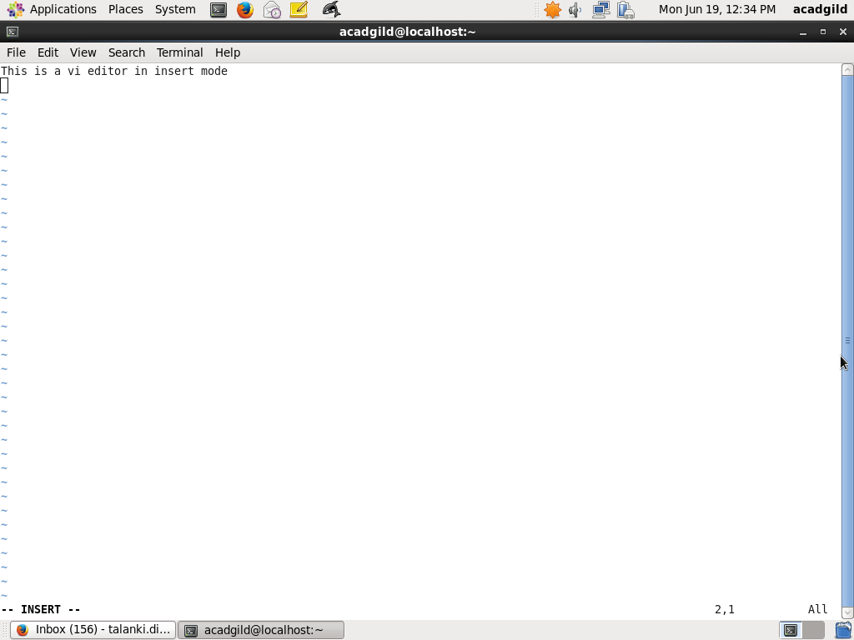

1. touch: The touch command can be used to modify the access/modification timestamps of files. It is more often used to actually just create an empty file quickly.

Ex: Below example will demonstrate the creation of empty file, multiple files and modify access times.

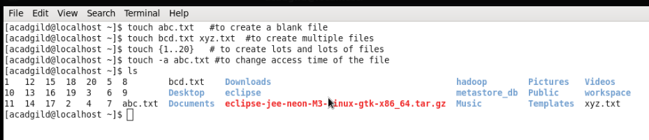

1. Mkdir : mkdir (Make directory) is used to create directories on the file system.

If the specified directory does not already exist, mkdir creates it.

More than one directory can be specified when calling mkdir.

Ex: Below screen shot will explain the example.

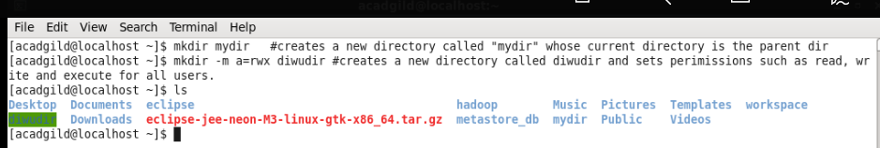

1. Rm : rm command is used to remove the files in the present directory.

Once removed we cant revert back

Ex screenshot

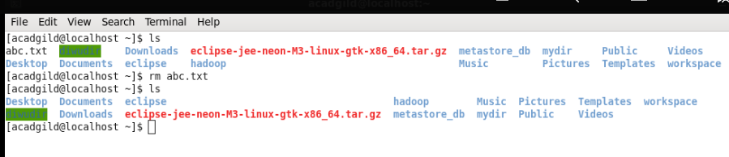

1. Ls : ls is used to list all the files and directories available in the file system.



1. Echo: In computing, echo is a command that outputs the strings it is being passed as arguments.

It is a command typically used in shell scripts and batch files to output status text to the screen or a file.

Ex:

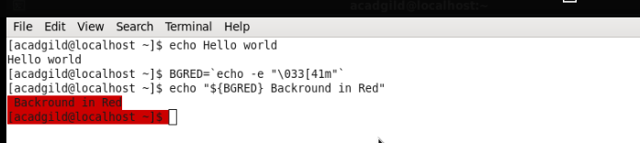

1. Cat: cat command allows us to create single or multiple files, view contain of file, concatenate files and redirect output in terminal or files. It is a standard Unix program used to concatenate and display files. The cat command display file contents to a screen. Cat command concatenate FILE(s), or standard input, to standard output. With no FILE, or when FILE is -, it reads standard input. Also, you can use cat command for quickly creating a file. The cat command can read and write data from standard input and output devices. It has three main functions related to manipulating text files: creating them, displaying them, and combining them.

Examples as shown in the screen shot.

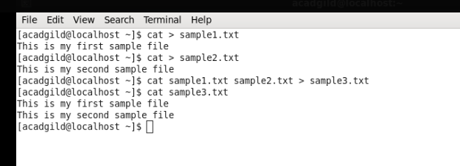

1. Who: Displays who is logged on to the system.

Prints information about all users who are currently logged in.

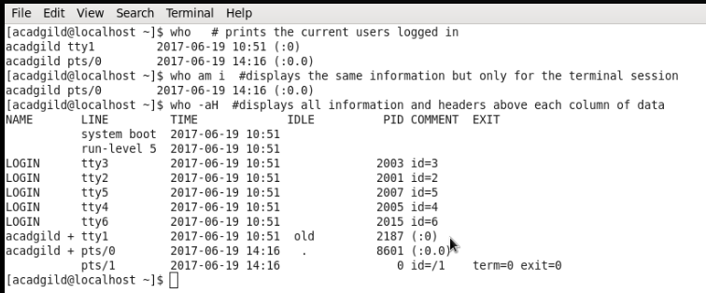

1. Cd: The cd command, also known as chdir (change directory), is a command-line OS shell command used to change the current working directory in Unix.

Examples

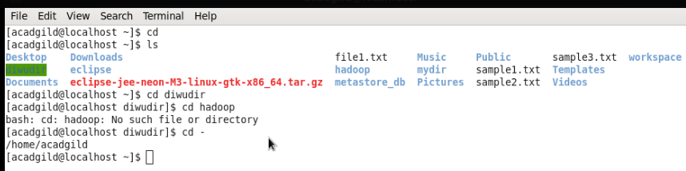

1. Date: The date command is used to print out, or change the value of, the system's time and date information.

Examples

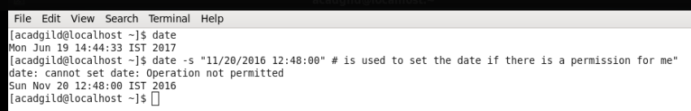

1. Cal: cal command is used to display a calendar.

A single parameter specifies the 4 digit year (1 - 9999) to be displayed. Two parameters denote the Month (1 - 12) and Year (1 - 9999). If arguments are not specified, the current month is displayed. A year starts on 01 Jan.

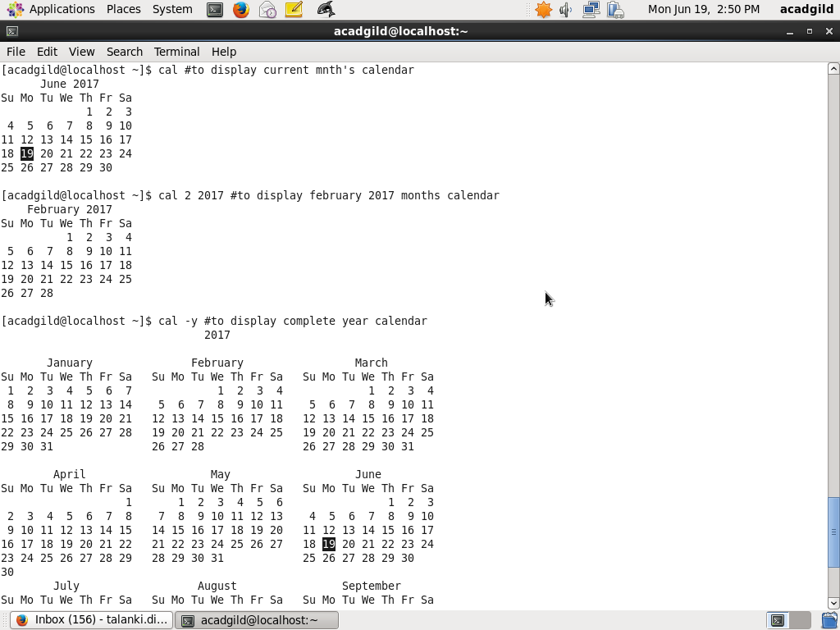

1. Mv: The mv command is used to move or rename files

mv renames file SOURCE to DEST, or moves the SOURCE file (or files) to DIRECTORY.

Example Screenshot

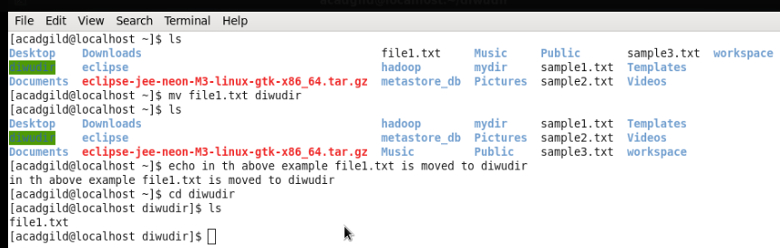

1. cp: The cp command is used to make copies of files and directories.

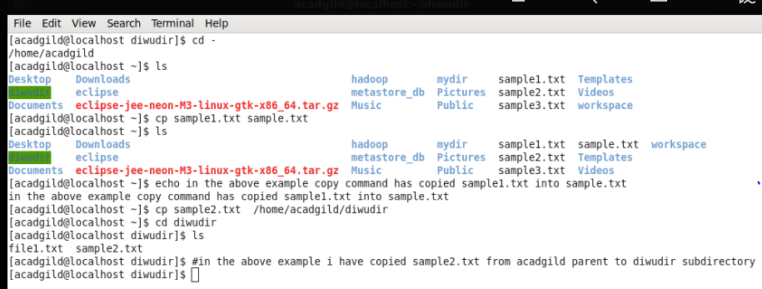

1. Which: Locate the executable file associated with a given command.

which returns the pathnames of the files (or links) which would be executed in the current environment, had the filename (or filenames) been given as a command (or commands) in a strictly POSIX-conformant shell. It does this by searching the paths in the PATH environment variable for executable files matching the names of the arguments.

Example screen shot

