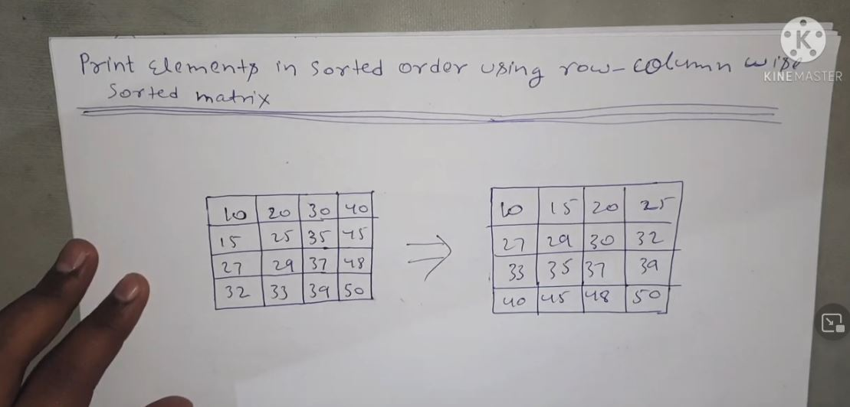

Like right side should return.

1st approach:

store all element in m*n array

use sorting and print it

time complexity->n*mlog(n*m)

space->n*m

2nd optimal:

Priority queue- <https://www.geeksforgeeks.org/priority-queue-in-cpp-stl/>

vector<vector<int>> sortedMatrix(int N, vector<vector<int>> Mat) {

priority_queue<int,vector<int>,greater<int>> pq;

for(int i=0;i<N;i++)

{

for(int j=0;j<N;j++)

{

pq.push(Mat[i][j]);

}

}

int r=0,c=0;

while(!pq.empty())

{

Mat[r][c]=pq.top();

c++;

if(c==N)

{

c=0;

r++;

}

pq.pop();

}

return Mat;

}