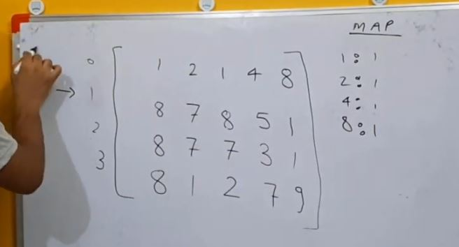

Store unique element already in map.

Here key value stores row number.