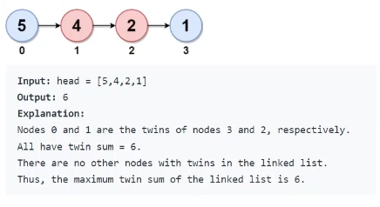

Divide the linked list in 2 half.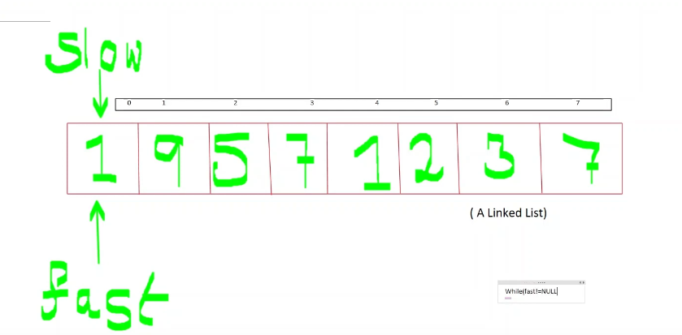

Use tortoise method of linked list to find the 2nd middle number.

2nd middle is n/2+1->here n is always even.here 2nd middle is 1.

The tortoise method:

While(fast!=NULL)

Slow=slow->next;

Fast=fast->next->next

Here how we can get 1957 simultaneously with 1237.we can get it by stack data structure.

Here how while use tortoise we can put the slow pointer data in stack.here just put condition fast->next->next!=NULL to make sure it stopes at 7 storage at stack.

Code:

